FLOOD FORECASTING AND PUBLIC AWARENESS

Janez Polajnar¹, Marko Polič² and Mitja Brilly³

¹ARSO – Environmental agency of Slovenia, e-mail: mbrilly@fgg.uni-lj.si
²University of Ljubljana, Faculty of arts, Ljubljana, Slovenia
³University of Ljubljana, Faculty of Civil and geodetic Engineering, Ljubljana, Slovenia

Abstract: Flood forecasting has been integrated in the decision-making system for flood protection. The question remains the level of trust that people and decision-makers put into hydrological forecasts and the scope of information that should be provided. The investigation was developed as part of the EU project European Flood Forecasting System – EFFS. It also included a round table of experts and a questionnaire among the inhabitants who had experienced serious floods in the past thirteen years.
The workshop ‘Round table on hydrological forecasts and warnings’ was made with end-users, and the questionnaire was developed for the inhabitants of the town of Celje, which was seriously flooded in 1990 and 1998, respectively. Four areas of the town were distinguished and in each area about 50 inhabitants were asked to participate. The responses concerning flood forecasts were analysed and result presented.
Keywords: floods, flood forecast, public awareness, civil defence, Celje

HOCHWASSERVORHERSAGE UND ÖFFENTLICHES BEWUSSTSEIN

Zusammenfassung: Hochwasservorhersage hat man in das Entscheidungssystem des Hochwasserschutzes integriert. Die Frage ist, wie hoch das Vetrauen in die hydrologische Vorhersage an der Seite der Leute und der Entscheidungsträger ist und welche Informationen sollte man zur Verfügung stellen. Die Erforschung wurde im Rahmen des EU-Projekts „Das europäische Hochwasservorhersagesystem“ (European Flood Forecasting System – EFFS) ausgeführt. Die Erforschung erfasste auch ein Rundtischgespräch von Experten und einen Fragebogen zur Einwohner, die in den letzten dreizehn Jahren erhebliche Hochwasserereignisse erfahren haben.
Das Arbeitsseminar „Rundtisch über hydrologischen Vorhersagen und Warnungen“ wurde mit Endbenutzer organisiert und der Fragebogen wurde für die Einwohner der Stadt Celje vorbereitet. Die Stadt war in der letzten Jahren zweimal überschwemmt: in 1990 und 1998. Man hat in der Stadt vier Gebiete abgegrenzt und in jedem Gebiet wurden 50 Einwohner zur Beteiligung gebeten. Die Antworten wurden analysiert and die Resultate präsentiert.
Schlüsselworte: Hochwasser, Hochwasservorhersage, öffentliches Bewusstsein, Zivilschutz, Stadt Celje

1. Introduction
Flood forecasting is integrated in the decision-making system for flood protection. The questions are how much people and decision-makers trusted to the hydrological forecast and what they, experienced with floods, really need as information. Investigation, developed as a part of EU project European flood forecast system – EFFS, will be presented. The investigation consists from roundtable of the expert user and questionarie of the inhabitatants that was seriously flooded in the past thirteen years.
Slovenia is situated in head part of the streams where frequent flush floods dominate. Inhabitants are very well familiar with flood risk and flood damage is not too high. In the past twenty years there were a lot of flood events with only some casaulties in the three events.
Slovenian Agency for Environment (ARSO) is responsible for meteorological and hydrological forecast. Hydrological measurement has more than hundred years in tradition. The Service of Monitoring Hydrological Conditions, Forecasts and Reporting (hydrological service) of ARSO daily disseminates reports of hydrological situations of Slovenian rivers, and issues forecasts on the expected changes of discharges. In the case of predicted high precipitation events with possibility of flood, hydrological service sends the flood warning to the Notification Centre of the Republic of Slovenia (CORS) at the Administration for Civil Protection and Disaster Relief of Slovenia. CORS disseminates warnings to the regional Notification Centres and media. In the last seven years, about 50 to 70 cases of critical water levels of rivers and sea levels were reported. Generally, the reliability of flood warnings was about 85 % for the entire Slovenian area.

2. Round table on hydrological forecasts and warnings
The round table on hydrological forecasts and warnings was organized on June 19, 2003 at the Environmental Agency of the Republic of Slovenia. The aim of the workshop was to identify the level of satisfaction by the end–users with regard to hydrological reports, forecasts and warnings made by hydrological service, to identify the missing information in these products in order to improve the contents and identify the lead-time needed to plan the actions. The users from governmental services, local authorities and media were invited to the workshop. The aim was to identify the differences between flood warnings designed for the governmental services and local authorities, as well as the requirements for media. Unfortunately, the participation was not satisfactory, especially from media. We received seven responses with highly useful comments. The number of participants is not significant for statistical analysis, but nevertheless we received a very informative respond.
The workshop began with a short presentation of the work and technical capabilities of the hydrological service to ensure flood warning in the average lead-time of 24 up to 35 hours as introduction to discussion (Appendix 1). Through the discussion the information was collected by the prepared questionnaire (Appendix 2). We had the opportunity to hear the suggestions from the local Civil protection services and from the Notification Centre of the Republic of Slovenia. The discussion with end-users and questionnaire responses gave several useful hints to improve flood forecasts and warnings:

- Flood warnings issued by hydrological service are recognizable in local civil protection services. All end-users use additional sources of information for decision making.
- Only 50 % of present users are satisfied with the current form of flood warnings. They ask for more locally specific and informative reports. Information could be equipped with percentiles for experts. Occasionally the information was received too late and a lack of information during the event was identified.
- The users are mainly satisfied with the lead-time of the flood warning, which is 24 to 36 hours (75 %).
- The users are mainly satisfied with the prediction accuracy on the regional scale and the prediction of catchments with the possibility of floods (62 %).
- The users agree that the recurrence interval on maximum discharge is necessary in the evaluation of flood magnitude.
- The users dismiss the use of percentile presentation in hydrological reports and warnings for public purpose.
- The users were satisfied with lead-time of 1 to 2 days, up to 4 days maximum, due to specific, mainly torrential runoff of the Slovenian rivers, as well as expressed confidence in daily forecasts and functioning of civil defence service. No trust was laid upon long-term (seven-day) forecasts.
- Majority of the users (87 %) believes that the Internet is the most sufficient dissemination method enriched with GIS presentations, a minority (37 %) supports the GSM network. They fully support further technical development of flood forecast systems.

2.1 Recommendations of end-users
On the current flood warning forms, the end-users miss some information to relieve their operative work in the field and triggering necessary actions:
- Predicted flood magnitude should be recognized with warning levels:
- Notice of flood possibility (probability of yearly flood)
- Warning of flood (probability of 5-yearly flood)
- Extra warning (probability of flood exceeding 5-yearly flood)
  - Information and on-line now-casting should be issued more frequently, especially in the time of flooding..
  - Prediction of flood areas of small rivers also (tributaries) should be given.
  - More on-line hydrological data are needed to enable the actions that can be taken before flood.
  - The users believe that false flood warnings are problem. They do not trust in warnings issued prior to 3 days in advance.
  - Flood warnings should be separated for media and governmental services. The media and the public do not well understand some of the professional terms used for forecasts.

2.2 Conclusions
With the workshop ‘Round table on hydrological forecasts and warnings’ the hydrological service got a confirmation of the previous work done in the field of flood forecasts and warnings. End-users, especially Civil defence squads are quite satisfied with existing flood warnings, but they also contribute some valuable remarks on the contents of flood warnings that will be the guidelines in our future work. Relevant information might include the estimation of the expected flood, the estimation of the time before impact, a description of the present environmental conditions and providing specific instructions for proper measures. The level of the predicted flood should be stressed in the warning with regard to the three categories of flood warnings. It is necessary to include more data from the field into the warning and to define flood areas on smaller rivers also.
Flood warnings based on flood prediction should be prepared with more details for governmental services and in a more common form issued for the media.

3. Questionnaire developed in town Celje
The questionnaire, Appendix 3, was developed for the inhabitants of the town of Celje that was seriously flooded in 1990 and 1998, respectively. Four areas of the town were distinguished and in each area about 50 inhabitants were asked to participate. The responses concerning flood forecasts were analyzed.

3.1 Area description
The investigations were underway in the areas presented in Figure 1.
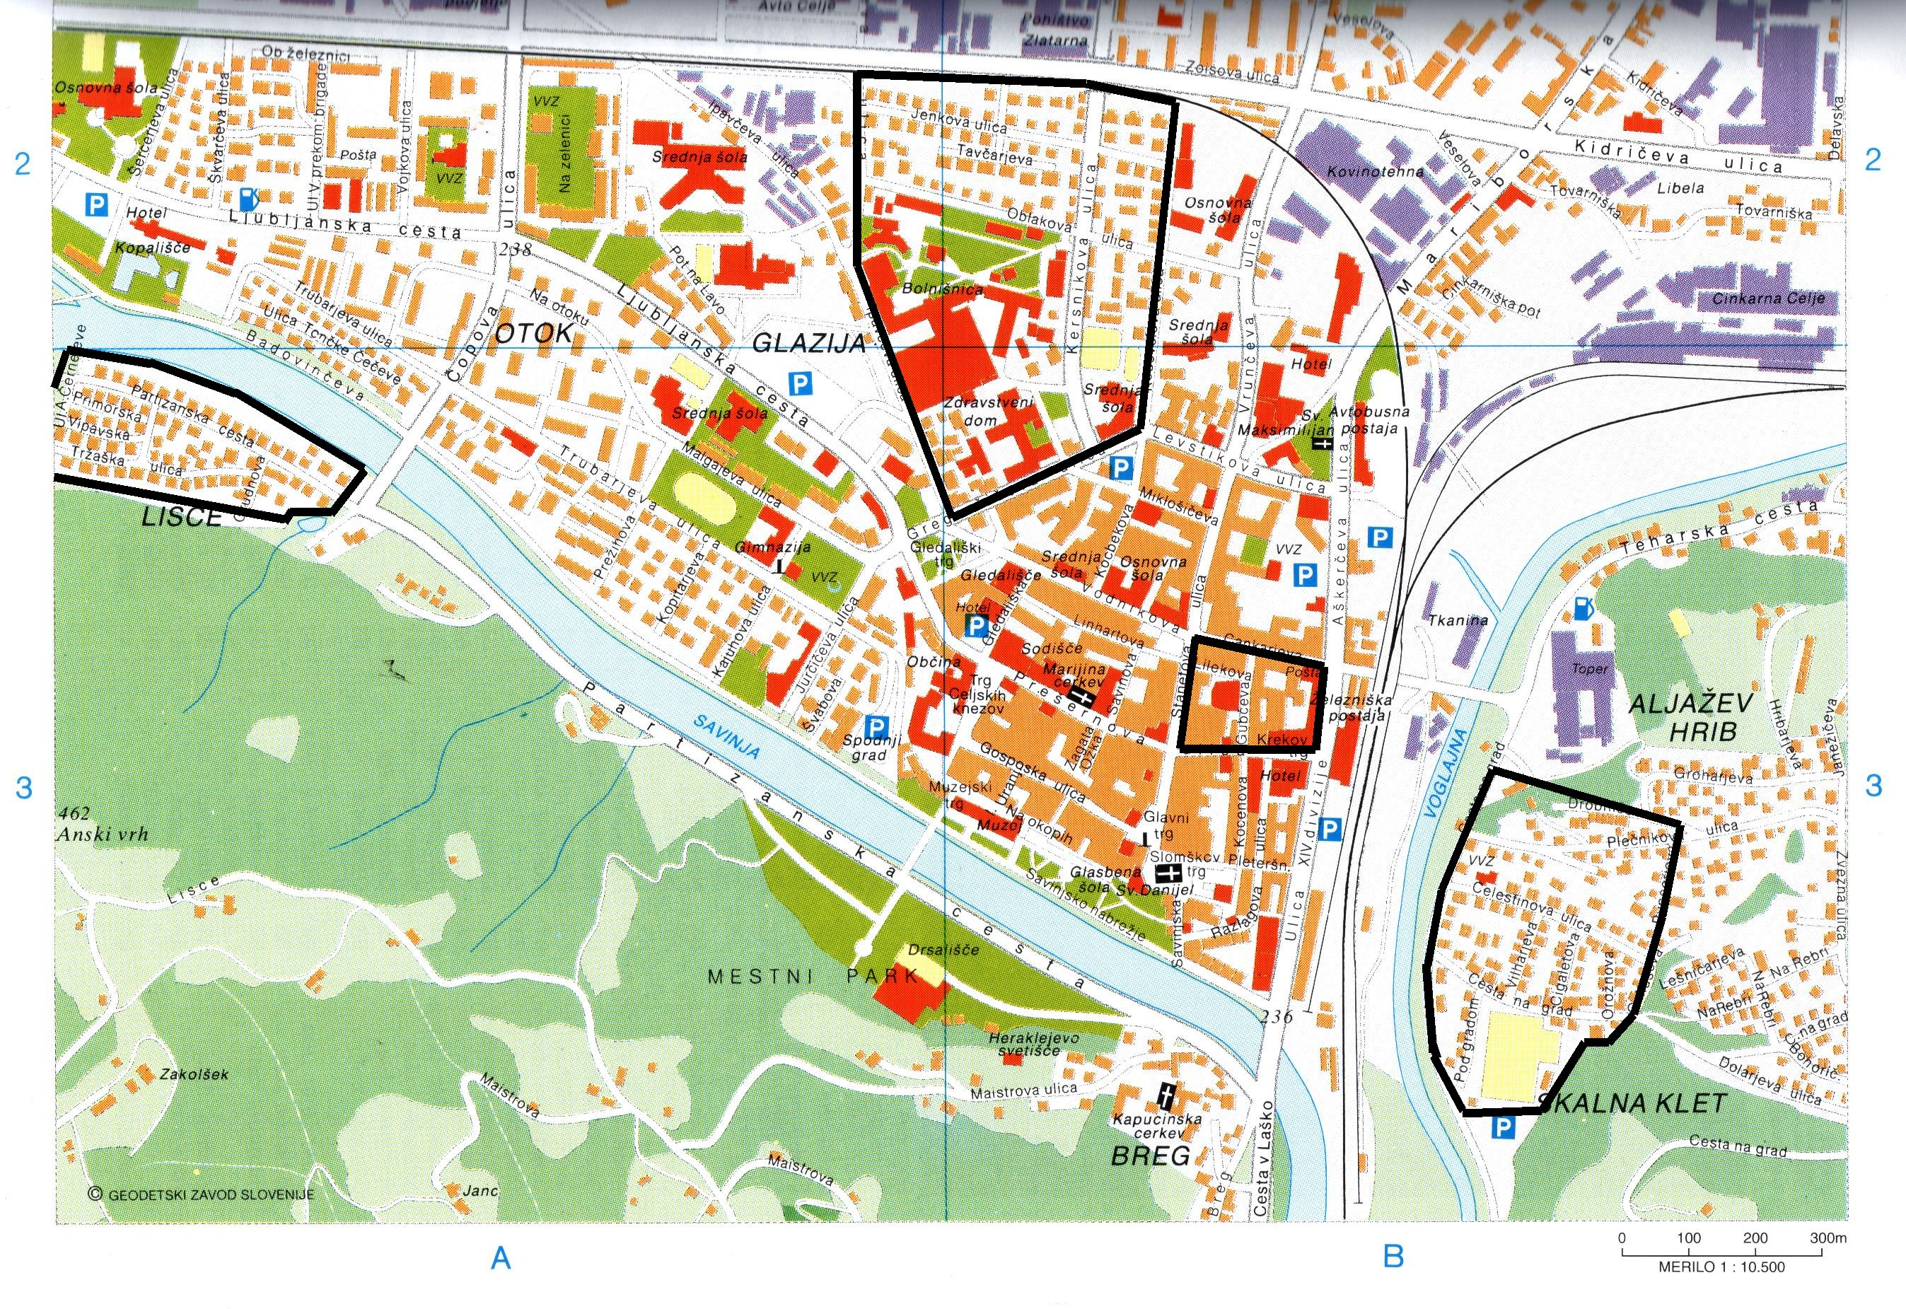
Figure 1. The Areas of investigation
- Center is in the medieval part of the town and outside the flooded area. The inhabitants suffered only because the surrounding parts were flooded but they and their property were out of danger.
- Glazija, the area northwest of Center, has been settled in the past hundred years. The urban area is half a kilometer far from the riverbed and embankment. Inhabitants suffered from the 1990 flood, however floods do not threaten the area frequently.
- Lisce, the area west of Center, is inundated by the river protected by levees. The area has been settled in the past thirty years on a frequently flooded surface. The inhabitants are fairly familiar with the Savinja River water regime, which could be observed through the windows in their living rooms.
- Skalna klet, the area east of Center, is inundated by the river protected by levees and pumping station for drainage during a flood event. The area has been settled in the past thirty years on a frequently flooded surface. The inhabitants are very familiar with the river water regime, and they feel safe and protected enough. They were not flooded in the 1990 flood, but there were serious floods in 1998 caused by the Voglajna River tributary of the Savinja River.

3.2 Analysis of the responses
The question: “To what extent do you trust weather forecasts and flood forecasts in the following public media?” provided multiple-choice answers, such as newspapers, Internet, national TV, national radio and local radio. ‘Local radio’ received the highest score, since it seems more up to date than other media. Newspapers print data with 24-hour time lag. National TV and national radio are more regionally oriented without paying special attention to local conditions. The local radio has field reporters and caters to local interests. Accordingly, many people are still not familiar with the Internet.
Another question was: “What lead-time is necessary for being able to take appropriate measures?” The mean score of answers ranged between 3 (6-12hours) and 4 (12-24 hours). The respond is closely connected to the responses given to the question: “How far ahead would you still trust in the flood forecast?” People trust in forecasts issued from less than 6 hours and up to 24 hours ahead. Owing to the lack of trust in flooding possibility, the hydrological forecasts are not “needed” more than 24 hour ahead. There is also significant difference in respond from particular area. Inhabitants from Centre, which was never flooded, trust much more than inhabitants from Glazia heavily flooded in 1998. The inhabitants from Lisca and Glazia areas give close respond in between.

Figure 2. Answers to the question: To what extent do you trust weather forecasts and flood forecasts in the following public media?
Interestingly, there was a high score attained in the question: “How often do you keep up with weather reports in the media?” The mean answers range between ‘frequently’ and ‘always’, meaning that the inhabitants like to be informed and that the information can be trusted.
Surprising are the responses to the question: Would you like to be warned against flooding when the event is not certain? Almost all answers are ‘by all means’. People like to be informed and are not concerned with the “crying wolf syndrome”.

Figure 3. Several opinions regarding trust in weather forecasts.

4. Conclusions
Flood forecasting is integrated in the decision-making system for flood protection. The decision-making system was developed in accordance with the to day confidence level and lead-time of flood forecasts. Flood forecasting with lead-time longer than 1 to 3 days ahead called for changes in the decision-making procedure.
Integrated approach to flood protection and rapid technical development demands additional education of experts and improved public education. The information should be equipped with proper explanations of the terminology used.
Respond of inhabitants on the flood forecast differentiate in depends of how far from riverbank they live and time lag from last flood event.
People mostly trust in local media, since it seems more up to date and reports place. People like to be informed, they watch weather forecast prominently and they are not concerned with the “crying wolf syndrome”.

Acknowledgement
The organising team wishes to thank all participants for their suggestions and ideas that facilitate the hydrological service in improving hydrological forecasts and warnings. The initiatives will be taken into account in future. The investigation was developed as part of EU EFFS research project

