Forecast system of flow regime operative control in the Elbe River basin

Ing. Pavel Řehák, Ing. Jiří Petr

Povodí Labe, statní podnik, Hradec Kralové, Czech Republic,
e-mail: prehak@pla.cz, jpetr@pla.cz

- Introduction

In last years floods affected great part of our republic and caused extensive floodings and huge damage in areas along watercourses. In flood situation on watercourses, prognosis of meteorological and hydrological development, monitoring of meteorological and hydrological phenomena in real time, operative evaluation of all information and subsequent warning of inhabitants and other subjects have principle importance for elimination or reduction of damage extension. The knowledge of the actual development of rainfalls, flows and the other quantities is also the basic condition for control of the flow regime in river basins influenced by dams and in stretches of watercourses with cascades of water structures that enable water manipulation.
Actual information about situation on watercourses and water structures including the prognosis of presumed development is provided by the Czech Hydrometeorological Institute (CHMI) and the administrators of watercourses. These subjects were joined into the Forecast and Warning Flood Service and their information serves for flood and crisis authorities that control security and rescue operations in affected area during the flood.

- Data and information sources

Mutual connection of meteorological forecasts, monitoring systems and forecast hydrological systems is the basic condition for operational evaluation of rainfall-runoff relationships in river basins. This activity is provided by forecast workplaces of the CHMI and the administrators of watercourses. CHMI has the central forecast workplace in Prague – Komorany and regional forecast workplaces in regional branch offices of the Institute. The state enterprises Povodi as administrators of watercourses have their dispatching centres, in our case it is the dispatching centre in Hradec Kralove that is closely connected with central and regional forecast workplaces of CHMI. For mutual distribution of data and information, standard communication ways as e-mail, fax and also an automatical connection through the FTP server are exploited.

  - Meteorological forecasts
The main tasks of the meteorological service by weather forecasting is to observe the weather situation, create the weather forecasts and issue warnings against dangerous meteorological phenomena, especially against great and intensive rainfalls, hailstorms etc.
The rainfall forecast is the primar information about rainfalls entering into the system. This forecast is a task for the department of meteorological prognosis of CHMI. Every rainfall forecast entering into the system is taken from this department and consulted there at the central as well as at regional levels. The important output is the quantificated rainfall forecast, for which processing the results of meteorological models Aladin LACE, Brecknel EGRR, Reding ECMWF, Washington KWBC and Offenbach EDZW are exploited. Pictures from meteorological satellites and maps of rainfall intensities from meteorological radars are used as complementary qualitative information.

  - Monitoring system
Reliable monitoring system with optimum density network of measuring stations on water structures, watercourses and in the river basin that ensures data transmission to the dispatching centre in automatic regime is the most important condition for all forecast systems working in real time.
The measuring stations network in this country is realized in close cooperation with CHMI. From the final stage of 235 stations (70 of them CHMI), nowadays 190 station were automated (45 of them CHMI). For final realization it is needed to build monitoring systems on water structures of the Middle Elbe (from Obristvi to Melnik) and to connect inter and professional rain gauge stations of CHMI that are in operation.
Measuring stations automatically monitore effectiveness and intensity of rainfalls and development of discharges in rivers. On dams and weirs they observe some other meteorological phenomena and effects of these structures on the discharge regime, as water level in reservoirs and its volume, position of gates of outlet devices and the discharge of them, flows through turbines of powerplants etc. Complementary monitored quantities are temperatures of the air and water, thickness of the snow cover and its water equivalent and other meteorological phenomena.
In spite of the rugged topography of the administered area we was not able to exploit only one means of on-line communication but we have to use different combinations of them. For data transmission we exploit radio networks, WAN, phone lines, GSM etc., what results in different frequency of communication with measuring stations (on-line, off-line). We try to eliminate this imperfection by observing of limit values at main measured quantities (stages of flood activity, rainfall intensity, water level in reservoirs etc.) and in case of overrun of the limit the measuring station immediately transmits data to the system that will send SMS message to certain cellular phones.
Most data are presented for professionals and general public on web pages of Povodi Labe (www.pla.cz). Data of main profiles in accordance with „Instructions for the warning flood service“ as well as data of rain gauge stations and reservoirs are presented this way. During flood situation, data are actualized each hour.

- Forecast model Hydrog

Forecast workplaces are main guaranters for issued hydrological prognosis about the situation on watercourses and dams and for this activity, operational mathematical models and systems create an important support. However, a specialist for hydroprognosis must in each case decide about the purpose for which the model output can be exploit and evaluate the uncertainty that can be involved in the model output.
Mathematical model HYDROG that is exploited in the dispatching centre of Povodi Labe, created by Mr. Milos Stary, simulates the rainfall-runoff process. It means that the only input for the solution (by given start state of the system) is the distribution of rainfalls in time and room in the river basin (in winter period also information about temperature and snow cover). The whole process is then simulated on base of these information and the output is created by hydrograms of the river basin in any stream profile in the river network.

  - Description of the model
The program system Hydrog is set for simulation or operative control of the discharge of water from the flush or regional rainfalls, or of the discharge caused by snowmelting, outwards of the river basin. Reservoirs in the river basin can be or need not be. By the simulation there is supposed that hydrodynamical characters of the system would not change, it means that regulating gates of reservoirs are firmly set. Discharge of chosen reservoirs can be imposed. By using in operative control, discharges are set in mutualy shifted time points based on the present state of the system and rainfall prognosis in rain gauge stations. The present state of the system can be estimated by simulation in previous period. In this case we go back in time up to the time point in which the steady flow can be supposed. In chosen profiles where the flow is measured, there is possible to make correction of calculated values with measured ones. Also the correction of water levels in reservoirs can be made. Then, the positions of regulating gates would be calculated.
The program system enables also to correct the water flow in certain river stretch by exploitation of polders. Inflow and outflow of polders is imposed depending on the flow in river stretch. This way it is possible in very simplified form to simulate the overtopping of diked river stretches during extremely high floods.
The rainfall rate in the river basin can be entered in following three ways:
- uniformly distributed in the whole river basin area – supposes that input data are taken from only one rain gauge station;
- non-uniform distributed in the river basin area by Thiessen (Horton) – input data are taken from more than one rain gauge stations;
- non-uniform distributed in the river basin area by linear interpolation. The area is divided into triangles, rain gauge stations giving input data are placed in their apexes. The linear interpolation of the rainfall rate is made in these triangles.
Possibilities described above are valid also for temperature, thickness of the snow cover and its water equivalent.
By exploiting for operative forecasts of the water discharge from the river basin or for operative control of the water discharge from the river basin with reservoirs, the program system supposes the availibility of numeric forecast models for rainfalls and air temperatures forecasts, for example the model ALADIN. There is possible to forecast rainfalls in simplified form also by included linear extrapolation in all stations, or by the function of keeping of the last rainfall rate values before the forecast issue.

  - Operative exploitation of the model
Introduction of the model Hydrog in our conditions is ensured by the dispatching centre and nowadays the model is in full operation for basins of upper Elbe (up to the town Jaromer), Upa, Metuje, Divoka Orlice, Orlice, Ticha Orlice, Jizera, Chrudimka and Doubrava Rivers.
The most often exploitation of the model is the control of manipulations on dams but it is step by step also exploited for discharge forecasts in various places on rivers (towns, water measuring and warning profiles etc.). For calibration of models, data of floods in 1997, 1998, 2000 and 2002 were used.
Models were calibrated for these floods that provided sufficien amount of calibration data and became the suitable background for preparation of the model for daily operation.

Fig. 1 Model calibration in the Chrudimka River basin

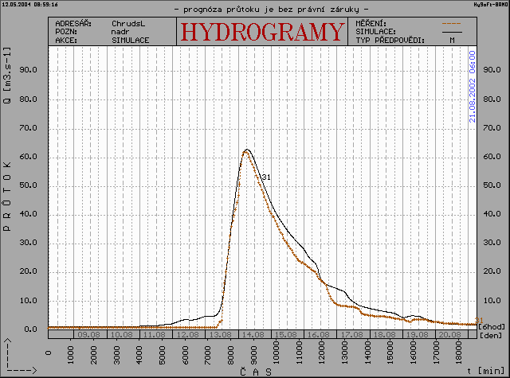

The model means was fully connected with the monitoring system from which it takes all measured data and in the same time it was connected with the meteorological model ALADIN provided by CHMI from which we get twice a day rainfalls and temperatures forecasts with 48 hours timing advance. Thanks these facts we can prepare discharge forecasts for 48 hours and during the flood we are able to repeat the whole process on base of new information for more accurate results. Optimum period for model using during the flood is from 3 to 6 hours.
By the operation it was necessary to calibrate the model twice – for the winter and for the summer periods differently, this way we got better results. We use the model in our conditions only in case of an adverse meteorological situation but in future we plan to use it daily for example for determination of harmonograms of peak-load hydro-power plants etc.
The model was in operation during summer as well as winter floods that are for successful forecasts more difficult. In the beginning of 2002 in the period January – March many situations of higher flows (Q₁-Q₂₀) caused by the high water equivalent of the snow, rainfalls and rising temperatures occured in our river basin. At figures 2 – 5 you can see this winter situation at the dam Pastviny.
Now we are going to extend the model into other river basins – Loucna, Luzicka Nisa, Smeda, Klejnarka, Cidlina and Mrlina Rivers.

Fig. 2 Situation on the 10th February 2002 in 18:00

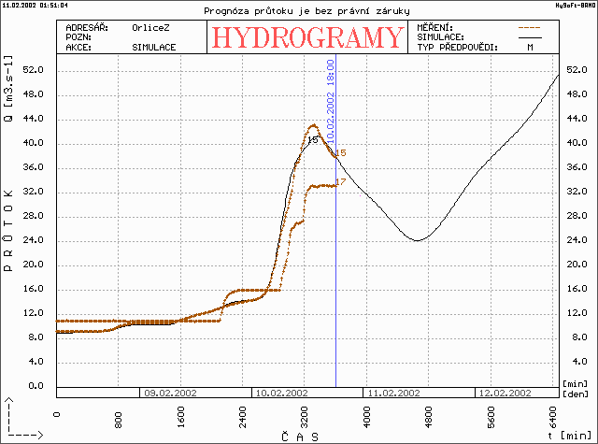

Fig. 3 Situation on the 11th February 2002 in 18:00

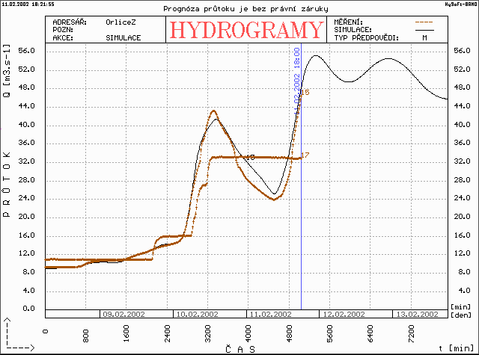

Fig. 4 Situation on the 12th February 2002 in 18:00

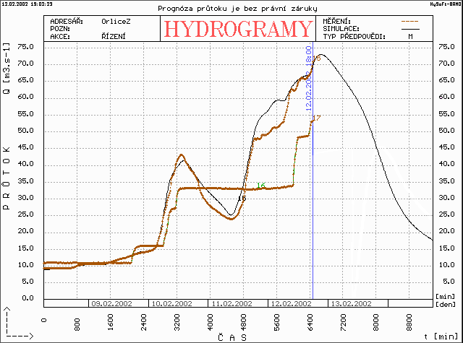

Fig. 5 Situation on the 14th February 2002 in 18:00

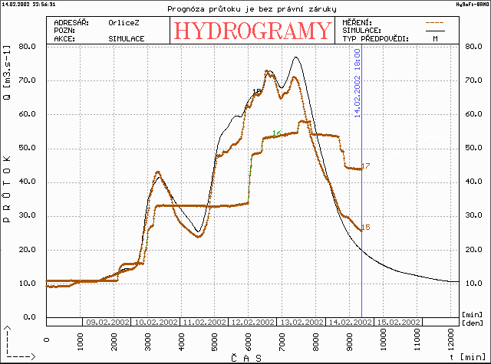

  - Prepared intentions for forecast systems
As next step for providing better information from the dispatching centre of Povodi Labe we prepare presentation of information about awaited extension of the flooded area based on the actual development of the rainfall and flood situations. This activity supposes that the whole area administered by Povodi Labe will be included in the rainfall-runoff model, hydrodynamical models will be prepared for the most important streams and then the rainfall-runoff model will be connected with models of flows in river beds. In the first stage, one of in advance prepared maps with plotted border line of flood areas of Q₅, Q₂₀, Q₅₀ and Q₁₀₀ will be presented. In future, the on-line connection of the rainfall-runoff and hydrodynamical models with following projection of gained results into DMT and vizualization of this way determined flood area border on chosen map can be supposed. Probably it will be not an automatic process and the supervision of the processor will be necessary.

- Conclusion

Experience gained from the operation of the model Hydrog that has been exploited at dispatching centre of Povodi Labe since 1999 entirely in flood situations can be evaluated as very positive. Development and introduction of forecast systems into common practice contributed to the shift of given problematics on a higher level not only from the internal point of view but also form the view of wider and better links to the state authorities and general public during flood situations.
The most important factor affecting outputs is the quality of meteorological forecasts that can reduce the rate of uncertainty of hydrological forecasts. Regarding to the probability of its successfulness, there is suitable to create different versions of the development of hydrological situations in river basin and currently predict these versions based on the real development and new forecasts.

Main objectives that still remain are to improve the forecast system, this way to improve the output information about the posible flood situation as well as about passing flood and also to enable warning of inhabitants and reduction of flood damage to the minimum level. To this aim it should contribute:
- prolongation of the forecast period (prolongation of the rainfalls forecast);
- on-line connection of workplaces of CHMI and state enterprises Povodi and mutual evaluation of single forecast models;
- ensuring of forecasts for more forecast profiles including mountain areas where the travel times are very short;
- interconnection of the operative model with hydraulic models and determination of the flooded areas and water levels for areas endangered by floods.

