Possibilities of Improvement of Hydrological Forecast’s Models in
Extreme Situations

Pavla Řičicová, Jan Daňhelka, Jana Chalušová

Czech Hydrometeorological Institute, Praha, Czech Republic,
e-mail: ricicova@chmi.cz; danhelka@chmi.cz; chalusova@chmi.cz

Abstract: The contribution is concerned with hydrological modelling during extreme rainfalls and with catchment responses on the example of the August 2002 flood in the Jizera catchment. It documents the difference between the operative use of the model and supplementary simulations in dependence on the character and quality of entry data. For the trials of runoff simulation, stations from Jizerské Mountains experimental catchments increased the density of the existing precipitation-measuring network of operative stations of the AquaLog system. As a second variant of gaining better information about precipitation in a 1-hour step we have made use of the radar reflectiveness converted to precipitation intensity as a supplement to the rain-gauge measurements. The third researched possibility was the combination of both previous methods. The measurement of precipitation in the operative stations in regions with a sparse use of automatic rain gauges was supplemented with data from radar. From the procedures above it follows, that for the successful hydrological modelling in mountainous regions, the sufficient density of precipitation gauge network and its representative placement has unambiguously good reason for use.
Key words: hydrological modelling, rainfall-runoff model, automatic rain gauges, density of precipitation network, radar reflectiveness, precipitation intensity

Möglichkeiten der Verbesserung der hydrologischen vorhersagen Modelle in den extremen Situationen

Zusammenfassung: Der Beitrag befasst sich mit der hydrologischen Modellierung bei einer extremen Niederschlagsmenge und Reaktion des Flusses im Falle des Hochwassers von August 2002 im Jizera Einzugsgebiet. Der Unterschied zwischen der operativen Modellanwendung und zusätzlichen Simulationen in Abhängigkeit von dem Charakter und Qualität der Eingabedaten ist dokumentiert. Aus dem andeutenden Verfahren hat sich ergeben, dass für erfolgreiche hydrologische Simulierungen in den Bergegebieten ausreichende Dichte der Messungsnetz und ihre repräsentative Aufstellung ihre eindeutige Begründung hat.
Schlüsselworte: hydrologische Modellierung, Niederschlag -abfluss Model, automatische Niederschlagmessstation, Dichte der Messungsnetz, Radarreflexionsvermögen, Niederschlagsintensität

- Introduction
After passed flood situations, forecasters investigate success of their forecasts and look for reasons why the results were not always such as they would imagine. Together with meteorologists, they analyze precipitation forecasts, which as an important factor are input into models. They compare results and see how the forecasting system would operate, if precipitation forecasts were error-free. Not in all cases can the simulation according to the measured rainfall sufficiently truly duplicate the real course of discharges. The correlation between the computed and the observed value depends above all on two factors. The first of these is the question whether or not the forecast model was correctly calibrated. Providing the rainfall-runoff model is correctly calibrated, the accuracy of the forecast is decided by the quality and representativeness of the entry data. The station network density for the operative operation of models, in other regions than lowlands, is for the time being still not ideal, and therefore we try methods which could partially replace automatic rain gauges, or which would on the other hand show, that without making the measuring network in the mountainous regions more dense, the success of the forecasts is not possible.
For testing this problem, we chose the catchment of the upper Jizera river down to Železný Brod. In the top part of the Jizerské Mountains, the Czech Hydrometeorologic Institute (CHMI) applied hydrology research workplace monitores experimentally 7 small catchments on the catchment boundary of Lužická Nisa, Smědá and Jizera rivers with a catchment area of 1.87 - 10.6 km². The catchments are equipped with automatic stage measurement apparatuses and with 22 rain gauges. Even though in the Jizerské Mountains during the August 2002 flood the average return intervals of discharges recorded were not as extreme as in the catchment of the Vltava river, the Jizerské Mountains still had the highest recorded daily rainfall sums on the territory of the Czech Republic (CR). The automatic rain gauge of the experimental catchment at Knajpa on the 13th August 2002 recorded 278 mm. However, the rainfall forecast for the Jizerské Mountains region was significantly lower than reality (on 13th August the forecast was 40 to 100 mm, but in reality the rainfall in the mountainous regions of the upper Jizera was 200 mm on average, and for the whole catchment down to Jablonec nad Jizerou it was about 130 mm). Fig. 1 shows the map of rainfall totals measured during the most-rainy days of August in the Jizerské Mountains experimental base stations, and in other CHMI climatic stations.
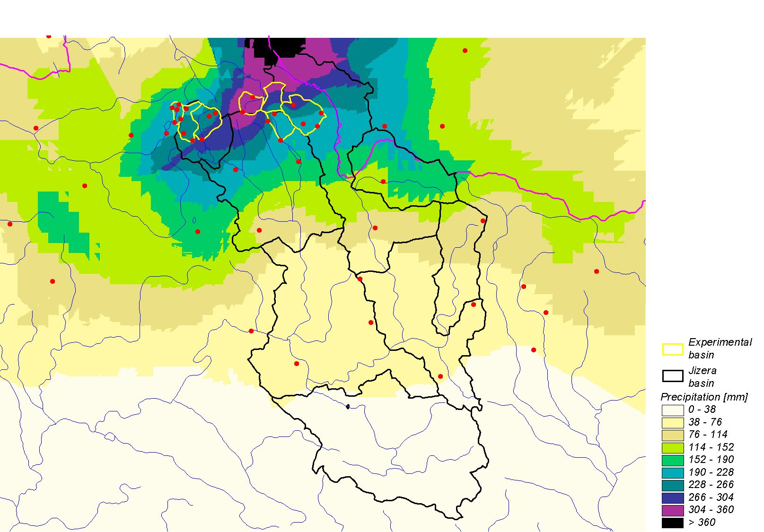
Figure 1. 1 Distribution of the rainfall totals on the 12th and 13th August in the Jizerské Mountains experimental catchments and in other climatic stations

The existing rainfall measurement network of the operative stations in the Jizera catchment of the AquaLog system was for the experiments with the 2002 flood runoff simulation made denser with stations from the experimental catchments (see Tab. 2). As the second variant of gaining better rainfall information in a time step of 1 hour, we utilised the measurement of radar reflectiveness recalculated to the rainfall intensity, as a supplement to the measurement of the ground rain gauges. For the estimates of aerial precipitation we therefore had at our disposal the combined estimates from the radar- rain gauges in a one-hour time step. The third tested possibility was the combination of both of the proceeding ways. The measurement of precipitation in the operative network of stations in the regions with sparsely of automatic rain gauge was supplemented with data from radar.

- Utilisation of precipitation measurement network of Jizerské Mountains experimental catchments in the AquaLog system
For the entry of precipitation into the rainfall-runoff model, weights are assigned to the individual precipitation measurement stations, which determine the share on the aerial rainfall on the basis of relative area (derived by the Thiessen Polygon Method) and rainfall

Table 1. List of rain gauges in the experimental catchments
Catchment | UHLÍŘSKÁ | m a.s.l. | Catchment | JEZDECKÁ | m a.s.l.
 | Uhlířská | 775 |  | Jezdecká | 780
 | Tomšovka | 810 |  | Kůrovec | 883
 | Stará Hejnická | 835 |  | Kasárenská | 917
 | Prameny Černé Nisy | 828 | Catchment | ČERNÁ SMĚDÁ
 | Olivetská hora | 881 |  | U Jeřábu | 903
Catchment | KRISTIÁNOV |  | Catchment | BÍLÁ SMĚDÁ
 | Kristiánov | 800 |  | Knajpa | 967
 | Černá hora | 981 |  | Smědavská hora | 1006
 | U Podkovy | 884 | Catchment | JIZERKA
Catchment | BLATNÝ RYBNÍK |  |  | Jizerská | 920
 | Nová Louka | 810 |  | Jizerka | 855
 | Hřebínek | 815 |  | Lasičí | 945
 |  |  |  | Promenáda | 927

Table 2. Rain gauges used in hydrological model in August 2002 and other non-operative rain gauges used for simulation (bold writing)
Catchment/ station | Rain gauges
Mumlava  Harrachov | Souš VD, Medvědín, Labská b., Jablonec nad Jizerou  Jakuszyce,
Jizera  Jablonec | Souš VD, Medvědín, Jablonec nad Jizerou  U jeřábu, Jizerská cesta, Lasičí, Promenáda
Jizera  Dolní Sytová | Souš VD, Medvědín, Jablonec nad Jizerou, Dolní Sytová, Dolní Štěpanice, Labská VD
Jizerka  D. Štěpanice | Labská, Medvědín, Jablonec nad Jizerou, Dolní Štěpanice, Labská VD
Kamenice  Plavy | Josefův Důl, Železný Brod, Souš VD, Jablonec nad Jizerou  Kristiánov, Jezdecká, Kasárenská, Knajpa, U Podkovy, Kůrovec, Černá hora, Promenáda, Knajpa
Oleška  Slaná | Dolní Sytová, Dolní Štěpanice, Slaná, Nová Paka
Jizera  Železný Brod | Železný Brod, Souš VD, Jablonec nad Jizerou, Dolní Sytová, Dolní Štěpanice, Slaná

totals. At the same time, the individual catchments are further articulated on the basis of elevation into more zones. From the isohyetal map of the average yearly total, the aerial rainfall is calculated and a weight is assigned to the individual rainfall measurement stations, which accounts for both the size of the appropriate partial area, and share of the value of the average rainfall in the catchment. In the interest part of the Jizera river catchment, the individual subcatchments are divided into 2 to 5 zones for usage in the AquaLog model.
According to elevations, the stations were classified into height zones and the weights of individual stations were recalculated. For the calculation of runoff from the Mumlava catchment, even the Jakuszyce station from the neighbouring Kamienne catchment from the climatological network IMGW Wroclaw was used.
For the individual forecast stations presented in Table 2, simulations of runoff were made by use the input data only from the operative network of the rain gauges and from data enhanced with stations from the experimental catchments. Jizerka river in Dolní Štěpnice, where the runoff was not significant compared to the rest of the catchment, and Oleška river in Slaná, for which at the time of the flood no measurement facilities were available, were both not evaluated.

- Utilisation of combined radar information
For a combined radar-rain gauge estimation, precipitation data are used from the network SYNOP from both the CR and neighboring countries, from the network INTER, and further, values from supplementary automatic rain gauges (installed purposely for hydrological forecast models) including stations of the River Basin Authority. For the catchment of the upper Jizera river, station Liberec enters into the calculation of the combined precipitation estimation, and from the catchment of the upper Labe – stations Labská Bouda and Pec pod Sněžkou.
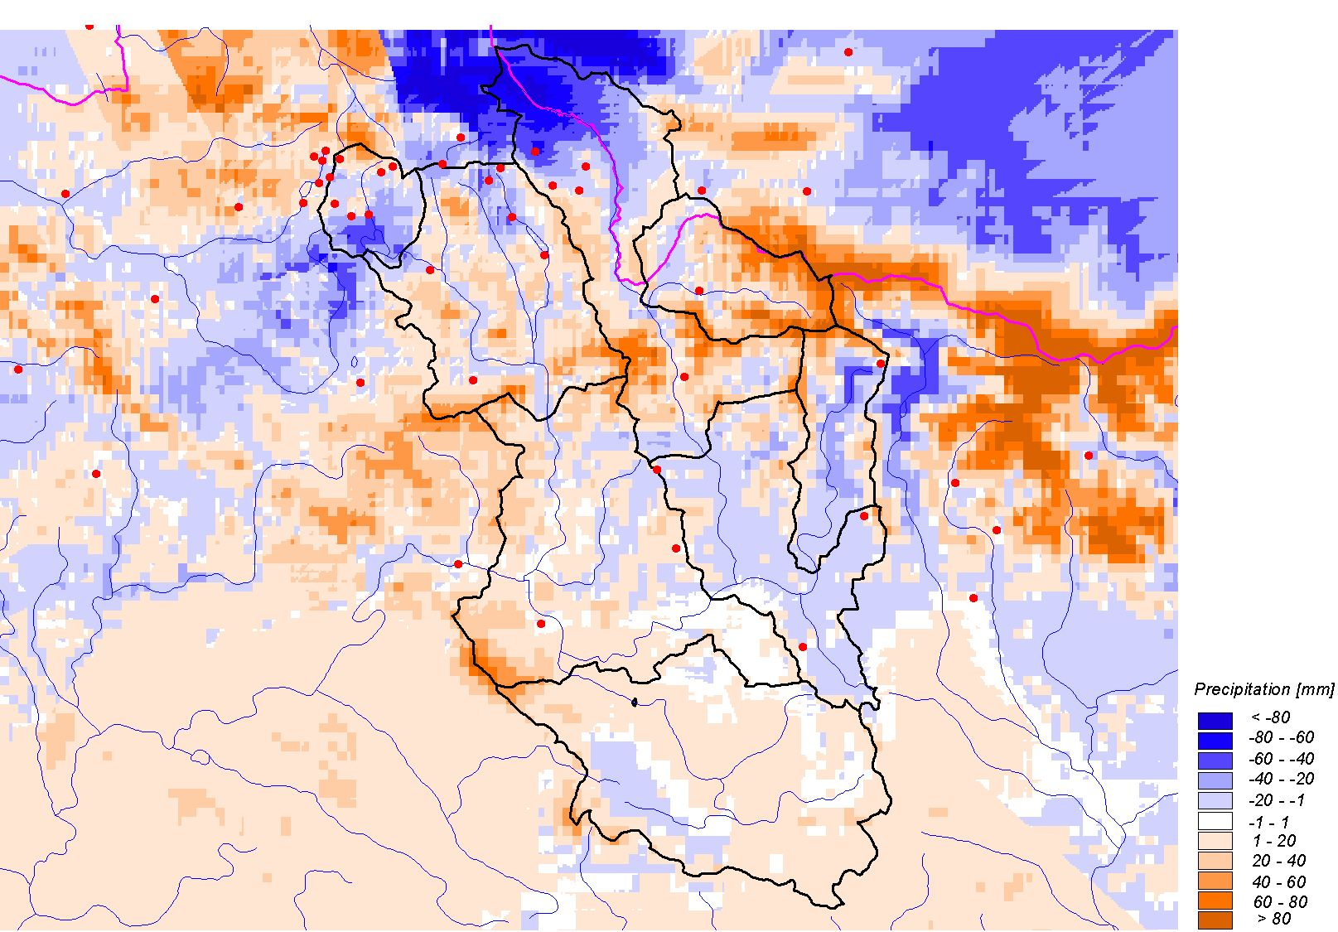
Figure 2. Map of differences of precipitation totals measured in ground stations, and totals gained from radar information

Fig. 2 shows a map of precipitation differences measured in ground stations and by combined radar estimation for a 24-hour total from 13th August, which was the day with the greatest precipitation in this region. Blue colour represents a region which was underestimated by radar, and orange shows overestimation. One colour shade corresponds to 20 mm. The region of the top parts of the Jizerské Mountains was underestimated by radar, and the region of the Krkonoše Mountains was overestimated; equality occurred only sporadically.
The radar results for the Jizerské Mountains were not too good, which is given especially by the distance of the mountain range from both radars, which is larger than 150 km (160 km from Brdy, 190 km from Skalky) and therefore there is a relatively great height of the radar ray above terrain, but there is also shielding of the region by great precipitation on the route of the radar ray between the radar location and the Jizerské Mountains. The radar, even in combination with used ground rain gauges during the significant orographic precipitation, underestimated the region of the Jizerské Mountains. For a better quality application of combined precipitation estimation, it would be desirable in operative hydrology to use for adjustment stations from higher parts of the Jizerské Mountains. We expect the solution of this problem simultaneously with full-value putting into operation of the operative databasis Oracle, even for the deposition of data from stations belonging to the Prague Central forecasting office.
Hourly values of aerial averages of the combined precipitation estimate for a subcatchment were used as the precipitation input into the model. Results of the modeling in the individual forecast stations are shown in graphs together with the other variants of the computed hydrographs.
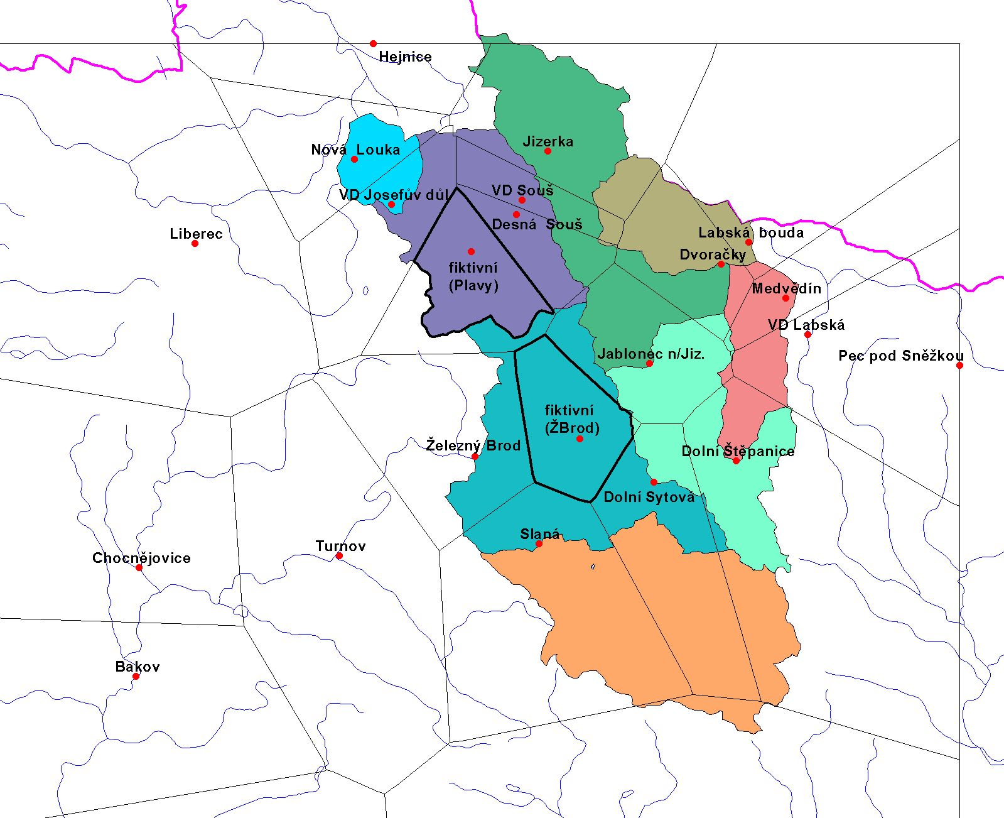

Figure 3. Scheme of the distribution of rain gauges in the catchment – variant with fictitious stations
Further, a variant with only partial utilization of combined estimation was simulated, namely in regions with sparse automatic rain gauges. In our case, top parts were not involved, where this approach was not able to estimate the precipitation, but the hilly area just under the mountains in the catchments of the Kamenice and Jizera rivers above Železný Brod. In both catchments in the center of gravity of areas, where rain gauges with relay are lacking, so called fictitious stations were established, which were allocated the respective values of combined precipitation estimates for individual hours. For this newly created distribution of rain gauges, the relevant areas and their weights were added. The scheme of the new distribution appears on Fig. 3, on which we can see the weight significance of new stations in the catchment of the Kamenice river (over 40% of the total area relevant) and the Jizera river down to Železný Brod (over 30%). The computations of runoff with entries extended by data from new “fictitious” stations appear in Figs. 4 and 5 together with the simulations of hydrographs for conditions specified in the proceeding articles.

- Evaluation of results by simulation
For all marked cases, the simulated runoffs in the individual stations of the Jizera river were mutually compared. Clearly the best simulations were reached when the operative rain gauges were supplemented by the stations from the experimental catchments, especially for station Jablonec nad Jizerou and Dolní Sytová on Figs. 4 and 5, when the volume of the wave and its peak were relatively accurately estimated. Very good agreement with reality occurred also in the case of simulation on the basis of using only operative data. Results in the catchment of the Mumlava in Harrachov were rather problematic, as this catchment is not sufficiently covered with rain gauges, but at the same time was relatively less hit. Namely the simulated waves are delayed behind the real wave and their shape is flatter. The utilisation of further precipitation entries (Jakuszyce station) meant a clear improvement in the simulation results in the sense of volume, hydrograph shape and the value of the peak, Fig. 6.

Figure 4 Comparison of individual simulations for the Jablonec nad Jizerou station

The results of the runoff simulations from rainfall data according to radar in combination with used ground rain gauges were in all monitored stations low, as compared to measured values. Not even the variant with the partial utilisation of the combined estimate in the catchments of the Kamenice and the Jizera above Železný Brod brought improvement with respect to the significant underestimation of rainfall by radar and the absence of comparison rain gauge in the top part of Jizerské Mountains.

Figure 5. Comparison of individual simulations for the Dolní Sytová station

Figure 6¨. Comparison of individual simulations for the Harrachov station

- Conclusion
From the mentioned procedures it follows, that for successful hydrological modeling in the mountainous areas, the sufficient density of the rain gauge network and its representative distribution have their clear justification. Where the results of rainfall-runoff computations were not convincing because of the absence of operative rain gauges, it is necessary to look for other localities for their installation. Therefore, for more accurate computations of runoff, a greater number of operative data will be available, and catchments will be able to be divided into smaller areas, for which the given stations are more representative. When utilising the applications of the combined rainfall estimate, to make up for the insufficient number of ground stations in mountainous regions, it is however necessary to proceed very carefully. From reverse simulations of floods, made on the basis of subsequently corrected entry data it follows, that the forecasting system AquaLog can, given ideal conditions (accurate entries and forecast), forecast discharges with sufficient accuracy.

- References
AquaLogic-Software Development and Consulting: Modelling system of hydrological and water resources processes, Reference manuals of the program AquaLog and AquaBase, Prague 1999-2000
Bubeníčková, L., Hancvencl, R., Chalušová, J., Kulasová, A., Pobříslová, J., Stehlík, J., Flood in August 2002 in the Jizerské Mountains. In: Transactions of contributions from Workshop 2003 Extreme hydrological phenomena in catchments. GWPČR, Prague 20036, pp. 31-42.
Hydrological evaluation of the catastrophic flood in August 2002. 2nd stage of the project Evaluation of the catastrophic flood in August 2002. CHMI 2003, 134 p.

