FLOOD WARNING SYSTEM FOR WESTERN STYRIAN CATCHMENTS – STRUCTURE AND CASE STUDY

Robert Schatzl¹, Maximilian Heilig²

¹Amt der Steiermärkischen Landesregierung, Wasserwirtschaftliche Planung und Siedlungswasserwirtschaft, Referat 1 – Hydrographie, Graz, Austria,
e-mail: robert.schatzl@stmk.gv.at
²Oberpetersdorf, Austria, e-mail: maximilian.heilig@aon.at

Abstract: Especially in the summer months, the possibility of flood events in the catchments of the rivers Kainach, Lassnitz and Sulm in Western Styria is very high compared with other parts of Styria. In 1997 a project was initiated with the aim to develop a flood warning system for those catchments, whereas it was planned to use data from the net of telemetric stations (about 30 rainfall stations and gauges) of the hydrographical service as well as weather radar data as input data. At the moment, the system is in function, the link to radar data will be implemented in the next future.
In the first part of this report, the structure of the flood warning system is shown, which basically consists of 3 conceptual catchment models (Kainach, Lassnitz, Sulm-Saggau). Each catchment model is based on a rainfall model, a rainfall – runoff model and a flood routing model. The rainfall model calculates the areal precipitation based on the information of about 20 rainfall stations (in future also weather radar information are used) combined with a forecasting tool. In the rainfall – runoff model, the precipitation is transformed into discharge using different methods, where also the influence of seasons (especially summer and winter floods) is considered in the model. The flood routing model is a combination of the “Mehrkaskadenmodell” developed by TU Wien (Gutknecht, 1978; Kresser et. al. 1980; Gutknecht, 1987; Heilig 1992), cross correlation functions and regression methods.
In the second part of the report, a flood event (winter 2002) is analysed, where the measured and calculated time series of runoff for selected gauges are compared. Based on the results of this analysis the strategies for using this system in the operational work of the hydrographical service of Styria are developed.
Keywords: Flood warning system, catchment model, rainfall model, rainfall – runoff model, flood routing model, flood event

DAS HOCHWASSERPROGNOSEMODELL FÜR DIE WESTSTEIERMARK – AUFBAU UND FALLSTUDIE

Zusammenfassung: Vor allem in den Sommermonaten ist die Wahrscheinlichkeit von Hochwasserereignissen in den Einzugsgebieten der Kainach, Lassnitz und Sulm in der Weststeiermark sehr hoch im Vergleich mit anderen Teilen der Steiermark. Im Jahr 1997 wurde ein Projekt ins Leben gerufen mit dem Ziel, ein Hochwasserprognosesystem für diese Einzugsgebiete zu entwickeln, wobei als Eingangsdaten Fernmeldedaten des hydrographischen Dienstes Steiermark (ca. 30 Niederschlagsstationen und Pegel) als auch Wetterradardaten geplant waren. Derzeit ist das Modell bereits in Betrieb, die Anbindung an die Wetterradardaten ist jedoch noch nicht fertiggestellt.
Im ersten Teil des Berichts wird der Aufbau des Hochwasserprognosesystems erläutert, welches sich grundsätzlich aus drei Flussgebietsmodellen (Kainach, Lassnitz und Sulm – Saggau) zusammensetzt. Jedes dieser Flussgebietsmodelle besteht aus einem Niederschlagsmodell, einem Niederschlags – Abflussmodell sowie einem Wellenablaufmodell. Das Niederschlagsmodell berechnet den Gebietsniederschlag aus den gemessenen Niederschlägen von ca. 20 Niederschlagsstationen (hier werden in Zukunft auch Wetterradarinformationen genutzt) kombiniert mit einem einfachen Vorhersagetool. Im Niederschlags- Abflussmodell wird der Niederschlag nach verschiedenen Methoden in Abflüsse umgerechnet, wobei auch der jahreszeitliche Einfluss im Modell berücksichtigt wird (hauptsächlich Sommer- und Winterhochwässer). Das Wellenablaufmodell ist eine Kombination des Mehrkaskadenmodells, das von der TU Wien (Gutknecht, 1978; Kresser et. al. 1980; Gutknecht, 1987; Heilig 1992) entwickelt wurde, mit Kreuzkorrelationsfunktionen und Regressionsmethoden.
Im zweiten Teil des Berichts wird ein Hochwasserereignis analysiert (Dezember 2002), wobei die gemessenen und prognostizierten Durchflüsse für ausgewählte Pegel verglichen werden. Basierend auf den Ergebnissen dieser Untersuchung werden Strategien entwickelt, wie das System im operationellen Betrieb des hydrographischen Dienstes Steiermark eingesetzt werden kann.
Schlüsselwörter: Hochwasserprognosesystem, Flussgebietsmodell, Niederschlagsmodell, Niederschlags – Abflussmodell, Wellenablaufmodell, Hochwasserereignis

Introduction
In 1997, a project was initiated to develop a flood warning system for the catchments of Kainach, Lassnitz and Sulm in the western part of Styria. The project was finalised in 2003, the model is now in function. For 2004 it is planned to include also weather radar information in the system. A map of the region and the catchments can be seen in figure 1.

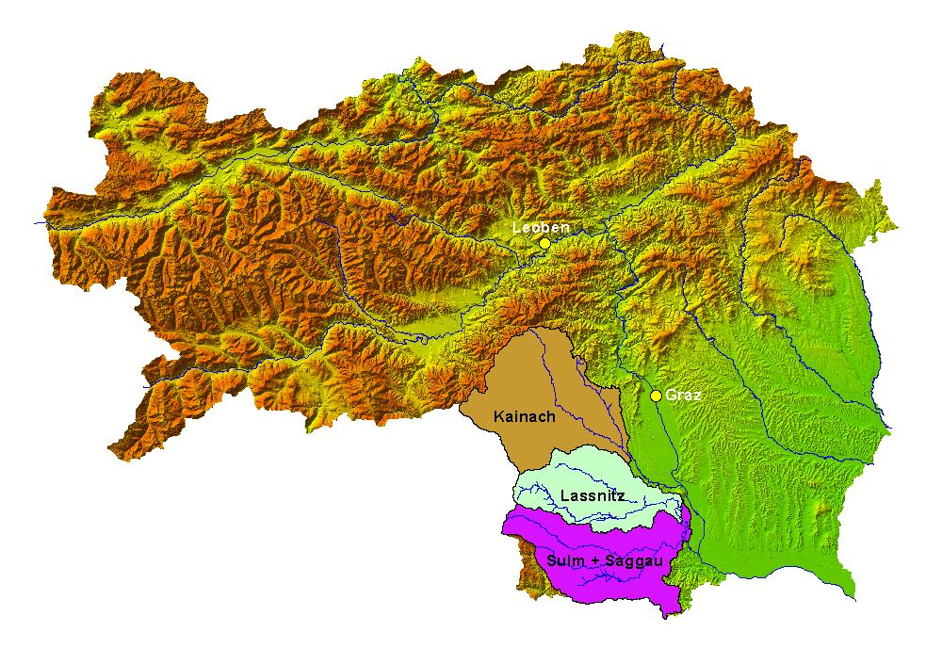
Fig. 1: Map of Styria with the catchments of Kainach, Lassnitz and Sulm

In the first part of the report, the structure of the flood warning system is shown. In the second part, a flood event of December 2002 is analysed.

The structure of the flood warning system
The flood warning system basically consists of 3 conceptual catchment models for Kainach, Lassnitz and Sulm.
Catchment model for Kainach
In Fig. 2, the telemetric stations in the catchment of Kainach can be seen.

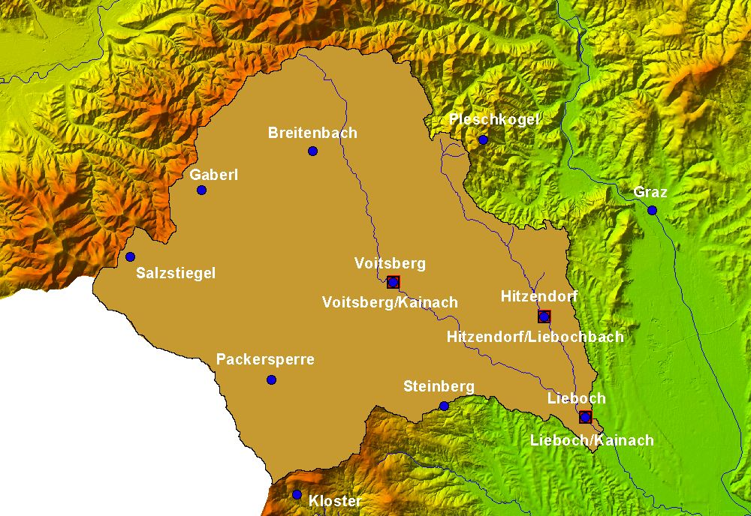
gauge
precipitation

Fig. 2: Telemetric stations in the catchment of Kainach (blue: precipitation; red: gauges)

At the gauge Lieboch/Kainach (773 km²), forecasts for water level and discharge are made based on rainfall-runoff models for the gauges Voitsberg/Kainach and Hitzendorf/Liebochbach and a separate model for the intermediate catchment of Kainach. As input, areal precipitation is calculated from the telemetric rain gauges, which can be seen in Fig. 2.
The big intermediate catchment (about 490 km²) represents a factor of uncertainty, which influences the quality of the forecast. A planned gauge at one of the biggest tributaries (Teigitsch) should improve the situation. The catchment model structure is shown in Fig. 3.

Fig. 3: Catchment model structure for Kainach

Catchment model for Lassnitz
Fig. 4 shows the telemetric stations in the catchment of Lassnitz.

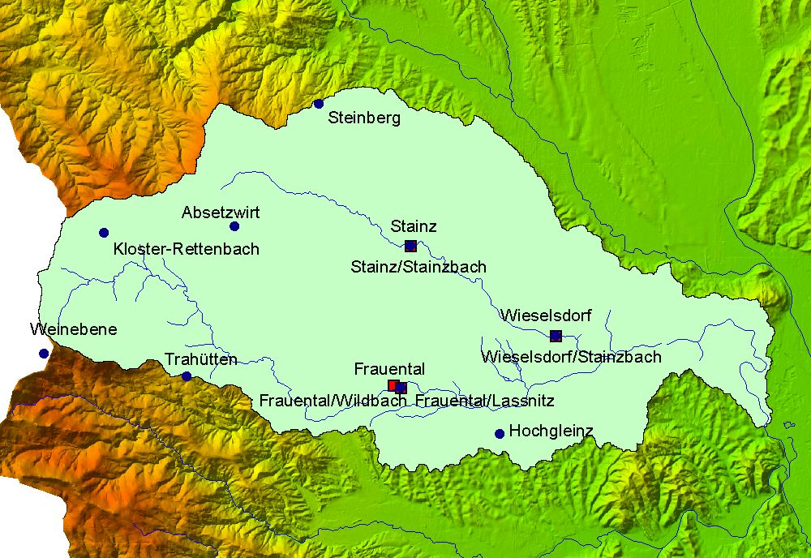
gauge
precipitation

Fig. 4: Telemetric stations in the catchment of Lassnitz (blue: precipitation; red: gauges)

At the gauges Frauental/Lassnitz, Frauental/Wildbach and Stainz/Stainzbach, the discharges are forecasted with separated rainfall-runoff models, for the gauge Wieselsdorf/Stainzbach a combination between rainfall-runoff model and flood routing model is used. Input data are precipitation values from the rain gauges shown in Fig. 4. Flood inundation areas between Stainz and Wieselsdorf and downstream of Frauental are modelled with separated inundation cascades due to stronger wave propagation caused by the retention effects. The structure of the catchment model is similar to the Kainach model (see Fig. 3).

Catchment model for Sulm
Fig. 5 shows the telemetric stations in the catchments of Sulm and Saggau.

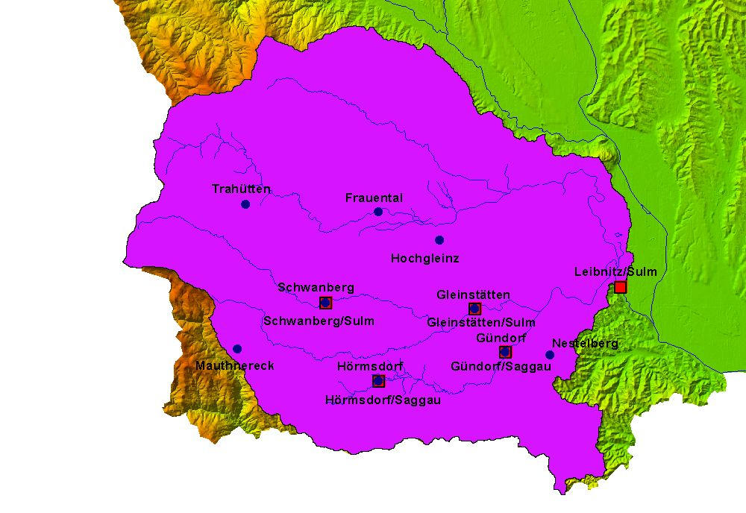
gauge
precipitation
Fig. 5: Telemetric stations in the catchment of Sulm (blue: precipitation; red: gauges)
Forecasts are made for the gauge Leibnitz/Sulm based on rainfall-runoff models for the gauges Schwanberg/Sulm and Hörmsdorf/Saggau and a combination of rainfall-runoff and flood routing models for the gauges Gleinstätten/Sulm and Gündorf/Saggau. If the forecasted discharge at the gauge Gleinstätten exceeds a certain value (100 m³/s), the inundation is modelled with an additional cascade. For the gauge Leibnitz/Sulm, the flood inundation is also modelled with a cascade, if the discharge exceeds 150 m³/s. Again, the structure of the catchment model is comparable to the Lassnitz model (see Fig. 3), data input comes from the rain gauges shown in Fig. 5.

The forecasting modules
Rainfall model
The rainfall model calculates the areal precipitation based on the telemetric rain gauges in all catchments by arithmetic mean and also offers the possibility of rainfall forecasts in two ways:
- automatically: the actual intensity is fixed for the next two hours
- manually: input of forecasts up to 6 hours with distributions according to DVWK (1979)

Rainfall – runoff model
In the rainfall – runoff models, the following methods for runoff generation can be used optionally:
- Horton
- constant runoff index
- phi – index
- dynamical runoff index
For the calculation of runoff concentration, there are several unit hydrographs, which have been adapted on historical flood events:
- winter model
- spring model
- summer model
- model for wet summers
- model for extreme floods
- fall model
If the areal precipitation exceeds 80 mm from the beginning of the event, the model for wet summers will be chosen, if it is over 150 mm, the model for extreme floods will be set automatically.

Flood routing model
On Kainach, especially Sulm and Saggau there are several great floodplains, which influence the runoff in these regions. Therefore, so called “Mehrkaskadenmodelle”, which were developed for the flood warning system of the Danube by Kresser et.al. (1980) are used. In these models, retention effects by inundation are considered with additional impulse response functions. Analyses of the runoff time are made by cross correlation functions, whereas for the parameterisation of the functions the Ridge method (David, Heilig 2002) showed better results than the multiple regression function.
For the gauge Lieboch/Kainach, “good” forecasts can be made for 2 to maximum 3 hours, for the gauge Leibnitz/Sulm for 3 to 5 hours, for extreme events this time for Leibnitz exceeds up to 6 hours. Generally, at the gauge Leibnitz/Sulm the quality of the forecasts is the best, which depends on the whole hydrological situation and the registration of the most important tributaries.

Flood event Dezember 2002 (Case study)
In the following, the measured and calculated (if the model had already be in function) time series of runoff at the most important gauges are compared for the flood event from December, 4 – 9 2002 and the maximum errors are shown. It must be mentioned that the gauge Frauental/Lassnitz was out of function during the flood event, therefore a comparison is not possible.

Kainach
Lieboch/Kainach
Fig. 6 shows the measured and calculated time series of runoff for the gauge Lieboch/Kainach, where it can be seen, that both are very similar, but there is a plain time shift of about 2-3 hours for a lead time of the forecast of 3 hours.

Fig. 6: Measured and calculated time series of runoff for gauge Lieboch/Kainach with lead time of forecast of 3 hours

Table 1 shows the mean, minimum, maximum and the standard error in the forecasts for different lead times (from 1 hour to 6 hours).

Error [%] |  | Lead time
 |  | 1 | 2 | 3 | 4 | 5 | 6
Lieboch | mean | 4.82 | 8.25 | 11.55 | 14.22 | 16.69 | 19.50
Lieboch | min | -38.47 | -53.12 | -69.61 | -89.76 | -104.42 | -109.91
Lieboch | max | 36.64 | 56.79 | 75.11 | 95.26 | 106.25 | 111.75
Standard error [ ] |  | Lead time
 |  | 1 | 2 | 3 | 4 | 5 | 6
Lieboch | < 0.1 very good  < 0.2 good | 0.09 | 0.15 | 0.21 | 0.26 | 0.30 | 0.34

Table 1: Mean, minimum, maximum and standard error for different lead times of the forecast for the gauge Lieboch/Kainach

Table 1 shows, that the maximum error for a lead time of 3 hours is approximately 70%, for a lead time of 6 hours over 100%. The mean error amounts to 12% for a lead time of 3 hours and 20% for 6 hours. The standard error exceeds the quality criteria of 0.1 for a “very good” forecast already with a lead time of 2 hours.
Saggau
Gündorf/Saggau
In Fig.7, measured and calculated time series of runoff for the gauge Gündorf/Saggau can be seen. For a lead time of 3 hours, the time series are comparable with a slight time shift and a slight overestimation of the flood peaks by the model.

Fig. 7: Measured and calculated time series of runoff for gauge Gündorf/Saggau with lead time of forecast of 3 hours

Table 2 shows the mean, minimum, maximum and the standard error in the forecasts for different lead times (from 1 hour to 6 hours).

Error [%] |  | Lead time
 |  | 1 | 2 | 3 | 4 | 5 | 6
Gündorf | mean | 2.32 | 4.42 | 6.83 | 9.64 | 12.94 | 16.65
Gündorf | min | -13.60 | -27.19 | -43.51 | -62.54 | -78.86 | -106.05
Gündorf | max | 24.47 | 43.51 | 62.54 | 73.42 | 81.58 | 87.01
Standard error [ ] |  | Lead time
 |  | 1 | 2 | 3 | 4 | 5 | 6
Gündorf | < 0.1 very good  < 0.2 good | 0.04 | 0.08 | 0.13 | 0.17 | 0.22 | 0.27

Table 2: Mean, minimum, maximum and standard error for different lead times of the forecast for the gauge Gündorf/Saggau

Table 2 shows the mean error in the forecasts at the gauge Gündorf for a lead time of 3 hours with about 7%, the maximum error with about 64%. For a lead time of 6 hours, the mean error exceeds to 16% and the maximum error to 108%. The standard error shows a “very good” quality for a lead time till 2 hours and still “good” quality up to 4 hours.

Sulm
Gleinstätten/Sulm
Fig. 8 shows a comparison between measured and calculated time series of runoff for the gauge Gleinstätten/Sulm. With a lead time of 3 hours, there is a good correlation with a slight time shift but the flood peak is overestimated by the model.

Fig. 8: Measured and calculated time series of runoff for gauge Gleinstätten/Sulm with lead time of forecast of 3 hours

In table 3, mean, minimum, maximum and standard error in the forecasts for different lead times can be seen.

Error [%] |  | Lead time
 |  | 1 | 2 | 3 | 4 | 5 | 6
Gleinstätten | mean | 3.28 | 5.69 | 8.35 | 11.26 | 15.12 | 20.10
 | min | -30.65 | -49.81 | -61.30 | -76.63 | -118.77 | -149.42
 | max | 53.64 | 42.15 | 42.15 | 57.47 | 65.13 | 68.96
Standard error [ ] |  | Lead time
 |  | 1 | 2 | 3 | 4 | 5 | 6
Gleinstätten | < 0,1 very good  < 0.2 good | 0.06 | 0.09 | 0.13 | 0.18 | 0.24 | 0.31

Table 3: Mean, minimum, maximum and standard error for different lead times of the forecast for the gauge Gleinstätten/Sulm

Table 3 shows, that the mean error in the forecasts at the gauge Gleinstätten for a lead time of 3 hours is about 8%, the maximum error about 60%. For a lead time of 6 hours, the mean error exceeds to 20% and the maximum error to 150%. The standard error shows a “very good” quality for a lead time of 2 hours and “good” quality up to 4 hours.

Leibnitz/Sulm
Fig. 9 and 10 show the measured and calculated time series of runoff for the gauge Leibnitz/Sulm, where it can be seen, that both are very similar, especially with a lead time of 3 hours.

Fig. 9: Measured and calculated time series of runoff for gauge Leibnitz/Sulm with lead time of forecast of 3 hours

Fig. 10: Measured and calculated time series of runoff for gauge Leibnitz/Sulm with lead time of forecast of 6 hours

In table 4, mean, minimum, maximum and standard error in the forecasts for different lead times are shown.

Error [%] |  | Lead time
 |  | 1 | 2 | 3 | 4 | 5 | 6
Leibnitz | mean | 1.65 | 2.35 | 3.12 | 4.22 | 5.32 | 6.43
 | min | - 8.15 | -11.77 | -17.21 | -25.36 | -32.61 | -36.23
 | max | 8.29 | 13.59 | 18.12 | 19.93 | 24.46 | 28.08
Standard error [ ] |  | Lead time
 |  | 1 | 2 | 3 | 4 | 5 | 6
Leibnitz | < 0,1 very good  < 0.2 good | 0.03 | 0.04 | 0.05 | 0.07 | 0.09 | 0.11

Table 4: Mean, minimum, maximum and standard error for different lead times of the forecast for the gauge Leibnitz/Sulm

It can be seen that the mean error in the forecasts at the gauge Leibnitz/Sulm for a lead time of 3 hours is about 3%, the maximum error about 18%. For a lead time of 6 hours, the mean error exceeds to 6% and the maximum error to 36%. The standard error shows a “very good” quality for a lead time up to 5 hours and “good” quality for 6 hours (Table 4).

Conclusions
In the first part of the report, the structure of the flood warning system for the Western Styrian catchments of Kainach, Lassnitz and Sulm are shown. In the second part, a flood event of December 2002 is analysed. The measured time series of runoff at the gauges Lieboch/Kainach, Gündorf/Saggau, Gleinstätten/Sulm and Leibnitz/Sulm were compared with time series calculated by the model with different lead times. It was shown that with a lead time of 3 hours at all gauges the quality of the forecasts (standard error) was at least “good”. For a lead time of 6 hours, only the forecast for the gauge Leibnitz/Sulm meets the standard for a “good” quality, the forecasts for all other gauges with a lead time of 6 hours are problematic. In conclusion, the best results can be seen at the gauge Leibnitz/Sulm, which depends on the hydrological situation and the registration of most of the important tributaries.
In the next future also weather radar data of the radar station at Zirbitzkogel (distance about 40 km) will be used as input. This will be the first model in Austria where radar data are used online for flood warning purposes.

References
David Labor, E., Heilig, M. (2002): Hydrologische Prognosen in Niederösterreich. Wiener Mitteilungen, Band 164: Niederschlags- Abfluss Modellierung – Simulation und Prognose.
Deutscher Verband für Wasserwirtschaft und Kulturbau (DVWK), 1979: Regeln zur Wasserwirtschaft. Nr. 101: Hochwasser. Verlag Paul Parey. Hamburg/Berlin.
Gutknecht, D. (1978): Methoden zur hydrologischen Kurzfristvorhersage. Wiener Mitteilungen, Band 26 Wien
Gutknecht, D. (1987): Gesichtspunkte zur Auswahl der Modelle. DVWK 16. Fortbildungslehrgang für Hydrologie: „Wasserstands- und Abflussvorhersage“. Wenningen/Deister BRD
Heilig, M: Die Erweiterung der Abflussmodelle der Donau und ihrer Zubringer und ihre Anwendung zur Vorhersage der Donauhochwässer des Jahres 1991. Mitteilungsblatt des hydrographischen Dienstes Nr. 68, S. 1 – 24, Wien 1992
Kresser, W., Gutknecht, D., Dreher, J., und Kirnbauer, R. (1980): Bericht über die Untersuchungen zur Entwicklung eines Abflussmodells für die niederösterreichische Donau zwecks Erstellung von Wasserstandsvorhersagen. Institut für Hydraulik, Gewässerkunde und Wasserwirtschaft, TU Wien

