APPLICATION OF THE HBV HYDROLOGICAL MODEL USING ADDITIONAL SNOW MELT FACTOR FROM THE UKRAINIAN “SNEG-2” MODEL FOR THE BULGARIAN MOUNTAIN PART OF THE MESTA RIVER BASIN

Krassimir Stanev

National Institute of Meteorology and Hydrology, Sofia, Bulgaria,
e-mail: Krassimir.Stanev@meteo.bg

Abstract: The Mesta river basin is situated in the South - West part of the Bulgarian territory. It flows from North to South through Bulgarian and Greek territory, being relatively well isolated from the northern continental climate influence by the surrounding high mountains.
The HBV model, originally developed at the Swedish Meteorological and Hydrological Institute in the first half of the seventies has gained widespread use for a large range of applications both in Scandinavia and beyond. The Norwegian DOS version is used in this work. The HBV model can be classified as a semi-distributed conceptual model.
The mathematical model of water balance type for the formation of runoff from snow melt and rainfall, SNEG-2, is developed in the Ukrainian Hydrometeorological Institute. It simulates the processes of runoff formation in a mountain area during the winter-spring period.
The obtained results show that the HBV model using of additional snow melt factor from the SNEG-2 model gives approximately the same output as the original version of the HBV model.

Keywords: Mathematical modelling, Conceptual model, Snow melt, Runoff, Gauging station, South - West Bulgaria

- Introduction
The mathematical models can be applied to solve a large number of problems in hydrology and water resources. The most common are simulations of the natural river discharge and operational forecasting. Simulation of the natural discharge means that the models are used to simulate runoff from meteorological data input available in the catchment or in its neighborhood. The models are first calibrated and tested in order to verify their ability of runoff simulation from the meteorological data.
The HBV model is widely used for operational runoff forecasting in many countries (Sweden, Norway, etc.). The Norwegian DOS version is used in this work. This paper presents a study for the application of the HBV model for discharge simulations using data from the Bulgarian mountain part of the Mesta river basin and the obtained results. The model was calibrated and tested using both original snow procedure and snow procedure work with additional snowmelt factor from the Ukrainian SNEG-2 mathematical model.

- Hydrological conditions in Mesta river basin
The HBV model was applied to the Mesta river basin for the cross section “Hadji Dimovo”. The main purpose was to test the capability of the model to simulate a given hydrograph of the Mesta river after calibration using different snow procedures.
The Mesta river basin is the highest in Bulgaria compare with the other main river basins. It is situated in the South - West part of the country and surrounded by three relatively high mountains – Rila, Pirin and the Rhodops (Figure. 1).

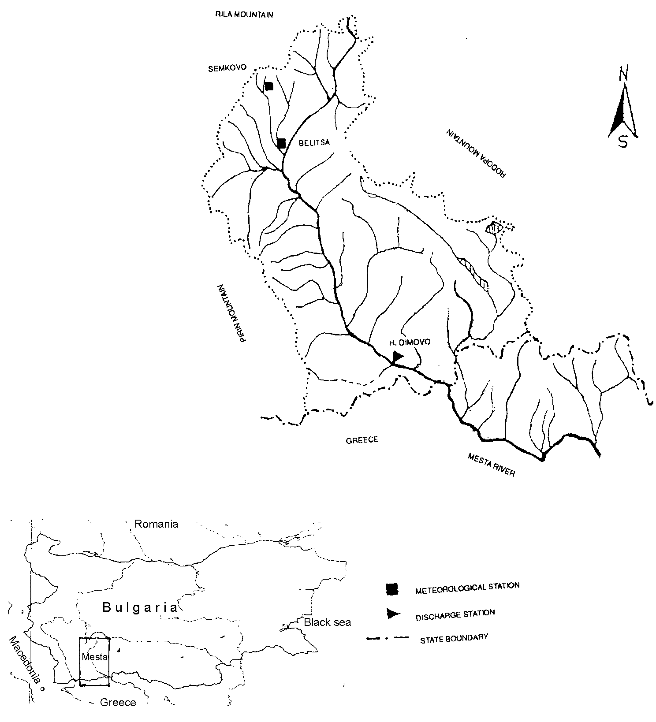

Figure 1. Principle scheme of the Mesta river basin

The Mesta river basin is relatively well isolated from the northern continental climate influence by the surrounding mountains. The climate of the region is under the influence of the Mediterranean one. The Mesta river is flowing from North to South through Bulgarian and Greek territory up to Aegean sea. The general catchment characteristics are shown in Table 1.

Table 1. The Mesta river catchment characteristics

Catchment characteristics | Values
Catchment area (km²) | 2260,0
Average slope of the river (º/_{oo}) | 22,4
Length of the river (km) | 102,9
Altitude range of the catchment area (m a.s.l.) | 390,0 – 2851
Forested area (%) | 38,0

The floods on the Mesta river basin are mainly of snowmelt-rainfall type having peak discharge usually more than 5 times the average one. This situation is due to the complex natural hydrological conditions. The upper part has regular and stable snow cover during the winter because of the higher elevation (up to 2851 m a.s.l.). The melting process is going more than once during the winter – when Mediterranean cyclones are passing the region. Another problem making river flow modeling in the region more difficult and complex is related to the soil moisture conditions and evapotranspiration. This part of the country is semi-arid and during the summer significant precipitation volumes could not produce flood wave going most of all for infiltration and evapotranspiration. In the region, except for the three winter months the evaporated amounts are limited not by the energy but by the availability of water and the soil conditions. The latest is especially true for the lower part (river terraces) where the snow cover is occasional and the groundwater storage could be significant.

- Models description
The Norwegian DOS version of the HBV model is used in this work. The snow procedure of the Ukrainian SNEG-2 mathematical model was implemented in the HBV model. The aim was to compare how the HBV model performs with both the original snow routine and the SNEG-2 one.

3.1. The HBV model
The HBV model originally developed at the Swedish Meteorological and Hydrological Institute in the first half of the seventies (Bergstrom, 1976) has gained widespread use for a large range of applications. It can be classified as a semi-distributed conceptual model. It uses sub-basins as primary hydrological units, and within these an area-elevation distribution and a crude classification of land use (forest, open, lakes) is implemented. The model consists of three main components:
(a) snow accumulation and melt subroutines;
(b) soil moisture accounting subroutines;
(c) response and river routing subroutines.
The main structure of the HBV model (Saelthun, 1996) is a sequence of sub-models as it is shown on Figure 2: snow, soil moisture, dynamic and routine. The model is further structured in altitude intervals. This subdivision can be applied only to the snow sub-model, or to the whole model. Even when the model distributed on altitude intervals, the parameters are generally the same for all sub-models. Interception, snow melt parameters and soil moisture capacity can however be varied according to vegetation type. The main input variables in the HBV model are temperature precipitation and potential evapotranspiration.

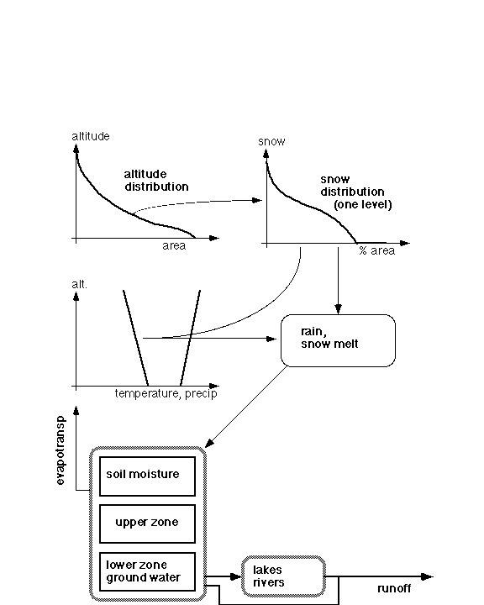

Figure 2. Structure of the HBV model (Saelthun, 1996)

In the HBV model the air temperature is accepted as a determining factor whether precipitation accumulates in form of snow or enters the soil moisture zone. Snow accumulation in an altitude level starts when precipitation falls at temperature lower than certain threshold value.
It was found that a distributed description of the snow cover within an altitude interval performs better (Killingtveit & Aam, 1978). The actual form of the snow distribution is specified by its coefficient of variation.
Basically the HBV model uses a temperature index (degree-day) method for snowmelt calculation. The temperature index melt equation is

M = CX.(T - TS) .Δt for T > TS
M = 0 T < TS (1)
where: M is the melt (in mm), T is the altitude level temperature during the time step Δt, TS the threshold temperature, and CX the temperature index.

3.2. SNEG-2 snow melt calculations
The mathematical model of the water balance type for the formation of runoff from snow melt and rainfall, SNEG-2, is developed at the Ukrainian Hydrometeorological Institute, Kiev (Sosedko, 1987). It simulates the processes of runoff formation in a mountain area during the winter-spring period. The SNEG-2 model is a complex system consisting of three subsystems. It describes the processes of snow melt and water yield from snow, the distribution of snow melt and rainfall water on the basin surface and in its soil, and the regulating effect of the drainage basin and the river network on the transport of water.
In present study are used some equations from the subsystem of snow melt and water yield processes of the SNEG-2 model describing the dependence of snow melt temperature index from the percentage of forested area in the basin. The snow melt temperature index calculated according to the SNEG-2 model formulas has been tested in snow routine procedure of the HBV model. These equations are presented below according to Sosedko, 1987:

CK_{f} = 0,10 Δt_{c} when Day ≤ 60
CK_{f} = (0,188 lgDay – 0,229) Δt_{c} when Day > 60 (2)
CK_{u} = 0,15 Δt_{c} when Day ≤ 60
CK_{u} = (0,0025 Day) Δt_{c} when Day > 60 (3)

Where: CK_{f} is the snow melt coefficient in forested area;
CK_{u} - the snow melt coefficient in non forested area;
Day – the day number after January 1;
Δt_{c} – the computational time interval.
The calculated snow melt coefficients are adjusted according to the air temperature and they are valid for Δt_{c} = 24 h:

CK = (1,29 – 0,074 T) CK + 0,0117 T – 0,072 (4)

Where CK represents CK_{f} or CK_{u}.

- Data base
A period of eight years (1967 – 1974) with continuous daily meteorological and hydrological measurements was chosen in the Mesta River basin for the calibration of the both above mentioned HBV model modifications. For the test another eight years period (1977 – 1984) with continuous data was used. The source of information from the National Institute of Meteorology and Hydrology consisted of standard observation data - discharge, temperature and precipitation with a temporal resolution of 24 h.
The historical temperature and precipitation information from two meteorological stations (“Semkovo”, 1560 m a.s.l. and “Belitza”, 836 m a.s.l.) was taken (Figure 1). The stations are situated on the Northern part of the catchment and the weight of each is 50%.
Air temperatures measured in standard thermometer shelters, 2,0 m above the ground, were used for the basin of the Mesta River. Daily means were generally computed from the three standard daily readings (7 h, 14 h and 21 h) according to:
$t_{d}=\frac{t_{7}+t_{\text{14}}+2t_{\text{21}}}{4}$ (5)
where: $t_{d}$ is the daily mean of the temperature (ºC);
$t_{7}$- the air temperature at 7 o’clock (ºC);
$t_{\text{14}}$ - the air temperature at 14 o’clock (ºC);
$t_{\text{21}}$ - the air temperature at 21 o’clock (ºC).
The temperature is adjusted to the different altitude levels by the lapse rate parameter. Daily totals of precipitation from standard rain gauges were used in the river basin. The measurements of daily totals are done at 7 o’clock in the morning and dated with the day of observation. This means that the main part of the measured precipitation normally has fallen on the previous day. Therefore the values of precipitation are shifted one day, better to represent the time of precipitation accumulation.
The recorded runoff data were used for comparison of the observed and simulated hydrographs. The used discharge gauging station “Hadji Dimovo” (73,94 m a.s.l.) is located on the main river channel near to the Bulgarian – Greece border (Figure 1) and it is the last station on Bulgarian territory.

- Results
A calibration period of eight years (1967 – 1974) was used for parameter evaluation of the HBV model modifications, and the period of 1977 – 1984 for independent verification as it was mentioned above. The simulations were started on the October 01, 1967 and 1977 respectively in order to avoid carry over effects due to snow storage.
During the calibration of the HBV model both subjective methods and numerical criteria were used. The subjective method is efficient in the initial phase of the model calibration, where several parameters may have to be changed simultaneously. The numerical criterion R² (Nash & Sutcliffe, 1970) was used during the “fine tuning” of the model:
$R^{2}=1−\frac{\sum{{\left(Q_{\text{sim}}−Q_{\text{obs}}\right)}^{2}}}{\sum{{\left(Q_{\text{sim}}−\overline{Q}\right)}^{2}}}$ (6),
where:
$Q_{\text{obs}}$ is observed discharge;
$\overline{Q}$ - average discharge;
$Q_{\text{sim}}$ - simulated discharge,

During the application of the HBV model using additional SNEG-2 model snow melt factor the upper four altitude zones were regarded as forested and the rest of the catchment as non forested.
Some of the most important general results obtained after the application of both modifications of the HBV model (original and with SNEG-2 snow routine) are shown in Table 2.

Table 2. Some general results from the different HBV model modifications

Type of values |  | Original HBV model | HBV model with additional SNEG-2 snow melt factor
Calibration  period | Observed precipitation (mm) | 5486,0 | 5486,0
Calibration  period | Computed precipitation (mm) | 4697,1 | 4697,1
Calibration  period | Evapotranspiration (mm) | 1685,0 | 1684,5
Calibration  period | Observed runoff (mm) | 2876,1 | 2876,1
Calibration  period | Simulated runoff (mm) | 2893,4 | 2892,0
Calibration  period | R² value | 0,76 | 0,75
Test  period | Observed precipitation (mm) | 4638,7 | 4638,7
Test  period | Computed precipitation (mm) | 3965,6 | 3965,6
Test  period | Evapotranspiration (mm) | 1672,1 | 1670,9
Test  period | Observed runoff (mm) | 2537,1 | 2537,1
Test  period | Simulated runoff (mm) | 2276,2 | 2277,5
Test  period | R² value | 0,54 | 0,54

The agreement between the observed and computed hydrographs for the different modifications and different periods expressed as R² values is given in Table 3.

Table 3. Agreement between observed and computed hydrograph of different periods and modifications expressed as R² values

Periods |  | Original HBV model  (R²) | HBV model with additional SNEG-2 snow melt factor (R²)
Ca  l  i  brat | 01.10.1967 – 31.12.1968 | 0,54 | 0,54
Ca  l  i  brat | 01.01.1969 –31.12.1969 | 0,75 | 0,72
Ca  l  i  brat | 01.01.1970 –31.12.1970 | 0,70 | 0,67
Ca  l  i  brat | 01.01.1971 –31.12.1971 | 0,90 | 0,90
Ca  l  i  brat | 01.01.1972 –31.12.1972 | 0,77 | 0,76
Ca  l  i  brat | 01.01.1973 –31.12.1973 | 0,86 | 0,86
Ca  l  i  brat | 01.01.1974 –31.12.1974 | 0,34 | 0,26
Ca  l  i  brat | 01.10.1967 –31.12.1974 | 0,76 | 0,75
Tes  t | 01.10.1977 –31.12.1978 | 0,20 | 0,21
Tes  t | 01.01.1979 –31.12.1979 | 0,45 | 0,44
Tes  t | 01.01.1980 –31.12.1980 | 0,51 | 0,55
Tes  t | 01.01.1981 –31.12.1981 | 0,65 | 0,66
Tes  t | 01.01.1982 –31.12.1982 | 0,65 | 0,64
Tes  t | 01.01.1983 –31.12.1983 | 0,57 | 0,58
Tes  t | 01.01.1984 –31.12.1984 | 0,68 | 0,67
Tes  t | 01.10.1977 –31.12.1984 | 0,54 | 0,54

From the Tables 2 and 3 is possible to be seen that the HBV model with SNEG-2 model snow melt factor gives approximately the same results as the original version.

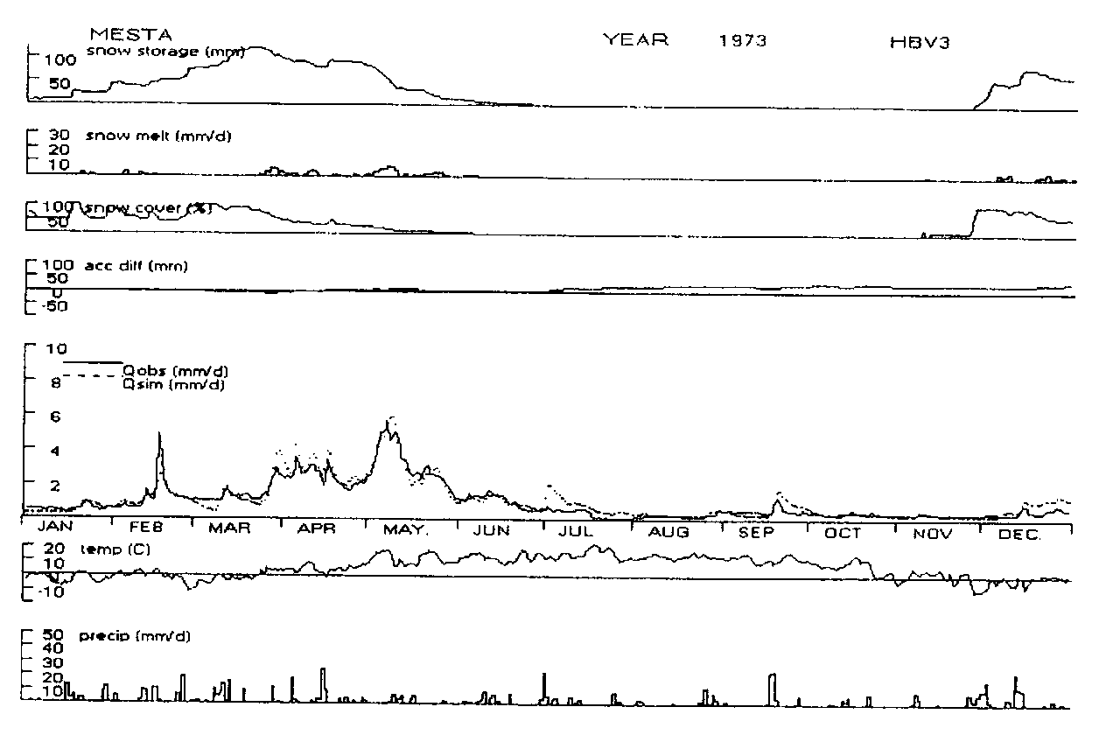Figure 3. A sample graphic result from the original HBV model simulations
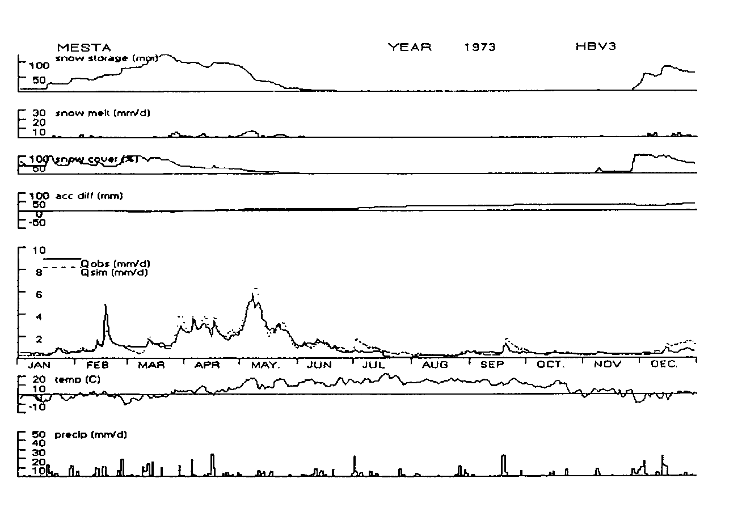

Figure 4. A sample graphic result from the HBV model using additional melt factor from the SNEG-2 model simulations

Sample plots of simulated hydrograph for both HBV model modifications (original and using snow melt routine from the SNEG-2 model) with recorded discharge for chosen year (1973) of the calibration period are shown on Figure 3 and Figure. 4. On the same plots are also presented the snow storage (mm), snow melt (mm), snow covered area (%), accumulated difference between observed and simulated runoff, daily temperature (ºC), and daily totals of precipitation (mm/d). Snow storage, snow melt and precipitation are catchments averages, while temperature is represented to the medium catchment altitude.

- Conclusions
As first, the results from the calibration of the two different HBV model versions are promising for the Mesta river basin (cross section “Hadji Dimovo”). Table 2 and Table 3 show that the total volume of runoff during the calibration period is approximately well reproduced for both HBV model modifications (original and using snow melt routine from the SNEG-2 model), which is of course natural, as this is one of the calibration criteria. The volumes of the individual years are also well simulated for most of the years, with exception of 1970 (approx. 120,0 mm underestimation) and 1974 (approx. 100,0 mm overestimation) for both. The volume is underestimated by approximately 10% for the whole period of the tested period. The standard error of the estimate of yearly volumes is 15%. The estimation of yearly volumes could be improved by using more precipitation stations. It should be kept in mind that:
- the daily precipitation data used in this study are not verified;
- winter precipitation data involving snow fall are strongly influenced by wind.
The dynamics of the runoff is generally simulated well for both HBV modifications (original and using snow melt routine from the SNEG-2 model), which can be seen also from a selected year (1973) on the sample plots (Figures 3 and 4).
The underestimation of several flood peaks may to some extent to be caused by the use of the R² criterion, as this tend to “punish” overestimation, especially in events with timing problems in the flood peak. The weakness of R² as a criterion of fit is evident for some of the simulations. Some observed flood peaks are clearly not consistent with the observed, precipitation, for instance the beginning of April 1979 and the end of August 1979. Simulating autumn and winter floods with mixed rain and snow precipitation is always difficult and in some cases the model fails on such floods, for instance in December 1969 and January 1970.
The station representatives are also important and the analyses in this direction should continue. The simulations could be additionally improved in future after analyzing the real weight for runoff generation of each measurement station.
This study shows that the HBV model using the Ukrainian SNEG-2 snow melt sub model perform on par with the original HBV model version with temperature index snow melt sub model.

- References
Aam, A. & Killingtveit, S. (1978): En fordelt modell for snøkkumulering og –avsmelting (In Norwegian). EFI/Institutt for Vassbygging, NTH Trondheim.
Bergström, S. (1976): Development and Application of a Conceptual Runoff Model for Scandinavian Catchments. Swedish Meteorological and Hydrological Institute, rep. RHO, Norrköping. 134pp.
Nash, J. E. & Sutcliffe, J. V. (1970): River flow forecasting through conceptual models. A discussion of principals. J. Hydrol. 10, 282-290.
Saelthun, N. R. (1996): The "Nordic" HBV Model. Description and documentation of the model version developed for the project Climate Change and Energy Production. NVE Publication 7, Norwegian Water Resources and Energy Administration, Oslo. 26pp. ISBN 82-410-0273-4.
Sosedko, M. N. (1987): Osobenosti modelirovaniya protsesov formirovaniya talo-dojdevogo stoka na gornom vodosbore (In Russian). UkrNIGMI Goskomgidrometa Series, Vol. 220, pp. 3-15.

