Bavarian innovation project “quantitative HYDROLOGY”

Dipl.-Met. Joachim Stoermer

Bavarian Water Management Agency (LfW), München, Germany,
e-mail: joachim.stoermer@lfw.bayern.de

Abstract: In 1999, the Bavarian Innovation Project “Quantitative Hydrology” was passed by the Bavarian Parliament and the main objective is to improve the automation, fail-safe run and data transmission of the hydrological networks (precipitation, water level, discharge). In 2003 the extension and continuation of the Innovation Project was decided upon to realize additional measures which could improve the hydrological service (measuring snow cover data, flood-safe extension of gauging sites, specific training, optimized precipitation-discharge-modeling). The time frame of this project is scheduled up to the year 2006.
Keywords: precipitation network, data access, snow cover data, water gauging system, fail-safe instrumentation, flood-safe extension of gauging sites

Innovationen in der quantitativen Gewässerkunde Bayerns

Zusammenfassung: Das Innovationsprogramm “Quantitative Hydrologie” wurde 1999 vom Bayerischen Landtag genehmigt und hat die Verbesserung der Datenermittlung im Niederschlagsmess- und Pegelwesen zum Ziel (Automatisierung, Erhöhung der Ausfallsicherheit durch Redundanz, optimaler Datenzugriff). Die Fortsetzung des Innovationsprogrammes wurde 2003 beschlossen und bis 2006 sollen weitere wichtige Maßnahmen zur besseren Erfassung hydrologischer Messdaten realisiert werden (Erfassung der Schneebedeckung, hochwassersichere Umrüstung von Pegelanlagen, Aus- und Fortbildungen, Verbesserung der Modellierung).
Schlüsselworte: Niederschlagsmessnetz, Datenabruf, Schneemessnetz, Pegelmessnetz, Redundanz, Hochwassersicherheit von Pegelanlagen

1. New Precipitation Network
The build up of the new precipitation network was started after the extreme flood of May 1999. This once-in-a-hundred-years flood event (e.g. at the rivers Iller, Ammer and upper Danube) showed, that it is essential for discharge modeling to gain representative precipitation measuring data as early as possible. For this purpose the Bavarian Water Management Agency (LfW) and the German Weather Service (DWD) concluded an agreement about the configuration, installation and operation of such a network. The afterimages show the allocation of the precipitation measuring points, the ownerships and the responsibilities respectively.

1.1. Special features
All stations are identical in construction, in particular they have the same sensor types (weighing principle) and components. Modifications are only depending on the local altitude and lead to a selected volumetric capacity of the precipitation sensor (lowland: 250 mm, highland: 1000 mm) and different installation heights (1 m, 1.5 m to 2 m), to avoid snow cover impact.

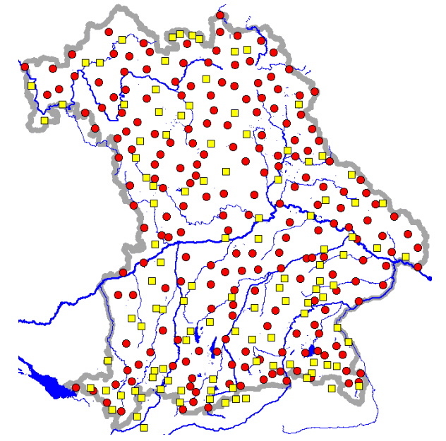

Figure 1. Automatic Recording of Precipitation in Bavaria (planned extension),
circle: Precipitation Gauge of the German Weather Service, quadrat: Precipitation Gauge of
the Bavarian Water Management Administration.

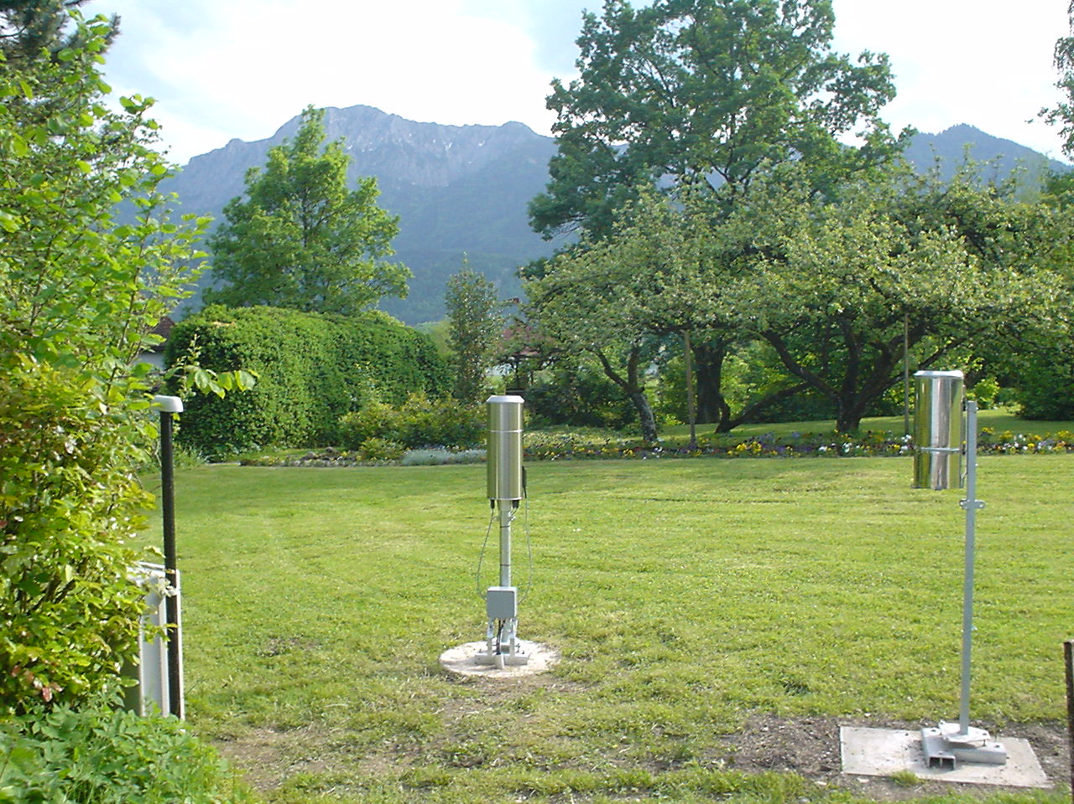

Figure 2. Components of a new precipitation measuring station: computer cabinet with
ISDN-data line-access, high resolution pluviometer, Hellmann Gauge (from left to right,
not shown: input terminal for additional observed parameters).

The special features of this new precipitation network are:
- online access of all stations via ISDN-data-line-connection,
- precipitation data with high resolution (accuracy: 0,04 mm, time interval: 1 min),
- direct precipitation gauging (no dew or evaporation losses, etc.),
- day-to-day supervision by the local weather observer (apparatus check, control survey by Hellmann gauging, radio controlled transmission of additional observed parameters),
- computer-aided quality control,
- calibration of radar data.
The Bavarian Water Management Agency and the German Weather Service have installed a similar host system to recall precipitation data. Besides this central data maintenance, every State Office for Water Management will be able to recall their dedicated stations (relevant river catchment areas) by a separated information system. This second way of data supply allows an independent access and shall ensure a fail-safe system.

1.2. Current status and extension
At present, the build up and online access of 170 precipitation stations is realized, the agreed extension number amounts to 326 stations (Table 1) and will probably reach that number in the year 2006. Besides this installation, one important objective of the Innovation Project, Part II is to extend the precipitation network instrumentation to gather snow cover data. The most stations will be equipped with tools for manual measuring (snow staff and snow balance for measuring the water equivalent). Selected gauging sites will be automated (e.g. ultrasonic measuring). Detailed information about snow cover and the corresponding water equivalent is essential to forecast flood events caused by snowmelt due to heavy rainfall.

Table 1. Distribution and status of the new automatic precipitation stations in Bavaria
 | Operating stations  (July 2004) | Planned stations  (realization till 2006)
German Weather Service | 80 | 216
Bavarian Water Management Administration | 90 | 110
Total | 170 | 326

- Water-Gauging-System
In Bavaria, the water level is measured at about 600 gauging sites of hydrological interest (category A and B) and at other points of special interest (category C). The most important measuring points (200 of category A and other essential for the flood warning service) were (and will be) equipped with fail-safe instrumentation and improved data transmission in the context of Innovation Project, Part I till the end of the year 2005. To achieve such a fail-safe status, redundant systems, consisting of two sensors, data logging units and data access paths, will be installed.
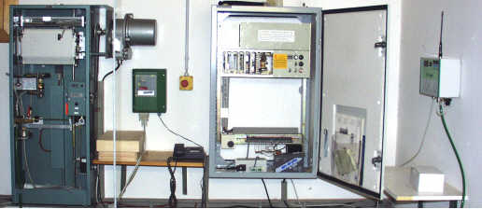

Figure 3.Water Level Gauging Station Freising/Isar
(Redundant equipment relative to water level sensors and data logging)
Also, new methods of discharge measuring (radar- and ultrasonic-supported) will be tested and installed at suitable sites. Additional measures to enhance the quality and availability of water level and discharge data are planned in the Innovation Project, Part II.

2.1. Flood-safe extension of gauging sites
An important objective of the Innovation Project, Part II is the flood-safe extension of the most important gauging sites to maintain the measuring and data access even under extreme conditions (greater than 100-year-events referring to mean discharge values and regarding additional particularities). A first inquiry was started to discover such stations. Half of them are characterized to have deficiencies; but this classification includes also a lot of simple cases like an insufficient long staff for water-level measuring or something else. Therefore a further selection is necessary, especially to use the limited funds for practicable structural engineering measures or suitable dislocation of the instrumentation.

2.2. Additional measures
Other measures to improve the hydrological service refer to optimized precipitation-discharge-modeling and specific training to raise quality of measuring and interpretation (e.g. discharge measurement training, tracer methods, etc.) .

Besides the measuring networks pointed out (precipitation, water-level, discharge), there are many others pushed forward by the Bavarian Water Management Agency with regard to quantitative aspects, e.g.: Groundwater, Spring Water, Water Temperature. Substantial improvements refer to solid revision of the instrumentation, extension of automation, rapid data access and quality control.

Above all, great efforts were (and will be) made to develop an effective data maintenance and an useful Intra-/Internet presence (www.lfw.bayern.de and www.hnd.bayern.de).

