APPLICATION of SAC-SMA and HSPF hydrological models

lenora basin case study

R. Košková, J. Buchtele, B. Volos, M. Fořtová

Institute of Hydrodynamics ASCR, Praha, Czech Republic; e-mail: koskova@ih.cas.cz

Abstract: Research aim is the application of two different rainfall-runoff models to a specific basin and comparison of the results of rainfall-runoff simulations obtained both with and without respect to data spatial variability. The SAC-SMA model works as a classical lumped conceptual water balance model contrary to the HSPF model incorporated in the WMS system enabling the usage of GIS data. The results of the surface flow, interflow and base flow simulations obtained in dependence on land-use and precipitation spatial distribution were compared in several time periods by means of simulated and observed runoff cumulative differences methodology, which could show the difference in runoff regime.
Keywords: rainfall-runoff simulation, land-use, semi-distributed models, water regime.

DIE ANWENDUNG DER SAC-SMA UND HSPF ABFLUSSMODELLEN IN DEM LENORA EINZUGSGEBIET

Zusammenfassung: Die Anwendung der zwei abweichenden Abflussmodellen worden in einem konkreten Einzugsgebiet ausgeführt. Die Resultate der Niederschlag–Abflussen Simulationen der auswählen Modellen worden unterainander konfrontiert. Das SAC-SMA Modell wurde als ein klassisches gesammtes Konzeptmodell des Wasserhaushaltes angewendet. Das HSPF Modell wurde in dem WMS System integriert und die Abflussimulationen werden mit dem Respekt zu der GIS Daten (speziell zu der Gebietverwendungsart und zu der Niederschläge) realisiert. Die modelle Resultate der Überland- , Unterdischer- und Grundigwasserabflüsse sind mit der Methode der kumulativen Unterschiede zwischen den simulierten und gemessenen Tagesabflüssen vergleichen. Diese Methode besonders die Differenzen des Wasserhaushalts dokumentiert.
Schlüsselworte: Nierderchlag-Abflusse Simulationen, Gebietverwendungsart, Semi-distributive Modelle, Wasserhaushalt.

1. Introduction
Interlacing of individual models into one integrated system represents world modern trend. It supports data process rationalisation, implementation of models and their use in user-friendly standardised environment of GIS tools and makes easier a gradual shift from primarily conceptual water balance models to semi-distributed modes or to their distributed forms. This stimulated the present study for comparison of two hydrological rainfall-runoff models – SAC-SMA (Sacramento) and HSPF (Hydrological Simulation Program – Fortran) used for hydrology modelling in a Lenora watershed.

1.1. Study area
The Lenora basin is a small mountain watershed with the area of 180 km². It is located in a relatively unaffected territory of the Sumava Mts. and forms a part of the Sumava National Park. The Lenora Basin belongs to the upper segment of the Vltava Basin. Forest – especially coniferous and mixed woods – represents dominant vegetation cover (Figure 1). Forest covers about 130 km² of the basin – 70 % of whole basin area. Meadows (18 % of area) are partly used as grasslands. The rest of the area is used as arable land or is covered by swamps and peat. Settlement in this locality is sporadic consisting mainly of the small villages and challets. The height difference at the basin reaches 600 meters.

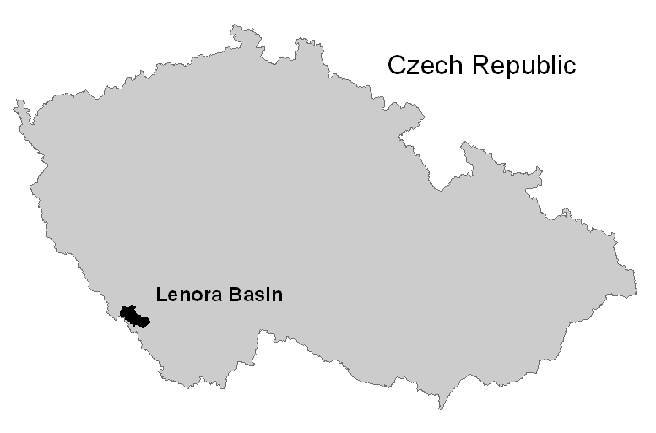

Figure 1. Location of the Lenora Basin

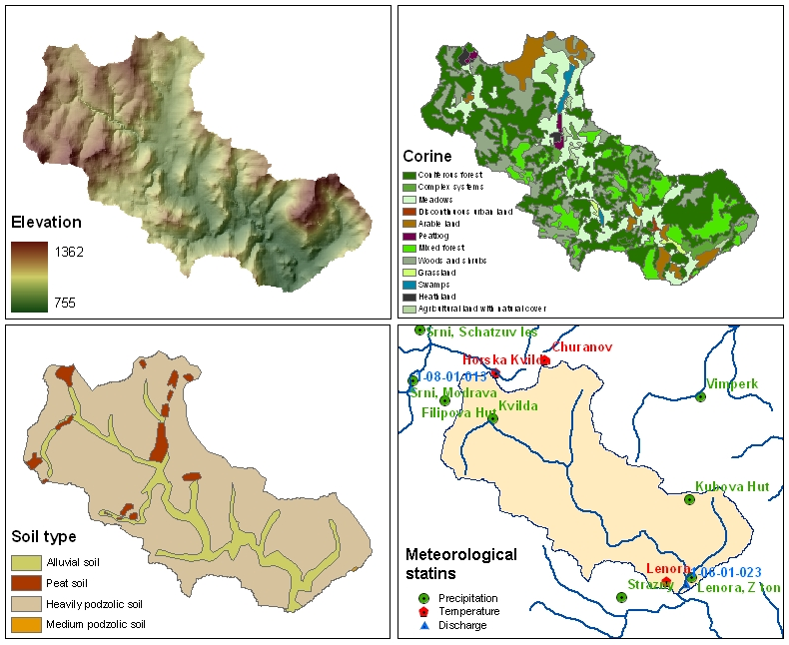

Figure 2. Elevation, vegetation cover (Corine), soil types and data stations at Lenora basin
Several meteorological and gauging stations in the region were taken into account as the data sources for the rainfall-runoff simulation (see Figure 2). The basic characteristics of the basin used are summarised in Table 1.

Table 1. Basic characteristics of the Lenora Basin
Catchment | P  (km²) | Period of Observation | H (m) a. s. l. |  | Precipitation | Runoff
Catchment | P  (km²) | Period of Observation | min | max | (mm/year)
Vltava-Lenora | 176.3 | 1961-98 | 761 | 1360 | 1028 | 556

2. Methodology
The conceptual water balance SAC-SMA model - Sacramento Soil Moisture Accounting (Burnash, 1995) has been used as the comparing basis for evaluation of newly implemented HSPF model. The earlier relatively long-term and successful experience with the SAC-SMA model application in many locations – also at the Lenora Basin – showed that this model may be the appropriate tool for rainfall-runoff simulation in the Czech Republic (Buchtele et al., 2002). The SAC-SMA model was used as a classic conceptual water-balance model of a rainfall-runoff process without direct connection to GIS data. The Hydrological Simulation Program – Fortran (HSPF) (Bicknell et al., 2000) is an analytical tool for simulation of hydrology and water quality in natural and man-made systems. The model was implemented within the WMS (Watershed Modelling System) – a multipurpose environmental analysis system for performing watershed- and water-quality based studies. It provides techniques for analysing landscape information and for revealing the environmental relationships. The simulations with the HSPF model were performed in semi-distributed mode using the land-use data.

2.1 The Sacramento SAC-SMA
The SAC-SMA model is a conceptual water balance model, which requires for calibration daily time series: precipitation, discharge and air temperature. The continual simulations in annual cycle provide as outputs e.g. contents of water in three zones of the model denoted by the symbols LZTWM, LZFSM and LZFPM. Volume of percolated water is computed as the amount proportional to the deficit of water in the zones (´reservoirs´) of the model. The corresponding five water storage variables are computing during simulation. The model produces six runoff components, which are presented as:
- direct runoff from permanent impervious areas,
- runoff from temporary impervious areas,
- surface runoff due to precipitation occurring at a rate faster a percolation and interflow can take place,
- interflow resulting from the lateral drainage,
- supplementary base flow,
- primary base flow.
The other main features of the model are in brief discussed elsewhere (Buchtele, 1996) and the full description can be found in (Burnash, 1995).

2.2 The Hydrologic Simulation Program – Fortran (HSPF)
The HSPF model (Bicknell et al., 2000) can simulate the hydrologic, and associated water quality, processes on pervious and impervious land surfaces and in streams and well-mixed impoundments. The HSPF consists of a set of modules arranged in a hierarchical structure. This is done by subdividing the basin into the "elements" which consist of "nodes" and "zones”. The response of the land phase of the hydrologic cycle is simulated using the elements called "segments” – PLS – land with a pervious surface and – ILS – land with an impervious surface. A segment is a portion of the land assumed to have uniform properties. Constituents in a PLS are represented as resident in a set of zones – snow, surface, upper, lower, ground-water zones. A channel reach is modelled as one-dimensional element consisting of a single zone situated between two nodes. Flow rate and depth are simulated at the nodes; the zone is associated with storage. The model needs minimal input precipitation, temperature and discharge data sets. In addition, the more accurate computing method requires wind velocity, dew point, radiation and potential evapotranspiration. The model produces primarily three runoff components – surface flow, interflow and base flow. Additionally the model could simulate water volumes in selected zones, transport of sediments, actual evapotranspiration, temperatures, nitrogen and phosphorus amounts etc.

2.3 The WMS - Watershed Modelling System
WMS is a comprehensive environment for hydrologic analysis, which allows by means of the graphical user interface to set up any of the several supported hydrologic models – including the HSPF model. The WMS uses GIS tools and data layers as digital elevation, land use, soil and other data to automate the development of hydrologic models. Geometric attributes such as area basin boundary, sub-basins, slope and runoff distances are computed automatically. A topological tree representation of the watershed is created. The WMS interface creates a procedure for the user how to input parameters into the input file and then to run the HSPF model in connection with spatially distributed data.

2.4 Data and results processing
With respect to data ability, the simulations were carried out for the period 1961 to 1998. Calibration of the models was performed in the period 1961-65 with respect to the water balance for whole simulation period. The temperature was measured for the both models at the Churanov meteorological station. The method of precipitation data processing and parameters determination was dependent on selected rainfall-runoff model and its input demands. The SAC-SMA model was implemented to the Lenora Basin in the classical lumped way with one parameter set for the whole area. The precipitation was considered as four data sets weighted average – stations Churanov, Vltavice, Kvilda and Lenora. The HSPF model was implemented using the WMS system reflecting the topography and land-use data. The relevant schematic maps are presented in Figure 3.

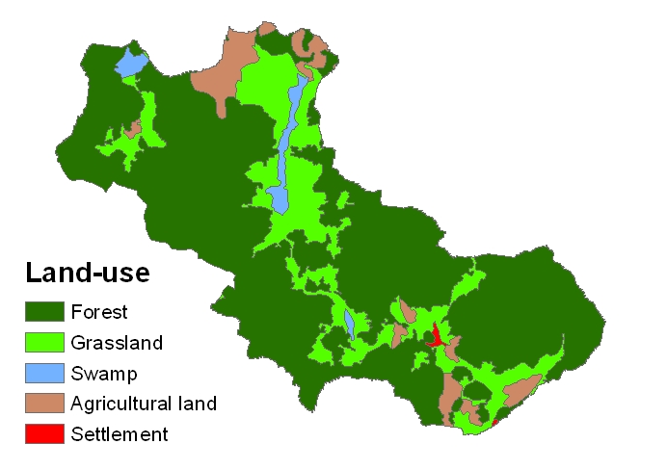
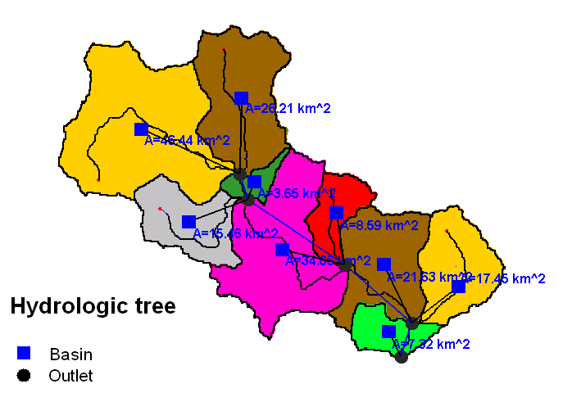

Figure 3. Simplification of land-cover and partitioning of the Lenora Basin into sub-basins

First step consisted in simplification of the land-cover into five basic classes (forest, grassland, swamp, agriculture land and settlement) to make easier model land-use parameter estimation as interception, deep of root zone, root density, ability to cover transpiration demands from lower soil zones, shade land and forest extent percentage. Secondly, the basin was delineated to sub-basins with one major land-use and the hydrology tree was created. The nearest meteorological station as a source of precipitation data set was assigned to each sub-basin – for the left upper sub-basin the Filipova Hut station, for the right upper sub-basin the Churanov station, for the middle sub-basins the Kvilda station, and finally for the three lower sub-basins the Lenora station. The parameters of the model change with each sub-basin (mean elevation, slope, area etc.) and with each land-use. Daily time series of precipitation, air temperature and discharge were used for simulation. The results of the simulations were mutually compared with respect to their ability to reproduce real conditions, sensitivity to parameter changes and prediction of the extreme hydrologic events. The flow rates of surface, interflow and subsurface flows were computed and the results were compared. The comparison of deviations between measured and simulated runoff and resulting trends in long-term course of deviations represents a base for searching possible reasons for appearing runoff changes. This is a similar approach to those applied in several other cases (Brandt et al., 1988 Luckey et al., 2000, Buchtele et al., 2002).

3. Results

3.1 Daily runoff simulation
Both models calibration was been performed for the same time period 1961 – 1965 under consideration of similar initial conditions. The calibration method could be described as “interactive hydrograph reading” based on comparing simulated and observed hydrographs and model parameters adjustment to achieve the highest consensus that is possible. Several experimental runs of the HSPF model with different combination of precipitation data sets were executed to obtain the most suitable variant. The resulting simulated flows averages are shown in Table 2. The observed total long-term average flow at the Lenora Basin is 3.12 m³/s, maximum total flow 68.2 m³/s and minimal total flow 0.33 m³/s. The total flow components were not measured.

Table 2. Simulated long-term average, minimal and maximal total flow, surface flow, interflow and base flow for both models
Flow | Total flow Qsim (m³/s) |  | Surface flow SU (m³/s) |  | Interflow IN  (m³/s) |  | Base flow GW  (m³/s)
Flow | SAC-SMA | HSPF | SAC-SMA | HSPF | SAC-SMA | HSPF | SAC-SMA | HSPF
Average | 3.12 | 3.12 | 0.23 | 0.13 | 0.01 | 0.87 | 2.87 | 2.12
Maximum | 39.20 | 135.37 | 24.76 | 94.89 | 2.05 | 41.61 | 24.64 | 12.69
Minimum | 0.19 | 0.36 | 0.00 | 0.00 | 0.00 | 0.00 | 0.00 | 0.36

The results in the Table 2 – especially values of the maximal and minimal flows indicate the models differ in the simulated runoff components rates. There is also a significant difference in the average interflow rates. These facts stimulated the necessity to carry out the analysis of the runoff components.

3.2 Long-term monthly runoff
Computation of long-term monthly flow was performed to assess the model ability to describe the annual hydrological regime of the river (Figure 4). The HSPF model results differ from the observed long-term monthly flows more than the SAC-SMA model ones. In the period not covering a growing season the flow trends are similar, therefore the model differences were caused by the more complicated land-use parameter determination over the course of the HSPF model calibration. The simulation show that the HSPF model substantially depends on the parameter describing the lower soil water usage covering evapotranspiration demand. Second reason of dissimilarity was assigned to different evapotranspiration input. The HSPF model calculates the potential and actual evapotranspiration rates from the meteorological data in contrast to the SAC-SMA model that derives the actual evapotranspiration from the observed mean monthly values.

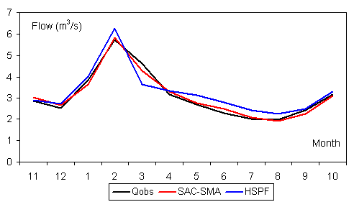

Figure 4. Observed and simulated long-term monthly flows for the SAC-SMA and HSPF models

3.3 Surface flow, interflow and base flow analysis
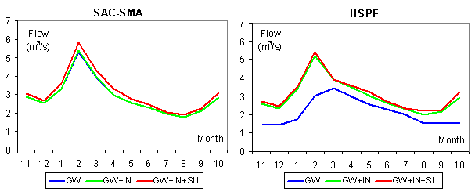

Figure 5. Simulated long-term monthly surface flow, interflow and base flow for the SAC-SMA and HSPF models

Figure 5 shows the surface flow (SU), interflow (IN) and base flow (GW) division during water year. It is recognisable that the SAC-SMA model produces negligible interflow values in contrast to the HSPF model. It follows the different evapotranspiration demand covering and diverse maximum water content parameter for the single soil segment. Four selected year simulation results are drawn in Figure 6. The analysis was performed for years 1965, 1970, 1988 and 1994. The tendency of different runoff component formation described above is clearly visible for each case. The HSPF model likely produces the flood flows peak preferably from the surface flow and the flood wave body from the interflow. The SAC-SMA model creates the flood wave body from the base flow on the contrary.

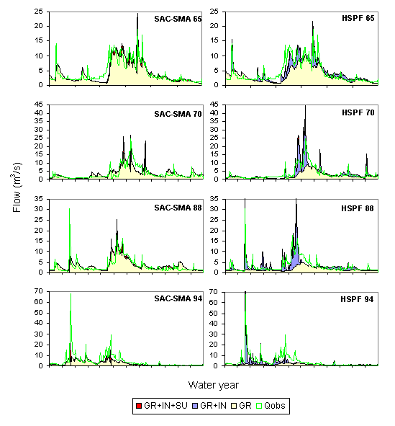

Figure 6. Comparison of the simulated daily components of total runoff for selected years 1965, 1970, 1988, 1994 – the SAC-SMA and HSPF models

The HSPF model also more accurate simulate the cold year periods – the winter foods peaks are drawn more precisely considering the assumption of deeper frozen soil and generating the runoff from the surface flow and interflow. There is visible better flow agreement in the summer periods for the SAC-SMA model. There were carried out total flow, surface flow, interflow and base flow tendency estimations additionally. The aim was to assess the possible changes in hydrological regime during last 40 years. As the suitable methodology there was selected the comparison of deviations between measured and simulated runoffs. The resulting trends in long-term course of deviations represent a base for searching the possible reasons for appearing runoff changes (Figure 7). Since the natural surface flow, interflow and base flow were not measured, the appropriate cumulative differences were computed as daily simulated values difference from the long-term mean values.
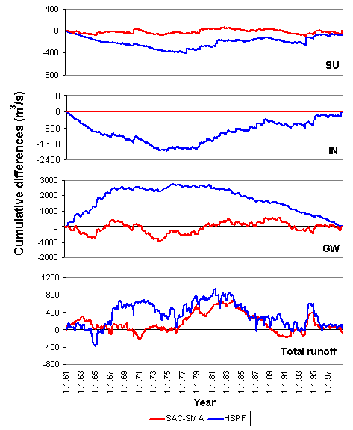

Figure 7. Trends of cumulative differences of total runoff and of flow components

Unfortunately the processing of the HSPF simulated flow components and its cumulative difference trends indicate necessary calibration and verification model improvement and necessity of more experience. Therefore the objective could not be reached according to the assumption. The conclusions could be made on the basis of the SAC-SMA model results only. Figure 7 indicate the component balance in the HSPF simulation is not exactly proper despite the tendency of total flows cumulative differences indicate the similar trend. In the total runoff (right graph in Figure 7) there is apparent a significant period of unbalanced water budget – the simulated flows exceed the observed ones in the long run – for the late seventies and sixties. Comparing the preceding study results (Buchtele et al., 2003) carried out at the adjacent Modrava Basin the deviation is probably caused by simultaneous deforestation in this region.

4. Conclusions
The results show a necessity to enhance simulation of flow components in the further studies. The HSPF rainfall-runoff model implementation has to inevitable include the flow component verification. Although the total runoff modelling in the Lenora Basin is valid, the flow component simulation causes irrelevant results. More satisfactory results are subjected to better determination of land-use parameters and implementation of the model under different conditions in other larger basins. In this case the topography variability plays more significant role in rainfall-runoff modelling and land-uses differentiate more substantially. Next research will concentrate on methodology concerning estimation of land-use and land-cover parameters.

Acknowledgement: The financial support of GA AS CR projects KJB3060302 and GA AS CR A3017301 is acknowledged.

5. References
Brandt, M., Bergström, S., Gardelin, M. (1988): Modelling the effects of clearcutting on runoff – examples from central Sweden. Ambio, Vol. 17, No. 5, pp. 307 – 313.
Buchtele, J., Buchtelova, M., Kulasova, A., Tesar, M., Sir, M. (2002): Monitoring and Modelling of Runoff Changes in two hilly Areas in Czech Republic. CD-ROM: FRIEND 2002, 4th Int. Conf. on Friend: “Bridging the gap between research and practice“, 18-22. March 2002, Poster Paper Proc., Cape Town, South Africa.
Buchtele, J., Buchtelova, M., Martin, C., Didon-Lescot, J.-F (2002): Investigation of runoff changes after deforestation – comparison of runoff three experimental basins. ERB2002 & NE FRIEND 5, 25-28 Sept. 2002, Conf. Proc. CD-ROM, Demanovska dolina, Slovensko.
Buchtele, J., Koskova, R., Fortova, M. (2002): Results of a rainfall-runoff model used for simulations in selected sub-basins of the Czech part of the Elbe River (in Czech). Workshop 2002 Extreme hydrological events in catchments, 12. November 2002, Conf. Proc., CVTVHS, Prague, Czech Republic.
Buchtele, J., Buchtelova, M., Koskova (2003): Changes of water regime due to the land use change (in Czech). Workshop 2003 Extreme hydrological events in catchments, 4. November 2003, Conf. Proc.,CVTVHS, Prague, Czech Republic.
Lukey, B. T. et al (2000): Test of the SHETRAN technology for modelling the impact of reforestation on badlands runoff and sediment yield at Draix, France. Journal of Hydrology, Vol. 235, pp. 44 – 62.

