A NEURAL NETWORK MODEL FOR RAINFALL-RUNOFF IN URBAN AREA

MSc Marija Šperac, MSc Damir Varevac

Faculty of Civil Engineering, Osijek, Croatia,
e-mail: msperac@most.gfos.hr; dvarevac@most .gfos.hr

Abstract: The rainfall-runoff process is believed to be highly nonlinear, time varying, spatially distributed, and not easily described by simple models. The process consist of the movement of rainfall through different media and its transformation to the runoff in channels either natural or man made. Run-off in an urban setting differs from the one in a natural setting. In built-up settings the shape of a run-off hydrogram is changed, the time of concentration is decreased, the peak of hydrogram is increased, a smaller amount of water is infiltrated into the underground, a volume of surface waters is increased up to two times. Run-off in an urban catchments area presents a complex problem, which calls for the integral approach. Precipitation and run-off as basic parameters of a hydrologic cycles are of a stochastic character.
An Artificial Neural Networks is a flexible mathematical structure, which is capable of identifying complex nonlinear relationship between input and output data sets. The results of applicability of neural network for determination of run-off in the urban discharge system show advantage in comparison to standard methods. These advantages particularly refer to the possibility of fast and easy generation of hypothetical hydrograms of runoff in sewage systems. Such hydrograms can be applied in the procedures for finding best management decisions when solving tasks related to operational management of sewage systems.
Key words: Artificial Nerual Networks, rainfall-runoff, urban area, hydrological inflow estimator, sewage system.

MODELL DES ABFLUSSNEURONNETZES IN DEM URBANEN GEBIET

Zusammenfassung: das Abflussprozess ist nicht linear,es ist zeitvariabel, separat distribuiert und ist als solches mit den einfachen Modellen schwer zu beschreiben.
Dieses Prozess umfasst den Durchgang des Niederschlags durch unterschiedliche Schichten sowie seine Transformationen und Abfluss duch natürliche und ausgebaute Kanäle.
Der Abfluss in einem urbanen Gebiet unterscheidet sich vom Abfluss in einer natürlicher Umgebung.
In den bebauten Gebieten verändert sich die Form des Abflusshydrogramms , die Konzentrationszeit vermindert sich, die Hydrogrammspitze nimmt zu, eine kleinere Wassermenge versickert in den Untergrund, das Gesamtvolumen des Abflusses wächst bis zu zweimal.. Der Abfluss in einem urbanen Flussgebiet stellt ein komplexes /umfassendes Problem dar, mit dem man sich integrativ beschäftigen soll.. Niederschlag und Abfluss als Grundfaktoren des hydrologischen Kreislaufs /Zyklus/ sind nach ihrem Wesen stochastisch. Die künstlichen Neuronnetze sind flexible mathematische Strukturen, die komplexe nichtlineare Beziehungen zwischen Eingangs- und Ausgangsdaten identifizieren können. Ergebnisse der Neuronnetzanwendung weisen auf ihre Vorteile im Vergleich mit den Standardmethoden.hin. Diese Vorteile beziehen sich vor allem auf die Möglichkeit schneller und leichter Generierung hypothetischer Abflusshydrogramme in den Kanalisationssystemen. Solche Hydrogramme finden ihre pragmatische Anwendung in der Suche nach den besten Führungsentscheidungen sowie in den operativen Verwaltungsaufgaben , die sich auf die Kanalisationssysteme beziehen.
Schlüsselwörter: künstliches Neuronnetz , Abfluss, urbanes Gebiet, Kanalisationssystem, integrales Verfahren

1.Introduction
Urbanization can be defined as gradual process of changing natural state of landscape or space with different kind of (artificial) engineering structures created by man. This process is gradual and spans through long period of time, in average about 20 years. From the hydrological viewpoint, the most important changes caused by urbanization are mirrored in the simple fact that most of the natural drainage surfaces are replaced with impermeable artificial materials.
Run-off in urban areas is completely different than run-off in natural surroundings. Urbanization changes basic characteristics of catchment surface. In those areas less water is infiltrated in the underground, but more flows over the surface. The result is changed run-off hydrogram. Also, faster run-off of the surface water causes reduction of the evaporation to the atmosphere. Since two components of the run-off are reduced, third component – surface drainage is increased up to several times, depending on characteristics of the urban area and natural characteristics of the cathcments area before urbanization. The volume of the surface waters is increased 1.5-2 times and peak hydrogram up 5 times. Thus, (output) hydrogram in urbanized area is significantly different than one in natural settings (see fig. 6.3.)

Q URBAN AREA

NATURAL SETTING BEFORE
URBANIZATION

T

Figure 1. Change of run-off hydrogram due to urbanization

Urbanization causes:
- increasing of the peak of hydrogram
- shortened time of concentration
- increased volume of run-off water (due to reduced loss)

Natural runoff system after urbanization is significantly changed, but some areas, which are left, still has some connection with underground (although very changes). Consequence is that basic runoff is reduced, sometimes disappeared.
Hydrogram of the urbanized catchment, caused by same rainfall, is much higher than hydrogram of the same catchment area before urbanization. This is because vast majority of ground surfaces are covered with impregnable materials (roofs, streets, parking spots) which prevent infiltration of rainfall into the ground. Runoff coefficient from such surfaces is nearly the value α ≅ 1 (except just small losses of water in cracks and local depressions), while on natural, unurbanized, surfaces this coefficient is much smaller, usually 0,1 in dry areas up to 0,3 in moderate climates and damp areas.

Also, surface runoff in urbanized areas is much faster. Higher flow speed is caused by reduction of roughness coefficient, but also by building surface and underground drainage system.

Hydrological changes in the chatchment are directly influence aquatic ecosystem and also wider part of ecosystem of catchment area. Faster flow reduces aquatic habitats which results with reduction of biological diversity. Part of local flora and fauna is destroyed with polluted and runoff water. Urbanization in its first stage usually goes along with removal of vegetation with serious consequences on whole ecosystem. Such consequences are hardly or impossible to repair.

Intensive rainfalls in urban areas cause different problems which can be put in following groups:
- drain surface water runoff into the drainage system and controlling floods
- erosion and land sliding
- disposition of eroded material
- soil and water pollution (rivers, natural and artificial accumulations, underground waters)
- pollution of underground reservoirs for water supply

2. Neural networks
From the last decade a new modelling approach is added to the literature of rainfall-runoff modelling. Artificial Neural Networks (ANNs) are mathematical paradigm, which tries to represent low-level intelligence in natural organisms. Although, rainfall-runoff modelling is paradigm is categorized in system theoretical approaches, there is significant difference between their bases and inspiration. As a result, ANNs should be classified in a new category with some others having similar foundations. Usually ANNs show grater performances in comparison to conventional regression approaches based on statistical analysis.

There are two categories of neural networks: biological and artificial. The example of biological neural network is nerve system of living beings. Artificial networks are, by their structure, function and data processing, similar to biological neural networks but they are man created for the specific function. Although the complexity of the most rudimentary biological networks is not reached yet, we are able to design artificial network to solve specific problem with implementing computer technology. Creating the artificial network using computer, basically we design tightly connected net of computing cells (“neurons”).

Axon(-output)
Nucleus
input

input output
Synapses
) input
Dendrite (input)

Figure2.: A human brain-neuron and a neural networking neuron

Artificial neural network is the set of the mathematical models which simulate some of the biological neural system characteristics. Basic goal in artificial neural network design is adaptive learning. This is achieved by defining great number of «neurons» (elementary processors), interconnected with data links. Each link has its own weight, and the sum of the signals from each «neuron» can or can not «trigger» the output. This is very similar to synapses in biological networks.

Advantages and Disadvantages of Neural Network
Neural Networks have certain advantages and disadvantages over more classic methods of computational calculation. These advantages can be split in practical advantages and theoretical advantages.

Advantages

Practical advantages
- Development of a neural network takes less time than the development of an expert system (ES) or the part of an expert system. However, the neural network can behave like a part of an expert system
- Neural networks are good with missing data or data with noise
- To develop neural networks formulas or algorithms don’t need to be known
- Neural networks are good with non-linear behaviour of system
- Neural networks are good with large datasets, large number of variables or parameters
- The results of neural networks quickly give general solutions with a good predicative accuracy
- Parallel distributed processing is used in neural networks
- With this parallel processing speed improvements can be made
- Many inputs and outputs are accepted and the correlation between them is learned by the network

Theoretical advantages
- All continuous bounded functions functions can be learned by a neural network
- The shape and location of the base-functions can be adjusted
- Very good approximation with a low number of neurons can be met with the existing techniques
- Neural networks are capable of learning and improving themselves
- Neural networks are capable of generalization

Disadvantages

Practical disadvantages
- Neural networks need large datasets to be trained accurate
- Training neural networks consumes a lot of time

Theoretical disadvantages
- Neural networks don't explain the solution to a certain problem. The neural network can give a very good performance on the solution of a certain problem, but cannot explain it.
- Neural networks cause a large problem of validation, since the network does not provide an insight into the background (formulas) of the modelled data.

3. A neural network model for rainfall-runoff process in urban area
In purpose to support hypothesis about dynamic non-linear behaviour of hydrological systems, in this paper neural networks are studied as tool for realization such non-linear time depending dynamic systems of rainfall runoff model in urban catching areas.
Learning data set is extracted from chronological rainfall data (pluviograms), which consist of time (unit is 1 hour) and output chronological data about runoff (stage hydrographs and hydrograms), i.e. levels (m) and flow rates (m³/s) in the sewer system, recorded every hour.
Data is collected in the urban catching region of Osijek, drainage sub area 2. The amount of rainfall is measured by ombrograph, and level of water by SEBA pressure limn graph, type MDS Insider. Flow rates are calculated on the basis of gathered data. For each variable exist 3472 values, prepared for input in neural network by EXCEL table calculator.

Data is separated into two groups: learning set with 80% of total data set, randomly chosen, and the rest 20% is in the test set. Separation of data is made using implemented routines in software package (NeuroShell 2).
Self organizing BPN network architecture is applied with following structure: input layer, three hidden layer and output layer. Input layer has two neurons (time variable and rainfall variable); output layer has also two neurons (water level and flow rate). Each of three hidden layers has eighteen neurons. Such architecture shown the best results comparing to test set.

Hidden layer of neurons

Input layer of neurons 18
logic f. Output layer of neurons

( 2 )
2 Gauss f.

( 1 )
time
2

( 5 )
water level
18

( 3 )
Gauss logic f.
complementary f.
rainfall
flow rate
tangens hyperbolic 18

( 4 )

logic f.

Figure 3.: Neural network architecture

Activation function between input and first hidden layer of neurons is Gauss function. Input layer and second hidden layer are connected by Gauss complementary function and link between input and third hidden layer is tangens hyperbolic function. Hidden layers are interconnected with logic function.
Testing the network after learning process, following values are obtained:

Table 1.: Statistics of BPN network
Input | Water level | Flow rate
Mean absolute error | 0,015 m | 0,012 m³/s
Min absolute error | 0,000 m | 0,000 m³/s
Max absolute error | 0,036919 m | 0,01610 m³/s
Correlation coefficient r | 0,861 | 0,9237
Percent within 5% | 72,298 | 82,258
Percent within 5% to 10% | 13,051 | 7,084
Percent within 10% to 20% | 9,908 | 8,902
Percent within 20% to 30% | 2,553 | 1,239
Percent over 30% | 1,904 | 0,978
Output | Time | Rainfall
Weight | 0,2697 | 0,7303

Main influence (weight) on flow rate in the sewer system has rainfall (73%) which is expected. Time has weight 27%.
Learning process lasted for 144 hours. After that period, authors concluded that further learning has no significant influence on achieved learning level. Correlation factors for water level and flow rate were high, 0,86 and 0,92 respectively, and maximum absolute error was only 3 cm for water level and 0,016 m³/s for flow rate. Testing of BPNN on new data shows that implemented network is able to predict 89% results with accuracy up to 10%.

From diagrams (Fig. 6 and 7) it can be seen that network has understood the phenomena of transformation rainfall-runoff, and excellent coincidence between actual data and BPNN prediction is achieved.
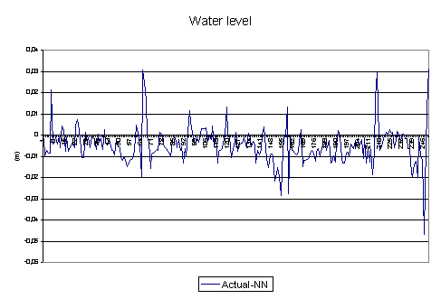
Figure 4.:Deviation between BPNN prediction and actual data for water level

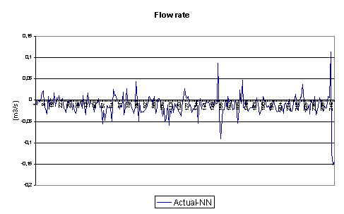

Figure 5.: Deviation between BPNN prediction and actual data for flow rate

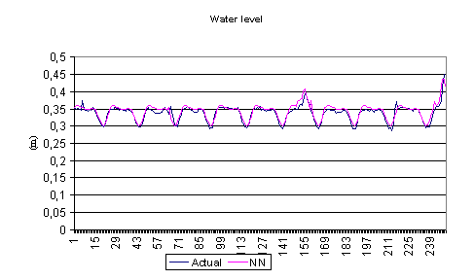

Figure 6.:Comparison between measured data and BPNN prediction for water level

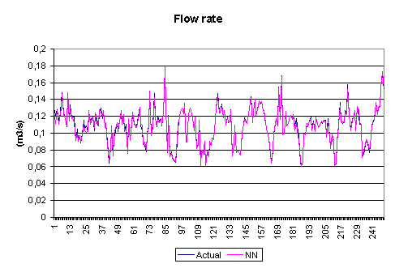

Figure 7.: Comparison between measured data and BPNN prediction for flow rate

4.Conclusion
The rainfall-runoff process is believed to be highly non-linear, time varying, spatially distributed, and not easily described by simple models. The process consist of the movement of rainfall through different media and its transformation to the runoff in channels either natural or man made. Run-off in an urban setting differs from the one in a natural setting. In built-up settings the shape of a run-off hydrogram is changed, the time of concentration is decreased, the peak of hydrogram is increased, a smaller amount of water is infiltrated into the underground, a volume of surface waters is increased up to two times. Run-off in an urban catchments area presents a complex problem, which calls for the integral approach. Precipitation and run-off as basic parameters of a hydrologic cycles are of a stochastic character.
An Artificial Neural Networks is a flexible mathematical structure, which is capable of identifying complex non-linear relationship between input and output data sets. Artificial Neural Networks models have been found useful and efficient, particularly in problems for which the characteristic of the process are difficult to describe using physical equations. An expert system for determination of run-off based on the application of neural network is made. The architecture and operating principles of expert systems based on neural networks are described. The results of applicability of neural network for determination of run-off in the urban discharge system show advantage in comparison to standard methods. These advantages particularly refer to the possibility of fast and easy generation of hypothetical hydrograms of runoff in sewage systems. Such hydrograms can be applied in the procedures for finding best management decisions when solving tasks related to operational management of sewage systems. Besides this purpose, neural networks can be used for the creation of hydrological inflow estimator for optimalization synthesis tasks, i.e. when planning and designing manageable sewage systems.

5.References

[1]G. Andrew (1994): "The Human Impact on the Natural Environment", The MIT Press,
[2] Butler,D.,Parkinson,J.(1997): Towards Sustainable Urban Drainage, Wat.Sci.Tech. Vol.35.,No. 9,pp.53-63

[3] Billings,S., Chen,S. (1992): Neural Networks for Non Linear Dynamic System Modelling And Identification, International Journal of Control, 51(6) pp 1191-1214

A NEURAL NETWORK MODEL FOR RAINFALL-RUNOFF IN URBAN AREA

MSc Marija Šperac,
Faculty of Civil Engineering, Drinska 16a, 31000 Osijek,Croatia, msperac@most.gfos.hr
MSc Damir Varevac,
Faculty of Civil Engineering, Drinska 16a, 31000 Osijek,Croatia, dvarevac@most .gfos.hr

Abstract
The rainfall-runoff process is believed to be highly nonlinear, time varying, spatially distributed, and not easily described by simple models. The process consist of the movement of rainfall through different media and its transformation to the runoff in channels either natural or man made. Run-off in an urban setting differs from the one in a natural setting. In built-up settings the shape of a run-off hydrogram is changed, the time of concentration is decreased, the peak of hydrogram is increased, a smaller amount of water is infiltrated into the underground, a volume of surface waters is increased up to two times. Run-off in an urban catchments area presents a complex problem, which calls for the integral approach. Precipitation and run-off as basic parameters of a hydrologic cycles are of a stochastic character.
From the last decade a new modeling approach is added to the literature of rainfall-runoff modeling. Artificial Neural Networks (ANNs) are mathematical paradigm, which tries to represent low-level intelligence in natural organisms. Although, rainfall-runoff modeling is paradigm is categorized in system theoretical approaches, there is significant difference between their bases and inspiration. As a result, ANNs should be classified in a new category with some others having similar foundations. Usually ANNs show grater performances in comparison to conventional regression approaches based on statistical analysis.
An Artificial Neural Networks is a flexible mathematical structure, which is capable of identifying complex nonlinear relationship between input and output data sets. Artificial Neural Networks models have been found useful and efficient, particularly in problems for which the characteristic of the process are difficult to describe using physical equations. An expert system for determination of run-off based on the application of neural network is made. The architecture and operating principles of expert systems based on neural networks are described. The results of applicability of neural network for determination of run-off in the urban discharge system show advantage in comparison to standard methods. These advantages particularly refer to the possibility of fast and easy generation of hypothetical hydrograms of runoff in sewage systems. Such hydrograms can be applied in the procedures for finding best management decisions when solving tasks related to operational management of sewage systems. Besides this purpose, neural networks can be used for the creation of hydrological inflow estimator for optimalization synthesis tasks, i.e. when planning and designing manageable sewage systems.

Key words: Artificial Nerual Networks, rainfall-runoff, urban area, hydrological inflow estimator, sewage system.

