SPECIFIC PROBLEMS IN THE DEFENCE AGAINST FLOODS ON THE COMMON REACH OF THE RIVER TIMIS BETWEEN CEBZA (ROMANIA) AND BOKA (SERBIA)

Niculae Iulian Teodorescu

N. A. “Romanian Water”, Department of Water Banat Timisoara, Romania,
e-mail: teodorescuniculae2@hotmail.com

Abstract: Twice in the last century (1966 and 2000), there have occurred dam breaches in the section of common interest between Cebza (Romania) and Boka (Serbia). These have had the most unwanted effects. In the year 1966, approximately 6500 ha have been flooded on Romanian territory and 20.000 ha on Serbian territory. In the year 2000, as a result of the two dam breaches that occurred on the right bank of the river Timis in Graniceri (Romania), there have been flooded 16.000 ha only on Romanian territory. As a result, in the following we present the causes that have led to the appearance of these dam breaches as well as possible measures to prevent such future events.

Keywords: river Timis, common reach, defence against flood

SPEZIFISCHE PROBLEME IN DER VERTEIDIGUNG GEGEN ÜBERSCHWEMMUNGEN IN DEM GEMEINSAMEN GEBIET DES FLUSSES TIMIS ZWISCHEN CEBZA (RUMANIEN) UND BOKA (SERBIEN)

Zusammenfassung: Zweimal im vergangenen Jahrhundert (1966 und 2000) wurden in dem Sektor zwischen Cebza (Rumanien) und Boka (Serbien) Dammrisse erzeugt. Diese habe viele unerwunschte Effekte gehabt. Im Jahre 1966 wurden ungefahr 6500 Hektare auf dem rumanischen Territorium und 20.000 Hektare auf dem serbischen Territorium uberschwemmt, wahrend im Jahre 2000, als Folge zwei Risse in dem rechten Ufer des Flusses Timis in Graniceri (Rumanien), nur auf dem rumanischen Territorium ungefahr 16.000 Hektare uberschwemmt wurden. Folglich, diese Arbeit stellt sowohl einige der Ursachen vor, die zu diesen Dammrissen gefuhrt haben, als auch moglichen Ma$nahmen fur das Vorbeugen solcher zukunftlichen Ereignissen.
Schlüsselwörter: flusses Timis, gemeinsamen gebiet, verteidigungung gegen überschwemmungen

1. General presentation
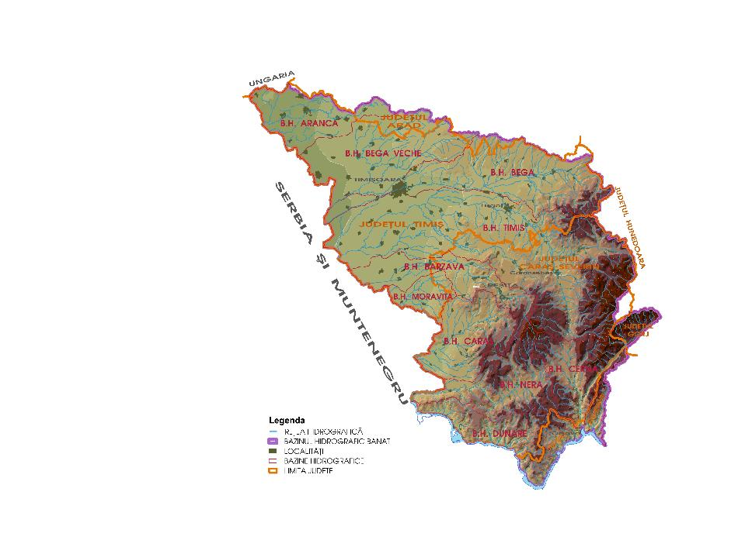
The hydrographic basin of the river Timis is the biggest one in the Southwest of Romania. It has in the frontier section with Serbia a surface of F = 5.790 km² and a length of the main water- course of 232 km (figure 1).
Figure 1. The frontier between Romania and Serbia
There function or have functioned a series of gauging stations in the section of common interest with a length of 13,55 km: Sag, Graniceri, (in Romania) Iasa Tomici, Seceani (in Serbia) (figure 1).
Taking into account the existing running conditions in the major streambed on both sides of the frontier, it was considered that the leakage is influenced by:
• The vegetation in the major streambed;
• Formations of ice;
• The correction of the streambed by cutting the meanders (in the Surian region – Serbia).
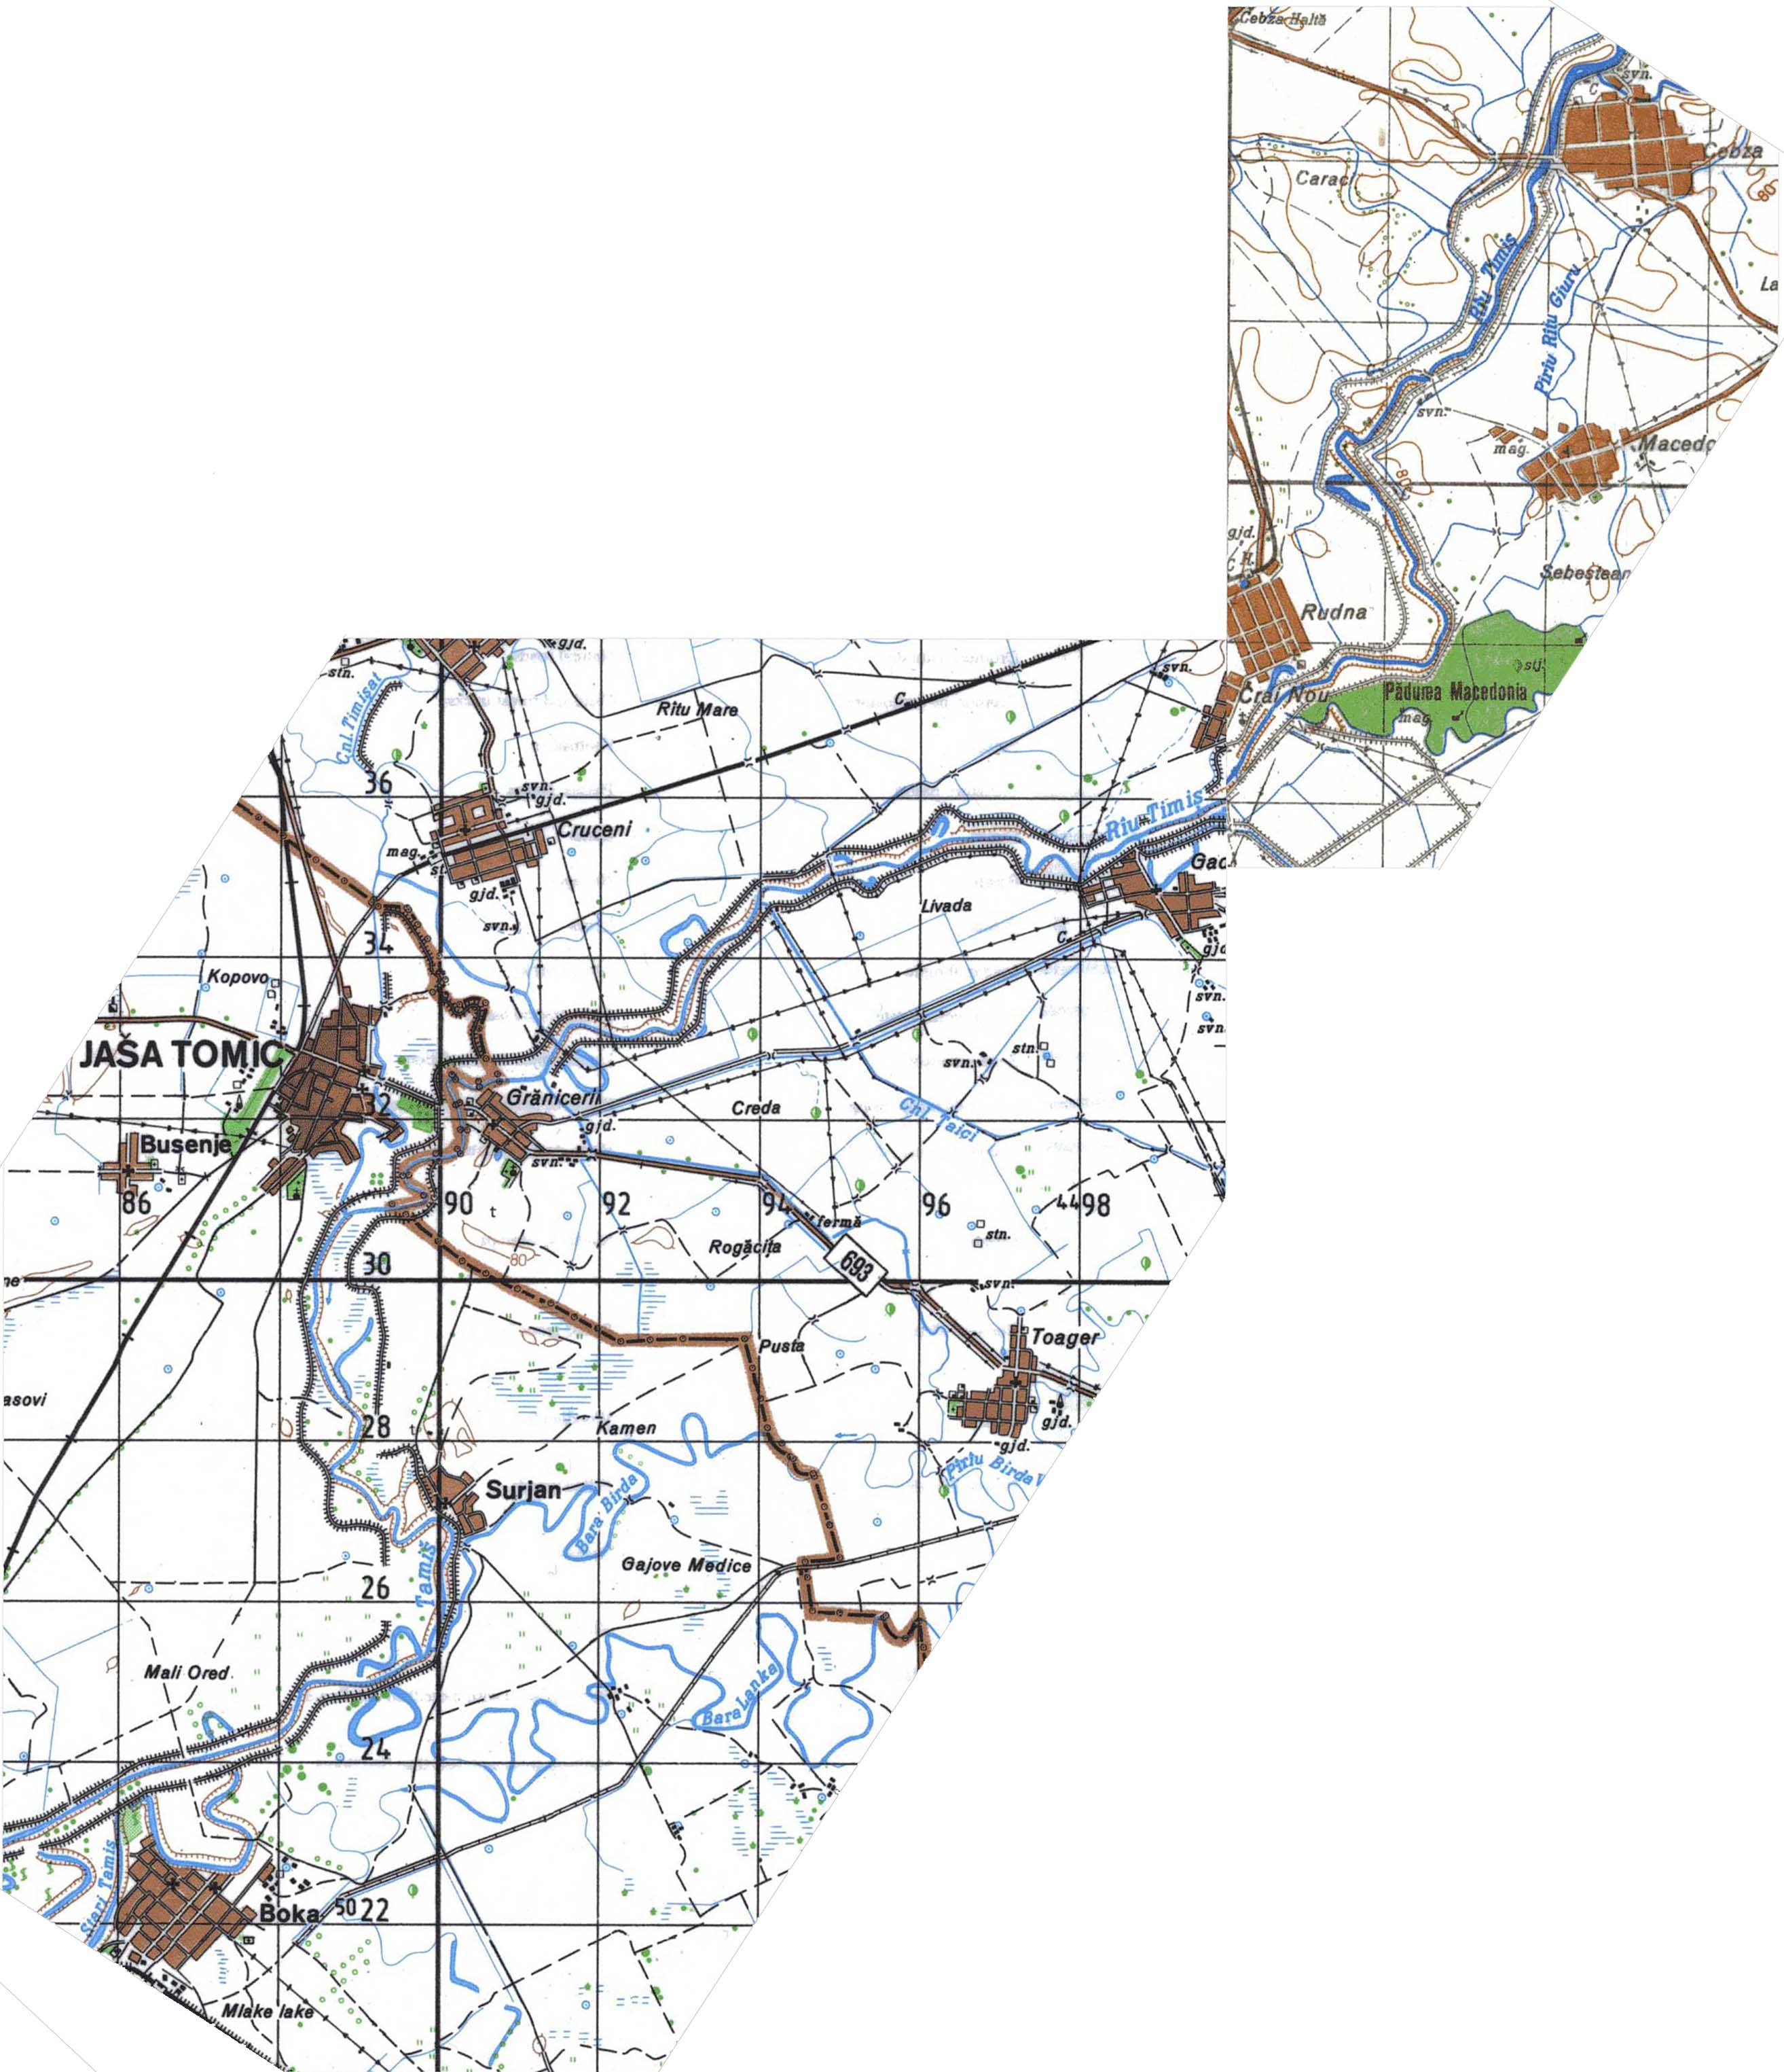
Figure 2. The sector of common interests between Cebza and Boka
Boka
Cebza

There have been made a series of hydrographic workings starting with the first part of the XVIIIth century in the hydrographic basin of the river Timis and the one neighboring it at the North - Bega, workings which have continued up to the present moment. Among the types of the hydrotechnical workings, we mention:
• Permanent and temporary accumulations;
• Hydrotechnical knot;
• Segment gates;
• Channels of derivation.
At the beginning, these were thought considering the basin as a whole, but after its division between the two states – Romania and the present Serbia – Muntenegro, we can state that the arrangement of the hydrographic basin has suffered from different ways of thinking.
In what follows, we are going to present some of these hydrotechnical workings from the category of those that influence the maximum leakage.

Workings on Romanian territory:
- The Maru Accumulation (in the final stage of realization) is situated on the affluent of the Bistra Marului river at the altitude of 645 m;
- The Trei Ape Accumulation in the superior basin of the river Timis;
- The canal of discharge Bega – Timis from Topolovat can transfer high waters from the river Bega into the river Timis so that the maximum flow of 82,5 m3/s on the shipping canal Bega in the frontier section shouldn’t be exceeded – established value with the Serbian part.
- The Padureni Accumulation.
- The Hitias Accumulation.
- The dams along the river Timis.

1.1. Hydrotechnical Workings with Important Effects upon the Modification of the Natural Leakage

The Hitias Polder
The Accumulation is delimited by the right-bank dam of the river Timis at the South, by the left-bank dam of the river Bega at the North and the discharge canal dam Timis – Bega at the East.
The filling of the accumulation is done by overfall from the river Timis and from the river Bega;
Emptying it into the Discharge Canal Timis-Bega does the water discharge from the accumulation.

The Padureni Polder
The Accumulation is situated on the left bank of the river and is delimited at the North by the left-bank dam of the river Timis and by an embanked area of L = 8,64 km, the maximum capacity being of 35 mill. m 3 and the surface of 1120 ha.

The Cadar-Duboz Polder
The Accumulation is situated on the river Poganis and it controls approximately 75% of the reception surface of the river, which can attenuate floods having a volume of 43,9 mill cm, a height of the waste weir of 13 m and a length of the crowning of 1590 m.

The Dams in the Cebza Section – the State Frontier:
The dams stretch on both banks on the whole section. The relative height oscillates between 4 and 7 m while the breadth at the superior part of the dams oscillates between 2,5 and 4 m. The water level at the superior part is of 82,70 mdMA on the right bank and of 82,30 m on the left bank, the average slope of the dams crowning being of 0,14%.
It should be mentioned that all these workings have been done with the purpose of preventing floods, most of them being achieved after 1975.

Workings on Serbian territory:
- The segment gate Tomasevec is a common objective of the “Hydrosystem DTD” and the Hydrosystem Dunav, which produces backwater at low flows, which can be experienced also on the Romanian territory. The leakage at normal conditions is of 35,0 m 3/s at upstream altitude of 74,00 mdMA. The Serbian part appreciates that if this flow value is exceeded, the influence upon the upstream levels is reduced;
- The hydrotechnical knot Bortos is situated on DTD;
- The segment gate Opovo;
- The segment gate Centa – both play the part of maintaining the levels stipulated in the Common Regulations AIIG;
- The cutting of the meanders from Surian; in the part between km 108,302 – 111,376 the meanders have been cut, thus shortening the length of the course with approximately 1,4 km – which led to the improvement of the morphological and hydraulic conditions with major effects upon the transport capacity and the water speed, especially during low flows with direct effects on the appearance of ice phenomena.

Beside these hydrotechnical workings, we must also add the vegetation from the major streambed, which consists of poplar trees, which occupy the major streambed between the passage of 130-200m breadth of the river Timis and the dams that follow the river course on both banks. If the hydraulic workings generally have positive effects, this leads to the aggrandizement of the strictness from the bank - dam area. Further more, the cleaning of the vegetation from the inferior stories on the course of the water doesn’t always take place or takes place only in some plantations and if this happens, only perpendicular on these, the major effects being sometimes grievous.
Apart from these, an important role in the water leakage during floods plays the water level from the Danube – Tisa – Danube Canal, because even though the river Timis flows into the Danube, it is connected to the DTD system through the segment gate Tomasevat.
According to the precautions registered in the official report of the Romanian – Serbian Hydrotechnical Session from 1975 (Varset), it is stipulated that in case of low and medium waters of the river Timis the upstream level at the segment gate Tomasevat should be maintained at the altitude of 74,00 mdMA.
It is considered that in case of floods (at flows below 35m³/s) the segment gate Tomasevat doesn’t influence the upstream level.
Between the years 1998 – 2000 the two co-working parts have each worked out independently a study on the establishment of the influence of the mentioned factors upon the running of high waters through the streambed.

The study of the Serbian part
The calculation pattern of the uniform running has been done with the help of the simplified Saint Venan equations, while in the case of uneven running based on the developed Saint Venan equations. For this, there have been used a number of 29 transversal profiles of only 7 which run through the major streambed. For the other 22, the completion of the profiles was done on the basis of a situational plan with the scale 1:5000.

The study of the Romanian part
The influence of the vegetation has been established with the help of a computer program (MIPE, author R. Amaftiesei), whose calculations were based on the algorithm numerical integration of the Bernoulli equation. The pattern is based on 39 topographic profiles raised through the streambed of the river Timis between Sag and Tomasevat (Serbia).

2. Defence against Floods
The floods in the section of common interest between Cebza (Romania) and Boka (Serbia) have total duration of 180 to 320 hours, which can lead to a soaking of the dams. These are made of sandy-clay earth with inhomogeneous layers, so there are teams along the dams on both banks who follow the reaction of the dams. It is being intervened in those areas by setting up sandbags in order to prevent overfalls of the dams, which can cause dangerous effects upon important areas neighboring the river.
During the last 38 years, the two parts have exchanged information on the highest floods and their main characteristics, like: maximum flows, the total duration of the flood, W – the volume of the flood, the leaked layer – h_{s}, the fallen layer – h_{c}.
Afterwards, the proposed calculation methodologies for the establishment of the influence of
• Hydrotechnical objectives;
• Vegetation
• Different forms of ice
upon the transport capacity of the streambed have changed.
The Serbian part has performed a study that was meant to establish the main influences upon the leakage. These are:
• The vegetation from the major streambed on the Serbian territory;
• The hydrotechnical workings.
Even though the factor with the highest influence upon levels – vegetation – is the same, the conclusions differ from one another.
Essentially, the Serbian part considers that:
• The present state of the vegetation should not be altered – even though they admit that the influence in the frontier section varies from +37 cm to +79 cm;
• The necessity of the over-raising of the dams.

3. Conclusions
It is imperative that the activity between the two states be restarted – suspended out of known reasons.
• The clearing up of suspicions in discussions;
• The re-establishment of the data basis which is used when drawing up studies;
• The acceptance of the idea that it is far less expensive to cut the vegetation in the major streambed than to over-raise the dams – fact that also has positive effects on the water level in the frontier section;
• The hope that both sides will prove mature enough in the approach of this matter and of other unsolved matters between the two states.

References

Neicu, S, (2001) – Studiul conditiilor de scurgere a apelor mari si gheturilor in albia r. Timis
pe sectorul intre Cebza si Boka - studiul partii romane, INMH, Bucuresti
x x x (2000) – Studiul conditiilor de scurgere a apelor mari si gheturilor in albia r. Timis pe
sectorul intre Boka si Cebza – sectorul partii iugoslave, Institutul “J. Cerni”, Belgrad
x x x – Anuare hidrologice
x x x – Arhiva Directiei Apelor Banat

