Monitoring of rainfall – runoff relationship in small mountainous catchments

Miroslav Tesař1, Miloslav Šír1, Ľubomír Lichner2

1Institute of Hydrodynamics, Academy of Sciences of CR, Praha, Czech Republic,

e-mail: tesarihas@iol.cz, msir@mereni.cz

2Institute of Hydrology, Slovak Academy of Sciences, Bratislava, Slovak Republic,

e-mail: lichner@uh.savba.sk

Abstract: Wide monitoring network covering the main massifs of the Bohemian border is discussed. As an example of obtained results, the influence of vegetative cover on the soil water regime in the Modrý potok catchment in the Giant Mts. (Krkonoše) is presented. Several monitored plots, located in this catchment in different positions (valley, slope), are covered by different vegetation (dwarf pine forest, spruce forest, meadow). Maximum retention capacity of the catchment (about 70 mm) and retention capacity of the soil surface (20 mm) are evaluated in two contrast periods: catastrophic flood in August 2002 and long-term drought in August 2003. Based on the soil moisture measurement in monitored plots fully covered by plants, it is shown that: (1) In the wet conditions, when the plants can fully transpirate, the vegetative cover composition does not influence the soil water regime. (2) In the course of droughts, the soil water regime is highly influenced by the plant cover composition. Based on the monitoring of the water and heat regime in the growing season the homeostatic role of the plant transpiration was proved. Consequently, the water regime of a catchment during wet conditions (so called rainfall – runoff relationship) is independent on the species composition of the plant cover if the area of the transpirating vegetation remains unchanged.

Keywords: runoff hydrology, plant transpiration, water retention in a catchment

Monitorování srážko–odtokového vztahu v malých horských povodích

Souhrn: V příspěvku se popisuje rozsáhlá monitorovací síť pokrývající hlavní horské masivy českých hranic. Výsledky monitoringu jsou ukázány v povodí Modrého potoka v Krkonoších, kde je analyzován vliv vegetačního pokryvu na vodní režim půdy a povodí. V povodí je rozmístěno několik monitorovacích stanic v různých porostech (kleč, les, louka) v odlišných expozicích (údolní niva, svah). Ve dvou kontrastních obdobích – srpnu 2002 (katastrofální povodeň) a srpnu 2003 (dlouhodobé sucho) – je stanovena maximální retenční kapacita povodí (70 mm) a retenční kapacita půdního povrchu krytého vegetací (20 mm). Z měření půdní vlhkosti v kořenové zóně porostů plyne: (1) V podmínkách dostatečné vlhkosti, kdy porost může plně transpirovat, neovlivňuje druhové složení vegetace vodní režim půdy. (2) V případě sucha je vodní režim výrazně odlišný pod druhově odlišnými porosty. Monitoring vodního a teplotního režimu prokazuje, že transpirující vegetace působí ve vegetační sezóně homeostatickým účinkem na hydrologický cyklus. Vodní režim povodí, vyjádřený např. srážko-odtokovým vztahem, není v podmínkách dostatečné vlhkosti ovlivněn druhovým složením vegetace.
Klíčová slova: odtoková hydrologie, transpirace rostlin, retence vody v povodí

1. Introduction
Long-term attention is paid to the study of the relationship between the vegetation cover and the heat and water circulation in the landscape. The question how the water regime of a catchment is influenced by forest has been studied in the Czech Republic from the beginning of the 20th century. The first research basins – Kychová and Zděchovka in the Beskydy Mts. – were established by Válek in 1928 (Válek, 1937). Precipitation and runoff measurement in these basins continues to the present times. Another experiment started in 1954 in the Ráztoka catchment (Beskydy Mts., drainage area 2.067 km2, elevation from 602 to 1084 m a.s.l., mean annual precipitation total 1269 mm and depth of runoff 833 mm, bedrock is formed by sandstone). Based on this experiment, it was found that the rainfall-runoff transformation is not significantly influenced when the spruce forest is replaced by beech forest. This conclusion was derived using the double mass curve of the precipitation and runoff (Chlebek, Jařabáč, 1988).
Present research activities are aimed to the mountainous regions covered by damaged forests. This interest was invoked by series of climatic and hydrological disasters like floods in 1997, 1998 and 2002 or droughts in 2000 and 2003. A calamitous deforestation of the Bohemian and partly Silesian border causes such significant ecological damages that it is impossible to rely on the remedial potency of the nature, and it is necessary to step up to the active renewal of the vegetation cover. The antecedent research was predominantly motivated by the effort to better recognize the hydric functions of the forest (Chlebek et al., 1988). The majority of the affected mountains is situated in the landscape protected areas or national parks. So that the use of the well-tried techniques for clear cutting of the damaged forest with subsequent afforestation of the clearings is questionable.
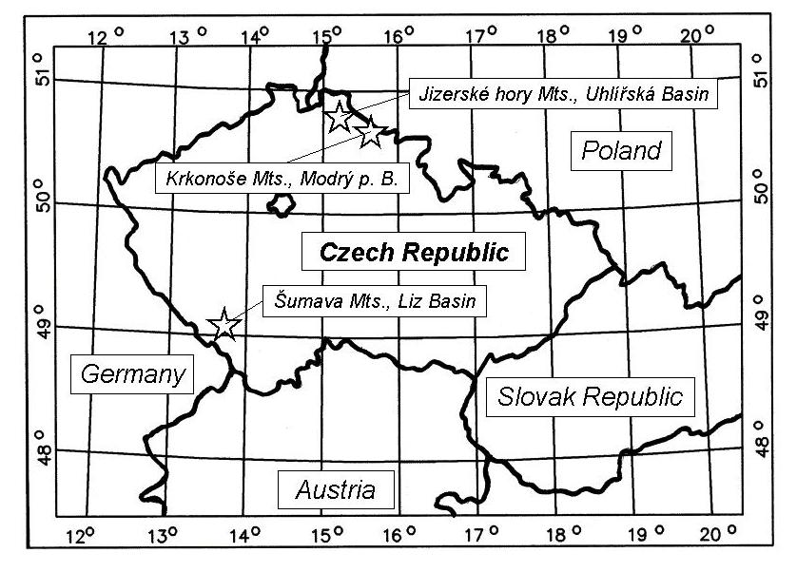
Figure 1. Situation of the experimental plots in the Czech Republic

In addition, the research effort is complicated by the 50 years lasting climatic change that became marked global warming in the course of the last decade. The annual average of the air temperature in the open landscape of the Czech Republic was increased of about 1.4 ºC during last 50 years (Bodri, Čermák, 1997). Taking into account the altitude gradient of the average temperature –0.66 ºC per 100 m of the elevation above sea level for the Czech Republic, warming represents an illusory decrease of the whole country of about 210 m, and thus, the shift of the mountains to the climatic zone corresponding rather to highlands, too. This fact complicates the application of older results of hydrological research. These results were obtained in different climatic conditions compared to present ones.
In this article typical results of monitoring of the influence of various vegetation cover on the soil water regime and water retention in the catchment are shown. The contribution is based on the monitoring of the hydrological and meteorological data in the four experimental plots in the Modry potok catchments in the Giant Mts. These plots differ in both the type of the vegetation (dwarf pine, spruce forest, meadow in the valley and meadow above the forest margin) and position (valley and different elevation of the slope). In two contrast periods – during the catastrophic flood in August 2002 and during long-term drought in August 2003 – the retention capacities are estimated. The vegetation cover influence on the soil water regime is documented with the help of soil moisture measurements.

2. Monitoring network
In order to study the water regime of mountainous forested catchments three experimental watersheds were established. (1) The Liz basin (the Šumava Mts. – southern Bohemia, brown podzolic soil, moldanubic crystallinicum, paragneiss, prevailing type of the tree is a spruce forest with the age up to 120 years). (2) The Uhlířská basin (the Jizerské hory Mts. – northern Bohemia, brown podzolic soil, podsole, peat, Variscan igneous rocks of granite massif of the Krkonoše-Jizerské hory crystalline complex, biotitic gneiss, prevailing type of the tree is a spruce forest with the age up to 80 years about 15 % and 15 years about 85 %). (3) The Modrý potok basin (the Giant Mts. – north-eastern Bohemia, ferrous humic podsole, brown podzolic soil, rocks of metamorphic aureole of Variscan granite pluton, mica schist, spruce forest and dwarf pine stands 62 %, meadow 38 %).
These experimental catchments are placed in the main massifs of the Bohemian border mountains. They especially differ in the level of the anthropogenic load affecting the vegetation cover. The Liz catchment represents a relatively healthy productive forest in a clear landscape. The Uhlířská basin is situated in a former heavy polluted region of the so-called “Black triangle”. In the beginning of the nineties the top parts of the Jizerské hory Mts. were nearly completely deforested. At present the prevailing part of this catchment is covered by the regenerated forest. The Modrý potok basin in the Giant Mts. represents the original spruce forest in lower part of the basin and the arctic-alpine tundra with dwarf pine stands in the upper part above the timberline. Brief characteristics of the catchments are presented in Tables 1, 2 and 3. Position of the catchments on the map of the Czech Republic is depicted in Figure 1.
The basic quantities (precipitation total and intensity, air and soil temperatures, global radiation, suction pressures and soil moistures, discharge in the closure profile) are recorded in the experimental catchments. Based on the measured data the actual transpiration and outflow of water below the soil profile to the transporting collector are evaluated. Further the total retention capacity of the basin, retention of water on the soil surface, in the soil profile, and in the subsoil layer (in the transporting collector) are assessed. The methodology of the measurement, data processing and evaluation were published (Tesař, Šír, 1998; Tesař et al., 2001, 2003). The monitoring network is formed by twenty fully automatic stations. The network is operated by the Institute of Hydrodynamics of the Academy of Sciences of the Czech Republic in Prague, Faculty of Civil Engineering of the Czech Technical University in Prague, Czech Hydrometeorological Institute in Prague and Hradec Králové and Krkonoše National Park Administration at Vrchlabí.

3. The Šumava Mts.
The Liz catchment and Zábrod – arable land and Zábrod – meadow experimental areas are situated in mountainous and submontane region of the Šumava Mts. These localities lie in the Vimperk Highlands that extends by its south-east part to the Landscape Protected Area and National Park of the Šumava Mts. The Vimperk Highland belongs to the upland with broken terrain. This region is a part of the metamorphic complex – Moldanubicum. It is formed mainly by the metamorphosed rocks, paragneiss with smaller injected localities in the northern part of the region. At valleys all the bedrocks are covered by valley noncalcic (acid) sediments, at depressions and on the bottom and middle parts of the slopes also by quaternary sediments.
The clayey-sandy and sandy-clayey soils of middle depth represent the prevailing soil type. The forest soil type is mainly the Eutric Cambisol (Stagno-slightly-gleyic Cambisol, Stagno-gleyic Cambisol, Albic Luvisol). Relatively frequent soil type is Ferro-humic Podzol. In the valleys close to the water courses occur Eutric Fluvisol, Gleyic Fluvisol and Eutric Histosol. At the highest levels of the hilltops Lithosol can be found. Eutric Cambisol, Gleyic Fluvisol and partly also Eutric Fluvisol are agriculturally exploited. The increased amount of precipitation together with lower temperatures resulted to the increased leaching intensity, that jointly with an acid reaction causes the significant accumulation of the acid organic matter on the soil surface. The fleeter granularity composition of the bedrocks of the acid Eutric Cambisol and Ferro-humic Podzol eliminates the influence of the higher amount of precipitation so that the gleyzation does not appear. Only at the bottom part of the slopes and on the platforms with stratified deposited geest rock-forming material a relatively lower permeable deluvium is formed with various stage of the gleyzation. Gleyic Fluvisol is significantly influenced by the relief feature and hydrological conditions.

Table 1. Characteristics of the Liz experimental catchment in the Šumava Mts.
District | Prachatice
Land register of the village/town | Zdíkov
Geographic position – eastern longitude Gr. of the closure profile | 13º40' 58.38"
Geographic position – northern latitude of the closure profile | 49º3' 59.20"
Maximum elevation | 1074.0 m a.s.l.
Minimum elevation | 828.0 m a.s.l.
Drainage area | 0.989 km²
Vegetation cover and land-use | Mixed forest (spruce 87 %, beech 6 %, other 7 %), age up to 120 years
Geological unit | Moldanubic Crystalline Massif; gneiss, paragneiss
Soil type | Podzolic Eutric Cambisol
Average annual of the air temperature | 6.3 ºC
Average of the air temperature in January | –3.4 ºC
Average of the air temperature in July | 13.6 ºC
Average annual precipitation total | 825 mm
Average annual number of days with snow cover | 92

The Liz catchment lies in the south-western part of the Vimperk Highland in the basin of the Zdíkov brook that flows through the wider meadow depression. At its upper part this brook is formed on the northerly oriented forest slopes – the Liz catchment is placed here at a distance of about 4 km from Zdíkov village in a district of Prachatice town. The experimental areas Zábrod – arable land and Zábrod – meadow are situated below the forested slopes. The Liz catchment is fully forested. Forest cover belongs to the acid spruce beech type. The soil type is the oligotrophic forest Eutric Cambisol. Eastern geographic longitude is Gr. 13º 40´ 01´´ – 13º 41´ 00´´, northern geographic latitude is 49º 03´ 23´´ – 49º 04´ 09´´, maximum elevation 1074 m a.s.l., minimum elevation 828 m a.s.l., mean elevation 941.5 m a.s.l., average land slope 16.55 %, catchment length 1.45 km, length of streams 2.28 km. Table 1 brings the characteristics of the Liz catchment. The Zábrod – meadow experimental area is exploited as a permanent meadow. In 1976 the locality was drained by pipe drainage. The soil type is the acid slightly-gleyic Eutric Cambisol. Eastern geographic longitude is Gr. 13º 41´ 45´´, northern geographic latitude is 49º 04´ 15´´, elevation is 788 m a.s.l. The Zábrod – arable land experimental area was exploited as a arable land, now is covered by permanent grass. In 1976 the locality was drained by pipe drainage. The soil type is the acid podzolic Eutric Cambisol. Eastern geographic longitude is Gr. 13º 41´ 45´´, northern geographic latitude is 49º 04´ 13´´, elevation is 789.5 m a.s.l.
The above mentioned experimental stands are equipped with the automatic monitoring stations for the continuous measurements of the air and soil temperatures, suction pressures in the soil (water tensiometers), soil moisture (HFP soil moisture meters) and precipitation amount and intensity (the rain gauge with the catching area of 500 cm²). The HFP soil moisture meter is a microcomputer-controlled device where the soil moisture is estimated using the high-frequency permittivity measurement. Measurement accuracy in the field conditions is about 1% (vol.). In the closing profile of the Liz catchment the discharge is recorded. Next to this closing profile an automatic monitoring system for the gradient measurement of the heat and water transfer in the surface layer of the atmosphere and soil is installed. The Liz catchment has been involved to the GEOMON monitoring network. The mass balance is measured since 1994 (chemistry of the surface runoff, throughfall and bulk precipitation).

4. The Giant Mts. (Krkonoše)
The experimental locality Labská louka lies in the western part of the Giant Mts. close to the headspring of the Elbe river. The Modrý potok catchment is placed in the eastern part of the Giant Mts. with the highest point of Studniční hora Mt. This region is formed by the Krkonoše-Jizerské hory crystalline complex. The crystalline complex is placed on the northern margin of the Bohemian Massif. Due to the type and age, the rocks forming the crystalline complex are similar to the rocks of the Moldanubic Crystalline Massif in south Bohemia. The bedrock differs in Labská louka and Modrý potok. In the Labská louka the bedrock is formed by the biotitic granite with a conversion to the coarse-grained granite in the southern margin of the given locality (Variscan granite pluton). In the Modrý potok the bedrock is formed by rocks of the crystalline complex. These rocks form here the contact of the older rocks (pre-Cambrian) with granit rocks of the Paleozoic – the beginning of the Upper Carbon (metamorphic aureole). The rocks types are presented by the mica-schist, phyllite, gneiss, amphibolites and here and there quarzite and erlan.
The Labská louka lies in the western part of the arctic-alpine tundra of the Giant Mts. on its northern margin close to the border with Poland, above the timberline. The climatic conditions correspond to the characteristics of the cold climatic zone (the average air temperature in January of about –6 ºC, in July from 10 ºC to 12 ºC). Mean annual precipitation total ranges from 1300 to 1400 mm. The Labská louka is placed on the flush surface (peneplain) of the granite massif that is affected by the chemical weathering from the warm period of the end of the Mesozoic era and Tertiary. This disintegrated surface was tabulated to the form of a peneplain. The content of the clayey minerals presents a testament of the weathered surface of the granite pluton. The depth of weathered zone ranges from units to tens of meters. The structure of the soil profile reflects relatively homogeneous geological bedrock with the occurrence of the stony fields, detritus and stony streams with occurrence of solifluction. The prevailing soil type is the mountainous humic and ferro-humic podsole with an admixture of peat (Dystric Histosol). The peat-bogs are developed on the susceptible places (e.g. Pancava peat-bog).
On the Labská louka, several experimental sites differing in the vegetation cover (grass and dwarf pine stand) are placed. Each of experimental sites is equipped by an automatic monitoring station for continuous measurement of the air and soil temperatures, suction pressures in the soil, soil moistures and precipitation totals and intensity.
On the east part of the Giant Mts., the Modrý potok catchment (upper part of the Modrý důl) is situated. It lies at a distance of about 5 km from Pec pod Sněžkou village in a district of Trutnov town. A drainage area of this catchment is 2.62 km². The highest point is the Studniční hora Mt. (1554 m a.s.l.), minimum elevation of the closing profile is 1010 m a.s.l. This catchment lies in the centre of crystalline rocks. Eastern geographic longitude of the closing profile is Gr. 15º 42´ 49´´ and northern geographic latitude is 50º 42´ 48´´. In the upper part of the catchment, on the southern slope of the valley below the Modre saddle, an avalanche slope exists. On this south-faced slope with a nivation depression (so-called the map of the Republic) an extensive snow accumulation appears annually and creates big transverse snowpatch. The same situation sets in the upper closure of the valley and long-lasting snowpatches rise. Under the spring melting the big water storage accumulated in the snow is released. Table 2 brings the characteristics of the Modrý potok catchment.
On the southern slope of the Studniční hora Mt the extended stony fields and detritus are located formed mainly by the greyish white mica schist here and there with quartzite and erlan, also gneiss. Along the Modrý potok brook stream and sporadically along its tributaries the fluvial or fluviodeluvial sediments are deposited and in some place the peat-bogs are developed in a smaller rate. The soil types are the mountainous humic and ferro-humic podsole and Lithosol with a very thin humic layer, the deeper soil (of about 60 cm) can be found at the bottom part of the valley close to the Modrý potok brook. The climatic conditions correspond to the characteristics of the cold humid climatic zone. Mean annual precipitation total ranges from 1200 to 1300 mm.

Table 2. Characteristics of the Modrý potok experimental catchment in the Giant Mts.
District | Trutnov
Land register of the village/town | Pec pod Sněžkou
Geographic position – eastern longitude Gr. of the closure profile | 15º 42´ 49´´
Geographic position – northern latitude of the closure profile | 50º 42´ 48´´
Maximum elevation | 1554.0 m a.s.l.
Minimum elevation | 1010.0 m a.s.l.
Drainage area | 2.620 km²
Vegetation cover and land-use | Forest (spruce and dwarf pine) 62 % and mountainous meadows 38 %
Geological unit | Krkonoše-Jizerské hory Crystalline Complex; mica-schist, phyllite, gneiss, amphibolites, quarzite, erlan
Soil type | Mountainous humic and ferro-humic podsole, Lithosol
Average annual of the air temperature | 2.9 ºC
Average of the air temperature in January | –5.9 ºC
Average of the air temperature in July | 12.1 ºC
Average annual precipitation total | 1261 mm
Average annual number of days with snow cover | 196

Automatic monitoring stations are installed on several localities differing in the type of vegetation cover – in the grassland above the forest margin (in figures marked as upper meadow), in the growth of the dwarf pine (in figures marked as dwarf pine), in the growth of mature spruce forest (in figures marked as spruce forest), and in the grassland below the spruce forest close to the bottom of the valley (in figures marked as valley meadow). The discharge at the closing profile is continuously recorded. An automatic meteorological station on the Studniční hora Mt. represents a top point of the catchment. The Modrý potok catchment has been involved to the GEOMON monitoring network. The mass balance has been measured since 1994 (chemistry of the surface runoff, throughfall and bulk precipitation).

5. Jizerské hory Mts.
The Uhlířská catchment is placed in the western part of the Jizerské hory Mts. at a distance of about 7 km from Bedřichov village in a district of Jablonec nad Nisou town. It lies in the Černá Nisa basin. The region of the Jizerské hory Mts. is built by granite and monzogranite rocks of the Variscan granite pluton Massif. The basic rock type is presented by porphyry medium granular biotite granite. In the crystalline complex cover the metamorphic rocks of the Under-Proterozoic and Under-Paleozoic age occur. The quaternary cover sediments are shallow. They are predominantly formed by the slope detritus with weathered substratum, peat sediments and fluviodeluvial sandy loam often with an admixture of the rock fragments.
In the Uhlířská catchment soil profiles can be split into two basic groups. The first is formed by the soil profiles at the upper part of the catchment originated on the weathered granite substratum belonging to the Cambisols registered as acid Eutric Cambisol with soil subtype Distric Gleyic Cambisol. From the structure point of view the soil represented the clayey-sandy and sandy-clayey soils with an admixture of the rock fragments partly very coarse without any marked structure. The soil profile is regularly formed by the 5 cm of a vegetation cover, 15–20 cm of the peat humic black coloured layer, 10 cm of the transitional gleyic greyish black clayey-loamy layer, 30 cm of the brown or ochre clayey-sandy layer, and 30 cm of the eluvial yellow brownish layer fluently crossing to the weathered granite bedrock. Through the whole soil profile the emphatic disturbances occur in the form of connected vertical in-leaks of the iron oxide. The second group is formed by the soil profile at the valley bottom arisen by the alluvium deposition that are cover by the peat layer with various depth. The soil profile is regularly formed by the 5 cm of a vegetation cover, 0.5–2.0 cm of the peat, 0.5–1.0 m of very compacted clayey-gravel soil without any structure with the depth of a few meters. These peat regions cover of about 10 % of the drainage area of the catchment. The rest area of the catchment is formed by the soil profile of the Eutric Cambisol that becomes peat in the waterlogged spots.

Table 3. Characteristics of the Uhlířská experimental catchment in the Jizerské hory Mts.
District | Jablonec nad Nisou
Land register of the village/town | Bedřichov
Geographic position – eastern longitude Gr. of the closure profile | 15º 08´ 54´´
Geographic position – northern latitude of the closure profile | 50º 49´ 31´´
Maximum elevation | 870.0 m a.s.l.
Minimum elevation | 774.0 m a.s.l.
Drainage area | 1.870 km²
Vegetation cover and land-use | Forest (prevailing type is spruce 15 %), naked surface or spruce forest up to 15 years old 85 %
Geological unit | Krkonoše-Jizerské hory Crystalline Complex; porphyry medium granular biotite granite
Soil type | Podzolic Eutric Cambisol, Ferro-humic Podzol, Eutric Histosol, Distric Histosol
Average annual of the air temperature | 6.5 ºC
Average of the air temperature in January | –4.8 ºC
Average of the air temperature in July | 13.8 ºC
Average annual precipitation total | 1400 mm
Average annual number of days with snow cover | 172

The drainage area of the Uhlířská basin is 1.87 km². Eastern geographic longitude of the closing profile is Gr. 15º 08´ 54´´ and northern geographic latitude of the same point is 50º 49´ 31´´. Maximum elevation of the catchment is 872 m a.s.l., minimum elevation 774 m a.s.l., mean elevation 822 m a.s.l., average slope of the thalweg 2.3 %, catchment length 2.1 km, average width of the catchment 0.89 km. The mean length of the slopes is about 450 m. The area of the catchment Uhlirská was nearly completely deforested at the beginning of the eighties. A new growth is up to 20 years of age. Table 3 brings the characteristics of the Uhlířská catchment.
The Uhlířská catchment lies in the area with the highest precipitation total in the Czech Republic (more than 1300 mm.year⁻¹), the average air temperature is 6.5 ºC. This area represents the region of the mountainous type with the average elevation 780 m a.s.l. The results of precipitation measurements for the time period of 1901–1950 are: the precipitation total for the growth season (April – September) 781 mm and for the winter season (October – March) 598 mm. The hydrological data for the Černá Nisa basin, the Uhlířská catchment (time period 1931–1960) are as follows: the annual precipitation total 1400 mm.year⁻¹, runoff depth 1018 mm.year⁻¹, runoff depth loss 382 mm.year⁻¹, annual mean discharge 63 l.s⁻¹, annual runoff unit-yield 33.7 l.s⁻¹.km².
In the Uhlířská catchment the slope transect was chosen and instrumentally equipped. The slope soil profile developed on the granite is very shallow, it reaches the depth of about 1 m in average and it is formed by the Eutric Cambisol with important percentage of the rock fragments. The conversion from the soil profile to the weathered zone of the granite is very gentle. At the valley bottom the surface layer of the moist peat with the depth of 0.5–1.0 m exists and below it clayey gravel of the ochre colour lies. On the monitored slope and on the forest stand the sets of the water tensiometers are installed.
An automatic meteorological station is located at the upper part of the catchment. In forest are situated two catching areas for the measurements of the throughfall. In the second third of this catchment the snow monitoring station is placed for the continuous monitoring of the snow cover depth and water equivalent, snow temperatures at various levels and air temperatures and humidity at 2-m height. Five automatic raingauges, two cloud and fog water collectors are placed in the Uhlířská catchment. In the closure profile an automatic station continuously recording the discharge, pH and conductivity of the surface runoff is located. On the right bank and close to the climatic station the plastic pipes for the measuring of the soil moisture were installed (32 pieces in sum). The Uhlířská catchment is involved to the GEOMON monitoring network. The mass balance is measured in this basin since 1994 (chemistry of the surface runoff, throughfall and bulk precipitation).
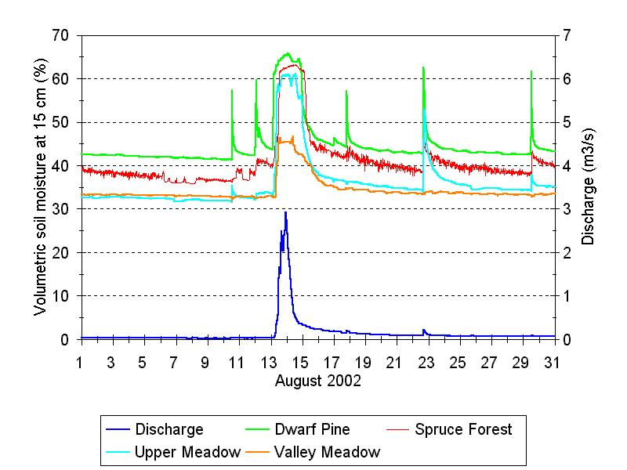
Figure 2. Soil moisture at the depth of 15 cm in four localities in the Modrý potok catchment and discharge during August 2002

6. Results and discussion
Measured courses of the soil moisture at the depth of 15 cm during August 2002 and 2003 at the measuring plots in the catchment Modrý potok are shown in Figure 2 and Figure 4. Soil moistures above 50 % (vol.) are biased due to non-linearity of the soil moisture sensors. Results presented clearly illustrate how the soil moisture of the surface layer reacts on the precipitation. The corresponding precipitation totals are depicted in Figure 3 and Figure 5. The highest soil moisture was found below the dwarf pine cover. It can be explained by the high content of the peat in the soil. The lowest soil moisture was evaluated in the both grassland stands: above the forest margin (in figures marked as upper meadow) and the grassland below the spruce close to the bottom of the valley (in figures marked as valley meadow). It is caused by a low retention capacity of the mainly mineral and roughly structured soil. The peat soil below a dwarf pine cover greatly accumulates water so that even a small precipitation input causes a marked soil moisture increase (Figure 3).
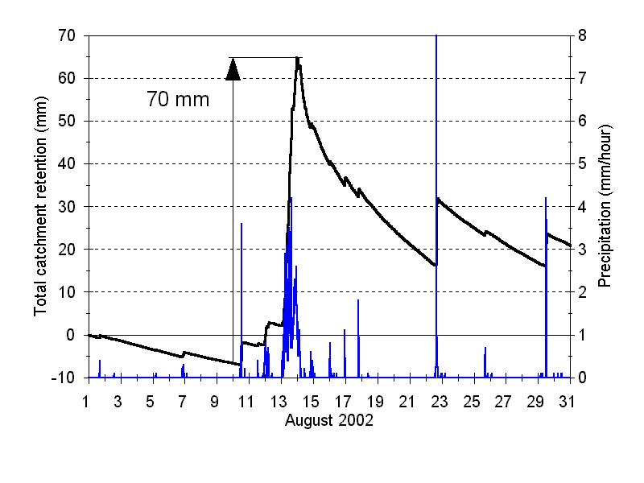
Figure 3. Precipitation and water retention in the Modrý potok catchment during August 2002
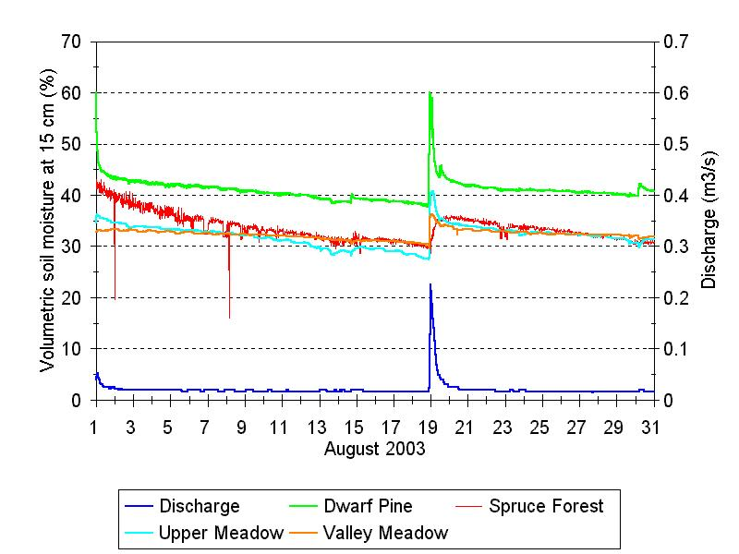

Figure 4. Soil moisture at the depth of 15 cm in four localities in the Modrý potok catchment and discharge during August 2003

The August 2003 was extraordinary warm. Figure 4 describes a withdrawal of the soil moisture in time till the precipitation events on August 18th and 19th. The decrease of the soil moisture at the depth of 15 cm is roughly the same as in each of monitored plots. It proves that different vegetation covers transpirated identically. The same phenomenon was observed after infiltration of the precipitation since August 21st until the end of August.
The total catchment retention was derived as a difference of the cumulative precipitation and cumulative runoff (Czelis et al., 2003). The maximum total catchment retention during the precipitation event in the course of August 18th and 19th is evaluated in Figure 5. Under this precipitation event the maximum total retention represents of about 50 mm when the precipitation total at a moment of the maximum retention was 60 mm. Any surface runoff did not arise in all probability. A surplus of 10 mm probably flowed through the soil profile to the subsoil. The retention capacity of the surface layer was not filled by rain water. The precipitation amount of 60 mm represents a maximum that does not yet cause a surface runoff.
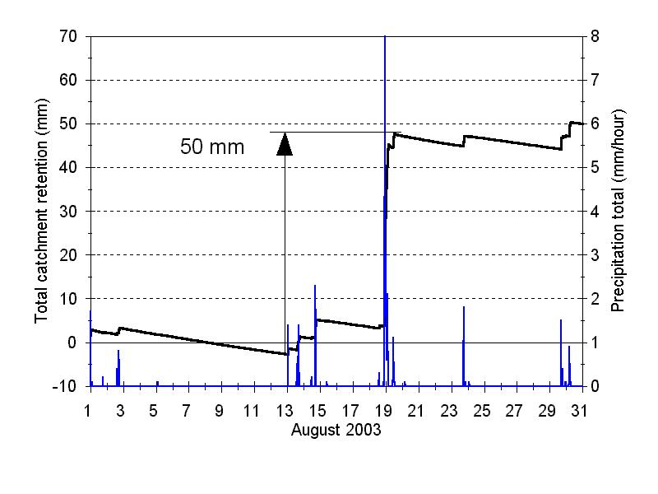
Figure 5. Precipitation and water retention in the Modrý potok catchment during August 2003

In the course of extremely rainy August 2002 (Figure 2) the maximum rainfall total was recorded from August 10th to 14th. The maximum total catchment retention during this precipitation period can be estimated as 70 mm (Figure 2). The precipitation reached 130 mm at a moment of the maximum retention. During the rainfall event a surface runoff arose because a retention capacity of the surface layer (20 mm) was highly exceeded. This capacity can be estimated as a difference between a maximum total retention during an extreme precipitation (70 mm) and a retention (50 mm) during a maximum precipitation which does not cause any surface runoff.

7. Conclusions
As a conclusion it is possible to state that an actual knowledge about the influence of the vegetation cover and its changes on the regime of the soil and catchment in the head water not only in the Giant Mts., but also in the Šumava and Jizerské hory Mts., confirms a validity of the conclusions of the long-term experimental research in the Beskydy Mts. following the publication (Chlebek et al., 1988): “The research of the rainfall-runoff relationships in the experimental catchments of the Beskydy Mts. provided a finding that the successive renewal intervention, affected less than 50 % of a drainage area, did not influence the annual runoff depth. Only after the exceeding of this percentage it is possible to observe a tendency to a reasonable increasing of the runoff depth (…), but the reasons of these changes cannot be exactly identified. The probable explanation means that the restriction (…) of the evapotranspiration for benefit of the runoff arises when the whole ecosystem is suddenly affected. Under conditions of successive renewal of the vegetation cover, a natural compensatory tendency supporting a stability of the water component of the forestry environment can be long-term applied. The practical effects of this finding will be possible to put on the strategy of both the forestry and water management after verifying it by the next research”.
It is necessary to emphasize that a conclusion on the independency of the soil water regime on the vegetation cover diversity is not valid in the course of droughts that are extreme from the plant growing point of view. Under these conditions the diversity of the water operation of the plants are expressed markedly between the individual vegetation cover. That is shown in the studies of the water regime under the subtropical climatic conditions when the lack of water represents a limiting factor of the plant grows.
In the course of extreme precipitation with the total above 60 mm, the retention of water on the soil surface strongly depends on the species composition of the vegetation cover and on its evolutionary stage (Kuřík, 2000). Approximately 20 mm from the maximum total retention (70 mm) can be influenced by the vegetation type at the Modrý potok catchment.
A monitoring of the water and heat regime provides the data proving the homeostatic mechanism of the plant transpiration in the course of the growing season. Account on that the water regime of a catchment will not change if the area of the transpirating vegetation cover is not changed. This is evidently a reason why even an extended calamity deforestation of the border mountainous regions of the Czech Republic had not caused any water management disaster. On the deforested areas a substitutive herbal and shrubby vegetation cover grew up and undertook a hydric function after the dead or lumbered trees. This positive fact supports a possibility not to rush out the forest renewal. It is convenient to go on the initiated monitoring and simultaneously to attempt a new growth plantation with the vegetation diversity that will be able to face the evolving climatic change – warming.

Acknowledgement: The research has been supported by the Academy of Sciences of the Czech Republic – Projects S2060104, AV0Z2060917, K3046108.

8. References
Bodri, L., Čermák, V. (1997): Climate changes of the last two millenia inferred from borehole temperatures: results from the Czech Republic – Part II. Global and Planetary Change, 14, 163–173.
Chlebek, A., Jařabáč, M. (1988): Consequences of the forest renewal on the runoff from the experimental catchments in the Beskydy Mts (in Czech). Forestry Research Reports, 33(4), 7–12.
Czelis, R., Spitz, P. (2003): Retention of water in the catchments during floods (in Czech). Acta Hydrologica Slovaca, 4(2), 233–241.
Jařabáč, M., Chlebek, A. (1989): Methodological topics on the measurements in the experimental catchments (in Czech). Forestry Research Reports, 34(1), 13–17.
Kuřík, P. (2000): Influence of the forests on the extreme runoff (in Czech). Forestry Research Reports, 45(2), 33 – 37.
Tesař, M., Šír, M. (1998): Influence of land use on the water regime of soil in the headwater regions, Czech Republic. In: Haigh, M. J., Krecek, J., Rajwar, G. S., Kilmartin, M. P. (eds), Proc. of the Fourth International Conference on Headwater Control “Headwater '98“, Merano, Italy, April 1998, 357–363, A. A. Balkema, Rotterdam, Brookfield.
Tesař, M., Šír, M., Lichner, Ľ. (2003): Runoff formation in a small mountainous catchment. Acta Hydrologica Slovaca, 4(2), 265–270.
Tesař, M., Šír, M., Syrovátka, O., Pražák, J., Lichner, Ľ., Kubik. F. (2001): Soil water regime in head water regions – observation, assessment and modelling. J. Hydrol. Hydromech., 49, 6, 355–375.
Válek, Z.: Research and observation results of the influence of the vegetation on the rainfall-runoff formation in the head water Kychova and Zdechovka catchments in 1928–1934. Proceedings of the Agriculture Research Institutes (In Czech), No. 144, 1937.

