TOWARDS A FLOOD ALERT SYSTEM FOR EUROPEAN TRANS-NATIONAL
RIVER BASINS
K. Wachter1,2, M. Kalas1,3, J. Szabo1,4, J. Younis1,5, S. Niemeyer1, M. Gierk1,6, A. de Roo1
1 Institute for Environment and Sustainability, DG Joint Research Centre,
European Commission, TP 261, 21020 Ispra, Italy
2 Detached from Department of Water Management, Government of Lower-Austria, Austria
3 Detached from Department of Land and Water Resources Management, Faculty of Civil
Engineering, Slovak University of Technology, Slovakia
4 Detached from Department of Sanitary and Environmental Engineering, University of
Technology and Economics. Budapest, Hungary
5 Detached from Czech Hydrometeorological Institute, Prague, Czech Republic
6 Detached from Department of Protection of Waters and Water Resources Management,
Brandenburg State Environmental Agency, Potsdam, Germany
corresponding authors: stefan.niemeyer@jrc.it, ad.de-roo@jrc.it

Abstract: The European Flood Alert System (EFAS) for medium-range flood forecasting in
trans-national European catchment areas is presented in its concept and its current state of
development. The flood simulation model is based on the LISFLOOD hydrological model
already in use for the rivers Odra, Meuse and Elbe. Furthermore, an integrated modelling
system for the entire Danube catchment will allow for the evaluation of flood protection
measures and land use changes at the scale of the entire river basin. The contribution will
present the necessary steps in data collection, processing and the preparation for model
validation as well as first preliminary modelling results.
Keywords: Floods, Trans-national River Modelling, Flood Alert System, LISFLOOD,
Modelling

EIN EUROPÄISCHES HOCHWASSER-FRÜHWARNSYSTEM FÜR
GRENZÜBERSCHREITENDE FLUSSGEBIETE

Zusammenfassung: Dieser Beitrag stellt das Konzept und den aktuellen Stand des
Europäischen Hochwasser-Frühwarnsystems (EFAS) vor. Das Modell zur europaweiten
Hochwasservorhersage basiert auf dem hydrologischen Modell LISFLOOD, das schon für
die Einzugsgebiete der Oder, Meuse und Elbe erfolgreich verwendet wurde. Zusätzlich zur
Hochwasser-Frühwarnung wird das resultierende integrierte Modellsystem zukünftig auch
zur Szenariomodellierung verwendet werden, um die Auswirkungen von
Hochwasserschutzmaßnahmen oder Landnutzungsänderungen abschätzen zu können.
Neben den notwendigen Schritten der Datenaufbereitung werden erste Ergebnisse der
Modellierungen in ausgewählten Einzugsgebieten vorgestellt.
Schlüsselworte: Hochwasser, grenzüberschreitende Flussgebiete, Frühwarnsystem,
LISFLOOD, Modellierung

1. Introduction
In the last decade, several large floods have occurred in European trans-national
catchment areas, such as, among many others, the Rhine flooding in the winters of 1995,
2001, 2003, or the Odra flooding in 1997 and 2001, the Tisza flood of 2000, or the Danube
and Elbe flooding in August 2002. The simulation and forecasting of such events, as well as
scenario modelling for future water management and mitigation measures, requires a
catchment-wide, trans-national approach. Following the disastrous floods in August 2002 in
the Elbe and Danube river basins, the European Commission decided to support the
development of a European Flood Alert System (COM(2002)481-final)). Following this
decision the Joint Research Centre is developing and pre-operationally testing a European
Flood Alert System (EFAS), with the aim to provide National Flood Forecasting Agencies
with additional medium-range information besides their own – typically short-range -
forecasting systems. As main pilot basins the Danube and the Elbe have been selected, for
which also flood prevention scenario studies are foreseen. This is achieved in close
collaboration with national and regional water authorities of the respective member states
and with support of International River Commissions like for the Danube (ICPDR), the Odra
(IKSO) and the Elbe River (IKSE). Following the Danube and Elbe pilot studies, other transnational
river basins will be tested in more detail.
EFAS will act complementary to local and national forecasting systems and focus on
medium-range flood forecasts of three to ten days, thus extending the lead time compared to
pure hydrological forecasting and allowing regional and local authorities to take the
appropriate measures in case of a flood event. Besides the flood alerting capability of the
integrated modelling system, it will allow for scenario simulations to evaluate flood protection
measures and land use changes at the scale of the entire river basin.
Including the Danube River catchment area with more than 800’000 km² as the
largest European catchment area with eighteen countries involved into EFAS poses an
extraordinary effort on data requirements, management, and processing. Regarding the Elbe
River with a catchment area of about 148’000 km2 three countries and several national and
regional authorities are involved.
The contribution presents the current state of development of EFAS with emphasis on
the Danube and Elbe catchment area, explains necessary steps in data processing and
preparation for the modelling, and shows first preliminary modelling results. Finally it gives an
outlook to the next steps to be taken and still pending problems to be overcome in order to
create an operational European Flood Alert System.

2. The European Flood Alert System
Floods in large river basins are predominantly the consequence of extreme mesoscale
precipitation events in Europe that usually show a persistence of several days to
weeks. The European Flood Alert System makes use of these characteristics and combines
medium-range weather forecasts, e.g. from the European Centre for Medium-Range
Weather Forecasts (ECMWF) or the German Weather Service (DWD) with forecast times of
up to ten days, with a hydrological model that comprises the trans-national catchment areas
throughout Europe. The spatial resolution of the hydrological model initially has been set to
5 km and is currently increased to 1 km for all major river basins, including the entire Danube
catchment area. EFAS is run twice a day corresponding to the availability of meteorological
forecasts. The underlying hydrological model is the LISFLOOD model (De Roo et al., 2000)
and will be presented in the following section. Figure 1 shows the principle elements of EFAS
in its current phase, including ongoing developments.
After reception of the current weather forecast, the meteorological parameters are
downscaled to the hydrological model’s spatial resolution. The LISFLOOD model is run,
making use of previously derived calibration parameters and a set of static data that
characterize the physical properties of the catchment area. The model run produces
forecasted discharges on the basis of the forecasted precipitation and the initial conditions of
the previous model run. In the next step, the produced discharge values are compared to
long-term statistical threshold values derived from water balance runs over several decades.
Currently, forecasts are compared to water balance runs since 1990. As a next step, the
ECMWF ERA40 data will be used to obtain a 44-year discharge climatology. These water
balance runs have been performed beforehand, making use of the same model code to be
applied in the flood forecasting mode, as well as of calibration data derived from model runs
with long-term local precipitation and measured discharge data. If the simulated discharge
exceeds chosen threshold values of the water balance runs consistently for consecutive
forecasts, it will be taken as a strong indication of a flood event to be forecasted in the
respective region, and a flood alert will eventually be issued to the respective national or
regional river water authority.

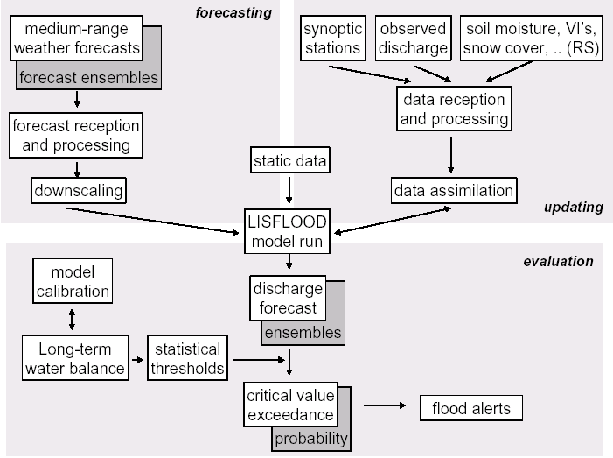
Figure 1: Overview sketch of the current EFAS system,
including ongoing developments (shaded boxes).

At the same time, after reception of measured data like precipitation or temperature
from synoptic stations, river discharges from gauging stations, or products derived from
remote sensing, these data are assimilated into the modelling system in order to update the
forecasts by the most accurate, measured values available.
As a novelty in hydrological flood simulation, EFAS explicitly will take into account the
uncertainty of medium-range weather forecasts, since the accuracy of the forecasted
parameters, especially the absolute quantity of precipitation, is decreasing considerably with
increasing lead time. EFAS will incorporate so-called ensemble predictions consisting of a
set of several tens of meteorological forecasts computed from slightly different initial
conditions and different model parameterisations. Using an ensemble of different realisations
of meteorological forecasts as the input rather than relying on a single meteorological
forecast, several runs of the hydrological model will produce an ensemble of discharge
forecasts as well, thus allowing for the quantification of the uncertainty of the forecasted
discharge.
Besides producing medium-range flood forecasts by EFAS, the modelling system is
used in parallel for scenario modelling in different catchment areas throughout Europe. In this
approach, the consequences of various potential flood protection measures can be simulated
for the large catchment areas, benefiting from the trans-national model set-up for EFAS. At
the moment, a study is ongoing in the framework of the Elbe Flood Action Plan from the
IKSE on the effect of reservoirs and polders on the Elbe discharge.

2.1. The LISFLOOD model
The physically based LISFLOOD (De Roo, 1999, De Roo et al., 2000) model has
been developed explicitly for the simulation of floods in large European drainage basins. It is
capable of simulating large areas, while still maintaining a high resolution, proper flood
routing methods and overall physical process descriptions. LISFLOOD is embedded in the
PCRaster GIS (Wesseling et al., 1995) and is using readily available European datasets,
such as Corine Land Cover (EC, 1993) and the European Soils Database (King et al., 1995
and Heineke et al. 1998). LISFLOOD simulates the hydrological processes at the surface, in
the soil, and in the river channel network on a regular horizontal grid (figure 2).
In the ground a total of four different layers are considered. For each grid point a
value is calculated at every time step. Processes simulated are interception, soil freezing,
snowmelt, evapotranspiration, infiltration, percolation and capillary rise, groundwater flow and
surface runoff.
Overland flow is simulated using a kinematic wave approximation. Channel flow is
simulated using either a kinematic wave or dynamic wave approximation, depending on river
channel bed gradient and the occurrence of backwater effects. The cross section of the river
and associated floodplain is taken into account by using series of water-level, wetted
perimeter, and hydraulic radius values for locations for which river geometry is available. The
user can define which sections of the river to simulate with a kinematic wave, and which
sections with a dynamic wave. The user also can choose both the spatial and temporal
resolution of the model. For European trans-boundary flood simulations, typically a grid-size
of 1 km and a time-step of 1 h are used. A detailed model description can be found in De
Roo et al. (2000).

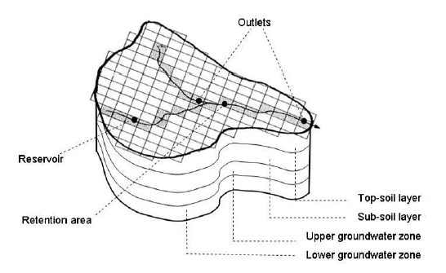

Figure 2: Schematic view of a catchment in LISFLOOD
including soil and groundwater layers.

The input parameters for the LISFLOOD catchment model are maps of topography,
land use, soil depth, and soil texture (see figure 3). Time series of precipitation amounts and
other meteorological parameters (minimum and maximum daily air temperature, actual
vapour pressure, sunshine duration, cloud cover, horizontal wind velocity) are needed for as
many meteorological stations within the catchment as possible. All meteorological
parameters are spatially interpolated, if necessary, and where appropriate the variables are
corrected for altitude, like e.g. air temperature.
The output of LISFLOOD consists of hydrographs at user-defined locations within the
catchment area, usually at the locations of gauging stations where the measured discharge
is known, too. Furthermore, time series of model parameters like, e.g. evapotranspiration,
soil moisture content or snow depth, can be created at selected locations. The model can
produce maps of any simulated variable, such as water source areas, discharge coefficient,
total precipitation, total evapotranspiration, total groundwater recharge or soil moisture.

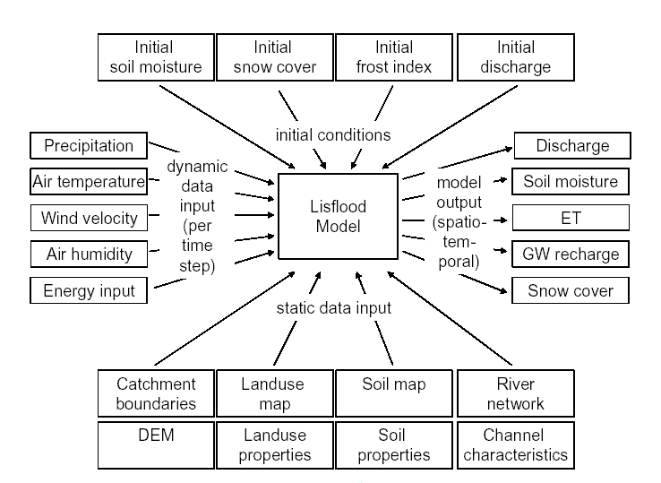
Figure 3: Data requirements of the LISFLOOD model.

3. Data preparation and model set-up
Data collection and preparation for the model runs requires substantial efforts and a
chain of tasks that consist of the following steps:
• data collection
• integrity checking of incoming data
• data conversion: re-formatting of received heterogeneously organised data
• transformation of co-ordinates and altitude to common reference system
• detection and correction of outliers in meteorological data
• spatial interpolation of meteorological data
• conversion of cross section geometry into channel properties for model input
• implementation of reservoirs and polders into the model
• model validation: comparison and evaluation of simulated and observed
discharges
Of this list, data collection, co-ordinates’ transformation and spatial interpolation will
be discussed in more detail in this chapter.
Furthermore, the large trans-national European catchment areas have been divided
into sub-catchments during data preparation, in order to work in parallel on different subcatchments,
in correspondence to the continuously incoming data, as well as to be able to
calibrate sub-catchments by using local data in high spatial resolution. As an example, data
processing has already been started or even completed on parts of Morava River, most
Slovakian rivers, the Tisza and Sava catchment areas. While the Elbe River catchment area
has been divided into nine sub-catchments, the Danube River catchment area has been
divided into the eight sub-catchments Upper Danube until Achleiten, the Danube stretch
down to Bratislava, the Morava catchments including Vah and Hron, Drava, Tisza, Sava, the
Danube down to the Iron Gate, and the Lower Danube (see figure 4).

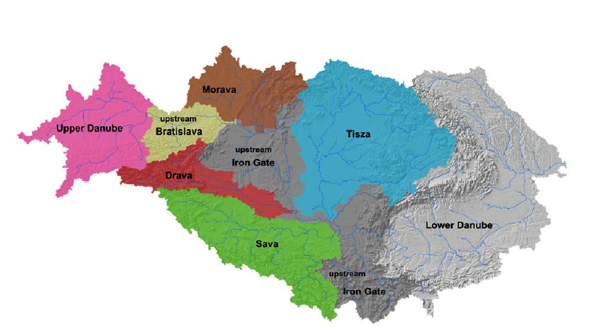

Figure 4: The Danube catchment area divided into eight sub-catchments.

3.1. Data collection
The Danube catchment area comprises eighteen countries, of which fourteen
covering the major part of the basin have been contacted for data collection. Relevant
authorities that hold necessary data are usually the national meteorological and hydrological
services, administrations responsible for landuse, soil and geological data as well as
authorities of national and regional water resources management. Some of these branches
are divided again into federal and regional or even local administrations with different tasks
so that sometimes it has been difficult to get in contact with the actually responsible person.
These problems have been encountered especially in countries with a distinct federal
administrative structure. Consequently it has been necessary to get in touch with more than
40 administrations altogether. Looking at data collection for the German part of the Elbe
catchment area, for example, at least six German state authorities and two federal institutes
have had to be contacted. For one of the biggest tributary only, the Saale, four German
states and one federal institute are responsible. On the contrary, the Czech part of the Elbe
catchment area is represented by three institutes only.
In addition, experience has shown that data delivered are usually very different in
format and content of the respective files; some data are not available in digital format at all.

3.2. Data transformation
Information on discharge gauging stations, rainfall stations, cross sections and
reservoirs as well as polders usually arrives with co-ordinates according to each country’s
standards. The definition of the corresponding projection systems and the precision of coordinates
vary considerably among the countries, and often even within one country or within
one authority (e.g. different dates of measurement, methodologies, geodetic surveys). Hence
it is necessary to convert these data to a common altitude and co-ordinate reference system
before feeding them into the LISFLOOD model. Regarding altitude, the European Altitude
reference system has been chosen (Altitudes of Amsterdam), while for the horizontal
projection the Lambert Azimuthal Equal Area reference system has been adopted (ETRS89-
LAEA, Annoni et al., 2003).
In order to perform the projection transformations, all necessary projective
parameters of the source projection system have to be known. Unfortunately, this piece of
information is often not provided together with the data delivery, sometimes it is not known to
the data providers, either. In these cases the projection parameters have to be examined and
retrieved on a case by case basis.

  - Processing of precipitation data
As precipitation is the most important input to a hydrological model, the precipitation
data received are processed carefully before being submitted to the modelling system.
Basically there are two sources of precipitation data. On the one hand, at JRC a
meteorological data base called MARS data base is existing (EC, 1998) that holds daily point
data from synoptic stations and spatial fields of meteorological parameters. On the other
hand, high-resolution historical measured rainfall data have been received from the
respective national, regional and local authorities. Besides precipitation, both sources of data
usually provide air temperature and sometimes the parameters horizontal wind speed, air
humidity and/or solar radiation input as well.
Before a spatial interpolation of the station data can be performed, a filtering of the
time series have had to be performed in order to identify outliers and anomalies in the
received precipitation data. A study on spatial interpolation method showed that Kriging using
an adaptive recognition algorithm of local anisotropy is the most suitable method for
interpolating point data of precipitation (Szabó, 2004). Figure 5 shows an example of the
chosen interpolation method in comparison to the MARS data.
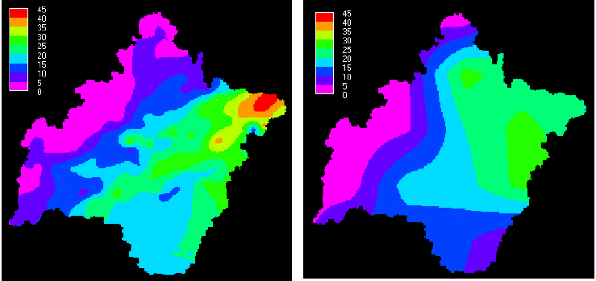
Figure 5: Example of interpolated precipitation data; left: MARS data, right: local network
data interpolated with Kriging using adaptive recognition of local anisotropy
(17.06.1997, Morava catchment area).

The influence of the meteorological input data on the resulting hydrograph is illustrated in figure 6. Because the MARS data are based on the synoptic network whose
density is lower than national networks, the volume of interpolated precipitation is generally
underestimated, producing a generally lower discharge values compared to the hydrograph
from high-resolution station data.

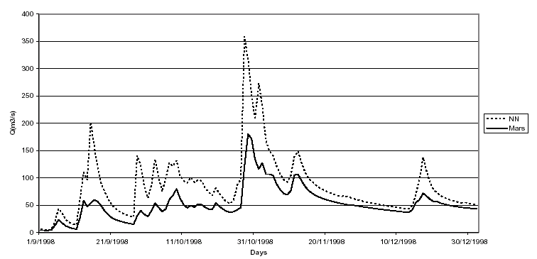
Figure 6: Comparison between the resultant simulated hydrographs of Morava River
at gauging station Kromerir, 1998, using MARS (Mars) and local network data (NN).

4. First results of simulation
The first simulations with LISFLOOD were run using both MARS and high resolution
historical meteorological data received from the national authorities. Figure 7 shows first
results for the Elbe River catchment area with MARS data; it produces big differences
between simulated and observed discharge data. Figure 8 shows the same simulation with
high resolution meteorological data; the resulting discharge values are in better
correspondence with the measured discharges.

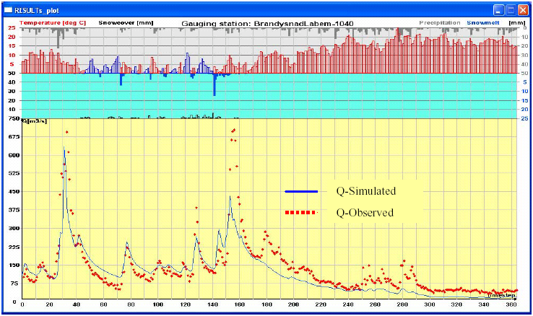
Figure 7: Simulated and measured discharge of Elbe River at Brandys nad Labem gauging
station, Poland, 1.10.1998 – 30.09.1999, using MARS rainfall data.

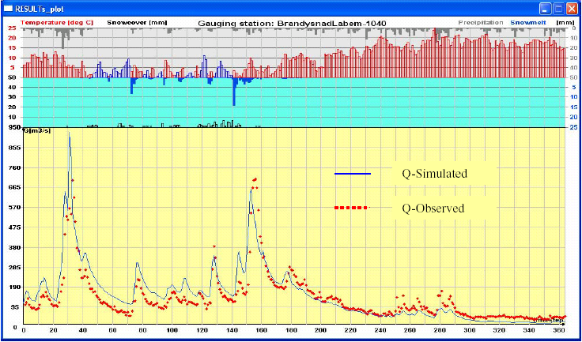
Figure 8: Simulated and measured discharge of Elbe River at Brandys nad Labem gauging
station, Poland, 1.10.1998 – 30.09.1999, using high resolution historical meteorological data.

Figures 9 and 10 show simulation results for the Morava River at Kromerir gauging
station and for Hron River at Banska Bystica gauging station, both within the Danube River
catchment area. For both simulations, high resolution meteorological data have been used.
Measured discharge values are reasonably well reproduced by the model.

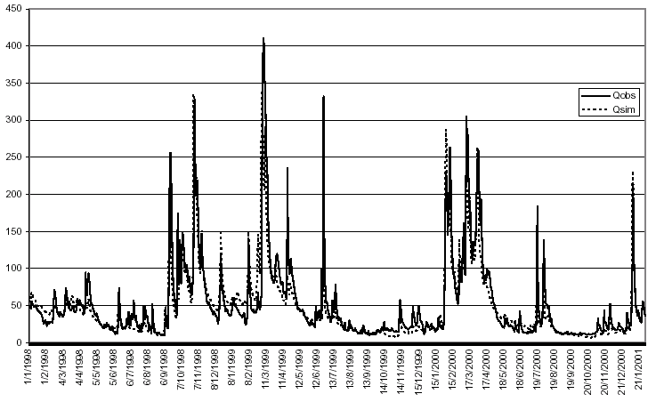
Figure 9: Simulated and measured discharge of Morava River at Kromerir, Slovakia,
using high resolution meteorological data.
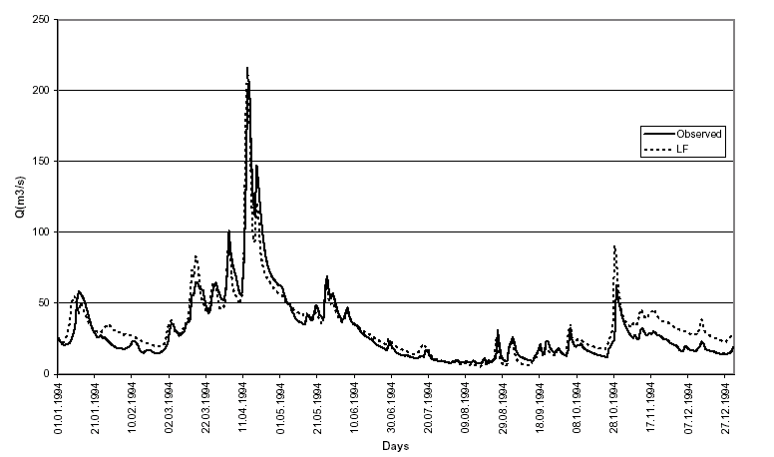
Figure 10: Simulated and measured discharge of Hron River at Banska Bystica, Slovakia,
using high resolution meteorological data.

First interim modelling results have been obtained from for the Upper Danube
catchment area as well (see figure 11).

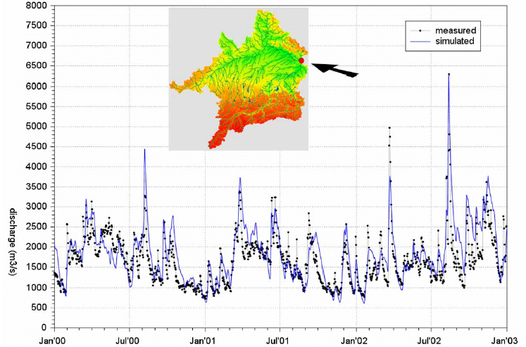
Figure 11: Preliminary LISFLOOD simulation result of the discharge of the Upper Danube at
Achleiten, Austria (see arrow) for 2000 to 2002. MARS data has been used for
meteorological input data and no calibration has been performed so far.

As local precipitation data have not been available yet, the simulations have been run
with MARS data. No calibration of the hydrological model has been performed so far. While
the general annual variation and especially the flood in August 2002 has been well
reproduced, minor peaks especially between summer 2001 and 2002 have been
underestimated by the simulation, which might be caused by the already mentioned
underestimation of the precipitation data. Further improvement and calibration is ongoing.

5. Conclusions
Setting-up the LISFLOOD model for the European Flood Alert System and scenario
modelling in trans-national catchment areas comprises many steps from data collection to
model calibration. The choice of the precipitation data input has proved to be most critical to
the resulting hydrographs. The results presented in this work show the usefulness of having
high-resolution rainfall and temperature data as input to the model. This is especially true for
regional scenario modelling, while for European-wide flood forecasts the model will have to
be run with the existing spatial forecast data. For the updating procedure of the modelling
system, the inclusion of additional precipitation data from automated national or regional
networks would be of great advantage.

6. References
Annoni, A., Luzet, C., Gubler, E., and Ihde, J. (eds.) (2003): Map projections for Europe.
Institute for Environment and Sustainability, Joint Research Centre, Commission of
the European Communities, Ispra, Italy.
De Roo, A.P.J. (1999): LISFLOOD: a rainfall-runoff model for large river basins to assess the
influence of land use changes on flood risk. In: Balabanis, P. et al. (eds.): Ribamod:
river basin modelling, management and flood mitigation. Concerted action, European
Commission, EUR 18287 EN, 349-357.
De Roo, A.P.J., Wesseling, C.G., Van Deursen, W.P.A. (2000): Physically-based river basin
modelling within a GIS: The LISFLOOD model. Hydrological Processes, 14, 1981-
1992.
EC (1993): CORINE Land Cover – Guide technique. Commission of the European
Communities, Office for Official Publications of the European Communities, EUR
12585 FR, Luxembourg, 144 pp.
EC (1998): Agrometeorological applications for regional crop monitoring and production
assessment. D. Rijks, J.M. Terres, P. Vossen (eds.), Joint Research Centre of the
European Commission, Ispra, Italy, EUR 17735 EN, 31-55.
Heineke, H.J., Eeckelmann, W., Thomasson, A.J., Jones, R.J.A., Montanarella, L. and
Buckley, B. (eds.) (1998): Land Information Systems: Developments for planning the
sustainable use of land resources. European Soil Bureau Research Report No. 4,
Office for Official Publications of the European Communities, EUR 17729 EN,
Luxembourg, 546 pp.
King, D., Jones, R.J.A. and Thomasson, A.J. (1995). European Land Information Systems for
Agro-environmental Monitoring. Office for Official Publications of the European
Communities, EUR 16232 EN, Luxembourg, 285pp.
Szabó, J. A. (2004): Application of Adaptive Recognition Algorithm of Local Anisotropy in
Case of Spatial Interpolation of Precipitation Fields with Kriging. In: Proc. XXIInd
Conference of the Danubian Countries on the Hydrological Forecasting and
Hydrological Bases of Water Management. 30 Aug. – 02 Sept. 2004, Brno, Czech
Republic (to appear).
Wesseling, C.G., D. Karssenberg, W.P.A. Van Deursen & P.A. Burrough (1995): Integrating
dynamic environmental models in GIS: The development of a dynamic modelling
language. Transactions in GIS, 1, 40-48.

