SIMULATION of extreme floods
in the upper hron river basin

Richard Kubeš, Kamila Hlavčová, Ján Szolgay, Silvia Kohnová

Slovak University of Technology, Faculty of Civil Engineering, Department of Land and Water Resources Management, Bratislava, Slovak Republic, e-mail: kubes@svf.stuba.sk; kamila.hlavcova@stuba.sk; jan.szolgay@stuba.sk; silvia.kohnova@stuba.sk

Abstract: The recent extreme floods in Central Europe have resulted in scientific and societal concerns about the reliability of flood mitigation measures, design flood estimates and design criteria in the region. The August floods have not caused extensive damage in Slovakia however the meteorological conditions and the atmospheric circulation patterns have led to severe flooding in the past. In order to test the reliability of the flood defence and flood mitigation measures, a synthesis of the atmospheric conditions causing the floods in the Czech Republic and several critical hydrologic conditions from the past were used to simulate hypothetic flood waves in the Hron River basin at Banska Bystrica. A conceptual rainfall runoff model was calibrated with special emphasis on the correct simulation of extreme events in the past. Different spatial and temporal distribution of the synthetic rainfall was used in order to assess the catchment response on extreme rainfall. The results are believed to refer to the real danger of flooding in the case of the occurrence of similar rainfall events and the efficiency of the existing flood defence and mitigation measures are discussed.
Key words: hydrological modeling, extreme floods, synthetic rainfall

Simulation der extremHochwÄsser in der einzugsgebiet Hron

Abstrakt: Die letzten Hochwaesser in Mitteleuropa haben Menschenleben gefaehrdet und viele Schaden verursacht. Das Hochwasser im August 2002 hat katastrophische folgen in der Czech Republik gehabt, weil die Slowakei wurde vom der Cyklone nur randlich angegriffen. In dieser Studie unser Ziel war es, ein hypothetisches Hochwasser auf dem Einzugsgebiet Hron - Banska Bystrica zu simulierem, mit aehnichen meteorologischen Randbedingungen, wie das Hochwasser im August 2002 in der Czech Republik hatte. Konzeptuelles Modell wurde dazu verwendet und kalibriert. Die Simulationen mit syntetischen Niederschlaegen zeigten, dass auf diesem Einzugsgebiet hohes Hochwasserrizikopotenzial zu erwaten ist.
Key words: hydrologische Modellierung, Hochwasser, synthetischer Niederschlag

1. Introduction
The research in the field of hydrology in the last decades is oriented mainly on better physical interpretation of hydrological processes and developing mathematical tools for effective management and water resources control.
In regard to the second aspect we can consider different problems such as design flood estimation, flood discharge management essentially by real time forecasting, hydrograph reconstruction in the catchments without meteorological and hydrological observations, impact of land use change and in the last years impact of human activity or climate change on hydrological behavior of the catchment.
A great amount of mathematical models has been developed to deal with these problems. Although these models are relatively available, not all are allowed to modify their structure with the aim to re(de)fine the hydrological processes considered and involved. This was the reason for developing own model, which would be possible to change according to the user needs using object oriented programming (Kubeš, 2001).

2. Model description
The conceptual lumped rainfall-runoff model (the Hron model) used in this study calculates runoff from precipitation and snowmelt using a daily time step (Kubeš, 2001,2002). It contains three basic components with 15 calibrated parameters. The snow sub-model with 5 parameters simulates runoff from precipitation, snowmelt and snow accumulation. The soil sub-model contains 4 parameters, simulates water storage and evapotranspiration from the soil profile. The runoff sub-model with 6 parameters simulates surface runoff, subsurface runoff and base runoff.
Input data needed for runoff simulation are mean daily precipitation values on the catchment, mean daily air temperature values, long-term mean monthly potential evapotranspiration and long-term mean monthly air temperature values. Measured mean daily discharge values in the closing profile of the selected basin are needed for the model parameters calibration.

3. Input data
The aim of this study was to assess the response of the upper Hron river basin with closing profile in Banska Bystrica on extreme rainfall event using the above mentioned rainfall-runoff model. The upper Hron river basin is located in Central Slovakia with an area of 1766 km². Measured data of precipitation, air temperature and discharges from the period of 1962-1998 were chosen to assess the basin feedback on extreme rainfall events.
The extreme rainfall was not generated as a synthetic one, but it was derived from real rainfall event, which occurred in south and northwest Bohemia in August 2002. During this event consisted of two successive waves with total duration of 8 days (6.-7. August a 11.-13. August 2002) more than 250 mm precipitation total was locally measured, some rain gauges recorded more than 400 mm precipitation total. Rainfall distribution of this event is shown in Figure 1.a, 1.b and 1.c. These maps have been drawn up on the basis of restricted number of rain gauges with operation data.
Kubát (2002) states that in selected stations during first rainfall event 50- up to 100-year precipitation totals occurred on the limited territory of south Bohemia (mostly the Malša river basin). During the second rainfall event it is a combination of areally very extensive rainfall with the return period about 50 years and local occurrence of extreme rainfall with more than 100-year return period. High precipitation total has affected a big territory, almost whole Vltava river basin including Berounka and Sázava river basin.
Synthetic extreme rainfall has been derived from maps of precipitation totals, which occurred in the Czech Republic in August 2002 (Figure 1a, 1b, 1c). It was assumed that similar meteorological situation could occur also above the territory of Slovakia. The rainfall event from 6. -7. 8. 2002 with precipitation total of 90 – 130 mm and 130 – 160 mm and rainfall event from 11. -13. 8. 2002 with precipitation total within the range of 130 – 160 mm and 160 – 190 mm have been considered. From this data 4 patterns of extreme rainfall events have been prepared for hypothetic runoff simulations (Table 1, 2).

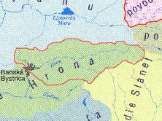
Figure 1a. Map of precipitation total from the period of 6. – 7.8.2002 (in mm)
and the comparison of rainfall affected area with the Hron basin area

Figure 1b. Map of precipitation total from the period of 11. – 13.8.2002 (in mm)

Figure 1c. Map of precipitation total from the period of 6. – 13.8.2002 (in mm)

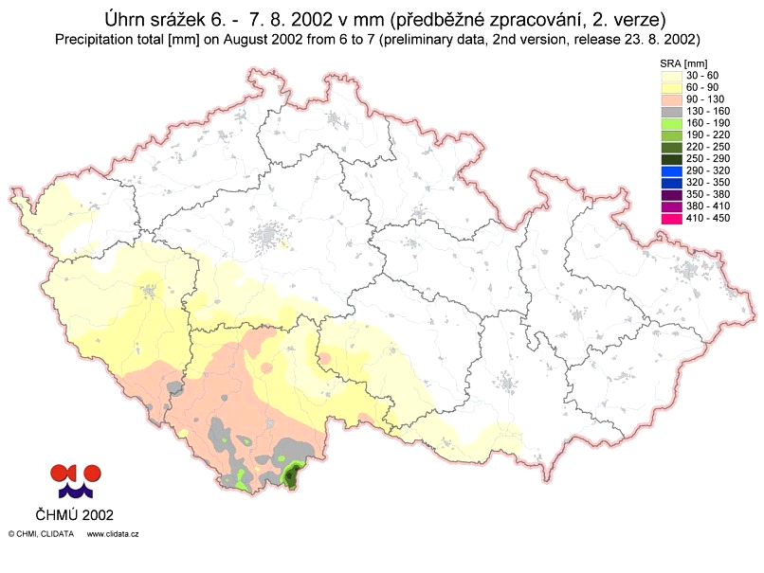
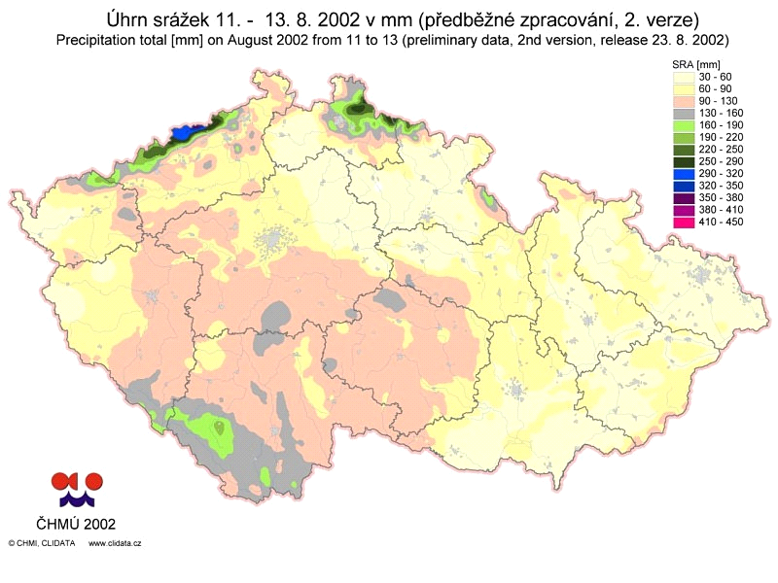

Table 1. Distribution of precipitation totals
 | 6. - 7.august 2002 |  | 11. - 13.august 2002
 | 2-day precip. total (mm) |  | 3- day precip. total (mm)
 | 90-130 | 130-160 | 130-160 | 160-190
1. Day | 45 | 65 | 30 | 40
2. Day | 45 | 65 | 70 | 80
3. Day | / | / | 30 | 40
Summa (mm) | 90 | 130 | 130 | 160

Table 2. Combinations of precipitation totals
Combinations of daily precipitation totals (mm)
Day | 1.pattern | 2. pattern | 3. pattern | 4. pattern
6.aug. | 45 | 45 | 65 | 65
7.aug. | 45 | 45 | 65 | 65
11.aug. | 30 | 40 | 30 | 40
12.aug. | 70 | 80 | 70 | 80
13.aug. | 30 | 40 | 30 | 40

In the next step joint effect of extreme rainfall and different antecedent saturation of the basin on runoff generation was estimated. Three periods with the length of one year have been find out from the historical data (Table 3.) representing different antecedent basin saturations (high, mean and low). These periods are characterized by mean annual runoff Qa, mean monthly runoff Qm, annual precipitation total Hz and monthly precipitation total Hm. The values Qm and Hm always relate to the month of August. Measured precipitation values from the period of 6.-13. August in these three periods have been replaced by one combination of synthetic extreme rainfall events (Table 2.) and hypothetic runoff considering high, mean and low antecedent basin saturation has been simulated. An example of modified input data in the model simulation is shown in Table 4.

Table 3.Characteristics of selected situation
Antecedent saturation | high | low | mean
Qa (mm/day) | 2.11 | 1.07 | 0.986
Qm, Aug. (mm/day) | 2.43 | 0.38 | 0.466
Hz, year (mm/year) | 1274 | 793 | 948
Hm, Aug. (mm/month) | 138 | 28 | 46

Table 6. Generated precipitation data

4. Model calibration
Calibration of the model parameters for the Hron river basin has been made on the periods, when a significant flood occurred in the basin. The aim of the calibration process was to find such parameter values, which would be able to give good results of flood peaks simulation and acceptable results of low flows simulation. Result of the calibration process with differences between measured and simulated mean daily discharges in the year 1974, when a flood with the return period of 100 years occurred, can be seen in Figure 2. The Nash-Sutcliffe value of 0.912 was considered as a sufficient agreement between measured and simulated discharges. The difference between observed and simulated maximum mean daily discharge was less than 1 mm/day (Table 5.).

Figure 2. Result of the Hron model calibration (year 1974)

Table 5. Measured and simulated maximum mean daily discharge in the year 1974
year 1974 - calibration | Hron model
 | mm | m³/s
observed discharge, Qobs | 25.2 | 515.223
simul. discharge, Qsim | 24.3 | 498.867
difference Qobs-Qsim | 0.9 | 16.356
disch. ratio Qsim/Qobs |  | 0.968
basin area (km²) | 1766.48

5. Results
Runoff simulation has been carried out for selected situations representing different antecedent basin saturation and for all derived patterns of synthetic extreme rainfall events. Because of the limited scope only the results from three simulations are presented here: one simulation for each situation, considering the first rainfall pattern in Table 2. Simulated mean daily discharges for three situations are illustrated in Figure 3a, b, c and Table 6.

Figure 3.a Runoff simulation for high antecedent basin saturation

Figure 3.b Runoff simulation for low antecedent basin saturation

Figure 3.c Runoff simulation for mean antecedent basin saturation

Table 6. The values of simulated maximum mean daily discharges from selected situations and the conversion to Qd and peak discharge Qpeak
 | Qsim |  | Qd | Qpeak
antecedent basin saturation | mm | m³/s | m³/s | m³/s
high | 33 | 674.70 | 697.00 | 757.61
low | 16 | 327.13 | 337.94 | 367.33
mean | 26 | 531.58 | 549.15 | 596.90
basin area (km²) | 1766.48 |  | 0.968 | 0.92
year 1974 | 25.2 |  | 515.22 | 560

Peak discharges Qpeak were estimated from mean daily discharges as follows: The ratio of simulated to measured maximum mean daily discharge (Qsim/Qobs) for the historical flood in 1974 was 0.968 and the ratio of measured maximum mean daily discharge to the peak discharge (Qobs/Qpeak) was 0.92 (the peak discharge with the returned period of 100 years reached value of 560 m³/s). After modifying simulated maximum mean daily discharges of 3 hypothetic floods by these coefficients, the corrected values of maximum mean daily discharges Qd and peak discharges Qpeak can be obtained. Table 6 shows the values of simulated maximum mean daily discharges for all 3 hypothetic floods and values of maximum mean daily discharges and peak discharges after the correction.
Results of simulations indicate that every antecedent basin saturation considered together with derived extreme rainfall could lead to an extreme flood situation. During the historical flood event in the upper Hron river basin in 1974 the peak flow reached the value of 560 m³/s, which represents the return period of 100 years (Gregorová and Kyselová, 1974). The simulations of hypothetic floods from synthetic extreme rainfalls have shown that already for mean antecedent basin saturation the peak flood reached the value of 596 m³/s (higher than the historical flood in 1974). Considering higher antecedent saturation the peak flow could reach extreme value, higher than 700 m³/s.

6. References:
Gregorová, M., Kyselová, D.: Historical flood in October 1974. SHMÚ, 2001.
Kubát, J. et al.: Overall preliminary report about the hydro-meteorological situation
during the flood event in August 2002, 2.version. ČHMÚ, Prague 2002.
Kubeš, R.: Advances of object oriented programming by rainfall-runoff modeling. Proceedings of the 13th Conference of Young Hydrologists, SHMÚ, Bratislava 2001.
Kubeš, R.: Using rainfall-runoff model by simulation of extreme rainfall-runoff situation. Proceedings of the 14th Conference of Young Hydrologists, SHMÚ, Bratislava 2002.

Acknowledgement:
The research presented in this paper has been supported by the Science and Technology Assistance Agency under the contract No. APVT-51-006502 and the Slovak Grant Agency under the projects 1/1145/04 and 2/2016/22. All supports are gratefully acknowledged.

