simulations of the floods at Slovak Danube River with historical inputs by model NLN – Danube

Veronika Mitková

Institute of Hydrology SAS, Bratislava, Slovak Republic, e-mail: mitkova@uh.savba.sk

Abstract: In this article analysis of the results of the extreme historical flood simulations during September 1899 and July 1954 years of Danube river at Bratislava are presented. The
non-linear river model NLN - Danube was used to simulate the discharge during single floods. Model of each part (each section) of the simulated system is based upon the concept of a series of equal nonlinear reservoirs. Model was calibrated on the flood occurred in 1991 for Kienstock – Bratislava reach of Danube river and was verified on July 1997, March 2002 and August 2002 floods in this reach of Danube river. Consecutively, model was used for simulations of the historical floods (September 1899, July 1954) in current river channel conditions.
Key words: River model, cascade of the non-linear reservoirs, simulation of the move of the flood wave, Danube River.

SIMULATION DER HISTORISCHEN HOCHWÄSSEREREIGNISSE MIT DEM NLN – DANUBE MODELL AUF DER ÖSTERREICHISCH - SLOWAKISCHEN DONAUSTRECKE

Abstrakt: In dem Beitrag sind die Resultate der historischen Hochwässersimulationen analysiert, die unter den heutigen Abflußverhältnissen des Flußbetts entstanden hätten. Es handelt sich um die zwei höchsten Hochwässer der Donau im Pegel Bratislava während der Instrumentenperiode, und zwar die der Jahren 1899 und 1954. Für die Simulation wurden zwei hydrologischen Modelle benutzt. Das NLN – Danube Modell transformiert die Eingabe (Durchflußwellen) durch eine Serie von gleichen nichtlinearen Speicherelemente, das KLN – MLTI Modell ist von ähnlicher Serie linearen Speichereinheiten mit variablen Zeitkonstant zusammengestellt. Beide Modellen wurden für die Donaustrecke Kienstock – Bratislava kalibriert mit Hilfe der Daten die für den heutigen Zustand der Flußstrecke charakteristisch sind. Verifikation der Modellen fand auf den Hochwasserwellen von Juli 1997, Mai und August 2002 statt. Mit so entwickelten Modellparametern wurden dann die Abflüsse der genannten höchsten historischen Hochwässer simuliert.
Schlüsselwörte: Flußmodell, Nichlineare Speicherkaskade, Simulation der Hochwasserbewegung, Donaufluß.

Introduction
River regime conditions of the Danube River are always being changed. These changes result from the natural processes (erosion, sedimentation, vegetation cover) or anthropogenic activities (modification of the riverbank, construction of hydro–power stations). This has significant impact upon the water regime of the river. Channel training resulted in shortening of the flood wave travel times and changes of water levels in Danube river at Bratislava (Mišík, Capeková, 2001; Opatovská, 2002). Due to water flow changes on Danube river it is not possible to determine the range of hydrological characteristics (for ex. Q₁₀₀) only from the range of historical discharges at given station. For example based on simulation such meteorological situation, as occurred in 1899 would cause diametrically different hydrograph shape of flood wave on Danube River at Bratislava at present. The estimation of the discharge value for present conditions is possible only by simulations. For this purpose simple river model NLN – Danube (Svoboda 1993; Pekár et al., 2001) was configured.
The aims of this article are:
1. Description and calibration of the NLN – Danube model for August 1991 flood at Kienstock – Bratislava reach.
2. Verification of the model for July 1997, March 2002 and August 2002 floods at Kienstock – Bratislava reach.
- Simulation of historical floods occurred in September 1899 and in July 1954 at Bratislava by model NLN – Danube.

Description and calibration of model

Model NLN – Danube
Model NLN – Danube (Pekár et al., 2001) goes out from model NONLIN by A. Svoboda (1970, 1993, 1993b, 2000). Model of each section of the simulated system is based upon the concept of a series of equal non-linear reservoirs, thus belonging to the category of hydrological conceptual non-linear models. Model input (P) represents the input into the first reservoir of the cascade (Figure 1), its output is the input into the second one in series, etc., and the output from the last reservoir is the output (Q) from the model of the section.

Figure 1 Scheme of the river part - model NLN

Movement of the wave through reservoir is defined by discharge (Q) and by volume of reservoir (V) as:

$Q=B\text{.}V^{\text{EX}}$ (1)

where: Q - reservoir output;
V - volume of reservoir [m³];
EX - the nonlinearity parameter;
B - the proportionality parameter.

The flood wave propagation is modelled in equidistant discrete time steps 0, 1, 2, … M. The difference between two steps is given by parameter ΔT. In time steps i and i+1, for known input P_{i+1} and output Q_{i} , the unknown output Q_{i+1} is determined from the continuity equation within the time interval i+1 of the length ΔT as:

$(P_{i+1}−Q_{i+1})\text{.}ΔT=V_{i+1}−V_{i}$ (2)

Where: P_{i+1} ,Q_{i+1 -} the average input/output of the interval i+1;
V_{i+1} ,V_{i} - storage at the interval i+1 and i.

From equations (1) and (2) we receive
$(P_{i+1}−Q_{i+1})\text{.}ΔT=\frac{Q_{i+1}^{1/{\text{EX}}}−Q_{i}^{1/{\text{EX}}}}{B^{1/{\text{EX}}}}$ (3)
The equation (3) defines the non-linear function f of one unknown, Q_{i+1},

$f(Q_{i+1})=(P_{i+1}−Q_{i+1})\text{.}ΔT−\frac{Q_{i+1}^{1/{\text{EX}}}−Q_{i}^{1/{\text{EX}}}}{B^{1/{\text{EX}}}}$ (4)
which is searched by linearisation (Newton) method

$Q_{i+1}^{(k+1)}=Q_{i+1}^{(k)}−\frac{f\left(Q_{i+1}^{(k)}\right)}{f^{'}\left(Q_{i+1}^{(k)}\right)}$ (5)

what gives in our case the iteration formula:
$Q_{i+1}^{(k+1)}=Q_{i+1}^{(k)}+\frac{(P_{i+1}−Q_{i+1}^{(k)})\text{.}ΔT−\left[(Q_{i+1}^{(k)})^{1/{\text{EX}}}−(Q_{i})^{1/{\text{EX}}}\right]\text{.}B^{{−1}/{\text{EX}}}}{ΔT+(Q_{i+1}^{(k)})^{(1−\text{EX})/{\text{EX}}}\text{.}B^{{−1}/{\text{EX}}}\text{.}{\text{EX}}^{−1}}$ (6)
The parameters of the transformation curve shape are expressed by ratio parameter B,
$B={\left(\frac{N\text{.}ΔT}{\text{BK}}\right)}^{\text{EX}}$, (7)
Where: N - number of storages in one section of the model;
BK - ''time constant'' of an equivalent linear system.

The iteration process (6) is performed with accuracy of 0.001.
In this study model was calibrated only for Kienstock – Bratislava reach and parameters of the model are:
BK - time constant of the equvalent linear system [hrs];
DT - length of the time step [hrs];
QC - corresponds to the maximum capacity of the main river channel (flow, when water enters the inundation) [m³s⁻¹];
EX - the nonlinearity parameter, dimensionless;
N - number of reservoirs in series, dimensionless;
Parameters of the model from calibration are illustrated in Figure 2.

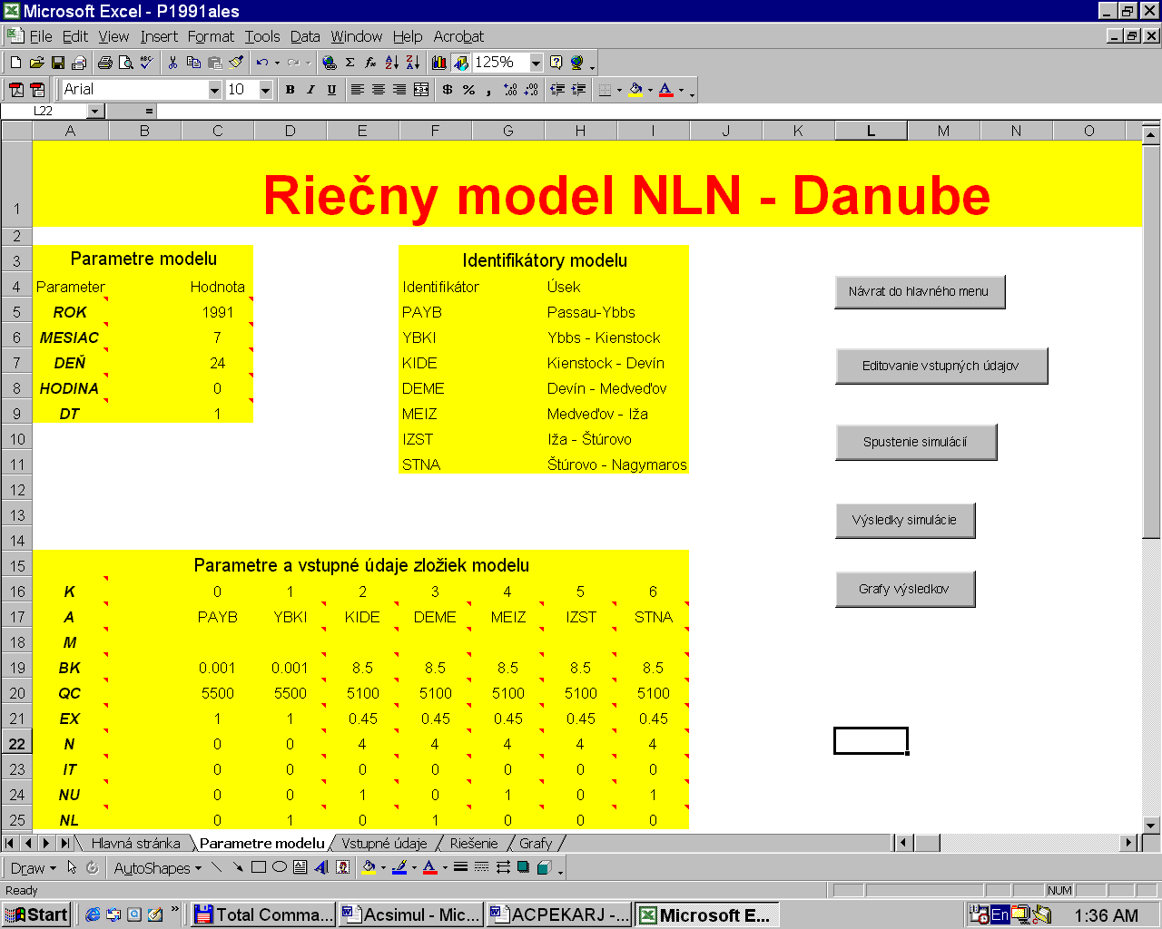
Figure 2. The parameters of the NLN-Danube.

Calibration of model – 1991 flood
Model NLN – Danube was calibrated for the summer flood occurred in July 1991. During this flood three waves with discharges 3600, 5200 and 9400 m³s⁻¹ were recorded. This flood is appropriate for calibration of river models. Hourly discharges for this flood from the both stations (Kienstock – Bratislava) were available. The result of calibration is shown
in Figure 3.

Figure 3. Calibration of the model NLN – Danube at Bratislava during flood in July 1991.

Verification of the model
Model was verified on new important flood waves occurred in July 1997, March 2002 and in August 2002. The aim of this study was to verify model for present water flow conditions on Danube River at Kienstock – Bratislava reach. The results of verification of the model NLN – Danube are shown in Figure 4 a) b) and c). It is obvious that discharges on the rising limbs were higher for the measured floods than for the simulated floods at the same time. Travel time of the rising limb of the waves in 1997-2002 was shorter than in 1991 and parameters of the model were modified (BK=8,4; QC=5200; EX=0,44).
The mean absolute percentage error (MAPE) of simulation was less than 5% for all three events (1997-2002) of verification. This value is allowable error of discharge measurements. Model NLN – Danube is fitted for the transformation of the flood waves simulations in Kienstock – Bratislava reach in present water regime conditions. For evaluation quality of the simulation following statistical criterions were used:

Correlation coefficient between simulated and measured discharges at the output of the reach
$R=\frac{\sum_{t=1}^{N}{\left(\left(Q_{\text{Bm}}(t)−{\bar{Q}}_{\text{Bm}}\right)\left(Q_{\text{Bs}}(t)−{\bar{Q}}_{\text{Bs}}\right)\right)}}{\sqrt{\sum_{t=1}^{N}{{\left(Q_{\text{Bm}}(t)−{\bar{Q}}_{\text{Bm}}\right)}^{2}}\sum_{t=1}^{N}{{\left(Q_{\text{Bs}}(t)−{\bar{Q}}_{\text{Bs}}\right)}^{2}}}}$ (8)

where:
Q_{Bs} - discharge at Bratislava – simulated;
Q_{Bm} - discharge at Bratislava – measured;
${\bar{Q}}_{\text{Bm}}$ - Mean discharge at Bratislava - measured;
${\bar{Q}}_{\text{Bs}}$ - Mean discharge at Bratislava simulated.

Mean error:
$\text{ME}=\frac{1}{N}\sum_{t=1}^{N}{\left(Q_{\text{Bm}}(t)−Q_{\text{Bs}}(t)\right)}$. (9)

Mean absolute error:
$\text{MAE}=\frac{1}{N}\sum_{t=1}^{N}{\left|Q_{\text{Bm}}(t)−Q_{\text{Bs}}(t)\right|}$ (10)

Mean absolute percentage error:
$\text{MAPE}=\frac{1}{N}\sum_{t=1}^{N}{\left|\frac{Q_{\text{Bm}}(t)−Q_{\text{Bs}}(t)}{Q_{\text{Bm}}(t)}\right|}$100%. (11)

Standard deviation:
$\text{SER}=\sqrt{\frac{1}{N}\sum_{t=1}^{N}{{\left(Q_{\text{Bm}}(t)−Q_{\text{Bs}}(t)\right)}^{2}}}$ (12)

Maximum absolute error:
$\text{Max}=\text{max}\left|Q_{\text{Bm}}(t)−Q_{\text{Bs}}(t)\right|$ (13)

4 a)
4 b)
4 c)
Figure 4. a-c Results of the verification of the model NLN – Danube.

Simulation of the historical floods occurred in 1899 and 1954

Description of the floods
Flood in 1899 year
The flood in September 1899 on Danube river had simple course as response to rainfall course, Kresser (1957) indicated that the flood at Inn River caused this flood on Danube river. Culmination of discharge at Inn was 6400 m³s⁻¹. There was a low water level before beginning of the flood on Danube River and some precipitation fell down as snow at higher altitude of the river basin.
Obviously, in that time some other facts had positive impact on transformation of the flood. One of them was, for example, larger inundation area.
Culmination of the flood was on the 17th September 1899 at 6:00 a. m. with peak discharge 11 200 m³s⁻¹ (972 cm) at Stein – Krems station and 10 500 m³s⁻¹ at Vienna station. The peak water level of the wave at Bratislava was observed on the 19th September with value 970 cm (10 870 m³s⁻¹).

Flood in 1954 year
The largest flood on Danube in last century was the flood in July 1954. This flood was higher then flood in 1899. This flood was caused by bad meteorological situation on upper alpine tributaries of Danube River. The peak water level of the wave at Bratislava was observed on the 15th July with value 984 cm (10 400 m³s⁻¹), (Angelini, 1955).

Results of the simulations
After calibration model the NLN – Danube was used for simulation of the historical floods occurred in 1899 and in 1954 on Danube river at Kienstock – Bratislava reach. Results of simulation are shown in Figure 5 a) and b).
The wave of 1899 would extend 61 m³s⁻¹ (it is 10 931 m³s⁻¹) and the flood of 1954 would extend 96 m³s⁻¹ (it is 10 496 m³s⁻¹) in present water flow conditions. The rising of the wave would be faster at 8000 m³s⁻¹ then in the past. Differences between volumes of the water accumulated in river reach are shown in Figure 6 a) and b) at Kienstock – Bratislava reach.

5 a)
5 b)
Figure 5. Course of measured wave at Kienstock and measured and simulated waves at Bratislava by model NLN – Danube: in 1899, b) in 1954.

6 a) 6 b)
Figure 6. Cumulative course of the differences between simulated and measured volumes of the water accumulated in river reach: a) in 1899, b) in 1954.

Conclusion
The hydrologic flood routing model, the cascade of nonlinear reservoirs (model NLN-Danube) was used for simulation of the transformation of two significant historical floods in the reach of the Danube between Kienstock and Bratislava.
Verification results showed, that model adequately represent the present hydraulic conditions in the given river reach. Two significant historical floods (from the years 1899 and 1954) were subsequently routed by model with parameters representing present conditions. It was shown that the simulated peak discharges have not changed significantly when compared to their historical counterparts, however the simulated hydrographs exhibit a significant acceleration of the flood wave movement. It can be expected therefore, that similar simulation of the transformation of smaller floods could lead to changes of the expected peak discharges. The methodology can be used to homogenise historical flood peaks for statistical flood frequency analysis. According to the results of the model NLN – Danube the peak discharges of the flood waves in both of September 1899 and of July 1954 at Bratislava would have been higher. The flood of September 1899 would have come to peak discharge about 10 931 m³s⁻¹ in present conditions at Bratislava. The flood of July 1954 would have come to peak discharge about 10 495 m³s⁻¹ in present conditions at Bratislava. Travel time of the rising limb of the wave of September 1899 and July 1954 would have been shorter at the present.

Acknowledgement
The study was supported by Science and Technology Assistance Agency under the contract No. APVT-51-006202 as well as by project MVTS 9248 and VEGA 2018.

Literatúra
Angelini, H., (1955): Danube flood in July 1954, (in Slovak) Bratislava, Hydrological study. HMI-department of hydrology, Bratislava, 23 pp.

Kresser, W. (1957) Die Hochwaesser der Donau. Wien, Springer Verlag, (in German), 95 pp.

Kresser, W., (1970): The change in the flood discharge in the Danube at Vienna resulting from hydraulic structures along the river and its drainage area. The conference of the Danube countries. Belgrade, 183–189 pp.

Miklanek, P., Mikulickova, M., Mitkova, V., Pekarova, P., (2002) Changes of floods travel times on upper Danube. CD from the XXI. Conference of the Danube Countries, Bucharest, and List of abstracts from conference, 29 pp.

Mišík, M., Capeková, Z., (2001): Reciprocal relationship of water regime of flood and antropogenic activity at Danube- Bratislava reach. Influence of the antropogenic activity on water regime of lowland area. IV. Scientific conference, Zemplínska Šírava, 98–101 pp. (In Slovak).

Mitková, V., (2002): The changes of the travel times of flood waves at Danube River Acta Hydrologica Slovaca, Bratislava, 20– 27 pp. (In Slovak).

Mitková, V., Pekárová, P.: Improvement of Danube floods real-time forecasting by empirical hydrological non-storage routings methods. (In press)

Opatovská, G., (2002): Influence of the sedimentation on changes of water level at Danube River at Bratislava. Vodohospodársky spravodajca, 11– 12 pp. (In Slovak)

Pekár, J., Miklánek, P., Pekárová, P., (2001): The nonlinear river model NLN – Danube for Ybbs – Nagymaros in EXCEL. Acta Hydrologica Slovaca, 130–137 pp. (In Slovak)

Svoboda, A., (1970): Some aspects of application of the mathematical models in hydrology. Journal of hydrology and Hydromechanics. XVIII, No. 3, p. 225-238, Slovakia

Svoboda, A., (1993): Component No. J15.2.02 „Nonlinear Cascade Hydrological Model NONLIN“. HOMS Reference Centre, WMO, Geneva.

Svoboda, A., Kunsch, I., Hajtášová, K., (1993b): Water structure Gabčíkovo amid the Danube flood regime. Collection of the reports from International conference. SCCI, Bratislava, p. 71-76. (In Slovak)

Svoboda, A., Pekárová, P., Miklánek, P., (2000): Flood hydrology of Danube between Devín and Nagymaros. SVH – ÚH SAV, 96 pp.

Szolgay J. (2003): Multilinear discrete cascade model for river flow routing and real time forecasting in river reaches with variable speed. Proceedings of the ESF LESC Exploratory Workshop. Bologna.

