APPLICATION OF METEOROLOGICAL ENSEMBLES FOR dANUBE FLOOD FORECASTING and WARNING

Gábor Bálint¹, András Csík¹, Péter Bartha¹, Imre Bonta², Balázs Gauzer¹

¹Water Resources Research Centre, VITUKI, Budapest, Hungary, e-mail: balint@vituki.hu; csika@vituki.hu
²Hungarian Meteorological Service, OMSZ, Budapest, Hungary, e-mail: bonta.i@met.hu

Abstract: Flood forecasting schemes may have the most diverse structure depending on catchment size, response or concentration time and the availability of real time input data. The centre of weight of the hydrological forecasting system is often shifted from hydrological tools to the meteorological observation and forecasting systems. At lowland river sections simple flood routing techniques prevail where accuracy of discharge estimation might depend mostly on the accuracy of upstream discharge estimation. In large river basin systems both elements are present. Attempts are made enabling the use of ensemble of short and medium term meteorological forecast results for real-time flood forecasting by coupling meteorological and hydrological modelling tools.
The system is designed in three parts covering the upper and central Danube with tributaries Tisza and Dráva. The large number of nodes (69) makes the system in fact semi distributed in basin scale. Out of the total number of nodes 46 are related to forecast stations. Real time mode runs are carried out in 12 hourly time steps. The available meteorological analysis and forecasting tools are linked to the flood forecasting system. Meteorological forecasts include the 6.5 km resolution ALADIN/HU model – 2-day ahead temperature and precipitation forecast and 6 days out of the ECMWF 10-day ahead temperature and quantitative precipitation forecast. The hydrological side of the system includes the data ingestion part producing semi distributed catchment wise input from gridded fields and rainfall-runoff, flood routing modules.
The feasibility of the ensemble system was studied by the comparison of real time forecast and ensemble hindcast results for the extreme flood event. of 2002 on River Danube. The period of July-August 2002 was selected including the period of the August flood. The two flood waves were induced by torrential rains on 7-8th and 11-13th of August consequently. The precipitation of the first rainfall caused high area average especially over the upper stage of the Danube The peak of the first flood wave reached Budapest on 11th in August with moderate flow rate. The following second rainfall period resulted extreme floods on Austrian tributaries Salzach, and on smaller streams in Upper Austria region with destructive consequences. The peak reached Vienna on 15 August. Historical high flows occurred along the Slovak-Hungarian section of the Danube.
The simulation experiment proved that the use of meteorological ensembles to produce sets of hydrological predictions increased the capability to issue flood warnings. The NHFS system can be used for such a purpose, however for real-time use the linkage between meteorological and hydrological modules should be considerable reviewed. The large number of model runs for the August 2002 extreme flood event could be performed within reasonable time. Appropriate decision support rules are needed to utilise the array of flood forecasts for flood management and warning purposes. The proper estimation of the contribution to forecast error by different modules of the system may help to better understand expected uncertainty of the forecast. Any future exercise should include longer period of low flow or medium flow period to have proper estimates of ‘false warning’ types of errors.
Keywords: real time flood forecast, hydrological ensembles, meteorological ensembles, River Danube, quantitative precipitation forecast, gridded fields, semi-distributed.

Anwendung von meteorologischen ENSemBLEs für die Hochwasservorhersage und –Alarmierung

Zusammenfassung: Es wurde versucht, die Ergebnisse von kurz- und mittelfristigen meteorologischen Vorhersagen in der Real-Time-Hochwasservorhersage, unter Koppelung des meteorologischen und hydrologischen Modell-Instrumentariums, zu verwerten. Das System wird in drei Teilen, mitsamt den Zubringern Theiß und Drau, behandelt. Infolge der großen Anzahl von Knotenpunkten (69) kann das System, im Einzugsgebiets-Maßstab, praktisch als halb-verteilt betrachtet werden. Davon sind 46 Knotenpunkte zu Vorhersage-Stationen bezogen. Real-Time-Berechnungen werden in Zeitschritten von 12 Stunden durchgeführt. Das zur Verfügung stehende Instrumentarium der meteorologischen Analyse und Vorhersage wird mit dem Hochwasservorhersage-System gekoppelt. Unter den meteorologischen Vorhersagen befinden sich das Modell ALADIN/HU mit einer Auflösung von 6,5 km, eine zweitägige Niederschlagsvorhersage, die ersten 6 Tage der 10tägigen ECMWF-Vorhersage, sowie auch eine quantitative Niederschlags-Vorhersage. Die hydrologische Seite des Systems beinhaltet den Teil der Dateneingabe in Form von halb-verteilten Einzugsgebiets-Inputs von Rasterfeldern sowie Niederschlags-Abfluß- und Flood-Routing-Modelle. Die Brauchbarkeit des ganzen Systems wurde an der Donau anhand eines Vergleichs zwischen den Daten der Real-Time-Vorhersage und den nachträglich ermittelten, tatsächlichen Werten des extremen Hochwasserereignisses von 2002 untersucht. Der Vergleich bewies, daß die Einbeziehung von meteorologischen Ensembles (Datensätzen) die Effektivität der Hochwasseralarmierung erheblich verbessern kann.
Schlüsselworte: Real-Time-Hochwasservorhersage, meteorologisches Ensemble, hydrologisches Ensemble, Donau, quantitative Niederschlags-Vorhersage, Rasterfelden, halb-verteilen Einzugsgebiet.

1. Components of the flood forecasting system
Flood forecasting provides essential information for flood defence. This type of information is handled within the national Flood Management Information System in Hungary. Transit flow originating from the upstream parts of the upper and central Danube Basin dominates hydrological regime of Hungarian rivers consequently hydrological systems cover an area of more than 300,000 km² mostly outside of the national boundary. The central unit of the forecasting system is operated for the 210,000 km² catchment of River Danube upstream of the southern border, limited by the cross section near the town of Mohács. Separate units deal with tributaries Tisza and Dráva. All three units are managed by the National Hydrological Forecasting Service (NHFS) within the Water Resources Research Centre.
The present paper concerns only Danube proper, which is the recipient of German, Austrian and Slovak tributaries. The Danube forecasting system is linked to the METINFO system of the Hungarian Meteorological Service providing meteorological forecasts and observations. The hydrological data collection and pre-processing system linked to similar services of the Danube countries handles part of the meteorological data and water level and discharge data of more than 90 hydrological observation sites. The NHFS modeling system performs data assimilation and produces 12-hour water level and discharge forecast 6 days ahead for 46 forecast stations.

1.1. METINFO - meteorological forecasts and other products
The European Centre for Medium-Range Weather Forecasts (ECMWF) products are used up to 10 days ahead. The ECMWF is an international organisation supported by 25 European States, based in Reading, west of London, in the United Kingdom. Products from the deterministic atmospheric model used mostly for hydrological purposes are: fields of 10m U-

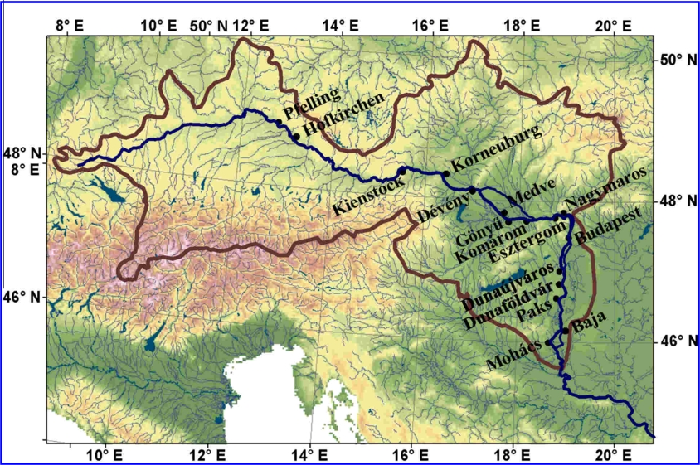
Figure 1. Upper, Central Danube forecast stations

velocity (10U); 10m V-velocity (10V); 2m temperature (2T); 2m dew point (2D); 2m max temperature (MX2T); 2m min temperature (MN2T), Total cloud cover (TC), Total precipitation (TP) in GRIB code form (40 x40 km grid). Further Atmospheric Products from the Ensemble Prediction System are also utilized, namely 2m temperature (2T), 2m max temperature (MXT), 2m min temperature (MNT), Total precipitation (TP) of the basic ensemble forecasts in 80X80 km grid.
The upper and central part of the Danube basin is covered by the forecasts LACE (Limited Area Modeling for Central Europe) model. LACE is the name of the co-operation between Central-European meteorological and hydro-meteorological Institutes (Austria, Croatia, Czech Republic, Hungary, Slovakia, Slovenia), which aims a common development and operational exploitation of a limited area numerical weather prediction model. The model used is the ALADIN spectral limited area model developed in an international collaboration (with the participation of 14 countries) led by Meteo France. Recently the operational version of the ALADIN model called ALADIN/LACE is exploited in Prague and Budapest for a domain covering Continental Europe. The model is launched twice a day (at 00 and 12 UTC) giving 48 hours forecasts. The products of the model are transferred through telecommunication lines to the disposal of the Member States. The received products are intensively used for the short-range forecasts issued by the Member States. Some of the Members run the local version of the ALADIN model centered for their territory providing an even more precise and exact short-range forecasts for the forecasters. HMS runs such local model utilizing the output of the central model as boundary conditions. The central model has the spatial resolution of 12x12 km grid, while the local ones 6.5x6.5 km. Time-step of model output is 400s i.e. 432 time steps within the 48 hours maximum lead time. Budapest window covers the whole Carpathian Basin including the Tisza catchment.

1.2. The hydrological modeling system
The NHFS GAPI/TAPI modeling system has been developed within the Hydrological Institute of the VITUKI Centre. The conceptual, partly physically-based GAPI model serves for simulations and forecasting of flow for medium and large drainage basins. The lumped system consists of sub-basins and flood routing sections (Figure 1.). In the course of a decade of development and upgrading the forecasting package has grown into a complex tool containing snow accumulation and snowmelt, soil frost, effective rainfall, runoff and flood routing modules, extended with statistical error correction - continuous updating and hydraulic - 'empirical backwater effect' modules.

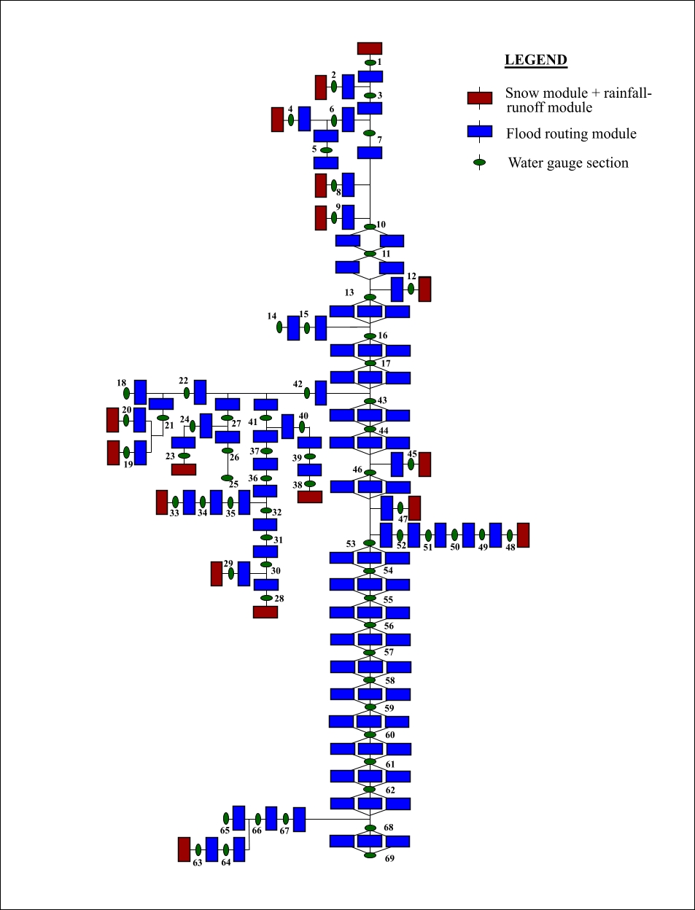

Figure 1. The overall sub-basin and river reach oriented scheme of the Danube hydrological forecasting system
The Discrete Linear Cascade Model (DLCM) developed by Szőllösi-Nagy (1982) utilizing an approach similar to the one reported by Szolgay (1984) serves for the routing of flow components and channel routing (Figure 2.). First version of the complex GAPI model with modular structure was designed by Bartha et al. (1983). The choice of the model was proved by a number of inter-comparison studies (WMO, 1992). The first model version was extended by a snowmelt module (Gauzer, 1990) and the complexity of the system was raised gradually. The backwater module utilizes simplifications similar those suggested by Todini and Bossi (1986).
The large number of nodes (69) makes the system in fact semi distributed in basin scale. Out of the total number of nodes 46 are related to forecast stations. Real time mode runs are carried out in 12 hourly time steps. Input/output values and state variables of the precipitation - runoff modules are integrated over sub-basins as weighted or simple arithmetic average of station or grid values. A special procedure was designed to interpolate sparse grid data of ECMWF products. The rapid growth of resolution and forecast range of numerical weather prediction models enabled the use of their result for hydrological forecasting purposes. Unfortunately Quantitative Precipitation Forecasts remain the most uncertain elements of any meteorological prediction. The growth of computational power available for meteorological centres allowed the introduction and real time application of ensemble techniques capable to deal with such uncertainty (Table 1.).

Figure 2. Scheme of the precipitation - runoff modules

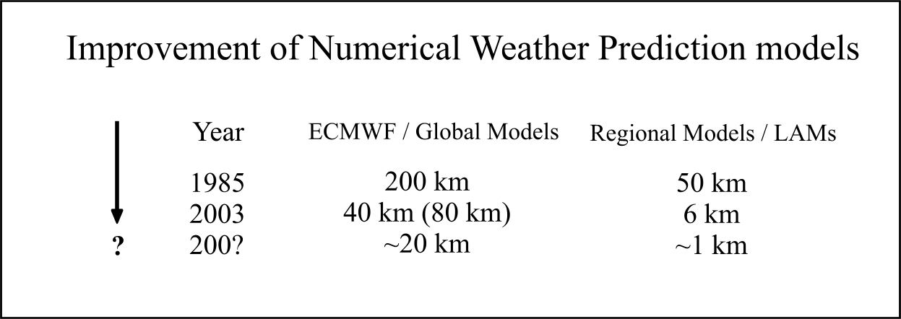
Table 1. Improvement of Numerical Weather Prediction Models

2. The use of meteorological ensembles for flood forecasting

2.1. Testing on an extreme event
Operational use of the above system often revealed the uncertainty of QPF taken into consideration while calculating expected Danube hydrographs. To test the feasibility of the use of meteorological ensembles a hindcasting experiment was designed. The aim of the investigation was also to assess how much prior estimates of uncertainty of can be given by the selected approach.
ECMWF archived forecast arrays were retrieved. Partly the standard data ingestion part of the NHFS system was used. 52 sets of input data arrays were produced using the 50 ECMWF ensemble elements, additionally deterministic and control runs were also carried. Control run input is identically produced as the deterministic one, but instead if the 40 km resolution 80 km resolution is used. The period of July-August 2002 was selected including the period of the August flood.
The two flood waves were induced by torrential rains on 7-8th and 11-13th of August consequently. The precipitation of the first rainfall caused high area average especially over the upper stage of the Danube The peak of the first flood wave reched Budapest on 11th in August with moderate flow rate. The following second rainfall period resulted extreme floods on Austrian tributaries Salzach, and on smaller streams in Upper Austria region with destructive consequences. The peak reached Vienna on 15 August. Historical high flows occurred along the Slovak-Hungarian section of the Danube.
The actual hindcasting took place after the cycles of input data preparation were completed. Due to the limitations of the NHFS system only 1-6-day ahead forecast was calculated for the period from 15th of July to 31st of August. Forecast was calculated at daily frequency using 12 hour time steps. That followed the running of the forecast-system. The calculation of the ensemble forecast is time demanding that is why the standard operational procedure was modified, flags and options were reduced to produce batch type of processing. (All together more than 5000 runs were performed which equals more than 6 years 'real time' activity.) 12 hour time step 1-6 day ahead forecast were calculated for 46 forecast stations. Out of those 21 were analysed comparing forecast results to observed hydrographs.

Figure 3. Hydrological ensembles indicating great dispersion on 7th and no dispersion on15th August 2002, at Budapest gauge

2.2. Results
Different behavior of the system can be observed on Figure 3. The 'torch' diagrams indicate the differences between situations with uncertain and univocal QPF ensembles. The 50-element ensemble of hydrological forecast reflects the great uncertainty associated with the August 7th forecast. The other case shows almost no differences on 15th August. The QPF error related forecast error is negligible in this case differences between observed water level/discharge values are explained by the relatively poor performance of the flood routing part of the system. Unfortunately for the hydrological users the cases of QPF with high certainty are usually associated with no rain situations.

Figure 4 shows main features of different sets of hydrological ensembles for gauging stations Devin and Budapest. The specific Box-Whisker diagrams indicate beside observed hydrographs forecast arrays showing minimum and maximum values of 50 element ensembles while quartiles above and below the mean values are indicated by wider boxes. Forecast is indicated for 24, 72, 144 hours of lead time. Even this two gauge comparison is sufficient to indicate the impact of growing travel time along the 200 km reach which is expressed in higher accuracy of forecast at the lower (Budapest) section while the rainfall - runoff module has higher weight at Devin, consequently forecast error is higher at the upstream station. The natural increase of error with the lead time can also be followed. Upstream rainfall induced flood waves have an impact on Budapest section only 2-3 days after the rainfall (or snowmelt) event occurs. The limit of predictability is reached at Devin at the 6th day, however ensemble means still give some useful information.

Forecast types are compared with each other on the table 2. The basic of the comparison was performed applying the so-called efficiency coefficient, a skill score widely used in hydrology. This table refers to the period 21 July – 31 August 2002 and the colours shows more efficient forecast type. In case of the upper section and higher lead time the mean of 50 members is better because the precipitation forecast is dominant in the hydrological forecast with high (3-6 days) lead time. Down to the stream – when the flow routing is dominant – the operative forecast gives the higher skill score values.

The simulation experiment proved that the use of meteorological ensembles to produce sets of hydrological predictions increased the capability to issue flood warnings. The NHFS system can be used for such a purpose, however for real-time use the linkage between meteorological and hydrological modules should be considerable reviewed. The large number of model runs for the August 2002 extreme flood event could be performed within reasonable time. Appropriate decision support rules are needed to utilise the array of flood forecasts for flood management and warning purposes. The proper estimation of the contribution to forecast error by different modules of the system may help to better understand expected uncertainty of the forecast. Any future exercise should include longer period of low flow or medium flow period to have proper estimates of ‘false warning’ types of errors.

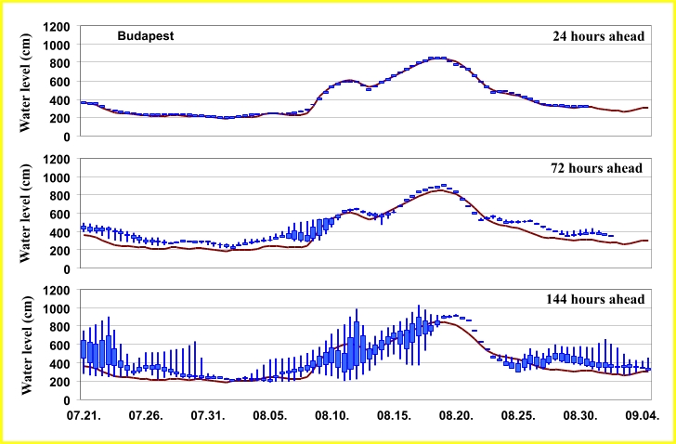
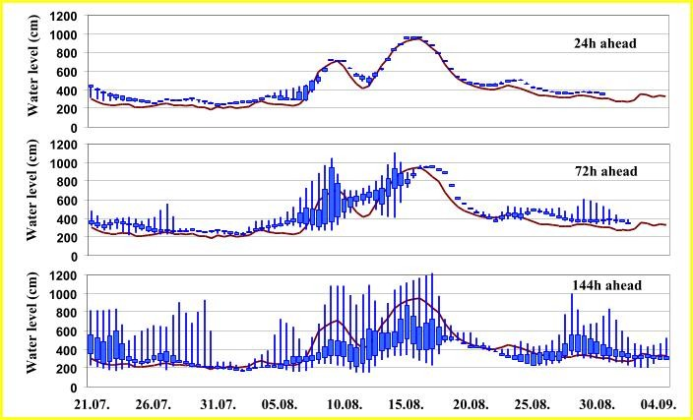
Figure 4. Hydrological ensembles consequently for Devin and Budapest gauges;
quartiles of 1, 3 and 6 day forecast

Table 2. Efficiency index for the period 21st July – 31st August 2002
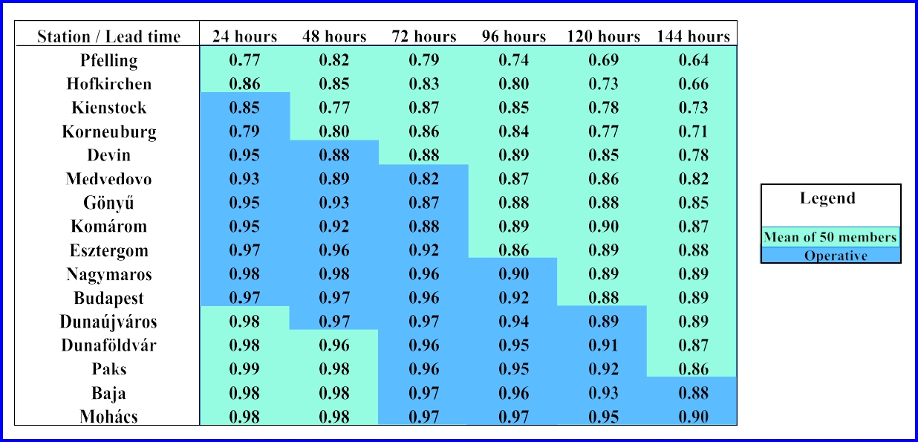

Table 3. Nash and Sutcliffe criterion for the period 21st July – 31st August 2002
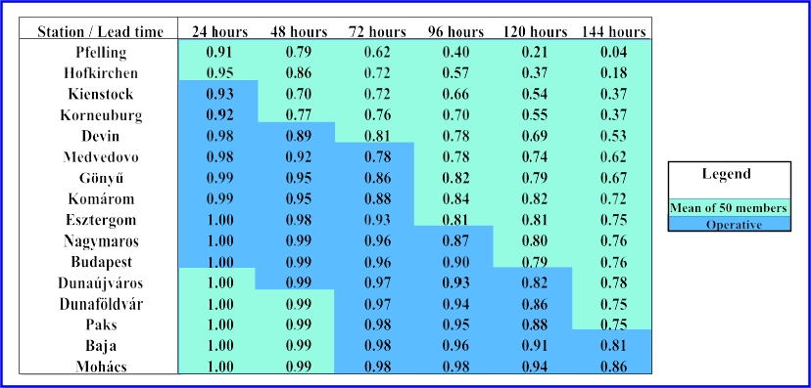

Table 4. RMSE for the period 21st July – 7th August 2002
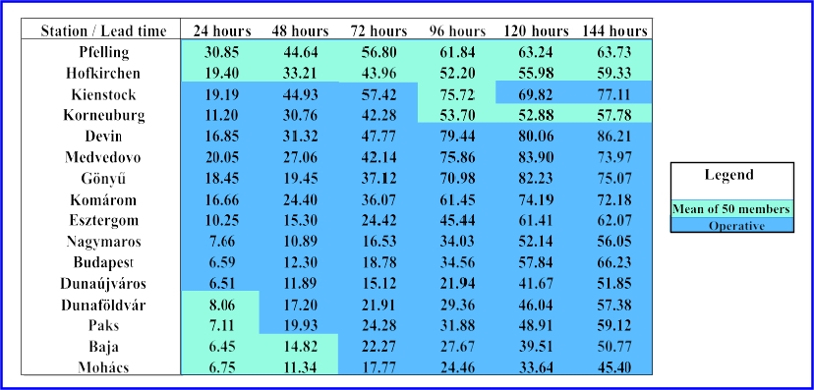

Table 5. RMSE for the period 8th August – 22nd August 2002
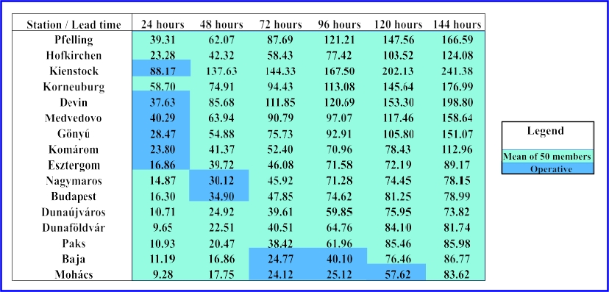

3. Conclusions
The hindcasting experiment proved that the use of meteorological ensembles to produce sets of hydrological predictions increased the capability to issue flood warnings. The NHFS system can be used for such a purpose, however for real-time use the linkage between meteorological and hydrological modules should be considerable reviewed. The over 5000 model runs for the August 2002 extreme flood event could be performed within reasonable time. Further important findings are:
- Appropriate decision support rules are needed to utilise the array of flood forecasts for flood management and warning purposes;
- The proper estimation of the contribution to forecast error by different modules of the system may help better understand expected uncertainty of the forecast;
- Any future hindcasting exercise should include longer period of low flow or medium flow period to have proper estimates of 'false warning' types of errors.

4. References
Bartha, P., Szőllösi-Nagy, A., Harkányi K. (1983): Hidrológiai adatgyűjtő és előrejelző rendszer. A Duna. Vízügyi Közlemények, Vol. 65. (LXV), 3., pp.373-388.
Gauzer, B. (1990): A hóolvadás folyamatának modellezése (Modeling of the processes of snowmelt). Vízügyi Közlemények Vol. 72. (LXXII) 3., pp.273-289.
Szolgay, J. (1984): Modellierung von Flubstrecken mit seitlichen Zuflüssen mit der linearen Speicherkaskade, XII. Konf. Donau., Bratislava, pp.381-390.
Szöllõsi-Nagy, A. (1982): The discretization of the continuous linear cascade by means of state space analysis. Journal of Hydrology, 58. 1-2
Todini,E. and Bossi,A. (1986): PAB (Parabolic and Backwater) an unconditionally stable flood routing scheme particularly suited for real time forecasting and control, Journal of Hydraulic Research, Vol. 24, n.5, pp.405-424.
WMO (1992): Simulated real-time intercomparison of hydrological models, Operational Hydrological Report No. 38, World Meteorological Organization, WMO No. 779, Secretariat of WMO, Geneva, Switzerland

