Influence of the atmospheric situation And physical geography conditions on the emergence of floods in the upper Ohře catchment

Radek Čekal

Czech Hydrometeorological Institute, Prague, Czech Republic, e-mail: cekal@chmi.cz

Abstract: Using an indicator referred to as flood efficiency, we have identified weather situations conducive to floods in the Upper Ohře catchment in the Czech territory. Analysis of daily precipitation totals measured in the catchment, and the sequence and reconfiguration of the causal circulation conditions occurring prior to culmination discharges has helped to identify the conditions that pose the greatest risk for the catchment. We have then assessed the effect of dynamic atmospheric factors, the resulting precipitation field, and the runoff response in the river network on the similarity of the shape and variation over time of flood waves at the last site in the catchment. The input set of data included that on summer (April to September) flood waves observed at the Karlovy Vary site between 1959 and 2002. Synoptic analysis has revealed that the distance, direction and speed of movement of the causal pressure lows influence the shape of summer flood waves.
Keywords: Flood efficiency of weather situation types, trajectory of the cyclone centre, types of flood waves.

Zusammenfassung: Die meteorologischen Situationen wurden auf dem Grund der sogenannten Hochwassereffektivität wohlwollend für die Bildung der Hochfluten im Einzugsgebiet obere Eger in Tschechien identifiziert. Die meteorologischen gefährlichen Situationen für das Einzugsgebiet wurden aus der Analyse der täglichen Niederschläge im Einzugsgebiet und aus der Forschung nach Reihenfolge und der Umgestaltung der Zirkulationen Bedingungen vor dem Kulminationsabflussvorkommen abgeleitet. Darauf wurde auch den Einfluss der dynamischen Faktoren, der implizierten Niederschlagsfelde und der Abflüssen Reaktion in der Fluss-Netz auf die ähnliche Bildung und der Durchlauf der Flutwellen im Abflussprofil Karlsbad bewertet. Als die Eingangsdatei wurde die sommerlichen Flutwellen (Apr. bis Sept.) aus dem Abflussprofil Karlsbad während der Zeit 1959-2002 angewendet. Aus der meteorologischen Analyse wurde hervorgeht, dass auf die Flutwellenform unter anderem auch das Abstand, die Richtung und die Geschwindigkeit des Zykloneablaufes Einfluss hat.
Schlüsselworte: Die Hochwassereffektivität der meteorologischen Situationen, die Trajektorie der Zyklonemitte, die Flutwellentypisierung

1. Introduction
From the perspective of the emergence of flood situations caused by precipitation on fronts it is essential that their meteorological causes are usually formed very far from the catchment under review. Atmospheric circulation, which is the main source of variations in weather, is also strongly affected in its surface layer by the physical geography of the catchment. In general this suggests that each catchment must have a different level of sensitivity to the various types of atmospheric circulation situations and their progressive combinations.
For the purpose of this contribution we therefore first examined whether there was a correlation between the occurrence of a flood situation and a certain type of atmospheric circulation in the Upper Ohře catchment, which is important for the further development of the flood situation at the foot of Krušné hory Mts. in terms of flood control. Subsequently, we wanted to find how the various types of weather situations differed from each other in terms of their ‘flood efficiency’. The ultimate goal was to examine whether certain categories of flood waves corresponded to these selected types of atmospheric circulation.

2. Determining the types of weather situations that carry a potential risk of floods

For our analysis, we have used a set of discharge waves observed at the last, closing site on Upper Ohře at Karlovy Vary for the period from 1959 to 2002. The set contains 15 summer discharge waves culminating above the threshold value of about 100 m³.s⁻¹. The day of the decisive causal precipitation had to be assigned to each of these selected flood episodes.

It was quite easy to identify the day with the respective causal weather situation in cases when only one type of weather situation occurred in the sequence of all days prior to the culmination (D-5 až D-1). A more complicated problem, which is usually more frequent, had to be tackled when the weather situation changed (reconfigured) on the days prior to the culmination. Under these circumstances, we used mean daily precipitation totals measured in the catchment to identify the causal weather situations. The causal weather situation is understood to be the one of the situations, which in their day-by-day sequence is the main cause of the flood. In the Ohře catchment, causal meteorological conditions occur in the vast majority of floods on day D-1 or D-2. To assess the atmospheric circulation, we used the Catalogue of Circulation Types [Brádka et al., 1967], which describes 28 typical situations. Since 1946, the Catalogue has been officially updated for each day once a year, based on the direction of currents and configuration of the pressure fields.
Table 1 shows the sequence and reconfigurations of weather situations, determining the causal situation (DD), for floods in the vegetation half-year.

Table 1 Summer flood waves in Karlovy Vary (1959 - 2002), determining the causal weather situation
Culmination day | Q_{cul} [m³.s⁻¹] | D – 5 | D - 4 | D - 3 | D - 2 | D - 1 | D | D + 1 | D + 2 | DD
10.6.1961 | 224 | Ec | Ec | B | B | B | B | B | B | B
12.5.1965 | 134,3 | Wc | Wc | Wc | NEc | NEc | NEc | NEc | NEc | Wc
11.6.1965 | 136,9 | C | C | C | C | C | C | C | C | C
30.6.1966 | 180 | B | B | B | B | B | B | A | A | B
26.4.1968 | 161,3 | SWa | SWa | SWa | C | C | C | C | SWc₁ | C
20.4.1970 | 244 | Ap₁ | Wc | Wc | Wc | Bp | Bp | Bp | Wc | Bp
22.8.1970 | 215 | Wal | Wal | Wal | SWc₁ | SWc₁ | SWc₁ | NEc | NEc | SWc₁
8.5.1978 | 217 | C | SWa | SWa | C | C | C | NEc | NEc | C
22.7.1980 | 196 | Bp | Wc | Wc | Wc | Cv | Cv | NEc | NEc | Cv
7.6.1984 | 137 | Sa | Sa | C | C | C | C | Nc | Nc | C
13.8.1984 | 98 | SEc | SEc | C | C | C | Nc | Nc | NWc | C
31.5.1986 | 99 | Ap₂ | SWc₂ | SWc₂ | B | B | B | C | C | B
1.9.1995 | 124 | Nc | Nc | Nc | NEc | NEc | C | C | C | NEc
16.9.1998 | 132 | B | B | C | C | C | Bp | Bp | Bp | C
13.8.2002 | 273 | C | SEc | SEc | C | C | C | NEc | NEc | C

Figure 1 shows the frequency, in percentage terms, of the occurrence of these types of weather situations on days D-5 to D in the period from 1959 to 2002. Their distribution suggests that situation C takes the largest share on causal days D-2 and D-1. On both days, its share accounts for almost one-half of the total number of floods caused by this weather type in the Upper Ohře catchment. Important shares are also taken by situation B (20%) and NEc (13%).

Figure 1 Frequency of the occurrence of weather situation types on days D-5 to D for floods in the vegetation seasons from 1959 to 2002

It applies in general that situations favourable for the emergence of flood situations are such situations, the probability of the occurrence of which is statistically significantly higher. To identify situations conducive to floods, the so-called flood efficiency (FE) was determined for each of the various types of weather situations on certain days before and on the day of the flood wave’s culmination [Buchtele, 2003], see Table 2.
This indicator is defined as the ratio of the relative frequency of the particular type in the portfolio of all recorded floods, and the relative frequency of the same type for the whole period under review (1959 - 2002). A flood efficiency value greater than one signifies that the occurrence of that particular type is relatively higher during flood situations than in periods without floods. On the other hand, if the flood efficiency value is lower than one it means that the relative occurrence of that particular type is lower during floods than in the whole period under review.

Table 2 Flood efficiency values of different types of weather situations in the Upper Ohře catchment on days before and on the day of culmination for floods in the vegetation seasons from 1959 to 2002
Situation | Day before culmination
type | D-5 | D-4 | D-3 | D-2 | D-1 | D
Ap1 | 5,96 | 0 | 0 | 0 | 0 | 0
Ap2 | 2,21 | 0 | 0 | 0 | 0 | 0
B | 1,43 | 1,43 | 1,43 | 2,14 | 2,14 | 2,14
Bp | 1,11 | 0 | 0 | 0 | 1,11 | 2,22
C | 4,42 | 1,47 | 5,90 | 10,32 | 10,32 | 8,85
Cv | 0 | 0 | 0 | 0 | 5,02 | 5,02
Ec | 1,66 | 1,66 | 0 | 0 | 0 | 0
Nc | 2,81 | 2,81 | 2,81 | 0 | 0 | 2,81
NEc | 0 | 0 | 0 | 1,94 | 1,94 | 0,97
Sa | 3,21 | 3,21 | 0 | 0 | 0 | 0
SEc | 2,53 | 5,06 | 2,53 | 0 | 0 | 0
SWa | 5,11 | 10,22 | 10,22 | 0 | 0 | 0
SWc1 | 0 | 0 | 0 | 1,83 | 1,83 | 1,83
SWc2 | 0 | 1,34 | 1,34 | 0 | 0 | 0
Wal | 1,01 | 1,01 | 1,01 | 0 | 0 | 0
Wc | 1,04 | 3,13 | 3,13 | 2,08 | 0 | 0

However, the FE values are strongly affected by a relatively low number of floods in the period under review. As expected, situations C and B achieved the highest FE values on average (on causal days, from 2 to 10).
In the vegetation season, three basic types of situation can be discerned from the perspective of the variation of FE over time in respect of the classified types of weather conditions:
- The first group includes situations with a relatively high FE throughout the period (D-5 to D). Situations B and, mainly, C rank among these types.
- In the second group, the FE steeply rises from zero on days D-2 or D-1. These are largely situations Bp, Cv, NEc, and SWc₁.
- The third group includes situations Wc, the FE of which is high on days D-5 to D-2, but it drops to zero on the following days.

3. Sequence and reconfiguration of weather situations before the causal day
The sequence of the various phases of the atmosphere’s dynamics, which precede the emergence of a flood situation, reveals that the sequential order and reconfiguration of the various types of atmospheric circulation before the causal day are not random but contingent. Based on these observations it can be expected in theory that the type arriving next in the sequence is more or less influenced by the preceding circulation conditions in the atmosphere.
Table 2 illustrates the frequency of the occurrence and seasonal nature of the causal weather situations in the vegetation season in the Upper Ohře catchment from 1959 to 2002. In the period under review, seven types of weather situations contributed to the emergence of floods. Situations C and B caused the highest absolute number of floods, also measured by occurrence. These two circulation types caused up to two-thirds of recorded floods. The remaining types Wc, Bp, Cv, SWc₁ and NEc were each represented only once.

Table 3 Frequency of causal weather situations in the vegetation season from 1959 to 2002
Type of causal situation | Month |  |  |  |  |  |  |  |  |  |  |  | Total
Type of causal situation | I | II | III | IV | V | VI | VII | VIII | IX | X | XI | XII | Total
C |  |  |  | 1 | 1 | 2 |  | 2 | 1 |  |  |  | 7
B |  |  |  |  | 1 | 2 |  |  |  |  |  |  | 3
Wc |  |  |  |  | 1 |  |  |  |  |  |  |  | 1
Cv |  |  |  |  |  |  | 1 |  |  |  |  |  | 1
Bp |  |  |  | 1 |  |  |  |  |  |  |  |  | 1
SWc₁ |  |  |  |  |  |  |  | 1 |  |  |  |  | 1
NEc |  |  |  |  |  |  |  | 1 |  |  |  |  | 1
Total |  |  |  | 2 | 3 | 4 | 1 | 4 | 1 |  |  |  | 15

For almost one-half of all flood waves caused by situation C we have found that situation C was preceded by four weather types in the interval monitored before DD. The largest share, 29%, can be seen equally for three situations, B, SEc, and SWa. Two types of weather situations were decisive immediately before the causal day. In most cases, the causal situation C itself preceded, i.e. in about four-fifths of cases, and in the remaining approximately 15%, it was the SWa situation. For days more distant in the sequence before the causal day, the number of occurring weather types has been found to increase, and only the share of situation C decreased – however, the latter started increasing again on day D-4, see Figure 2.

Figure 2 Sequence of weather situation types before causal situation C for floods in the vegetation season from 1959 to 2002

On average the highest (31.21 mm) precipitation totals were measured in the catchment on the causal day for floods caused as a result of the occurrence of situation (with causal situation) SWc₁. On the contrary, the lowest (9.57 mm) precipitation total can be seen for situation Wc, see Figure 3.
However, the distribution of precipitation related to the various causal types is quite uneven, see Figure 4.

Figure 3 Mean precipitation totals in the catchment on the causal day for certain weather situations for floods in the vegetation season from 1959 to 2002

Figure 4 Daily precipitation means in the catchment related to certain types of weather situations for floods in the vegetation season from 1959 to 2002

The highest mean two-day precipitation totals related to a potential two-day lead of the situation in the vegetation season have been identified in the Upper Ohře catchment for situations SWc₁ and C. The maximum (60.2 mm) two-day average precipitation total was achieved when causal situation SWc₁ recurred on the following day. Similarly with type C floods, the highest two-day precipitation total occurred when the same situation lasted without any interruption. Table 4 lists the sequence of pairs of weather situations on days D-1 and DD (causal day), for which the highest two-day precipitation totals have been identified in the vegetation season.

Table 4 The highest two-day precipitation totals and sequences of causal weather situations in the Ohře catchment identified in the vegetation seasons from 1959 to 2002

4. Effect of dynamic atmospheric factors on the categorisation of summer flood waves
In the next step, the author examined the effect of the position, direction, and speed of movement of the pressure low (cyclone) – relative to the position of the Upper Ohře catchment – on the shape of the flood wave at the last site of this catchment in Karlovy Vary. The related synoptic analysis of the causal meteorological situations has been carried out on the basis of maps of pressure fields over Europe published in the Daily Weather Overview periodical bulletin.
For the purposes of hydro-synoptic analysis of the floods, the centre of the cyclone on days D-3 to D+1 had to be located first of all. Connecting the points so found by a straight line yielded sections of a discretely schematised path of movement (trajectory) of each “flood” cyclone. An exception was the flood episode on 10 June 1961, where the zone of causal precipitation was formed in connection with the movement of an uneven cold front. With the help of visualised trajectories, their average shortest distance from the geometrical centre of gravity of the catchment was determined, and also the speed and prevailing direction of advance on days with the causal rainfall, see Table 5.
The runoff response in all analysed causal meteorological situations was represented by a set of 15 discharge waves from the summer half-years in the period under review. Different typified discharge waves were obtained by combinations consisting of superimposed discharge wave hydrographs along the vertical axis, always placed onto the moment of culmination, and by measuring their ordinates. On the basis of analysing the runoff formation of flood extremes in the catchment; the interferences in the confluence nodes of the river network; and the topology of precipitation fields, three basic categories have been defined to bring together floods waves having similar shapes and variations over time, see Figure 5.

Table 5 Characteristics of the trajectories of movement of the pressure lows’ centres for summer flood waves in the Upper Ohře catchment from 1959 to 2002
Culmination | Direction [°] | Shortest distance [km] | Speed [km.day⁻¹] | D-3 [km] | Progress  [km] azimuth [°] | D-2  [km] | Progress  [km] azimuth[°] | D-1 [km] | Progress [km] azimuth[°] | D  [km] | Progress [km]  azimuth [°] | D+1  [km]
10.6.1961 | _ | _ | _ | _ | _ | _ | _ | _ | _ | _ | _ | _
10.6.1961 | _ | _ | _ | _ | _ | _ | _ | _ | _ | _ | _ | _
12.5.1965 | SE | 604 | 707 | 1232 | 1090 | 713 | 324 | 604 | _ | _ | _ | _
12.5.1965 | 150° | 604 | 707 | 1232 | 130 | 713 | 170 | 604 | _ | _ | _ | _
11.6.1965 | SE | 18 | 398 | 618 | 618 | 30 | 178 | 151 | 533 | 610 | _ | _
11.6.1965 | 135° | 18 | 398 | 618 | 100 | 30 | 170 | 151 | 85 | 610 | _ | _
30.6.1966 | E | 367 | 829 | 1573 | 1078 | 707 | 563 | 367 | 1094 | 1466 | _ | _
30.6.1966 | 90° | 367 | 829 | 1573 | 100 | 707 | 140 | 367 | 40 | 1466 | _ | _
26.4.1968 | NE | 289 | 569 | _ | _ | 857 | 934 | 366 | 203 | 289 | _ | _
26.4.1968 | 30° | 289 | 569 | _ | _ | 857 | 50 | 366 | 10 | 289 | _ | _
20.4.1970 | E | 73 | 1237 | _ | _ | _ | _ | 904 | 1237 | 338 | 1040 | 1279
20.4.1970 | 75° | 73 | 1237 | _ | _ | _ | _ | 904 | 75 | 338 |  | 1279
22.8.1970 | E | 621 | 353 | _ | _ | _ | _ | 621 | 353 | 736 | 729 | 1137
22.8.1970 | 95° | 621 | 353 | _ | _ | _ | _ | 621 | 95 | 736 |  | 1137
8.5.1978 | N | 148 | 219 | _ | _ | 309 | 262 | 148 | 175 | 254 | 695 | 834
8.5.1978 | 5° | 148 | 219 | _ | _ | 309 | 0 | 148 | 10 | 254 |  | 834
22.7.1980 | E | 191 | 819 | 1714 | 1190 | 831 | 589 | 277 | 1049 | 863 | 369 | 1233
22.7.1980 | 100° | 191 | 819 | 1714 | 85 | 831 | 170 | 277 | 100 | 863 |  | 1233
7.6.1984 | NE | 18 | 824 | 1482 | 555 | 928 | 1052 | 131 | 596 | 613 | 182 | 661
7.6.1984 | 32,5° | 18 | 824 | 1482 | 50 | 928 | 65 | 131 | 0 | 613 |  | 661
13.8.1984 | N | 10 | 1079 | 749 | 695 | 168 | 1462 | 1302 | 1067 | 2301 | 568 | 2751
13.8.1984 | 17,5° | 10 | 1079 | 749 | 335 | 168 | 60 | 1302 | 45 | 2301 |  | 2751
31.5.1986 | NE | 435 | 1017 | _ | _ | 736 | 212 | 587 | 1017 | 776 | 480 | 1090
31.5.1986 | 40° | 435 | 1017 | _ | _ | 736 | 45 | 587 | 40 | 776 |  | 1090
1.9.1995 | SW | 126 | 431 | _ | _ | 1296 | 600 | 1114 | 608 | 541 | 431 | 126
1.9.1995 | 240° | 126 | 431 | _ | _ | 1296 | 350 | 1114 | 275 | 541 |  | 126
16.9.1998 | E | 411 | 694 | 727 | 518 | 1010 | 639 | 411 | 748 | 1147 | 436 | 1575
16.9.1998 | 87,5° | 411 | 694 | 727 | 315 | 1010 | 160 | 411 | 15 | 1147 |  | 1575
13.8.2002 | N | 200 | 776 | 852 | 552 | 536 | 776 | 330 | 738 | 990 | _ | _
13.8.2002 | 20° | 200 | 776 | 852 | 75 | 536 | 20 | 330 | 100 | 990 | _ | _

On the basis of analysing the runoff formation of flood waves in the catchment; the interferences of flood waves in the confluence nodes of the river network; and the topology of precipitation fields, the set of 15 summer waves was divided into three basic categories to bring together floods waves having similar shapes and variations over time, see Figure 5.

Figure 5 Categorised summer flood waves in Karlovy Vary in the Upper Ohře catchment from 1959 to 2002

First category waves: The dominant feature is the fast increase in discharges on the increasing part of the curve with a relatively “sharp” crest. After culmination, at first a gradual recession follows in most cases, which itself creates an additional attribute of waves in this category, i.e. tapered crest phase of the wave. Then follows a relatively rapid decrease in discharges. This category includes waves on 10 June 1961, 26 April 1968, 22 July 1980,1 September 1995 and 13 August 2002. The corresponding trajectories of the causal cyclones’ centres are shown in the map in Figure 6.

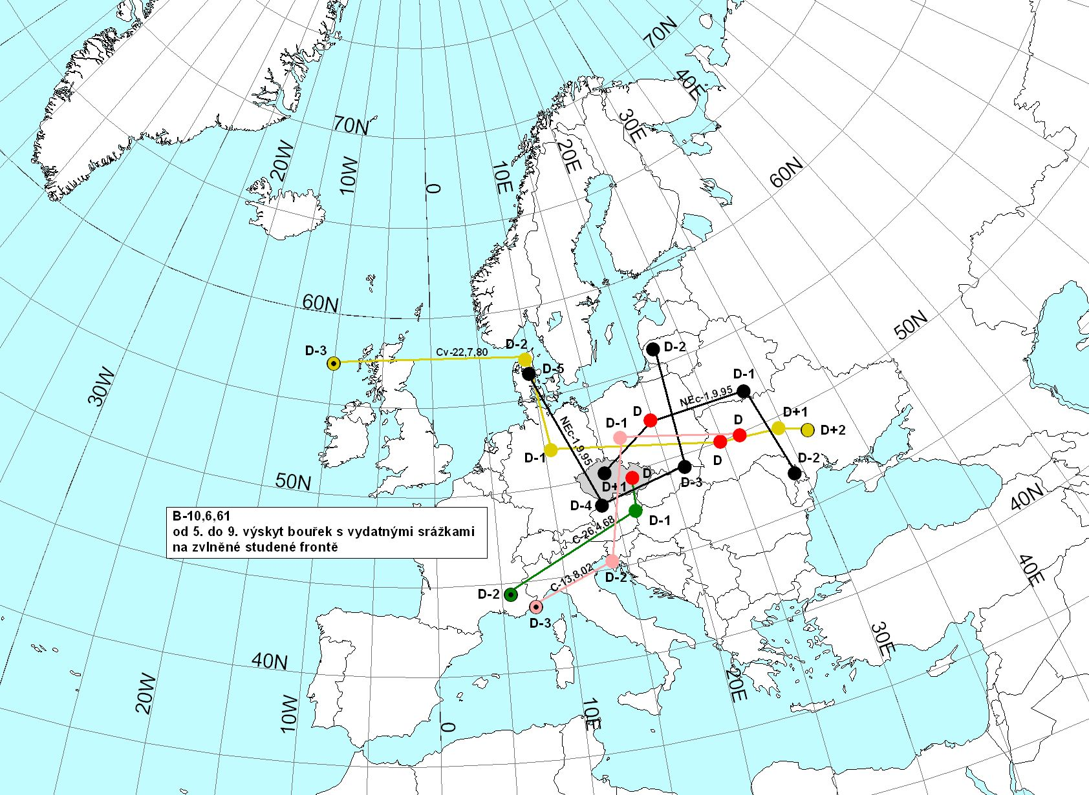
Figure 6 Trajectories of the cyclones’ centres for first category floods
Second category floods: The dominant feature is a more or less prominent secondary crest, or temporary stabilisation of discharge on the increasing or decreasing part of the flood wave curve. This category includes waves on 11 June 1965, 30 June 1966, 22 August 1970, 8 May 1978, 7 June 1984 and 13 August 1984. The corresponding trajectories of the causal cyclones’ centres are shown in the map in Figure 7.

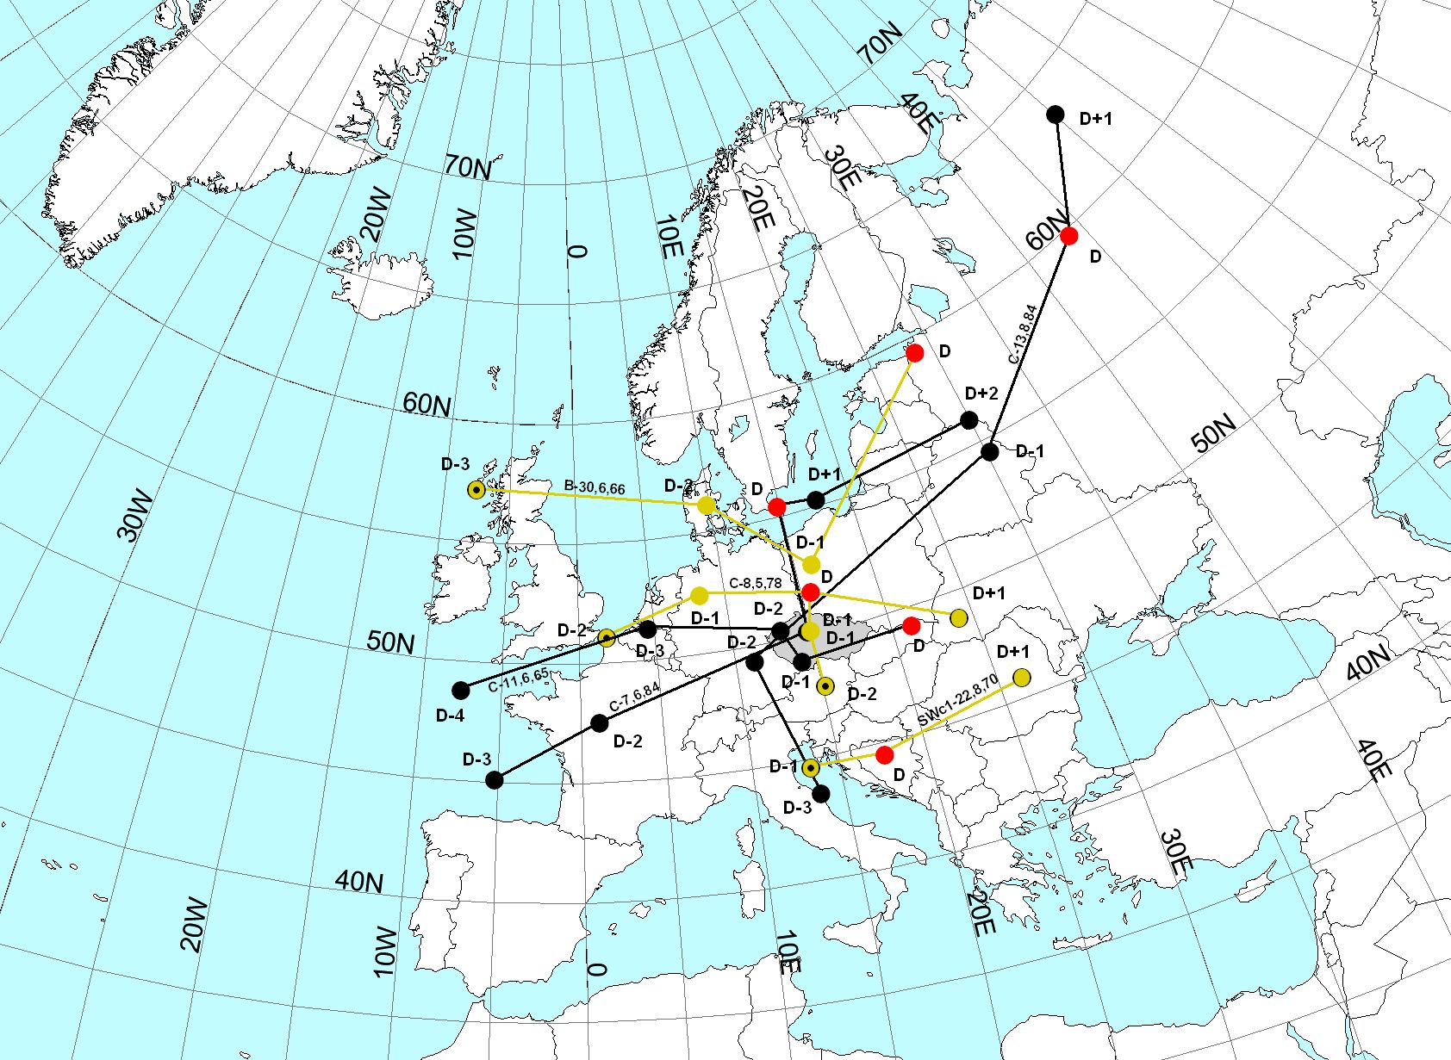
Figure 7 Trajectories of the eyes of cyclones for second category floods

Third category floods: Symptomatic of this category is the gradual increase in discharges with multiple secondary crests, and then a slow decrease in discharges. This category includes waves of 12 May 1965, 20 April 1970, 31 May 1986 and 16 September 1998. The corresponding trajectories of the causal cyclones’ centres are shown in the map in Figure 8.

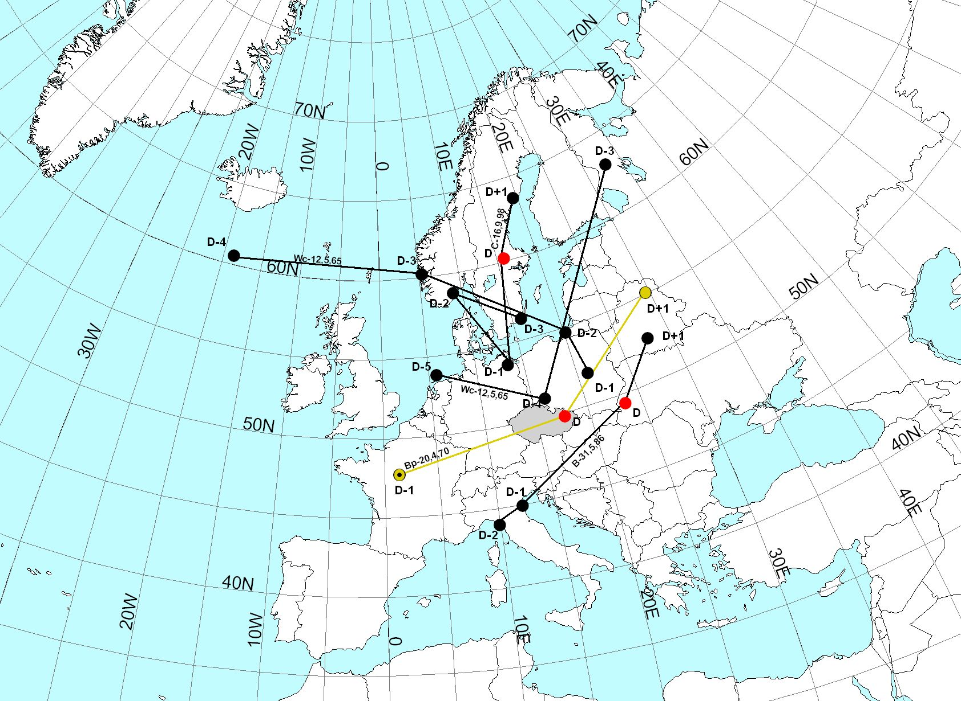
Figure 8 Trajectories of the eyes of cyclones for third category floods
For flood waves in the same category, we have tried to find their common features by means of spatial analysis of the located cyclone centres on days D-2, D-1 and D.
For day D-2 we have found that the cyclone centres are situated the nearest to the Upper Ohře catchment for second category flood waves, when they are usually located within a relatively smaller space west of the catchment. On the other hand, for first and third category flood waves, typical of this day is a relatively large spatial scatter of the locations of cyclone centres, see Table 6 and Figures 6, 7 and 8.

Table 6 Average shortest distance of cyclone centres from the Upper Ohře catchment
Day before culmination | Distance of trajectory, in km
Day before culmination | First category waves | Second category waves | Third category waves
D-2 | 880 | 428 | 820
D-1 | 522 | 453 | 626
D | 671 | 997 | 754

On day D-1 before the culmination discharge, the positions of cyclone centres for all wave categories start gradually coming nearer the catchment. Again, second category waves are the nearest to the Upper Ohře catchment. Third category waves can be found at the greatest distance, with the largest area of occurrence.
On the culmination day, D, the cyclone centres for first category waves can be found at the shortest distance from the catchment, in a relatively distinct grouping east of the catchment, whereas for the remaining two categories, they are quite scattered in space.
The position of cyclone centres on days D-2, D-1 and D for each of the flood wave categories suggests that typical of the first category waves is the slowest (on average 650 km.day⁻¹) shift of the cyclone on days D-1→D, see Table 6. This small shift near the Upper Ohře catchment results in intensive precipitation on these two days. For the second category waves, the movement of the cyclone is also slower (636 km.day⁻¹) on days D-1→D. However, on days D-2→D-1, the cyclone moves faster on average (703 km.day⁻¹) in the nearest vicinity of the catchment, which results in large amounts of precipitation on those days as well as the occurrence of a secondary crest on the wave at the last site in the catchment. On the other hand, third category waves feature much slower movement of the cyclone on days D-2 and D-1, but the considerably larger distance of the cyclone (in comparison with the other two categories) from the Upper Ohře catchment causes a more even distribution of the precipitation on the monitored days during the flood episode.

Table 7 Average speeds of the movement of cyclone centres on days (D-2) → (D-1) and

(D-1) → (D)
Period | Average speed of movement of cyclone eyes for
Period | first category waves | second category weaves | third category waves
(D-2) → (D-1) | 725 km.day⁻¹ | 703 km.day ^{–1} | 392 km.day ⁻¹
(D-1) → (D) | 650 km.day ^{–1} | 636 km.day ^{–1} | 1001 km.day ⁻¹

Connecting the average positions of cyclone centres on days D-2, D-1 and D for the flood waves in the respective categories has yielded the average geographical positions of the trajectories of moving cyclones related to each of the wave types, see Figure 9.

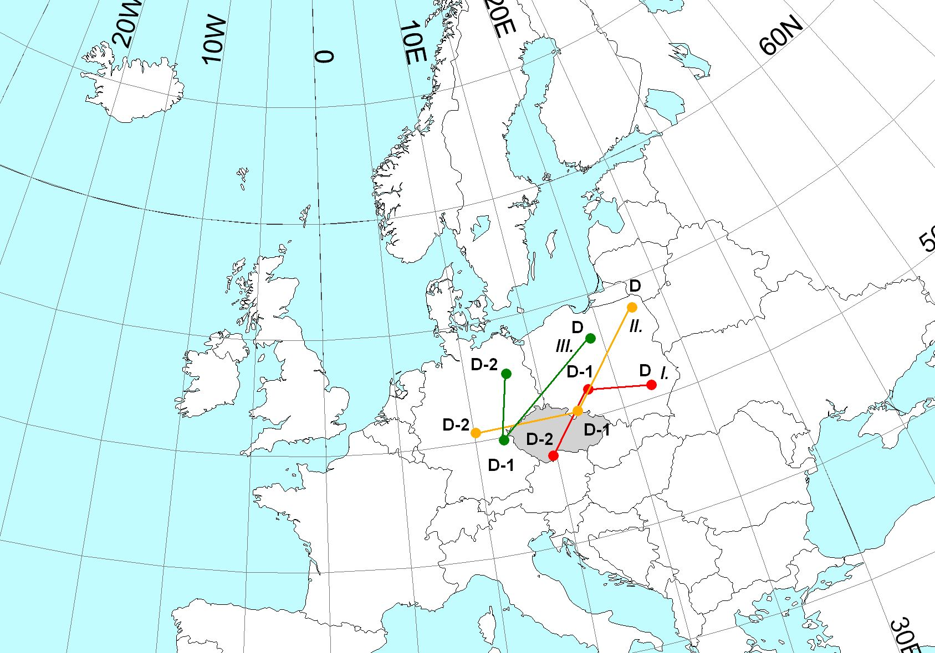

Figure 9 Average geographical positions of the trajectories of moving cyclones for floods of the first, second and third categories

The predominating number of cyclone trajectories for the first and second category floods towards the northeast indicates that most of the cyclones move along path V_{b} according to van Bebber [1891]. The difference is only in the trajectory’s distance from the Upper Ohře catchment and in the direction of the movement of the cyclone on days D-2→D-1 and D-1→D. The trajectory of the movement of the cyclone for second category waves passes in close vicinity of the catchment on days D-2→D-1 at an azimuth of about 90°, while for the fist category waves on those days the azimuth of the trajectory of the cyclone movement is about 45° and the distance from the catchment is relatively the smallest. For third category waves the characteristic feature is cyclone movement on days D-2→D-1 to the south and on days D-1→D to the northeast.

5. Conclusion
- To express the degree to which the various types of weather situations are conducive to floods, the author has used an indicator called flood efficiency. This approach has helped to prove that floods in the Upper Ohře catchment are usually closely related to situations formed by a central cyclone (C).
- In the vegetation half-year, weather situation C in the period under review (1959-2002) accounted for almost 50% of all major floods. In one-third of cases, the prior situations were B, SEc and SWa.
- Relatively heavier precipitation fell in connection with sequences of weather situations without their synoptic reconfiguration.
- The highest precipitation totals in the catchment on the summer floods’ causal day were recorded for flood waves caused by situation SWc₁. The lowest totals were connected with situation Wc.
- Synoptic analysis of summer flood waves at the Karlovy Vary site in the period from 1959 to 2002 indicates that the shape of the flood waves is also markedly influenced by the distance (from the Upper Ohře catchment), speed and direction (azimuth) of the movement of cyclone centres.

References

[1] Bradka, J. et al.: Catalogue of Weather Situations. Prague, HMÚ 1965. p 20
[2] Bebber, W. J.: Die Zugstrassen der barometrischen Minima. Met. Zeitschrift, 1891, p 361
[3] Křivancová, S., Vavruška, F.: Basic Meteorological Elements in the Various Weather Situations in the Czech Republic from 1961 to 1990. National Climate Programme of the Czech Republic, 1997, no. 27, ČHMÚ 1997, p 114
[4] Huth, R., Buchtele, J., 2003: Types of Atmospheric Circulation Related to Flood Episodes. Workshop 2003 – Extreme Hydrological Phenomena in Catchments, Prague, ČVÚT and ČVTVHS 2003, pp 271-280

