Use of QPF for hydrological modelling – a source of error

Jan Daňhelka

Czech Hydrometeorological Institute, Prague, Czech Republic, e-mail: danhelka@chmi.cz

Abstract: Quantitative Precipitation Forecast (QPF) is crucial for hydrological forecasting in headwater basins including Czech Republic. Nowadays practice of QPF use in flood forecasting at the Czech Hydrometeorological Institute (CHMI) is explained as well as its effect on the accuracy of hydrological forecast. Some possibilities of probabilistic approach use to eliminate uncertainty of QPF on stream flow prediction are described. We statistically evaluated QPF of meteorological model ALADIN for 14 selected catchments in the Czech Republic. Based on this statistical processing we are able to generate QPF ensembles and consequentially also the probabilistic hydrological forecast.
Keywords: QPF, uncertainty, hydrological forecasting, Czech Republic, probabilistic forecast, ALADIN

Zusammenfassung: Der Beitrag bietet Erfassung über die gegenwärtige Methode der Anwendung von Niederschlagvorhersage in der hydrologischen Modellierung für Grosswasservorhersage in der Tschechischen Republik. Der Einfluss von Niederschlag-vorhersageunsicherheit auf das Ergebnis der hydrologischen Vorhersage und die Möglichkeit seiner Elimination mit Hilfe der Wahrscheinlichkeitsvorhersagen wird beschrieben. Die Niederschlagvorhersagen des ALADIN Modells für 14 ausgewählten Bergeinzugsgebieten in der Tschechischen Republik wurden aufbereitet und statistisch bearbeitet. Ergebnisse dieses Verfahrens sind statistischen „Ensembles“, die in Zukunft für die hydrologische Wahrscheinlichkeitsvorhersage nützlich sind.
Schlüsselworte: Niederschlagvorhersage, hydrologische Vorhersageunsicherheit, Tschechische Republik, Wahrscheinlichkeitsvorhersagen, ALADIN

1. Introduction
The main purpose of the paper is to describe nowadays practice of QPF use in operational hydrological modeling in the Czech Republic, to evaluate the accuracy of QPF from the hydrological point of view and to try develop some simple method of "probabilistic" forecasting based on this evaluation.
Operational hydrological modeling and forecasting is highly dependent on many factors affecting its quality. As the main factors have to be mentioned the quality of calibration, the quality of input data and men's effect.
Concerning the quality of input data, following the GIGO (garbage in - garbage out) concept, we found that for the head water areas the Quantitative Precipitation Forecast (QPF) is the most sensitive factor for the result of hydrological forecast.
The problematic of the QPF as one of the most important issues of operational hydrometeorology was the subject of the special issues of Journal of Hydrology vol. 239 and 288 (Collier, Krzystofowitcz, 2000 and Krzysztofowicz, Collier, 2004) and is discussed in many articles, conferences and workshops. Unfortunately most of the contributions deal with meteorological point of view with the aim to adjust Numerical Weather Prediction (NWP) models or nowcasting procedures (Grecu, Krajewski, 2000). Only a few studies concern also the hydrological needs. Meteorologists evaluate precipitation outputs of NWP model (including Aladin) from their own perspective, which is often represented by setting the precipitation thresholds to 0.1 (rain vers. no rain) and 1 mm (heavy rainfall). From the hydrological point of view much higher threshold must be consider to evaluate the dangerous situations such are the floods.

2. Flood forecasting in the Czech Republic
Czech Hydrometeorological Institute (CHMI) is responsible for both meteorological and hydrological forecasting and warning in the Czech Republic. Central Forecasting Office (CFO) and six Regional Forecasting Offices (RFO) have meteorological and hydrological office closely cooperating together. That is very useful for hydrologists because of any time direct access to any necessary meteorological data and forecasts as well as there is some additional information about meteorologists "feelings and doubts" which isn’t transferable via officially issued meteorological forecast.
Hydrological offices of RFO’s forecast its competent part of the catchment. In the normal situation the model forecast is computed once a day in the morning. Data collection and model runs become more frequent during the flood depending on the needs. Also different variants of model forecast could be prepared.
Lead-time of the issued forecast is 48 hours in the condition of the Czech Republic. Therefore QPF of meteorological model ALADIN for 2 days is necessary to be used as an input. For that purpose the area of the Czech Republic was divided into 37 sub areas (figure 1) respecting the orography and catchment borders. For these entire sub areas 6 hours averages are counted and trough special database AquaBase input automatically hydrological forecasting systems AquaLog for Elbe River basin and HydrogS for Morava River and Odra River basins. Every ALADIN's QPF output is check and evaluated by meteorologists based on the other models outputs to eliminate evident errors. According to these evaluations the inputs of hydrological systems are corrected in the AquaBase interface.
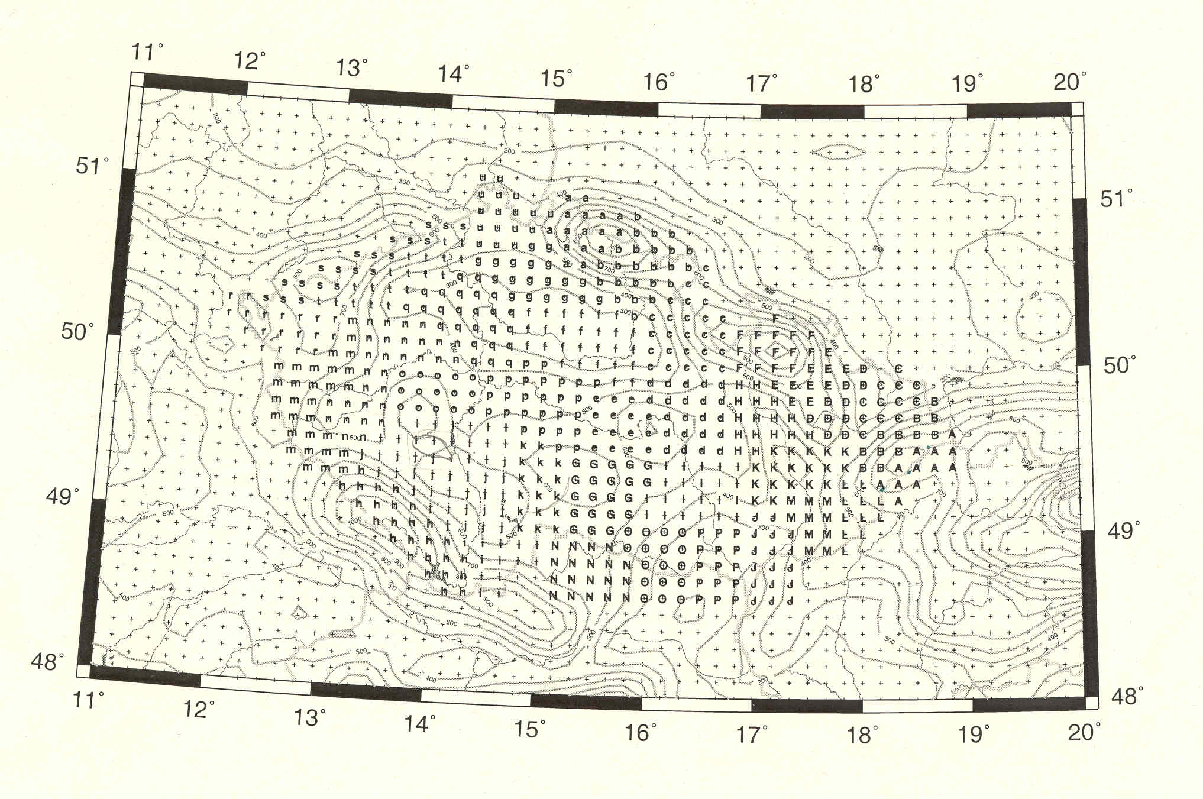
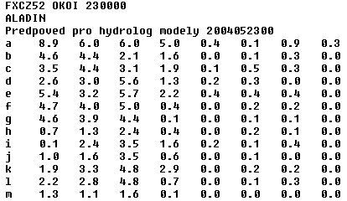
Figure 1 – Sub areas for QPF use in hydrological modeling in the Czech Republic and the preview of export txt file.

Experience of CHMI hydrologists shows the dominant role of QPF on the forecast results for basins of size up to 10 000 km².
The situation of August 2002 Flood in the Vltava River catchment is an excellent example of hydrological forecast dependency on QPF. The inflow to Orlík Reservoir (figure 2) is forecasted by RFO in České Budějovice. Colored lines represent real operational forecasts based on QPF. During the first flood period the underestimation of precipitation caused the error in hydrological forecast. Meteorologists of CHMI prepared three variants of expected precipitation before the second flood wave. The maximum variant (green) total rainfall average for south Bohemia was 145 mm while the minimum variant (yellow) 65 mm. It is evident that the dependency of QPF error and consequent error of hydrological forecast is not linear. Also the spread (uncertainty) of the possible development is very large. In such a case the probability information would be very beneficial for decision-making.
Figure 2 – Operational forecasts of Orlík reservoir inflow during 2002 Flood.

3. Probabilistic hydrological forecasting
Probabilistic hydrological forecasting and use of probabilistic QPF as its input is often discussed in works of Krzystofowitcz (2000, 2001a, 2001b, Krzystofowitcz and Herr 2001) and other authors.

Generally there are three different ways of probabilistic hydrological forecast using the QPF:

3.1. Use of QPF ensembles
Some meteorological models (for example ECMWF - European Centre for Medium Range Weather Forecast or EPS - Extended Prediction System of NWS) produce ensemble forecasts - different expected precipitation series for forecasted period. These models are mostly global models working in quite rough grid resolution. ECMWF model provides one main run, one control run (both 40 km grid) and 50 ensemble runs (80 km grid). The ensemble runs are based on the small difference in initial conditions of the atmosphere. Lead-time of the forecast is 10 days.
European Join Research Centrum in Ispra (Italy) uses selected ensembles to produce ensembles of hydrological forecast. For that purpose the distributed modeling system EFFS (European Flood Forecasting System) was developed.
The disadvantage of this method is that the grid cell of the meteorological output is quite rough and for that reason not suitable for forecasting of smaller streams and head water areas such as the Czech Republic. On the other hand its great advantage is long lead-time of the forecast.
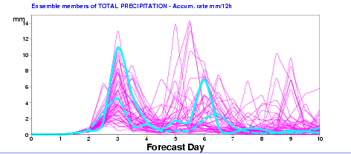
Figure 3 – Ensemble QPF of ECMWF.

3.2. Use of historical observed weather data
The principle of this method is to replace QPF by historically observed precipitation amounts for the upcoming days. For example: if we have meteorological data series from 1950 and we want to produce forecast on 1st of May 2004, than we use current initial condition of the hydrological model and historical time series. First we use data from year 1950 starting on 1st of May 1950 as one ensemble precipitation input. Analogically we process data from 1951 to 2003 what provides us 54 ensembles.
The results are clearly statistical and are valuable mainly for the longer periods (seasonal) forecast that could be use for reservoir operation decision making. The lead-time of the forecast is not limited but the longer lead-time the smaller is the effect of initial condition of the forecast and the result is becoming same as the long-term (annual) hydrologic cycle. Unfortunately this way of probabilistic forecast is not very useful for smaller streams and shorter lead-time forecast. Another limitation could be the lack of historical precipitation data. There are daily rainfall amount records of many rain gauges in the Czech Republic. However for modeling smaller streams the shorter time step resolution (1 hour) is necessary but it's available for last few years only.
Nowadays forecast of ESP system coupled with NWSRFS - the hydro forecasting system of the US National Weather Service (NWS) is operated daily to produce weekly probabilistic stream flow forecast (figure 4 and 5).
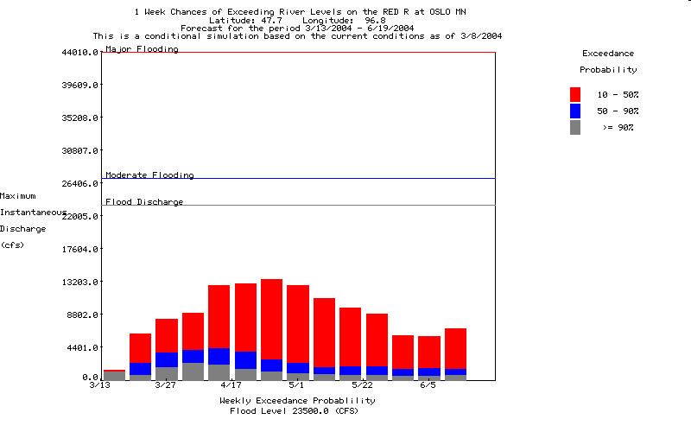

Figure 4 – Example of US NWS probabilistic stream flow forecast (http://www.nws.noaa.gov)
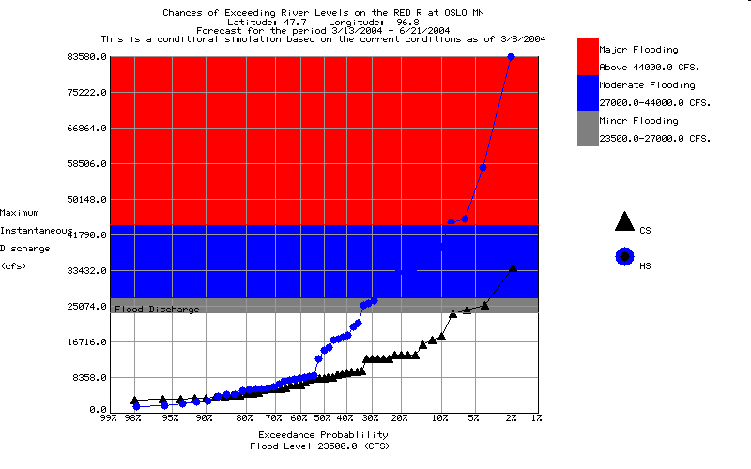
Figure 5 – Another example of US NWS probabilistic stream flow forecast (http://www.nws.noaa.gov)

3.3. Statistical processing of QPF
Deterministic QPF forecast could be evaluated and statistically processed to determine its uncertainty, bias and other statistical characteristics. Those describes the possible variation of the forecast from the observation and could be use to produce significant statistical "ensembles" from the deterministic QPF. Ensembles then input the hydrological model run accordingly to the method 1 explained above. The advantage of this method is the possibility of use of the high spatial and temporal resolution meteorological outputs what makes this method suitable for the head watershed areas including the Czech Republic.

4. Evaluation of ALADIN QPF
Some preliminary evaluation of ALADIN QPF has been made in Slovakia (Lešková, Mikuličková, 2002) and Czech Republic (Daňhelka, 2000 and 2003). Continuation of this work is in progress.

4.1. Method
Fourteen relatively small sub basins were selected for the QPF evaluation. Two of them belong to Danube River basin (Svratka River down to Borovnice and Rožnovská Bečva River down to Horní Bečva) other 12 basins belong to Vltava River basin but most of them lie in the border area with the Danube River basin.
Mean areal precipitation in six hours intervals were computed. For sub basins of Elbe River basin the AquaLog hydrological forecasting system itself was used for computation. The result was based on operational rainfall gauge network and operationally used techniques (Thiessen polygons and elevation correction). The advantage of that is the fact of comparing QPF to values to which the model is calibrated and trained. What separates the uncertainty of QPF from the other uncertainty sources (calibration etc.).
Because of different hydrological forecasting system is operated in the Czech part of Morava River basin the classical (Thiessen polygons) method had to be used for MAP computation of upper most part of Svratka River basin and Rožnovská Bečva River basin.

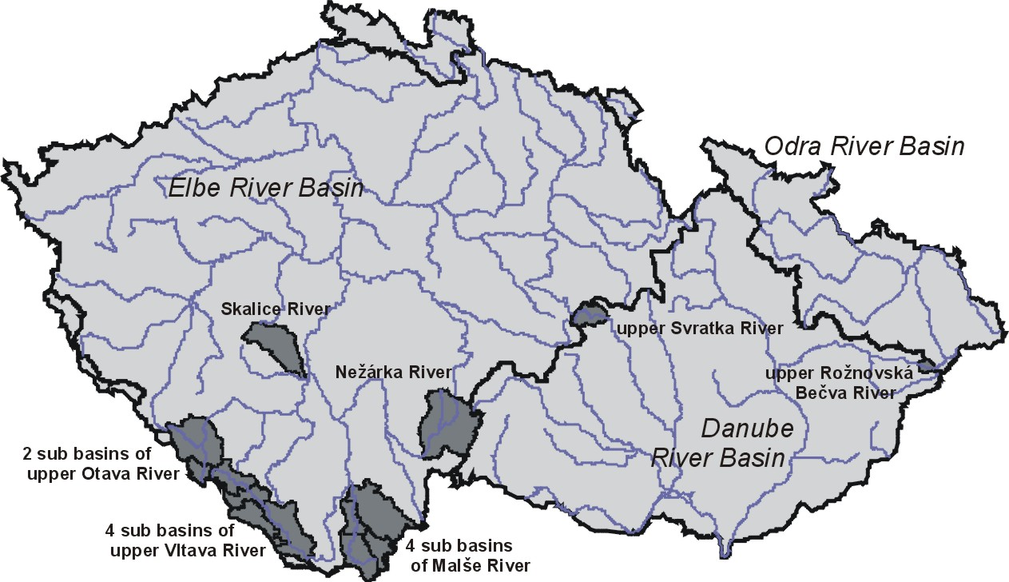
Figure 6 – Fourteen evaluated sub basins in the Czech Republic.

Delivered MAP amounts for selected sub basins were compared to six hours ALADIN's QPF for the period of 26 months (November 2001 - December 2003).
Then the absolute difference (in the case of 0 mm forecast) and relative difference (for QPF > 0 mm) were computed. Missing data were excluded as well as the cases of time bias of QPF. That was done by check all the differences higher than 500 % in the meaning of control of the previous and the next 6 hours interval QPF. If the difference of one of those intervals QPF to the observed MAP was between 50 and 200 % it was assumed that the forecast was correct in amount but shifted in time.
For all sub basins 8 time intervals of QPF were evaluated separately. Evaluation was made based on the value of QPF in seven different intervals (0; 0.1 – 0.3; 0.4 - 1.0; 1.1 – 3.0; 3.1 – 5.0 and more than 5 mm). It would be interesting to set the highest threshold to even higher value (for example 10 mm) but there wouldn't be enough members in that category for statistical processing. We assume that with the growing number of cases we would be able to use that threshold in future years.
Statistical processing of data was made and distribution functions were derived. Then the values of selected percentiles (min, 10th, 25th, median, 75th, 90th, 95th, 99th and max) were inferred from these functions for every sub basin, time interval and threshold (figure 7). That provides the information about typical error distribution. In the other words we could say that if the ALADIN’s QPF for Svratka River headwater area for lead-time 12-18 hours is 4 mm there's a 50 % probability that real precipitation would be 2.9 mm or lower, 75 % probability of 6.8 mm or lower but also 10 % probability of 8.9 mm or higher as well (figure 8).
Figure 7 – Probability of relative error exceedance for upper Svratka River Basin for all forecasting intervals.
Figure 8 – Probability of MAP exceedance if QPF is 4 mm for interval 12 – 18 h for upper Svratka River basin.

4.2. Results
Results of evaluation show that the relative value of the 90th and 75th percentile is highly dependent on the basin elevation. Another words the risk of underestimation of rainfall is higher for higher elevations (mountainous areas - upper Otava River basin, highest parts of upper Vltava River basin and upper Malše River basin). On the opposite Skalice River basin, Nežárka River basin, upper Svratka River basin, Vltava River basin around Lipno reservoir and partly lower part of Malše River basin have relatively smaller values of 90th and 75th percentile.
Evaluation shows that ALADIN overestimates the precipitation – the value of the median is always smaller than 1.0. Comparing the particular time intervals, QPF value intervals or particular basins we can talk about the relative overestimation or underestimation.
From the point of view of upper part of Rožnovská Bečva basin the QPF for area A is overestimated - also the value of 75th percentile is for higher values of QPF smaller than 1.0 for all time intervals.
Generally, highest overestimation occurs for time interval of 36 - 42 hours and also for interval 12 - 18 hours for QPF> 5 mm. These intervals accord to afternoon of second forecasted day (36 - 42 h) and afternoon of the first forecasted day (12 - 18 h). Overestimation of afternoon period may signalize overrated convective precipitation development in the model calculations. Concerning the QPF interval from 3 to 5 mm the highest overestimation was observed for period 42 – 48 h for upper Vltava River and Otava River basins. Result for Malše River basin was the same as for QPF > 5 mm.
On the other hand there's an underestimation of precipitation for the most of the evaluated basins for the morning of the first forecasted day (6 - 12 h) and for the last forecast interval (42 – 48 h). For interval 42 – 48 h the underestimation occurred for QPF > 5 mm and for QPF from 1 to 3 mm, but overestimation for QPF from 3 to 5 mm.
We expected that the higher is the QPF interval the higher will be relative value of 90th and 75th percentile. That is mostly true with except of Nežárka River basin and upper Svratka River basin. For these basins the values of selected percentiles for QPF interval from 3 to 5 mm are smaller than for interval from 1 to 3 mm. Similar situation we observed partly for the Malše River basin for intervals from 3 to 5 mm and > 5 mm.
Table 1 – Values of the 90th percentiles for QPF > 5 mm.
Closing profile | Stream | Area (km²) | Elevation (m a.s.l.) | Forecasting time interval (hours)
 |  |  |  | 0-6 | 6-12 | 12-18 | 18-24 | 24-30 | 30-36 | 36-42 | 42-48
Lenora | Studená Vltava R. | 176 | 761 | 1.63 | 1.67 | 1.83 | 1.72 | 1.56 | 1.25 | 1.41 | 2.98
Chlum | Studená Vltava R. | 164 | 731 | 1.34 | 1.44 | 2.10 | 2.21 | 1.45 | 1.01 | 1.09 | 2.44
Černý Kříž | Teplá Vltava R. | 104 | 735 | 1.30 | 1.44 | 2.27 | 1.92 | 1.47 | 0.99 | 0.99 | 2.36
Lipno | Vltava R. | 553 | 552 | 1.68 | 1.70 | 2.03 | 1.49 | 1.25 | 1.41 | 0.86 | 1.33
Líčov | Černá Brook | 126 | 585 | 1.63 | 1.48 | 2.77 | 1.92 | 1.62 | 1.99 | 2.45 | 5.79
Pořešín | Malše R. | 312 | 493 | 1.61 | 1.41 | 2.71 | 1.84 | 1.49 | 2.01 | 2.40 | 5.75
Římov | Malše R. | 57 | 419 | 1.54 | 1.43 | 2.70 | 1.72 | 1.57 | 1.91 | 2.36 | 5.37
Roudné | Malše R. | 466 | 390 | 1.19 | 1.28 | 2.48 | 1.57 | 1.53 | 1.63 | 1.86 | 4.63
Lásenice | Nežárka R. | 684 | 444 | 1.82 | 1.78 | 1.48 | 0.95 | 1.74 | 1.53 | 0.80 | 1.69
Modrava | Vydra R. | 90 | 973 | 1.61 | 2.16 | 1.35 | 1.59 | 1.81 | 1.37 | 1.20 | 3.85
Sušice | Otava R. | 446 | 466 | 1.80 | 2.29 | 1.35 | 1.64 | 2.09 | 1.43 | 1.55 | 2.92
Varvažov | Skalice R. | 367 | 380 | 1.38 | 1.43 | 0.60 | 1.40 | 0.95 | 1.17 | 0.74 | 0.86
Prostřední Bečva | Rožnovská Bečva R. | 85 | 430 | 0.84 | 1.02 | 0.77 | 0.97 | 0.87 | 1.00 | 0.86 | 1.11
Borovnice | Svatka R. | 128 | 515 | 2.10 | 1.12 | 2.21 | 1.59 | 2.32 | 0.95 | 3.41 | 0.98

4.3. Probabilistic hydrological forecast as a result of QPF evaluation
Hydrological modeling systems used for forecasting in the Czech Republic were developed for producing a deterministic hydrological forecast. But for evaluated basins we are able statistically infer few significant QPF ensembles. That could be used as alternative inputs to hydrological model. Nowadays we have to run model for every that ensemble manually and separately. This practice is quite recent and time consuming and therefore is plan to be used only in flood dangerous cases.
AquaLog system implements a semi-distributed version of Sacramento (SAC-SMA) rainfall-runoff model. To make the procedure of ensemble computing little bit easier we have defined new simplified scheme of the modeled basins with only one precipitation input for each sub basin (figure 9). For that purpose relevant MAPs computed during the standard deterministic run of the model are used as precipitation input. Then QPF ensembles extend precipitation time series for the forecasted two days period. Parameters, initial condition and other settings are taken from the deterministic run of the model to ensure the consistency of the results. That way hydrological ensembles are derived (figure 10).

One rain-gauge defined with weight = 1
Figure 9 – For all basins and zones only one precipitation input is defined in order to simplify input data management.
Figure 10 – Preview of derived hydrological probabilistic forecast.

5. Conclusion
Hydrologist - forecaster have to deal with many sources of errors and uncertainties during hydrological forecasting process. The uncertainty of QPF plays the dominant role quite often. Therefore the information about that is very beneficial. Statistical evaluation of QPF for selected basin was used to derive distribution function of the QPF error for selected areas and to generate statistical ensembles of QPF for use in hydrological forecasting. Using these ensembles hydrologist could prepare probabilistic hydrological forecast – the additional information for the end user and decision makers.
After the pilot evaluation of 14 small sub basins the same method will be applied in other important head water areas in the Czech Republic to provide QPF ensembles for the majority of the Czech rivers.
As the nowadays practice of QPF use for hydrological modeling is quite recent in the Czech Republic (since November 2001) the number of data for evaluation is growing instantly. Therefore continuing evaluation is necessary as well as later possible separate evaluation of summer and winter season.

6. References

Collier, C.G., Krzystofowitcz, R. (Eds.) (2000): Special Issue: Quantitative precipitation forecasting, Journal of Hydrology, vol. 239 (2000), Elsevier, Amsterdam, the Netherlands, p. 1 - 340

Daňhelka, J. (2000): Evaluation of precipitation forecast as an input to hydrological models, in Proceedings of Workshop 2000, September 2000, Prague, Czech Rep., (in Czech), p. 215 - 220

Daňhelka, J. (2003): Evaluation of the Quantitative Precipitation Forecast (QPF) as an Input of the Hydrological Model in the Czech Republic, Meteorological Journal (6) 1, SHMU, Bratislava, Slovakia, p 27 - 36

Grecu, M., Krajewski, W.F. (2000): A large-sample investigation of statistical procedures for radar-based short-term quantitative precipitation forecasting, Journal of Hydrology, vol. 239 (2000), special issue, Elsevier, Amsterdam, the Netherlands, p. 69 - 84

Krzystofowitcz, R. (2001a): The case for probabilistic forecasting in hydrology, Journal of Hydrology, vol. 249 (2001), Elsevier, Amsterdam, the Netherlands, p. 2 - 9

Krzystofowitcz, R. (2001b): Integrator of uncertainties for probabilistic river stage forecasting: precipitation dependent model, Journal of Hydrology, vol. 249 (2001), Elsevier, Amsterdam, the Netherlands, p. 69 - 85

Krzystofowitcz, R., Collier, C.G. (Eds.) (2004): Special Issue: Quantitative precipitation forecasting II, Journal of Hydrology, vol. 288 (2004), Elsevier, Amsterdam, the Netherlands, p. 1 - 236

Krzystofowitcz, R., Herr, H.D. (2001): Hydrologic uncertainty processor for probabilistic river stage forecasting: precipitation dependent model, Journal of Hydrology, vol. 249 (2001), Elsevier, Amsterdam, the Netherlands, p. 46 - 68

Leskova D., Mikulickova M., (2002): Quantitative Precipitation Forecasting in Hydroforecasting service, in Proceeding of conference on Participation of women in the fields of Meteorology, operational hydrology and related sciences, 16 – 17th May 2002, Bratislava, Slovak Rep., p. 198 – 202

Proceedings of International Conference on Quantitative Precipitation Forecasting (2002), Royal Meteorological Society, ECMWF, Reading, UK, 2-6 September 2002 http://www.royal-met-soc.org.uk/qpfproc.html

