ASSIMILATION OF RADAR DATA IN THE MESOSCALE NWP-MODEL OF DWD

Stefan Klink

Deutscher Wetterdienst, Offenbach a.M., Germany, e-mail: stefan.klink@dwd.de

Abstract: In the area of mesoscale modelling at DWD a very high resolution model for short term numerical weather prediction (NWP) based on the existing non-hydrostatic limited area model Lokal-Modell (LM) is under development. It is intended to run this NWP-model every 3 hours with a forecasting range of 18 hours. One reason for this design of the NWP model cycle is to provide the hydrological models of flood forecasting systems with input data with a high update rate. Especially to improve the quantitative precipitation forecasting (QPF) work has to be done in the area of data analysis. In addition to the assimilation of conventional data, like surface and radiosonde measurements, high-resolution observations derived from radar networks are introduced in the nudging-type assimilation of the LM. In the framework of the project RADVOR-OP funded by a working group of the hydrological authorities of the German federal states the use of radar data in the assimilation scheme of the LM will be made operational. Using the “Latent Heat Nudging” (LHN) technique the thermodynamic quantities of the atmospheric model are adjusted in that way, that the modeled precipitation rates resemble the observed precipitation rates.
Several basic investigations of the LHN algorithm have been carried out for a convective event, which caused flooding events in different river catchments. This event should be considered as an example. The results from these experiments show that precipitation patterns are introduced in the analysis in good agreement, both in position and amplitude, with those observed by radar. This evaluation is based on subjective assessment of the precipitation fields as well as on objective skill scores. Using a finer grid within the assimilation and the forecast simulation shows a potential for further improvements of the quantitative precipitation forecast. An additional adjustment of specific humidity (corresponding to the temperature increments) during the LHN leads to a better assimilation of newly developing thunderstorms and to a more realistic free forecast afterwards. The influence of the assimilation of radar derived precipitation rates lasts for several hours.
Keywords: data assimilation, mesoscale modelling, latent heat nudging, quantitative precipitation forecasting, radar data, flood forecasting

ASSIMILATION VON RADARDATEN IN DAS MESOSKALIGE NWV-MODEL DES DWD

Zusammenfassung: Im Bereich der mesoskaligen Modellierung wird beim DWD ein sehr hoch auflösendes Modell, basierend auf dem bereits existierenden nicht-hydrostatischen Ausschnittsmodell „Lokal-Modell“ (LM), für die kürzestfristige numerische Wettervorhersage (NWV) entwickelt. Es wird beabsichtigt, dieses NWV-Modell alle 3 Stunden neu zu starten und jeweils einen 18stündigen Vorhersagezeitraum zu berechnen. Ein Grund für dieses Design der NWV-Modellkette ist, dass die hydrologischen Modelle der Hochwasservorhersagezentralen möglichst mit aktuellen Eingangsdaten arbeiten können. Speziell um die quantitative Niederschlagsvorhersage zu verbessern, müssen weitere Anstrengungen im Bereich der Datenassimilation unternommen werden. Zusätzlich zur Assimilation von konventionellen Daten, wie z.B. bodennahe und Radiosonden-Messungen, werden auch hochauflösende Beobachtungen von Radarnetzwerken in die Nudging-Assimilation des LM eingebracht. Im Rahmen des Projektes RADVOR-OP, das von der Länderarbeitsgemeinschaft Wasser der Ministerien für Wasserwirtschaft und Wasserrecht der deutschen Bundesländer finanziert wird, soll die Verwendung von Radardaten innerhalb des Assimilationsverfahrens des LM operationell gemacht werden. Durch den Einsatz des „Latent Heat Nudging“ (LHN)-Verfahrens werden die thermodynamischen Grössen des atmosphärischen Modells so adjustiert, dass die modellierten Niederschlagsraten den beobachteten entsprechen.
Einige grundlegende Untersuchungen des LHN-Verfahrens wurden für ein konvektives Ereignis durchgeführt, das zu Hochwasserlagen in verschiedenen Flusseinzugsgebieten führte. Dieses Ereignis sollte als Beispielfall betrachtet werden. Die Ergebnisse dieser Experimente zeigen, dass die in die Analyse eingebrachten Niederschlagsmuster gut übereinstimmen mit den durch Radar beobachteten Niederschlagsverteilungen, sowohl was deren Position als auch was deren Grösse betrifft. Diese Bewertung basiert sowohl auf subjektiven Bewertungen der Niederschlagsfelder als auch auf objektiven Skill-Scores. Die Verwendung eines feineren Modellgitters in Assimilation und freier Vorhersage zeigt die Möglichkeit der weiteren Verbesserung der quantitativen Niederschlagsvorhersage. Eine zusätzliche Adjustierung der spezifischen Feuchte (entsprechend den Temperaturinkrementen) während des LHN führt zu einer genaueren Assimilation von sich neu entwickelnden Gewittern und zu einer realistischeren darauffolgenden freien Vorhersage. Der Einfluss der Assimilation von aus Radar abgeleiteten Niederschlagsraten hält für einige Stunden an.
Schlüsselworte: Datenassimilation, mesoskalige Modellierung, Latent Heat Nudging,
quantitative Niederschlagsvorhersage, Radardaten, Hochwasservorhersage

1. Introduction
In the matter of mesoscale modelling at DWD a very high resolution model for short term numerical weather prediction based on the existing non-hydrostatic limited area model Lokal-Modell (LM) is under development. It is intended to run this LMK (LM Kürzestfrist, German: short term) every 3 hours with a forecasting range of 18 hours. This version of LM should be run with a horizontal mesh size of 2-3 km and 50 vertical layers on a domain of 1300 km x 1300 km covering Germany. One reason for this design of the NWP model cycle is to provide input data with a high update rate for the hydrological models of flood forecasting systems. Especially to improve the quantitative precipitation forecasting (QPF) work has to be done in the area of data analysis. In addition to the assimilation of conventional data, like surface and radiosonde measurements, high-resolution observations derived from radar networks are introduced in the nudging-type assimilation of the LM. During the last years different methods, including variational as well as nudging-type schemes, have been developed for the assimilation of precipitation data (Alberoni et al., 2002). In the framework of the project RADVOR-OP funded by a working group of the hydrological authorities of the German federal states the use of radar data in the assimilation scheme of the LM will be made operational.
The assimilation scheme of LM is based on the Nudging. One main feature of this 4D method is that the prognostic variables of the model are relaxed towards the observations during a characteristic time frame. An advantage of this scheme is the possibility to use asynoptic observation data for the analysis as well. Nudging works in that way, that a relaxation term is added to the prognostic model equations, so that the temporal development of an arbitrary prognostic variable $ψ(r,t)$ reads as

$\frac{∂}{∂t}ψ(\vec{r},t)=F\left(ψ(\vec{r},t)\right)+G_{ψ}⋅\sum_{k_{\text{obs}}}{W_{k}(\vec{r},t)⋅\left[ψ_{k}^{\text{obs}}−ψ({\vec{r}}_{k},t)\right]}$ (1)

In equation (1) $F$represents the complete model dynamics and physical parameterisations. The second addend on the right hand side of equation (1) is the relaxation term (i.e. the stimulation caused by observation increments). $ψ_{k}^{\text{obs}}$ is the k-th observation, which influences the gridpoint $r$at time $t$. $W_{k}$ is the appropriate observation-dependent weight and $G_{ψ}$ the so called nudging coefficient. By choice of the value for $G_{ψ}$ it is guaranteed that in practical applications the nudging term should and usually does remain smaller than the largest term of the dynamics. This situation is related to the basic idea of the method that the model fields are to be relaxed towards the observed values without significantly disturbing the dynamic balance of the model (Schraff and Hess, 2002). An disadvantage of this assimilation scheme is, that all observation data have to be transformed into one or several prognostic model variables.

2. Theory and Implementation
Contemplating an utilisation of radar reflectivities in the LM, it has to be stated, that a direct assimilation of both radar reflectivities and precipitation rates is not possible, because both quantities are no prognostic variables of the LM. Even a future prognostic treatment of precipitation in the LM would not allow a reasonable direct assimilation of precipitation rates, because there is only a small feedback from the precipitation rate to model dynamics and physics. But these two components of the model are essential for the development of precipitation. Attempts have to be done in order to assimilate radar information into the model by the use of any other prognostic variables (e.g. temperature, specific humidity or components of the wind vector). Thus a relation between precipitation rate and prognostic model variables is wanted. Concepts basing on processes, normally present in the context of precipitation, are desired. One special process connected with the formation of precipitation is the condensation of water vapour. It is directly linked to the release of latent heat. Originally, most condensation processes must be considered as the formation of cloud droplets, but this is only a preliminary stage of the precipitation forming. Nevertheless it is possible to influence the model dynamics and consequently the formation of precipitation by adjusting the model-generated latent heat release. The diabatic heating rates, which are related to phase changes of water, are tuned in that way, that the model simulates the observed precipitation rates. This is realized by adding temperature increments to the 3D temperature field. This method is called “Latent Heat Nudging“ (e.g. Wang and Warner, 1988). A basic assumption one has to consider when using the LHN algorithm is, that the vertical integrated rate of latent heat release is proportional to the precipitation rate. This assumption can be made, because raining clouds do not store more and more cloud liquid water in the course of time. It can be supposed that there is a balance between cloud forming (condensation) and cloud dissolving (precipitation) processes.
The attempt to correct these processes in the model is the addition of a LHN temperature increment to the equation describing the temperature tendency (equation 2).

$\frac{∂T}{∂t}=F(T)+\frac{∂T_{\text{Nudging}}}{∂t}+\frac{∂T_{\text{LHN}}}{∂t}$ (2)

According to the general nudging equation (1), equation (2) describes the evolution of the temperature with time. The original prognostic model equation for $T$ is expanded by an addend caused by the conventional nudging and by a contribution due to the LHN.
A LHN algorithm, which originally has been developed by Jones and Macpherson (1997), has been operationally used at the UK MetOffice since April 1996 (Macpherson, 2001). The LHN algorithm implemented in the LM is based on the scheme described in Jones and Macpherson (1997).
An inaccuracy of the above mentioned assumption –proportion between vertical integrated rate of latent heat release and precipitation rate- is the fact that only the horizontal but not the vertical distribution of the rate of latent heat release can be derived from the 2D field of observed precipitation. Thus the model-generated rates of latent heat release are read as vertical profiles from the 3D model field and are afterwards scaled. An alternative could be the use of idealised profiles of latent heat release.
The contributions to the model-generated rate of latent heat release come from the cloud scheme, the parameterisation for grid-scale rain, the nudging scheme (for conventional data) and if necessary from the convective parameterisation scheme. Because explicit simulation of convection is one aim of the development of the very high resolution model at DWD, the convective parameterisation scheme has been switched off also for the experiments concerning latent heat nudging. Then the sum of the latent heating rates $\text{LH}$, when using a one-category ice scheme, is computed as follows (cf. Doms and Schättler, 1999).

$\text{LH}=\frac{{\text{ΔT}}_{{\text{LH}}_{\text{mo}}}}{\text{Δt}}=\frac{L_{V}}{c_{p_{d}}}(S_{c}−S_{\text{ev}})+\frac{L_{S}}{c_{p_{d}}}S_{\text{dep}}+\frac{L_{F}}{c_{p_{d}}}(S_{\text{nuc}}+S_{\text{rim}}+S_{\text{frz}}−S_{\text{melt}})+{\text{ΔLH}}_{\text{Nudging}}$ (3)

In equation (3) $L_{V}$ is the latent heat of vapourization, $L_{S}$ the latent heat of sublimation, $L_{F}=L_{S}−L_{V}$ the latent heat of fusion, $Δ{\text{LH}}_{\text{Nudging}}$ the contribution of the (conventional) nudging, $c_{p_{d}}$ the specific heat of dry air at constant pressure and $Δt$ the model time step. The microphysical processes are parameterized by corresponding mass transfer rates, which are listed in Table 1.

Table 1. microphysical processes and corresponding mass transfer rates
Symbol | Definition / Description
$$S_{c}$$ | Condensation and evaporation of cloud water
$$S_{\text{ev}}$$ | Evaporation of rain in subcloud layers
$$S_{\text{dep}}$$ | Depositional growth of snow
$$S_{\text{nuc}}$$ | Initial formation of snow due to nucleation from cloud water
$$S_{\text{rim}}$$ | Accretion of cloud water by snow (riming), T < 273.16 K
$$S_{\text{frz}}$$ | Heterogenous freezing of rain to form snow, T < 273.16 K
$$S_{\text{melt}}$$ | Melting of snow to form rain, T > 273.16 K

The calculation of the LHN temperature increment ${ΔT}_{\text{LHmo}}$is performed by scaling the model-generated latent heat rate with the ratio of analysed to modeled precipitation rate and subsequent subtraction of the model-generated part (equation 4).

${ΔT}_{\text{LHN}}=\left(\frac{{\text{RR}}_{\text{ana}}}{{\text{RR}}_{\text{mo}}}−1\right)⋅{ΔT}_{\text{LHmo}}$ (4)

The analysed precipitation rate is a weighted mean of observed and modeled precipitation rate (equation 5).

${\text{RR}}_{\text{ana}}=w⋅{\text{RR}}_{\text{obs}}+(1−w)⋅{\text{RR}}_{\text{mo}}$ (5)
Thus, at gridpoints where no radar-derived precipitation rate ${\text{RR}}_{\text{obs}}$ is availabel ($w=0$), the scaling factor and consequently the LHN temperature increment are zero. In order to prevent the LHN algorithm from producing too big temperature increments, both the scaling factor itself and the temperature increments can be limited by imposing threshold values.
In the case that the model is completely dry at a certain gridpoint, generally no vertical profile of latent heat release can be read from the model, because cloud forming processes and even clouds need not be present there. Thus, a gridpoint search for gridpoints with an appropriate precipitation rate and corresponding vertical profile of latent heat release can be performed as an optional feature of the LHN algorithm. The search radius is 10 gridpoints. When the gridpoint search fails, a climatological profile of latent heat release is used. Further procedures of the LHN algorithm, which can be used optionally, are:
- vertical filtering of the profile of latent heat rate
- horizontal filtering of the profile of latent heat rate
- adjustment of the vertical profile of specific humidity

Besides the tuning of the temperature profile at a certain gridpoint, the vertical profile of specific humidity at this gridpoint can be adjusted during the LHN. Depending on the sign of the temperature increment, specific humidity q is increased in order to reach a value of 100% of relative humidity (positive temperature increment) or specific humidity is decreased in order to retain relative humidity (negative temperature increment).

3. Preparation of Radar Data
Input data for the assimilation is the 2D field of the observed precipitation rate ${\text{RR}}_{\text{obs}}$. Starting point for the provision of the LHN scheme with radar derived precipitation rates is the international composite (PI), available at DWD. The measurements of radar reflectivities gained at each individual radar site of the German radar network and at several locations in the neighbouring countries are incorporated in this product. The local reflectivity product PL of the German radar network is derived from the volume scan. The data actually used are the echos next to the ground, coded in 7 reflectivity classes. The spatial resolution of the PI, which is originally delivered in polar-stereographic projection, is 4 km x 4 km. The product is available every 15 minutes. After a conversion of the reflectivity data into a precipitation rate by a simple Z-R-relation, an interpolation of the pixel values to the desired LM grid is performed.
Investigations of the LHN-algorithm by means of idealized experiments have shown, that a high update rate of radar data would lead to more realistic nudging-analyses and subsequent forecasts (Leuenberger and Rossa, 2003). Thus and because of some other reasons, which will be mentioned below, a new radar composite basing on the DX product of DWD (spatial mesh: 1 km x 1°, time resolution 5 min) will be used as proxy data for the LHN scheme. This product will be provided by the project RADOLAN as a preliminary product of the gauge adjustment procedure, the project is dedicated to. An advantage of this product, which is derived from the precipitation scan, is the additional correction of orographic attenuation and the use of a variable Z-R-relation for the calculation of precipitation rates from echo intensities.

4. Case Study
For a selected event LM-runs on the operational domain (mesh size 7 km, 325 x 325 gridpoints, 35 vertical levels) and runs on an experimental domain (mesh size 2.8 km, 361 x 441 gridpoints, 40 vertical levels) have been carried out. Results of horizontal fields are presented on a limited evaluation domain (see Figure 1). In general the convective parameterisation scheme has been switched off, in order to give the model the chance to directly simulate convection. The provisioning of the LM with boundary data is done by the GME. After 6 hours of
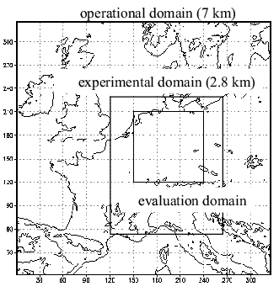
Figure 1. Domains of interest

data assimilation (nudging and latent heat nudging, including humidity adjustment during the LHN) from 6-12 UTC a free forecast lasting from 12-18 UTC has been carried out.

4.1. Overview of the Meteorological Situation
At the 28th of August 2002 Germany was influenced by only small synoptic-scale pressure gradients. In the warm, moist and unstable air mass a development of showers and thunderstorms took place in the afternoon in the area of a quasi-stationary front, which lay over Germany (see Figure 2). It was reported that heavy precipitation occured locally (e.g. 70 mm between 15.15 and 16.30 UTC in Herborn, Hesse and 85.5 mm within 4 hours in Wissen, Rheinland-Pfalz).

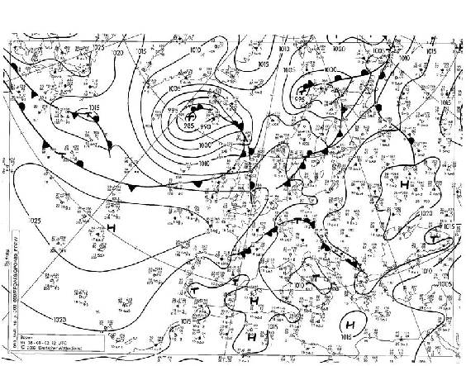
Figure 2. Meteorological situation at the 28th of August 2002, 12 UTC
4.2. Influence of the LHN on the nudging-analysis depending on the mesh size of the LM
In this paragraph three nudging-analyses, one without LHN and two with different mesh sizes (7 km, 35 vertical levels and 2.8 km, 40 vertical levels respectively) are compared with radar derived precipitation rates. The 2.8 km run was started at 21 UTC one day before by interpolating the analysis of the 7 km run to the finer mesh. Afterwards 9 hours of conventional nudging were carried out in both suites independently. This is the reason for the distinct differences between the 7 km and 2.8 km run in the first hour (6-7 UTC) of nudging and LHN (see Figure 4a). The simulation on the finer grid contains in this case not so much erroneous precipitation as the corresponding run on the 7 km grid. Thus the LHN algorithm has not to remove much misplaced precipitation from the run but mainly has to insert observed precipitation at points where the model does not simulate precipitation so far. In the first hour of LHN this works much better on the finer grid than on the operational one. Throughout the next two hours the assimilation of observed precipitation rates turns out well in both LHN runs. In contrast with these LHN suites the control run shows a more extended area of precipitation, which is shifted moreover to the southeast. After that the convection weakens over a wide range (except Bavarian forest, compare with Radar 10-11 UTC (Figure 4d)). But the convergence line remains in the Radar as well as in the LHN assimilation runs. During the last hour of assimilation from 11 to 12 UTC a revival of the convection can be observed in the Radar and in the LHN runs respectively but not in the control run. The assimilation of small convection cells e.g. in the Thuringian forest naturally works better in the 2.8 km run than in the 7 km run. All in all, the LHN experiments show precipitation patterns which fit much better to the corresponding radar derived observations than the control experiments without LHN (see Figure 4e). The hit rate for hourly precipitation sums (threshold 0.1 mm) reaches at the end of the assimilation period values, which are on an average 30 % higher than those of the control experiments (see Figure 3).

Figure 3. Hit Rate (left) and False Alarm Rate (right) in hourly precipitation sums
for different runs

At the beginning of the free forecast the convective cells are strongly intensifying in both LHN runs. The simulated intensities of precipitation reach maxima, which are clearly above the corresponding observations (see Figur 5a, 12-13 UTC). At the same time the convective cells remain strongly limited in their horizontal extension. The control run shows at this stage a further weakening of precipitation in contrast with the radar measurements. Throughout the third hour of free forecast the LM runs basing on LHN assimilations still have more forecast skill than the control run. This is especially true for the total amount of precipitation in the evaluation domain. But inaccuracies already occur in the correct position and intensity of single convection cells.
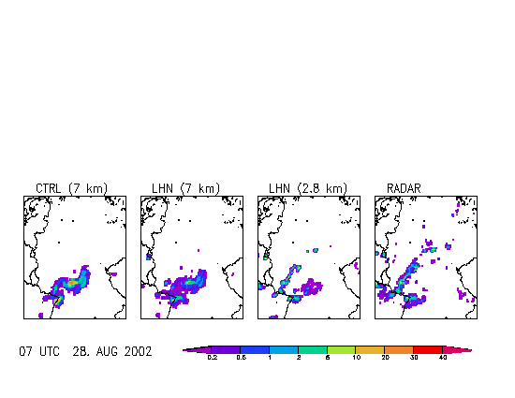
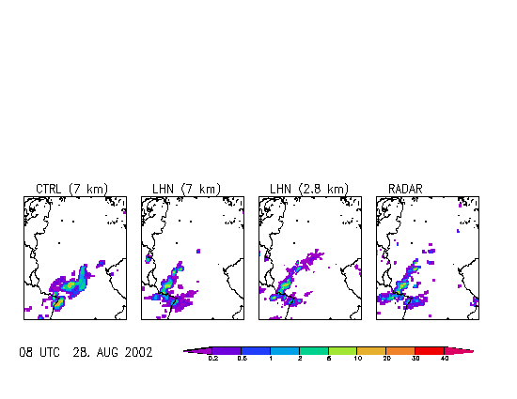
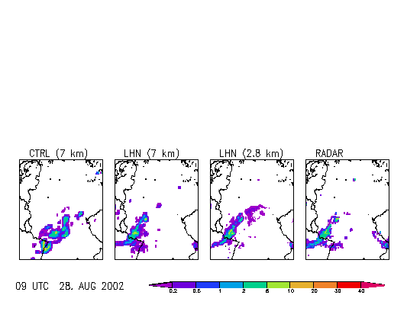
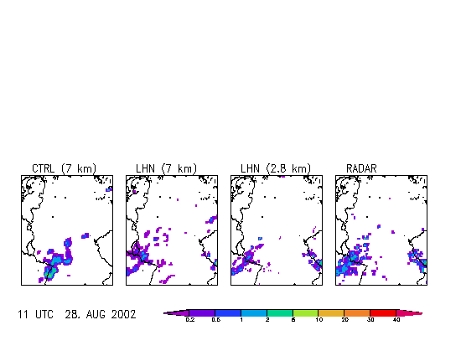
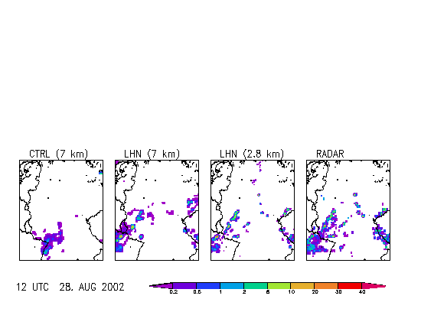
........................................................................................................................
hourly sums of precipitation in mm
Figure 4. Influence of the LHN on the nudging-analysis depending on the mesh size of the LM, assimilation (1st column: CTRL (7 km), 2nd column: LHN (7 km), 3rd column: LHN (2.8 km), 4th column: Radar)
CTRL (7 km) LHN (7 km) LHN (2.8 km) Radar
a) 06-07 UTC August 28, 2002
b) 07-08 UTC August 28, 2002
d) 10-11 UTC August 28, 2002
e) 11-12 UTC August 28, 2002
c) 08-09 UTC August 28, 2002
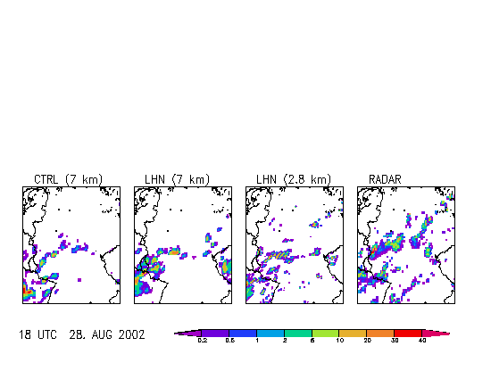
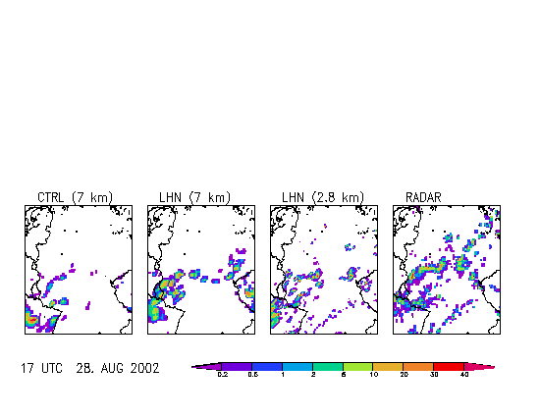
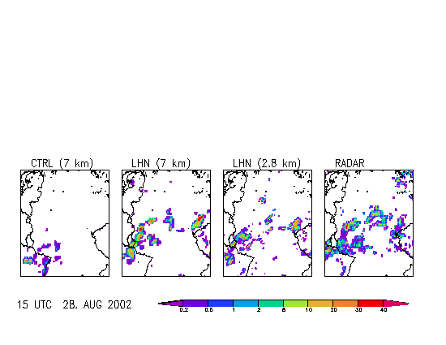
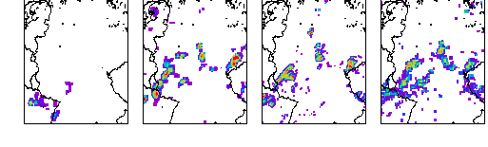
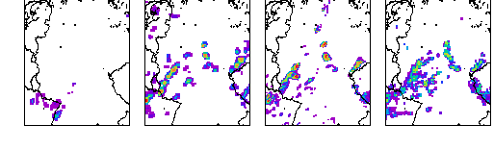
e) 17-18 UTC August 28, 2002
d) 16-17 UTC August 28, 2002
........................................................................................................................
CTRL (7 km) LHN (7 km) LHN (2.8 km) Radar
hourly sums of precipitation in mm
Figure 5. Influence of the LHN on the nudging-analysis depending on the mesh size of the LM, free forecast (1st column: CTRL (7 km), 2nd column: LHN (7 km), 3rd column: LHN (2.8 km), 4th column: Radar)
c) 14-15 UTC August 28, 2002
a) 12-13 UTC August 28, 2002
b) 13-14 UTC August 28, 2002

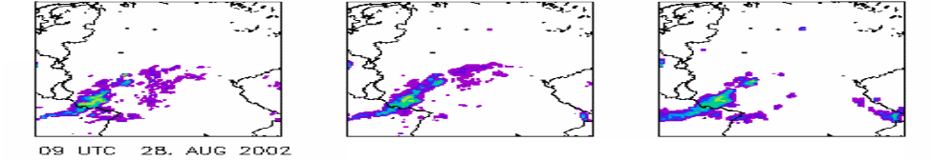
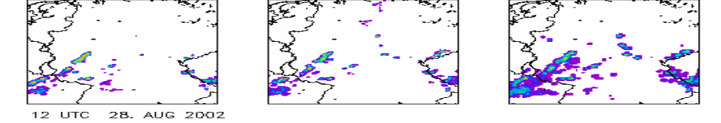
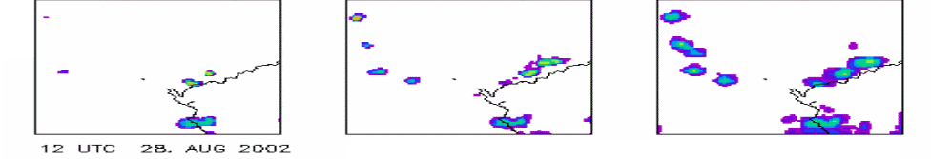
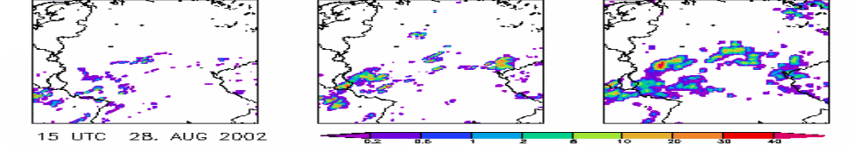
without hum. adj. with hum. adj. Radar
hourly sums of precipitation in mm
a) 08-09 UTC August 28, 2002
b) 11-12 UTC August 28, 2002
c) 11-12 UTC August 28, 2002 (zoom)
d) 14-15 UTC August 28, 2002
Figure 6. Sensitivity of LHN concerning humidity adjustment, (1st column: without humidity adjustment, 2nd column: with humidity adjustment, 3rd column: Radar)

An interesting aspect is the occurence of small convective cells over the mountain ranges of Swabian and Franconian Alb between 16 and 18 UTC. Besides the radar only the 2.8 km run shows these structures. Altogether the precipitation patterns of all three LM simulations resemble to each other more than to the radar observation in the sixth hour (17-18 UTC) of free forecast (see Figure 5e). This is also caused by the fact, that within this hour the convergence line, which has been introduced in the LHN-runs some hours earlier, is been developed even in the control experiment.

4.3. Sensitivity of LHN concerning humidity adjustment
Two LM runs have been carried out on the experimental domain (mesh size 2.8 km), one run with humidity adjustment during the LHN, the other one without. After three hours of nudging and simultaneous LHN both runs already show a good correspondence between their precipitation patterns and the distribution given by the radar observations (see Figure 6a). While the position of the precipitation maxima is assimilated quite well, there are problems in areas with low precipitation rates. Especially the assimilation run without humidity adjustment still depicts wide areas with weak precipitation between 8 and 9 UTC, which already have been misplaced in the analysis at 6 UTC (compare to Figure 4a) and could not be dried up completely throughout the following three hours. After another three hours of assimilation, i.e. within the last hour of nudging and LHN, the position of the convergence line over western Germany is reproduced well by both assimilation runs (see Figure 6b). At a first glance the two assimilation runs do not seem to differ much. But when zooming in the area of Thuringian forest and in the mountains of “Erz- and Fichtelgebirge“ (see Figure 6c), it can be seen, that the assimilation of the newly developing thunderstorms works better in the case of additional humidity adjustment. After three hours of free forecast, again the run with humidity adjustment during the LHN shows more realistic precipitation patterns than the corresponding run without humidity adjustment (see Figure 6d). This is especially true when concerning the intensity but lesser in case of the position of the maxima of the predicted precipitation fields. Both simulations have in common, that the horizontal extension of precipitation patterns is much smaller than in the corresponding radar observations. The total amount of precipitation (integrated over the evaluation domain) is too small in the forecasts compared to the radar observation.

5. Summary and Outlook
Incorporating the LHN-algorithm in the nudging-type analysis scheme of the LM makes it possible to assimilate the radar-derived precipitation rates during the assimilation runs very well. Experiments have shown that the explicit simulation of convection leads to more realistic results than model runs with parameterized convection. Using a finer grid within the simulation shows a potential for further improvements of the quantitative precipitation forecast. An additional humidity adjustment during the LHN results in a more exact analysis of the atmospheric state and in more realistic free forecasts.

6. References
Alberoni, P. P., V. Ducrocq, G. Gregoric, G. Haase, I. Holleman, M. Lindskog, B. Macpherson, M. Nuret und A. Rossa, 2001: Quality and Assimilation of Radar Data for NWP –a Review, available at http://www.smhi.se/cost717/
Jones, C. D. und B. Macpherson, 1997: A Latent Heat Nudging Scheme for the Assimilation of Precipitation Data into an Operational Mesoscale Model. Meteorol. Appl., 4, 269-277
Leuenberger, D. and A.M. Rossa, 2003: Assimilation of Radar Information in aLMo. Oral presentation, 5th General COSMO-Meeting, Sep. 2003, Langen (Germany)
Macpherson, B., 2001: Operational Experience with Assimilation of Rainfall Data in the Met Office Mesoscale Model. Meteorol. Atmos. Phys., 76, 3-8
Schraff, C. und R. Hess, 2002: Datenassimilation für das LM, in promet –Meteorologische Fortbildung, 27. Jg., Heft 3/4, 156-164
Wang W. and T.T. Warner, 1988: Use of Four-Dimensional Data Assimilation by Newtonian Relaxation and Latent-Heat Forcing to Improve a Mesoscale-Model Pricipitation Forecast: A Case Study. Monthly Weather Review, 116, 2593-2613.

