UNCERTAINTY OF PREDICTED PRECIPITATION AND ITS CONSEQUENCES IN HYDROLOGICAL MODELLING

Mira Kobold, Kay Sušelj

Environmental Agency of the Republic of Slovenia, Ljubljana, Slovenia,
e-mail: mira.kobold@gov.si; kay.suselj@gov.si

Abstract: The hydrological forecasts and warnings issued for flood protection are depending on measured and forecasted precipitation. The torrential nature of streams and fast runoff are characteristic for the most of the Slovenian rivers, and the distribution of rainfall has high influence to the runoff. The lag time between rainfall and runoff is about few hours or even less and measured on-line data are used only for now-casting. The predicted precipitation is necessary for short-term hydrological forecast. The global ECMWF model gives general forecast for several days ahead while more detailed precipitation data with ALADIN/SI model covering Slovenia are available for two days ahead. The variability of precipitation is very high in Slovenia. Therefore the verification of ECMWF predicted precipitation for Slovenian territory was performed. The results show that ECMWF model can predict precipitation events correctly, but it is unable to predict amount of precipitation correctly. The predictions of limited area ALADIN/SI model show greater applicability in hydrological forecasting. Hydrological models are tools for generating of runoff. The HBV model was tested on the Savinja River basin as contribution in EFFS project. The HBV models with time steps of one day and one hour show the applicability of the models for hydrological purposes.
Keywords: predicted precipitation, ECMWF, ALADIN/SI, hydrological modelling, flood forecasting, rainfall-runoff, HBV

DIE UNZUVERLÄSSIGKEIT DER NIEDERSCHLAGSPROGNOSEN UND IHRE KONSEQUENZEN IN HYDROLOGISCHER MODELLIERUNG

Zusammenfassung: Die für den Hochwasserschutz gelieferten hydrologishen Prognosen sind von dem gemessenen und prognostizierten Niederschlägen abhängig. Für meisten slowenischen Flüsse sind Wildbäche und schnelle Strömung charakteristisch. Die Niederschläge steuern einen hohen Anteil der Abflußmengen bei und die Zeitverzögerung zwischen Niederschlag und Abfluß beträgt oft nur einige Stunden. Daher können die Niederschlagsprognosen lediglich für kurzzeitige hydrologischen Prognosen angewendet werden. Das ECMWF Globalmodell gibt eine allgemeine Prognose für einige Tage im voraus, während genauere Niederschlagsdaten des ALADIN/SI für Slowenien für zwei Tage im voraus prognostiziert werden können. Die Niederschlagsprognose des ECMWF Globalmodells für Slowenien wurde geprüft. Die Ergebnise der Analyse zeigen, daß die Niederschlagsereignisse vom ECMWF Modell zwar richtig prognostiziert wurden, daß jedoch die Niederschlagsmengen im allgemeinen unterschätzt wurden. Die Niederschlagsprognosen des ALADIN/SI Modell zeigen bei den hydrologischen Prognosen einen weiten Anwendungsbereich. Die hydrologischen Modelle sind Hilfsmittel für die Abflußrechnung. Das HBV Modell wurde für das Savinja-Flußgebiet eingesetzt und kalibriert. Die HBV Modelle mit Zeitschritten von einem Tag und von einer Stunde beweisen ihre Anwendbarkeit in der Hydrologie.
Schlüsselworte: Niederschlagsprognose, ECMWF, ALADIN/SI, Hydrologische Modellierung, Hochwasserprognose, Niederschlag-Abfluß, HBV

1. Introduction
Slovenia lies on southern part of Alps with peaks up to 2800 meters. It has various orography causing very heterogeneous climatic conditions. Intensity of precipitation varies a lot over the country. The mean annual precipitation is 1570 mm, varying from 750 mm in the northeastern plain areas of Prekmurje to more than 3000 mm in the northwest in Julian Alps. Orography strongly influences on the amount of precipitation. The combination of frontal precipitation enhanced by orographic influence plays the most important role in the case of strong events. Specific orography of mountainous produces some dominant paths of storm movements and therefore causes different precipitation-climatic conditions. Slovenia is situated on head part of watersheds and runoff water is quickly collected and discharged across the country border within a day. Exceptions are the Drava and Mura Rivers with head part of watershed in high Alpine Mountainous in Austria. 81% of the territory of Slovenia (16400 km²) drains into the Danube River and the rest (3850 km²) into the Adriatic Sea.
Floods in Slovenia are occurred all over a year, but mostly and the heaviest are in spring and autumn time. Flash floods with hard torrent erosion are yearly events. Floods can threaten human life and property and cause great economic damage. They are becoming more common natural disasters in most parts of Europe (EEA, 2001). Flooding is on the rise, and part of the blame lies in climate change, which has triggered heavier precipitation in parts of the Northern Hemisphere (WMO, 2004). Two main groups of meteorological events generating floods can be distinguished in Europe by the European Environmental Agency. First belongs to floods in large river basins and covering wide areas. Wide-ranging and continuous precipitation is commonly the main factor in flood generation. Hydrographs are normally broad-based and peak discharges may last a number of days. The second are flash floods which are usually associated with isolated and localised very intense rainfall events occurring in small and medium-sized basins. Peak discharges are maintained only for hours or event minutes. Flash floods are typical for rivers originating in mountains.
Flood forecasting and warnings are necessary to reduce flood damages and save lives. A large variety of mathematical models exist to simulate runoff process with various degree of complexity, from simple empirical formulae or correlations to the complex mathematical models representing all phases of water balance in a river basin (WMO, 1994; Singh, 1995). Beside regression models, the HEC-1 model (HEC-1, 1990) has been used for flood forecasting and analytical purposes in Slovenian hydrological forecasting service (Kobold and Sušnik, 2000). The EFFS (European Flood Forecasting System) project (EFFS, 2003) gave the opportunity to test the HBV model (Bergström, 1995). The Savinja River basin, one of the most flood threatened region in Slovenia, was chosen as a test basin in the project. In flood forecasting, the predicted precipitation can be input into the rainfall-runoff models. Currently, predicted precipitation from four weather models with very different domain, spatial and time resolution is available at the Agency of the Republic of Slovenia. Results from two global models (ECMWF and DWD/GM) and two limited area models (ALADIN/SI and DWD/LM) are available each day. The uncertainty of predicted precipitation is still very large for hydrological purposes. The verification of ECMWF predicted precipitation for some relatively strong precipitation events was performed during the duration of EFFS project.

2. Verification of ECMWF predicted precipitation over Slovenian region
The verification of predicted precipitation by ECMWF model was performed for high precipitation events chosen from EFFS events (EFFS, 2002). EFFS events (December 1, 1994 - February 2, 1995; June 25, 1997 - July 31, 1997; October 15, 1994 - November 15, 1994) have been selected to cover some larger floods caused by major European rivers. Unfortunately, these events do not match with large flood event in Slovenian region. The ECMWF predicted precipitation was compared to interpolated measured precipitation. Data from meteorological stations covering Slovenia were interpolated on a 1 km grid using standard kriging procedure (Kastelec, 2001) and then averaged on the ECMWF grid. Analysis of precipitation was done in two steps. First, some three to six day’s precipitation events have been selected from EFFS events. The amount of predicted precipitation and delays of ECMWF predicted precipitation have been analysed. Convective precipitation events have not been analysed because ECMWF model cannot predict these events correctly.

2.1. ECMWF numerical weather prediction model
ECMWF (European Centre for Medium-Range Weather Forecast; Reading, UK) is operationally running global circulation model. It has grid resolution of 0.5°. In the first part of analysis verification was performed over all Slovenian region, while in the second part verification was performed only on 10 grid points indicated in Figure 1. Figure 1 is drawn in latitude/longitude projection.

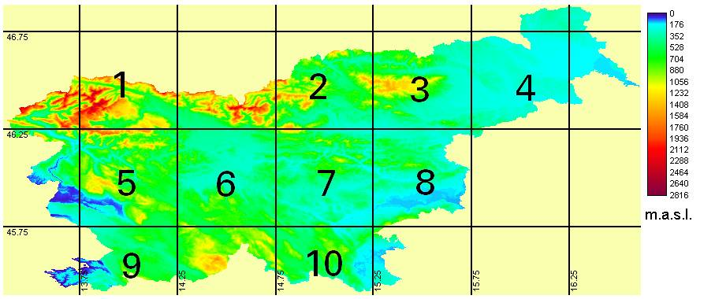
Figure 1. ECMWF grid points and relief of Slovenia.

ECMWF model runs every day using data from 12 UTC. Results are available for 240 hours in advance. Most of meteorological stations measure precipitation daily, at 6 UTC. For comparing interpolated measured precipitation and ECMWF predicted precipitation suitable time intervals have been used:
ECMWF-2: precipitation forecast between +18 and +42 hours ahead
ECMWF-3: precipitation forecast between +42 and +66 hours ahead
ECMWF-4: precipitation forecast between +66 and +90 hours ahead
ECMWF-5: precipitation forecast between +90 and +114 hours ahead

The maximum of precipitation lies in the northwest of the country in Julian Alps. Location of maximum precipitation depends on wind direction and wind shearing (Vrhovec et al., 2003). Orography strongly influences all types of precipitation. High precipitation events in Slovenia are usually occurred when cold front passes central Europe and northern Slovenia gets the most precipitation, or when Genoa cyclone passes Slovenia and north-west part of Slovenia gets the most precipitation, or in the case of convective precipitation when the amount and spatial distribution are unpredictable.

2.2. Comparison of measured and ECMWF predicted precipitation for few days events
For three to six days events analysis of ECMWF prediction was preformed. Average cumulative measured precipitation was compared with average cumulative predicted precipitation (ECMWF-2) for Slovenia region (Figure 2). It can be seen that ECMWF model underestimates the amount of precipitation in all cases. Factor of underestimation (average measured precipitations divided by average precipitation from ECMWF model) ranges from 1.4 to 5.6 and has a mean value of 2.8. However, ECMWF model predicts existence of precipitation events correctly since the rise in both lines is simultaneous.

Figure 2. Cumulative measured and ECMWF predicted precipitation (average over Slovenia) for some events.

2.3. Comparison of measured and ECMWF predicted precipitation for one day events
First step of analysis was the comparison of interpolated measured precipitation and ECMWF predicted precipitation for different time intervals. The relative difference between predicted and measured precipitation was calculated by equation 1 and it is shown in Figure 3:
$Δ{\text{RR}}_{\text{rel}}=\left\langle \frac{{\text{RR}}_{\text{meas}}−{\text{RR}}_{\text{mod}}}{{\text{RR}}_{\text{meas}}}\right\rangle ∗\text{100}$ (1)

where RR_{meas} is average measured precipitation inside one ECMWF grid point, RR_{mod} is model output for grid point and denotes averaging by grid points.

Figure 3. Relative difference between modelled and measured precipitation for different time intervals.

The bias of precipitation forecast in most cases decreases when time intervals are closer to measured precipitation. Event 28 June 1997 is exception because it is convective case. ECMWF model tends to underestimate amount of precipitation. The shorter time range forecast usually gives smaller deviation. The underestimation is between 35% and 85%, and average bias is about 60%.
For further analyses only precipitation of the closest time interval (ECMWF-2) was taken into account. Predicted precipitation was compared with measured amount of precipitation. Precipitation was averaged by grid points covering Slovenia for one-day events (Figure 4) to show model bias during each event. There is no regularity in Figure 4. However, the amount of ECMWF predicted precipitation is much smaller than measured precipitation. Model bias varies from 5 mm to 40 mm.

Figure 4. Amount of precipitation for one-day events averaged by grid points.

Precipitation was also averaged over events to see regions where ECMWF model gives better results (Figure 5). It is evident that the greatest deviations are on region with at least precipitation (grid points 3, 4 and 8 in Figure 1). On the areas with the most precipitation in Slovenia (grid points 1, 5 and 6 in Figure 1) ECMWF model behaves better.

Figure 5. Measured and ECMWF precipitation averaged by one-day events.

The verification has shown that the ECMWF model predicts precipitation events correctly, however it is unable to correctly predict the distribution and amount of precipitation. The comparison of measured and ECMWF predicted precipitation amount of chosen precipitation events has shown that the ECMWF model underestimates the precipitation amount in general. The underestimation is higher in the mountainous western part of the country. There were no regions in Slovenia where ECMWF overestimates the precipitation amount.

3. Hydrological modelling and flood forecasting
In the frame of EFFS project the HBV model was set up and calibrated for the Savinja River test basin. The Savinja basin is very often affected by exceptional precipitation amounts and intensities leading to relatively frequent high water events. It is situated in northeast of Slovenia with drainage area of 1848 km² (Figure 6). It is the largest tributary of the Sava River, main Slovenian watercourse. The upper part of the basin extends over the eastern Karavanke and the Savinja Alps with peaks higher than 2000 meters. The middle reach of the Savinja is mostly plain area with altitudes between 200 and 400 meters. The mean annual precipitation is about 2000 mm in the upper part and about 1300 mm in the lower part of the basin. The basin is mainly forested, especially in mountainous and hilly areas. Forest covers nearly 60% of the basin. There are several soil types, i.e. mainly shallow soil on the limestone bedrock or very permeable alluvial coarse gravel formations. The alluvial plains and the bottom of the river valleys are densely populated and used mainly for agriculture. These areas are the most affected in floods.
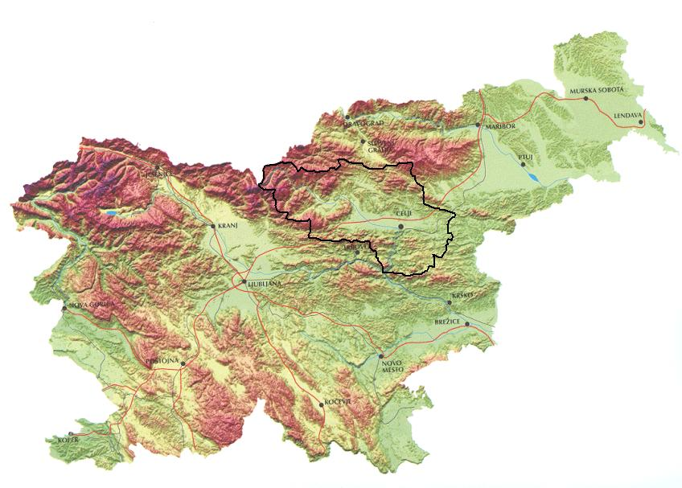
A u s t r i a
Figure 6. Relief of the Savinja basin.

Two HBV models were set up for the Savinja basin: a model with daily data and a model with hourly data. The time step in the HBV model is usually one day. But in Slovenia, the occurrence of flash flood caused by intense precipitation especially in mountainous parts is very frequent. Flood events are short time duration of one or two days. Timing of floods in hourly basis is of high importance and essential for flood warnings. Because of these specific hydrological characteristics the shorter time step of one hour was chosen.

3.1. Description of HBV model
The HBV model, version of HBV-96 (Lindström et al., 1997, IHMS, 1999), is a semi-distributed conceptual rainfall-runoff model for continuous calculation of runoff, developed by Swedish Meteorological and Hydrological Institute. The model consists of subroutines for snow accumulation and melt, a soil moisture accounting procedure, routines for runoff generation and a routing procedure. Input data are precipitation, air temperature and potential evapotranspiration. Normally, monthly standard values of potential evapotranspiration are sufficient. The principal output is discharge, however the other output variables relating to water balance components (precipitation, evapotranspiration, soil moisture, water storage) are available from the model. The model has a number of parameters, values of which are estimated by calibration. There are also parameters describing the geographical characteristics of the basin. The basin can be separated into a number of subbasins and for each one of these a subdivision into elevation zones can be made. Each elevation zone can further be divided into different vegetation zones (forested and non-forested area). The calibrated model can be used for hydrological forecasting in two ways: short-range forecast and longe-range forecast.
In the year 2003, the HBV model was tested on the Savinja River test basin as research contribution in EFFS project (EFFS, 2003). Two HBV models were set up for the Savinja basin: a model with daily data (Figure 7) and a model with hourly data (Figure 8). The time step in HBV model is usually one day (Bergström, 1995). But the occurrence of flash flood caused by intense precipitation especially in mountainous parts is very frequent. The lag time between rainfall and runoff is usually less than six hours. Because of these specific hydrological characteristics the time step of one hour was used in calibration of HBV model. The basin was divided into two subbasins regarding the most important hydrological gauging stations Nazarje and Veliko Širje. The area of subbasin to Nazarje collects water from 457.3 km², and remaining part to Veliko Širje, which is close to the outlet, from 1384.6 km². The average elevation of the upper subbasin is 940 m a.s.l., and lower one of 490 m a.s.l. Ten raingauge stations and two temperature stations (No. 268, 296) were taken to cover the basin with daily data (Figure 7). Monthly values of evapotranspiration were available for the temperature stations. For the model with hourly data only five recording raingauges to get hourly data are available on the Savinja basin and its closeness (Figure 8).
Figure 7. Representation of the Savinja basin for daily HBV model.

Figure 8. Distribution of recording raingauges on the Savinja basin for hourly HBV model.

3.2. Calibration and verification of HBV model with daily data
The measure of agreement between observed (Q_{obs}) and simulated (Q_{sim}) runoff is Nash Sutcliffe efficiency criterion, R² (Bergström, 1995), expressed as

$R^{2}=1−\frac{\sum{{\left(Q_{\text{sim}}−Q_{\text{obs}}\right)}^{2}}}{\sum{{\left(Q_{\text{obs}}−\overline{Q_{\text{obs}}}\right)}^{2}}}$ (2)

The value of R² above 0.8 means good fit of simulated and measured hydrographs. The calibration of the model for period October 1993 – December 1998 gave the value of R² 0.80 for Nazarje and 0.79 for Veliko Širje (Figure 9).

Figure 9. Calibration of HBV model with daily data for gauging stations Nazarje and Veliko Širje.

Verification of the model was done for period 1999-2002. R² is equal 0.85 for Nazarje and 0.84 for Veliko Širje (Figure 10).

Figure 10. Verification of HBV model with daily data.

The results have shown that the HBV model with time step of one day could be used for filling up the missing data and/or for daily hydrological forecasting.

3.3. Results of HBV model with time step of one hour
The hourly values of hydrological and meteorological data for period 1998-1999 were used to calibrate the model of the Savinja basin with time step of one hour (Figure 8). The calibration of the model gave the value of R² 0.76 for Nazarje and 0.86 for Veliko Širje (Figure 11). The results of calibration show greater deviations in upper subbasin which is mostly mountainous with strong orographic influences. However, five recording raingauge stations, from which only two are located inside the basin, are not sufficient to describe the precipitation correctly. The distribution of precipitation in upper part of the basin can vary a lot. The floods are commonly caused by intense frontal precipitation coming from west combined with orographic influences. In spite of small number of recording raingauges in the basin, the calibration of the model is quite satisfactory.

Figure 11. Calibration of HBV model with hourly data.

The year 2002 was used for verification of HBV model with hourly data. The results of verification are shown for Veliko Širje (Figure 12). The verification has shown that the model is convenient for using it in hydrological forecasting. It is needed to stress that recording raingauges do not give the values of precipitation in the case of snowfall and the model is not well calibrated for winter season. Most floods in Slovenia are caused in autumn, so the model could be used for hydrological forecasting.

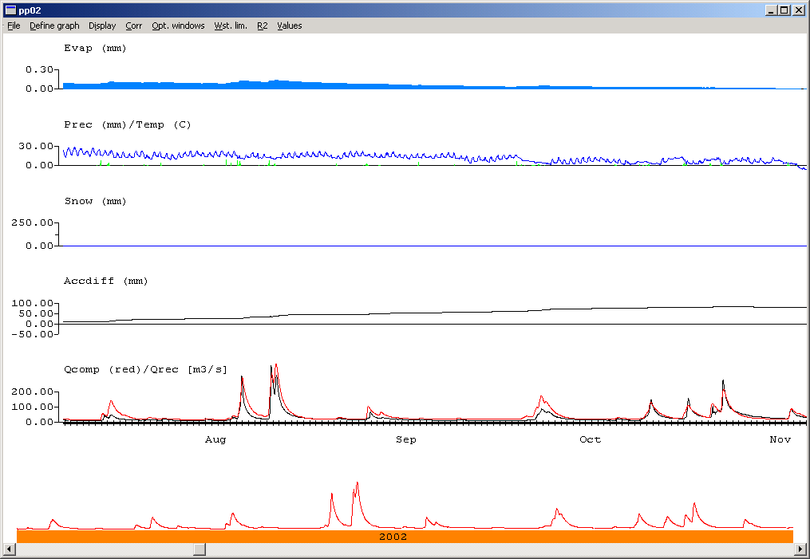
Figure 12. Verification of hourly HBV model for Veliko Širje.

4. Flood forecasting with predicted precipitation
The predicted precipitation can be input into the rainfall-runoff models used for flood forecasting. The global ECMWF model gives general forecast for several days ahead while more detailed precipitation data with ALADIN/SI model covering Slovenia are available for two days ahead. The verification of ECMWF predicted precipitation has shown that ECMWF model underestimates amount of precipitation for Slovenian territory in general. The average underestimation is about 60%. ECMWF model can predict precipitation events correctly, but it is unable to predict the distribution and amount of precipitation correctly. There was no sense to make hydrological simulations with these forecasts. The predicted precipitation of limited area ALADIN/SI model was used in analysis. The predictions of ALADIN/SI model show greater applicability in hydrological forecasting (Brilly et al., 2000). The ALADIN/SI forecast of meteorological parameter fields is made in high spatial resolution of 11 km over a domain covering the eastern Alpine and northern Adriatic regions (Vrhovec et al., 1998). The model is operational and run twice a day.
The analysis with predicted precipitation of limited area ALADIN/SI model was done for two high water events of August 5 to August 8, 2002 and August 10 to August 13, 2002. The cumulative precipitation of analysed events on the Savinja basin from ALADIN/SI model and simulated hydrographs for the Savinja River at Veliko Širje are presented in Figure 13 and Figure 14. For comparison, the areal cumulative measured precipitation on the basin and measured hydrographs are presented for those events. The simulated hydrographs from measured precipitation are also presented.

Figure 13. Cumulative precipitation on the Savinja basin, and measured and simulated hydrographs at Veliko Širje for August 5 to August 8, 2002.

Figure 14. Cumulative precipitation on the Savinja basin, and measured and simulated hydrographs at Veliko Širje for August 10 to August 13, 2002.

In first event, first run of ALADIN/SI model has underestimated the precipitation amount and there is not evident that the runoff would be high increased in the next day. Second run has predicted the precipitation amount with a little time delay. Simulated hydrograph show high water event similar measured one, with some hours delay. In second event, the amount and time distribution of precipitation were close to the measurements, but next model run gave greater temporal deviation as well lower amount of precipitation and consequently underestimated runoff.
It is clear that HBV model with time step of one hour is suitable for hydrological forecasting and can be used in pre-warning system. But for the time being the uncertainty of predicted precipitation is still very large and that make flood forecasting and warning much risky. If spatial and time distribution of forecasted precipitation is accurate enough with known uncertainty then hydrological models can aid to give advance warning of potential flooding.

5. Conclusions
Weather forecasts coupled with information on river basin character and hydrological rainfall-runoff model offer an advance warning of potential flooding. The performed analyses have shown that the uncertainty of ECMWF predicted precipitation is very large for Slovenian territory. The variability of precipitation is very high in Slovenia and ECMWF model with resolution of 0.5° cannot properly describe it. The ECMWF model can predict precipitation events correctly, but underestimates precipitation amount in general. The average underestimation is about 60%. More precipitation events should be included into the verification to find out the behaviour of the ECMWF model for Slovenian territory. Forecasting of smaller scale phenomena with a finer resolution of model space is crucial for the accuracy of regional forecasts, and especially important for countries with variable and complex topography such as Slovenia. Quantitative forecasting of various meteorological variables (such as precipitation, temperatures, etc.) with exact timing and location is needed. Limited area ALADIN/SI model shows greater applicability in hydrological forecasting, however, the uncertainty of the forecast should be given. The accurate precipitation forecasts are preliminary condition for reliable flood forecasting and warning.
The conceptual HBV rainfall-runoff model was applied on the catchment with rather complex topography. The models with time steps of one day and one hour are applicable to hydrological purposes. The HBV model with hourly time step is suitable for flash flood forecasting. It is well calibrated for the lower part of the catchment where the variability of precipitation is not so high than in the upper part, where the deviations are greater. Well-calibrated model is dependent on the sufficient number of recording raingauges on the basin to properly define the spatial and temporal variability of precipitation. The number and distribution of recording raingauges are not suitable for the Savinja basin and emphasize the need for more than a single recording raingauge on each subbasin. Conceptual rainfall-runoff models are normally calibrated and run with point values of precipitation as primary input data, and produce catchment values of runoff generation, precipitation, evapotranspiration, soil moisture, etc. In the case of flood forecasting, the predicted precipitation can be input into the model. The accuracy of simulated hydrographs depends on the uncertainty of precipitation. The uncertainty of future conditions, especially the occurrence and amount of precipitation, is the main source of uncertainty in hydrological forecasting. The incorrect estimation of precipitation can give an error in runoff and consequently, hydrological uncertainty.

6. References
Bergström, S. (1995): The HBV model. In: Computer Models of Watershed Hydrology (ed. by V. P. Sing), 443-476. Water Resources Publication, Colorado,USA.
Brilly, M., Rakovec, J., Vrhovec, T., Vidmar, A., Gregorič, G., Šraj, M. (2000): Application of meteorological mesoscale model ALADIN-SI for hydrological forecast. Proceedings of the twentieth annual AGU Hydrology days, Fort Collins: Colorado State University, 8-20.
EEA (2001): Sustainable water use in Europe, Part 3: Extreme hydrological events: floods and droughts. Environmental issue report No 21, European Environmental Agency, Copenhagen.
EFFS (2002): An European Flood Forecasting System. Annual report 2, Period March 2001 – March 2002, Contract no. EVG1-CT-1999-00011, WL ‌ Delft Hydraulics, Netherlands.
EFFS (2003): An European Flood Forecasting System. Final Report WP 8, Contract no. EVG1-CT-1999-00011, Deliverable no. 8.3, WL Delft Hydraulics, Netherlands. 38-43, 164-171.
HEC-1 (1990): Flood Hydrograph Package. User’s Manual, US Army Corps of Engineers, Hydrologic Engineering Center, Davis, CA.
IHMS (1999): Integrated Hydrological Modelling System. Manual, Version 4.5. Swedish Meteorological and Hydrological Institute, Norrköping, Sweden.
Kastelec, D. (2001): Objektivna prostorska interpolacija meteoroloških spremenljivk in njihovo kartiranje. Univerza v Ljubljani, Doktorska disertacija (in Slovenian).
Kobold, M. and Sušnik, M. (2000): Watershed modelling and surface runoff simulation. Internationales Symposion INTERPRAEVENT 2000, Villach, Österreich, Tagungspublikation, Band 2. 329 – 338.
Lindström, G., Johansson, B., Persson, M., Gardelin, M., Bergström, S. (1997): Development and test of the distributed HBV-96 hydrological model. Jornal of Hydrology 201, 272-288.
Singh, V. P. (1995): Computer Models of Watershed Hydrology. Water resources Publication, Colorado, USA.
Vrhovec, T., Žabkar, R., Sušelj, K., Dolinar, M., 2003. Strong precipitation cases and wind shearing in Southeast Alps. Extended abstract, volume A of International Conference on Alpine Meteorology and MAP-Meeting 2003, Brig, Switzerland.
Vrhovec, T., Žagar, M., Brilly, M. and Šraj, M. (1998): Forecasting of intense precipitation using the ALADIN-SI model and modelling of the runoff. Proceedings of the 17th Goljevšček Memorial Day, Acta hydrotechnica 16/23, Ljubljana. 71-84.
WMO (1994): Guide to hydrological practices, WMO-No. 168, Fifth edition, Geneva, Switzerland.
WMO (2004): Water and disasters. WMO-No. 971, Geneva, Switzerland.

