Contribution of Earth Observation Data to Flood Risk Analysis

Gheorghe Stancalie, Elena Savin, Corina Alecu, Simona Catana, Ion Poiana,
Vasile Craciunescu

National Institute of Meteorology and Hydrology, Bucharest, Romania,
e-mail:gheorghe.stancalie@meteo.inmh.ro

Abstract: The risk of flooding due to runoff is a major concern in many areas around the globe and especially in Romania. In the latest years river flooding and accompanying landslides, occurred quit frequently in Romania, some of which isolated, others-affecting wide areas of the country's territory. The modern management of spatial data related of river flooding largely relies on the functional facilities supplied by the Geographic Information System (GIS) info-layers, combined with Earth Observation (EO) data-derived information, Digital Elevation Models (DEM) and hydrological modeling. The paper assumes this multidisciplinary approach, in view to establish a methodology, which should further allow the elaboration of products useful for flooding risk analysis, such as: more accurate updated maps of land cover/land use, comprehensive thematic maps at various spatial scales with the extent of the flooded areas and the affected zones, maps of the hazard prone areas, etc.
There are stressed the facilities supplied by the geo-referenced information and the satellite images to manage floodings during their characteristic phases: before, during and after floodings; accent is laid on the pre and post-crisis phases.
Some applications developed in hydrographical basins Arges and Crisuri of Romania are presented.

Keywords: flood, risk, vulnerability, remote sensing, satellite, GIS.

Der Beitrag der Erdebeobachtung für die Flutgefahr Analyse

Zusammenfassung: Das Risiko der überschwemmungen infolge der Niederschläge ist ein großes Problem in vielen Gegenden der Erde und besonders in Rumänien.
In den letzten Jahren finden ziemlich oft überschwemmungen der Flüsse statt, von Erdrutschen begleitet, von denen manche isoliert sind, aber andere breite Gebiete des Landes.
Das moderne Management der Daten von Satelliten betreffen die funktionellen Lösungen, die von dem Geographic Information System (GIS) – Info – Karten bekommen werden, verbunden mit den Daten der Erdebeobachtung (EO), Digital Elevation Model (DEM) und der hydrologischen Modellierung.
Die Arbeit bietet ein multidisziplinäres Herangehen an, um eine Methodologie festzustellen, die in der Zukunft zu nützlichen Losungen führen, betreffs die Risikos der überschwemmungen, wie z. B.: mehrere präzisere und aktuelle Karten des bedeckten Bodens oder des Bodengebrauchs, thematische Karten in verschiedenen Maßstaben mit der Ausdehnung der überschwemmten Gebieten bzw. der betroffenen Zonen und der gerährlichen Zonen.
Hier werden die überschwemmungen während ihrer wichtigen Phasen behandelt: vorher, währenddessen und nachher. Als Grundlage dafür dienen die Informationen und die Bilder von den Satelliten. Der Schwerpunkt ist aber die Phase vor und nach der Krise.
Manche Anwendungen aus den hydrologischen Becken Rümaniens Arges und Cris werden hier dargestellt.
Schlüsselwörte: überschwemmung, Risiko, Schwächepunkte, Fernerkundung, Satellit, GIS.

1. Introduction
The risk of flooding due to runoff is a major concern in many countries.

Many flood events cross international borders, and changes upstream, such as additional river engineering to prevent local flooding, can exacerbate problems downstream.
Ever since the first satellite observations of the Earth, numerous studies have been achieved using information from the satellite systems and the facilities of GIS technology in the topic of managing flooding connected phenomena. Satellite images are objective information sources, available in time and relatively cheap, for the determination of parameters necessary to monitor and assess floods and their consequences (Wang et al., 1995). Orbital remote sensing is the only method available to document what land areas have actually been affected by flooding and without the constraints presented by national borders. Such maps can provide hydrologists with information concerning what floodplain areas become temporary water storage sites during large floods (thus attenuating the downstream flood wave). They can also provide society at large with immediately useful information concerning what land areas have been inundated and may, therefore, be considered at risk for flooding in the future.
The main contribution of EO derived information could be envisaged at the level of mapping aspects (Brakenridge et. al 2003). EO satellites can provide information necessary to elaborate cartographic documents, important for hazard and vulnerability mapping. EO derived data are useful to locate, measure and spatially represent up-to-date information such as: flooded areas, parameters on vegetation, human presence and terrain properties, which are directly used in the decision - making process.

Many flood events cross international borders, and it is well known that changes upstream, such as additional river engineering to prevent local flooding, can exacerbate problems downstream. Flood hazard assessment thus may require data from outside the nation of concern. Orbital remote sensing is the only method available to document what land areas have actually been affected by flooding and without the constraints presented by national borders. Such maps can provide hydrologists with information concerning what floodplain areas become temporary water storage sites during large floods (thus attenuating the downstream flood wave). They can also provide society at large with immediately useful information concerning what land areas have been inundated and may, therefore, be considered at risk for flooding in the future.
In order to obtain high-level thematic products the EO –derived information must be integrated with other non-space ancillary data (topographical, pedological, meteorological data) and hydrologic/hydraulic models outputs. The management of data helping to monitor the generated high floods largely relies on an integrated approach using the functional facilities supplied by the GIS (Harms et al., 1996). The paper assumes this multidisciplinary approach, in view to establish a methodology, which should further allow the elaboration of products useful for flooding risk analysis, such as: more accurate updated maps of land cover/land use, comprehensive thematic maps at various spatial scales with the extent of the flooded areas and the affected zones, maps of the hazard prone areas, etc. The applications, for flood hazard and vulnerability assessment and mapping, developed in some international cooperation projects, in the framework of the European cooperation Programs, like EC PHARE LIFE (MOSYM) or NATO Science for Peace (Monitoring of extreme flood events in Romania and Hungary using EO data), are also presented.

2. Study areas
The study areas were represented by two Carpathians basins of Romania affected by extreme floods.

2.1. The Arges basin
The Arges hydrographic basin is affected by flooding as ascertained by the frequency of these phenomena: 1972 – 1973, 1975, 1979, 1983, 1991, 1997, and 1998. This area is so much the more critical one, considering that it comprises the capital, as well as several other important economic centers. As regards the results damages, the high flood of March 29 - April 10 1997, alone affected nearly 600 households and annexes, over 4000 ha of arable land, 4 bridges, more than 40 footbridges and 40 Km of roads, along with important hydro technical constructions.
Situated in the south of the country, the Arges river, its tributaries included, constitutes one of the most important hydrographic basin in the country with respect to its hydro-energetic potential and the water supplies of the industrial centers and crop lands. Through the position it occupies in a physico-geographic ensemble with specified characters, with a moderate continental climate, sufficiently humid in the mountain areas and drier in the plain, is playing a large variety of the relief and lithology, the Arges river hydrographic basin has a complex hydrological regime.

2.2. The Crisul Alb basin
In the Crisul Alb basin, near the Romanian – Hungarian border, there can be registered precipitation amount between 600 and 800 mm/year in the plain and plateau areas and in the mountain one, over than 1200 mm/year. In other areas of the country, the precipitation amount is smaller, so that in the plain area it registers on amount between 400 and 600 mm/year while in the mountain area it is between 1000 and 1200 mm/year. The western region of Romania registers the highest values of the multi-annual precipitation. This distribution can be explained by the fact that humid air masses brought about by fronts from the Icelandic Low, frequently come in this area. The orography of the area (Apuseni Mountains) amplifies the precipitation on the western side of the mountain chain; so that the Crisuri Rivers Basin is frequently affected by large water amount in short time intervals. In the last years, the downpours registered a serious increase in this area.
The frequency and importance of floods in the region require work to reduce such damage, and better facilitate efficient monitoring by the organizations in charge of natural hazards, such as government agencies, civil protection authorities or municipalities. For example in in the spring of 2000 two large floods brought important damages of more than USD 20 millions. These losses included damages to 807 houses, 196 km of roads and railways, 170 bridges, 35 objectives social economic and 84 hydraulic structures, and loss of 134 domestic animals.

3. EO data used
NOAA/AVHRR satellite data (locally received), and the high-resolution images supplied by the European and American orbital platforms (SPOT, ERS, Landsat–7, EOS-AM “Terra” and EOS–PM “Aqua”) have been used. Especially the new satellite EOS-AM “Terra” platform, launched in December 1999 by NASA, equipped with different sensors such as MODIS and ASTER, provides comprehensive series of flood event observations (every 2 days) with much higher spatial resolution where available. The information is of a higher quality than previously possible, and especially given the need for frequent repeat coverage while floods are underway.

4. Elaboration of products useful for flooding risk analysis
Within the framework of flood surveying, optical and radar satellite images can provide up-to-date geographical information. Integrated within the GIS, flood derived and landscape descriptive information is helpful during their characteristic phases of the flood (Tholey et al., 1997):
- before flooding, the image enables the description of the land cover of the studied area under normal hydrological conditions;
- during flooding the image data set provide information on the inundated zones, flood map extent, flood’s evolution;
- after flooding, the satellite image point out the flood’s effects, showing the affected areas, flood deposits and debris, with no information about the initial land cover description unless a comparison is performed with a normal land cover description map or with pre-flood data.
The products useful for flooding risk analysis, referred to: accurate updated maps of land cover/land use, comprehensive thematic maps at various spatial scales with the extent of the flooded areas and the affected zones, maps of the hazard prone areas.

4.1. EO data processing and analysis
Optical (LANDSAT–TM, IRS–PAN/LISS, SPOT-AN/XS) and radar satellite data (RADARSAT) have been used to perform the analysis for inventory purposes and different kind of flood related thematic information.
A series of specific processing operations for the images were performed, using the ERDAS Imagine software; geometric correction and geo-referencing in the stereographic 70 map projection system (using control points on the 1/50 000 scale map), image improvement (contrast enhancing, slicking, selective contrast, combinations between spectral bands, re-sampling operation), statistic analyses (for the characterization of classes, the selection of the instructing samples, conceiving classifications).
Optical high-resolution data have been used to perform the analysis for the inventory purposes under normal hydrological conditions as well as for determining the hydrographic network (Mertes, 2002). The radiometric information contained in these images allows the derivation of both biophysical criteria and those from human activity, through supervised standard classification methods or advanced segmentation of specific thematic indices. Once extracted, these geographical information coverages were integrated within the GIS for further water crisis analysis and management.
The interpretation and analysis of remotely sensed data in order to identify, delineate and characterize flooded areas was based on relationships between physical parameters such as reflectance and emittance from feature located on the surface: reflectance and/emittance decreases when a water layer covers the ground or when the soil is humid; also reflectance and/emittance increases in the red band because of the vegetation stress cause by moisture; reflectance and/emittance changes noticeably when different temperatures, due to thick water layer are recorded.
In the microwave region the water presence could be appreciated by estimating the surface roughness, where water layers smooth surfaces dielectric constant is then heavily correlated to soil water content. In case of radar images the multitemporal techniques was considered to identify and highlight the flooded areas. This technique uses black and white radar images of the same area taken on different dates and assigns them to the red, green and blue colour channels in a false colour image. The resulting multitemporal image is able to reveals change in the ground surface by the presence of colour in the image; the hue of a colour indicating the date of change and the intensity of the colour the degree of change. The proposed technique requires the use of a reference image from the archive, showing the « normal » situation.

4.1.1. The land cover/land use mapping
The methodology for the achievement of the land cover/land use from medium and high-resolution images developed within the Remote Sensing & GIS Laboratory of NIMH (Stancalie et al., 2000), is based on the observation of the following requirements:
- the structure of this type of information must be at the same time cartographic and statistic;
- it must be suited to be produced at various scales, so as to supply answers adapted to the different decision making levels;
- up-dating of this piece of information must be performed fast and easily.
The used methodology implies following the main stages below:
- preliminary activities for data organizing and selection;
- computer-assisted photo-interpretation and quality control of the obtained results;
- digitization of the obtained maps (optional);
- database validation at the level of the studied geographic area;
- obtaining the final documents, in cartographic, statistic and tabular form.
Preliminary activities comprise collection and inventorying of the available cartographic documents and statistic data connected to the land cover: topographic, land survey, forestry, and other thematic maps at various scales.
To obtain the land cover map, images used must have a fine geometrical resolution and rich multispectral information. That is why the data preparation stage consisted in merging data obtained from the panchromatic channel, which supply the geometric fineness (spatial resolution of 5 m for the IRS, 10 m for the SPOT), with the multispectral data (LISS for IRS, XS for SPOT), which contain the multispectral richness. For this application TERRA/ASTER data have also been used. These data proved to be suitable for detailed maps of land cover/land use, especially the visible and near infrared bands (1, 2, 3B) with 15 m resolution. In the figure 1 a flowchart for the generation of the land cover/land use maps using high-resolution satellite data is presented.
A series of specific processing operations for the images were performed with the ERDAS Imagine software. Those operations included: image improvement (through using the histogram, contrast enhancing, slicking, selective contrast, combinations between spectral bands, re-sampling operation), statistic analyses (for the characterization of classes, the selection of the instructing samples, conceiving classifications).
The computer-assisted photo-interpretation finalizes in the delimitation of homogeneous areas from images, in their identification and framing within a class of interest. Discriminating and identifying the different land occupation classes rely on the classical procedures of image processing and leads to a detailed management of the land cover/land use, followed by a generalizing process, which includes:
- identification of each type of land occupation, function of the exogenous data, of the "true-land" data establishing a catalogue;
- delimitation of areas suspected to represent a certain unity of the land;
- expanding this delimitation over the ensemble of the image areas, which display resembling features.

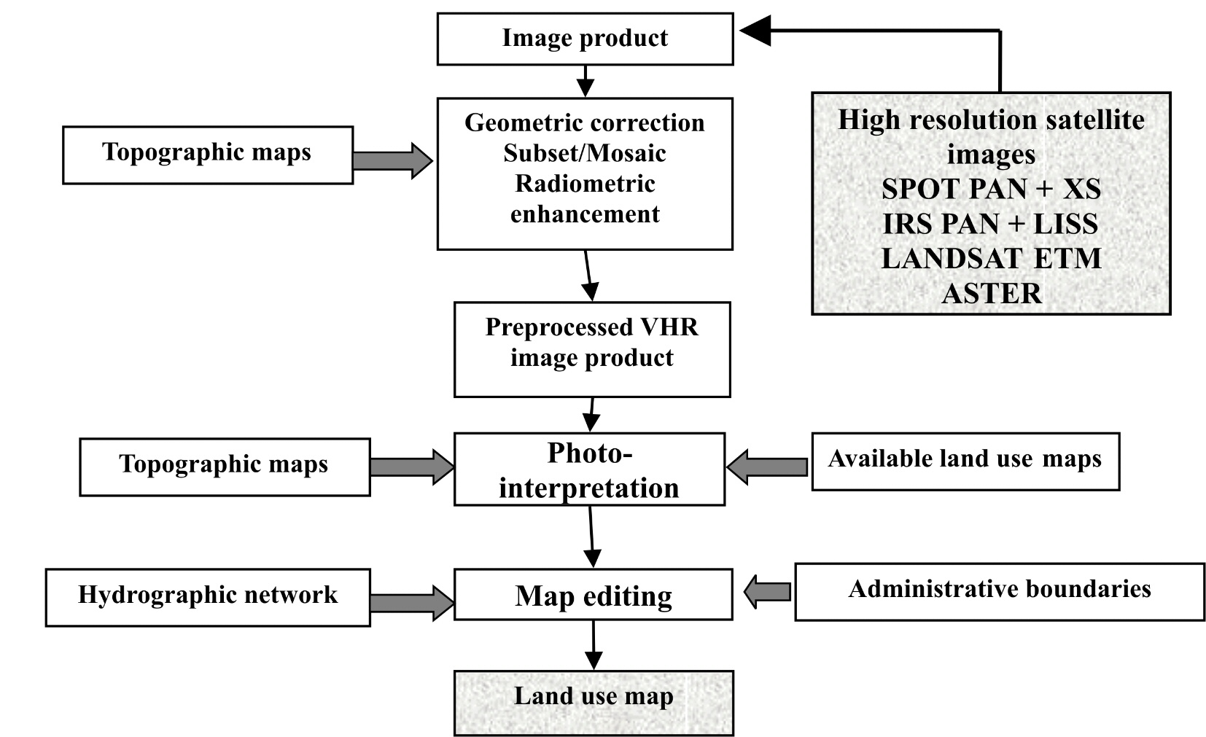

Figure 1. Flowchart for the generation of the land cover/land use maps

Validation of results from photo-interpretation, mapping (by checking through on land sampling at local and regional level) and building up the database aims at knowing the reliability level and the precision obtained for the delimitation of the units and their association to the classes in the catalogue.
The satellite based cartography of the land cover/land use is important because it makes possible periodical updating and comparisons, and thus contribute to characterize the human presence and to provide elements on the vulnerability aspects, as well as the evaluation of the impact of the flooding.
The figure 2 presents the updated map for the Arges basin, with the main classes of the land cover/land use: 1- artificial (built) surfaces (AS), 2-open spaces with little or no vegetation (OS), 3-vineyards and orchards (VO), 4-agricultural lands (AL), 5-forests (F), 6-pastures and natural grasslands (P), 7-heterogeneous lands belonging to households (LH), 8-humid surfaces (HS), 9-lakes and water bodies (WB). The product was obtained using IRS/PAN and IRS/LISS images from 9 April and 23 September 1999.
The land cover maps are useful to classify the terrain function of the main types of land cover, thus allowing their characterization function of the land impermeability degree, of their absorption capacity or resilience to in-soil water infiltration. The notion of terrain impermeability was connected to the necessity to determine the absorption capacity and resistance to in-soil water infiltration. It must be mentioned that these parameters represent “potential capacities”, having in view that the dry soil hypothesis is considered.
The satellite-based mapping approach proved to be very efficient for the elaboration of detailed land cover/land use maps. These products are useful to analyze certain hazard aspects of flooding.

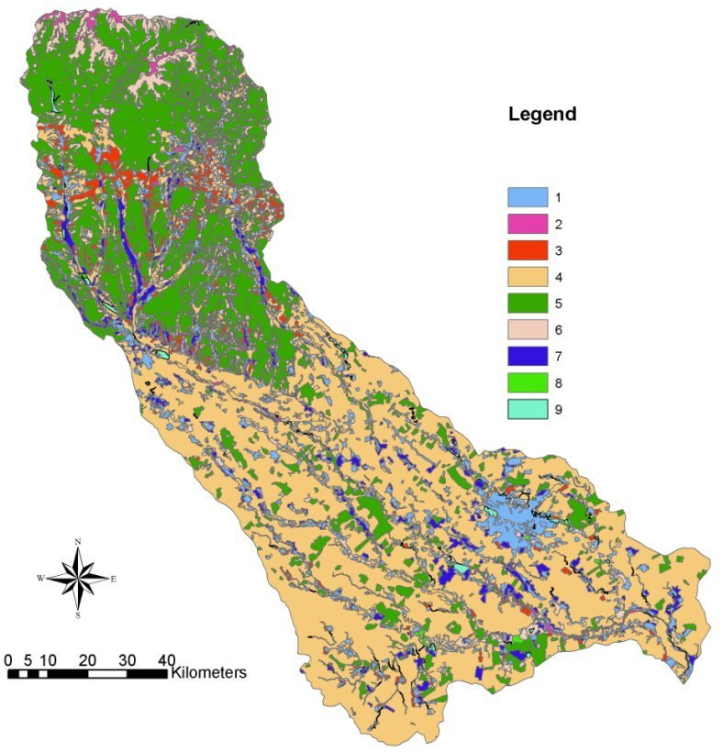

Figure 2. The land cover map for the Arges basin, derived from IRS images

4.2 Methodology for the identification and mapping of the flooded areas
The methodology for the identification, determination and mapping of the areas affected by floods is based on the different classification procedure of the optical and radar satellite images (Brakenridge et al., 1998). The advantage of the use of high-resolution optical satellite images consists in the possibility to select precise spatial information upon the respective area (through merging images) and to localize and define the flooded or flooding risk areas (through classifications). The radar images can bring even during the periods with abundant rainfalls useful information regarding the flooded areas. The multi-temporal image analysis, combined with the land cover/land use information allow the identification of the area covered by water (included the permanent water bodies) and then of the flooded areas. The figure 3 presents flowchart for the generation of the flood extent maps using satellite radar (SAR) images.
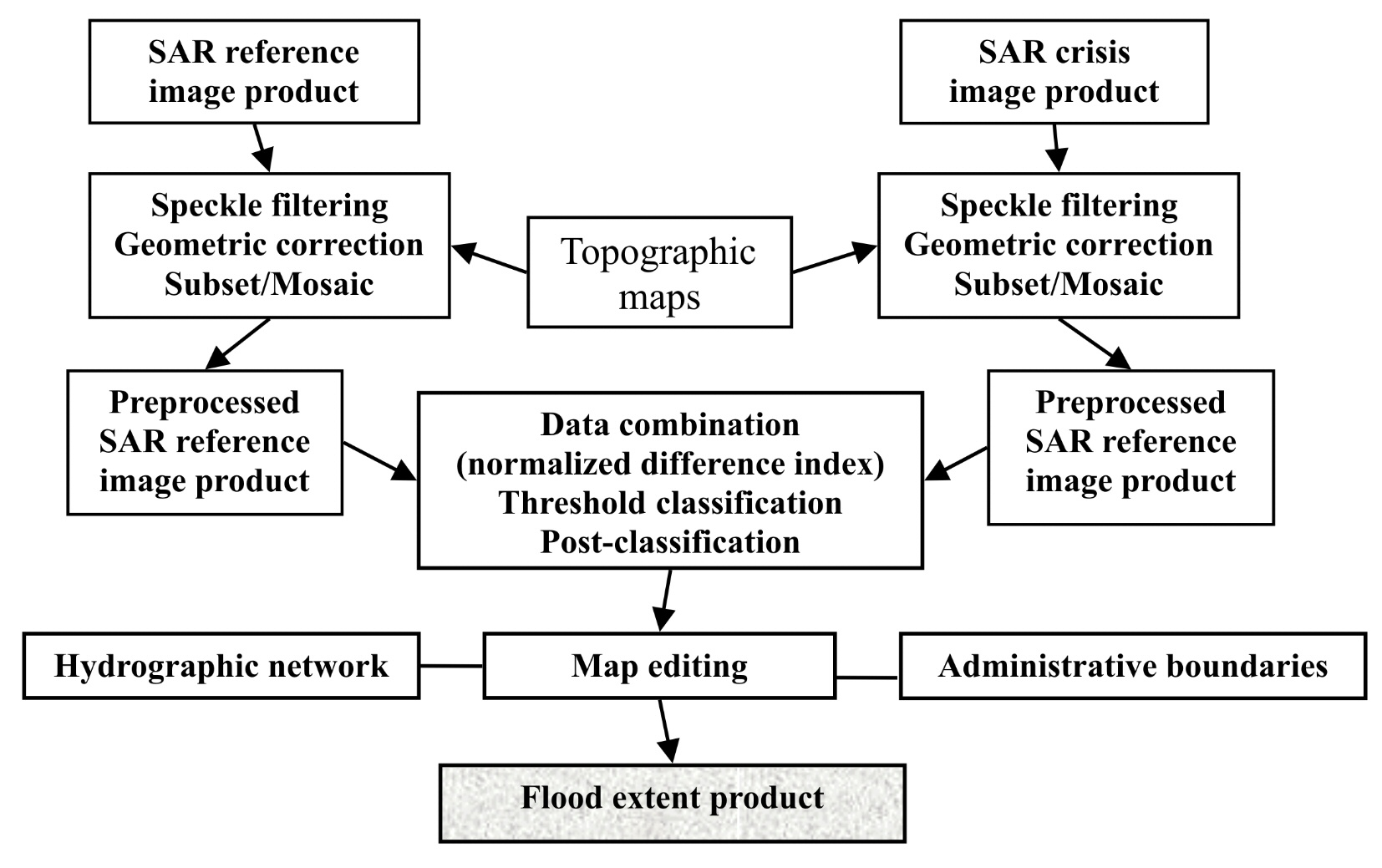
Figure 3. Flowchart for the generation of the flood extent maps using
satellite radar (SAR) images

Using the methodology for the identification and mapping of the flooded areas is possible to monitor and investigate the flood evolution during different phases. The figure 4 shows an example of the utilization of optical and radar data for the flood evolution monitoring, in the Crisul Alb basin using the RADARSAT image of 7.04.2000, during the flood event, comparing with the reference IRS image of 4.08.2000.

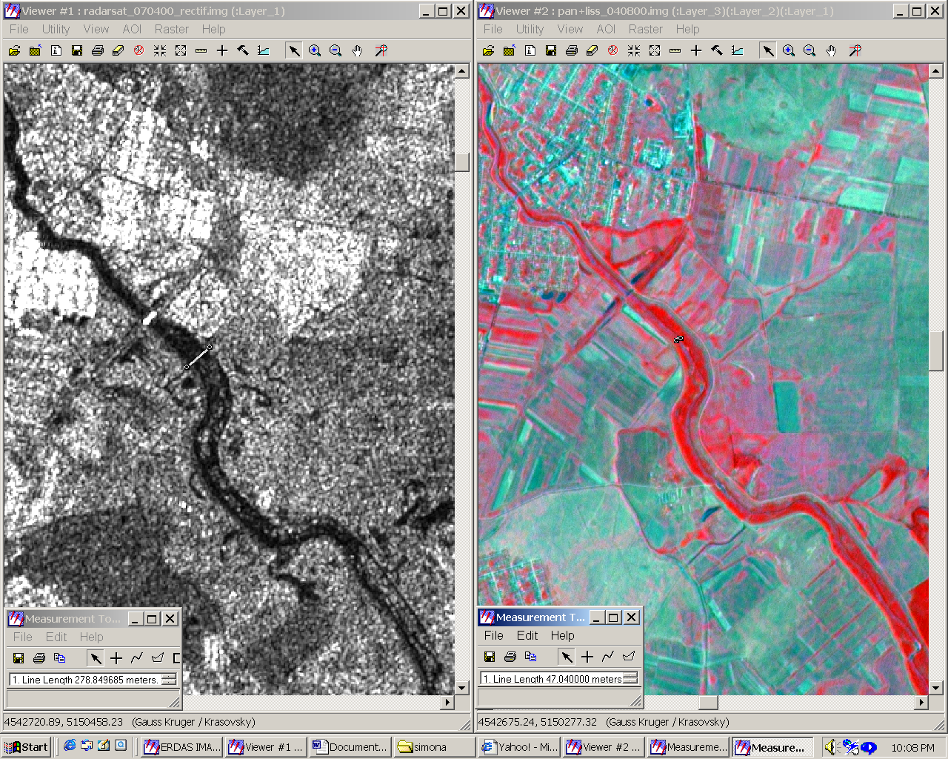

Figure 4. Flood evolution monitoring, in the Crisul Alb basin using RADARSAT image of 7.04.2000 (left), comparing with the reference IRS image of 4.08.2000.
This approach is very useful especially after the crisis for damages inventory and for recovery actions, taken to re-building destroyed or damaged facilities and adjustments of the existing infrastructure.

4.3. Method for the flooding risk maps preparation

Flood hazard satellite-based mapping, is based on the recognition that not only can floods be imaged and mapped as they occur, but these records of extreme events can and must also be preserved in archival form. In this way, maps of lands actually flooded complement maps of land areas predicted via modelling approaches to be subject to flooding. Remote sensing-based flood hazard mapping, which records what lands have actually been flooded, is a complement to, and does not compete with, traditional floodway mapping based on topography, local hydrologic data, and hydraulic modelling (Horitt and Bates 2002; Townsend & Walsh, 1998).
The structure of dedicated GIS was planned in order to be used for the study, evaluation and management of information that contribute to flooding occurrence and development, as well as for the assessment of damages inflicted by flooding effects. In this regard the database represented by the spatial geo-referential information ensemble (satellite images, thematic maps and series of the meteorological and hydrological parameters, other exogenous data) is structured as a set of file-distributed quantitative and qualitative data focused on the relational structure between the info-layers.
The GIS database could be connected with the hydrological database, which will allow synthetic representations of the hydrological risk, using separately or combined parameters. The figure 5 resumes the integration procedure of hydrologic/hydraulic model outputs and GIS info-layers for flooding risk maps preparation.

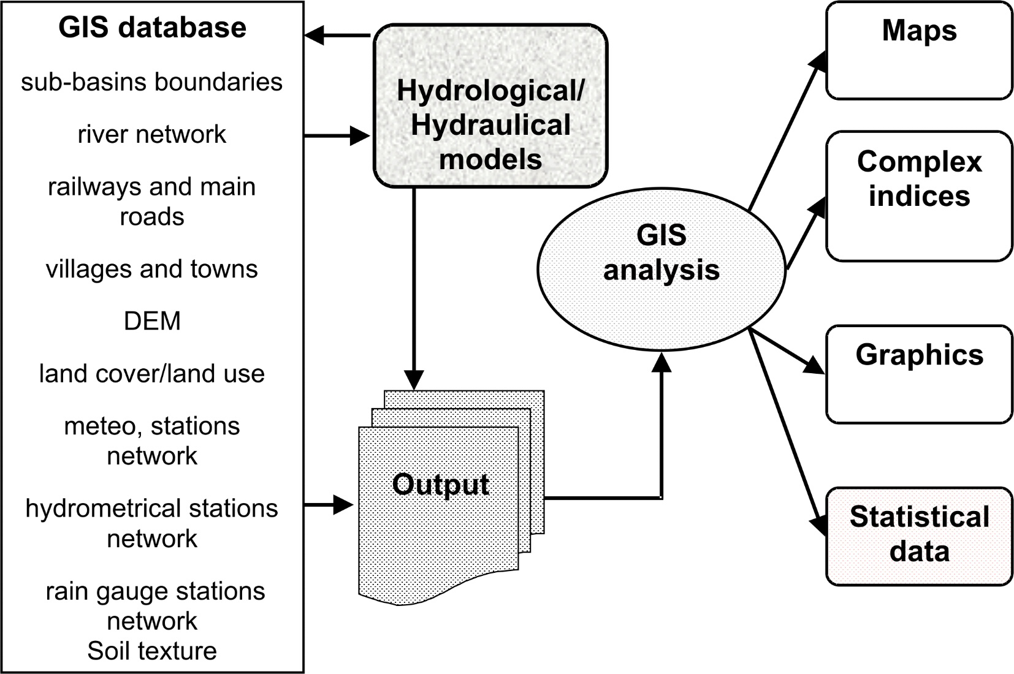

Figure 5. Integration of hydrologic/hydraulic model outputs and GIS info-layers
for flooding risk maps preparation

In the framework of the NATO Science for Peace project “Monitoring of extreme flood events in Romania and Hungary using EO data’, the construction of this GIS for the Crisul Alb, Crisul Negru, Körös basins was based, mainly on classical mapping documents, particularly represented by maps and topographic plans. Most of the thematic plans have been extracted from this classical mapping support. Due to the fact that, in most of the cases, the information on the maps is old-fashioned, it is imposed to update it, on the basis of the recent satellite images (e.g. the hydrographic network, land cover/land use) or by field measurements (e.g. dikes and canals network). The GIS database contains the following info-layers: sub-basin and basin limits; land topography (organized in DEM); hydrographic network, dikes and canals network; communication ways network (roads, railways); localities; meteorological stations network, rain-gauging network, hydrometric stations network; land cover/land use, updated from satellite.
In order to obtain the flood risk map for the study area, an important step refers to construction of the DTM and its integration, together with the land cover/land use maps in the GIS using a common cartographic reference system. The DEM was realized after the following steps:
- scanning the topographic maps at 1:5,000 and 1:10,000 at 300 dpi resolution;
- geo-referencing the maps in the UTM projection;
- color separation and raster information layer extraction as a linear image (black & white without gray tones);
- vectorization of raster images.
- merging the maps;
- generating a triangulated irregular network (TIN) model.
In a TIN the point density on any part of the surface is proportional to the variation in terrain. A surface is a continuous distribution of an attribute over a two-dimensional region. TIN represents the surface as contiguous non-overlapping triangular faces. The surface value is estimated in this way for any location by simple (or polynomial) interpolation of elevation in a triangle. As elevations are irregularly sampled in a TIN, it was possible to apply a variable point density to areas where the terrain changes sharply, yielding an efficient and accurate surface model.
Various morphological criteria may be extracted from a DEM, designed using topographical maps and geodetic measurement criteria, such as altitudes, slopes, exposures, transversal profiles and thalweg locations. All these parameters are useful to evaluate the local or cumulated potential flowing into a zone of the basin. This approach is also useful to get a realistic simulation of floods, taking into account the terrain topography, the hydrological network and the water levels in different transversal profiles on the river, obtained from the hydraulical modeling.
Using the GIS database for the study area, that include the DTM, the land cover / land use maps and the vector info-layers (hydrographical, dams and canals networks, the communication and localities network etc) several simulation outputs of hydrological or hydraulic models could be superimposed in order to elaborate the risk maps to flooding.

5. Conclusions
Considering the necessity to improve the means and methods to assess and monitor flooding, the paper presents the capabilities offered by remotely sensed data and GIS techniques to manage flooding and the related risk. Although satellite sensors cannot measure the hydrological parameters directly, remote sensing can supply information and adequate parameters to contribute to identify and map the hydrological risk at the basin level.
The basic concepts of the creation of products useful for flooding risk analysis (maps of land cover/land use, thematic maps of the flooded areas and the affected zones, flooding risk maps) can be summarized in the following stages:
- preparation of the EO data: radiometric, geometric correction and other basic image processing;
- combination of the interpretation techniques: automated and photo-interpretation tools, as well as radiometric techniques;
- multi-sensor approach: make the analysis process easier and provide the opportunity to improve the quantity and quality of the information obtained;
- multi-temporal approach: gives the possibility to monitor low frequency (land modification) and high frequency phenomena (evolution of the floods boundaries);
- integrated approach: the high level products are based on the EO derived information combined with other ancillary data, hydrologic/hydraulic models outputs using the GIS facilities.
The GIS dedicated database, was useful for the elaboration of the flooding hydrological risk indices and gas allowed obtaining synthetic representations of the hydrologic risk, through separate or combine use of the risk parameters, as well as for interfacing with the hydrological models in view to improve them as regards compatibility with input data, recovering results and the possibility to achieve scenarios.
The products derived from EO data and GIS info-layers (land cover/land use digital maps, satellite-derived maps, parameters derived from satellite images and GIS database, flood hazard maps for several probabilities of the maximum discharge occurrence) could be used in several category actions:
- in the preparedness/warning actions, taken to insulate people or infrastructure from specific hazard events, to plan for possible scenarios to minimize the potential impacts and subsequently to establish the necessary infrastructure to either prevent it or minimize its impacts.
- In the recovery actions for pinpointing locations and the degree of damages, for re-building destroyed or damaged facilities, for the insurance companies as a up-to-date information to settle claims.
Flood hazard information obtained on the local scale can be combined with vulnerability data on population, land use, type of buildings, infrastructure (roads, railways, bridges, hydraulic structures, etc.) and socio–economic activities in order to assess the risk and to create/update flood risk maps.

6. References
Brakenridge, G. R., Tracy, B.T. & Knox, J.C. (1998): Orbital remote sensing of a river flood wave. Intern. J. Remote Sens. vol. 19, p.1439-1445.
Brakenridge, G. R., E. Anderson, S. V. Nghiem, S. Caquard and T. B. Shabaneh (2003): Flood Warnings, Flood Disaster Assessments, and Flood Hazard Reduction: The Roles of Orbital Remote Sensing. In Proc. of the 30th International Symposium on Remote Sensing of the Environment, Honolulu, Hawai'i, November 10-14, 2003.
Harms, J., Massue, J. P., Tarel, G., Pirre, G., Petit, J.C., Meyer-Roux, J. and Cinotti, C.
(1996): Use of space technologies for major risks management. In: Proc. of the 16-th Symposium: Integrated Applications for Risk Assessment and Disaster Prevention for Mediterranean, EARSel Publications.
Horitt, M. S., and Bates, P. D.(2002): Evaluation of 1D and 2D numerical models for predicting river discharge. Journal of Hydrology, v. 268, p. 87-99.
Mertes, L.a.K. (2002): Remote sensing of riverine landscapes. Freswater Biology, vol. 47, p. 799 – 816.
Stancalie G., Alecu, C., Catana, S., Simota, M. (2000): Estimation of flooding risk indices
using the Geographic Information System and remotely sensed data. In Proc. of the XX-th Conference of the Danubian Countries on hydrological forecasting and hydrological bases of water management, Bratislava, Slovakia.
Tholey, N., Clandillon, S., Fraipont, P. (1997): Flood surveying using Earth Observation Data.
In: Proc. of the Eurisy Colloquim “Earth Observation and the Environment: benefits for Central and Eastern European Countries”, Budapest, pp. 77 – 88.
Townsend, P., Walsh, S.J.(1998): Modelling of floodplain inundation using an integrated GIS with radar and optical remote sensing. Geomorphology, v. 21, p. 295-312.
Wang, Y., Koopmans, B. and Pohl, C. (1995): The 1995 flood in The Netherlands monitored
from space – a multisensor approach. International Journal of Remote Sensing, vol. 16, pp. 2735 – 2739.

