THE USE OF COMBINED RADAR AND RAINGAUGE PRECIPITATION ESTIMATES IN HYDROLOGICAL MODELLING FOR SVITAVA RIVER BASIN

Milan Šálek¹, Lucie Březková², Petr Novák³

Czech Hydrometeorological Institute, Regional Office Brno, Czech Republic, e-mail: ¹salek@chmi.cz; ²lucie.brezkova@chmi.cz
³Czech Hydrometeorological Institute, Radar Dept., Praha, Czech Republic,
e-mail: petr_novak@chmi.cz

Abstract: Weather radars of the Czech Hydrometeorological Institute are used for precipitation detection, nowcasting and wind measurement. They are also increasingly utilized for quantitative precipitation estimation. Since the radar precipitation estimates are error prone they routinely undergo further processing which consists of two steps: adjustment and combination with operationally available raingauges. The combined radar-raingauge and raingauge-only interpolation field generation have been originally developed by D.-J. Seo (1998a, 1998b).
The original radar estimate, adjusted radar estimate, raingauge-only field and combined radar-raingauge estimate (called ‘merge’) are available operationally for visual inspection for hourly accumulation and then for 6-hour accumulation (for 00, 06, 12, 18 UTC) and 24-hour accumulation (for 06 UTC). The precipitation totals for predefined areas (e. g. catchments) are available, too, and the hourly values have been tested for hydrological simulation using model Hydrog for Svitava river basin (catchment area 1118 km²; the Svitava river lies in Morava river catchment in the eastern part of the Czech Republic). The model runs have been compared with simulation when using hourly measurements of additional dedicated network consisting of six raingauges. According to the preliminary results obtained, it can be stated that the adjusted radar estimates and/or combined raingauges-radar estimates provide precipitation estimates which can be well used in hydrological modelling and the results are at least comparable with utilization of dense network of telemetric raingauges. Especially in convective rainfall the radar offers very good image of spatial distribution of precipitation.

Keywords: hydrological modelling, precipitation estimation, weather radar

1. Background
Areal quantitative precipitation estimation (QPE) is difficult task which is traditionally made by raingauge ‘point’ measurements and subsequent computations using interpolation, kriging, Thiessen’s polygons etc. Weather radar offers another possibility to provide ‘direct’ QPE but until recently this option was not used too much. Among the reasons which caused not-so-widespread use of the radar QPE were (i) rather limited availability of the weather-radar-based QPE, (ii) errors of the radar-based QPE, (iii) lack of experience with radar data. The Czech Hydrometeorological Institute modernized its weather radar network during the last decade of the 20th century, which resulted in fully digitized data processing with the option to control all the volume reflectivity and Doppler wind data. It allowed much better data processing optimalization for the quantitative precipitation estimates. Šálek and Kráčmar (1997) and Kráčmar et al. (1998) calculated time series of the radar-based daily QPE, compared it with the climatological network of raingauges and confirmed that ‘pure’ radar-based QPE is often accompanied by non-negligible errors which stem from the nature of the radar measurement. For thorough information on the radar precipitation estimations and the measurements errors, see Joss and Waldvogel (1990), who pointed out that the main problems of radar–based QPE are not connected mainly with the inaccuracy of the Z-R formula (see further) but rather with the beam propagation. Nowadays it is widely accepted that the radar-based QPE is influenced mainly by the beam width and height, by the precipitation processes inside the beam scanning volume and below the radar beam. The ‘tuning’ of the Z-R relationship according to the precipitation type is not the most important issue.
The errors of the radar measurement have lead to the development of some correction algorithms. One of the best-known correction methods is adjustment of the radar-based QPE by available raingauge measurements. The method of application of one single coefficient (adjustment factor, bias) on the area of interest (radar domain, catchment etc.) is usually called mean field bias (MFB) adjustment and the application of the spatially variable factor can be named as spatial adjustment. However, all adjustment methods are heavily influenced by the typical scale of the measurements (sampling problem); it compares a raingauge measurement (G) of the typical sampling area of 5.10⁻² m² to a radar estimate (R) of the areal element of at least 10⁵ m², usually 10⁶ m². However, if we compare sufficient number of raingauge measurements, then the average raingauge/radar (G/R) factor becomes more stable (representative) provided no significant change in the precipitation processes takes place. From the last condition it can be deduced that the time span of the raingauge accumulation and the corresponding radar measurement must be a compromise between the need to have most representative radar-raingauge relationship and the necessity to react quickly enough to the possible or actual change of the precipitation type (convective, stratiform, snow, rain etc.). Moreover, if the significant dependence of the G/R on the range form radar site is detected, then this relationship has to be taken into account, too (for detailed discussion about these adjustment techniques, see e.g. Collier, 1996, Wood et al., 2000 and Michelson et al., 2000).
The problem of invisibility of the area below the lowest usable radar beam can be decreased by correction method based on the vertical profile of reflectivity (VPR). This correction method assumes that in the areas of reduced radar visibility of low layers (i.e. below 2-3 km above the ground) a vertical profile of reflectivity can be extrapolated using VPR course that is obtained in the areas of good radar visibility (near the radar site). Although there is a serious problem of representativity of the VPRs, this correction method is able to significantly reduce at least the dependence of the G/R ratio on the distance from the radar site, which is caused by the increasing height and width of the radar beam (e.g., Kráčmar et al., 1998). The VPR correction then makes the estimate more suitable for MFB adjustment and, if applied, must precede any raingauge-based adjustment.
For the purpose of obtaining the most accurate operational QPE, some algorithms have been developed, which combine the radar estimate with the raingauge measurements using geostatistical approach (cokriging, optimum interpolation). Conceptually, it is a linear combination of radar precipitation estimate and raingauge measurements in a way that minimizes the expected error variance.
The Czech Hydrometeorological Institute has recently put into operation a QPE system that consists of original radar precipitation estimate, a MFB-adjusted radar estimate, raingauge-only (interpolation) estimate and a combination (see Fig. 2). The procedure is inspired by similar algorithm described by Fulton et al. (1998). The aim of this multisensor QPE system is to provide users with most accurate precipitation estimate along with information about the performance of the particular measurement system. Moreover, areal QPE for particular areas (catchments and/or Thiessens’ polygons) are calculated and besides used as a precipitation input into hydrological models.

2. Radar data
The Czech Hydrometeorological Institute (CHMI) operates two C-band Doppler weather radars which are used for precipitation detection and estimation, nowcasting and wind measurement. Their parameters are listed at the Table 1 and their geographical positions are depicted at Fig. 1. Since the beginning of their operations they have been used for the quantitative precipitation estimation but until 2001 no corrections of the radar-based QPE were applied routinely except some experiments.
The radar-based QPE is based on the conversion of the radar reflectivity Z into precipitation rate R by following formula (see e.g. Collier, 1996):
$$Z=\text{200}R^{1\text{.}6}$$ | (1)
in interval <7dBZ–55dBZ> (for Z<7dBZ is R=0mm/h and for Z>55dBZ is R=R(55dBZ)=99.85mm/h).

Table 1. Parameters of the weather radar of the Czech Hydrometeorological Institute.
Radar station | Skalky u Protivanova | Brdy - Praha
WMO Indicative | 11718 | 11480
Location | Central Moravia | Central Bohemia
Latitude | 49,501 N | 49,658 N
Longitude | 16,790 E | 13,818 E
Ground altitude of the station | 730 m | 860 m
Altitude of the antenna. | 767 m | 916 m
Measurement cycle | 10 min. | 10 min.
In operation since | 1995 | 2000
Made by | Gematronik | EEC
Type | Meteor 360AC | DWSR-2501C
Frequency band | C | C
Doppler mode | yes | yes
ANTENNA
Diameter | 4,2 m | 4,27 m
Beam width | 0,8 deg. | 0,96 deg.
Gain | 44 dB | 45 dB
Polarization | lin.horizontal | lin.horizontal
TRANSMITTER
Wavelenght | 5,31 cm | 5,3 cm
Frequency | 5652 MHz | 5660 MHz
Pulse power | 250 kW | 305 kW
Pulse lenght | 2 micro seconds | 0,8 micro seconds
Pulse repetition freq. | 560 Hz | 584 Hz
RECEIVER | log. | log.
Min.det.signal | -139 dBW | -140 dBW
Dynamic range | 80 dB | 80 dB
Intermediate frequency | 30 MHz | 30 MHz
Min.detectable reflectivity | 9,7 dBZ | 10,6 dBZ
at max.range of | 260 km | 256 km

The reflectivity used in the conversion into the precipitation rate is taken from the altitude 2 km above seal level, technically called pseudoCAPPI 2 km. It is calculated from the volume reflectivity data using vertical interpolation between two closest elevations measured by the radar (PPI levels) or taken from the lowest available PPI (if the lowest available PPI is above 2 km level). The ten-minutes precipitation rates are then integrated for given time periods – 1, 3, 6, 12 and 24 hours. VPR corrections are applied routinely but since there is substantial overlap of both radars, the potential benefit of the VPR correction is not so significant. The VPR corrections are much more important when one of the radar is out of operation for a long time. Therefore the VPR-corrected radar data are not yet operationally used in further processing and hydrological simulations except some experiments.

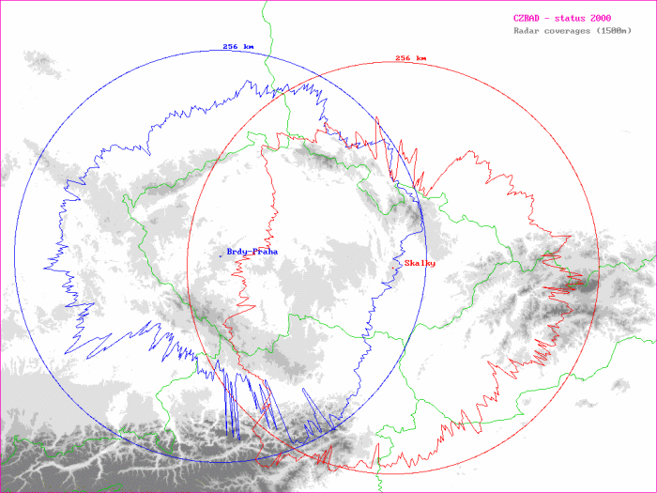
Fig. 1. Locations and coverage of the the CHMI weather radars (circles) and coverage for precipitation estimation according to recommendation of project COST 73 (the lowest usable beam 1500 m above ground level).

3. Combined (multisensor) precipitation estimate
The original radar precipitation estimate is routinely adjusted using the mean field bias adjustment. As introduced in chapter 1, the key issue is to estimate the bias factor optimally. If one uses the assessment factor only for the given time period (e.g. one hour), usually only a few raingauge measurements (and small precipitation accumulation) are available and the bias tends to be unrepresentative for the whole radar domain. Therefore the adjustment algorithm accumulates the radar data and the corresponding raingauge measurements (for the raingauge up to 150 km from the radar site) for time-moving window of typical size of several days. The time moving window is also dependent on the mean areal accumulation of precipitation and in some extreme dry spell it could reach even several weeks until predefined accumulation threshold is reached. However, as it is assumed that the ‘old’ precipitation regime is not representative for the beginning of ‘new’ precipitation process and long-time assessment factor should not be far from one, during ‘dry’ weather the bias slowly drifts to value of ‘1’.

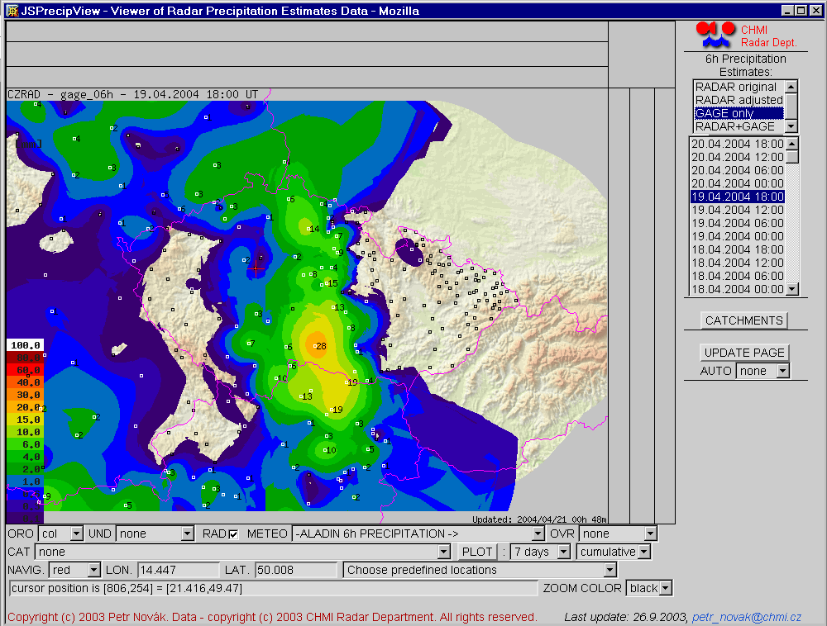
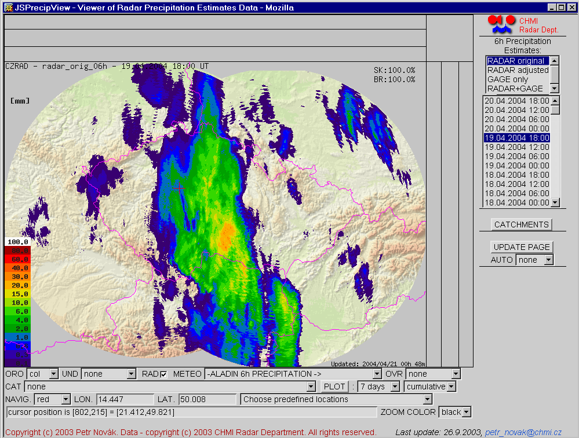
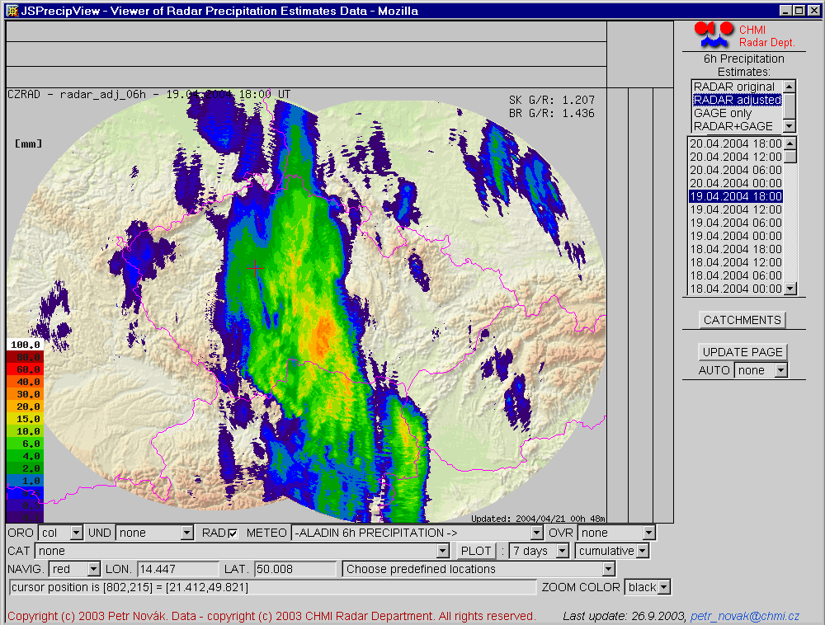
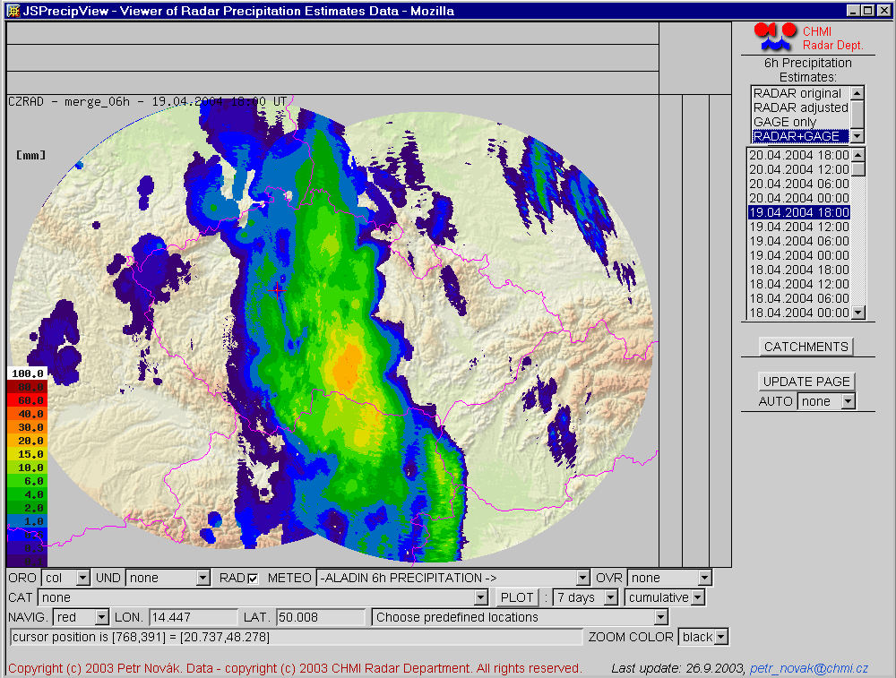
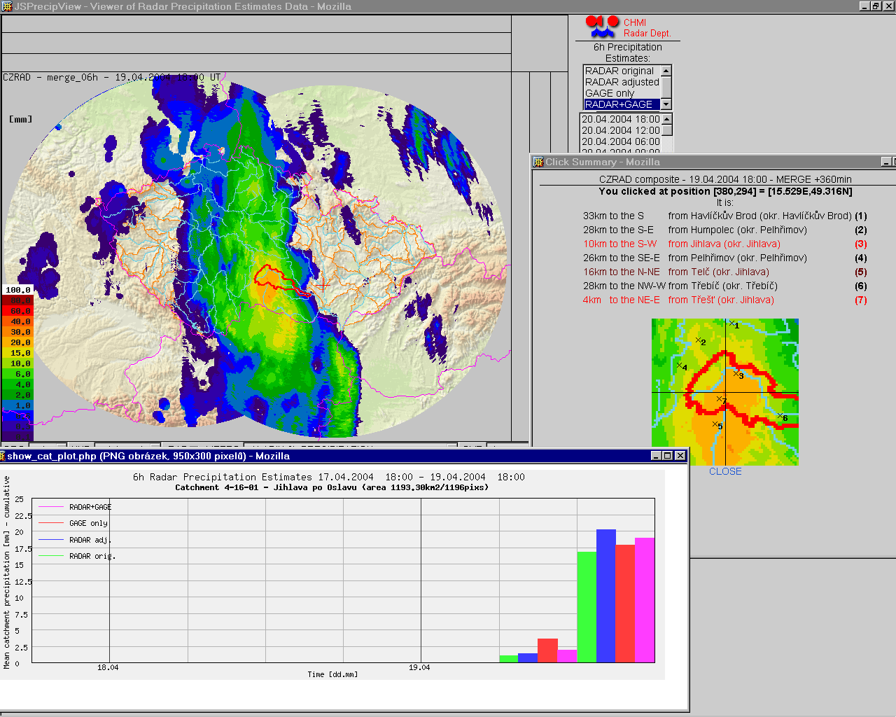

Fig. 2. Examples of gauge-only, original radar, adjusted radar and combined 6-hour estimate (from left to right, from top to bottom) for 19 april 2004, 18 UTC, as presented in the system JSPrecipView. At the bottom you can find an example of the areal precipitation estimate displayed in a form of accumulation of the different types of estimate for the catchment highlighted in the map and in the zoom.
The combination (called ‘merge’) is computed as a simplified version of double optimum interpolation (Seo, 1998b). It is a linear combination of adjusted radar estimate and raingauge data. The weights of the radar and raingauge(s) contribution are estimated using the distance from the raingauge site(s) and the average variability of the radar and raingauge precipitation fields. Generally, the weight(s) of raingauge measurement(s) is (are) inversely proportional to the distance from the nearest raingauge(s) and the course of the weights is modelled by negative exponential function with a parameter dependent on the variability of the precipitation field.
In addition, the multisensor procedure routinely provides also a raingauge-only interpolation estimate that is computed by a adapted version of the Seo (1998a) algorithm.
The original radar estimate, adjusted radar estimate, raingauge-only field and combined radar-raingauge estimate (called ‘merge’) are available operationally for visual inspection for 1-hour accumulations, for 6-hour accumulations (calculated at 00, 06, 12, 18 UTC) and 24-hour accumulations (calculated at 06 UTC).
All the precipitation estimate for given time period can be displayed using WWW browser. The user has an option to choose between two type of visualization: ‘JSPrecipView’ and ‘Diagnostic’. The JSPrecipView is a JavaScript-based system which uses PHP scripts at the server side and provides the user with the option to switch between original radar, adjusted radar, raingauge-only and merged estimate (see Fig. 2). The application is equipped by advanced features of geographical information systems (GIS): It can provide the user with geographical coordinates at any point at the map(s), distance from predefined locations (mostly towns), layers of main roads, railways, districts, rivers and catchments. The system is able to compute areal precipitation accumulations within predefined catchments in a user-adaptable time-moving window spanning from 1 to 21 days (see Fig. 2).
The ‘Diagnostic’ presentation provides the user with more information about the radar-raingauge relationship for both radars and with more statistical characteristics of the radar and raingauge data. It also displays raingauge data that were rejected from the further processing due to obvious malfunctioning of raingauge and the raingauge data that are ‘suspicious’ because their values are outlying too far from the radar estimates. An example of the ‘Diagnostic’ presentation of an 24-hour precipitation estimate is here (when the directory listing appears, click please at the file ‘index.html’). The purpose of the diagnostic version is to allow the user or supervisor for deeper insight into the radar and raingauge precipitation estimates, radar-raingauge relationships (by scatterplots), MFB adjustment performance etc. This presentation can better explain possible deficiencies of the sensors than the JSPrecipView images and is useful mainly for application development and for analyzing of problematic/suspicious cases by well-experienced users. On the contrary, the JSPrecipView is designed for advanced presentation of all precipitation estimates to wide user-base.

4. The use of multisensor estimates in hydrological modelling
4.1 Radar-raingauge merged data for hydrological modelling
Since 2003 the hourly combined (merged) QPE is used as a precipiattion input into the hydrological model Hydrog that is used for several catchments in the eastern part of the Czech Republic (see Fig. 3). Because the optional use of either the raingauge data or the combined estimates (easy ‘switch’ from gauge data to merged data) had to be ensured, the merged QPE is calculated for the areas of Thiessen’s polygons pertinent to the installed/planned raingauges. Then it is relatively easy to change the data input without too serious intervention in the modelling system. Moreover, since the radar (or combined) estimate is available very quickly, it offers an opportunity to run the hydrological models promptly after significant precipitation is detected, without the necessity to wait until all the raingauge data are collected.
Since the radar (or radar-raingauge merged) QPE input into hydrological models is rather new technology, comprehensive testing of the performance of the model runs with the various inputs (raingauge, radar, combinations) was needed. These tests have been performed for Svitava river catchment that is located nearby the Skalky radar (from 0 to approx. 50 km far from the radar site).

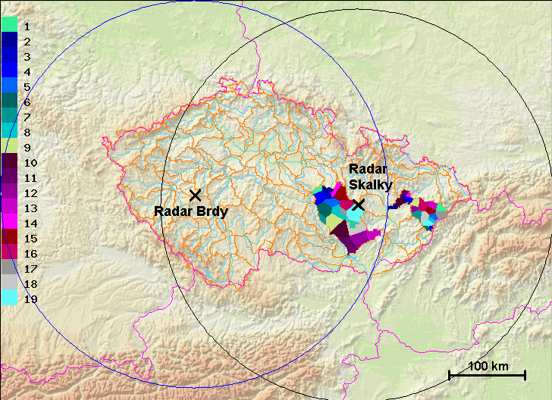
Fig. 3. Areas of the Thiessen’s polygons for which the areal precipitation estimates are computed (colored fields in the eastern part of the Czech Republic), along with the radar sites and the maximum range of the CHMI radars. The polygons southwest of the radar Skalky are used for Svratka and Svitava catchments, the polygons to the east of the radar Skalky are utilized for Bečva catchment.

Table 2. Characteristics of the Svitava river catchment (discharge characteristics are influenced by reservoirs)
Catchment area | 1118 km²
Final profile (altitude) | Bílovice (218 m a. s. l.)
Highest altitude | 586 m a.s.l.
Average annual precipitation 1931-1980 | 649 mm
Discharge Q_{355d} (from 1931-1980 data) | 1.52 m³
Discharge Q_{30d} (from 1931-1980 data) | 11 m³
Discharge Q_{100y} (from 1931-2003 data) | 179 m³

4.2 Hydrological modelling on the Svitava river using merged precipitation data
4.2.1 The description of the Svitava catchment and the model Hydrog
The characteristics of the Svitava river catchment (see Fig. 4) are in Table 2. The Svitava river flows in an almost southerly direction and the catchment has an elongated shape. Water reservoirs within the catchment are Letovice on the Křetínka River (11,6 mil. m³) and Boskovice on the river Bělá (7,3 mil. m³). The catchment water balance is influenced by a permanent take-off of around 1 m³.s⁻¹ by a so called Březová watermain that serves for the city of Brno.
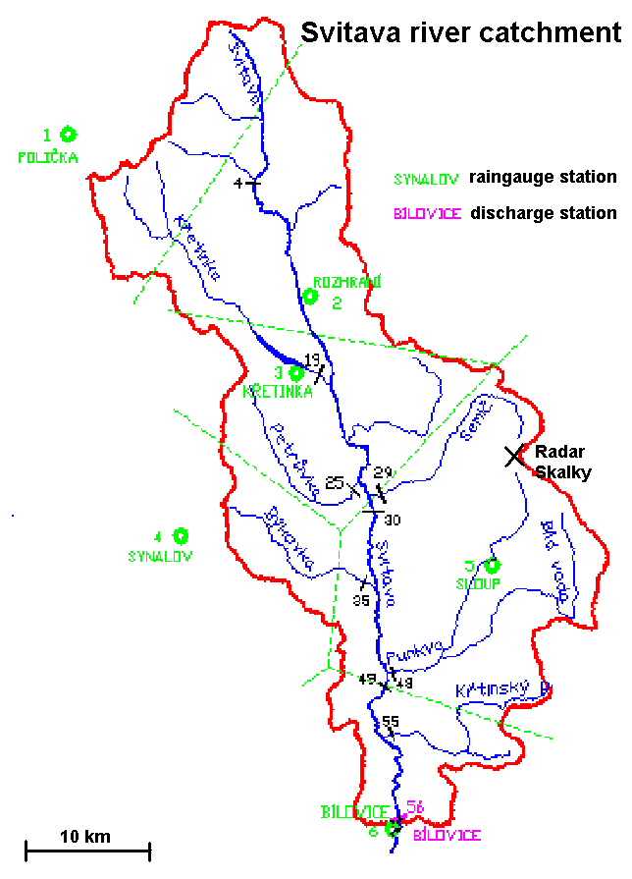

Fig. 4. The Svitava river catchment with the used raingauge stations and the main discharge station. The Thiessen’s polygon pertinent to the raingauge stations are hinted by hashed green lines.

The discharge at various profiles of the Svitava river catchment is being modelled by model Hydrog. The model is designed for the simulation and operative forecasts of water runoff with the ability to take into account the artificial outflow from chosen reservoirs. The immediate state of the system supposes either simply stabilised flow of water in the river network or it is possible to estimate it by simulation from the preceding period. In this case it comes back in time to the time point, when it is possible to suppose stabilised flow. In chosen gauging stations, in which discharge is measured, it is then possible to make correction of the calculated values by the measured ones. Then the calculation of the forecasted discharge follows.
The computation is being made on a schematised catchment, where the real catchment is replaced by an oriented evaluated graph. It consists of stream sections, areas suspended onto them, surface reservoirs and an underground reservoir. During the course of the rainfall-runoff process, the rain fallen on the catchment flows through such a graph. During this process, two kinds of routing are considered: hydrological and hydraulic.

During hydrological routing hydrological losses are gradually subtracted from the total intensity of the rainfall falling on the areas – the model respects these losses by a universal loss curve, in which the loss of infiltrations dominates in relation to the rainfall sum in the preceding week. During the hydraulic routing the simulation of areal runoff takes place on the areas of the graph and concentrated runoff on the stream channels, reservoir routing down to the gauging stations of the catchment.
Since the use of the radar-raingauge combined precipitation data in the hydrological models started only in 2002, there are only a few episodes available, for which the model Hydrog utilizing the merged estimates was tested. All the analyses were performed as simulations on archived discharge values and precipitation data. It has to be noted that the hourly merged radar-raingauge areal estimates for the Thiessen’s polygons were computed without the dedicated raingauge (telemetric tipping-bucket gauges) measurements whose positions are depicted at the Fig. 4. Nowadays the radar-raingauge merged estimate counts with all these data (if they are available) but the aim was to simulate the effect of missing raingauge data when only a few raingauge reading from the main meteorological network were available.
In addition to the merged estimates, the model Hydrog was experimentally run with the areal precipitation using only MFB-adjusted radar estimate. Besides the Thiessen’s polygons, we tested the model performance with the precipitation field that were decomposed according to the subcatchments of different size (on average 108, 80 and 59 km²), which were called V1, V2 and V3, respectively (V1 referring to ‘Variant 1’, V2 to ‘Variant 2’ etc.).

4.2.2 The results of simulation of significant runoff events
4.2.2.1 Widespread heavy precipitation in August 2002
Significant increase of streamflow took place in August 2002 when the Svitava river basin was partly hit by widespread heavy precipitation that caused disastrous floods mainly in western part of the Czech Republic (in the river basins of Vltava/Moldau and Labe/Elbe). During the test the model parameters were kept constant to default values. The results of the model runs for river-gauging station Bílovice are depicted at the Fig. 5 and Table 3, from which it can be deduced that the radar influences beneficially the result for peak discharge, but the contribution varies according to the method and the particular river gauging station.

4.2.2.2 Flash flood on 26 May 2003
A flash flood took place on 26 May 2003 in the afternoon in the area of Sloup village (see Fig. 4, south of radar Skalky) and significantly increased streamflow was observed also at the river gauge Bílovice. The flash flood was caused by an intense convective storm which affected very limited area (170 km² received the precipitation over 50 mm/day and only 5 km² were hit by the rainfall exceeding 70 mm with a maximum observed precipitation of 90 mm/day). The rainfall lasted only two hours. From the modelling point of view, it was noticeable that part of the heavy precipitation was captured by the raingauge Sloup. Interestingly enough, the raingauge-based model run was very successful compared to the run when using the combined precipitation estimates calculated for the Thiessen’s polygons (see Fig. 6 and Table 4). However, the reason was quite obvious – the particular Thiessen’s polygon pertinent to the raingauge station Sloup is one of the largest ones and the limited-area (yet heavy) precipitation, well captured by radar, was averaged on the whole area, resulting in severe underestimation of the runoff. The model runs, which were performed on the smaller subcatchments, were improving the model results according to decreasing size of the subcatchments; the best results (yet a little worse than the raingauge-only simulation) were achieved by the highest resolution (V3); according to the correlation coefficient the adjusted radar estimate was even slightly better than the combination of adjusted radar with reduced network of raingauges.

Fig. 5. Simulation of the discharge at the river gauge Bílovice in August 2002. The V1R, V1K, V3R and V3K are abbreviations for Variant 1 using adjusted radar, Variant 1 using (radar-raingauge) combination, Variant 3 using adjusted radar and Variant 3 using combination. The ‘variants’ denote the decomposition of the basin into subcatchments of different size (V1 – 108 km², V3 – 59 km²) for which the areal QPE are computed.

Table 3. Standard deviation and correlation coefficients of the simulated and measured discharge at the river gauges Rozhrani, Letovice and Bílovice (see also the Fig. 4; the Letovice gauge is nearby Křetínka station but note that is heavily influenced by the reservoir).
Varianta | Standard deviation |  |  | Correlation coefficient
Varianta | Rozhraní | Letovice | Bílovice | Rozhraní | Letovice | Bílovice
(only) Raingauges | 0.84 | 1.55 | 4.51 | 0.14 | 0.97 | 0.69
Merged - Thiessen | 0.62 | 1.21 | 2.99 | 0.69 | 0.98 | 0.83
V1R | 0.67 | 1.28 | 3.08 | 0.57 | 0.98 | 0.82
V1K | 0.55 | 1.07 | 3.12 | 0.71 | 0.98 | 0.80
V3R | 0.66 | 1.27 | 3.16 | 0.58 | 0.98 | 0.80
V3K | 0.54 | 1.07 | 3.15 | 0.74 | 0.98 | 0.79

Fig. 6. Simulation of the discharge at the river gauge Bílovice in May 2003. The V1R, V1K, V2R, V2K, V3R and V3K are abbreviations for Variant 1 using adjusted radar, Variant 1 using (radar-raingauge) combination, Variant 2 using adjusted radar, Variant 2 using combination, Variant 3 using adjusted radar and Variant 3 using combination. The ‘variants’ denote the decomposition of the basin into subcatchments of different size (V1 – 108 km², V2 – 80 km², V3 – 59 km²) for which the areal QPE are computed. ‘M’ denotes ‘Measured discharge’.

Table 4. Standard deviation and correlation coefficients of the simulated and measured discharge for the significant discharge which occurred on about the 26th of May 2003 at the river gauges Rozhrani, Letovice and Bílovice (see also the Fig. 4)
Variant | Standard deviation |  |  | Correlation coefficient
Variant | Rozhraní | Letovice | Bílovice | Rozhraní | Letovice | Bílovice
Raingauges | 0.180 | 0.103 | 2.677 | -0.142 | 0.840 | 0.914
Merged - Thiessen | 1.398 | 1.312 | 3.980 | 0.774 | 0.377 | 0.844
V1R | 1.311 | 1.207 | 3.301 | 0.654 | 0.324 | 0.845
V1K | 0.564 | 0.549 | 4.392 | 0.450 | 0.367 | 0.860
V2R | 0.989 | 1.175 | 3.066 | 0.660 | 0.300 | 0.848
V2K | 0.381 | 0.607 | 4.218 | 0.554 | 0.379 | 0.866
V3R | 1.690 | 1.460 | 2.221 | 0.785 | 0.395 | 0.918
V3K | 0.725 | 0.651 | 2.608 | 0.687 | 0.423 | 0.923

Concerning the interesting fact that the best performance was achieved by using of the dedicated network of raingauges, it has to be stressed that the measured precipitation reached the ‘optimal’ value in this case by mere accident; if the raingauge had been located a few kilometers far from its actual position, the measured rainfall depth would have been far less or more, which would have resulted in the corresponding error of the polygon-based QPE and the consequent error of the model output.

5. Conclusion

According to the preliminary results presented above, the combined radar-raingauge-based QPE can be well used in hydrological modelling, provided careful maintenance of the radar and scrutiny of the radar performance and of the raingauges is ensured. On average, the radar-raingauge combined estimate is the best QPE available for the modelling but the contribution of the radar depends significantly on the precipitation processes and the decomposition of the catchment. In the widespread (stratiform) precipitation the decomposition is not so important and the radar contribution is rather modest. In convective precipitation the radar QPE is very important but its performance depends significantly on the decomposition of the river basin. However, the decomposition has its obvious lower limit that is determined by the average size of the storm cells (approx. 10 km²); if smaller area are used, then negative effects of up- and downdrafts on the radar-based QPE are likely to be more significant.
The radar should be considered not as a competitor to raingauges but as a complementary tool for the QPE. The radar is important especially by his ability to provide a prompt overview, or, in other words, the ‘first guess’ of the precipitation. The radar information is valuable especially in highly variable convective precipitation while in some stratiform rainfall with strong orographic enhancement the radar-based QPE may be too erroneous. The user must be trained to be able to assess the performance of the radar precipitation measurement.

References:
Fulton, R., J. Breidenbach, D.-J. Seo, D. Miller and T. O'Bannon, 1998. The WSR-88D rainfall algorithm. Wea. Forecasting, 13, 377-395.
Collier, C. G. (1996): Applications of weather radar systems. Ellis Horwood Limited Publishers. Chichester UK, 408 pp.
Joss, J., Waldvogel, A. (1990): Precipitation measurement and hydrology. In: Radar in Meteorology, D. Atlas (Ed.), AMS, 577-606.
Kráčmar, J., J. Joss, P. Novák, P. Havránek and M. Šálek, 1999. First Steps Towards Quantitative Usage of Data from Weather Radar Network. In: Final Seminar of COST 75: ‘Advanced Weather Radar Systems’ - Locarno, 23.-27. 3. 1998, European Commission, Luxembourg, 91-101.
Michelson, D., T. Anderson, J. Koistinen, C. G. Collier, J. Riedl, J. Szturc, U. Gjertsen, A. Nielsen and S. Overgaard (2000): BALTEX Radar Data Centre Products and Methodologies. SMHI Reports Meteorology and Climatology No. 90, August 2000.
Seo., D.-J. (1998a): Real-time estimation of rainfall fields using rain gage data under fractional coverage situations. J. Hydrol., 208, 25-36.
Seo., D.-J. (1998b): Real-time estimation of rainfall fields using radar rainfall and rain gage data. J. Hydrol., 208, 37-52.
Šálek M., Kráčmar, J. (1997): Precipitation estimates from the weather radar Skalky. (in Czech). Meteorolog. Magazine., 50, 4, 99–109.
Wood, S. J., Jones, D. A., Moore, R. J. (2000): Static and dynamic calibration of radar data for hydrological use. Hydrology and Earth System Sciences, 4, 545-554.

