Adapting stochastic daily precipitation models for climatic change studies
Neyko Neykov¹, Plamen Neytchev¹ and Walter Zucchini²
¹National Institute of Meteorology and Hydrology, Bulgarian Academy of Sciences, 66 Tsarigradsko chaussee, Sofia 1784, Bulgaria, e-mail: neyko.neykov@meteo.bg
²Institut für Statistik und Ökonometrie, Georg-August-Universität Göttingen, Germany

Abstract: Development of daily precipitation models for some sites in Bulgaria is considered. The precipitation processes is modeled as a two-state first-order non-stationary Markov model. Both the probability of rainfall occurrence and intensity are allowed to depend on the intensity on the preceding day. A synthesis of the methodology presented in Grunwald and Jones (2000) and the idea behind the classical running windows technique for data smoothing are used to investigate the existence of long-term trend and of changes in the pattern of seasonal variation. The resulting time series of model parameters are used to quantify changes in the precipitation process over the territory of Bulgaria.
Keywords: Binary time series, gamma time series, generalized linear models, Markov chain, rainfall modeling.

1. Introduction
We consider development of daily precipitation models for some sites in Bulgaria. The precipitation process is described as a two-state first-order Markov chain, which has been found to be an adequate model in many different regions. Details can be found in Coe and Stern (1982), Katz (1977), Stern and Coe (1984), Woolhiser (1992), and Zucchini et al (2001a). Finite Fourier series are used to approximate the seasonal cycle in the probability of rainfall occurrence and in the parameters of the intensity (amount when it rains) distribution. The resulting generalized linear models (GLMs) (McCullagh and Nelder, 1989) can be fitted using standard software. A good overview concerning daily precipitation modeling techniques is given in Woolhiser (1992).
The methodology developed in Stern and Coe (1984) is designed to describe the daily rainfall process under the assumption that there have been no changes in the process, i.e., that there are no long-term trend and that the seasonal pattern remains the same in each year. Furthermore their analysis is based on that the probability of rain occurring on a given day depends only whether it was wet or dry on the preceding day. However, it is plausible that this probability also depends on how much it rained on the previous day. The dependency on the previous intensities simultaneously in the occurrence and intensity models was studied for the first time in Grunwald and Jones (2000). Moreover, apart from seasonal-- and temporal--dependence effects, some slowly-varying trend function (linear spline with unknown knots) over the years were considered in Chandler and Wheater (1998), and Grunwald and Jones (2000) using GLMs, which are able to accommodate the high variability present in the data.
In order to analyze not only the long-term changes (slowly-varying trend, temporal variation) but also the changes of the seasonal variation pattern Zucchini et al. (2001b) propose a synthesis between the methodology presented in Grunwald and Jones (2000) and the basic idea behind the classical running windows technique for data smoothing, that is to estimate the parameters of the model for each year using only the data from a symmetric ''window'' of neighboring years. The neighborhoods are necessarily asymmetric at the start and at the end of the rainfall record. In this way the model is fitted for each year separately using only the 365m observations from it's corresponding window of length m years. Thus, for example, the data used to model the rainfall occurrences for a given year data comprise 365m Bernoulli (wet day or dry day) observations; the covariates are day of the year and the rainfall intensities on the previous day. Logistic regression is used to fit these Bernoulli (binary) data.
The aim of the paper is to demonstrate the statistical technique developed in Zucchini et al. (2001a) for the detection of precipitation climate changes over the territory of Bulgaria and to quantify these changes.

2. Description of the daily precipitation model
Let S_{t} be a nonnegative random variable denoting the precipitation amount at day t=1,2,…,n, and s_{t} be its observed value. The stochastic process S_{t} is referred to as the amount process. The distribution of S_{t} is assumed to be a mixture of a discrete component at s_{t}=0 and a continuous component for s_{t}>0. Denote by f_{t}(s|X_{t}=x_{t}) the transition mixed density of S_{t}, where X_{t} is a vector of covariates (explanatory variables) including S_{t-1}. It is convenient to express the density of S_{t} in an explicit form by the so-called occurrence and intensity processes introduced by Katz (1977), and Stern and Coe (1984).
The occurrence process is a binary (Bernoulli) process J_{t} defined as J_{t} =1 if S_{t}>0 and J_{t}=0 otherwise. Denote by $π_{t}^{w}$=$\text{Pr}(J_{t}=1)$ and $π_{t}^{w}(x_{t})$=$\text{Pr}(J_{t}=1|X_{t}=x_{t})$ the unconditional and conditional binary distribution of the process $J_{t}$, where a vector of possible covariates is $X_{t}=(J_{t−1},\text{.}\text{.}\text{.},J_{t−p},S_{t−1},\text{.}\text{.}\text{.},S_{t−p},X_{1t},\text{.}\text{.}\text{.},X_{k−p,t})^{T}$.
The intensity process is defined to be Z_{t}=S_{t} when S_{t}>0 and missing otherwise. Let the intensity process Z_{t} have a positively skewed continuous conditional distribution with density q_{t}(z|X_{t}) for z>0 and 0 otherwise. Common assumptions for the density q_{t}(z|X_{t}) are exponential, lognormal, Weibull or Gamma.
Therefore the transition distribution of precipitation amount S_{t} under the above assumptions is a mixture of the occurrence and intensity distribution
$$f_{t}(s_{t}|X_{t}=x_{t})=(1−π_{t}^{w}(x_{t}))δ_{o}(s_{t})+π_{t}^{w}(x_{t})q_{t}(s_{t}|x_{t}),$$
where δ_{o}(s_{t}) is the Dirac delta function with zero support as Grunwald and Jones (2000). Inference about S_{t} can be done provided f_{t}(s_{t}|X_{t}=x_{t}) and q_{t}(z_{t}|x_{t}) are known. For instance, the expressions for the conditional expectation and variance of S_{t} are given by
$$E(S_{t}|X_{t}=x_{t})=π_{t}^{w}(x_{t})μ_{t}(x_{t})$$
$$\text{Var}(S_{t}|X_{t}=x_{t})=π_{t}^{w}(x_{t})\text{Var}(Z_{t}|X_{t}=x_{t})+π_{t}^{w}(x_{t})(1−π_{t}^{w}(x_{t}))μ_{t}^{2}(x_{t})\text{.}$$
Special interest is the unconditional mean $E(S_{t}|X_{1t}=x_{1t},\text{.}\text{.}\text{.},X_{k−p,t}=x_{k−p,t})$ and variance $\text{Var}(S_{t}|X_{1t}=x_{1t},\text{.}\text{.}\text{.},X_{k−p,t}=x_{k−p,t})$. These quantities are difficult to calculate analytically from the fitted model because they require integration. However, this can be overcome by simulations, i.e., 5000 synthetic precipitation sample paths can be performed from the model and then by simply averaging over the generated sequences, that is treating the generated sequences as it were a very long real precipitation.
In this study we will restrict the covariate vector X_{t} to account only the previous states of the occurrence process J_{t-1} and the precipitation total S_{t-1} if it is wet and thus $X_{t}=(J_{t−1},S_{t−1})$. However, more complicated models involving appropriate meteorological variables could be considered.

2.1.The occurrence model
Let $π_{t}^{w|d}$=$\text{Pr}(J_{t}=1|J_{t−1}=0)$ and $π_{t}^{w|w}$=$\text{Pr}(J_{t}=1|J_{t−1}=1)$ are the two-state Markov chain transition probabilities of a wet period following a dry period, and a wet period following a wet period, respectively. Having the information about the previous state of the occurrence process and using arguments based on the total probability we can express the probability for a wet state at moment t as follow
$π_{t}^{w}$=$π_{t}^{w|w}$$π_{t−1}^{w}$+$π_{t}^{w|d}$(1-$π_{t−1}^{w}$).
Under the plausible assumption that $π_{t}^{w}$≈$π_{t−1}^{w}$ for any t, an appropriate expression about the probability of wet day is given by
$π_{t}^{w}$≈$π_{t}^{w|w}$/($π_{t}^{w|d}$+1-$π_{t}^{w|w}$).
However, we would like to account in the probability of the occurrence process not only the previous states but the precipitation total S_{t-1} as well. Thus instead of the term $π_{t}^{w|w}$ we would like to use $π_{t}^{w|w}(s_{t−1})$=$\text{Pr}(J_{t}=1|J_{t−1}=1,S_{t−1}=s_{t−1}>0)$, i.e., the Markov chain transition probability of a wet period following a wet period, conditional of the previous period amount. The probabilities $π_{t}^{w|d}$and $π_{t}^{w|w}(s_{t−1})$ can be estimated using the same method but different data sets. In case of $π_{t}^{w|w}(s_{t−1})$, t=1,…,n as the state of the previous moment is wet, the data are regarded as n binary observations, indexed by the day, year and the corresponding precipitation totals on the previous moment. In the case of $π_{t}^{w|d}$, t=1,…,n as the state of the previous moment is dry, the data are regarded as n binary observations, indexed by the day and year.
In order to model these two posterior probabilities, Stern and Coe (1984), and Grunwald and Jones (2000), and Zucchini et al. (2001) used the logit link function
$π^{}(u(t,x_{t}))$=$\text{exp}(u(t,x_{t}))/(1+\text{exp}(u(t,x_{t})))\text{.}$
In the above expression ‘*’ means w|w or w|d. The function u(t,x_{t}) should be a periodic parametric function, approximately sinusoidal in shape, that links the covariates and the unknown parameters in order to account for various hourly, daily, seasonal and long-term temporal effects. Thus it should be composed of daily and seasonal terms that repeat each year and represent a 'typical' year, and a remainder term that represents deviation from these regular patterns. We use the following functions about daily models
u(t,st-1)=$α_{o}+α_{1}\sqrt{s_{t−1}}$+$\sum_{k=1}^{m}{\left\{α_{2k}\text{sin}\left(\frac{2π\text{tk}}{\text{365}}\right)+α_{2k+1}\text{cos}\left(\frac{2π\text{tk}}{\text{365}}\right)\right\}}$,
where m denotes the number of harmonics for the model term. In place of the square root another smooth function of s_{t}, e.g, logarithm, a cubic root, or power transformation could be used.
The corresponding sets of unknown parameters $α_{0},α_{1}$,$α_{2},\text{.}\text{.}\text{.},α_{2m+1}$ for both $π_{t}^{w|w}(u(t,s_{t−1}))$ and $π_{t}^{w|d}(u(t,s_{t−1}=0))$ can be estimated by the maximum likelihood method, i.e., maximization of the likelihood function of the observed values given by
L($α_{0},α_{1}$,$α_{2}\text{.}\text{.}\text{.},α_{2m+1}$)=$\prod_{t=2}^{n}{(1−π^{}(u(t,s_{t−1})))^{1−j_{t}}π^{}(u(t,s_{t−1}))^{j_{t}}}$.

2.2. The Intensity Models
The distribution of precipitation depths on wet period is positively skewed (i.e. smaller amounts occurring more frequently than the larger amounts), and exhibits the same seasonal variability as found with the precipitation probabilities. To account this the simplest solution is to fit a family of distributions and then to allow the parameters to vary over the days (respectively year, if daily precipitation model is considered), where these parameters are expressed in terms of their Fourier series approximation. This technique of modeling precipitation amounts is widely accepted; see Stern and Coe (1984), Katz and Parlange (1995), Grunwald and Jones (2000), and Zucchini, Neykov and Neytchev (2001a). In this study we use the gamma probability density function given by
$$γ(z)=\begin{aligned}\left\{\frac{{\left(β/μ\right)}^{β}z^{β}\text{exp}\left(−β z/μ\right)}{Γ\left(β\right)} z>0 | \right.\end{aligned}$$
where Γ(.) is the gamma function, μ is the mean and β is the shape parameter. The conditional density function q_{t}(z|X_{t}) is obtained under the appropriate reparametrisation of μ and β. In order to ensure always a positive estimate of μ the log link function is used for the mean of intensity model
$$\text{log}(μ(t,s_{t−1}))=θ_{o}+θ_{{}_{1}}\sqrt{s_{t−1}}+\sum_{k=1}^{m}{\left\{θ_{2k}\text{sin}\left(\frac{2π\text{tk}}{\text{365}}\right)+θ_{2k+1}\text{cos}\left(\frac{2π\text{tk}}{\text{365}}\right)\right\}}$$
where m denotes the number of harmonics for the model term. Similarly the shape parameter β can be modeled in the same manner if needed (see, Zucchini, Neykov and Neytchev, 2001a).
The unknown parameters $θ_{0},θ_{1},θ_{2},\text{.}\text{.}\text{.},θ_{2m+1}$ and β can be estimated by the maximum likelihood, i.e., maximization of the likelihood function of the observed values given by
$$l(θ_{0},θ_{1}\text{ ,}θ_{2}\text{.}\text{.}\text{.},θ_{2m+1},β)=\prod_{t=2}^{n}{q_{t}(z_{t})}=\prod_{t=2}^{n}{{\left(β/μ(t,s_{t−1})\right)}^{β}z_{t}^{{}^{β}}\text{exp}\left(−β z_{t}^{{}^{β}}/μ(t,s_{t−1})\right)/Γ\left(β\right)}\text{.}$$

2.3. Computational aspects and model choice
Because the Bernoulli and Gamma distributions belong to the exponential family, the estimates of the unknown parameters may be obtained by using the theory for estimation for GLMs (McCullagh and Nelder, 1989) and therefore the estimates of $π_{t}^{w|w}(u(t,x_{t}))$, $π_{t}^{w|d}(u(t,x_{t}))$ and μ(t,x_{t}). From computational point of view this approach is equivalent to a direct maximization of the log-likelihood over the unknown parameters.
The Akaike Information Criteria and Bayesian Information Criteria can be used in order to select the number of harmonics m in the above models. Details can be found in MacDonald and Zucchini (1997), and Zucchini et al. (2001a).
More general classes of link functions for the occurrence and intensity models can be specified to satisfy various user requirements.

2.4. The amplitude-phase interpretation
The sine-cosine representation used in the rainfall model specification is convenient for computational purposes, but for interpretating the parameters, or for comparing the parameters of different sites, the (equivalent) amplitude-phase representation is preferable. For example the phase parameters indicate the time of year of maximum probability of rain, or of maximum mean intensity; the amplitudes describe the maximum size of the seasonal change in mean intensity, or in the probability of rainfall. The intercepts represent the average rainfall intensity, or the average probability of rain over the year.

3. Applications
Many different aspects of the precipitation process are of interest in meteorological and hydrological applications, for example the monthly, seasonal and annual means, the distribution n-day extreme precipitation totals, the expected number of wet days, the expected length of dry spells, and so on.
An important feature of the proposed model is that it can be applied to quantify complex features of daily precipitation without special knowledge of the underlying statistical theory. Once the model has been calibrated at a given site one uses it to generate long sequences of artificial precipitation for that site. These sequences can be used to estimate any statistic, or probability, relating to precipitation event of interest in exactly the way one would do so if a long sequence of real rainfall data were available. Furthermore, by using appropriate adjustments that are considered in the next sections, some properties of the process can be obtained approximately but directly from the model.

3.1. Seasonal adjustments
Because the transition probabilities of the amount process S_{t} depend on the intensity of the previous day, the main findings and results of the well developed stationary theory of chain-dependent Markov process do not apply. One way to overcome this problem of dependence (approximately) is to replace the expressions $π_{t}^{w|w}(x_{t})$, $π_{t}^{w|d}(x_{t})$ and $μ_{t}(x_{t})$ by their expectations with respect of the preceding day amount, namely by $π_{t}^{w|w}$, $π_{t}^{w|d}$ and $μ_{t}$, respectively. Alternatively we can make the approximation that the transition probabilities of occurrence $π_{t}^{w|d}$and $π_{t}^{w|w}$, and the intensity mean $μ_{t}$ are roughly constant over a short T-day period of time, e.g. week, month or, in some cases, even season. Taking the expectation over a T-day period of time the corresponding transition probabilities $π_{t}^{w|d}$and $π_{t}^{w|w}$, and the intensity $μ_{t}$ of a stationary two-state first-order Markov chain can be determined using a fixed point algorithm such as the following:
$$\begin{aligned}π^{w|d}=l\left({\bar{s}}^{d}+{\hat{α}}_{0}^{d}\right) \\ π_{(i)}^{w|w}≈l\left({\bar{s}}^{w}+{\hat{α}}_{0}^{w}+{\hat{α}}_{1}^{w}\sqrt{μ_{(i−1)}}\right) \\ π_{(i)}^{w}≈\frac{π^{w|d}}{π^{w|d}+1−π_{(i)}^{w|w}} \\ μ_{(i)}≈\bar{μ}\text{exp}\left({\hat{θ}}_{0}\right)\left(1−π_{(i)}^{w}+π_{(i)}^{w}\text{exp}\left({\hat{θ}}_{1}\sqrt{μ_{(i−1)}}\right)\right)\end{aligned}$$
where,
$$\begin{aligned}{\bar{s}}^{d}=E_{t}\left\{{\hat{α}}_{2}^{d}\text{sin}(2{πt}/{\text{365}})+{\hat{α}}_{3}^{d}\text{cos}(2{πt}/{\text{365}})\right\} \\ {\bar{s}}^{w}=E_{t}\left\{{\hat{α}}_{2}^{w}\text{sin}(2{πt}/{\text{365}})+{\hat{α}}_{3}^{w}\text{cos}(2{πt}/{\text{365}})\right\} \\ {\bar{μ}}^{s}=E_{t}\left\{\text{exp}\left({\hat{θ}}_{2}^{μ}\text{sin}(2{πt}/{\text{365}})+{\hat{θ}}_{3}^{μ}\text{cos}(2{πt}/{\text{365}})\right)\right\},\end{aligned}$$
where the hats indicate parameter estimates of the daily rainfall model fitted using observations in the relevant (running) window; l(.) is logit link function and i is the current iteration number. Starting with $μ_{(0)}$ equal to the mean daily precipitation (approximately 2 mm) convergence is reached in about 3 iterations.
The annual period of time can be treated similarly because the expectations ${\bar{s}}^{w},{\bar{s}}^{w}$ and ${\bar{μ}}^{s}$ equal to zero over a year and thus the above technique reduces to the seasonal adjustment.
For a given T-day period of time this procedure is repeated for each year in the rainfall record; the output of the running windows technique comprises four time series of the estimates $π^{w}$, $π^{w|w}$, $π^{w|d}$ and $μ$ which can be used for further analysis.

3.2. Monthly, seasonal, annual and extreme statistics
Having the quantities outlined in the previous subsection, the methodology concerning the monthly, seasonal, annual and maximum precipitation can now be applied (Katz and Parlange, 1998). Recall that the number of wet days $N(T)=\sum{J_{j}}$ and the total precipitation amount $S(T)=\sum{W_{j}}$ in a T-day time period are random variables. Therefore, the expected number of rainy days, the total precipitation amount and their variances over a T-day time period are given by
$$\begin{aligned}E\left[N(T)\right]={Tπ}^{w} \text{and} \text{Var}\left[N(T)\right]≈{Tπ}^{w}(1−π^{w})[(1+ρ)/(1−ρ)] \\ E\left[S(T)\right]={Tπ}^{w}μ \text{and} \text{Var}\left[S(T)\right]≈{Tπ}^{w}\left(σ^{2}+(1−π^{w})[(1+ρ)/(1−ρ)]μ^{2}\right),\end{aligned}$$
where $ρ=\text{Corr}(J_{t},J_{t+1})=π^{w|w}−π^{w|d}$ is the first-order auto-correlation coefficient and $σ^{2}=\text{Var}(W_{t})=\text{Var}(S_{t},J_{t+1}=1)$.

4. Assessment of the effects of climate change
In order to assess the effect of climate change on the precipitation the running windows technique is applied, i.e., the time series of estimates are produced for each gauge. The series comprise intercepts, amplitudes, phases for the model parameters and also the deviances. For the purpose of exploring this series, an appropriate graphical technique based on the R environment, was developed.
The plots in Figures 1, 2 and 3 show the time series of the model parameter estimates at the Plovdiv gauge. They are based on 5-year running windows. The continuous lines shown are the lowess smoother of the data presented in the subplots.
A formal goodness-of-fit test on the fitted model can be carried out using the fact that (under the hypothesis) the relevant deviance for the linear logistic model for each running window is approximately equal to its degrees of freedom, i.e., the ratios of the deviances to their degrees of freedom are approximately equal to one.
The plots exhibit long-term trends as well as changes of the seasonal variation patterns. However, the visual inspection alone is not sufficient for identifying changes in the parameter estimates series. Thus a modification of the Mann-Whitney test (Pettitt, 1979) was used to detect the years of changes. In all the subplots the sub-intervals means determined by the change-point technique are marked. A significant level of α=0.05% was used. The results of these tests provide evidence that change-points did indeed occur in the period considered.
Figure 4 refers to May precipitation characteristics at Plovdiv. The plots are based on a 5-year running window. The top left-hand window in each case is a scatterplot of the observed rainfall amounts against the corresponding expected amount under the model. The term "relative error" in the legend is the average ratio of the observed and to expected rainfall amounts. The subplots entitled "Rainfall Probability", "Rainfall Intensity" and "Expected Amount" correspond to the estimates of the basic rainfall model elements $π^{w}$, $μ$ and $π^{w}μ$ respectively, and the values of which are marked as by small circles.
Figure 5 is analogous to Figure 4 but refers to annual precipitation. Correspondingly the headings of the plots are prefixed with the words "seasonally adjusted". The rainfall data amounts in the subplots "Observed and Expected Amount" are marked as small circles.
Figures 1 to 5 illustrate the nature of the changes in the rainfall process over the period of observations. Interesting (Figure 5) is the indication that seasonally adjusted rainfall intensity decreased in the 1930's (and possibly again in around 1990) whereas the seasonally adjusted probability increased in the 1930's but there is a hint that it is gradually decreasing again. Until recent times these two (opposing) features compensated each other so that the seasonally adjusted expected amount was approximately constant until about 1980.

5. Conclusions and prospects for future research.
Stochastic daily rainfall models have a long history and have been successfully applied in many parts of the world. The main advantage that they offer is that, via simulation, they can be used to estimate any aspect of the daily precipitation process, no matter how complex. In most applications they have been fitted under the assumption that the process has not changed, i.e. that there were no trends and that the seasonal pattern has remained unchanged and (if one wishes to base decisions on the model) that it will remain unchanged. However it is becoming increasingly apparent that such an assumption cannot be taken for granted. Our analysis provides a case in point. The technique outlined in this paper is to fit a daily model in a running window of observations. This enables one not only to detect the existence changes but also to quantify such changes in terms of the model parameters, and hence to arbitrary properties of the process.
Of course such a model does not enable us to forecast the future behavior of the process. One possible way doing that would be to identify an appropriately strong relationship between the model parameters and some indicator for which long-term forecasts can be made, perhaps global temperature or atmospheric circulation patterns. Nevertheless for the present one can use of the model as a mechanism to generate "scenarios". Under the stationarity assumption very dry (or very wet) years are regarded as extreme observations from the model. If one relaxes the assumption of stationarity then such years can be regarded as "normal" years in a dry (or wet) period. One can use the estimates of the parameters from such periods in the historical record to assess the properties of the process under a dry (or a wet) scenario.
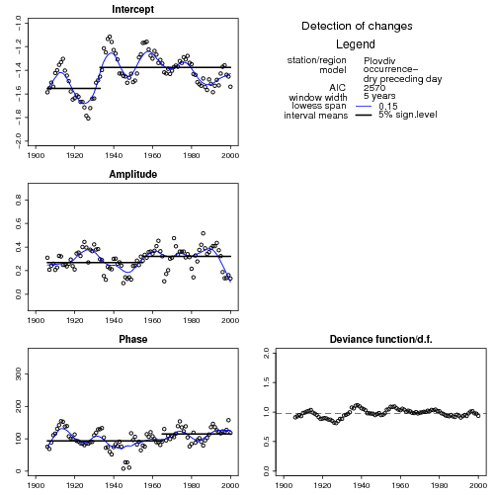
Figure 1. $π_{t}^{w|d}$ model estimates for gauge Plovdiv based on 5-years window.
The means of the sub-interval, determined by the change points are marked.
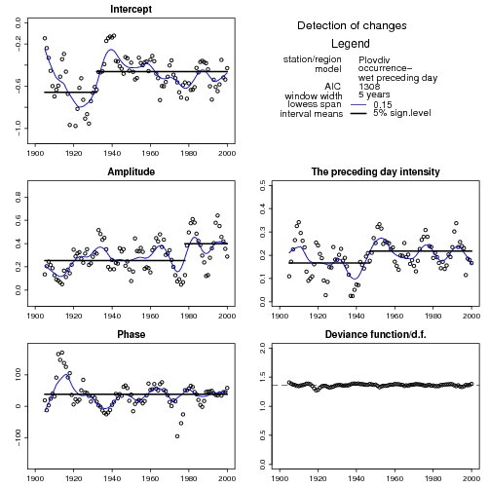
Figure 2. $π_{t}^{w|w}$ model estimates for gauge Plovdiv based on 5-years window.
The means of the sub-interval, determined by the change points are marked.

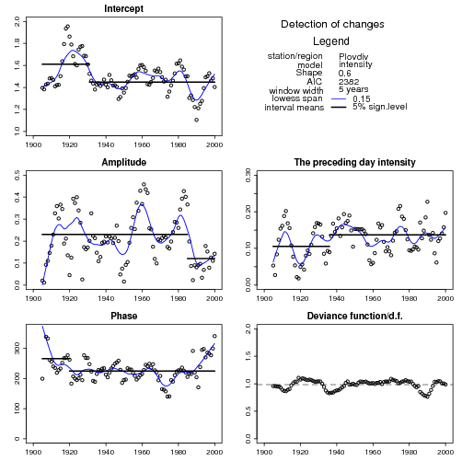
Figure 3. $μ_{t}$ model estimates for gauge Plovdiv based on 5-years window.
The means of the sub-interval, determined by the change points are marked.
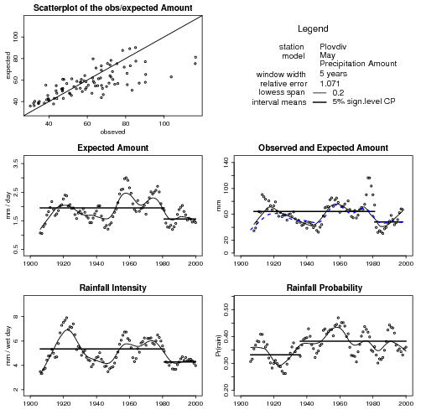
Figure 4. Monthly (May) model precipitation total for gauge Plovdiv

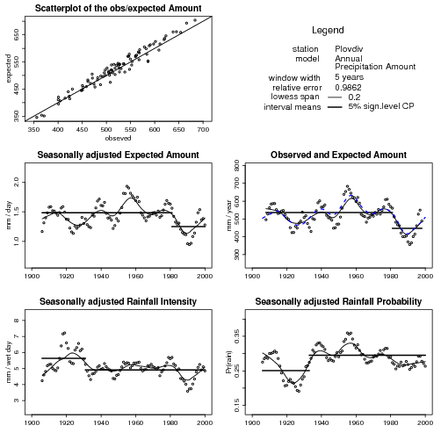
Figure 5. Annual model precipitation total for gauge Plovdiv
6. Acknowledgements
The “Development of a Daily Precipitation Model for South-west Bulgaria” and “An Assessment of the Effects of Climate Change on Precipitation in Bulgaria” studies of N. Neykov and P. Neytchev were fully supported by Deutsche Forschungsgemeinschaft within the framework of cooperation between the Deutsche Forschungsgemeinschaft and the Bulgarian Academy of Sciences while they were Visiting Fellows of the Institute of Statistics and Econometrics, University of Göttingen during the periods May-June 2000 and September-November 2001.

7. References
Chandler, R. E., Wheater, H. S. (2002): Analysis of rainfall variability using Generalized Linear Models: A case study from the West of Ireland. Water Resources Res. 38,
Coe, R., Stern, R.D. (1982): Fitting models to daily rainfall data. J. Appl. Meteorol., 21, 1024-1031.
Grunwald, G.K., Jones, R.J. (2000): Markov models for time series with mixed distribution. Environmetrics, 11, 327-339.
Katz, R.W. (1977): Precipitation as a chan-dependent process. J. Appl. Meteorol., 16, 671-676.
Karz , R.W. (1999): Extreme value theory for precipitation: sensitivity analysis form climate change. Adv. Water. Resour. 23, 133-139.
Katz, R.W., Parlange, M. B. (1995): Generalizations of chain-dependent processes: Application to hourly precipitation. Water Resour. Res., 31, 1331-1341.
MacDonald, I. L., W. Zucchini (1997): Hidden Markov and Other Models for Discrete-valued Time Series. Chapman & Hall. London.
Pettitt, A. N. (1979): A nonparametric approach to the change point problem. Appl. Statist., 28, 126-135.
Stern, R.D., Coe, R. (1984): A model fitting analysis of daily rainfall data. J. R. Statist. Soc. A, 147, 1-34.
Woolhiser, D.A. (1992): Modeling daily precipitation - progress and problems. In: Statistics in the environmental and earth sciences, Walden, A.T. and Guttorp, P. (eds.), Halsted Press, 71-89.
Zucchini, W., Neykov, N., Neytchev, P. (2001a): Development of a Daily Precipitation Model for South-west Bulgaria. Research Report conducted within the framework of cooperation between the Deutsche Forschungsgemeinschaft and the Bulgarian Academy of Sciences.
Zucchini, W., Neykov, N., Neytchev, P. (2001b): An Assessment of the Effects of Climate Change on Precipitation in Bulgaria. Research Report conducted within the framework of cooperation between the Deutsche Forschungsgemeinschaft and the Bulgarian Academy of Sciences.

