USE OF MATHEMATICAL MODELING FOR PREDICTION OF NATURAL AND ANTHROPOGENIC CHANGES IN THE HYDROLOGICAL REGIME OF THE DANUBE DELTA

S.A. Aleshkin, V.N. Mikhailov

Moscow State University, Moscow, Russia, e-mail: hydrology@mtu-net.ru

Abstract: A new mathematical model of hydro-morphological processes in non-tidal river deltas was used for simulation studies of water discharge redistribution between delta branches as consequences of both natural changes in channel morphology and hydrotechnical actions.
Keywords: modeling, hydro-morphological process, delta, water runoff, prediction, branch.

DER GEBRAUCH DER MATHEMATISCHEN MODELLE FÜR DIE VORHERSAGE NATÜRLICHER UND ANTHROPOGENICER ÄNDERUNGEN INS HYDROLOGISCHE REGIME DES DELTAS VON DONAU

Zusammenfassung: Ein neues mathematisches Modell von hydromorphologischen Prozessen in Nichtgezeitenflussdeltas wurde für Simulierungsstudien der Wasserentladungsneuverteilung zwischen Delta-Zweigen als Ergebnis wie der natürlicher Änderungen in der Kanalmorphologie als auch hydrotechnical Handlungen verwendet.

Schluesselworte: das Modellieren, hydromorphologischer Prozess, Delta, Wasserentscheidungslauf, Vorhersage, Zweig

1. Hydro-morphological processes in river deltas and methods of their study
River deltas are very unsteady geographical objects, exposed
to complex hydro-morphological processes, that consist of joint processes of dynamics of water stream, sediments and river branch system. The basis of hydro-morphological processes in deltas are redistribution of water and sediment discharges between delta branches, channel deformations of branches (their erosion and activization or, on the contrary, sedimentation in them and dying off), and processes of delta coastline dynamics (its promotion into the sea or, on the contrary, abrasion and retreat).

The listed processes are simultaneously subject to the laws of river hydraulics (including the influence of a reception water body); the laws, which operate channel deformations in watercourses; the laws regulating coastal processes, including promotion or retreat of deltas. Research of deltas formation in the world and Russia was carried out at a qualitative level; the review of these researches was given in (Deltas…, 1975; Mikhailov, 1997).

Methods of complex mathematical modeling of hydro-morphological processes in river deltas are not created yet. Methods of hydraulic calculation of distribution of water discharges in delta branches (Mikhailov, 1971) are rather well developed, and in work (Ivanov et al., 1983), a hydraulic method of calculation of discharges and water levels in watercourses of deltas is combined with a method of calculation of channel deformations, based on definition of "not washing away" velocity of water flow and the discharge of attracted sediments. The first attempts to develop a method of calculation of processes of the delta branches activization or dying off, are based on the concept of assessment of morphometrical characteristics of watercourse to their dynamically steady condition, offered by V.N. Mikhailov (1971).

2. Modeling of the water discharges redistribution between branches in river deltas

One of the main scientific and applied points in the modern hydrology of river deltas is the calculation of water discharges and levels in delta branches and their changes under the influence of natural and anthropogenic factors.

This problem can be solved in two ways: hydrometrical, using the data of field measurements, and mathematical modeling, based on the equations of river hydraulics. Prognostic estimates can be done only using the second method.
A method of the cumulative modules of hydraulic resistance for calculation of the redistribution of water discharges in system of branching watercourses during the change of their morphometrical characteristics is a basis of the proposed mathematical model. The advantage of this method in solving of this problem is in opportunity of direct (without a procedure of iterations) analytical calculation of water discharges distribution in delta branches at set of morphometrical characteristics of watercourses – length $L$, width $B$, average depth $h$ and area of cross section $ω=\text{Bh}$, and also roughness coefficient $n$. The method is based on the assumption, first, about existence of full balance of water discharges in a system of delta water courses, i.e. about absence of linear losses or additions of water runoff in delta, and, second, about equality of the sum of water level fall $Δz$ from the delta head to the sea along any adjacent directions. The essence of the method consists in replacement modules of hydraulic resistance of watercourses and their systems with some "cumulative module", calculated, by analogy with electric network, in accordance with schemes of consecutive, parallel and consecutive-parallel connections of watercourses, their parts and systems.
Using this method, distribution of water discharges can be calculated by the formula
$Q_{i}/Q_{j}=\sqrt{F_{\text{com} j}/F_{\text{com} i}}$, (1)
where $Q_{i}$ and $Q_{j}$ are water discharges in sources of two adjacent branch systems with the common point of branching and inflow in the same deep mouth nearshore, $F_{\text{com} i}$ and $F_{\text{com} j}$ are the cumulative modules of hydraulic resistance of both branch systems, calculated according to the following equation
$F_{\text{com} i}=F_{i}+F_{\text{com}}=F_{i}+\frac{1}{{\left(1/\sqrt{F_{\text{com} i+1}}+1/\sqrt{F_{\text{com} i+2}}\right)}^{2}}$, (2)
where $F_{i}$ is the module of resistance of the main channel of the system, and $F_{\text{com} i+1}$, $F_{\text{com} i+2}$ are the cumulative modules of resistance of the private subsystems, which are included in system $i$ (they could be calculated also with the formulas of a kind (2)).
For the elementary two-branch system, consisting of channels I and II, the formula (1) takes a simple form
$Q_{I}/Q_{\text{II}}=\sqrt{F_{\text{II}}/F_{I}}$. (3)
The module of hydraulic resistance of a branch or its part (the characteristic entered into hydraulics by N.N.Pavlovsky) is defined by the following equation, obtained from the formula of Chezy-Manning:
$F=Δz/Q^{2}=\ln^{2}/B^{2}h^{\text{10}3}$. (4)
The roughness coefficient can be calculated with the V.M. Makkaveev-A.V.Karaushev formula $n=0,\text{03}d^{16}$, where $d$ is average diameter of bed deposits in mm.
The method of the cumulative modules of resistance has been earlier applied to calculation of the distribution of water discharges in deltas of the Don (Mikhailov, 1971) and Yana (Aleshkin et al., 2002) and has satisfactory results.

3. Modeling of the water discharges redistribution between the branches in the Danube delta
F

or the Danube delta, a method of cumulative modulus of hydraulic resistance was applied.

For application of this method, it is necessary to know the present or expected (project) morphometrical characteristics of delta branches (their length, width and depth) and the roughness coefficients.

The water discharges distribution between all branches of the Danube delta was calculated in the paper with the help of described method for periods 1976–1980 and 1996–2000. At the same time, not only the hydraulic resistance of delta branches, but also of all shallow mouth bars were taken into account.

This method allows us to estimate the influence of the natural changes of delta branches morphometrical characteristics on redistribution of water discharges between them. In addition, it made it possible to assess the influence of the cut-off of the meanders in the Gheorghe branch on redistribution of the Danube water runoff from the system of the Chilia branch into the system of the Tulcea branch.
The Danube mouth region belongs to the delta type and consists of the river part (length about 85 km), the delta (one of the largest in Europe, the area 5640 km² and the mouth nearshore area about 1360 km². A share of the Ukraine is 22 % of the full delta area, i.e. 1240 km²; other part belongs to Romania. The length of delta along its main branch is 116 km, the extension of nearshore line is about 180 km, the average width of mouth nearshore zone is 6–10 km. The common area of mouth region is about 7000 km². The head of the Danube delta is a place, where river splits in two largest branches – Chilia (left) and Tulcea (right) (Figure 1).
The Chilia branch serves as continuation of the Danube River and is the main delta branch. Over the course of the river it forms two internal and one external (Chilia) deltas.
Simplified scheme of the Danube delta was created for modeling. Branches and their rated sections were numbered by the Roman figures (i = I, II, III…XXXII); 32 branches and their sections were taken into account. Number "zero" was given to the Danube above head of the delta. Points of a branching and connection of watercourses were numbered by the Arabian figures (k = 1, 2, 3…17); 17 points were taken into account. Mouth bars were designated by capital Latin letters (j = A, B, C…L); it was taken into account 11 mouth bars.
In the simplified scheme of the delta network, very shallow natural and artificial watercourses, which do not play an appreciable role in distribution of water of the Danube on space of delta were not taken into account. Also, for simplification of the scheme small overflows from one system in others were not taken into account, which had allowed using a method of the cumulative modules of resistance. For example, channels XVII, XVIII and XIX near to an outlet on nearshore incorporate. In the rated scheme, they are given as independent from each other. If two or three branches form on the same mouth bar, the last one is conditionally divided in a cross-section direction in two or three identical parts (for example, bars D1, D2, D3).
The results of water discharge distribution modeling in the main branches of the Danube delta (Table 1) produced satisfactory results.
The mathematical model of the hydro-morphological processes in the Danube delta allowed us to do the next studies:
1) simulation study of water discharges in delta branches in periods of high and low flow periods (for sections, were data of field measurements are absent);
2) determination of tendency of channel deformations in delta branches;
3) simulation study of redistribution of the water flow due to the artificial deepening bar of the Bystriy branch;
4) simulation study of redistribution of the water flow due to the artificial deepening of the Prorva branch;
5) simulation study of redistribution of the water flow due to the cut-off of the channel of the Gheorghe branch;
6) simulation study of redistribution of the water flow due to the promotion of the Potapovsky branch into the sea.

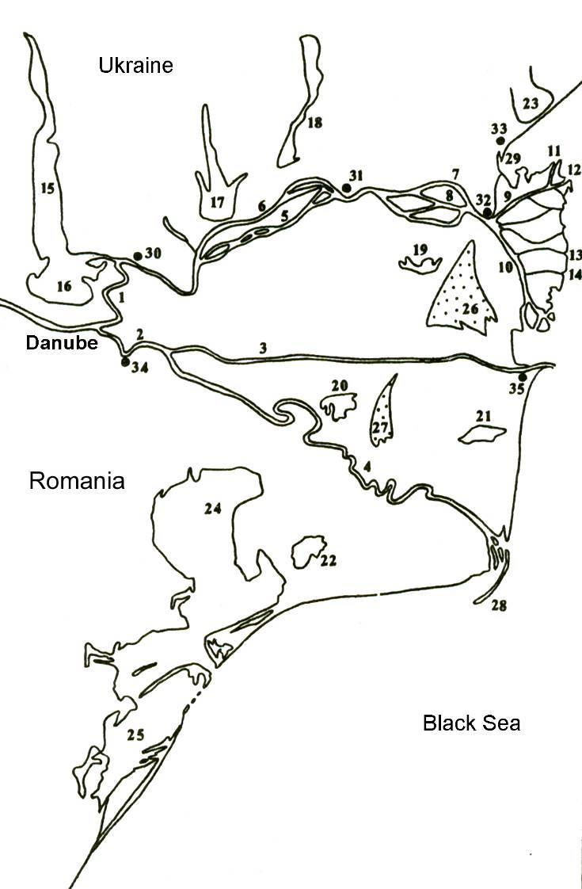

Figure 1. The scheme of the Danube delta.
Branches:1 – Chilia, 2 – Tulcea, 3 – Sulina, 4 – Gheorge,; 5 – Sredny, 6 – Kislitsky, 7 – Solomonov, 8 – Praymoy, 9 – Ochakovsky, 10 – Starostambulsky, 11 – Prorva, 12 – Potapovsky, 13 – Bystriy, 14 – Vostochny; lakes: 15 – Ialpug, 16 – Cuhurlui, 17 – Catlapug, 18 – Chitai, 19 – Merhei, 20 – Uzlina, 21 – Rosu, 22 – Dranov; lagoons: 23 – Sasyk, 24 – Razelm, 25 – Sinoe; sandy ridges: 26 – Letea, 27 – Caraorman; 28–island Sahalin; 29–Jebriensky bay; settlements: 30 – Izmail,31 – Chilia, 32 – Vilkovo, 33 – Primorskoe, 34 – Tulcea, 35 – Sulina.

Table 1. The results of water discharge distribution modeling in the main branches of the Danube delta for period 1996–2000 (low flow period)
№ of branch | Name of branch | Water discharges |  | Imbalance (%)
№ of branch | Name of branch | By modeling (m³/s) | By field measurements (m³/s) | Imbalance (%)
I | Chilia (1) | 1553 | 1560 | 0,4
II | Tulcea | 1447 | 1440 | 0,5
III | Kislitsky | 68 | 66 | 3,0
IV | Sredny | 1071 | 1080 | 0,8
IVа | Sredny | 1435 | – | –
IVб | Ivanesht | 365 | 365 | 0
V | Chilia (2) | 1503 | – | –
Vб | Babina | 511 | 548 | 6,8
VI | Solomonov | 501 | 502 | 0,2
VII | Pryamoy | 491 | 510 | 3,7
VIII | Chilia (3) | 1503 | 1510 | 0,5
IX | Ochakovsky | 394 | – | –
XII | Prorva | 144 | 140 | 2,9
XIII | Connection channel | 69 | 66 | 4,5
XV | Potapovsky | 142 | 140 | 1,4
XVII | Gneyshev | 39 | 39 | 0
XVIII | Poludenny | 69 | 63 | 9,5
XIX | Ankudinov | 38 | 37 | 2,7
XX | Starostambulsky | 1109 | – | –
XXI | Bystriy | 543 | 585 | 7,2
XXIII | Vostochny | 63 | 64 | 1,6
XXVI | Limba | 10 | 10 | 0,0
XXVIII | Kurilsky | 13 | 13 | 0,0
XXIX | Tsygansky | 70 | 75 | 6,7
XXXI | Sulina | 608 | 615 | 1,1
XXXII | Gheorghe | 829 | 815 | 1,7

For example, the result of simulation study of redistribution of the water flow due to the artificial deepening mouth bar of the Bystriy branch is presented in Table 2.
Mathematical modeling was also used by authors for the prediction of influence of expected channel processes in the delta and the Black Sea level eustatic rise and possible hydrotechical works (channel dredging and training) in the Prorva, Bystriy, Potapov branches and their mouth bars on the delta hydrological regime. The results of modeling can be used for the choice of the optimal variants of the hydrotechical works from the hydrological and ecological points of view.

)

Table 2. The results of simulation study of redistribution of the water flow on the Bystriy branch mouth bar due to it artificial deepening
Parts of the bar | Before works |  | Variant A |  | Variant B
Parts of the bar | Water discharge (m³/s) | % of total | Water discharge (m³/s) | % of total | Water discharge (m³/s) | % of total
Bar above its dividing | 542 | 100 | 543 | 100 | 543 | 100
Left shallow part | 109 | 20.1 | 89 | 16.4 | 77 | 14.1
Left channel | 90 | 16.5 | 172 | 31.7 | 225 | 41.4
Middle shallow part | 189 | 34.9 | 155 | 28.6 | 133 | 24.6
Right channel | 74 | 13.6 | 60 | 11.1 | 52 | 9.5
Right shallow part | 80 | 14.8 | 66 | 12.1 | 56 | 10.4
Parts of the bar | Variant C |  | Variant D
Parts of the bar | Water discharge (m³/s) | % of total | Water discharge (m³/s) | % of total
Bar above its dividing | 542 | 100 | 543 | 100
Left shallow part | 93 | 15.1 | 82 | 16.4
Left channel | 77 | 12.5 | 68 | 31.7
Middle shallow part | 162 | 26.4 | 143 | 28.6
Right channel | 142 | 26.2 | 190 | 11.1
Right shallow part | 69 | 12.7 | 60 | 12.1

Comment. Variants of artificial deepening of mouth bar channels: А – left up to 7 m, B – left up to 9 m, C – right up to 7 m, D – right up to 9 m.

4. Acknowledgments
This work was supported by the Russian Foundation for Basic Research (grant №02-05-64034).

5. References

Aleshkin, A., Babich, D., Mikhailov, V. (2002): Mathematical model of water discharges distribution between branches of the Yana delta. Vestn. Moscow University. Ser. 5. Geography. №: 5. P. 43–49. In Russian.
Deltas – models for exploration (1975). Ed. by M.L. Broussard. 555 p. Houston, USA.
Ivanov V., Marchenko A., Mikhalev M., Piskun A., Ghernin K. (1983): Hydraulic method of study of water and channel regime in multibranch river systems. P. 5–22. Trans. of AASRI. Vol. 378. Gidrometeoizdat, Leningrad, USSR. In Russian.
Mikhailov V. (1971): The dynamics of stream and channel at nontidal river mouths. 260 p. Gidrometeoizdat, Moscow, USSR. In Russian.
Mikhailov V. (1997): Mouths of rivers in Russia and adjacent countries: past, present and future. 413 p. GEOS, Moscow, Russia. In Russian.
Mikhailov, V., Gan, G., Makarova, T. (1973): Method of water discharges and levels calculation in delta branches using the cumulative module of resistance. P. 63–73. Trans. of SORI. №116. Gidrometeoizdat, Moscow, USSR. In Russian.

