REVIEW OF MAIN CHANNEL AND FLOODPLAIN INTERACTIONS ON RIVER TISZA

Margit Gulyás¹, Gábor Bálint¹, András Csík¹, Szabolcs Erdélyi¹,
Gyula Gábris², Tamás Telbisz²

¹Water Resources Research Centre Plc., Budapest, Hungary, e-mail: balint@vituki.hu
²Loránd Eötvös University Budapest, Hungary

Abstract: Significant changes took place along the Tisza River after the regulation of the main river in the 19th century. The wide flood plain was constrained by the system of flood embankments cutting of river bends and navigation route supporting river training had major impact on the lowflow channel. Sediment transport capacity of the river had grown considerably in the first period after the regulation took place. Scouring of the river bed and that of the unprotected floodplain was observed in the period of 1876-1911. This process was accompanied with the lowering of flood peaks. While the scouring of lowflow channel can be followed without interruption during all of the following decades the rising flood levels especially after 1961 indicate different trends in the development of the floodberm. The flood conducting cross section has been reduced in the last 40 years by 5-20 per cent. The interaction between the main channel and the floodberm can be followed by the formation of natural levees at sites where the flow leaves the main channel and enters to the floodplain. Single flood waves can produce depositions above 50 cm of sand and silt in the natural levee zone, however the deposition rate over the whole floodberm is significantly less and only 45 cm for the last 120 years. Many other semi-natural and completely man induced processes having an impact on the flood conducting capacity of the river channel - floodberm system have been revealed. The most significant ones are the contraction of the floodplain, flow systems of river bends, height and position of summer dikes, changes of natural and cultivated vegetation on the flood -- leading to the increase or decrease of the roughness, creation of bottle necks by different structures and with the rise of built in areas, summer houses etc. The questions of subsidence and recent tectonics related rise of different river reaches have not been studied in details.
Keywords: sediment, geomorphology, flood, meander, point bar, levee

ÜBERSICHT DER WECHSELBEZIEHUNGEN ZWISCHEN DEM FLUSSBETT UND DEM DEICHVORLAND AN DER THEIß

Zusammenfassung: An der Theiß konnten nach ihrer im 19. Jh. stattgefundenen Regulierung signifikante Veränderungen verzeichnet werden. Das weite Flutgebiet wurde durch Hochwasserschutzdeiche eingeengt, zahlreiche Krümmungen wurden durchgestochen und das Flussbett wurde für die Schifffahrt ausgebildet, was sich besonders auf das Niedrigwasserbett ausgewirkt hat. Unmittelbar nach der Regulierung hat die Feststoffführungskapazität des Flussbettes beträchtlich zugenommen. Während der Periode 1876-1911 wurde eine Auskolkung des Flussbettes sowie des ungeschützten Flutgebietes verzeichnet, was mit einer Abnahme der Hochwasserscheitel einherging. Während in den darauffolgenden Jahrzehnten eine ununterbrochene weitere Senkung des Niedrigwasserflussbettes beobachtet werden konnte, deutet die seit 1961 erfolgte allmähliche Erhöhung der Hochwasserniveaus auf entgegensetzte Tendenzen im Deichvorland hin. Die für die Ableitung der Hochwassermengen zur Verfügung stehende Querschnittsfläche hat sich während der vergangenen 40 Jahre um 5 bis 20% vermindert. Die Wechselwirkung zwischen dem Hauptflussbett und dem Deichvorland kann besonders an der Entwicklung der natürlichen Bodenrücken (Uferkanten-Erhöhungen) solcher Stellen verfolgt werden, wo während der Flutperiode das Wasser aus dem Flussbett in das Deichvorland hinaustritt. Einzelne Hochwasserwellen können dabei über 50 cm hohe natürliche Bodenrücken aus Sand und Schluff absetzen, wobei das Ausmaß der allgemeinen Sedimentation über dem ganzen Deichvorland natürlich geringer, undzwar etwa 45 cm während der letzten 120 Jahre war. Zahlreiche weitere halb-natürliche sowie völlig anthropogene Vorgänge wirken sich auf das aus Flussbett und Deichvorland bestehende System aus. Die wichtigsten darunter sind die folgenden: die Einengung des Deichvorlandes, die Verminderung der Durchflussfähigkeit der Flussbettkrümmungen, die Höhe und die Lage der Sommerdeiche, Veränderungen der natürlichen und der kultivierten Bepflanzung des Deichvorlandes (was zu Veränderungen des Rauhigkeitsbeiwertes führt), die Schaffung von Engpässen durch Errichtung verschiedener Bauwerke sowie die Zunahme der eingebauten Flächen im Deichvorland, der Anzahl von Sommerhäusern, usw. Die Fragen der Senkung und der tektonisch bedingten Erhöhungen verschiedener Flussabschnitte wurden nicht ausführlich untersucht.
Schlüsselworte: Sediment, Hochwasser, Bodenrücken, Morphologie, Uferwall, Krümmung

- Introduction
In the Tisza River Basin (Figure 1) the recent years were characterised by the enormous increasing of flood level (Figure 2). Although the consequences of these extremely high flood crests reached disastrous magnitudes only at upstream sections (mostly outside of the borders of Hungary) in many cases the safety of flood embankments was at stake, along
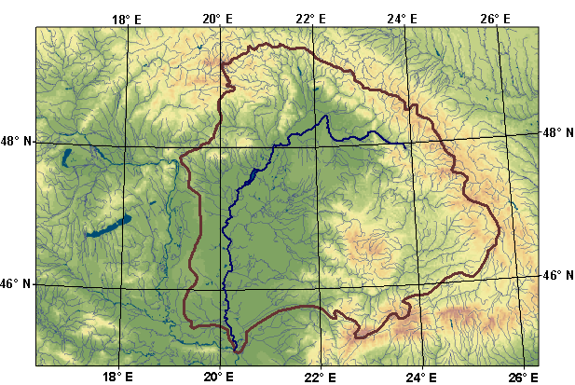
Figure 1. The Tisza River Basin

the middle and lower currents of the Tisza River. Flood defence demanded enormous efforts and there was no clear guarantee of success. The population and significant volume of national wealth on the protected floodplain experienced imminent danger in the course of these flood events. Continuation of these trends may lead to future flood disasters, dyke failures and inundation of the protected floodplain.
Significant changes took place along the Tisza River after the regulation of the main river in the 19th century. The wide flood plain was constrained by the system of flood embankments cutting of river bends and navigation route supporting river training had major impact on the lowflow channel. Sediment transport capacity of the river had grown considerably in the first period after the regulation took place. Scouring of the river bed and that of the unprotected floodplain was observed in the period of 1876-1911. This process was accompanied with the lowering of flood peaks. While the scouring of lowflow channel can be followed without interruption during all of the following decades the rising flood levels especially after 1961 indicate different trends in the development of the floodberm. The flood conducting cross section has been reduced in the last 40 years by 5-20 per cent.

Figure 2. Rising flood peaks on the Tisza and her tributaries

Peak levels of the floods of 1999 and 2000 have broken all previous records (Figure 3) (Figure 4) and created a new situation along the River Tisza in which the traditional flood defence practices of continuously increasing the flood levees are not sufficient and not even efficient anymore.
The planning and implementation of those measures requires clear understanding of the causes of the increased flood crests. Characteristics of streamflow indicate virtually unchanged conditions of flow generation (Fig. 4.) while annual maxima of water levels show a clear increasing trend. Man made and semi natural changes of the main channel and floodberm (unprotected/natural floodplain) geometry, channel and floodplain interactions are among the causes. There was an urgent need for reconsidering the basic principles of flood control, tailoring and modifying them to suit the new situation. To develop a new concept one needs to know much better the reasons that which caused the increase of flood levels, determining them and proving these morphology related questions. This was the motivation of the present effort trying to summarise and analyse some of the results of recent research.
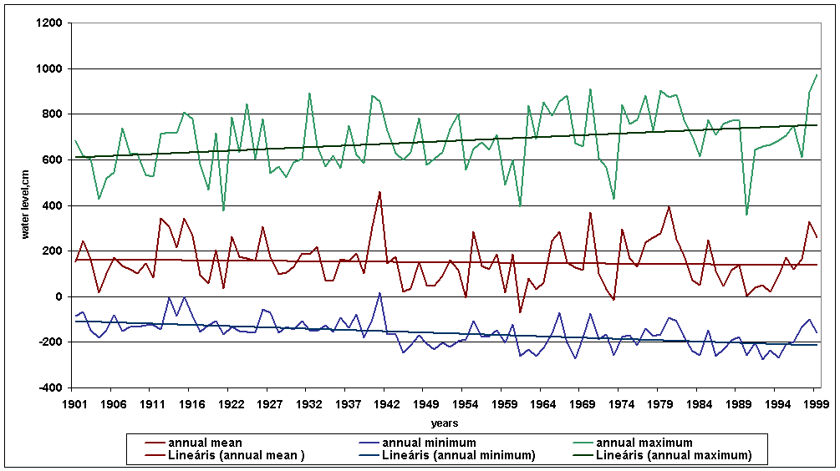
Figure 3. Water level fluctuation on the Tisza at the station Szolnok
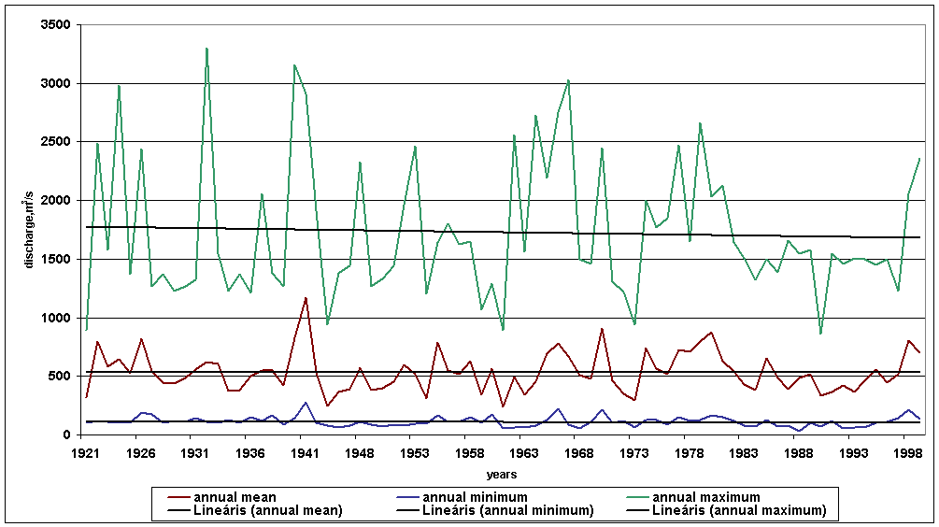
Figure 4. Discharge fluctuation on the Tisza at the station Szolnok

- Recent investigations
In Kiss, Sipos and Fiala (2002) study was measured the depth of the sediment of the floodplain of Mindszent (river kilometres 212-216). They have measured since the autumn flood of 1998 by direct methods, including the physical characteristics of the deposits. The upsilting effects of three large floods were investigated: the first two ones jointly, while that of the record-breaking springtime flood of 2000, separately.
Detailed geomorphological maps were prepared for the area, showing the main surface-forming processes and formations. They realized that the depth of the deposits created by the floods investigated (1998-2001) was found as 20.5 mm, in average. The actual deposit depth varies, however, over wide ranges. The bulk of the sediment was deposited in the 10-20 m wide zone along the river bank. These differences can be explained by the different hydrological properties of the floods investigated, namely, that they inundated the floodplains for different periods of time. The geomorphological situation and the surface-forming processes basically determine the rate of deposition and the further destiny of the sediment within the flooplain. The near-bank zone, characterized by the most intensive sediment accumulation, is not only building actively up, but also gets eroded. Thus the flood-accumulated deposits will get back into the channel within a few years.
Their calculations indicate that the cross-section area of the flood channel was decreased by the 1998-1999 floods by 0.89%, while the spring flood in 2001 resulted only 0.09% decrease. These can be considered overestimated values, however, these are new deposits, which will be compacted as the time proceeds. They have corrected the values, disregarding the sediment accumulation of the near-bank zone. The corrected estimate was 0.3% decrease of the flood channel, caused by the floods of 1998-2000.
By Gábris et al (2002) the study area for the research was the location of the very first cut-off of a meander during the river regulation, on the river reach between Tiszadob and Tiszaszederkény. The digital topographic map of the area was prepared on the basis of the topographic map of scale 1:10 000 (Figure 5).

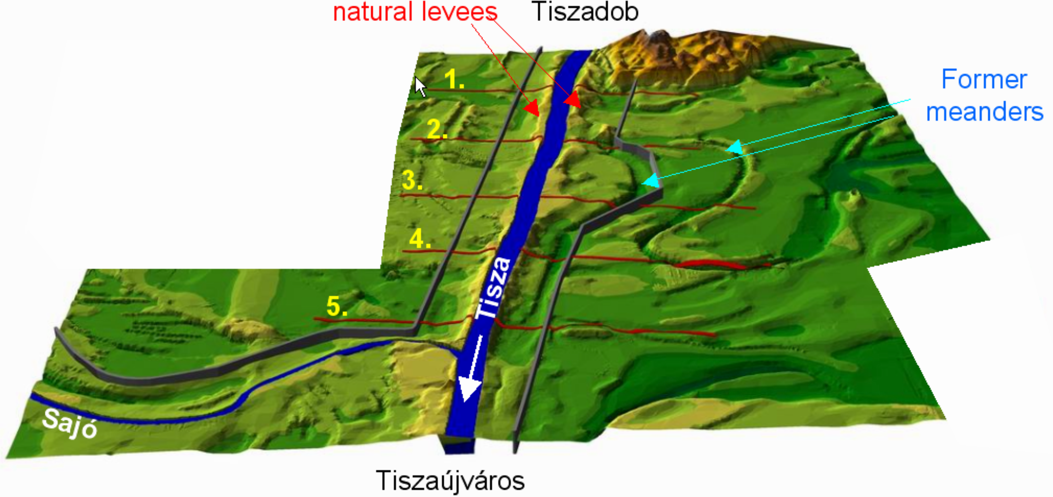
Figure 5. DEM of the area (red lines: selected profiles, grey lines: dikes, the distance between profiles is 1 km)

The method applied was aimed at the quantitative determination of the extent of the deposition, which resulted on the floodplain during the period of 120 years, elapsed between the time of river regulation an the time of making the map.
Two methods were used for the determination of the depth of sedimentation between the levees. The first was based on the values obtained from the sections (profiles), which were drawn perpendicularly to the river. The second was based on the evaluation of indices determined for areas between the profiles. The profiles were taken at about 1 km pacing.
On the basis of the profiles the average elevation of the terrain on the protected side of the levee was calculated. These values were considered the base terrain level before river regulation. The degree of sedimentation was measured relative to this base level.
The results of the calculation made on the basis of the digital terrain model indicated that the depth of sediment deposition between the sections of the five kilometre long artifical river reach between Tiszadob and the Sajó mouth varied in the range 0.23-0.60 metres, during the 120 years (Table 1)(Table2). This means that the original floodplain through-flow cross-section was reduced by 5-16%. These results are in harmony with the similar results of others, made by different methods. The differences can be due to the effect of floodplain erosion, scouring back into the river, and to the compaction of the deposited material. The width of the floodplain can be considered a significant affecting factor.

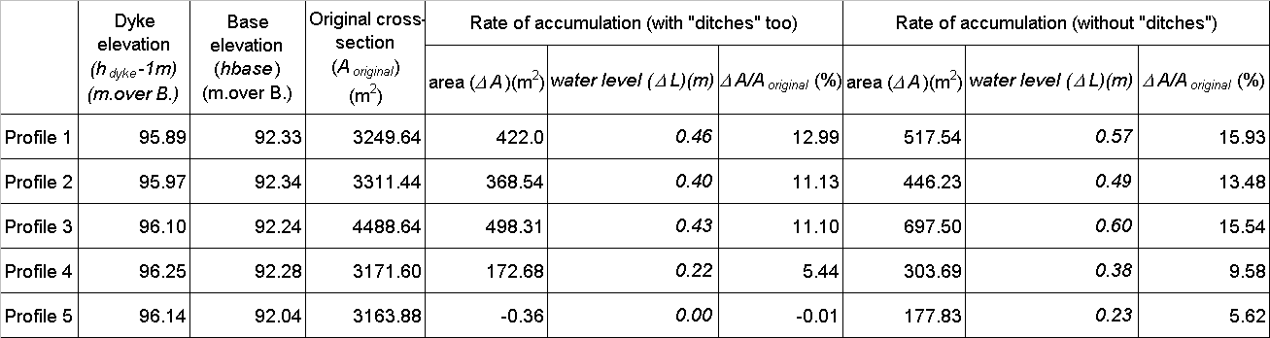
Table 1. The rate of accumulation in the profiles

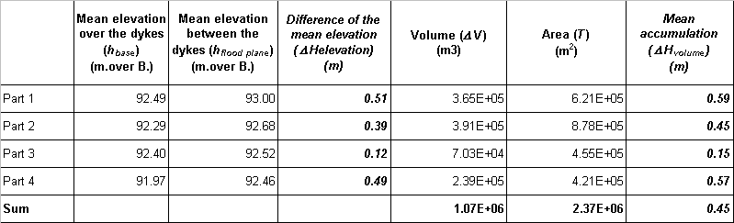
Table 2. The mean accumulation in the parts

Braun et al. (2003) conducted investigations along the Szolnok reach of the River Tisza, aiming at the age of upper sediment layers. The analysis included the short halfing period ¹³⁷Cs originating from nuclear tests of the 1950’s and 1960’s and also from the Chernobyl accident of 1986.
Significant maximum of ¹³⁷Cs was detected in the upper 30 cm layer of sediment. Beneath this layer this isotope was still found down to the depth of 120 cm, i.e. a clear proof that the upper 120 cm had been accumulated after 1950, while the upper 20-30 cm layer after 1986.
Copper, zinc, chromium and lead concentration was also analysed. The heavy metall concentration is related to this kind of pollution of the River Tisza itself.
Based on the analysis four layers can be distingiushed with well expressed differences in heavy metall concentration. Heavy metall concentration has its maximum in the 0-30 cm layer, the difference is significant relative to the 30-130 cm layer. Within the 30-130 cm range Pb and Cu have maximum in layers of 90-130 cm. The third zone in 130-205 cm depth is characterised by high concentration of Ca. Chalky formations are frequent. The fourth zone has high concentration of Na and K, while Cu shows also a relative high value (Figure 6) (Figure 7).
Significant copper, lead and zinc maximum are related to World War I pollution expressed at depths 220, 195 and 190 cm consequently. The speed of deposition is estimated by linear model in the range of 2 - 3 cm / year.

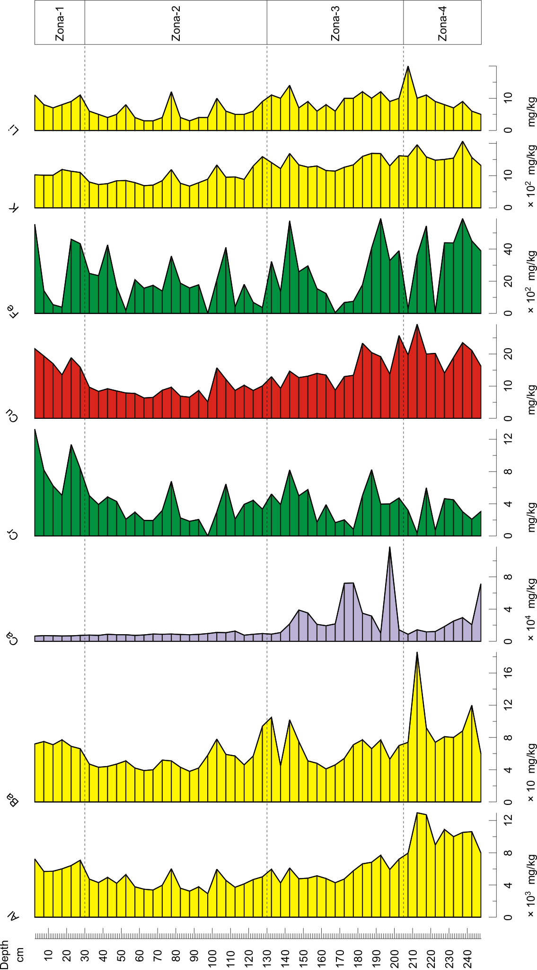
Figure 6. Distribution of the elements

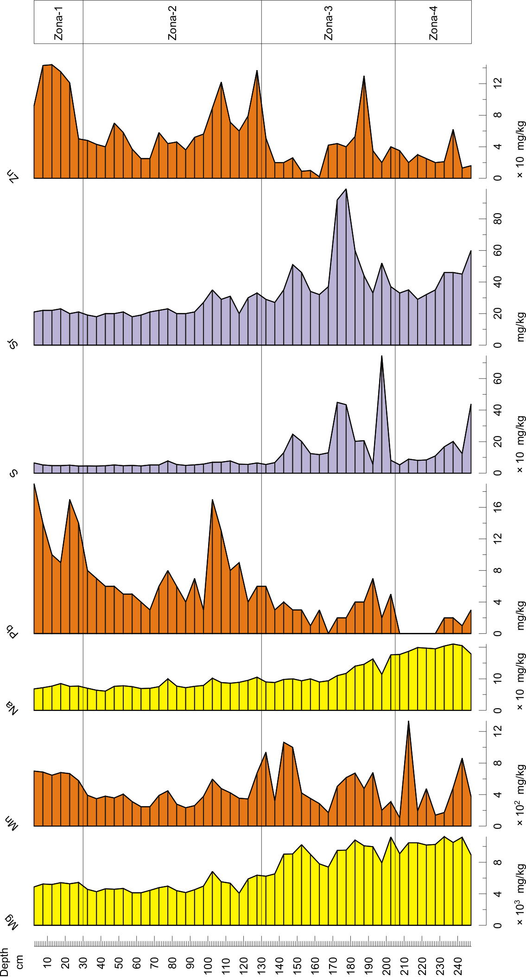
Figure 7. Distribution of the elements

- Formations on the floodplain
The determination of the morphology of the floodplain (and that of the flood-basin in general) is an important issue from the practical point of view. A similarly important issue is to provide an unambiguous terminology for them.
The point bar is formed by the deposition of sediment along the mildly sloping river banks of the convex side of the river bend at falling water level. These sand-bars are the more marked, the slower the side-wise movement of the river bend. Their height decreases parallel to the increase of the water depth from the inner part of the bend towards the concave bank. The crest lines of the point bars are separated from each other by depressions, called the swales. When these latter get firstly inundated by the floods they illustratively indicate the series of point bar sand-bars. On the bottom of the point bars there are deposits of relatively rough particles (where the sediment originating from the upstream parts of the river might get mixed with the debris originating fromt the local bank-erosion). Finer inclined layers, getting finer towards the top, are following these rougher bottom deposits. Horizontal clayey-silt layers are found, a top of these inclined layers, at the level of the highest floods. The upstream part of the point bar consists of rougher and more stable material, while the downstream part of finer particles.
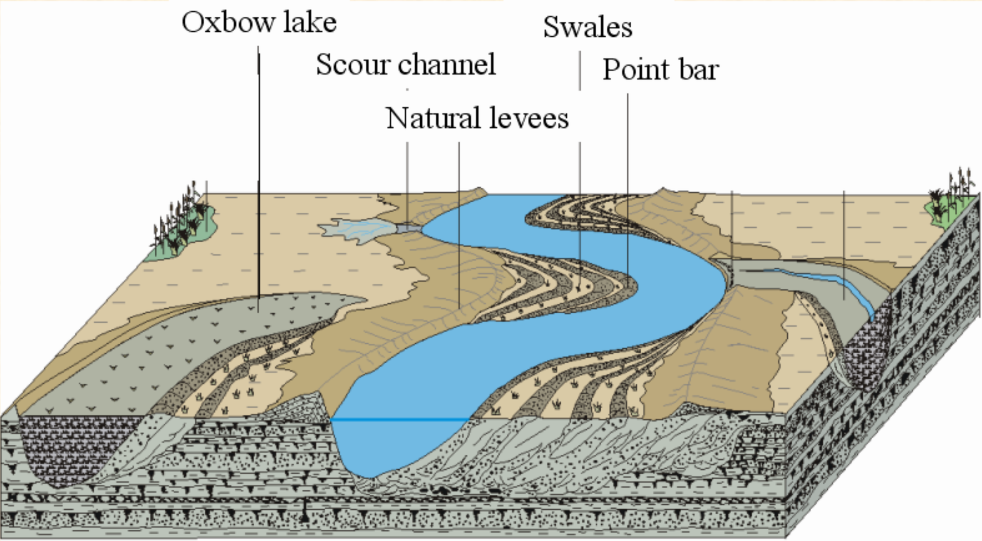
There might be several other formations along the river, generated in more or less continuous manner. The roughest material (mostly sand) is found right outside of the near-bank zone, where the outflowing water losses its velocity. This forms a natural bank-ridge or natural levee along the bank line (Figure 8). Further off the main channel ever finer particles cover the original terrain. This explains the asymmetry of the ridges, which are steeper towards the main channel and mildly sloping away from it. The degree of development of these natural bank-ridges can be much varying in the middle reach-type meandering river lengths. They can be more developed and higher at the outer, concave side than in the convex one, where they may also be missing. On this side, the zone of the point bars may be directly transformed into the zone of floodplain sediments of fine particles. The natural levees are also layered because rising and falling out-flowing waters result in different particle depositions. However, the layers are relatively horizontal ones or follow the mildly arching shape of the bank-ridge. During floods the water flows out at the lowest point of the bank-ridge and the fast flowing water breaks through the natural levee, thus forming the scour channel. The sediment deposited from the out-breaking water (of somewhat rougher particle size than that of the material of the natural levee) forms a smaller delta or crevasse splay on the deepest part of the flood-plain.

Figure 8. Geomorphological interpretation of floodplain landforms of a meandering river
Formations along the river bank are due not only to the work of the river water. The dry and bare sand surfaces are subject to wind forces that can make the moving over shorter distances. The height of both the point bars and natural levees can be increased by sand: at low water level the dry sand will be moved by the wind, thus increasing their height. The name of these forms is the bank-dune and they have outstanding importance along the River Tisza from both economic and flood-control point of view. They are, however, mostly not developed in our area, but were generated in the near-past of the geological history, in the dry centuries and millenia of the Holocene and the last cold stadials of the glacial period.

- Formations on the floodplain
Significant changes took place along the Tisza River after the regulation of the main river in the 19th century. The wide flood plain was constrained by the system of flood embankments cutting of river bends and navigation route supporting river training had major impact on the lowflow channel. Sediment transport capacity of the river had grown considerably in the first period after the regulation took place. Scouring of the river bed and that of the unprotected floodplain was observed in the period of 1876-1911. This process was accompanied with the lowering of flood peaks. While the scouring of lowflow channel can be followed without interruption during all of the following decades the rising flood levels especially after 1961 indicate different trends in the development of the floodberm. The flood conducting cross section has been reduced in the last 40 years by 5-20 per cent. The interaction between the main channel and the floodberm can be followed by the formation of natural levees at sites where the flow leaves the main channel and enters to the floodplain. Single flood waves can produce depositions above 50 cm of sand and silt in the natural levee zone, however the deposition rate over the whole floodberm is significantly less and only 45 cm for the last 120 years. Many other semi-natural and completely man induced processes having an impact on the flood conducting capacity of the river channel - floodberm system have been revealed. The most significant ones are the contraction of the floodplain, flow systems of river bends, height and position of summer dikes, changes of natural and cultivated vegetation on the flood -- leading to the increase or decrease of the roughness, creation of bottle necks by different structures and with the rise of built in areas, summer houses etc. The questions of subsidence and recent tectonics related rise of different river reaches have not been studied in details.

- References
Braun, M., Szalóki, I., Posta, J., Dezső, Z. (2003): Estimate of the speed of the sediment accumulation in the floodplain of the River Tisza. Proceedings of the Annual Convention of the Hungarian Hydrological Society 2003, Convention Number 2-2.
Gábris, Gy., Telbisz, T., Nagy, B., Belardinelli, E. (2002): Upsilting of the floodplain of the River Tisza and the geomorphologic basis of the formation of deposits. Vízügyi Közlemények, 2002/3, 305-322, Budapest, Hungary
Kiss, T., Sipos, Gy., Fiala, K. (2002): Investigation of the rate of recent sediment accumulation in the Hungarian Lower Tisza river. Vízügyi Közlemények, 2002/3, 456-472, Budapest, Hungary

