SURFACE AND GROUNDWATER INTERACTION IN WETLANDS
Case study: ASAR, MERIS Data Use in Sultan Reedfields, Kayseri, Turkey

Ibrahim Gurer, F. Ebru Yildiz

Civil Engineering Department, Enginering and Architecture Faculty, Gazi University, CelalBayar Bulvari, Maltepe, Ankara, Turkey,
e-mail: gurer@gazi.edu.tr; feyildiz@gazi.edu.tr

Abstract: Sultansazligi marsh, being as one of the seven important wetlands of Turkey and the second important bird habitat of the country, is also known as one of the most important wetlands of Eastern Europe and Middle East. Sultansazligi is placed at the lowest elevation of Develi closed basin, which is located at the south- west of Erciyes Mountain, at central Anatolia, Turkey. In recent years, this wetland faced water shortage and salinity, due to the climatic change and irrigation return flow with high salt content. There is an intensive irrigated agricultural practice around the marsh with abundant use of water due to wild flooding. The irrigation water is supplied from three reservoirs and in dry years from groundwater aquifer. By using ASAR and MERIS images, it is planned to follow up the spatial variations of the wetlands and the variation in canopy. When the planned drip irrigation method will replace the existing wild flooding, the loss of water as evaporation will be less.
With this study, the water budget and the water related problems faced at Sultansazligi wetland area are introduced with their solutions. Both the surface and groundwater budgets of the closed basin are computed. In computation, ENVISAT images are planned to be utilized to support the computational outcomes. The recent geophysical electrical resistivity test results done at close neighborhood of the marshes proved the intensive salinity problem of the area. With this study the ground observations are planned to be related to satellite data as well.
Keywords: ASAR, MERIS, ENVISAT data, Surface water-groundwater interaction, water budget, wetlands, Sultansazligi.

GEGENSEITIGE BEZIEHUNGEN ZWIESCHEN OBERFLAECHEN-WASSER UND GRUNDWASSER IN DER WETTLANDSGEBIETE
Fallstudie: Verwendung der ASAR, MERIS Daten für Sultan Reetfeld, Kayseri, Türkei

Zusammenfassung: Sultansazligi ist eine der wichtigsten Wettlands gebiete und der zweit wichtigste Vogel-Paradies der Türkei. Sultansazligi ist gleichzeiting eine der wichtigsten Wettlandsgebiet der Balkanen und Nahen-Osten. Sultansazligi liegt südöstliche Erciyes Gebirge im Mittel- Anatolien, auf der niedrigsten stelle der Develi Tall- Kessel. In letzten Jahren wird im Wettland eine Vertrocknung und versalzung beobachnet. Und diese Erscheinung wird, mit den klimatichen Veraenderungen und durch die salzreiche Rückehr des Bewesserungswasser erklaert. In der Umaebung des Wettlandes wird auf eine ziemlich grosse flaeche irregulaere bewaesserte Landwirtschat betrieben. Das Bewesserungs wasser wird normalen Zeiten aus drei Speicherbecken entommen. In trockenen Jahren bedekt man das Bedarf jedoch aus dem Grundwasser. Man versucht aus den satelliten Bilder vom ASAR und MERIS, die flachen Veraenderungen des Wettlands und Landwirtschaflich benutze Gelaende.
In diesem paper wird über die wasser wirtschafliche probleme Sultansazligi und über ihre lösungen berichtet und eine Wasserhaushalt der Oberflaechen-und Grundwasser zusammen gestellt. Es wird geplannt, dass die Befunde der ENVISAT Satelliten Bilder mit den Rechenergebnissen unterstütz werden. In unmittelbare Naehe des Wettlandsgebiet vergenommene geophisikaliche Wiederstands-messungen haben die Salzgehaltserhöhung bestaetigt. In diesem paper wird versucht die übereinstimmung der Gelaendebeobachtung mit der satelliten bilder zu eraeutern.
Stichwörter: ASAR,MERIS, ENWISAT Daten, Oberflaechen wasser-Grundwasser Interaction, Sultansazligi.

1. Introduction
There are Yay Lake, Col Lake and reedfield in Sultansazligi Wetland Region in Develi Closed Basin.
This wetland area is a conservation area protected by International Ramsar Agreement. Col and Yay Lakes are rather shallow. The reedfield, Yay Lake and Col Lake are entirely dry during irrigation period because there is no inflow to feed the reedfield and the evaporation is very high. According to the conceptual model defining the interrelation among the water components of surface and subsurface water of Sultansazligi Wetland Region; reedfield and Yay Lake are fed by the precipitation (rainfall and snow) and by the irrigation return flow. The intrusion between the aquifer and the wetland is unknown at present, therefore it is planned to find out this relation by using environmental isotope studies. There are many springs in the basin but almost all spring water is used for irrigation in summer so springs can feed the wetland only during winter but this water amount is very little. There are three dams for irrigation purpose in this region but irrigation areas are very large, irrigation water from these dams is not sufficient so many deep wells had been drilled to use existing groundwater for irrigation.
While preparing the water budgets, all the former studies on the same topic done by different organizations have been taken into considerations. Groundwater and surface water budgets are prepared for four different type of long term average precipitation conditions; 390 mm/year to represent the wet period, 330 mm/year for the dry period, 345 and 363 mm/year for the below average and average precipitation periods.
Electrical resistivity test was carried and the salinity problem of the soil was observed. The salinity problem is due to returned irrigation water having high concentration of salts to the wetland.
(Figure 1) shows location of the project area, Sultan Marshes (Sultansazligi) and
its surrounding first and second phase irrigation projects including dams, diversion
tunnels and irrigated areas.
(Figure 2) shows the conceptual model showing the interrelation among the
water components of surface and subsurface water. Surface water budget computations
are made according to this conceptual model.

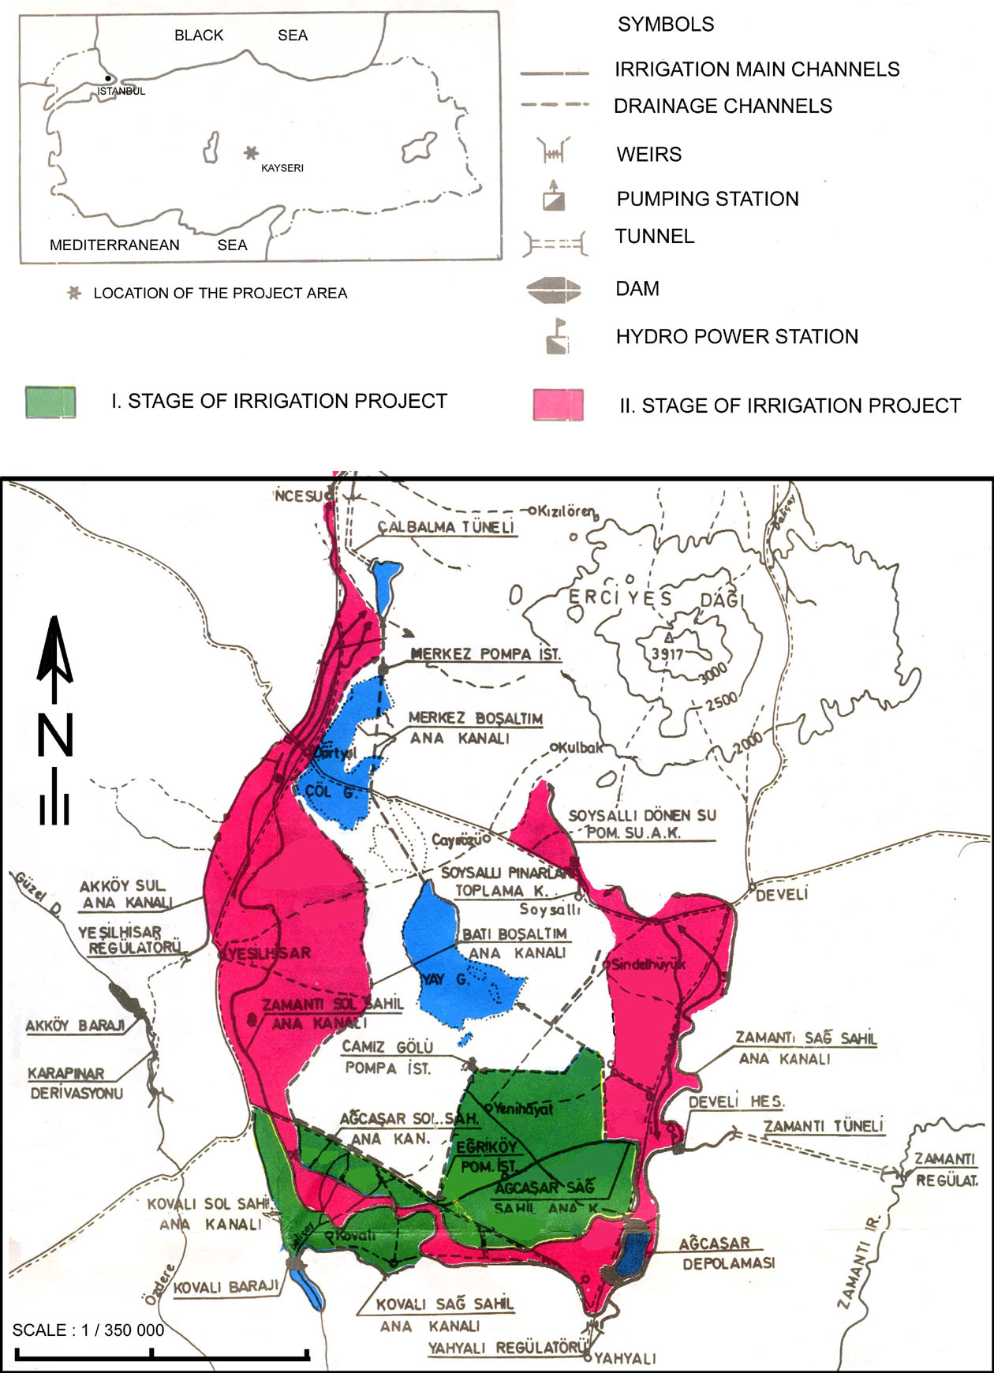

Figure 1. Sultan Marshes and surrounding first and second phase irrigation projects including dams, diversion tunnels and irrigated areas
(modified after DSI 1988)

