THE HYDROLOGICAL BALANCE OF THE LOWER HRON WATERSHED

Mgr. Oliver Horvát

Slovak University of Technology in Bratislava, Faculty of Civil Engineering, Department of Land and Water Resources Management, Bratislava, Slovakia, http://www.kvhk.svf.stuba.sk/

Anotation: This study deals with the computation of the equation of hydrological balance with every elements with accent to the comparison of methods, which evaluate a real evapotranspiration. There is listed methodical progress of computation and applied formulae for evaluation of real evapotranspiration.

Abstract: This study deals with the computation of the equation of hydrological balance with every elements without using of any model with accent to the comparison of methods, which evaluate a real evapotranspiration.
Low part of the Hron watershed with the area of 1444.93 km² was selected as a pilot basin. The hydrological years 1995 – 1999 was evaluated. At first simple hydrological balance was computed with and without changes of groundwater resources for demonstration of their influence in short-time (1 year) and long-time (5 years) interval where real evapotranspiration was result. Real evapotranspiration was determinated by empirical formulae and these different results were compared with results from simple hydrological balance. In this case the exactest method was Thornthwaite´s method and therefore is recommended for certain hydrogeological structures. Acceptable results offered the method of Liebscher – Kliner and formula of Turc. The value of real evapotranspiration from the exactest method was appointed in the whole hydrological balance. Thus were determinated a total annual outflow of water by the Hron River and annual groundwater flow from lower Hron watershed. In the work the methods for determination of each member of the hydrological balance are individually assessed.
Indisputable additions of this study are realized calculation of this complicated equation and the explanation of relations of precipitation, surface water and groundwater in the lower Hron watershed.
Keywords: hydrological balance, real evapotranspiration, lower Hron watershed

1. INTRODUCTION
Not only hydrologists need to determine the hydrological balance in their practice. The water quantity estimation is based on the hydrological (water) balance which compares the water increase and the water decrease water in a basin, an area or water formation during the time step. The water cycle in nature with human intervention is illustrated by the equation of the hydrological balance:

R + I_{s} + I_{e} + I_{b} = O_{s} + O_{e} + O_{b} + E_{r} ± θ ± G
where:
R - rainfall,
I_{s} - surface inflow into basin,
I_{e} - water endow into basin,
I_{b} - basic inflow of groundwater into basin,
O_{s} - surface outflow,
O_{e} - water extraction out of basin,
O_{b} - basic outflow from basin,
E_{r} - real evapotranspiration,
± θ - soil moisture content,
± ΔG - groundwater storage.
It reports either in long-term mean or in individual year (pertinently only part of the year) the most efficient possibilities of water management. The calculating of natural water resources (sum of the surface water and groundwater) and rainfall excess, the evaluation of accumulation capability of land cover in relation to rainstorms and floods, the evaluation of invisible groundwater transfers (inputs and outputs) between basins or hydrogeological structures are possible by means of the hydrological balance [1].
This paper refers to the methods of the estimation of the real evapotranspiration and hydrological balance, their application in specific terrain conditions in Slovakia and reached results.
It´s easy to talk about the hydrological balance or imagine it, but determination of all factors is very challenging. Particularly the real evapotranspiration and the basic inflow are difficultly determinated. The real evapotranspiration can´t be determined by direct approach. Up to now it´s not any methodology of its calculation in the world. Scientists, who solve this problem, help themselves by ignorance of some factors. In the closed geological structures the groundwater transfers can be excluded from water balance equation. If long-term period (several years) is assessed, the groundwater storage and soil moisture content will be able to excluded, too. The result of the equation can be the real evapotranspiration, groundwater storage, surface outflow or inflow by ignorance of some factors. The results are basic outflow and total outflow from basin by determination of all factors.
The main objective was application of arranged and used methodology of the hydrological balance in Slovakia in Hron subbasin of Hron River, namely its lower part where Hron River is defined as a flat river. Hron River flows into the evaluated area in the altitude of 172 meters above sea level where are many meanders and blind branches. Its way up to river mouth is 44.5 kilometers long. The basin outlet is in the altitude of 102.9 meters above sea level.The slope of the river in this part is small, only 1.55 ‰. The basin area is 1,444.93 square kilometers. The evaluated area has a complicated open-outflow hydrogeological structure with drainage by surface streams and direct groundwater transfer into the Hron River.

2. METHODOLOGY
Used methods of the hydrological balance in Slovakia is able to divide to two basic categories:
a) methods which is based on the long-term observations of basic estimated factors (precipitation, surface inflow and outflow ) and their processing in long-term means is used by simplified water balance equation;
b) methods which is based on the short-term observations of all estimated factors.
The procedure was elected as follows:
1. At first the simplified hydrological balance was computed individually for hydrological years 1995 – 1999, and also the mean of the whole period by method b) with water extraction out of basin and groundwater storage. The real evapotranspiration was an unknown variable. The hydrological balance for closed hydrological structure can be calculated by this approach (without groundwater transfers).
2. Then the hydrological balance was computed without the groundwater storage so that it was found how important is the groundwater storage in different-term periods. (1 year or mean from 5 years).
3. The real evapotranspiration was calculated by means of selected formulae.
4. The calculated real evapotranspiration by simplified hydrological balance (points 1 and 2) was compared with the calculated real evapotranspiration by formulae (point 3) and with reduced measured values from pan.
5. The values from the most exact formula were installed to the water balance equation which was computed with all factors. Both, the annual values of the groundwater storage and invisible basic inflow were calculated as totals, others were calculated as averages. The basic outflow out of basin was result which is sensitive to precision of determination of all factors.

3. RESULTS

3.1 DETERMINED FACTORS BY DIRECT APPROACH

3.1.1 RAINFALL
The method of the arithmetic mean was selected to determination of total rainfall in basin because altitude difference between 13 gauge stations in basin is only 120 meters above sea level (Fig. 1).

3.1.2 INFLOW AND OUTFLOW
Inflow and outflow factors are necessary divide on 2 groups. The factors in the first group are: surface inflow and outflow, water endow and extraction. The springs in the basin periphery is possible to assign to those factors. All of those factors are direct measurable [1]. Systematic measurements of the Slovak Hydrometeorological Institute (SHMI) in their gauging objects and announced water extractions were used to data processing (Fig. 1). The water from Hron River is the only which flows into the evaluated area. The measured data from the hydrological station Psiare were used as the values of surface inflow.

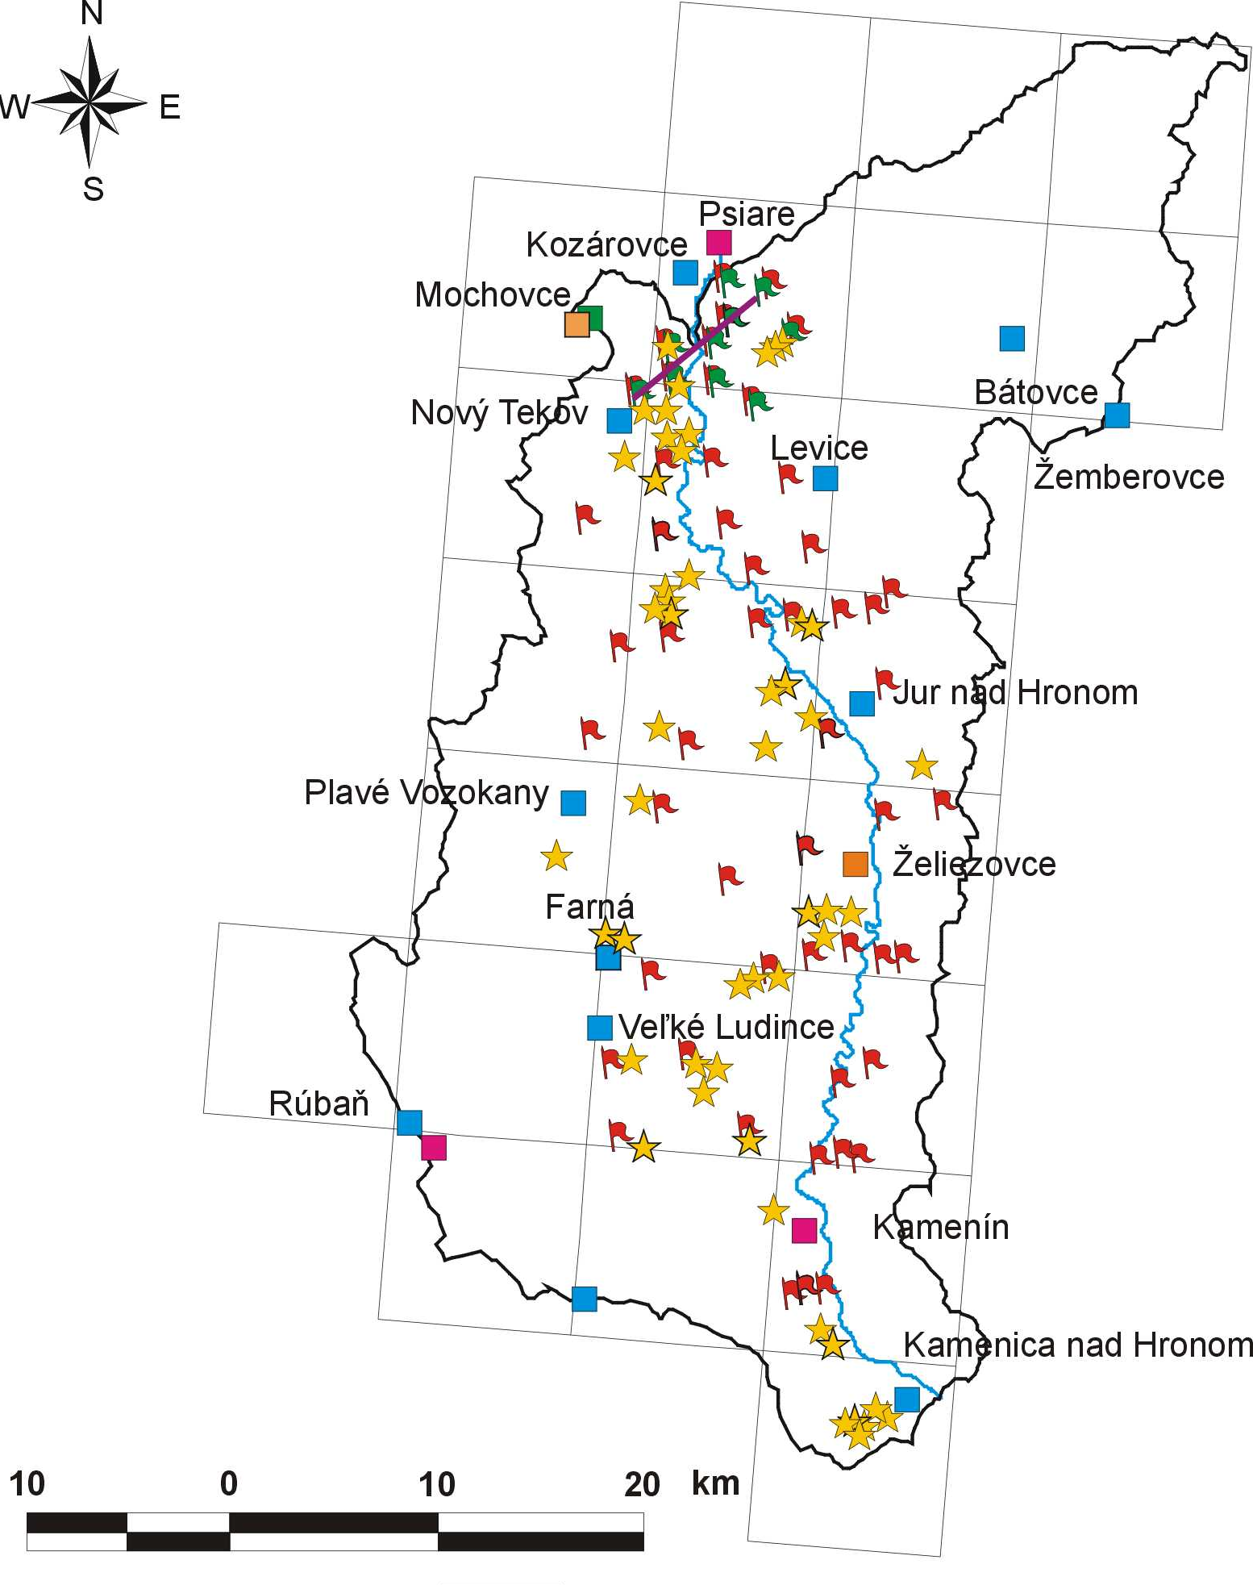

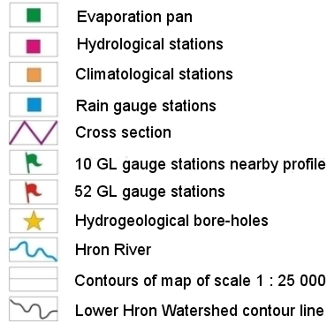

Figure 1. SHMI gauge stations in the lower Hron watershed

The values of surface outflow were received by addition the measured data from the 2 hydrological stations: Kamenín in the Hron River and Rúbaň in the Paríž Creek because Paríž Creek flows into Hron River under the hydrological station Kamenín.
The second group is formed by the groundwater transfers which are determined only at the open hydrogeological structures. The more important direct groundwater transfers into the evaluated basin are from the Kozmálovce´s groundwater reservoir and therefore was made one cross section in that place (Fig. 1 and 2). In the ESRI ArcView GIS 3.2 mean annual groundwater table contours was made from 6 groundwater level gauge stations and groundwater level decline was calculated by Darcy´s law from them.
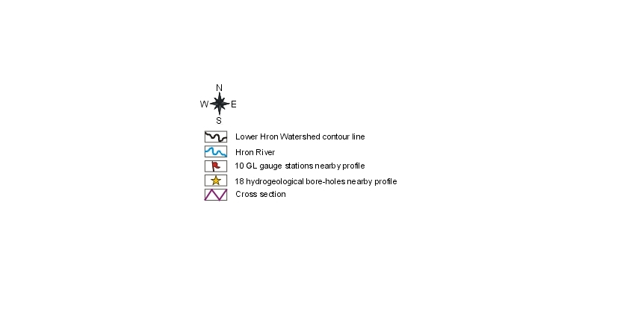
km

Figure 2. The cross section through the Kozmálovce´s groundwater reservoir

3.1.3 GROUNDWATER STORAGE
The use of method which is based on the evaluation of the groundwater level changes is dependent on systematic measurements of groundwater level changes in SHMI objects. The method calculates increase or decrease of groundwater storage from the differences of the groundwater levels at the beginning and at the end of evaluated period by quantification of total content in the evaluated area and its reduction by the storativity coefficient (Fig. 3). The measured data from 52 observational objects were used for this purpose. The objects are regularly distributed in the area so that they could represented the whole area (Fig. 1). The existing data were taken into account on determination of the mean storativity coefficient for each map of the scale 1: 25 000. From these values was calculated the mean storativity coefficient for the whole basin by method of arithmetic mean. Its value was 0.1138.
The zones, which are built from rocks with intergranular permeability, have a great compensation in relation to groundwater outflow. At long-term hydrological balances (10 years and more) the influence of the changes of groundwater storage is negligible. But the opposite situation is at short-term hydrological balances where the changes of groundwater storage can be important.

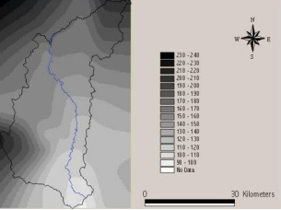
Figure 3. Average stage of groundwater level in the lower Hron watershed during the hydrological years 1995 – 1999

3.2 DETERMINED FACTORS BY INDIRECT APPROACH

3.2.1 REAL EVAPOTRANSPIRATION AND SOIL MOISTURE CONTENT
Both, the real evapotranspiration and soil moisture content, were indirectly determined. The most exact method was selected from thirteenth evapotranspiration formulae. The soil moisture content was determined by Thornthwaite´s formula which is the only formula from selected methods which calculates this factor.
The specified determination of the real evapotranspiration is not only basic but also the most complicated problem of the precise solution of the hydrological balance and also precise determination of the natural water resources. Not a single one method can include any factors of the hydrological balance as well as possible by calculation of the water balance equation [1].
The confrontation of these results with the results by computational methods during enough long-term period enables the selection and proposal of the most proper method of computation of the real evapotranspiration in the conditions for certain region.
Empirical relations for determination of the real evapotranspiration base from the basic hydrometeorological quantities like saturation deficit, wind speed, air temperature, total precipitation, solar radiation etc. The saturation deficit is difference between saturation (maximum) and actual vapor pressure. With the wind speed are considered as the most important factors by some scientists who mainly come from past Soviet Union [2]:

a) Meyer: $E_{m}=d⋅\left(\text{15}+3⋅v\right)$
b) Kricke–Menkel–Rosinskij: $E_{m}=9⋅d⋅\sqrt{1+0\text{.}\text{15}⋅v}$ , where

E_{m} - mean monthly real evapotranspiration [mm]
d - saturation deficit (d = e_{s} - e_{a}) [-]
v - wind speed in applicative height above terrain a) [m.s⁻¹]; b) [km.hod⁻¹]
e_{s} - saturation vapor pressure [hPa]
e_{a} - actual vapor pressure in applicative height above terrain [hPa]
Only with air relative humidity and air temperature calculate:
c) Schendel [2]: $E_{m}=\text{480}⋅\frac{T}{U}$
d) Šatský [3]: $E_{m}=0\text{.}\text{06}⋅\left(\text{15}+T\right)⋅\left(\text{100}−U\right)$ ,where
T - mean monthly air temperature [°C]
U - mean monthly air relative humidity [%]
Every method with annual time step evaluation and nomographical methods take mutual relation between total precipitation and air temperature into account:
e) Turc – annual and monthly [2]: $E=\frac{R}{\sqrt{0\text{.}9+{\left(\frac{R}{E_{p}}\right)}^{2}}}$
$E_{p}=\text{300}+\text{25}⋅T+0\text{.}\text{05}⋅T^{3}$
f) Coutagne [4]: $E_{a}=R−\frac{R^{2}}{0\text{.}8+1\text{.}4⋅T}$
g) Liebscher-Kliner [1]: $E_{a}=\text{255}+0\text{.}\text{12}⋅R+\text{19}\text{.}6⋅T$ ,where
R - total annual rainfall e,g)[mm]; f) [m]
T - mean annual air temperature [°C]
E_{a} - annual total real evapotranspiration e,g)[mm]; f) [m]
h) Wundt [4]: if you hurry somewhere and you want to determine the real evapotranspiration in a moment and you can annual total precipitation and annual air temperature, it doesn´t the fast method than this one. The values of the air temperature in °C are in the x coordinate axis, total precipitation in mm in the y coordinate axis, in the coordinate system from curves you can read the real evapotranspiration in mm or share of real evapotranspiration and precipitation in %.
i) Poljakov [4]: comes from 6 monthly nomographs, 2 of them include negative temperatures. In forest areas Tomlain recommends to multiply that value by coefficient 1.1.
The formula which calculates real evapotranspiration in mm.day-1 and has determined monthly coefficient:
h) Haude [2]: $E_{d}=x⋅e_{s}⋅\left(1−U\right)$ ,where
e_{s} - saturation vapor pressure [hPa]
U - mean monthly air relative humidity [-]
x - crop coefficient which varies between 0.26 – 0.36 [-]
The most complicated and the most refined computation where inputs are air temperature, total precipitation and geographical location:
i) Thornthwaite: American botanist and climatologist found out that water cycle between vegetation and atmosphere is mostly conditioned by vegetation growth. Computation procedure is described in books [1], [5], [6].
j) The measured data from evaporation pan in each hydrological year from april to october, 7 months (214 days). These values were reduced by Davydov´s coefficient which is equal to 0.68.
At first real evapotranspiration was determined from hydrological balance with the neglect of groundwater transfers. The equation is formed as follows:
E_{r} = R – (O_{s} – I_{s}) (± ΔG)
It was calculated with and also without groundwater storage. The results are in Tab. 1 and 2. The quantification of percentage differences between real evapotranspiration which was calculated by water balance equation and real evapotranspirations which were calculated by individual methods is given in Tab. 3.

Table 1. Simplified water balance equation calculated with groundwater storage
hl year | R [mm.year⁻¹] | R [m³.year⁻¹] | O - I [m³.year⁻¹] | ± ΔG [m³.year⁻¹] | E_{r} [m³.year⁻¹] | E_{r} [mm.year⁻¹] | E_{r}/R [%]
1995 | 604.4 | 873,314,811.2 | 128,636,380.8 | -71,896,453.6 | 816,574,884.0 | 565.1 | 93.5
1996 | 655.0 | 946,428,195.4 | 116,162,294.4 | 87,093,088.2 | 743,172,812.8 | 514.3 | 78.5
1997 | 458.0 | 661,777,272.5 | 51,016,089.6 | -85,373,981.0 | 696,135,164.0 | 481.8 | 105.2
1998 | 654.0 | 944,983,266.9 | 41,611,104.0 | -38,127,545.0 | 941,499,707.9 | 651.6 | 99.6
1999 | 657.6 | 950,185,009.6 | 139,572,201.6 | 105,717,697.7 | 704,895,110.4 | 487.8 | 74.2
Avg | 605.8 | 875,337,711.2 | 95,399,614.1 | -517,438.8 | 780,455,535.8 | 540.1 | 89.2
Total | 3029.0 | 4,376,688,555.7 | 476 998 070.4 | -2,587,193.8 | 3,902,277,679.1 | 2 700.7

Table 2. Simplified water balance equation calculated without groundwater storage
1995 | 604.4 | 873,314,811.2 | 128,636,380.8 | 0.0 | 744,678,430.4 | 515.4 | 85.3
1996 | 655.0 | 946,428,195.4 | 116,162,294.4 | 0.0 | 830,265,901.0 | 574.6 | 87.7
1997 | 458.0 | 661,777,272.5 | 51,016,089.6 | 0.0 | 610,761,182.9 | 422.7 | 92.3
1998 | 654.0 | 944,983,266.9 | 41,611,104.0 | 0.0 | 903,372,162.9 | 625.2 | 95.6
1999 | 657.6 | 950,185,009.6 | 139,572,201.6 | 0.0 | 810,612,808.0 | 561.0 | 85.3
Avg | 605.8 | 875,337,711.2 | 95,399,614.1 | 0.0 | 779,938,097.1 | 539.8 | 89.1
Total | 3029.0 | 4,376,688,555.7 | 476,998,070.4 | 0.0 | 3,899 690,485.3 | 2,698.9

The most accurate computational method was Thornthwaite´s one with monthly time step for individual years and conversion from potential evapotranspiration (E_{p}) to real evapotranspiration (E_{r}). These values of real evapotranspiration were substitutes to the water balance equation.

Table 3. Percentage expression of differences between real evapotranspiration calculated by simplified hydrological balance (HB) and real evapotranspiration determined by reduced values of the evaporation pan, computational and nomographical methods
Hydrological years | E_{r} from HB with groundwater storage |  | E_{r} from HB without groundwater storage |  | Methods with annual time step |  |  |  |  |  |  |  | Direct measurement
Hydrological years |  |  |  |  | Turc |  | Coutagne |  | Wundt |  | Leibscher - Kliner |  | Evaporation pan in Mochovce *
Hydrological years | E_{r1} = R + I_{s} - O_{s} ± ΔG |  | E_{r2} = R + I_{s} – O_{s}
Hydrological years |  |  |  |  | R, T |  | R, T |  | R, T |  | R, T
Hydrological years | [mm] |  | [mm] |  | % E_{r1} | % E_{r2} | % E_{r1} | % E_{r2} | % E_{r1} | % E_{r2} | % E_{r1} | % E_{r2} | % E_{r1} | % E_{r2}
1995 | 565.1 | 100% | 515.4 | 100% | -21.8 | -14.2 | -21.8 | -14.2 | -18.6 | -10.7 | -6.2 | 2.9 | 3.8 | 12.2
1996 | 514.3 | 100% | 574.6 | 100% | -16.2 | -25.0 | -13.9 | -22.9 | -13.5 | -22.6 | -1.9 | -12.2 | -2.3 | -10.9
1997 | 481.8 | 100% | 422.7 | 100% | -23.3 | -12.6 | -25.6 | -15.2 | -22.2 | -11.3 | 2.3 | 16.6 | 8.1 | 19.6
1998 | 651.6 | 100% | 625.2 | 100% | -28.3 | -25.3 | -28.0 | -24.9 | -24.8 | -21.6 | -16.2 | -12.7 | -16.9 | -14.2
1999 | 487.8 | 100% | 561.0 | 100% | -7.2 | -19.3 | -5.6 | -18.0 | -2.6 | -15.3 | 8.4 | -5.8 | 7.7 | -2.8
Avg | 540.1 | 100% | 539.8 | 100% | -19.5 | -19.5 | -19.1 | -19.0 | -16.7 | -16.6 | -3.6 | -3.6 | -0.9 | -0.9
Dev |  |  |  |  | 19.4 | 19.3 | 19.0 | 19.1 | 16.3 | 16.3 | 7.0 | 10.0 | 7.7 | 11.9
*) Potential evaporation from free water table determined by evaporation pan type GGI - 3000 and reduced by Davydov´s coefficient which is equal to 0.68. It measures only in not-freezing period (from april to october).
Hydrological years | Methods with monthly time step
Hydrological years | Poljakov |  | Haude |  | Šatský |  | Thornth-waite |  | Turc |  | Kricke - Menkel - Rosinskij |  | Schendel |  | Meyer
Hydrological years | R, T |  | U, x, e_{s} |  | T, U |  | Z, T, N |  | R, T |  | v, d |  | T, U |  | v, d
Hydrological years | % E_{r1} | % E_{r2} | % E_{r1} | % E_{r2} | % E_{r1} | % E_{r2} | % E_{r1} | % E_{r2} | % E_{r1} | % E_{r2} | % E_{r1} | % E_{r2} | % E_{r1} | % E_{r2} | % E_{r1} | % E_{r2}
1995 | -31.6 | -25.0 | -20.7 | -13.1 | -15.9 | -7.8 | -6.6 | 2.5 | 5.3 | 15.4 | 9.3 | 19.9 | 49.3 | 63.7 | 78.2 | 95.4
1996 | -25.5 | -33.3 | -25.2 | -33.0 | -18.8 | -27.3 | 6.9 | -4.4 | 3.6 | -7.3 | 1.9 | -8.8 | 41.6 | 26.7 | 65.6 | 48.3
1997 | -33.1 | -23.8 | -6.1 | 7.0 | 2.6 | 16.9 | -5.2 | 8.1 | -10.8 | 1.6 | 30.9 | 49.2 | 68.8 | 92.4 | 113.4 | 143.2
1998 | -32.5 | -29.7 | -29.4 | -26.4 | -23.4 | -20.2 | -20.0 | -16.7 | 4.8 | 9.3 | -0.4 | 3.8 | 34.6 | 40.3 | 62.6 | 69.4
1999 | -2.8 | -15.5 | -13.6 | -24.9 | -7.5 | -19.6 | 28.8 | 12.0 | 23.8 | 7.7 | 20.1 | 4.4 | 67.0 | 45.3 | 95.7 | 70.2
Mean | -25.1 | -25.1 | -19.8 | -19.7 | -13.4 | -13.4 | -0.6 | -0.6 | 5.3 | 5.4 | 11.4 | 11.4 | 51.0 | 51.1 | 81.5 | 81.6
Dev | 25.1 | 25.4 | 19.0 | 20.9 | 13.6 | 18.3 | 13.5 | 8.7 | 9.7 | 8.3 | 12.5 | 17.2 | 52.3 | 53.7 | 83.1 | 85.3

The most accurate method from methods with annual time step was Liebscher – Kliner´s and surprise was that its deviations were small. It´s very simple formula with good sensing to given background. The direct measurements by evaporation pan had a very similar results, even the more accurate with difference less than 1 % and that is a great result. But that station Mochovce is located in the basin boundary where were gauged the lower temperatures by 0.5 °C than in the basin centre. The tolerable values were determined by Turc´s formula with monthly time step, its deviations mainly were small.

Figure 4. Representation of average rainfall excess, real evapotranspiration and rainfall for each month during the hydrological years 1995 - 1999

Table 4. Evaluation of water production in the lower Hron watershed based on the hydrological balance
Hl years | Units | R | E_{r} | ± θ | R_{ef} | ± ΔG | O_{sum}*
Hl years | Units | Rainfall | Real evapotranspiration | Soil moisture content | Rainfall excess | Groundwater storage | Outflow
1995 | mm | 604.41 | 528.08 | -20.00 | 96.33
1995 | m³.s⁻¹ | 27.69 | 24.20 | - | 4.41 | -2.280 | 6.693
1995 | % | 100.00 | 87.37 | -3.31 | 15.94
1996 | mm | 654.97 | 549.59 | 0.73 | 104.65
1996 | m³.s⁻¹ | 29.93 | 25.11 | - | 4.78 | 2.754 | 2.028
1996 | % | 100.00 | 83.91 | 0.11 | 15.98
1997 | mm | 457.97 | 456.94 | 1.03 | 0.00
1997 | m³.s⁻¹ | 20.98 | 20.94 | - | 0.00 | -2.707 | 2.707
1997 | % | 100.00 | 99.77 | 0.23 | 0.00
1998 | mm | 654.03 | 525.65 | 98.24 | 30.14
1998 | m³.s⁻¹ | 29.97 | 24.08 | - | 1.38 | -1.209 | 2.590
1998 | % | 100.00 | 80.37 | 15.02 | 4.61
1999 | mm | 657.62 | 628.34 | -96.52 | 125.80
1999 | m³.s⁻¹ | 30.13 | 28.79 | - | 5.76 | 3.352 | 2.412
1999 | % | 100.00 | 95.55 | -14.68 | 19.13
average | mm | 605.80 | 537.72 | -3.30 | 71.38
average | m³.s⁻¹ | 27.74 | 24.62 | - | 3.27 | -0.016 | 3.285
average | % | 100.00 | 88.76 | -0.55 | 11.78
* Outflow: mean annual outflow produced in the balanced watershed

Table 5. Whole result of the water balance equation of the lower Hron watershed during the hydrological years 1995 - 1999

Hydrological years | Increase factors |  |  | Decrease factors |  |  | ± factors |  | Result
Hydrological years | Rainfall | Surface inflow | Basic inflow | Real evapotranspira-tion | Surface outflow | Water extractions | Soil moisture content | Groundwater storage | Calculated basic outflow
Hydrological years | R | I_{s} | I_{b} | E_{r} | O_{s} | O_{e} | ± θ | ± ΔG | O_{b}
1995 | 27.693 | 56.933 | 0.357 | 24.196 | 61.012 | 0.158 | -0.916 | -2.280 | 2.814
1996 | 29.928 | 46.690 | 0.337 | 25.112 | 50.363 | 0.152 | 0.033 | 2.754 | -1.460
1997 | 20.983 | 32.247 | 0.297 | 20.936 | 33.865 | 0.148 | 0.047 | -2.707 | 1.239
1998 | 29.967 | 34.991 | 0.292 | 24.084 | 36.311 | 0.101 | 4.501 | -1.209 | 1.462
1999 | 30.131 | 50.845 | 0.315 | 28.790 | 55.271 | 0.135 | -4.423 | 3.352 | -1.834
avg | 27.742 | 44.342 | 0.320 | 24.624 | 47.366 | 0.139 | -0.151 | -0.016 | 0.443

The evaluation of relations among rainfall, real evapotranspiration and soil moisture content enables to calculate the rainfall excess. It is able to divide on part which produces outflow and part which participates on increase of groundwater storage by consequential computation of groundwater storage in individual hydrological years. Whole amount of rainfall excess participates on outflow in the case of draining of groundwater storage. Moreover it is added up by drained groundwater storage from the balanced watershed. This evaluation is not dependent on discharge data of surface streams because it comes from another bases for solution [1]. The solution for evaluated balanced watershed in 5 hydrological years 1995 - 1999 is summarized in Tab. 4. Fig. 4 represents average monthly sums of rainfall, rainfall excess and real evapotranspiration during the hydrological years 1995 – 1999. Comparison between short-term (1 year) and long-term (5 years) water balance is illustrated in Fig. 5.
Figure 5. Sample of hydrological balance in 1 year (1995) and 5 years (1995 - 1999)

4. SUMMARY AND CONCLUSIONS
Both, the total mean annual water inflow into Hron River (surface water & groundwater) and part of direct groundwater transfer from whole sum of transfers which endows Hron River from other basins, were calculated for individual hydrological years by realized hydrological balance. From Tab. 4 figures that:
In the hydrological year 1995 amount of water produced from rainfall corresponded to possible mean annual outflow of 4.41 m³.s⁻¹ which was represented by rainfall excess. This whole part produced outflow of water from balanced watershed. Moreover groundwater storage was drained by 2.28 m³.s⁻¹, and therefore mean annual outflow from the balanced watershed increased to 6.69 m³.s⁻¹.
Hydrological year 1996 was very wet so big amount of water was created from rainfall which corresponded to possible mean annual outflow of 4.78 m³.s⁻¹. Relatively significant part from it (2.75 m³.s⁻¹) increased groundwater storage, thereby outflow decreased from potential 4.78 m³.s⁻¹ to 2.03 m³.s⁻¹.
In the hydrological year 1997 mean annual outflow was endowed only by groundwater storage in the consequence of minimum total rainfall and full groundwater storage. The amount of outflow was 2.71 m³.s⁻¹.
In the hydrological year 1998 water amount created from rainfall corresponded to possible mean annual outflow of 1.38 m³.s⁻¹. It was continued the draining of groundwater storage which made 1.21 m³.s⁻¹, so total created outflow in the basin was 2.59 m³.s⁻¹.
Hydrological year 1999, similar like year 1996, was very wet, rainfall excess achieved the values of 5.76 m³.s⁻¹. Significant part of this amount corresponded to mean annual outflow of 3.35 m³.s⁻¹ increased the drained groundwater storage in the watershed and thereby amount of outflow was decreased from potential 5.76 m³.s⁻¹ to 2.41 m³.s⁻¹.
The period of the hydrological years 1995 – 1999, characterized as wet, had mean annual rainfall excess 3.27 m³.s⁻¹. Minimal resultant groundwater storage with low average 0.02 m³.s⁻¹ supplied total mean outflow from basin, its value was 3.29 m³.s⁻¹.
From Tab. 5 figures that:
Total outflow from Hron basin in annual means for individual hydrological years 1995 - 1999 was in 1995: 63.98 m³.s⁻¹, in 1996: 50.52 m³.s⁻¹, in 1997: 35.25 m³.s⁻¹, in 1998: 37.87 m³.s⁻¹, in 1999: 55.41 m³.s⁻¹. These values are extensively deviated. These results are in good harmony with climatic conditions for water production in individual evaluated years, and therefore big errors are not assumed. In very wet years (1996 and 1999) value of groundwater transfer was negative, what means that output owing to input was very small. In the places where output was assumed, there was opposite flow direction in that period. It was caused by big water in the Danube River, its groundwater rised insofar that it influenced groundwater of the adjacent lower part of Hron watershed. Direct basic outflow from the balanced basin in the hydrological years 1995 - 1999 was in annual means between 0 – 2.81 m³.s⁻¹. Mean basic outflow during these 5 years was 0.44 m³.s⁻¹, basic inflow was 0.32 m³.s⁻¹, so basic outflow was higher than basic inflow by 0.12 m³.s⁻¹.
The evaluated area is intensively irrigated. It causes that there ratio between real evapotranspiration and outflow is higher than in non-irrigated areas. But irrigation is not possible to calculate to the water balance equation because water doesn´t go away from the area, other use is only. Not a single one method of determination of real evapotranspiration doesn´t include the irrigations to formulae.
Indisputable additions of this study are realized calculation of this complicated equation and the explanation of relations of precipitation, surface water and groundwater in the lower Hron watershed.

5. REFERENCES
[1] KULLMAN, E. (2000): Koncept manažmentu povrchových a podzemných vôd v hraničnom regióne. Final report, 177 p., Slovakia.
[2] FENDEKOVÁ, M. (1991): Hydrológia pre geológov. Skriptum, 111 p., Bratislava, Slovakia.
[3] KERTÉSZ, A. (1984): Dolný Hron - pravostranné terasy. Manuskript - archive GS SR Geofond, Bratislava, Slovakia.
[4] PM Consulting Engineers (1997): Evaluation of Groundwater Resources in Slovakia. PHARE Project No. EU/95/WAT/31. Manuskript – Ministry of the Environment of the Slovak Republic, 459 p, Slovakia.
[5] HORVÁT, O. (2003): Bilancia podzemných vôd na území dolného Hrona. Diploma thesis, 92 p, Faculty of Natural Sciences, Department of Hydrogeology, Bratislava, Slovakia.
[6] THORNTHWAITE, C. W., MATHER, J. R. (1957): Instructions and tables for computing potential evapotranspiration and the water balance. Book, p. 185-311, Publ. Climatol. Lab. Climatol. Dresel Inst. Technol. 103, USA.
Used programs:
ESRI ARCVIEW GIS 3.2,
MICROSOFT EXCEL,
TOPOL GIS,
MICROSOFT WORD,
ADOBE PHOTOSHOP,
COREL PHOTO-PAINT.

