Discharge measurement using the instrument WorkHorse Rio Grande ADCP

Ing. Kožnárek, Ing. Kocman

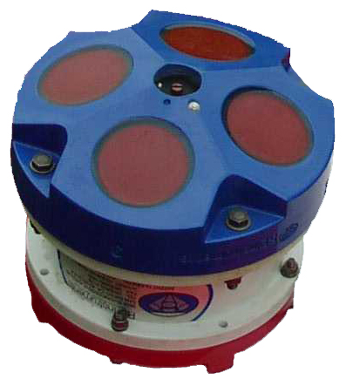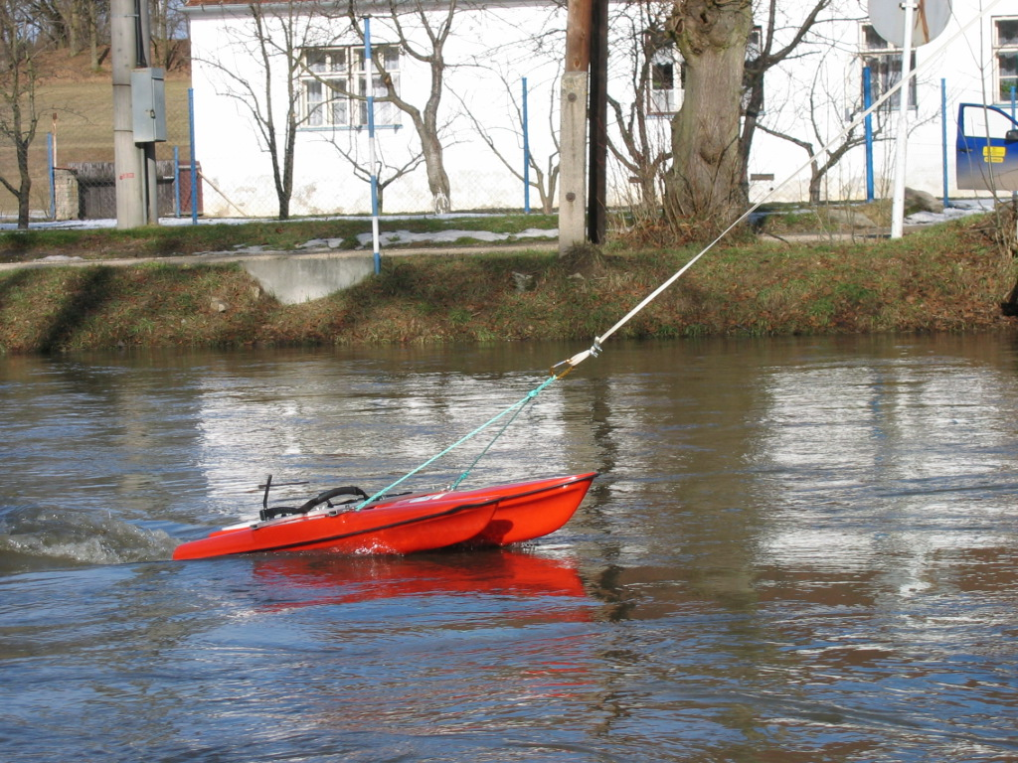Modern instrument measuring equipment has moved the measurement of discharges, especially during floods, to a higher quality level. The classical measuring equipment used so far, i.e. current meters, is very suitably supplemented by the Workhorse Rio Grande instrument, which works on the ADCP principle – measurement of velocity segments in a stream cross-section using the Doppler’s effect with fully automated processing. The software equipment enables a very fast sequence of measurement of the velocity field, while the measurement with the ADCP instrument in comparison with the original principle of discharge measurement with the current meter propeller is much faster, keeping the required accuracy of discharge measurement.
Fig. 1 ADCP sensor Fig. 2 measurement with trimaran and attached ADCP

The measurement itself consists of a mere pulling of the measuring boat (trimaran) with the ADCP measuring sensor across the stream. During this, the discharge cross-section and velocities are measured in segments of the cross-section selected beforehand according to the defined depth, water velocity, type of river bed etc. The basic processing of the measured data is recorded by the WinRiver program, which is then converted to what is the usual hydrometric form in the CHMI hydrological service by the Agila program. The main work procedure when preparing the ADCP instrument for measurement is the choice of suitable program modes for the given locality from the point of view of estimated velocity, depth and other cross-sectional hydrological characteristics.

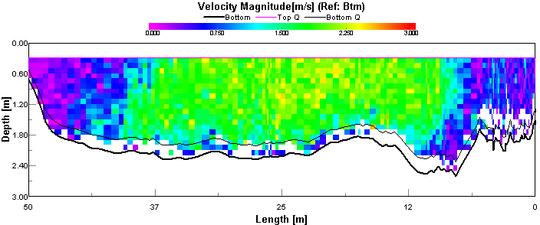

Fig.3.Discharge cross-section with measured velocity segments in Bechyně on the LužniceRiver on the 5th February 2004

Fig. 4 Example of evaluation of discharges in the measurement cross-section on the Lužnice
river in Bechyně by the AGILA 4.2 program

Calculation by the AGILA 4.2 program

Bechyně – Lužnice river

Date Time Q-Trans Q-Agila % towards vs. b
/m/s/ /m/

Average 99.50 98.55;
Bechyne001t.000; 5.2.2004; 10:37:59; 98.20; 98.55; 0,0; 1,36; 35,38;
Bechyně000t.000; 5.2.2004; 10:34:51, 100.10; 99.04; 0.5; 1,38; 36,06;
Bechyne002t.000; 5.2.2004; 10:41:29; 99.70; 98.92; 0,4; 1,39; 34,74;
Bechyne003t.000; 5.2.2004; 10:43:07; 95.40; 98.24; -0,2; 1,31; 35,03;

Speed, and also accuracy of information are remarkable, in the course of 5 minutes the values of discharge are measured three times with small deviations with respect to themselves. It is necessary to still authorise this “hot discharge” into the final form. A small correction of the beginning and end of the measurement is possible for the resultant tabular processing with a minute change of of the discharge amount, while the other parameters of the measurement remain in the norm. An example of the final processing for the Bechyně cross-section on the Lužnice river appears in the table below:

Repeated calculation by the AGILA program

Bechyně – Lužnice river

Date Time Q-Trans Q-Agila % towards Dev. Vs b

of Q in % /m/s/ /m/

Average 99,47; 98.40;
Bechyne000t.000; 5.2.2004;10:34:51; 99.60; 98.12; -0.3 -0.1 1.37 36.01;
Bechyne001t.000; 5.2.2004;10:37:59; 98,20; 99,04; 0.6 0.0 1.38; 36,06;
Bechyne002t.000; 5.2.2004;10:41:29; 99,70; 99.05; 0.7 0.1 1.38; 35.99;
Bechyne003t.000; 5.2.2004;10:43:07; 95,40; 98,43; 0.0 0.2 1.30; 36.03;

After these corrections, which the program enables in the repeated regime, the width of the measured cross-section is in the norm, and the original discharges are minutely corrected by the new calculation (by ± 0.1 to 0.3 %). The average value of the discharge, calculated from three measurements, is then the final value for the measured stage on the staff gauge for the record into the discharge rating curve. The graphical presentation in the Agila program on the previous Figure serves for the judgement of the representativeness of measurement, and together with view at the distribution of speed segments in the WinRiver program in the Playback regime (Fig. 4) it serves for the judgement of further processing. At this moment, the experiences of a hydrologist are needed for the alternative procedure for suitable corrections. According to our experiences, we recommend to proceed during the final processing as follows:

• It is possible to specify and correct the beginning and end of the measured sequences in such a way, so that the resultant stream width does not have a significant scatter.

• To make selection of the velocity course in the cross-section only quite rarely and very
justifiably, when it is possible to remove the point of average velocity in the vertical (even
with respect to the course of velocities in the cells of the WinRiver program), if the worker is
convicted about the correctness of such action.

Fig.5. Graphical expression of the courses of velocities in the vertical and shape of
cross-section

The processing and representation of the result corresponds to the custom in the hydrological service of the CHMI and expresses the course of the average velocities in the vertical and their distribution in the measuring cross-section. In practical application, optimally 4 cycles of measurement are made in this way, out of which after an objective selection (deviation to an average value greater than 1.5 %) a final evaluation is made. The method of discharge measurement by the ADCP principle appears to be a very good and accurate measurement procedure, especially during floods, with a speedy effect of resultant values.

