Regionalization of Mean Flow and Low Flow for Lower Austria

Christian Krammer¹, Hans-Peter Nachtnebel²

¹Abteilung Hydrologie, Amt der Niederoesterreichischen Landesregierung, St. Poelten, Austria, e-mail: Christian.krammer@noel.gv.at
²Institut fuer Wasserwirtschaft, Hydrologie und Konstruktiven Wasserbau, Universität für Bodenkultur, Wien, Austria,
e-mail: Hans_Peter.Nachtnebel@boku.ac.at

Abstract: By means of a water balance model and statistical and geostatistical analysis an approach is proposed to estimate the mean flow and the low flow parameters for ungauged sites in Lower Austrian basins.
For the estimation of the mean flow (period 1961 – 2000) grid-based models were applied using the long-term averages of monthly precipitation and evaporation. Precipitation was related to elevation data, potential evaporation was calculated from TURC’s equation after a regionalization of the mean monthly temperature and global radiation, and the actual evapo-transpiration was obtained using BAGROV’s equation.
For the estimation of low flow parameters a regression analysis performed well utilizing climatologic and basin related indicators. In total, about 90 gauging stations were analysed.
Keywords: regionalization, mean flow, low flow, water balance, GIS

1. Introduction
Lower Austria is the largest province of Austria. The capital Vienna is embedded within.
The total area of Lower Austria is 19.174 km², and Vienna has an additional area of 415 km². Altitudes range between 140 m in the very east to up to 2076 m (Schneeberg). The Danube River crosses the country from west to east (Fig. 1).

Elevation zones of Lower Austria

Fig. 1: Map of Lower Austria

The mean annual precipitation ranges from less than 500 mm (north-east) to over 2000 mm in the high alpine parts of the south and south-west.

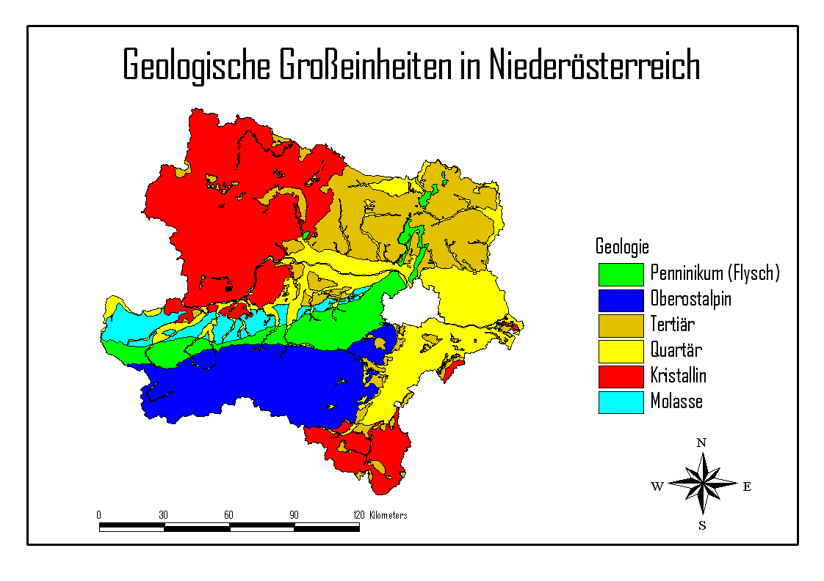
Geological Units in Lower Austria
Fig. 2.: Geological classification

It was the objective of this work to apply methods for regionalization of average flow and low flow to obtain a fair estimation for ungauged catchment areas, using climatic and catchment parameters, in combination with GIS.

Limits of modelling
At first it was necessary to exclude parts of the country from such a regionalization due to strong interaction between the surface water system and accompanying groundwater flows in flat areas. This comprises the flat land of the “Wiener Becken” in the east of the country and some small basins along the Danube.

There is also a lower limit for the catchment area where the method is supposed to work, depending on the geology (carstic springs) and on climatic factors (dry regions). Artificial influences (abstraction of groundwater for supply, storage in big reservoirs, pond management for fishery, irrigation, etc.) have to be taken into account.

2. Methods
2.1. Regionalization of Mean Flow
A water balance model was used to obtain the long-term mean annual runoff.

$\overline{R_{\text{ges}}}$ = ($\overline{P}$ - $\overline{{\text{ET}}_{a}}$) +/- $Δ$S/m (1)

The mean annual runoff $\overline{R_{\text{ges}}}$ is calculated by the difference of precipitation $\overline{P}$ and actual evapotranspiration $\overline{{\text{ET}}_{a}}$. For long time series (m = 20 to 40 years) the storage term ($+−ΔS$/m) was considered as small in comparison to the other terms.

For this work time series between 1961 – 2000 were used. The model was calculated cell by cell with a 200 m grid in ARC-INFO-GRID. Observed runoff data of 90 catchments could be compared with the result of the water balance obtained from the model.

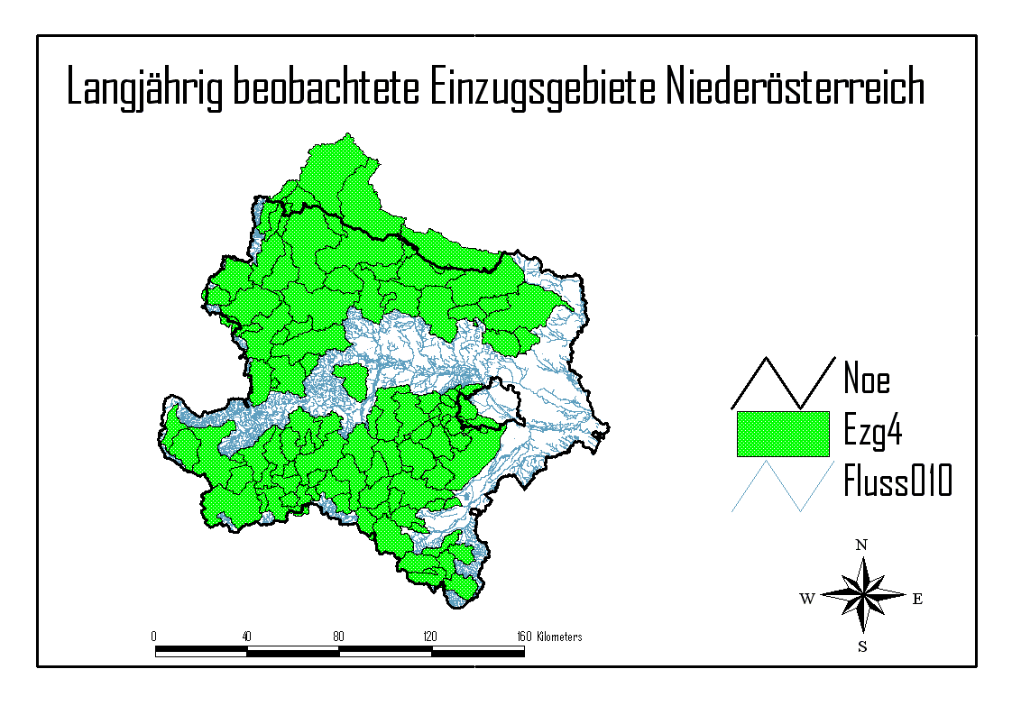

Catchments with long observation series
Fig. 3: Observed catchment areas used for regionalization

2.1.1. Precipitation
It is a well known fact that the surface altitude by itself does not have a very good correlation with precipitation patterns in mountainous terrain (e.g.: KLEIN,1994). Therefore, the regionalization of precipitation was based on the FOCAL-functions of the Arc-Info-Grid. This means, within moving squares around each cell the maximum, minimum, average and standard deviation of the ground altitude was calculated. Different sizes of these squares were used and a regression was made to obtain best fit to the measured data.

Fig. 4: Example of a moving field with size 5 x 5 grid cells around a central cell.

It was found that the correlation between these focal values and precipitation data increase with size of the squares until a certain limit. An optimisation of linear combinations of the parameters obtained with different square sizes allowed to find a better estimation of the precipitation patterns, which explained about 85 % of the variance.

A comparison with other models, especially with data from a study from LORENZ/SKODA (1998) showed no significant spatial difference.

2.1.2 Evapotranspiration
The mean annual evapotranspiration had to be agglomerated from monthly values, using long term monthly means. At first the potential evapotranspiration ET_{p,TURC} [mm] was obtained using adapted TURC’s formula

ET_{p,TURC} =0.0031 * $\frac{T}{T+\text{15}}$ * (I_{g} + d * 209) (2)

T ………. mean monthly temperature (${}^{0}$ Celsius)
$I_{g}$……… global radiation (Joule/cm²/month)
d ……….. number of days of the month

The monthly average temperature was expressed as a linear function of altitude. Global radiation was calculated for a typical day within each month (KLEIN, 1976) by using a regression function based on relative sunshine hours and altitude. The radiation input for each grid cell was then calculated regarding shadow effects, slope, exposition, sky radiation component etc. (acc. to BEHR, 1996).

The actual evapotranspiration was calculated by the BAGROV equation

$\frac{d\overline{{\text{ET}}_{a}}}{d\overline{P}}$ = 1 - ${\left(\frac{\overline{{\text{ET}}_{a}}}{\overline{{\text{ET}}_{p}}}\right)}^{n}$ (3)

with n……parameter of effectivity

This parameter of effectivity could be obtained from a relation using estimations for root depth “We” [mm] and the water storage capacity of the soil “NFK”. The relation for “n” was estimated according to GLUGLA et al. (1999).

$n$ = 0,15 + 0.02555 * NFK * We (4)

These parameters (NFK, We) were estimated using the CORINE land information data set and geologic information. Bagrov’s equation was then applied to the mean annual values of precipitation and the potential evapotranspiration.

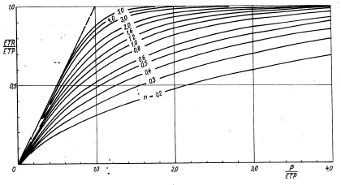
Fig. 5: Bagrov’s relation (from: DYCK/PESCHKE, 1995)

The estimations for runoff at gauging stations were compared with the measured values. A geographic pattern for the residuals was found that indicates a bias in the estimation procedure. Whereas in many parts of the country there is a slight over-estimation of the runoff component, while in the west and south-west an under-estimation was produced by this method. Efforts to correct for instance the precipitation fields or increasing the evapotranspiration do not really improve the performance of the model.
It can be assumed that these errors are partly due to measurement errors, partly due to the simplified modelling of precipitation (especially in the high mountainous areas). In two catchments carstic influences are assumed to be the main reason for the under-estimation.

Fig. 6: Comparison of results for Mean Discharge

A comparison of results showed that a very simple model - only based on precipitation - allowed the estimation of mean flow with almost the same efficiency as for the rather complex and time consuming model presented above. This is due to the fact that spatial variability of precipitation is more dominant than in the evapotranspiration.

Due to the clear spatial pattern one can regionalize the residuals which will help in the estimations of the values for mean discharge in ungauged catchments.

2.2. Regionalization of Low Flow parameters
The parameter Q_{95%} (the 5% quantile of the flow duration curve) was chosen as a value which has relevance for many cases in Austrian administration, especially for ecological questions.
It was found that this parameter can easily be estimated by linear regression, given that the value for mean flow is available. The regression equation is of the form:

Y = $\sum_{i}{β_{i}}∗X_{i}$
with Y being either “Q_{95%}” [m³/s], “q_{95%}”[m³/s/km²] or “Q_{95%}/MQ” [-]

As predictors the following variables were tested:
- catchment area
- mean altitude
- range of altitudes (max – min)
- mean slope
- part of flat land (slope < 2 %)
- drainage density
- lake area
- mean annual flow
- specific mean annual flow [m³/s/km²]
- N_{summer} /N_{winter}
- mean annual precipitation
- variances of monthly precipitation (jan – dec)
- evapotranspiration
- land cover classification, esp. percentage of forest
- geologic classification
- days of rainfall

Best results were obtained by calculating the specific q_{95%} (m³/s/km²) using average slope of catchment and the Mq-value (average specific discharge (m³/s/km²)).

A reasonable regression was found in the following example:

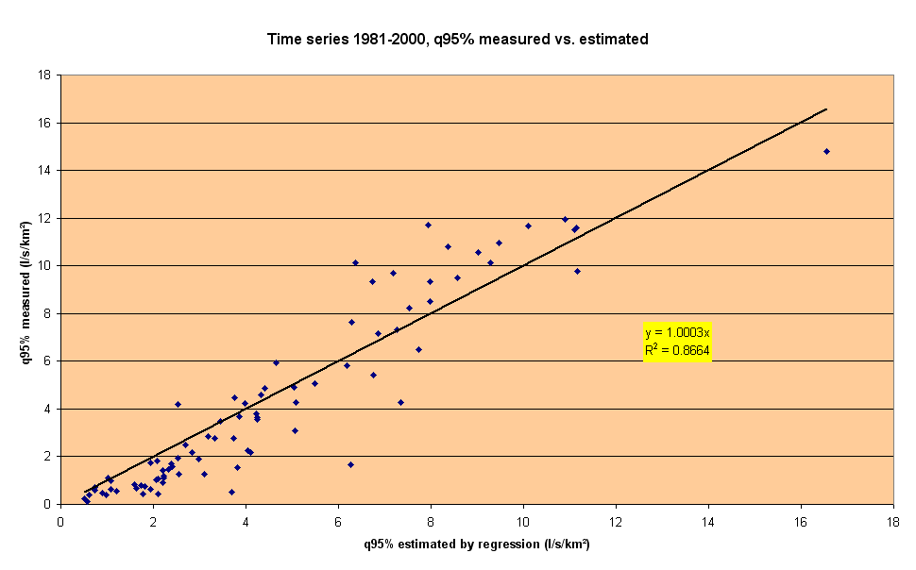
Fig. 7: Results of a linear regression for q95%

It can be concluded from Fig.7 that the accuracy is poor in basins with quite low runoff quantiles, whereas in the right half of Fig. 7 the performance is sufficient for estimation.

3. Conclusions
The work showed that a water balance estimation in combination with a GIS including digital terrain data, geological information and land use data yields reasonable results for mean discharge in the province of Lower Austria. As precipitation plays the most important role in this balance, it is an important objective to improve regionalization for this component. Smaller catchments in the carstic areas should be measured however, else the errors of estimation can be quite high.
For the low flow parameter “Q95%”, a reasonable regression was obtained using linear estimation functions, especially when a fair estimation for mean discharge is available.

4.References:

Aschwanden H., Weingartner R., Leibundgut C., 1986. Zur regionalen Übertragung von Mittelwerten des Abflusses. Deutsche Gewaesserkundliche Mitteilungen 30, Heft 2/3 + Heft 4.
Behr O., 1996: Digitale Erfassung und Anwendung abflußrelevanter topographischer Information. Oesterreichische Wasser- und Abfallwirtschaft, Wien, Jahrgang 48, Heft 1/2, pp. 53 - 61.
DVWK-Merkblatt Nr. 238/1996. Ermittlung der Verdunstung von Land- und Wasseroberflaechen, Deutscher Verein für Wassertechnik und Kulturbau, Bonn.
Dyck S., Peschke G., 1995. Grundlagen der Hydrologie. Verlag fuer Bauwesen, Berlin.
Glugla G., Müller E., Jankiewicz P., Rachimow C., Lojek K. (1999). Entwicklung von Verfahren zur Berechnung langjaehriger Mittelwerte der flaechendifferenzierten Abflussbildung (Abschlussbericht). Bundesanstalt für Gewaesserkunde, Berlin.
Klein G., 1994: Regionalisierung von Niederschlag mit Hilfe digitaler Gelaendeinformationen. Freiburger Geographische Hefte, Heft 44, Freiburg im Breisgau.
Klein S. A., 1976. Calculation of monthly average insolation on tilted surfaces, in: Solar Energy, Vol, 19, pp. 325 - 329.
Lorenz P., Skoda G., 1998. Ermittlung von Flaechenmitteln des Niederschlags aus punktuellen Messungen, Forschungsbericht, Hydrographisches Zentralbuero, Wien.
Milly P.C.D., 1994. Climate, soil water storage, and the average annual water balance, in: Water Resources Research, Vol. 30, No. 7, pp. 2143 - 2156.
Neuwirth F., Bruck M., Heindl W., Schaffar G., 1979: The estimation of global and sky radiation on horizontal and inclined surfaces in Austria, published by ASSA (Austrian Solar and Space Agency), Wien.
Schreiber, P., 1996. Regionalisierung des Niedrigwassers mit statistischen Verfahren, Freiburger Schriften zur Hydrologie, Band 4, Freiburg i. Br.

