EXTREME LOW WATER STAGES IN BULGARIAN SECTION OF DANUBE RIVER IN 2003

Teodossia Andreeva, Martin Martinov

National Institute of Meteorology and Hydrology (NIMH), Sofia, Bulgaria,
e-mail: teodosia.andreeva@meteo.bg

Abstract: The navigation on the river Danube was difficult during two periods of the low water stages of the year. The summer was the first period – as a result of the drying. The second one is during the winter, when there were the freezing precipitation and the run-off process is absented.
The summer low water stages in the Bulgarian section of the Danube River are examined in the work. The weather conditions and the hydrological situation in 2003 varied dramatically. There were big seasonal variations in precipitation and the related discharge in the lower Danube basin. During last summer as a result of unexpected continued drying in West and Central Europe the water level of the river Danube achieved a record extreme subside for last 100 years. It was the result of the breach of order of zonal atmospheric circulation over Europe and the blocking atmospheric circulation for any length of time over the West part of Europe. Key words: blocking atmospheric circulation, low water stages, precipitation.

EXTREM NIEDRIGE WASSERSTANDE IM BULGARISCHEN
ABSCHNIT DER DONAU IM JAHR 2003

Zusammenfassung: Die Navigation auf der Donau wird während zwei Perioden des Jahres wegen des niedrigen Wasserstandes erschwert: Der Sommer ist der erste Zeitraum – als Ergebnis der Trockenheit. Der zweite Zeitraum ist der Winter.
In der Arbeit werden die Sommerwasserstände des bulgarischen Teils der Donau untersucht. Im Sommer 2003 erreichte der Wasserstand der Donau aufgrund der ausgesprochen langanhaltenden Trockenperiode in West-und Zentraleuropa extrem niedrige Werte bezogen
auf die letzten 10 Jahre. Das war das Ergebnis der Unterbrechung der zonalen Zirkulation über Europa und Blockierung der atmosphärischen Zirkulation für eine langanhaltende Zeit über dem westlichen Teil von Europa.
Schlüsselworte: niedrige Wasserstände, blockierte atmosphärische Prozesse

1. INFORMATION DATABASE

Utilised data: time-series (1961-2003) of the monthly mean temperatures, precipitation from some surface synoptic stations and climatic stations have been used as initial data.

The fields for seasonal air temperature and precipitation are studied for this period for all territory of the country. The behavior of the fields charactericing the change of the temperature and precipitation anomalies is analysed by physical-statistical methods. The variations of the temperature and precipitation during the summers were estimated expressed in relation to the 1961-1990 period.

2. SUMMER SPATIAL-TEMPORAL DISTRIBUTION OF PRESSURE PATTERNS
During last summer there was the blocking process (Andreeva 1988) over West part of Europe and the baric gradient decreases for long time. There was not dynamics of the atmospheric circulation during summer period over the Continent.
The moving of Island cyclone to Southeast was the basic reason for the destruction of Azores high pressure (Figure 1, a) by (MWB 2003).

Figure 1. (a, b, c). Mean atmospheric pressure for June, July and August in 2003
a)
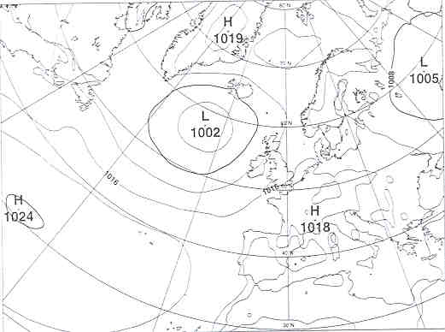

During July and August the decreasing of Azores high pressure continues (Fig.1, b and c). The synoptical situation over the Continent kept and the drought continues.

b)
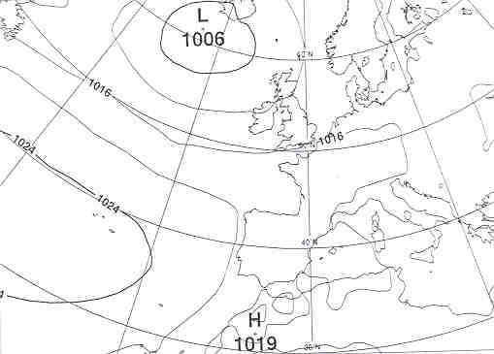

c)
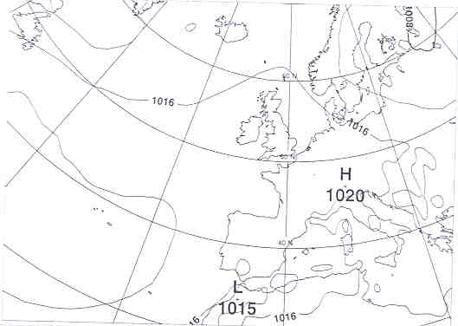

Figure 2. Atmospheric pressure at sea and 500 hPa levels on 7-th of June
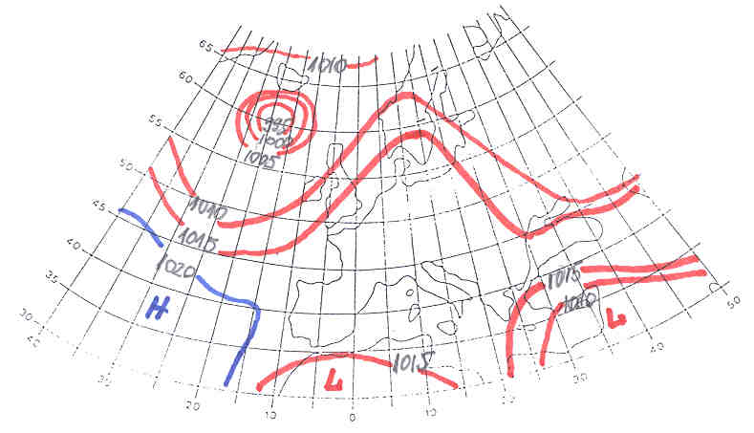
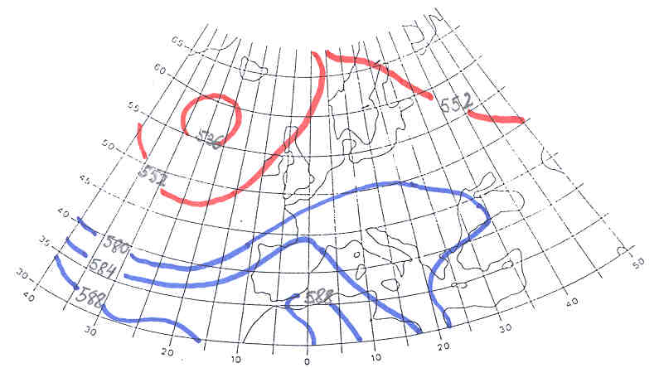

The typical example for atmospheric pressure at sea level and 500 hPa level on 7-th June is presented on Figure 2.
The advection of cool and moist air masses from Atlantic ocean to West and Central Europe decreased. After that became air mass transformation over most part of Europe. The air temperatures increased and the moisture decreased.

3. SIGNIFICANT CLIMATE ANOMALIES

3.1. Analysis of precipitation and air temperature at the territory of Bulgaria
Precipitation climatic variability estimates for the country is of great interest as temperature data (Andreeva, 2002. 1998. 1995). Mean temperature of 2003 was closer to average (Figure 3), but during summer months the temperatures kept over normal (Figure 4). The annual precipitation for 2003 difference from 1961-1990 was below normal (Figure 5).
After relatively cold weather in most places during the first four months of the year and rainfall totals about normal everywhere the summer was warm (2,8°C warmer than average). Temperatures reached their highest values (Figure 4) at most stations in months May, June and August. The drought continues all season (Figure 6). Just before May there was a period of much cold weather.

Figure 3. Annual mean temperatures difference from 1961-1990 normal for station Ruse

Figure 4. The deviation air temperature for station Ruse during 2003

Figure 5. Annual precipitation difference from 1961-1990 for station Ruse

Figure 6. Percentage of 1961-1990 normal for January to December 2003 for station Ruse

3.2. Extreme low water stages
As a upper limit of low water level can use positions below which must limit the load up of vessel and thus appears the erosion of the river thresholds, by investigation of Nikolov (1965) this limit of low water level of the river Danube is the next: Vidin with water position 250 cm, Lom – 260 cm, Svishtov – 200 cm, Ruse – 200 cm about elevation 0 (zero) of the depth gauges.
The duration of low water positions varies in the wide limits but the case of extreme low water stages is observed during summer period of 2003, when still in the beginning of June (Figure 7) the water position was below the upper limit of low water level which continuously increase. In the middle of August it falls below elevation (zero) for a long period of time which continues till September 6 including. This was a period of extreme low water positions at whole part of the Danube River in Bulgaria. During the first decade of October the water positions continue to be low, which for two days in the beginning of the month they were extremely low below zero. It is in consequence of exceptionally dry last summer.

Figure 7. Extreme low water stages

4. BASIC RESULTS
- There is the tendency for decreasing of precipitation during the 1961 - 2003 period in Bulgaria.
- There is exceptionally dry period for all territory of the country for the summer of 2003.
- The reduction in summer precipitation during the drought period in Bulgaria had strong negative influence on water level of the rivers in Bulgaria.
- The blocking processes over West Europe and Atlantic Ocean interrupted zonal circulation over the Continent, which is significant importance for continuously dry period over West, Central and Southeast Europe.
- The anticyclonality of the baric field during the warm months (May -September) was over normal.
- The climate variability during the drought period influenced considerably on the water regime in Bulgaria.

5. REFERENSES
Andreeva T., M.Martinov, St. Momcheva (2002). Seasonal impact of the Climatic Variations on the Balkan Peninsula. 4-th European Conference of applied Climatology. Brussels. Andreeva T.(1998) Circulation Peculiarities of the Periods with Positive and Negative Anomalies of Mean Months Temperatures and Precipitation in Bulgaria, 2-nd European Conf. on Applied Climatology, Vienna, Austria.
Andreeva T. (1995) Study of spatial-temporal changes of monthly temperatures over Balkan Peninsula, 3-th Int. Conf. MGCCV, Hamburg.
Andreeva T, M.Martinov (1988). Study of the blocking processes over the European region. Long-range forecasting research report series, No. 8, WMO/T No.147, Geneva.
Monthly Weather Bulletin (MWB) (2003), No. 206, 207, 208.MetEireann,Dublin.
Nikolov, P. (1965) Adaptation of permanently curves of the level for the definition of shipping depths. Geographical Review XIV, 3 (in Hungarian).

