Water levels in the Danube delta and their changes
OVER the last 40 years

M.V. Mikhailova

Water Problems Institute, Russain Academy of Sciences, Moscow, Russia,
e-mail: maria@aqua.laser.ru

Abstract: Flow-induced water levels, i.e. levels without the influence of storm surges, and their changes in the Danube delta over the last 40 years were investigated. Natural reduction of seasonal variations in these levels along the Lower Danube and the Chilia branch was revealed. Connection of these levels with river water discharges was established. Changes of water levels for the last few decades were fixed. It was found that long-term variations in water runoff of the Danube River and eustatic rise of the Black Sea level are the main reasons of these changes.
Keywords: river mouth, delta, water level, water flow, calm, sea level

Die Wasserstände im Donau-Delta und ihre Veränderungen in den letzten 40 Jahren

Zusammenfassung: Es wurden Abflußstände im Donau-Delta untersucht, d.h. die Stände ohne Berücksichtigung des Stromeinflußes, und ihre Veränderungen in den letzten 40 Jahren. Auch wurde natürliche Reduzierung der saisonbedingten Schwankungen von diesen Ständen der Niedrigen Donau und dem Kilier Flußarm entlang festgestellt. Entdeckt wurde die Verbindung zwischen diesen Ständen und dem Wasserverbrauch des Flußes. Es wurden Veränderungen der Wasserstände in den letzten Jahrzehnten konstatiert. Festgestellt wurde, dass vieljährige Schwankungen des Wasserabflusses der Donau und evstatischer Aufstieg des Niveaus von Schwarzen Meer Hauptgründe dieser Veränderungen sind.
Schlüsselworte: Flußmündung, Delta, Wasserstand, Abfluß, Windstille, Meeresniveau

1. Introduction
Variations of water levels with space and time are the key characteristics of hydrological regime of any water object. In consequences of a low relief of river deltas, water levels changes have a drastic effect both on delta water regime, and on water management in these regions.
Water levels changes in the Danube delta are determined by a number of factors, of which the more important are river water runoff variations, water runoff redistribution between delta branches, eustatic sea level rise, storm-surges, ice jams, as well as dredging of branch channels and embankment in floodplain areas.
The regime of water levels in the Danube delta has been studied comprehensively in the 1960s (Hydrology…, 1963). Over the last 40 years, water levels in the Danube delta were subjected to great changes connected for the most part with the changes in the river water runoff and the rise of the Black Sea level. The paper is aimed at studying these changes.

2. Initial data for analysis and calculations
The following information was used in the paper as initial data:
water discharges Q of the Danube River at the delta head (the hydrometric section of "54th mile"), and near the head of the Chilia branch (the hydrometric section of "115 km");
water levels H at the gauging stations from Reni (upstream of the delta head) to Primorskoye (sea coast).
The scheme of the Danube mouth area and the location of the gauging stations are shown in Figure 1.
The changes in water levels without the influence of storm surges over the last 40 years were analyzed. To do this, we used the data on flow-induced water levels (or so called “calm” levels).

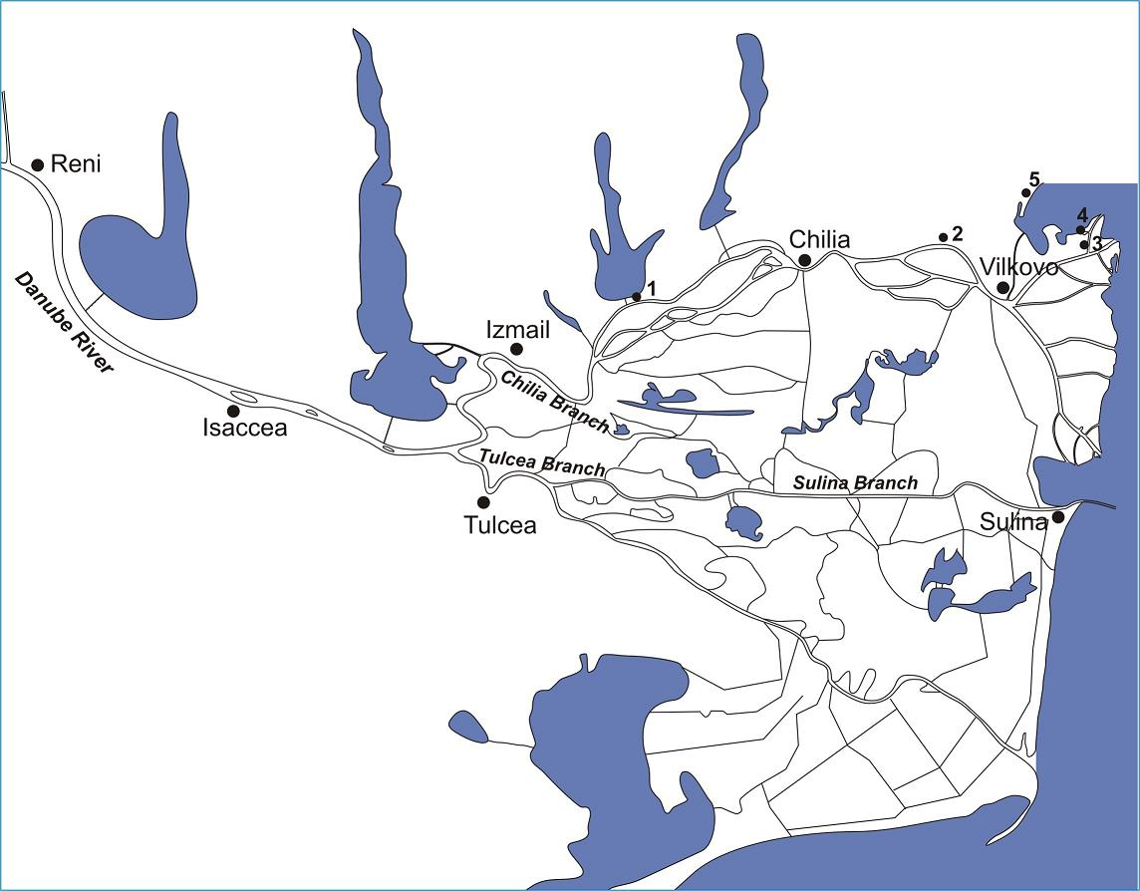

Figure 1. Scheme of the location of gauging stations in the Danube delta.
1 – Kislitsa, 2 – Liski, 3 – Prorva, 4 – Ust’-Dunaisk, 5 – Primorskoye

3. Theory
The main reasons of the changes in water levels in the Danube delta are the seasonal and long-term variations in river water discharges and the eustatic rise of the Black Sea level.
The following relationships are typical for the Danube delta branches in conditions of quasi-steady regime, without the influence of storm surges
H_{i}=f (Q_{r}, Н_{s}) (1)
or
H_{i} =φ(Н_{r}, Н_{s}), (2)
where H_{i} is water level in any point in the delta branches, Q_{r} is river water discharge, Н_{r} is water level at the reference gauging station upstream of the delta head, Н_{s} is mean sea level. There is a steady connection between Н_{r} and Q_{r} in the form Q_{r}=ψ(Н_{r}).
The relationships of (1) and (2), with the understanding that the mean sea level does not changes over a period of time, can be replaced by more simple relationships
H_{i}=f (Q_{r}) (3)
or
H_{i} =φ(Н_{r}). (4)
The existence of the relationships of (3) and (4) for the Danube delta shows, that the key factor of the changes of water levels in the delta is seasonal fluctuations of the Danube River runoff. The presence of such connections allows us to develop a method of calculation of water levels at any gauging station under the given water level at the reference gauging station of Reni (Н_{Reni}) or the Danube River water discharge (Q_{Reni}).
The relationships for the delta branches in the form of (4) were first obtained for year of 1962 in (Hydrology…, 1963; Mikhailov, Massalitinova, 1964).

4. Calculations of present-day flow-induced water levels
The new calculations of flow-induced water levels (or “calm” levels), i.e. levels without the influence of storm surges, were made for the year of 2000. As “calm” days, we considered those days on hydrometeorological station Ust’-Dunaysk at the delta coastline, when the wind speed does not exceed 3 m/s. The days with ice phenomena had not been considered.
We took into account daily water levels with the following time lag: at the gauging stations of Primorskoye, Ust’-Dunaysk, Prorva, Vilkovo, Liski in a “calm” day, at the gauging stations of Chilia, Kislitsa, Izmail, Tulcea – 1 day ahead a calm; at the gauging stations Isaccea, Reni – 2 days ahead a calm.
Based on these flow-induced water levels, diagrams of connections in the form (4) were constructed
H_{i}=aН_{Reni}+b, (5)
where H_{i} is water level at any gauging station, a and b are parameters.
Several relationships are presented as examples in Figure 2. These relationships are appeared to be linear in the range of the water levels at Reni from 100 to 500 cm above datum of the gauging station of Reni.
Relationships of flow-induced water levels in this range are reliable (Table 1). Reni is located at a distance of 163.3 km from the Prorva branch mouth. Datum of the gauging station of Reni is 0.36 m in the Baltic system.

5. Water levels at any gauging station under the water level at the gauging station of Reni in the range from 100 to 500 cm and different water runoff of the Danube River
To calculate flow-induced water levels in the range of 100–500 cm, we used relationships of (5), submitted in Table 1.
The analysis of the equations (Table 1) shows the following:
1) the relations of water levels on the gauging stations with water levels at Reni in a range from 100 up to 500 cm are approximated by the equations of a direct line;
2) the coefficients of correlation of these empirical relationships are rather high. They are not lower 0.97 for the gauging stations between Isaccea and Vilkovo. Relationships are less reliable for the gauging stations of Prorva, Ust’-Dunaysk and Primorskoye: the coefficients of correlation equal accordingly 0.79, 0.61 and 0.43. The reduction of the coefficients of correlation for the relationships of water levels for seaside gauging stations is explained by increase of the scatter of points (Figure 2), connected with the influence of the sea level fluctuations;
3) as the sea is approached, angular inclination of the diagrams of relationships in the form H_{i}=aН_{Reni}+b decreases from 0.89 at Isccea up to 0.022 at Primorskoye (Table 1). It reflects stabilizing impact of the sea on seasonal fluctuations of water levels in the delta and spreading out the flow-induced water level fluctuations;
4) the ranges of present seasonal water level variations at different gauging stations (when the water level at Reni is from 100 to 500 cm) are the following: Isaccea – 3.56, Tulcea – 3.02, Izmail – 2.64, Kislitsa – 2.07, Chilia – 1.56, Liski – 1.00, Vilkovo – 0.74, Prorva – 0.26, Ust’-Dunaysk – 0.18, Primorskoye – 0.09 m.
Curves of water surface along the Danube upstream of the delta head and the Chilia branch were constructed (Figure 3). The analysis of these curves shows the following: the longitudinal profiles of a water surface from Reni to the Black Sea represent a system of recession or backwater curves. At the Danube water discharges >8000 m³/s, longitudinal profiles of a water surface have the convex form (type of recession curve), and at the water discharges <6000 m³/s – concave form (type of backwater curve).

(a)

(b)

(c)

(d)

Figure 2. Dependences of flow-induced water levels (2000):
Reni – Izmail (a), Reni – Chilia (b), Reni – Vilkovo (c), Reni – Primorskoye (d).

Table 1. Dependences of flow-induced water levels (cm)
for the main gauging stations in the Danube delta for up-to-date situation
(Н_{Reni} is water level near Reni)
Gauging station | Distance from the Prorva branch mouth (km) | Datum in the Baltic system (m) | Equation in the form  H_{i}=aН_{Reni}+b | Coefficient of correlation  r
Isaccea | 139.7 | –0.06 | Н_{Is}=0.890Н_{Reni}+20 | 0.999
Tulcea | – | –0.13 | Н_{Tul}=0.754Н_{Reni}+9 | 0.998
Izmail | 93.6 | –0.18 | Н_{Izm}=0.659Н_{Reni}+14 | 0.998
Kislitsa | 68.0 | –0.47 | Н_{Kis}=0.518Н_{Reni}+20 | 0.996
Chilia | 47.0 | –0.33 | Н_{Chil}=0.391Н_{Рени}+7 | 0.992
Liski | 27.5 | –0.43 | Н_{Lis}=0.249Н_{Reni}+25 | 0.986
Vilkovo | 18.0 | –0.75 | Н_{Vil}=0.187Н_{Reni}+55 | 0.972
Prorva | 3.6 | –0.63 | Н_{Pr}=0.066Н_{Reni}+45 | 0.787
Ust’-Dunaisk | 0 | –5.00 | Н_{UD}=0.044Н_{Reni}+490 | 0.614
Primorskoye | 0 | –5.00 | Н_{Prim}=0.022Н_{Reni}+486 | 0.429

Figure 3. Longitudinal profiles of water surface along the Danube mouth reach from Reni to the Black Sea under the water discharges:
1 – 3000, 2 – 4000, 3 – 6000, 4 – 8000, 5 – 10 000, 6 – 12 000, 7 – 14 000 m³/s.

6. Changes in flow-induced water levels over the last 40 years
An analysis of the long-term changes in the flow-induced water levels under the same water discharges of the Danube River was made. This analysis was carried out by comparison of up-to-date data and the data in (Mikhailov, et al., 1981). This comparison characterizes changes in water levels at the Danube mouth during the few last decades (from the period of 1965–1979 to the period of 1999–2000) (Table 2).

Table 2.Long-term changes in flow-induced water levels at the Danube mouth at the different water discharges.
Above line is data after (Mikhailov et al., 1981), below line is up-to-date data
Water discharge at the delta head (m³/s) | Water levels (m in the Baltic system)
Water discharge at the delta head (m³/s) | Reni | Izmail | Chilia | Vilkovo | Prorva
3000 | 0.73  0.79 | 0.28  0.24 | –0.11  –0.09 | –0.29  –0.12 | –0.41  –0.15
4000 | 1.31  1.41 | 0.69  0.65 | 0.13  0.15 | –0.17  0.00 | –0.36  –0.11
6000 | 2.41  2.54 | 1.46  1.40 | 0.59  0.59 | 0.06  0.21 | –0.27  –0.04
8000 | 3.35  3.49 | 2.12  2.02 | 0.99  0.96 | 0.26  0.39 | –0.18  0.03
10000 | 4.10  4.30 | 2.64  2.86 | 1.30  1.28 | 0.41  0.54 | –0.11  0.08
12000 | 4.73  5.02 | 3.08  3.03 | 1.57  1.56 | 0.54  0.67 | –0.06  0.13
14000 | 5.26  5.70 | 3.45  3.48 | 1.79  1.83 | 0.65  0.80 | –0.01  0.17

The results of the analysis given in Table 2 shows the following:
1) water levels in Reni raised, apparently, in connection with large-scale embankment of channel in the Danube upstream of the delta head;
2) water levels in Izmail under the same water discharges of the Danube River were slightly lowered, apparently, in connection with reduction of the Chilia branch water runoff because of its redistribution into the Tulcea branch;
3) water levels in Vilkovo and Prorva increased as a result of backwater spreading due to the Black Sea level rise;
4) water levels of water in Chilia have changed a little, that, apparently, is connected to an intermediate site of this gauging station.

7. Trends in variations of water levels in the Danube delta after the construction of Iron Gate-I reservoir
The analysis of the temporal trends in water levels and their connections with governing factors led us to similar conclusions.
Since 1971, main changes in water levels in the Danube delta were connected with natural and anthropogenic variations in water runoff of the Danube River and eustatic rise of the Black Sea. An analysis of the changes in river water runoff and water levels were made for mean annual values, mean monthly values for May (high flow period) and for October (low flow period) (refer to Figures 4–6).
Figure 4.Variations of water discharges at the delta head (hydrometric section of “54 mile”) over the period of 1971–2003.

Figure 5. Variations of the sea level at the gauging station of Primorskoye over the period of 1971–2003.

The results of this analysis showed an decrease of mean annual and May discharges and increase of October discharges. These changes are likely to be consequences of the reservoir construction. Revealing trends can be expressed by the following equations:
Q_{mean an}=–3.187t+12926, (6)
Q_{May}=–1.1804t+11540, (7)
Q_{October}=11.679t–18301. (8)
Here Q is water discharge of the Danube River at the delta head (the hydrometric section of "54th mile"), t is chronicle year.

Figure 6. Variations of water levels at the gauging stations of Izmail (a), Chilia (b), Vilkovo (c) over the period of 1971–2003.

Table 3. Equations of the trends in water levels over the period of 1971–2003
Gauging station, distance from the sea (km) | Period of averaging | Equation in the form  H=at+b  (H, cm above datum) | Trend (mm/year)
Reni, 163.3 | Year | H=–0.528t+1283 | –5.3
Reni, 163.3 | May | H=–0.810t+1955 | –8.1
Reni, 163.3 | October | H=0.144t–135 | +1.4
Izmail, 93.6 | Year | H=–0.486t+1137 | –4.9
Izmail, 93.6 | May | H=–0.519t+1278 | –5.2
Izmail, 93.6 | October | H=0.045t+205 | +0.4
Chilia, 47.0 | Year | H=–0.190t+478 | –1.9
Chilia, 47.0 | May | H=–0.352t+842 | –3.5
Chilia, 47.0 | October | H=0.084t–100 | +0.8
Vilkovo, 18.0 | Year | H=0.301t–504 | +3.0
Vilkovo, 18.0 | May | H=0.223t–328 | +2.2
Vilkovo, 18.0 | October | H=0.482t–880 | +4.8
Prorva, 3.6 | Year | H=0.398t–735 | +4.0
Prorva, 3.6 | May | H=0.372t–676 | +3.7
Prorva, 3.6 | October | H=0.530t–1006 | +5.3
Primorskoye, 0.0 | Year | H=0.332t–173 | +3.3
Primorskoye, 0.0 | May | H=0.273t–50.1 | +2.7
Primorskoye, 0.0 | October | H=0.444t–401 | +4.4
Sulina, 13.0 | Year | H=0.030t–7.76 | +0.3
Sulina, 13.0 | May | H=0.005t+50 | +0.1
Sulina, 13.0 | October | H=0.353t–656 | +3.5

Similar analysis was made for water levels (Table 3).
Eustatic sea level rise at the gauging station of Primorskoye can be illustrated by Figure 5. Over the period of 1971–2003, the trend of this rise consists 3.3, 2.7, and 4.4 mm/year for mean annual water level, mean monthly water level for May and October correspondingly.
Therefore, over this period (33 years), water levels in this place increased by 11 cm (mean annual), 9 cm (May), 14 cm (October).
Changes in water levels at different gauging stations in the Danube delta are presented in Figure 6.
Analysis of these changes in water levels showed the following (Table 3, Figure 5, 6):
1) in the upper part of the Danube delta (Izmail) mean annual and mean monthly water levels for May decreased by 16–17 cm, but mean monthly levels for October increased by 1 cm. These variations are in agreement with changes in water runoff of the Danube River;
2) in the lower part of the Danube delta (Prorva, Sulina, Vilkovo) water levels noticeably increased as a result of the sea level rise;
3) in the middle part of the delta (Chilia) long-term changes of water levels are the least;
4) distance that the backwater penetrates into the delta depend on the eustatic sea level rise and estimated as about 30–35 km from the sea during mean and high water flow periods, but about 70–80 km during low flow period (Figure 7).

Figure 7. Values of the trends in water level changes over the period of 1971–2003 along the Danube delta during high water period (May) (1), mean annual water runoff (2), low flow period (October) (3).

8. Conclusions
As discussed above, flow-induced water levels in the Lower Danube and the delta were subjected to significant changes over the last few decades. These changes are directly related to natural and anthropogenic variations in governing factors, in particular, to the stream-flow regulation by reservoirs, redistribution of river water runoff into the Tulcea branch system, large-scale embankment along the channels, and the Black Sea level rise.

9. Acknowledgments
This work was supported by the Russian Foundation for Basic Research (grant №04-05-64149).

10. References
Hydrology of the Mouth Area of the Danube River (1963): 383 p. Gidrometeoizdat, Moscow, USSR. In Russian.
Mikhailov, V.N., Massalitinova, K.V. (1964): About the establishment of a series of water level observations at river mouths by hydrological methods (the Danube River mouth area as an example). Proc. of State Oceanographic Institute. Vol. 78, 111–135, Moscow, USSR. In Russian.
Mikhailov, V.N., Vagin, N.F., Morozov, V.N. (1981): General peculiarities of the hydrological regime of the Danube delta and its anthropogenic changes. Water Resources. №6, 22–44. Moscow, USSR. In Russian.

