CHELIM - Excel application for the analytic expression of rating tables/curves

Ph. Dr. eng. Ion Pasoi ¹, Adrian Purdel²

¹National Institute of Hydrology and Water Management – Romania, Bucuresti, Romania, e-mail: ion.pasoi@hidro.ro
²National Institute of Hydrology and Water Management – Romania, Bucuresti, Romania, e-mail: soulwhisper2001@yahoo.com

Abstract: The Excel application CHELIM allows the expression of rating tables/curves using 1 to 3 polinoms of 2nd degree (Q = aH² + bH + c ). For this it is necessary to know 3 – 5 level/discharge pairs and the minimum level of the rating curve/table.
Based on these, the application automatically calculates three equation systems of 2nd degree with 3 variables:
A₁H₁² + b₁H₁ + c₁ = Q₁ (1)
A₁H₂² + b₁H₂ + c₁ = Q₂ (2)
A₁H₃² + b₁H₃ + c₁ = Q₃ (3)

A₂H₃² + b₂H₃ + c₂ = Q₃ (4)
A₂H₄² + b₂H₄ + c₂ = Q₄ (5)
2a₁H₃ + b₁ = 2a₃H + b₂ (6)

A₃H₄² + b₃H₄ + c₃ = Q₄ (7)
A₃H₅² + b₃H₅ + c₃ = Q₅ (8)
2a₂H₄ + b₂ = 2a₃H₄ + b₃ (9)

where equations 1, 2, 3, 4, 5, 7, 8 are conditions of passing the polinoms through the given points and equations 6 and 9 are conditions of continuity of the rating curve in the points of polinoms junctions. Also the minimum level should be bigger than b₁: 2a₁ and a₁, a₂, a₃ should take positive values.
The results are used in order to further calculate the discharge at the required levels, and the differences (in percents) which result from the comparison with the discharge measurements.
The application allows the reduction of the number of discharge measurements from 70 – 100/year (the average number of discharge measurements at a station gauge from Romania) to around 20 – 30/year (according to WMO recommendations) or even less for very stable valleys, with practically no influence over the quality of the final material.
The application has the advantage of the precise calculation of discharge, formerly impossible due to the graphic representation. Another advantage is that the application has an user friendly interface, thus being easy to use by less experimented PC operators. The working under Excel was preferred to working with other programs or computer languages because all the computers from Romania’s hydrological network use Microsoft Office and buying licenses for other computer programs would have been more expensive and less efficient due to the need of teaching people to work with those computer programs. The computer’s precision ( with practically no decimal place limit ) is also useful in the case of the installation of an automatic station which measures the level in millimeters ( former precision was 1 cm ).
The paper ends with a study case from Romania.
Keywords: rating curve, rating table, polinom, aplication, Excel
CHELIM –Excel Anwendung zur analitischer Bestimmung der Wasserstandabhänging – Durchflusskurven

Kurzfassung: Die Anwendung in Excel CHELIM gestatet den Ausdruck der Wasserstandabhänging Durchflusskurven nuzend 1 –3 Polynoms zweiten Grades (Q=aH²+bH+c).
Dafür ist es nötig die 3-5 Paar H – Q Werte und den mindesten gültigen Wasserstand der Durchflusskurven zu kennen.
Die Ergebnisse sind benutzt für die Berechnung der Durchflusswerte bei verschiedenen Wasserständen und der Irrtüme gegenüber den Messungen.
Die Anwendung erlaubt die Messungnummer von 70 – 100 Jährlich ( der Mittelwert der bei einer Rumänischen Messstation ausgeführte Messungen) zu vermeiden, oder gar weniger bei sehr feststehenden Flussbeten, ohne die Qualität der endgültigen Ergebnissen zu affectieren.
Diese Anwendung hat die Genauigkeit im rechnen als Vorteil, die Irrtüme beim grafischen lesen beseitigend. Ein anderer Vorteil ist ein auch von den weniger eingeschulten PC Benutzen leicht brauchbares Zusammenwirken zu haben. Es wurde die Arbeit mit Excel Program vorgezogen, weil alle Elektronenrechner des rumänischen hydrologischen Netzes Microsoft Office nutzen und anderseits, neue Programme zu kaufen teuer und unwirksam ist ( wegen der erforderlichen Einschülung um die neuen Programme kenenlernen). Die Genauigkeit der Rechnungen( praktisch ohne Dezimalen Grenze) ist auch im Falle der Einrichtung von automatischen Stationen, welche den Wasserstandim m.m. lesen können, nützlich.
Am Ende wird ein Studium Fall aus Rumänien vorgetragen.
Schlüsselworte: wasserstand, abflusstabelle, polynom, aplication, Excel

- Introduction
The expression of the rating curve through a single mathematical function is based on an optimization of solving a system with “m” equations and “n” variables ( m – the number of flow measurements; n – the number of parameters of the mathematical function). The optimum results from the condition that the average square deviation is minimum. From the hydrological point of view, to this condition it is added another one which is that the flow measurements should have a deviation from the rating curve of maximum 5%.
For the rivers the optimum expression of the rating curve can be done by using an exponential function Q = a(H-H₀)^{b} (where H₀ is the zero flow level, a,b – the parameters of the mathematical function) ore by using a polynom of n degree, Q = $\sum{\text{ai}×H_{i}^{i}}$, where a_{i} are the parameters of the polynom. In the case of the exponential expression of the rating curve the calculation algorithm is difficult, solving being made by using mostly iterative calculation. The analytical expression of the rating curve by a polynom of n degree has the following restrictions: for the levels for which the rating curve is applicable, the polynom should not have inflexion points, and the shape of the polynom should be the one of the rating curve.
The analytical expression by more than one mathematical function is based on solving an equation system which fallows the fallowing laws:
- the mathematical functions should pass through certain formerly established points
- in the intersection points of two mathematical functions the value of Q(H) should be the same as calculated by both of the functions
- in the intersection points of two mathematical functions the tangents to them should be equal
Based on the above mentioned and taking into account the determination problems and the restrictions imposed, it is proposed the analytical expression of the rating curves by using 1 – 3 polynoms of 2nd degree, calculated under MsOffice Excel

2.The analytical expression of the rating curves through 2nd degree polynoms:
For the analytical expression of the rating curves, by using 2nd degree polynoms, the present paper is based on solving a system of 9 equations with 9 variables (when using 3 polinoms) with the aid of Excel:

A₁H₁² + b₁H₁ + c₁ = Q₁ (1)
A₁H₂² + b₁H₂ + c₁ = Q₂ (2)
A₁H₃² + b₁H₃ + c₁ = Q₃ (3)

A₂H₃² + b₂H₃ + c₂ = Q₃ (4)
A₂H₄² + b₂H₄ + c₂ = Q₄ (5)
2a₁H₃ + b₁ = 2a₃H + b₂ (6)

A₃H₄² + b₃H₄ + c₃ = Q₄ (7)
A₃H₅² + b₃H₅ + c₃ = Q₅ (8)
2a₂H₄ + b₂ = 2a₃H₄ + b₃ (9)

where equations 1, 2, 3, 4, 5, 7, 8 are conditions of passing the polinoms through the given points and equations 6 and 9 are conditions of continuity of the rating curve in the points of polinoms junctions. The restriction imposed are: a_{1,2,3} > 0, and H_{min} (minimum level for the rating curve ) > - b₁/2a₁

3.CHELIM
CHELIM is an application which runs under excel and allows the expression of the rating curves and tables by using a maximum number of 3 polinoms of 2nd degree ( Q = aH² + bH + c ). For this it uses 3 – 5 pairs of values Q – H. This pairs can be flow measurements, points which are within 5% from the rating curve, points chosen by the operator ( considered as belonging to the rating curve). (fig. 1) The establishment of the number of polinoms and the pairs of values are made by the operator.
The application is structured in 3 sheets: (“Calcule”; “Arhiva”; “Grafice” )
The sheet “Calcule” (Calculation) has three tables: (fig. 2)
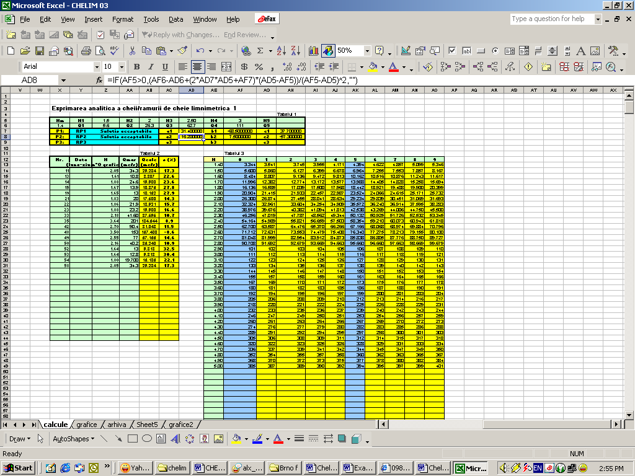
Fig 2
Table 1 – the analytical expression of the rating curve
Table 2 – the calculation of the deviation between measured flow and the rating curve
Table 3 – the rating table

Table 1 has three zones: input data zone with data filled by the operator (minimum level of the rating curve’s availability and the pairs of Q – H points), the restriction zone (when restriction are obeyed “Solutie acceptabila” – that is “accepted solution” – is written and when not it will appear there “Solutie innaccepatbila” – that is “unaccepted solution”) and the calculation zone where calculated parameters of the polinoms are displayed.
Table 2 has two zones: input data zone with data filled by the operator (number of flow measurements, its date, its level and its value), the calculation zone (the calculated flow and the errors towards the rating curve).
Table 3 has two zones: input data zone with data filled by the operator (the level value from 10 to 10 cm) and the automated calculation (the flow calculated for levels with 1 cm step).
A good solution has “Solutie acceptabila” (acceptable solution) written in the restriction zone and 5% error from the rating curve.
The sheet “Arhiva” (Archive)contains the result of rating curves determinations for each of them.
The sheet “Grafice” (Charts) contains auxiliary charts which can be helpful for choosing the pairs of points, the time period of the rating curve, and so and so forth.

4.Ways of using CHELIM
CHELIM allows the expression of the rating curve after each flow measurement (if it is within 5% from the rating curve0 or after periodical analysis of the points distribution on possible time intervals between the changing point of the rating curve. Also CHELIM allows the reduction of the number of flow measurements and eliminates (in many cases) the need for extrapolation.
CHELIM was successfully tested on cases of different complexity from Romania (up to 6 rating periods). The necessary time was usually under 30 minutes.

4.1.The analytical expression of the rating curve on Berheci river at Feldioara gauging station, using CHELIM
For the year 2001 CHELIM was used for expressing the rating curve from Berheci/Feldioara which had 4 rating periods; the final solution needed only 18 flow measurements.
In Fig. 3 it is presented a detail of the rating periods is presented.
5.Conclusions:
- The analytical expression of the rating curve reduces a great deal of the subjectivism of drawn rating curve.
- The application allows fast control of the flow measurements deviations
- The application runs under Excel, a very accessible programme (from the point of view of operating facilities and license agreement)
- The needed free space on HDD is under 1 MB

