Rainfall interception by two deciduous forests of contrasting stature in southwestern Slovenia

Mojca Sraj

University of Ljubljana, Faculty of Civil and Geodetic Engineering, Ljubljana,
e-mail: msraj@fgg.uni-lj.si

Abstract: Precise measurements of precipitation above the canopy, throughfall and stemflow were made on the south and north-facing slopes of a deciduous forest on the experimental watershed of the Dragonja river. For this reason, two forest plots were selected. One is located on the north-facing slope and the other on the south-facing slope. Analyses and modelling were made for a one-year period from October 2000 to September 2001. The research is a part of an extensive scientific-research project “Dragonja: Forest – Water – Soil – Climate Interactions”, which has been carried out by Vrije University from Amsterdam and University of Ljubljana since 1999. The Dragonja watershed was chosen as an experimental watershed, since it is interesting because of the intensive natural reforestation in the last decades, which has caused a decrease in minimal and maximal flows. At the same time no noticeable precipitation and temperature changes have been perceived.
Keywords: rainfall interception, Gash, modelling, Dragonja, leaf area index, field measurements, throughfall, stemflow.

DIE INTERZEPTION DES NIEDERSCHLAGES IN ZWEI LAUBWALDBESTÄNDEN VON unterschiedlicher struktur im südwestlichen Slowenien

Zusammenfassung: Präzisionsmessungen des Niederschlages über dem Kronenschluss, durchfallender Niederschlag und Stammablauf in zwei nach Süden und Norden liegenden Beständen auf dem Versuchseinzugsgebiet des Flusses Dragonja waren ausgeführt. Dementsprechend wählte man zwei Waldbestände. Der eine liegt nach Norden und der andere nach Süden. Analysen und Modellierungen für die einjährige Periode von Oktober 2000 bis September 2001 waren ausgearbeitet. Die Untersuchungen sind Teil des umfangreichen Forschungsprojekts “Dragonja: Forest – Water – Soil – Climate Interactions” und wurden seit 1999 von der Vrije Universität aus Amsterdam und Universität Ljubljana durchgeführt. Das Einzugsgebiet der Dragonja wurde als Versuchseinzugsgebiet gewählt, denn es ist wegen seiner intensiven natürlichen Wiederaufforstung in den letzten Jahrzehnten höchstinteressant; die Wiederaufforstung verursachte nämlich eine Senkung vom minimalen und maximalen Abfluss. Gleichzeitig waren keine bemerkbaren Veränderungen des Niederschlages und der Temperatur anerkannt.
Schlüsselworte: Interzeption des Niederschlages, Gash, Modellierung, Fluss Dragonja, Blattflächenindex (LAI), Feldmessungen, durchfallender Niederschlag, Stammablauf.

Introduction
Undoubtedly, forests exert a major influence on water regime. However, since the end of the 20th century, worldwide researches have shown that the influence of forests on the water regime is not only positive: an increase of overgrown areas results in a reduction of surface water runoff, on the other hand, forest harvesting causes an increase of minimum and maximum runoffs. This is true for the Dragonja watershed as well, where the gradual overgrowing of the area has been causing a reduction in runoffs. The mean annual discharges have reduced by 35 %. Discharges with an event frequency of 90 % are half the size of the average discharges from 1961 to 1995. The number of days with extremely low discharges has increased by 30 %. The frequency of high waters has reduced by 60 %. Parallel, there were no significant changes recorded in precipitation and temperature regimes (Globevnik, 2001).
Interception loss is a major component in the water balance of forested areas. Numerous studies have provided evidence of this (e.g., Horton, 1919; Law, 1956; Rutter, 1967; Gash and Stewart, 1977; Gash et al., 1980). The aim of the study was to determine the quantity of the intercepted precipitation and evaporation, respectively, for the deciduous forest on the Dragonja watershed through measurements of single elements of the forest hydrologic cycle and determination of vegetation parameters, as well as to make a comparison of the intercepted precipitation in the forests in the south and north plots. Namely, the forests in the south and north plots of the watershed differ considerably in terms of structure, density and tree heights as well as in composition, thus they need to be dealt with separately.

The study area

General
The Dragonja watershed is located in the southwestern part of Slovenia near the Adriatic coast (Fig. 1). The region is part of the Istrian Peninsula. A smaller part of the watershed belongs to Croatia. The watershed is a hilly region, between 150 and 450 m above sea level and with an area of 90.5 km². The Dragonja river is a border river between Slovenia and Croatia. It flows into the Secovlje salt pans (nature park, a Ramsar locality) before reaching the Adriatic Sea. The watershed is divided into five subwatersheds on the forth level of the watershed coding system of Slovenia (Sraj, 2001).

Figure 1. Location of the study site in the Dragonja watershed, southwestern Slovenia and measurement points.

According to today’s standards, the Dragonja watershed is poorly populated. Characteristically, the area was mainly inhabited in the wide, plane hilly ridges, but the narrow tributary valleys and the Dragonja valley remained hardly populated. Before 1955 land use in the watershed area was intensive. Most of the population lived from agriculture on the ridge tops. In the 1960’s and 1970’s, a process of depopulation began with the arrival of industry along the nearby Adriatic coast. Parallel to abandonment of extensive agricultural land use and out-migration, the anti-erosion vegetation stabilisation works were underway, all of which increased intensive overgrowing of land, and in the Dragonja watershed an increase in overgrowth from an average of 25 % (in 1953) to more than 60 % (today) (Brilly and Globevnik, 2003).
The Slovene Istria was divided into 5 extensive climatic units, with a larger part of the Dragonja watershed being in the climatic unit of the central flysch area. The monthly precipitation distribution indicates the sub-Mediterranean precipitation character. In contrast to the proper Mediterranean precipitation character, there is no seasonal distribution of precipitation that would result in dry summer months and wet winter months, on the contrary, all months are evenly wet, however, autumn stands out with 30 % of the annual precipitation. The total annual precipitation increases with the distance from the sea, ranging from 1000 mm to 1300 mm. Snow is extremely rare and moderate. According to Thornthwait, the annual mean evapotranspiration amounts to 670 mm in Portoroz. Mean annual temperatures by the coast are around 14⁰C (Ogrin, 1995). The most common wind is a north-east wind called burja. On the annual average, it occurs in more than one-third of the year. Regarding the frequency, the south-east wind (jugo) and south wind (jug) follow, both fairly evenly distributed throughout the year. According to the phytoclimatic distribution, the Dragonja watershed is a sub-Mediterranean area with characteristic deciduous sub-Mediterranean vegetation.

The study plots
Two forest plots in the 30–35 year-old forest above the confluence of the Dragonja river and the Rokava river were selected for the current study. A first one was chosen on the north facing slope in the Rokava watershed (1420 m²) and a second one on the south facing slope in the Dragonja watershed (615 m²), about 400 m apart, both about 2500 m away from the village of Labor and about 200 m above sea level. Between the village of Labor and both plots a chronosequence of natural reforestation has been identified from the 4–5 year-old forest near the village to the 30–35 year-old forest on the slopes (30⁰) near the plots.
The surface area of the north plot is 1419 m². There were 117 trees with a diameter at breast height (DBH at 1.35 m) ≥ 3 cm, counted in September 2000. This resulted in a stem density of 0.09 trees per square metre of forest floor. Hornbeam (Carpinus orientalis croaticus) represents almost half of all trees (47 %), followed by pubescent oak (Quercus pubescentis) (34 %), ash (Fraxinus ornus) (5 %), maple (Sorbus torminolis) (3 %), and other species (11 %). The undergrowth is dominated by butcher’s broom (Ruscus aculeatus). Mean tree height was 12.3 m and mean DBH 0.14 m (Te Linde, 2001).
The south plot has an area of 615 m² or approximately half the size of the north plot. Nevertheless, the number of counted trees on the south plot (191) exceeded the number of trees in the north plot. The stem density was 0.31 trees per square metre and was about three times higher than in the north plot. More than half of the trees are ash trees (Fraxinus ornus) (54 %), followed by oak (Quercus pubescentis) (26 %), hornbeam (Carpinus orientalis croaticus) (4 %), maple (Sorbus torminolis) (2 %), and other species (14 %). The tree height could not be measured because of the high tree density but it was estimated at 8 m in average. The mean DBH for all species was 0.71 m. The south plot has a much more abundant understory, diverse vegetation, it is drier and receives more radiant heat energy in comparison to the north plot.

Instruments and methods

Precipitation above the canopy
In the south plot the precipitation above the canopy was being measured from October 2000 on, using a tipping bucket rain gauge (0.2 mm/tip) with an automatic digital data logger at 10-minute intervals (Campbell Scientific Ltd. 21-X data logger) in combination with a totalisator with manual emptying for control (both set up on a tower 8 m above the grounds), and in the north plot since March 2002 with the Hellman, at a height of 10 m; notably this instrument also required manual emptying.

Throughfall (Tf)
Throughfall is a portion of precipitation, which reaches the forest floor directly without touching the canopy (direct throughfall), and portion of precipitation intercepted by the canopy, which after the storage capacity of the canopy has been filled, reaches the floor as crown drip. Direct throughfall and crown drip cannot be measured separately, so that together they represent throughfall.
In experts’ opinions, the measurement of throughfall is best in the combination of fixed and manual roving gauges, thereby providing a more representative sampling (Bruijnzeel, 2000; Waterloo et al., 1999). With manual roving gauges the so-called drip-points are calculated in, where the Tf is higher than the precipitation.
In September 2000, two stainless steel gutters (30 x 370 cm) were set up, equipped with a tipping bucket and a logger system (0.05 l/tip) with digital recording of results every 10 min (Campbell Scientific Ltd. 21-X data logger) in combination with 10 manual roving gauges (100 cm²) that were emptied manually and moved randomly after each reading of water quantity on each plot separately.

Stemflow (Sf)
Stemflow was measured on two individual trees of two most typical species in each plot. On the north plot, oak and hornbeam trees were selected and on the south plot ash and oak trees. Each tree was fitted with a rubber collar around the stem connected to a tipping bucket with a logger system with digital recording of the results at 10-minute intervals (Campbell Scientific Ltd. 21-X data logger).

Leaf area index (LAI)
First, the specific leaf area (SLA) was estimated for the main species in order to estimate the leaf area index. The SLA is an area-to-weight relationship [m²/kg]. It was estimated for five most typical species for each plot separately and also for the “other leaves” category as well as for fine leaf material.
LAI was estimated for two seasons, i.e. for 2000/01 and 2001/02. It was estimated with one direct and two indirect methods. The direct technique for estimating the LAI was litterfall collection. Litter was collected regularly in 10 randomly positioned plastic baskets with a surface area of 0.2 m² in each plot. Each season 10 series were collected. The collected samples were first air- and then oven-dried to the constant weight. Dried leaves were then sorted and weighed by species to the nearest 0.001 g for each basket separately. The total leaf area index was calculated from dry weights of individual species of each basket and SLA.
Hemispherical photography was one of the applied indirect methods. It was done in the seasons of 2000/2001 and 2001/2002, respectively. Hemispherical photographs of canopies were taken at the same 10 points where the baskets were situated. Five series of photography were done in each season. The 28 mm lens was used in this study. Photographs were scanned at 300 dpi and converted to 1-bit images. The threshold value was estimated for each picture in order to distinguish between the canopy and the sky upon which the canopy gap fraction was computed. LAI was then calculated considering the Beer-Lambert Law and the Miller equation for foliage density (Miller, 1967).
The second indirect method that was applied was the photosynthetically active radiation (PAR) measurement with a Sunflect Ceptometer. Only three series of measurements of PAR were made in October 2000 at the same 10 points where the baskets were positioned in the south plot. In the north plot, the method could not be applied because not enough sunlight reached the forest floor on the north facing slopes at this time of year (Te Linde, 2001).

Other meteorological parameters
At the same time, within the scope of the entire project other measurements, used in this study, were carried out in the watershed. There were several rain gauges arranged over the watershed and two meteorological stations in Borst and Kubed that measured incoming and outgoing radiation, temperature, relative humidity, wind velocity, direction, and precipitation.

Analyses of measurements

Rainfall
Between October 5, 2000, and September 19, 2001, a total of 1323 mm of rainfall was measured, distributed over 139 rainy days and 199 events. The events were separated by periods without rain, in which canopies could dry up. The amount of rainfall per event was between 0.2 and 100.2 mm and the intensity between 0.16 and 44.7 mm/h. The average amount of rainfall per event was 6.6 mm, the average duration and intensity of the event were 3.8 hours and 2.51 mm/h, respectively.

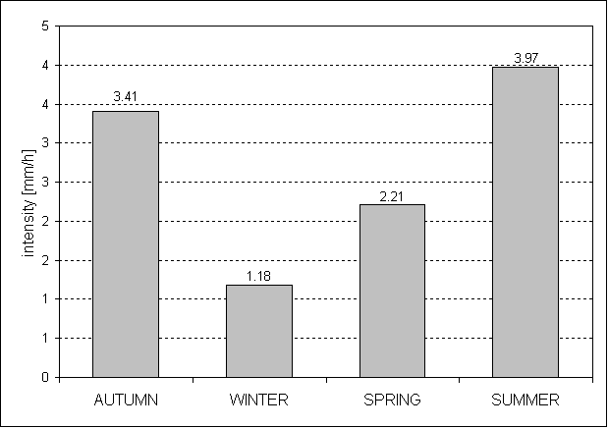
Figure 2. Average precipitation intensity during different seasons.

The comparison of precipitation intensity during different seasons has shown considerable differences (Fig. 2). Highest mean precipitation intensity was identified for the summer-time period, i.e. 3.97 mm/h, this being a consequence of summer showers. In winter, the mean intensity is lowest, being almost four times lower than in summer.
By way of comparison of 35-year mean monthly precipitation (1960–1995), it can be established that in the respective period there were significant deviations from the year-long average, especially in autumn months. In October and November 2000 there was 492 mm of rainfall, this being twice the 35-year average and a third of the whole annual precipitation.
Regression analyses among the precipitation at respective rain gauges indicated high correspondence with a correlation coefficients over 0.95.

Throughfall
Regression analyses between fixed and roving gauge measurements were made for each plot in terms of growing and leafless seasons, respectively. A comparison of the two methods shows that roving gauges indeed gave larger amounts of Tf with correlation coefficients over 0.98 (Fig. 3). On the basis of regression equations the Tf quantities measured with fixed gauges were corrected. All calculations are based on distribution of single events. The mean annual corrected Tf value in the south plot is 67.1 %, and in the north plot 71.5 %.

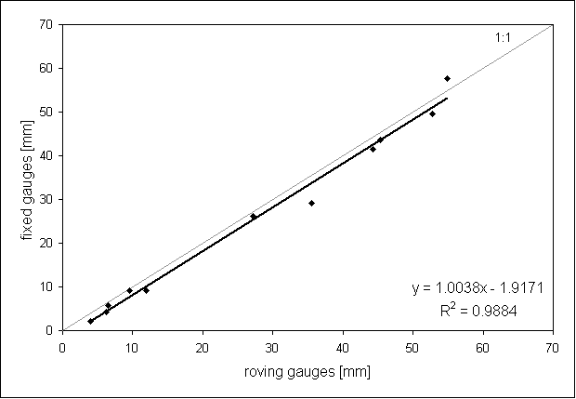
Figure 3. Regression analyses between fixed and rovin gauge measurements for full growing season on south plot.

By comparing the results according to seasons, it may be established that in both plots the values are of approximately the same size order, except in summer, when there are 17 % higher quantities on the north plot (Fig. 4). This may be attributed to pronounced “drip-points”, since the trees in the north plot are less dense and in general the edges of their crowns do not overlap, thus in summer, i.e. in the period of full growth, the phenomenon is even more pronounced. The highest Tf values are expected during winter, when there is no foliage and when a large proportion of precipitation reaches the grounds. However, the results of the measurements show the highest values in summer, and that in both plots. The underlying reason is high intensity of precipitation, which occurs as a result of summer showers. The comparison of the autumn and spring quantities also shows the dependence upon precipitation intensity. Autumn Tf values are higher than during the spring, corresponding to the associated precipitation intensity.

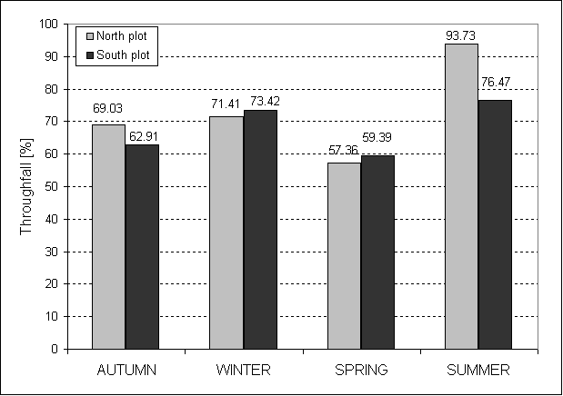
Figure 4. Comparison of throughfall according to seasons.

The measured values are comparable with those gained in other similar researches or else they are about 10 % lower. For the deciduous forest in Canada, Carlyle-Moses and Price (1999) estimated the Tf value at 76.4 %, Dolman (1987) for oak forest in the Netherlands an average of 77 %, and for the deciduous forest in the Netherlands Lankreijer with associates (1993) estimated the value at 77–82 %.

Stemflow
The average stemflow fraction amounts to 4.5 % and 2.9 % of the associated rainfall for the south and north plots, respectively. The difference is a result of different structure and characteristics of forests on both slopes.

Leaf area index (LAI)
The best results were achieved by the litterfall collection method. Most foliage in the Dragonja watershed was lost from the beginning of November to the end of December. The obtained values of LAI were 6.7 and 7.3 for the south and north slopes, respectively (at the height of the growing period). A smaller value of LAI on the south slope (for about 10 %) was expected, because of the more open character of this forest. Similarly, the total quantity of the collected foliage in both plots differs in approximately same value.

The interception loss
On the basis of the measurements and water balance equation, it was calculated that the average annual interception losses amount to 28.4 and 25.4 % for the south and north slopes, respectively. Both values are similar and rather high compared with the interception losses of deciduous forests, which are usually between 15 and 25 % (Bruijnzeel, 2000). In their research for deciduous forest in Canada, Carlyle-Moses and Price (1999) estimated the amount of the evaporated throughfall at 19.3 %, Dolman (1987) for oak forest in the Netherlands in an average of 23 % and Lankreijer et al. (1993) for the deciduous forest in the Netherlands 18–23 %. In reality, the losses are even higher, since the measured precipitation was not corrected for the systematic error of the measurement (Bonacci, 1991).
Comparison during different seasons (Fig. 5) shows similarities between both plots, with the exception of summer, when the difference between both plots is five times the initial value. In summer, the evaporation in the south plot is estimated at 18.8 %, and in the north plot 3.8 %, respectively. This was expected, since the south plot is much more exposed to solar radiation. The highest estimated values of evaporated throughfall were in spring, the lowest in summer. Low summer values are a consequence of great precipitation intensity in summer time, corresponding to high Tf values in the respective period.

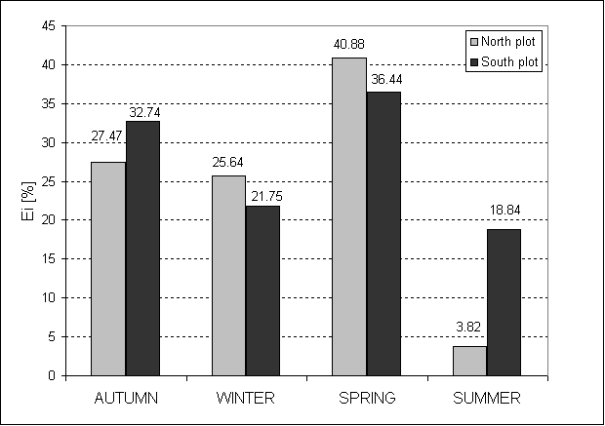
Figure 5. Comparison of interception loss according to seasons.

Modelling of interception loss
The revised Gash interception model (Gash et al., 1995) was a base for all variants of the applied models. It considers rainfall as a series of discrete events. The canopy is assumed to dry out between each storm. Each event has three phases: a wetting, saturation and drying phase. Five variants of the models were made. Into model 5 the parameter of leaf area index LAI is introduced as a function of time. The canopy cover c is expressed as a function of LAI, as adopted by the revised Gash model (van Dijk and Bruijnzeel, 2001a; b). The use of both parameters is the newest approach towards the modelling of rainfall interception.
In general, the models yielded good results. The modelled values were in general well fitted to the measured values (Fig. 6 and 7). Deviations were within the limits of standard error with the exception of the model, where the evaporation intensity from wet canopy was calculated using the Penman-Monteith equation. The resulting values of evaporation intensity are strongly underestimated, as shown by the model, and has also already been confirmed by many researches particularly in wet maritime conditions (Bruijnzeel and Wiersum, 1987; Dykes, 1997; Waterloo et al., 1999; Schellekens, 2000; Gash et al., 1980). We can summarise that the Penman-Monteith equation, despite its accuracy and high data demand, is not appropriate for the calculation of interception losses from a wet canopy in the given climatic conditions. All models show a slightly higher interception loss in the south plot, which was also confirmed with measurements.
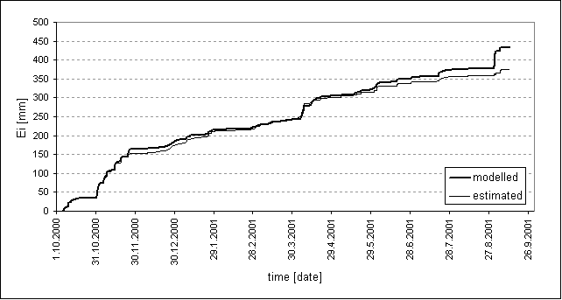
Figure 6. Comparison of estimated and modelled interception losses for the south plot.

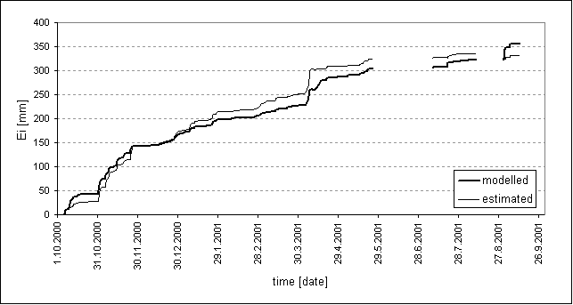
Figure 7. Comparison of estimated and modelled interception losses for the north plot.

The influence of wind over intercepted precipitation can be significant. If the wind velocity is high enough, the wind brings the trees in motion and reduces the storage capacity of the canopy and thus the evaporation of the intercepted precipitation. Furthermore, during the analysis of the measured data it was established that in the precipitation events, where the south-east wind (jugo) blew with a velocity higher than 4 m/s, there occurred unusually low throughfall Tf and as a result high interception loss Ei (Fig. 8). In these cases, the increased evaporation is probably the result of the rise in temperature, deriving from the warm east-south wind, which has a characteristic temperature rise. Accordingly, those events were excluded from the determination of canopy parameters in the south plot. The same phenomenon was identified in the north plot, however in a less marked manner (Tf was on average higher than on the south plot by about 20 percent).

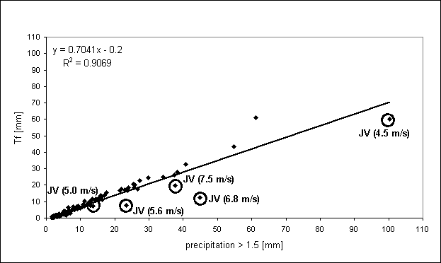
Figure 8. Influence of the south-east wind on throughfall and interception loss on the south plot..

Conclusions
More than a quarter of the precipitation above the forest of Dragonja watershed evaporates back into the atmosphere during the storm or right after. However, these losses are relatively great, having in mind that the evaporated throughfall of deciduous forests is usually between 15 and 25 % (Bruijnzeel, 2000). Similar results were also obtained with different models of interception. The only exception was the model, where the evaporation intensity from wet canopy was calculated using the Penman-Monteith equation. Such high loss of the deciduous forest of the Dragonja watershed confirms the assumption that the overgrowing of the catchment is probably the cause of the reduction of runoff. For proof of this assumption some additional measurements and analyses should be done.
Admittedly, between the forests in the north and south slopes higher differences were expected, since there are considerable differences in structure, density, and tree heights, as well as in the composition itself. Despite a predicted higher difference, the results of the measurements and analyses show a lower difference of mean annual interception loss between the plots. A comparison by seasons also fails to show any significant deviations, with the exception of summer, when the evaporation of the throughfall of the south plot is almost five times higher than the evaporation on the northern side. A much higher quantity of interception loss in the southern plot in summer is a consequence of higher solar radiation in sunny areas.
In the research, a significant influence of the wind over the value of interception loss was proven. If the wind velocity is great enough, the wind shakes the trees and thus reduces the storage capacity of the canopy and therewith the interception loss. Furthermore, in data analysis it was established that the warm southeastern wind (jugo) increased the interception loss considerably. The increased evaporation in such events is probably the result of temperature increase, because jugo is a warm wind with the characteristic rise in temperature. For this reason a new version of model was created, which takes into account the influence of warm south winds. Thus, underestimation of interception losses based on the Penman-Monteith equation was eliminated.

Acknowledgements
I would like to thank Dr. L. A. Bruijnzeel and the Vrije Universiteit, Amsterdam, which enabled me the use of modern measuring equipment, the Slovenian National Committee for the IHP UNESCO for financial support and Environmental Agency of the Republic of Slovenia for data provision.

References
Bonacci, O. (1991). The influence of errors in precipitation measurements on the accuracy of the evaporation measurements performed by a class A evaporation pan. Theoretical and applied climatology 43, 181–183.
Brilly, M., Globevnik, L. (2003). Sustainable Water Resources Management in the Dragonja Catchment, Slovenia. Water Resources Systems – Hydrological Risk, Management and Development. IAHS Publication 281, 334–340.
Bruijnzeel, L.A. (2000). Forest Hydrology. In Evans, J.S. (Editor): The Forestry Handbook, Volume 1. Blackwell, Oxford, 301–343 (Chapter 12).
Bruijnzeel, L.A., Wiersum, K.F. (1987). Rainfall interception by a young acacia auriculiformis (a. cunn) plantation forest in West Java, Indonesia: application of Gash's analytical model. Hydrological Processes 1, 309–319.
Carlyle-Moses, D.E., Price, A.G. (1999). An evaluation of the Gash interception model in a northern hardwood stand. Journal of Hydrology 214, 103–110.
van Dijk, A.I.J.M., Bruijnzeel, L.A. (2001). Modelling rainfall interception by vegetation of variable density using an adapted analytical model. Part 1: Model description. Journal of Hydrology 247, 230–238.
van Dijk, A.I.J.M., Bruijnzeel, L.A. (2001). Modelling rainfall interception by vegetation of variable density using an adapted analytical model. Part 2: Model validation for a tropical upland mixed cropping system. Journal of Hydrology 247, 239–262.
Dolman, A.J. (1987). Summer and winter rainfall interception in an oak forest, predictions with an analytical and a numerical simulation model. Journal of Hydrology 90, 1–9.
Dykes, A.P. (1997). Rainfall interception from a lowland tropical rainforest in Brunei. Journal of Hydrology 200, 260–279.
Gash, J.H.C., Lloyd, C.R., Lachaud, G. (1995). Estimating sparse forest rainfall interception with an analytical model. Journal of Hydrology 170, 79–86.
Gash, J.H.C., Stewart, J.B. (1977). The evaporation from Thetford forest during 1975. Journal of Hydrology 35, 385–396.
Gash, J.H.C., Wright, L.R., Lloyd, C.R. (1980). Comparative estimates of interception loss from three coniferous forests in Great Britain. Journal of Hydrology 48, 89–105.
Globevnik, L. (2001). An integrated approach towards water management in catchments: an integrated analysis of time and spatial components of water regimes as the basis of modern procedures of modelling and planning of water management solutions, land use, and environmental protection: the Dragonja catchment. PhD Thesis, University of Ljubljana, 176 pp.
Horton, R.E. (1919). Rainfall interception. Monthly Weather Rev. 47, 603–623.
Lankreijer, H.J.M., Hendriks, M.J., Klassen, W. (1993). A comparation of models simulating rainfall interception of forests. Agricultural and Forest Meteorology 64, 187–199.
Law, F. (1956). The effect of afforestation upon the yield of water catchment areas. Journal of the British Waterworks Associaton 38, 344–354.
Miller, J.B. (1967). A formula for average foliage density. Australian Journal of Botany 15, 141–144.
Ogrin, D. (1995). Climate of the Istrian Peninsula. Library Annales 11, 381 pp.
Rutter, A.J. (1967). An analysis of evaporation from a stand of Scots pine. In: Sopper W.E. and Lull H.W. (editors). International Symposium on Forest Hydrology, Pergamon Press, Oxford, 403–416.
Schellekens, J. (2000). Hydrological processes in a humid tropical rain forest: a combined experimental and modelling approach. PhD Thesis Vrije University, Amsterdam, 158 pp.
Sraj, M. (2001). Watershed coding system of the Republic of Slovenia. Acta Hydrotechnica, 19/30, 3–24.
Te Linde, A.H. (2001). Modelling rainfall interception by two deciduous forests of contrasting stature in the upper Dragonja catchment, southwestern Slovenia. Dragonja project working paper, 42 pp.
Waterloo, M.J., Bruijnzeel, L.A., Vugts, H.F., Rawaqa, T.T. (1999). Evaporation from Pinus caribaea plantations on former grassland soils under maritime tropical conditions. Water Resources Research 35, 2133–2144.

