GIS TECHNOLOGY USE

IN BASIN-WIDE WATER BALANCE ESTIMATION

OF THE DANUBE RIVER BASIN
Petrovic Pavel, Badurova Katarina, Water Research Institute, Bratislava, Slovakia
pavelp@vuvh.sk, badurka@atlas.sk

This paper was presented at the conference:

Abstract
Project "Basin wide water balance of the Danube river basin" is being solved under the frame of IHP UNESCO (International Hydrological Program UNESCO) co-operation of all Danube countries in order to meet the scientific need to prepare second Hydrological Monograph of the Danube river, with enlarged period of processed data and improved technology and methodology of balance evaluation. The international part of the project is financially supported by UVO-ROSTE (UNESCO Venice Office - Research Office of Science and Technology in Europe). The ICPDR (International Commission for Protection of Danube River) expressed its wish to take advantage of the project results.

Keywords: water balance, the Danube River basin, water dividing lines, balance regions, regional co-operation,

- Introduction

Administrative background of the project
Considering the experience of the Regional co-operation of the Danube countries in hydrology within the framework of IHP UNESCO which developed The Hydrological Monograph of the Danube River [1] in its first phase and a series of follow-up volumes of the monograph on specific hydrologic themes in Danube basin in next phases;
Considering the Convention on co-operation for the protection and sustainable use of the Danube River, Joint Action Plan [6] and a letter of Mr. Nick, President of the ICPDR, to Mr. Szöllösi-Nagy, Deputy Assistant Director-general of UNESCO and secretary of the IHP UNESCO, of June 19, 2001;
Considering the agreed preliminary version of project proposal in sense of the ICPDR Plenary session resolution, agreed in Vienna, 29 – 30 November, 2001;
Considering Recommendation On Regional Co-operation of the Danube Countries in the frame of IHP, agreed at the Regional Meeting of the National Committees of the Electoral Groups I and II of UNESCO in Berlin on 18 and 19 February 2002; and
Considering the continuing co-operation of the Danube countries in hydrology in the VIth phase of the IHP UNESCO (2002-2007),

the UVO ROSTE decided to manage support for the international component of the project "Basin-wide water balance of the Danube River basin".
In Slovakia the performance of the national portion of the project is supported by the Science and Technology Assistance Agency under the contract No. APVT-99-018202 since the year 2002.

Scientific background of the project
In respect to the implementation of the Water Framework Directive [2], it was scientifically needed to prepare the second edition of Hydrological Monograph of the Danube River (first published in 1986) [1] using new technologies, methodology and later period of processed data.
Participating countries agreed that GIS and modified WatBal [3,4] model will be used.

Participants
In principle, all countries whose discharge contributes to the water
capacity of the Danube River should participate in the estimation of the basin-wide water balance. From practical reasons, the obligatory contributors to the project solution are the countries, which are contract parties of the ICPDR and their catchment area in the Danube basin is more than 2000 km².
In consonance with Principles of co-ordination within the Danube IHP Group and also within the valid rules of participation of the ICPDR, the contract parties should cover their national contributions to the project on their cost.
Based on the supporting resolutions, the international co-ordination work, expert and steering committee meetings costs are supported by the UVO ROSTE.

Co-ordination
- international level: co-ordinated by the NC IHP UNESCO of Slovakia and Water Research Institute, Bratislava (Petrovic).
- international Working Steering Committee (WSC) was created by delegated
experts at the Danube NCs IHP UNESCO representatives meeting in Zagreb in 2002.

- national level: organized by Danube IHP NCs representatives or by countries` nominated liable experts.
- each country is represented by Working Group experts in applied hydrology and
water resources analysis.

- Objectives

The following set of goals has to be achieved:
- Elaboration of spatially distributed basin wide water balance by harmonized methodology for the whole Danube basin to provide the basis for transboundary water management and decision support.
- Water balance assessment (incl. considering our contribution to the water districts estimation methodology by defining water balance regions) in respect to implementation of the Water Framework Directive 2000/60 EC.
- Development of a standardized database in digital format to assist water related decision making at national and basin wide scale.
- Creation of a base for further harmonisation and unification of methodologies used in more sophisticated approach, like the assessment of long-term mean hydrological characteristics for selected representative period(s).
- Assembling of a base for further impact analysis of ongoing global and climate change.
- Creation of a base for knowledge transfer within the IHP UNESCO experts working on the water balance and related topics (incl. GIS) as an example study for application in other international river basins.

- Methodology

Input data assessment
Input data to water balance evaluation consist of monthly series of four hydrometeorological elements: precipitation, air temperature, air humidity and runoff. Areal evapotranspiration is computed on the base of air temperature and air humidity.
The participating countries were pushed to use the latest representative period of 30 years 1971 – 2000. In the process of data preparation it was found that there are certain difficulties in some countries to assemble data for the latest decade and therefore the Steering Committee meeting (Bratislava, May, 2003) modified selection of the processing period in that way, that the obligatory period is 1961 – 1990. Optionally also periods of 1951 – 1960 and 1991 – 2000 can be taken into consideration. In respect to the unified (and nearly unique) methodology it is unconditionally necessary to process the same time period for the whole Danube basin area.
The first important step was selection of runoff stations, which would become "closing profiles" to each balance region. These balance profiles should have good discharge measurements for the whole obliged period. The water dividing lines of balance regions have to be related to these profiles (Fig.1).
Each balance region should have as many precipitation stations as possible and at least three meteorological stations with full set of air temperature and air humidity data (Fig.2).

WatBal model application
For computing the water balance a modified mathematical model WatBal [5] was used (originally recommended by U.S. EPA - United States Environmental Protection Agency) for climate change studies. The WatBal model was developed on the base of results of both International Institute of Applied System Analysis (IIASA), Laxemburg, Austria and the University of Colorado.
The modified WatBal model has an open Excel structure.

Spatial interpretation of WatBal model results
The final part of the project is going to be solved by the team of the Institute of Hydrology of the Slovak Academy of Sciences on the base of WatBal model application results. Their task is elaboration of precipitation, evapotranspiration and runoff maps for the whole Danube basin (taylor-made maps).
Precipitation maps will be interpolated using krigging with external drift for the whole Danube basin based on the data provided by participating countries. Mean monthly precipitation will be extracted for each sub-basin.
Participating countries will compute monthly evapotranspiration using the WatBal model for balance regions. Mean evapotranspiration for each region will be disaggregated by the IH SAS according to the relationship between ET and energy income computed with the SOLEI model and tuned for the consonance with the WatBal results.
Runoff maps will be created as the difference between precipitation and evapotranspiration maps with respect to the variation of the snow pack, soil moisture and deep layers moisture storage.

- GIS use in the project

Common geographical co-ordinate system
It was agreed that for the whole Danube basin the co-ordinate system of the USGS (U.S. Geological Survey) defined for the Hydro1k DEM for the European space will be used:

Projection used: Lambert Azimuthal Equal Area
Units = meters
Pixel Size = 1000 meters
Radius of Sphere of Influence = 6,370,997 meters
Longitude of Origin = 20 00 00E
Latitude of Origin = 55 00 00N
False Easting = 0.0
False Northing = 0.0

It is expected that the final version will be transformed into ETRS 89 system.

Base map: Digital Elevation Model
It was agreed that a large scale, equal area USGS HYDRO1k Digital Elevation Model will be used or anything better if available in individual countries. The HYDRO1k is freely available at the Internet. Its resolution is 1 x 1 km pixels.
Usage: estimation of weighted mean, min. and max. elevation, vertical gradient of particular hydrometeorological elements for each balance region.

Assessment of water dividing lines
Construction of water divides was a task for each participating country itself (through NCs IHP UNESCO and national hydrological services). The expected precision was in reference to scale 1:50.000 or better.
The water dividing lines form "boundaries" of balance regions. Therefore the balance regions should be natural runoff areas (sub-basins or group of sub-basins) with quasi-homogeneous characteristics of vertical gradient of basic hydrometeorological elements. The regions (some of them transboundary) must fully cover whole territory of a country and they should be optionally identical with “water districts”, in sense of Art. 2 - Definition, par. 15 of the Water Framework Directive (WFD) 2000/60/EC agreed on 23 Oct. 2000.
In order to be used in WatBal, the balance regions represent polygons delineating drainage areas above selected closing profiles measuring runoff. Region area should be between 5.000-10.000 km2 as was agreed in the project methodology.

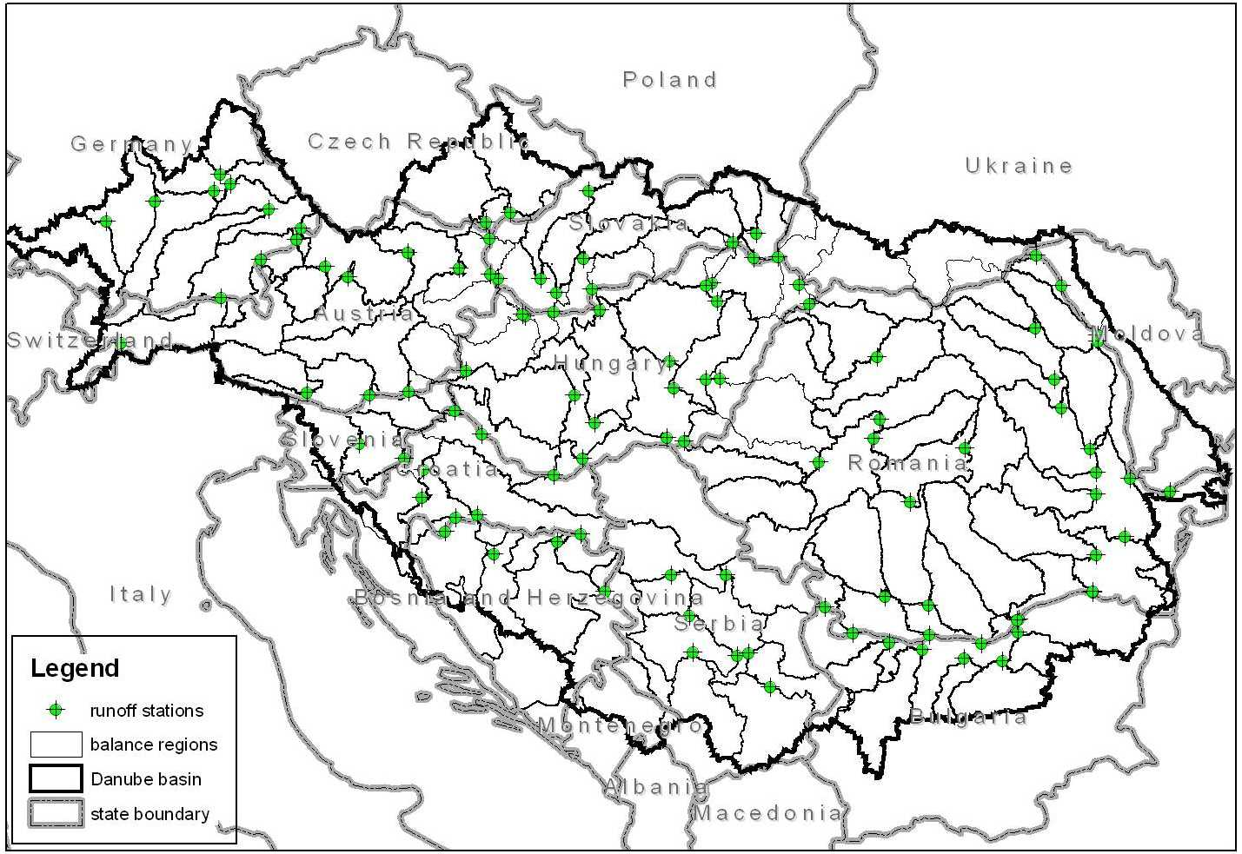
Figure 1: Danube basin balance regions and closing profiles.

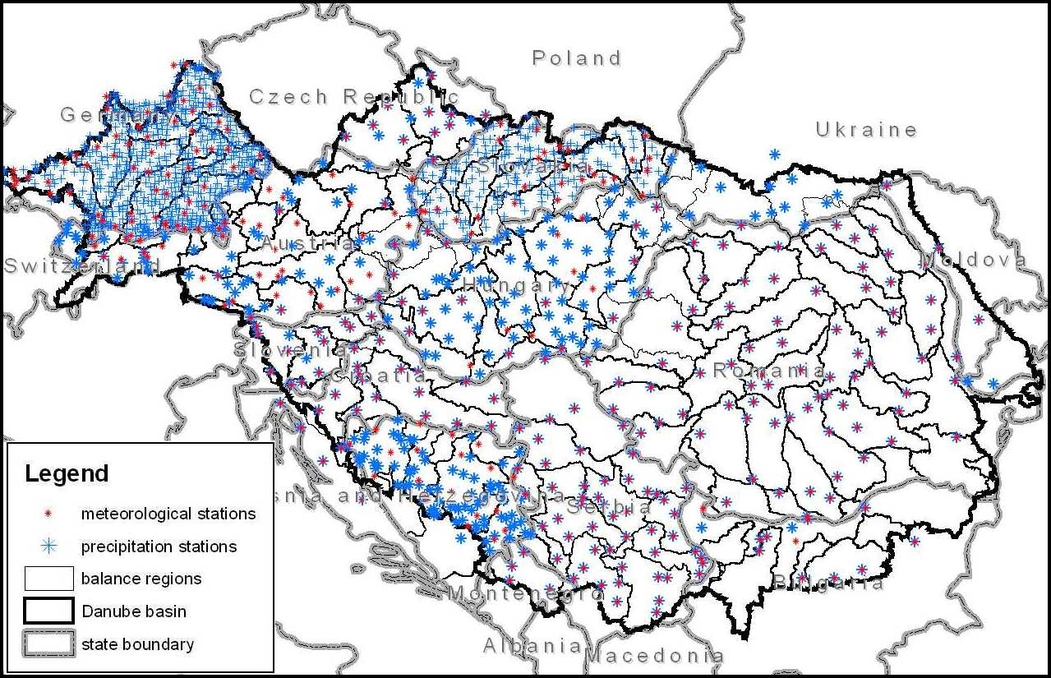
Figure 2: Danube basin balance regions and observation stations.

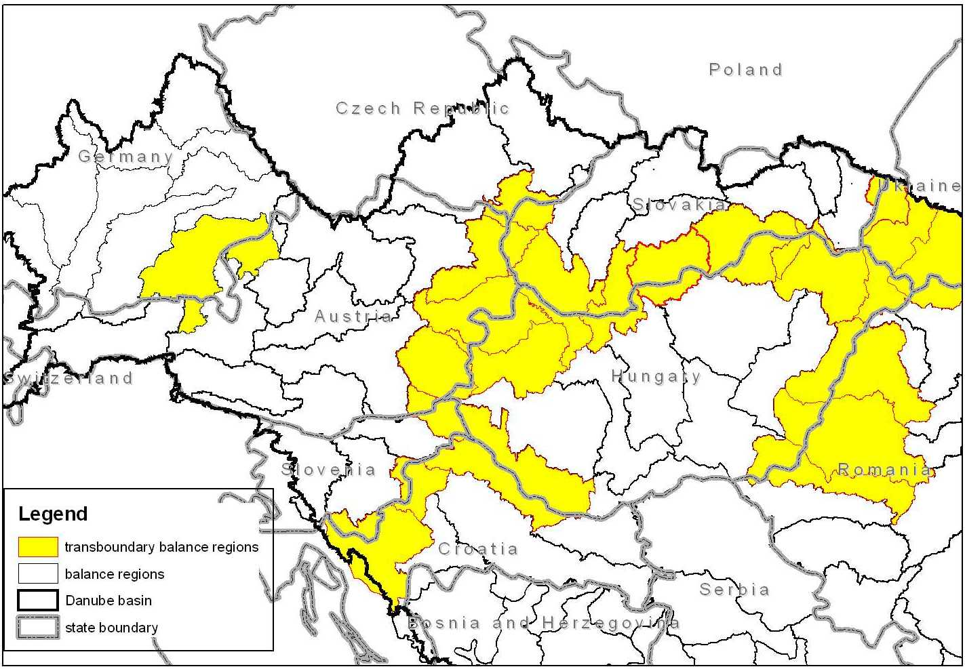
Figure 3: Unified transboundary balance regions in the upper Danube basin.

Transboundary balance regions
A specific problems occurred in delineation of balance regions which cross the national boundaries. In many cases bilateral and multilateral co-operation of neighbouring countries was necessary.
Linking water divides across state borders expected the neighbouring countries to "meet" with the water dividing lines from both sides of the border at a common point.
Discrepancies of boundary water divides had to be solved in such cases when the resulting balance region formed a region on the boundary between two or more countries.
Unifying transboundary balance regions into single polygons is the result of these bilateral/multilateral agreements of neighbouring countries (Fig.3).

- Conclusions

Presented paper is giving an overview on the state of the art in the “Basin-Wide Water Balance Estimation of the Danube River Basin” Project solution, which is a part of the IHP UNESCO co-operation programme in the Danube River basin and it is also in focus of interest of the ICPDR [6].
Water balance is one of topics, which should be included into the European Space decision support system with respect to the Water Framework Directive [2] and with respect to the expected studies related to different impact evaluation (climate change; global man made change - different than increase of greenhouse gases concentration; optional land use management, e.t.c.).
This project is giving the first step for an approach in estimation of water districts in sense of the Water Framework directive.
Further studies, which could include also the remote sensing technology – not only in estimation of the land cover characteristics, but also in e.g. the vegetative index distribution – could help in the decision support system in the basin – wide water management and flood protection measures proposals.
Finally the top present technology, like radar screening, could help in the subsoil water content estimation and further more precise tuning of yearly course of the water balance especially form the point of view of areal evapotranspiration.
Further co-operation and including of the remote sensing technology into hydrological research within the basin-wide hydrological studies seems to be unconditionally needed.

- Acknowledgements

Contribution of participating countries to this IHP Project was performed via the NC’s for IHP UNESCO of Danube countries.

Meteorological data for the upper Inn at the Swiss territory were granted by the Federal Office of Meteorology and Climatology (MeteoSwiss).

International portion of work related to the co-ordination of the Project and to the cost of expert meetings is supported by the UNESCO Regional Bureau for Science in Europe (ROSTE) under the contract No. 875.804.3.

In some countries, like Ukraine, Moldova, Romania, Serbia-Montenegro and Bosnia-Herzegovina certain additional financial assistance by UVO ROSTE was necessary with respect to the state of the art in the GIS and hydrometeorological data banks in particular countries.

International coordination is managed by Slovakia and work of the co-ordination team is financially supported by Science and Technology Assistance Agency under the contract No. APVT-99-18202

Last but not least authors would like to thank for getting a possibility to work also with the European Catchments data processed by the R. Hiederer, in IES, JRC, TP 262, 21020 Ispra (Italy) and to thank for the agreement obtained from the USGS to use their USHYDRO1k data for Europe.

- References

- Hydrology of the River Danube. (Chairmen of the Author’s team: Ing. Andrej Stancik, CSc., Prof. Dr. Slavoljub Jovanovic) Priroda Bratislava, 1998.

- Directive 2000/60/EC of the European Parliement and of the Council of 23 October 2000 establishing a framework for Community action in the field of water policy. Official Journal of the European Comminities L 327 (22. 12. 2000).

- Yates D. (1994a): WatBal - An Integrated Water Balance Model of River Basin Runoff. IIASA WP-94-64.

- Yates D., Strzepek K. (1994b): Comparison of Models for Climate Change Assessment of River Basin Runoff. IIASA WP-94-45, July 1994.

- Petrovic P.: The Danube Basin Water Balance – case study: The Nitra River Basin. The XXIst Danube Conference in Bucharest, 2002.

- Joint Action Programme for the Danube River Basin. ICPDR Document: IC/046 Version: FINAL - rev-1 Date of preparation: 30-JAN-01 Date of approval: 30-JAN-01
http://www.icpdr.org/pls/danubis/docs/FOLDER/HOME/ICPDR/JAP/JAP_2001.pdfor free approach via URL http://www.icpdr.org/pls/danubis/danubis_db.dyn_navigator.show

