DANUBE RIVER FLOODS in AUSTRIA
Comparison of the greatest occurrences

K.Wachter

Abstract
Flood occurrences on the Austrian Danube are caused by the flood discharges of the main tributaries and the coincidence of the flood peaks. Extreme Danube floods occur mainly in the summer when the precipitation as rainfall covers the entire catchments. The reduction of the flood plains causes a speed up of the velocity of the flood wave.
A comparison of the greatest flood occurrences on the Danube in Austria between 1862 and 2002 shows the different influence of precipitation, tributaries and cut off flood plains.
Keywords
Danube River, floods, velocity of flood waves

DonauhochwÄsser in Österreich
Ein Vergleich der gröβten Ereignisse

Zusammenfassung
Für die Hochwasserentstehung an der österreichischen Donau sind die Hauptzubringer Inn und Enns maβgebend sowie das Zusammentreffen der Hochwasserspitzen. Zu Extremhochwässern kommt es dann, wenn das gesamte Donaueinzugsgebiet gleichzeitig längere Zeit überregnet wird. Die häaufigsten Donauhochwässer treten statistisch gesehen im Sommer auf. Die Verringerung des Inundationsraumes (z.B. durch Schutzdämme, Kraftwerke) bescheunigt den Hochwasserablauf.
Die über 150 Jahre lange Aufzeichnung hydrologischer Daten erlaubt einen Vergleich der gröβten Hochwasserereignisse zwischen 1862 und 2002 und zeigt den unterschiedlichen Einfluss von Niederschlag, Zubringern und Verringerung des überflutungsraumes.
Schlüsselworte
Donau, Hochwasser, Wellenablauf

1. Introduction
The Danube catchments, with an area of about 800,000 km², are shared with 18 countries. The length of the Danube River is 2850 km and is the second longest river in Europe and the 19th longest of the world.
The upper Danube basin has a catchment area of about 100,000 km². The greatest floods during the last 140 years have had an average discharge peak of about 10,000 m³/s at the gauge in Vienna, Austria. The highest flood occurrence was recorded in the year 1501 and the flood peak was estimated with about 14,000 m³/s discharge.
Hydrological data has been recorded in the Danube basin since 150 years. Therefore it is possible to attempt a comparison of the greatest flood occurrences.
The Danube River’s length in Austria is 340 km. The Danube River basin upstream from Vienna has a total area of 101,000 km². The German Danube and the main tributaries from the Alps such as the Inn River, Traun River and Enns River play an important role in causing flood occurrences in Austria. At the gauging station in Passau (on the border Germany/Austria) the sum of the catchments is already 76,000 km², split up into 50,000 km² of the German Danube and 26,000 km² of the Inn River.

2. Extreme Floods

The greatest floods on the Upper Danube in the last 150 years are reported in the years 1862, 1897, 1899, 1954, 1991 and 2002. The floods occur mainly in summer and seldom in the late winter. Late winter floods are ice-floods caused by great ice-jam (e.g. 1830 and 1862). Unusual is a Danube flood in autumn and only one is recorded on All Saint’s Day in 1787 shown by the second highest flood marks on old buildings. The highest flood level marks are from the extreme flood of the year 1501.

Unusual was also the accumulation of floods during the years 1890 - 1899. In the years 1890, 1892, 1897 and 1899 floods with a discharge peak of more than 9000 m³/s occurred. Additionally ice floods were reported in the late winter of the years 1893, 1894, 1895 and 1899. A real wet decennium - but the lowest ever recorded discharge was also in this decennium by only 392 m³/s measured at the gauge in Vienna on 9 February 1895.

In the following period between 1899 and 2002 no flood with more than 10,000 m³/s of discharge occurred in Vienna. The flood in July 1954 was a statistical 40-year flood at the gauge in Vienna, but in Passau - about 300 km upstream of Vienna, on the Austrian-German border, - it was at least a 100-year flood caused by the extreme flood peak of the Inn River. The lower flood peak of the German Danube arrived in Passau two days after the Inn peak. Existing flood level-marks in Passau show a one meter higher flood level than 1899 and also 2002.

CATCHMENTS  (basins) | AREA  (in km²) | Average rainfall  (in mm/m²)
German Danube | 50,000 | 62 | 50 | 102 | 132 | 55 | 70
Inn River | 26,000 | 100 | 142 | 192 | 160 | 130 | 100
Traun River | 4,300 | 120 | 277 | 304 | 152 | 160 | 150
Enns River | 6,000 | 200 | 233 | 284 | 94 | 165 | 240
Danube River  (upstream Vienna) | 101,000 | 65 | 112 | 152 | 130 | - | -
HHQ at Vienna (in m³/s) |  | 10,200 | 9,835 | 10,500 | 9,600 | 8760 | 10,200
Date of the peak at Vienna |  | 5 Feb | 3 Aug | 17 Sep | 14 Jul | 4 Aug | 14 Aug
Main period of rainfall |  | 30/01-2/02 heavy rain, frozen soil,  30/01-5/02 thaw | 26/07 –  31/07 | 8/09 –  14/09 | 27/06 –  5/07  and  7/07 –  11/07 | 24/06 –  28/06  and  31/07 –  3/08 | 6/08 – 8/08  and  11/08-  13/08
Years of extreme floods |  | 1862 | 1897 | 1899 | 1954 | 1991 | 2002
Table 1: Data of extreme Danube floods

3. Changing of the flood plain area

Caused by the pressure of settlements the wet lands and flood plains are becoming smaller and smaller, and also many dykes were built during recent years. For instance the flood plain of “Tullnerfeld” in Lower Austria was reduced by about 60 % between the great flood of 1954 and the floods of 1991 and 2002. In this way the run-off situation of flood occurrences have changed.
The greatest part of the inundation plain was lost due to new great hydropower plants on the Danube River in Austria, because many flood plains were cut off by dykes. In the extreme flood year 1954 no Danube hydropower plant existed on the Austrian Danube.
Now there are 10 great hydropower plants on the Austrian part of the Danube River: Jochenstein, Aschach, Ottensheim-Wilhering, Abwinden-Asten, Wallsee, Ybbs-Persenbeug, Melk, Altenwoerth, Greifenstein and Vienna-Freudenau. In the entire main channel of the Upper Danube River upstream of Vienna there are 57 weirs of hydropower plants.
Because of the changed run-off situation in the Danube River between the Slovakian-Austrian border at Hainburg/Bratislava (river-km 1884) and the German-Austrian border at Passau (river-km 2225) the velocity of the flood wave has also changed. The significant run time of the flood wave (vertex) between Passau and Hainburg has decreased after the cut off of great parts of the flood plains. The run time of the flood wave in this distance of 350 km without any weirs in the Danube River in the extreme flood occurrences 1899, 1862 and 1954 was between 83 hours and 117 hours. The run time of the flood wave with the fewer number of flood plains and construction the hydropower plants was much shorter: The highest speed of the flood wave in 1991 was only 44 hours. The flood wave on August 2002 had a run off time between Passau and Hainburg of about 56 hours but was influenced by the coincidence of Enns River flood peak (see Figure 1 below).

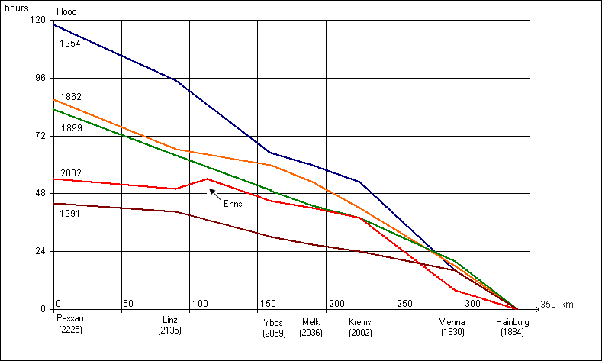
Figure 1: Comparison of the velocity of the flood waves on the Austrian Danube River

4. Danube Flood August 2002

Already at the end of March (on 20-22 of March) a HQ₁₅-flood occurred on the Austrian Danube. In the beginning of August a 3 days’ rainfall covered the entire Upper Danube catchments. The hardest rainfall was in parts of the northern edge of the Alps and in the Bohemian Highlands. Due to this precipitation some of the rivers in these regions flooded severely. Only five days later (11 – 13 August) a similar rainfall situation occurred again. The already saturated soil layers increased the run off and a 100-year flood arose in the Upper Danube.
The flood peaks of the main tributaries were:
German Danube: 3050 m³/s Inn River: 4400 m³/s
Traun River: 1400 m³/s Enns River: 3100 m³/s
Other tributaries: 1800 m³/s
The coincidence of the flood peaks of these tributaries with the Danube flood wave was not very high. The flood peak of the Inn River was mainly caused by its greatest tributary, the Salzach River. Nevertheless the flood discharge of the Danube had a peak of 11,400 m³/s at the gauge in Kienstock, Wachau, in Lower Austria.
Because of some flood plains and flood by-pass systems at the great hydropower plants, the flood peak in Vienna was about 1000 m³/s less.

Flood level 14.8.2002→

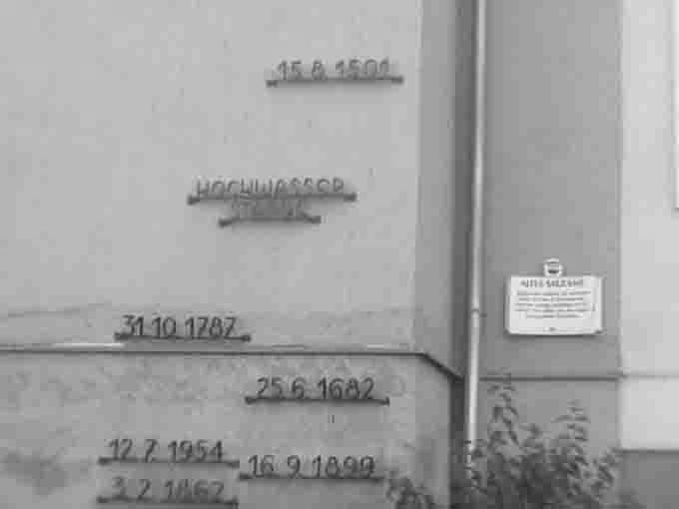
Photo1: Flood marks in Ybbs/Austria (Photo by the author)

5. Summary
Flood occurrences on the Austrian Danube depend on the flood discharges of the main tributaries and the coincidence of the flood peaks. Extreme Danube floods occur mainly in the summer time when precipitation as rainfall covers the entire catchments. The reduction of flood plains causes a speed up of the velocity of the flood wave.

6. References

Die Hochwasserkatastrophe des Jahres 1899 im österreichischen Donaugebiete. Beiträge zur Hydrogaphie Österreichs, Heft IV, Wien, 1900.
Das Hochwasser im Bayrischen Donaugebiet im Juli 1954. Besondere Mitteilungen zum Deutschen Gewässerkundlichen Jahrbuch Nr.14. Bayrische Landesstelle für Gewässer-kunde in München, 1955.
Bors, W.: Scheitellaufzeiten und Scheitelfortpflanzungsgeschwindigkeiten von Hochwässern ab 1954 im Abschnitt Ybbs-Hainburg. Unveröffentlichte Studie der Wasserstrassendirektion (WSD), Wien, 1985.
Wachter, K.J.: Donauhochwasser in Österreich/Entstehung und Ablauf. Proceedings of the International Association for Danube Research, Vienna, 1997.
Prohaska, S., D.Isailović, P.Srna and I.Marčetić, I.: Coincidence of Flood Flow of the Danube River and its Tributaries. The Danube and its Basin – A Hydrological Monograph, Follow-up volume IV, Water Research Institute Bratislava, March 2000.
Hydrographisches Jahrbuch von Österreich 2000, Band 108: Hydrographisches Zentralbüro, Wien, 2003.
Katastrophenhochwasser im August 2002 an Donau-Kamp-Krems, ÖWAV-Hochwasserseminar 11.-13. März 2003, Tagungsband, Wien, 2003.

Author:
Dr. Karl Wachter, Department of Water Management, Expert Unit,
Government of Lower-Austria, 3109 St.Pölten/Austria.

