The utility of GIS elements in water monitoring activity

Titu Bojin, Vlaicu Ionel, Diana Cristescu, Alina Blaj

Romanian Water Authority – Water Department Banat, Timisoara, Romania,
e-mail : diana.cristescu@dab.rowater.ro

Abstract: The paper presents the importance of GIS elements in the field of water management.
The paper is also a review of water monitoring activity in Romania.
Keywords: bodies water, water monitoring, Water Framework Directive

Die Verwendung der GIS-Elemente in die Wasserbeobachtungstätigkeit

Zusammenfassung: Die Arbeit zeigt die Bedeutung der Benutzung von GIS-Elemente für das Wassermanagement. Diese Arbeit macht eine Vorführung der Wasserbeobachtungstätigkeit in rumänische Gewässer.
Schlüsselworte: WasserKörper, wasser monitoring, Europäischen Wasserrahmen Richtlinie

Banat Hydrografical Area is positioned in the South West part of Romania. Occupies an area of 18.320 km² from Romania territory.
Total water resources of Banat Hydrografical Area is 1.118.350 x 10³ m³. From these, 608.350 x 10³ m³ is representative by surface water resources and 510.000 x 10³ m³ is representative by groundwater (Table 1).

Table 1. Water resources of Banat Hydrografical Area
Water resources | Source of water |  |  | Quantity  (m³)
Surface water resources | Assured in natural regime (m³) | Supplementary assured in reservoirs  (m³) | Assured by recirculation (m³) | 608.350 x 10³
Surface water resources | 313.000 x 10³ | 290.350 x 10³ | 5000 x 10³ | 608.350 x 10³
Groundwater | - | - | - | 510.000 x 10³
Total water resources | - | - | - | 1.118.350 x 10³

The network of monitoring in Banat Hydrografical Area include 30 sections of first order and 10 sections of second order (Figure 1).
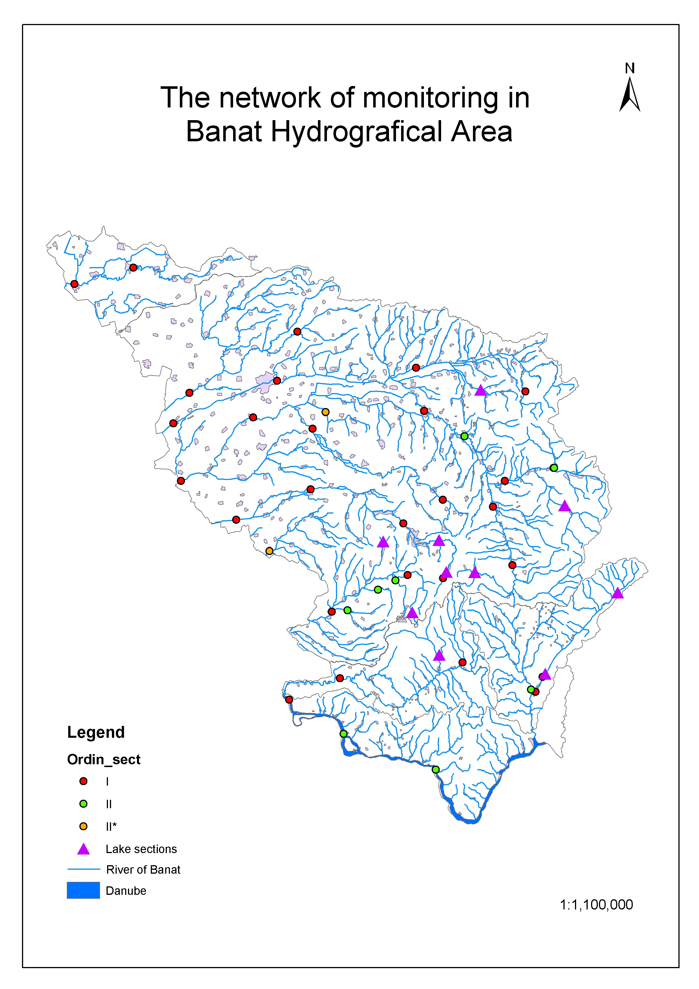 Figure 1. The network of monitoring in Banat Hydrografical Area

Supplementary it was add still 10 sections of references at monitoring network for definite the water typology.
For enable the status to be accurately described and compared to environmental objectives has been introduced the concept of “water bodies”.
Body of surface water means a discrete and significant element of surface water such as a lake, a reservoir, a stream, river or canal, a transitional water or a stretch of coastal water (Article 2.10 of Water Framework Directive).
The parameters used for identification of water bodies were:
- Discrete element – for a surface water body to be a discrete element of surface water, they must not overlap with each other or be composed of elements of surface water that are not contiguous.
- Surface water categories - a surface water body must not be split between different surface water categories, it must be of one category.
- Typology - a surface water body must not cross the boundaries between surface water body types. It must be of one or another since one purpose of characterizing surface water bodies it to differentiate them into types.
- Physical characteristics delineating discrete and and significant elements – physical features (geographical or hydromorphological) that are likely to be significant in relation to the objectives of Water Framework Directive should be used to identify discrete elements of surface water.
- Heavily modified and artificial water bodies - heavily modified water bodies may be identified and designated where good ecological status is not being achieved because of impacts on the hydromorphological characteristics of a surface water resulting from physical alterations.
The boundaries of heavily modified water bodies are primarily delineated by the extent of changes to the hydromorphological characteristics that result from physical alterations by human activity and prevent the achievement of good ecological status.
- Protected areas – this is an additional criterion for identifications of bodies water. The boundaries of water bodies and protected areas will, in most cases, not coincide because both geographical areas are being defined for different purposes on the basis of different criteria. In case a water body would not fully be inside or outside a protected area, it may be considered to sub-divide the water bodies into two parts so that the boundaries coincide.
A suggest for small elements of surface water is to:
  - Include small elements of surface water as part of a contiguous larger water body of the same surface water category and of the same type, where possible.
  - Where this is not possible, screen small elements of surface water for identification as water bodies according to their significance in the context of the Directive’s purposes and provisions (e.g. ecological importance; importance to the objectives of a protected area). In such case, small elements belonging to the same category and type, influenced by the same pressure category and level and having an influence on another well-delimited water body, may be grouped for assessment and reporting purposes.
Considered the qualitative category, the water bodies can be :
- water bodies modified qualitative;
- water bodies not modified qualitative.
Fallow this elements in Banat Hydrografical Area it was to identified next surface water bodies (Figure 2).

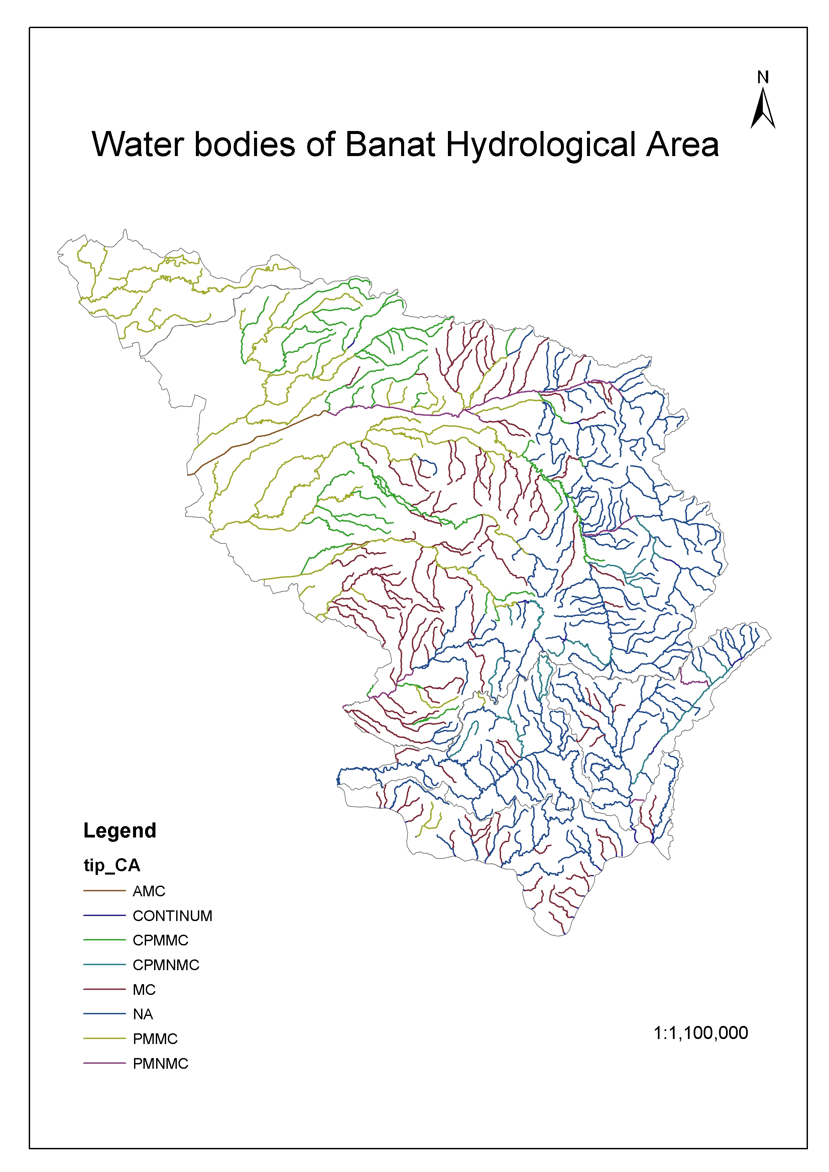
Figure 2. Water bodies of Banat Hydrografical Area

References
Common Implementation Strategy for the Water Framework Directive (2000/60/EC), Identification of water bodies, horizontal guidance, 15 January 2003
Methodology of River Management Plan - 2003
Water Framework Directive (WFD) – (2000/60/EC), 22 December 2000

