The main steps to establish the monitoring network in accordance with Water Framework Directive

Diana Cristescu¹,Alina Blaj², Stefan Cristescu³

Romanian Water Authority – Banat Water Branch Timisoara, Romania,
e-mail: ¹diana.cristescu@dab.rowater.ro; ²alina.blaj@dab.rowater.ro
³Banatul University of Timisoara, Romania, e-mail:stefan.cristescu2003@yahoo.com

Abstract: The Water Framework Directive establishes a strategic framework for managing water environment. The main scope of Water Framework Directive is the achieving of at least “good status” of all the European water courses in a certain framework of time.
The paper presents the main steps to establish the monitoring network in Romania in accordance with Water Framework Directive.
Keywords: Water Framework Directive, water typology, water monitoring

Die wichtigsten Schritte bei der Festsetzung des Beobachtungsnetzes in Übereinstimmung mit der Europäischen Wasserrahmen Richtlinie

Zusammenfassung: Die Europäischen Wasserrahmen Richtlinie bestimmt ein strategischer Arbeitsrahmen für das Wassermanagement. Der Hauptzweck des Europäischen Wasserrahmen Richtlinie ist die Erzielung, in einen bestimmten Zeitraum, eines guten Zustandes in alle europäische Gewässer.
Schlüsselworte: Europäischen Wasserrahmen Richtlinie, Wassertypologie, Wasserbeobachtung

The Water Framework Directive establishing a framework for community action in the field of water policy.
It is a comprehensive piece of legislation that sets out, inter alia, clear quality objectives for all waters in Europe.
The Banat Water Branch is placed in the south-west of Romania, occupy about 7,7% of territory and the total length of water courses is 6,296 km. Is positioned in the South West part of Romania; in South and West is limited by the Serbia-Montenegro border and in North-West by the Hungarian border (Figure 1).

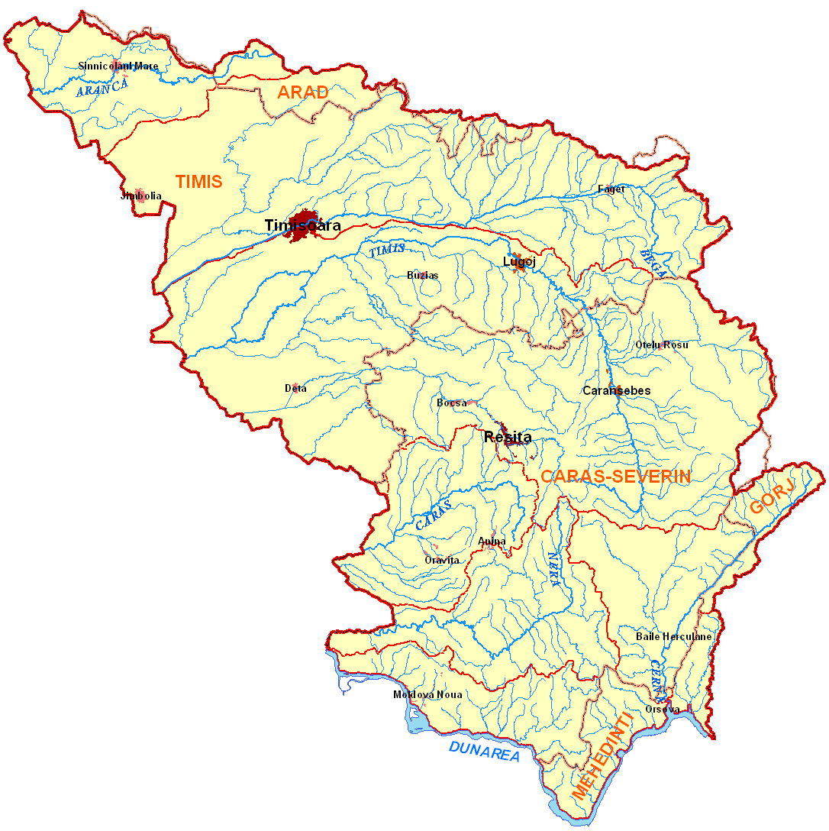
Serbia-Montenegro Republic
Hungary
Figure 1. BANAT WATER BRANCH

To establish the monitoring network in Banat Hydrological Area was identified the typology of rivers.
The parameters used for identification of river’s typology were:
- ecoregion;
- catchments area km²;
- geology;
- lithological structure;
- slope ‰;
- altitude mdBS;
- precipitations mm/an;
- temperature ⁰C ;
- q l/s/km²;
- q_{95%} l/s/km²;
- fish zoning.
On the first phase it was identified the typology of the streams with catchments area larger than 4000 km².
In Banat Hydrological Area are 2 streams with catchments area larger than 4000 km²: Bega and Timis (Figure 2).

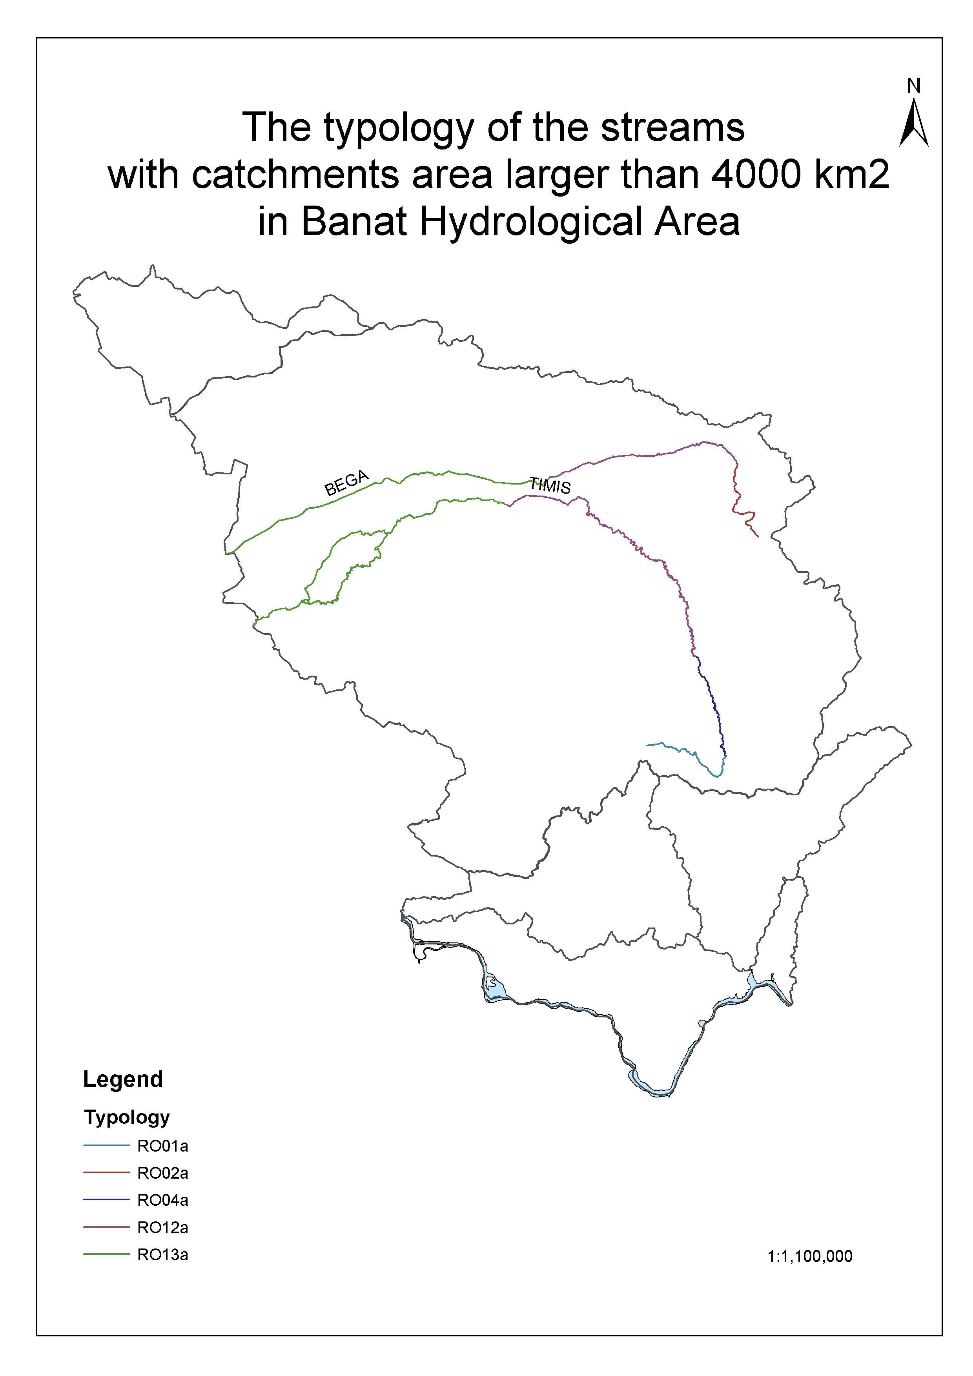
Figure 2. Typology of Banat`s rivers

The second phase it was to identified the typology by all rivers of Banat Hydrological Area.
In Banat Hydrological Area it was identified 12 tipes and 19 sub-tipes of water (Figure 3)
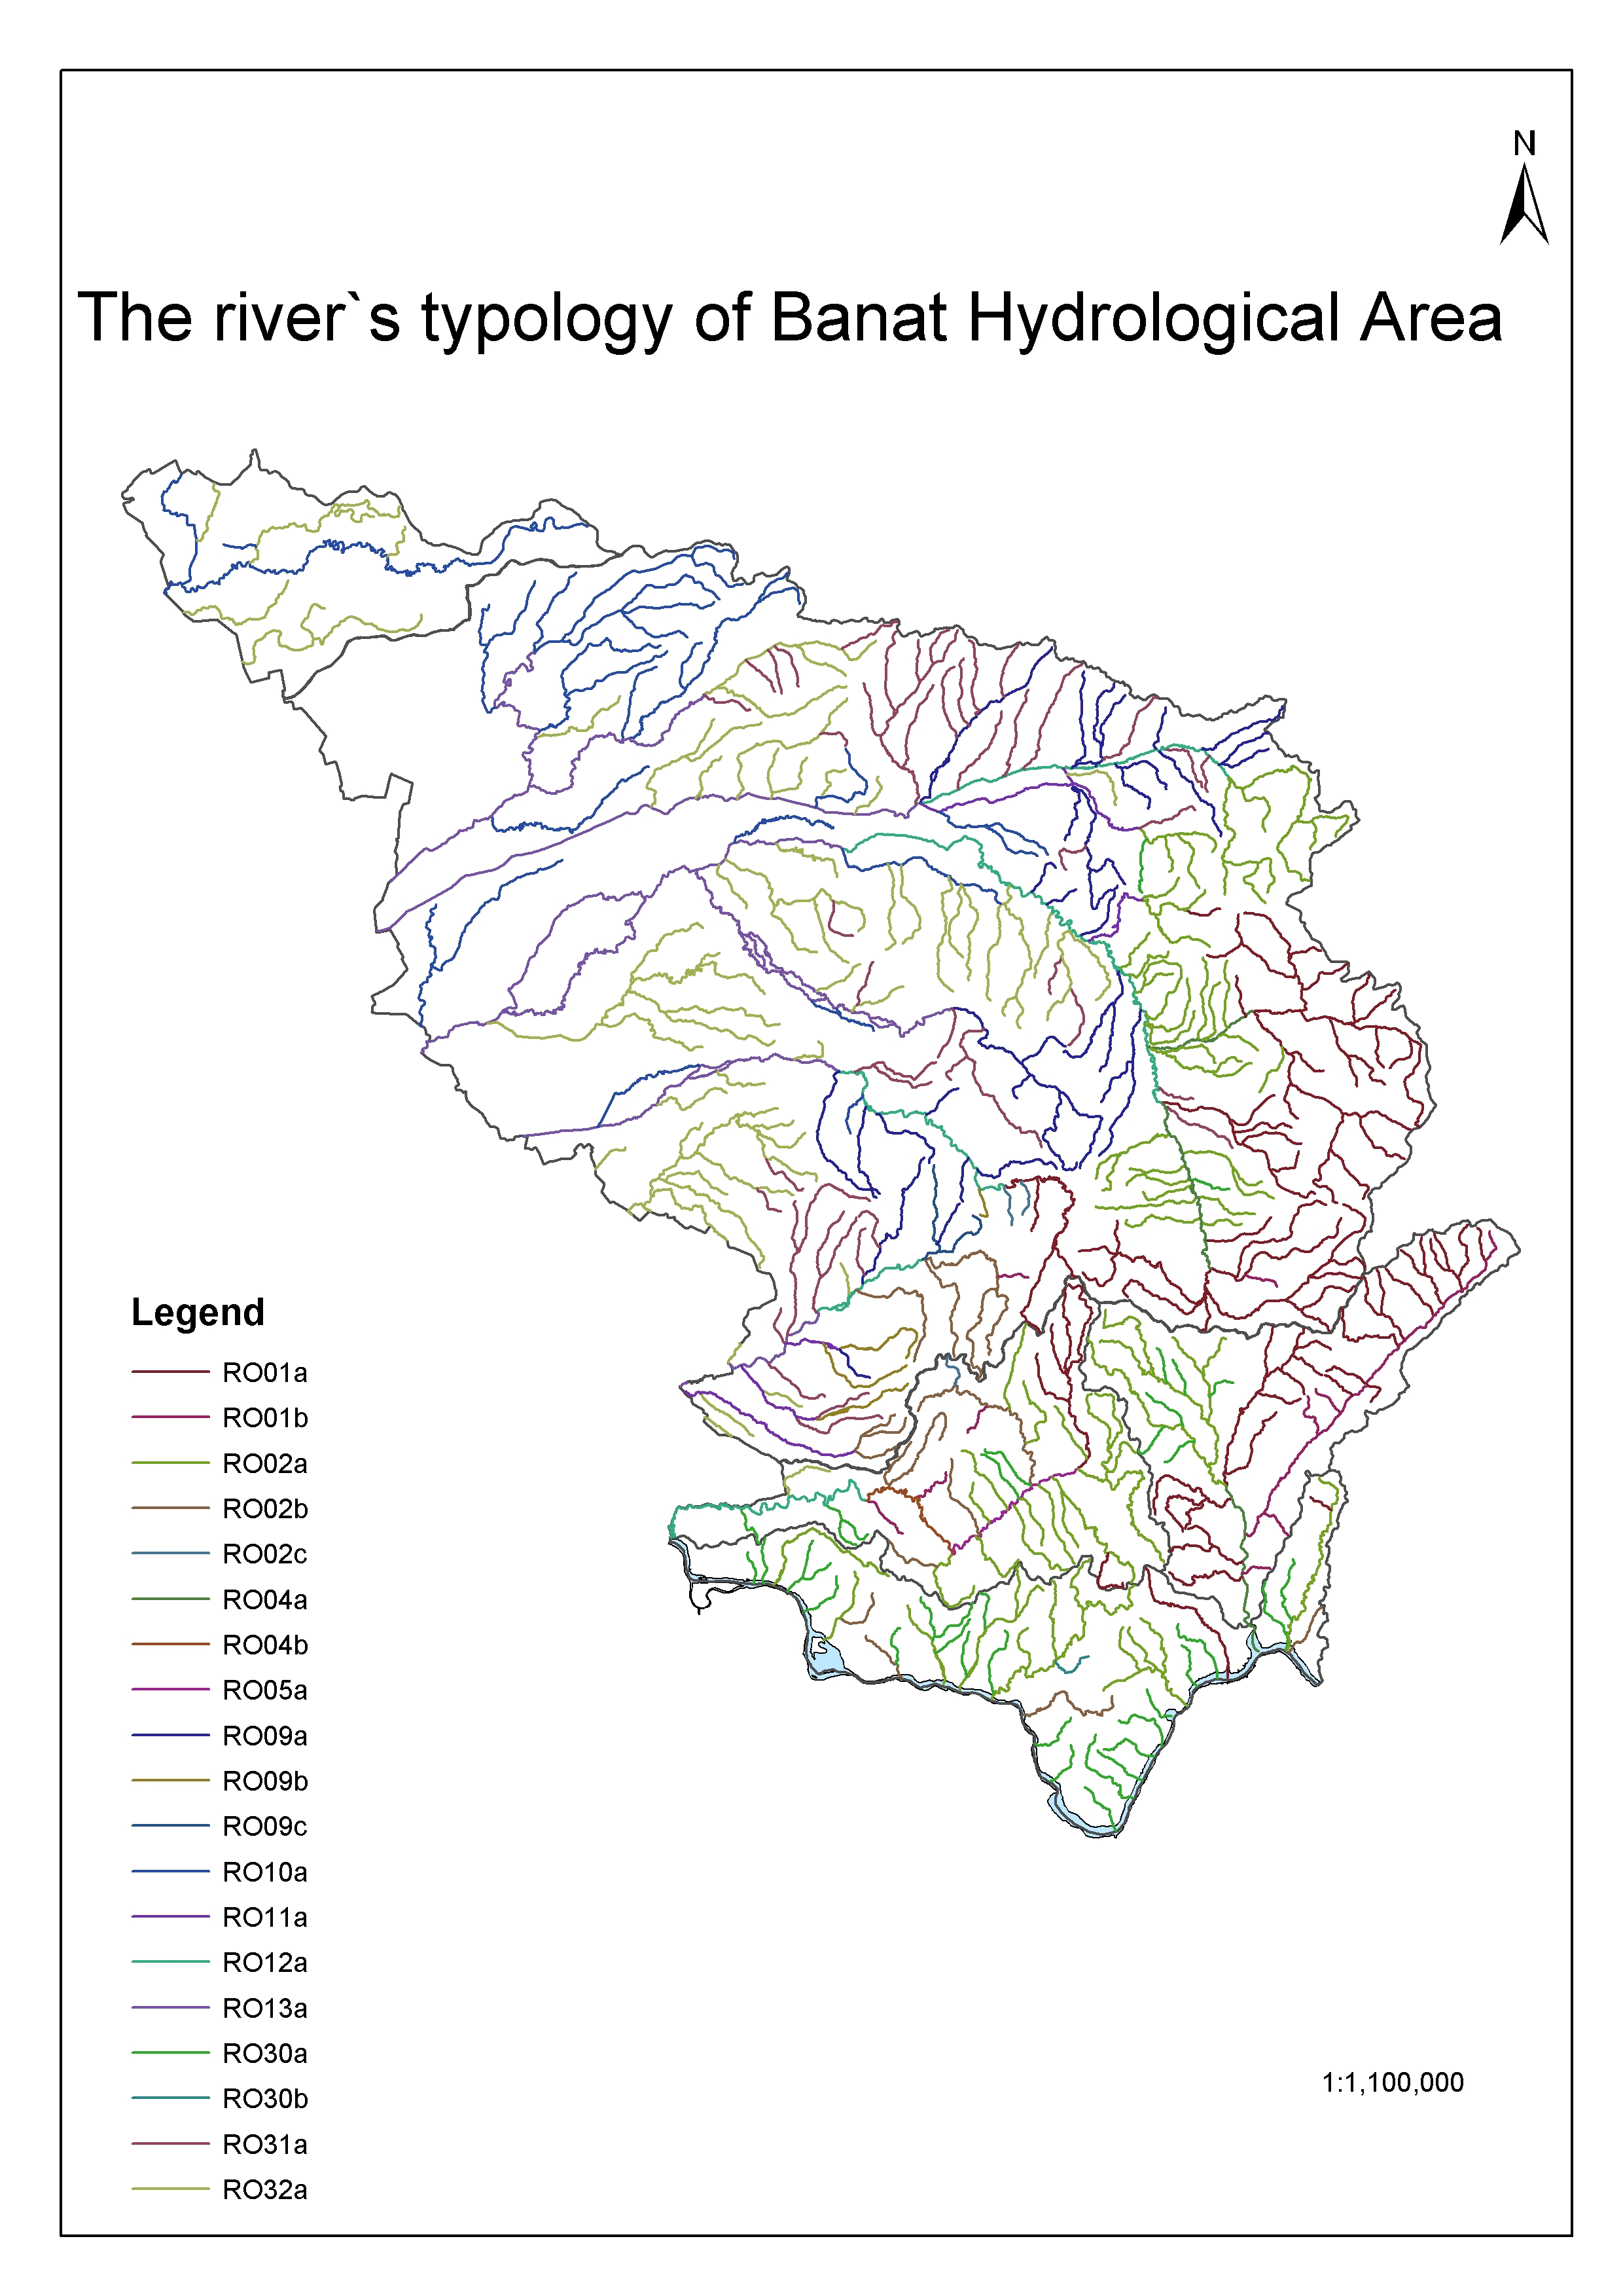
Figure 3. Typology of Banat`s rivers

The network monitoring it must contain sections of monitoring for all types of river.
When the identification of typology it was finished, we must add still 10 sections of references at our monitoring network.

References
Methodology of River Management Plan - 2003
Water Framework Directive (WFD) – (2000/60/EC), 22 December 2000

