Morphological changes of the danube river east of vienna over the last nine years

Tim Fischer-Antze, Dieter Gutknecht

Vienna University of Technology, Institute of Hydraulics, Hydrology and Water Resources Management, Vienna, Austria, e-mail: fischer@hydro.tuwien.ac.at

Abstract: The free flowing Danube reach between Vienna and the Austrian-Slovakian border has a length of 40 km. The hydro power station Freudenau is situated at the upstream end and acts as a barrier to the natural sediment transport. Historically, the Danube was a braided river, but in the 19th century river training work has led to significant changes. The flow was concentrated in a main channel and branches were cut off. In the main channel an alternate bar configuration with a bar length of 3 km developed in the first 20 km. The longitudinal changes of the bars were small, although significant changes occurred in the lateral direction. The enhanced forces on the river bed in the main channel lead to progressive bed erosion, documented by regular annual bed measurements with a profile distance of 100 m. An analysis of the surveys suggests that, on average, the erosion rate was 2.3 cm per year.
Keywords: free flowing reach, alternate bars, progressive bed erosion

sohlmorphologische veränderungen der donau östlich von wien in den letzten neun jahren

Zusammenfassung: Der 40 km lange Donauabschnitt zwischen Wien und der Staatsgrenze zur Slowakei ist eine von zwei verbliebenen freien Fließstrecken in Österreich. Am oberstromigen Ende befindet sich das Kraftwerk Freudenau, das einen Geschieberückhalt bewirkt. Der historisch verzweigte Flusslauf wurde durch umfassende Regulierungsmaßnahmen in der zweiten Hälfte des 19. Jahrhunderts signifikant verändert. Es wurde eine Abflusskonzentration in ein Hauptgerinne durch die Abtrennung von Seitengerinnen erzwungen. Im Hauptkanal haben sich alternierende Bankstrukturen mit einer Banklänge von 3 km überwiegend im ersten 20 km langen Abschnitt ausgebildet. Die Änderungen der Bänke in Längsrichtung sind klein, wohingegen in der Querrichtung signifikante Sohlveränderungen stattfinden. Der erhöhte Sohlangriff im Hauptgerinne bewirkt eine fortschreitende Sohlerosion, die durch regelmäßige jährliche Sohlgrundvermessungen dokumentiert wird. Es liegen Messprofile der letzten neun Jahre vor, die in 100 m Abständen aufgenommen wurden. Sie zeigen beim Vergleich miteinander die Dynamik der Flusssohle auf, die sich im Mittel um 2,3 cm pro Jahr eingetieft hat.
Schlüsselworte: freie Fließstrecke, alternierende Bänke, fortschreitende Sohlerosion

1. Introduction
The Danube river between Vienna and the Austrian-Slovakian border has a length of 40 km and is one of two remaining free flowing reaches in Austria. The mean bed slope in this reach is on the order of 40 cm/km, the mean discharge is 1915 m³/s and the mean grain diameter of the bed material is 26 mm (Zottl and Erber 1987), (Stiefelmeyer 2001).
The Danube in its original stage was dominated by alternating incised valley and wide basin formations. Within the basin formation, the Danube was a braided stream with vegetated islands. The river used to be in a stage of dynamic equilibrium (Schmautz et al. 2002). For navigation purposes, groynes and spur dikes were constructed (Klasz 2002). At the upstream end, the hydro power station Freudenau is situated. It acts as a barrier to the sediment transport and hence disturbs the natural sediment dynamics. The reach is significantly influenced by river engineering works. In the second half of the 19th century the discharge was concentrated in the main channel. Branches were cut off and banks were secured by riprap to prevent side erosion.
The morphology of a natural river is usually strongly influenced by the hydrological and granulometric situation. According to the ratios of width to depth and depth to mean grain diameter, the reach can be assigned to the class of alternate bars (Yalin and da Silva 2001). In the part of the river with minor river training works, mainly over the first 20 km, the formation of alternate bars can be observed.
The river training measures and the construction of hydro power plants has led to progressive bed erosion in the free flowing study reach. An encroaching measure is now under way. The operator of the hydro power station is required to add grain material regularly on the first 10 km to compensate for the lack of sediments that are retained by the upstream dam. Critical regions with low water depths are regularly dredged. Despite regular sediment dumpings, the bed erosion at the study reach does not come to a halt.

2. Measuring and processing technique
The operator of the hydro power station performs bed level measurements in one year's intervals. The measurements used in this study have been made over the period from 1994 to 2003. By comparing the bed measurements, the bed development can be analysed.
The bed levels are recorded by a surveying boat that navigates along pre-determined cross-sectional profile lines with a longitudinal distance of 100 m to facilitate the comparison between different measurement campaigns. Approximately 400 measured points per profile are collected. The position of the boat is determined by a differential GPS technology and the bed levels are measured by a single beam echo-sounder system in combination with water levelling.
The measured data are processed in different ways. A first analysis consisted of comparing the bed levels averaged over each profile between different surveys. The volume change is then the area change in one profile multiplied with the profile distance of 100 m. The area change is computed for the width of the channel that has been sampled in both campaigns. Shallow river reaches are not sampled and processed by this technique. Possible bed changes in shallow river reaches therefore are not considered in this study. The accumulated bed volume changes are a summary measure of the bed changes. This analysis is done for consecutive surveys and for longer periods. The thalweg development is found by plotting a map of the deepest points in every cross-sectional profile. A more detailed analysis is to plot contour maps. The bed level data are converted to depth below a fixed low water level and interpolated onto a 10 m x 10 m grid using a kriging algorithm. The topographical contours are plotted for two surveys. To analyse the bed changes between the two surveys, the values of the two grids are subtracted. This technique visualises the bed topography in combination with the spatial bed changes given as erosion and deposition patterns and hence demonstrates how bed structures evolve over time.
A parameter describing the shape of a profile and its deformation is introduced here as a simple measure representing the dynamics of the river bed. The parameter is the ratio of the river width at the low water level and the depth measured from the water level to the lowest point (thalweg) of a profile.
Furthermore, the correlation between the accumulated bed volume changes and the associated water volumes is examined. The bed changes are adjusted by the amounts of sediment dumpings performed by the operator of the hydro power plant. The total water volume and the water volume exceeding a discharge threshold is computed from the hydrographs.

3. Results
The results of the analysis of the measured bed levels show how the Danube river reach has changed over the study period of nine years. A profile averaged analysis of the bed volume changes is provided by analysing the accumulated bed changes. The accumulated bed changes for all consecutive bed surveys are depicted in figure 1. The trend of a successive bed erosion is evident from the figure. The negative gradients, which occur for most of the periods indicate that most of the study reach is exposed to continuous erosion processes. The total erosion volumes range from 150,000 to 600,000 m³ per period. An exception is the period 1996-1997 where apparently depositions took place. This period is discussed later in this paper in more detail.

Figure 1: Accumulated volume changes of the Danube river between Vienna (km 1920) and the Austrian-Slovakian border (km 1880).

The entire observation period was divided into two sub-periods, 1994 to 1996 and 1996 to 2003. 1996 was the year when the hydropower station was constructed and the sediment dumpings started. Figure 2 shows the accumulated volume changes of these periods. The sediment dumpings of the operator of the power station obviously showed an effect since the negative bed changes per year became less obvious after 1996. The figure shows small bed changes in the most upstream 4 km reach from stream km 1920 to 1916. The chosen processing method indicates that downstream of km 1916 erosion processes occurred. The bed volume changes in this period add up to 1.5 million m³. Given the length of 40 km and assuming a mean measured channel width of approximately 250 m, results in a mean bed erosion of 15 cm. The time between 1996 and 2003 surveys was approximately 6.4 years giving a mean erosion rate of 2.3 cm per year.

Figure 2: Accumulated volume changes 1994-1996 and 1996-2003.

The significant bed changes found by the volume comparisons raise the question, how the more detailed morphology of the river bed has changed. Figure 3 shows the position of the thalweg for the years 1994, 1996 and 2003. The thalweg only changed slightly in the first 20 km. In this reach, an alternate bar configuration is apparent. The bars are partly secured by river engineering measures, groynes and spur dikes, so that bar propagation is prevented. The flow is forced into a predetermined channel, therefore only minor structural changes occur. The downstream half of the study reach shows stronger structural variations. In this reach, the alternate bar structures are not apparent anymore. Groynes were constructed in this reach over the entire study period. The main structures remain unchanged although some reaches show cross-sectional changes.

Figure 3: Thalweg position 1994, 1996 and 2003.

More detailed information of spatial bed changes is provided by analysis of the contour plots. The methodology used here allows us to detect point-wise changes within the measured reach. This is an efficient method for detecting erosion and deposition patterns to help understand the processes acting on the river bed.
In figures 4 and 5, the water depths below a constant fixed low water surface for the years 1996 and 2003 are shown for parts of the reach. These are indicators of the bed levels. The bed changes obtained by subtracting the 2003 water depths from those of 1996 are shown. Please note that bed topography information is not available for the full profile width, since the measuring boat was not able to obtain data in the shallow water regions. As indicated previously by the thalweg position, the reach shown in figures 4 and 5 is dominated by alternate bar structures with a length of approximately 3 km. Pool and shallow sequences alternate with a distinct periodicity. For navigation purposes, special attention needs to be given to the shallows which can be found here at the mean stream kms 1917.2, 1915.3, 1913.8, 1912.0, 1910.0, 1908.2, 1907,2 , 1905.3 and 1902.0. Erosion areas can be found in most of these nine shallows. In the 7 year period, significant bed erosion occurred, especially in the shallows. The most significant bed changes were found there.
The alternate bar structures are located in the regions between the shallows. Another morphological process can be found here. Bar regions tend to be exposed to erosion processes while the associated pool regions tend to be filled by bed material. These erosion and deposition patterns are present in seven out of ten bars. This process results in bar profiles that tend towards a uniform distribution, i.e., the profile develops towards a compact shape.
Both processes, the erosion of the shallows and the compact bar profiles decrease structural diversity. The erosion in the shallows are likely not only a result of natural morphodynamic processes. Regular river training works include the dredging of shallow river reaches. Strong dredging activities took place at two shallows at stream km 1913.8 and 1902.0. Here, strong bed changes are apparent which indicate that the dredging measures showed an effect. Figure 2 also suggests a stronger variation in local bed changes in the upstream 20 km compared to the downstream reach where the morphological structures are less pronounced.

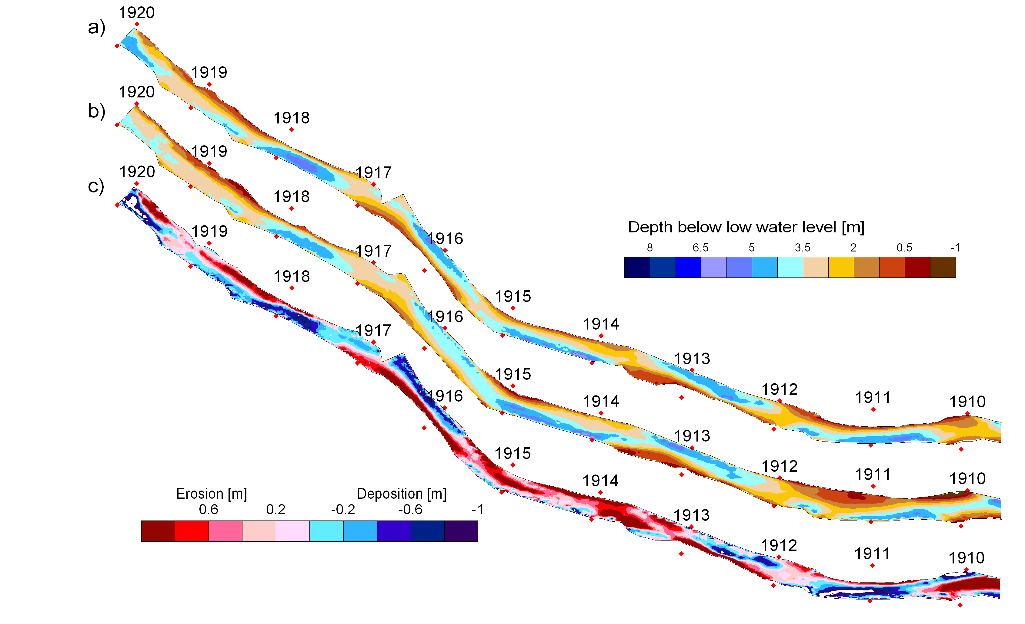
Figure 4: a) Water depths in 1996, b) water depths in 2003 and c) bed changes from 1996 to 2003 from stream-km 1920 to 1910.

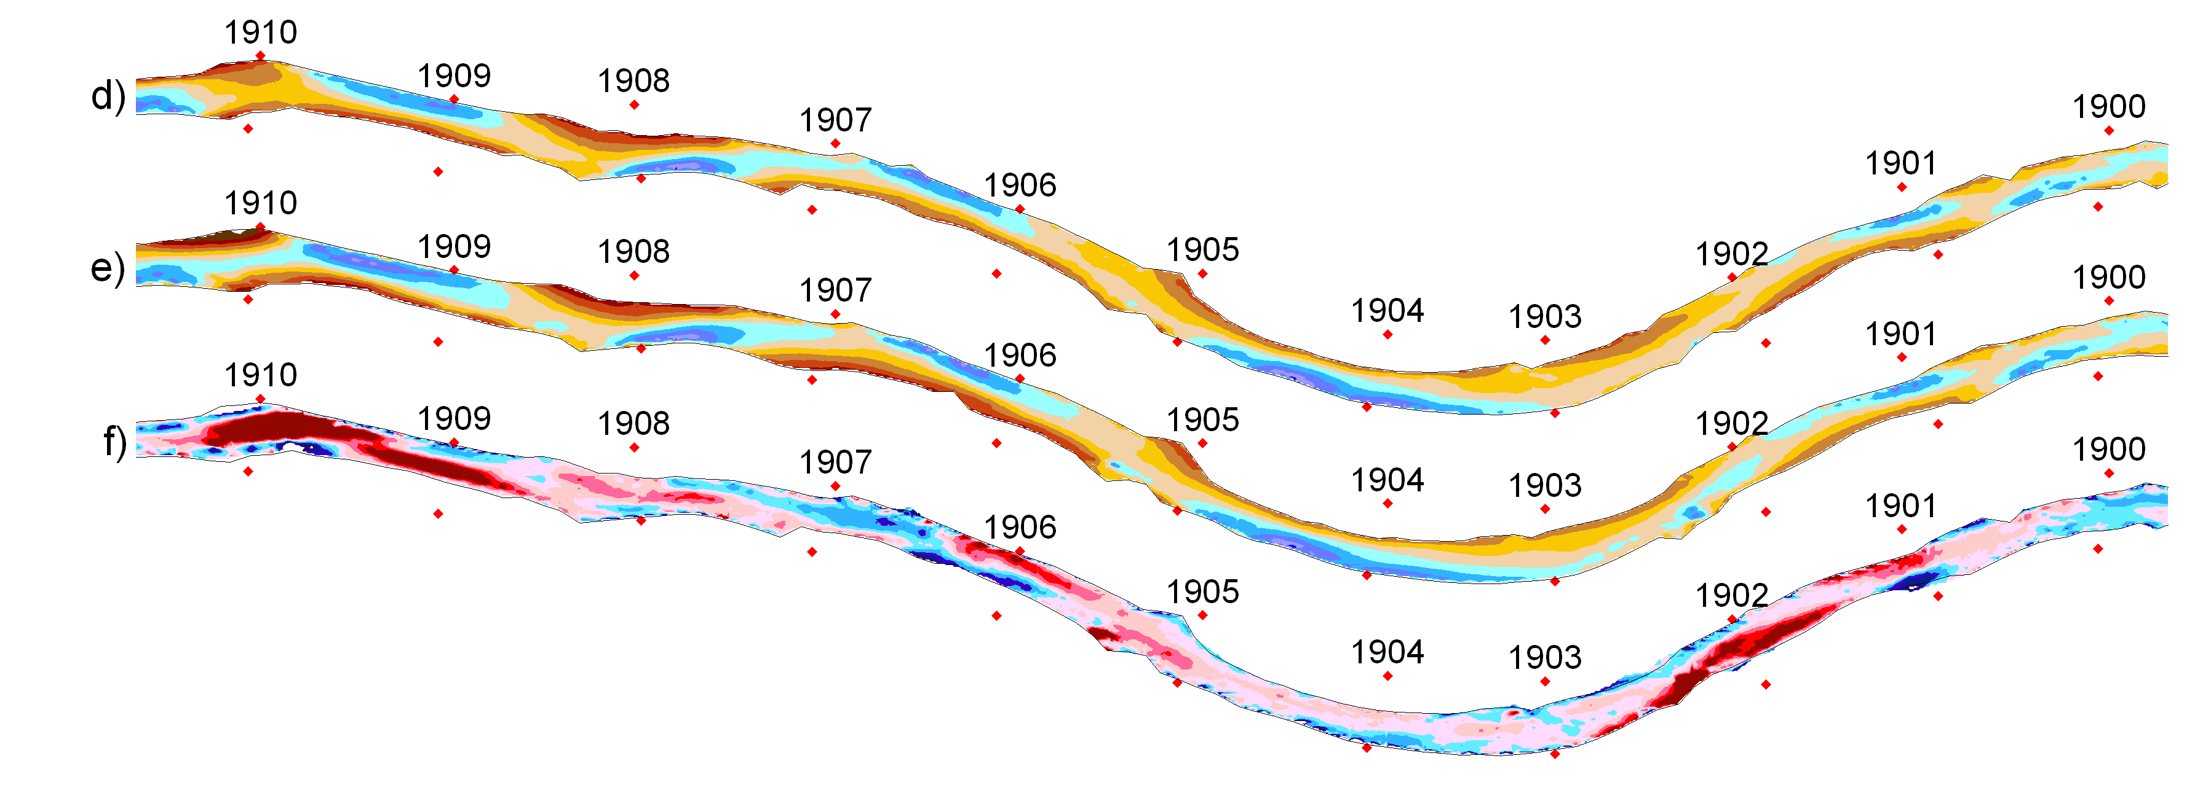
Figure 5: d) Water depths in 1996, e) water depths in 2003 and f) bed changes from 1996 to 2003 from stream-km 1910 to 1900.

The processing of the erosion/deposition patterns is quite involved, the areas of the overlapping measurements and the grids for the surveys have to be computed and the results have to be examined visually. For this study, the question arose, if it was possible to find a simple parameter representing the processes mentioned above. For clarity, figure 6 shows a schematic of the observed processes for both the bar and the shallow region. A shape parameter describing both the trend towards a compact shape for the bar profile and the erosion of the shallow profile was found to be the ratio s = B/h, where B is the profile width at a fixed low water level (LWL) and h is the water depth to the thalweg, i.e. the deepest point in the profile. An increase of s leads to a profile from 1996 to 2003 in figure 6a and a decrease leads to a profile from figure 1996 to 2003 in figure 6b.

Figure 6: Schematic of cross-sectional profiles in a bar region (a) and in a shallow region (b).

Figure 7 shows the result of the shape parameter s that was computed from stream-km 1917 to 1908, a reach with strong alternate bar configuration. The plot detects the development of typical bar and shallow regions when analysing the change of the parameter s. Reaches where the parameter increased over time (s₂₀₀₃>s₁₉₉₆) represent bar regions with a trend towards a compact shape, whereas reaches with a decreasing parameter (s₂₀₀₃<s₁₉₉₆) represent the shallow reaches. It can also be seen that the shallow at stream-km 1912.0 does not follow this trend. Here, the morphological change did not follow the mechanism shown in figure 6b. Unlike the other shallows, here, the bed change was affected by the downstream bar adjacent to this profile (see figure 4). Also, the bar downstream of km 1910 shows partly a different behaviour, since it is influenced by the erosion process of the upstream shallow. The aforementioned bar process is found further downstream of this bar.
Figure 7: Shape parameter s.

The analysed mean bed changes for the entire 40 km reach vary within quite a wide range. In most of the periods, erosion occurred (see figure 1). The sediment dumpings were not sufficient to solve the erosion problem for the entire reach. Assuming a negligible amount of sediments passing the weir at the power station, the total computed bed changes can be correlated to the hydrology for the same period. Note that the sediment dumpings for this analysis were accounted for in calculating the total bed changes resulting in bed changes that would have naturally occurred during the periods. Including the dumpings results in negative bed changes (=erosions) for all the periods, also in the period 1996-1997 that results in an accumulation period when comparing the bed levels only (see figure 1). An automatic stream gauge is located at stream-km 1895. Water stage and discharge data were recorded at 15 minutes intervals starting from 1996.
In figure 8, the water volume is plotted versus the corrected accumulated bed volume changes from 1996 to 2003. Both, the total water volume that passed the stream gauge during the measurement periods and the water volume that exceeded a discharge threshold of 3000 m³/s is depicted in the figure. A weak correlation between total water volume and bed changes can be seen with high water volumes being associated with large bed erosion. Period 2001-2003(1) does not conform to this trend which may be related to the uncertainty in the amount of sediment dumpings for this period. The relation of the bed change and the water volume in excess of a discharge threshold value was examined on the rationale that incipient sediment motion starts at the excess of a critical shear stress. For the excess volume the correlation is slightly better.
The studied Danube river reach is strongly influenced by the hydrological situation. It can be seen that high discharges with a long duration lead to significant bed erosion processes. In spite of regular river maintenance measures, a stage of dynamic equilibrium cannot be achieved for the entire reach.

Figure 8: Relationship of water volume and accumulated bed changes.

4. Conclusions
The river reach of the Austrian Danube between Vienna and the Austrian-Slovakian border is a 40 km, free flowing reach showing the formation of alternate bar structures. Due to severe river training measures in the 19th century, the reach is exposed to significant progressive erosion. In most of the periods from 1994 to 2003 erosion occurred, the mean annual erosion rate from 1996 to 2003 was 2.3 cm. When accounting for the regular maintenance measures, the calculated erosion rates are larger and all periods exhibit erosion when averaged over the entire reach. The alternate bars do not propagate in the longitudinal direction but show significant variations in the lateral direction with a trend towards a compact shape. The shallows, on the other hand, tend to be subject to significant erosion. Although the correlation between water volume and bed changes is rather weak, it is clear, that high discharges with a long duration lead to stronger erosion.

5. References
Klasz, G. 2002. Ein Beitrag zur sohlmorphologisch orientierten Untersuchung der Sohlstabilisierung der Donau zwischen Wien und Marchmündung (Vorabzug). Institut für Hydraulik, Gewässerkunde und Wasserwirtschaft, TU Wien, Wien.
Schmautz, M., M. Aufleger, and T. Strobl. 2002. Anthropogene Einflussnahme auf die Flussmorphologie der Donau in Österreich. Österr. Ing. und Arch.-Zeitschrift 147.
Stiefelmeyer, H. 2001. Dynamische Sohlstabilisierung durch Grobkornanreicherung für einen nationalparkkonformen Donauausbau zwischen Wien und Bratislava. Institut für Konstruktiven Wasserbau, Wien.
Yalin, M. S., and A. da Silva. 2001. Fluvial Processes. IAHR, Monograph.
Zottl, H., and H. Erber. 1987. Untersuchung der Sohlstabilität im Zusammenhang mit der Staustufe Wien. Auftraggeber MA 45, Wien.

