EFFECT OF EROSION CONTROL WORKS ON SOIL EROSION AND SEDIMENT TRANSPORT IN THE ALDINAČKA REKA WATERSHED

Stanimir Kostadinov and Igor Stajić

Faculty of Forestry, Belgrade University, Belgrade, Serbia and Montenegro,
e-mail: kost@EUnet.yu

Abstract:During the period from mid sixties to 1992, to protect the settlements and agricultural areas from torrential floods, large-scale erosion control works (ECWs) were undertaken in the Aldinačka Reka channel and watershed.After the erosion control works, the intensity of erosion decreased significantly. Based on field research, during the spring 2003, erosion map was produced by S.Gavrilović's method. It shows that the erosion intensity in the drainage basin ranged between weak and medium soil erosion.Before ECWs, mean annual sediment transport was 86,062.10 m³year⁻¹. After the works, mean annual sediment transport was 44,882.0 m³year⁻¹.The study results show that ECWs had a very significant effect reflected in the decrease of erosion and sediment transport intensities In order to protect the future storage from silting up, the designed ECWs should be continued.
Key words: soil erosion, erosion map, sediment transport, erosion control works, effect.

EFFEKT DER ANTIEROSIONSMAßNAHMEN AUF DIE BODENEROSION UND DEN GESCHIEBETRANSPORT IM EINZUGSGEBIET DES ALDINAČKA FLUSSES

Zusammenfassung: In der Zeit seit dem Beginn der Sechziger bis zum 1992. wurden viele Maßnahmen gegen Bodenerosion im Einzugsgebiet des Aldinačka Flusses unternommen. Somit hat die Stärke der Bodenerosion in diesem Gebiet deutlich abgenommen. Aufgrund der Untersuchungen im Gebiet während des Sommers 2003. wurde die Erosionskarte nach der Methode von S. Gavrilović erstellt. Die Erosionskarte zeigt schwache bis mittlere Stärke der Bodenerosion im untersuchten Gebiet.Vor den durchgeführten Schutzmaßnahmen gegen Bodenerosion, der mittlere jährliche Geschiebetransport lag bei 86062,10 m3. Heutzutage beträgt er 44820,00 m3. Die Ergebnisse der Untersuchungen zeigen dass die Schutzmaßnahmen haben den Geschiebetransport und die Bodenerosion allgemein stark reduziert. Die Antierosionsmaßnahmen müssen weiter durchgeführt werden, damit die künftige Wasserstauungen geschützt werden können.
Schluesselworte: Bodenerosion, Erosionskarte, Geschiebetransport, Antierosionsmaßnahmen, Effekt.

1.Introduction
Aldinačka Reka is the right tributary of the river Trgoviški Timok, its confluence is about 10 km upstream from Knjaževac. The direction of the watershed and the recipient is east–west. Its drainage basin area is 104,43 km². During the fifties and sixties of the 20th century, Aldinačka Reka was a typical torrent with very intensive water erosion processes. The consequences of erosion processes in the watershed were frequent torrential floods causing huge damage to the villages, agricultural areas and the regional road Knjaževac–Kalna–Pirot, as well as the transport of vast amounts of sediment into Trgoviški Timok.
For this reason, during the sixties and till to 1992, large-scale erosion control works (ECWs) were performed in the Aldinačka Reka watershed contributing to the reduction of erosion intensity in the watershed and to the reduction of sediment transport.
According to Water Management Plan of Serbia in 1996, the dam and storage "Žukovac" were planned on Aldinačka Reka, as a source of water supply of the town Knjaževac and the surrounding villages.
In this aim, during 2003, the state of erosion in the Aldinačka Reka watershed was researched, as well as the effects of previously performed erosion control works.The results of the research are presented in this paper.

2.Study Area And Research Methods

2.1.Study Area
Aldinačka Reka is one of the largest tributaries of the river Trgoviški Timok. The Trgoviški Timok watershed is situated in east Serbia on the territory of the municipalities Knjaževac and Pirot (Fig.1). At Knjaževac, Trgoviški Timok joins Svrljiški Timok and makes Beli Timok river.
The source of the Aldinačka Reka is on the slopes of the mountain Stara Planina, where its divide forms the boundary with Bulgaria. The villages in the watershed are: Aldinac, Balinac, Drvnik, Dejanovca, Staro Korito, Gradište, Kanjalica, Gornja Sokolovica and Žukovac (about 4.0 km upstream of the confluence in Trgoviški Timok). Downstream from Žukovac, Aldinačka Reka is named Žukovska Reka. Aldinačka Reka is formed after the Leva Reka and Šipkova Reka join at the village Aldinac. The watershed has a longitudinal form and belongs to the slopes of Stara Planina. The terrain is dissected, and Aldinačka Reka receives a series of smaller tributaries and several larger tributaries. The largest right tributaries are: Balinačka Reka, Drvnička Reka, Vitonjina and Leva Reka, and the largest left tributaries are: Šipkova Reka, Zubrov Do, Dejanovačka Reka and Pričevačka Reka. The main parameters of the watershed are presented in Table 1.
The channel of Aldinačka Reka is cut to the bedrock, therefore there is no more deepening of the channel. At its confluence in the Trgoviški Timok, Aldinačka Reka forms a large debris cone. The most represented particle sizes are gravel and sand, while sediment pieces of 10 cm in diameter and larger ones are much less represented.

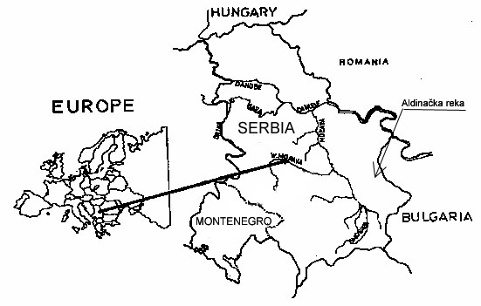
Figure 1. Study area

The parent rock in the watershed is composed of: gabbro (60%), schists (30%), and other geological formations (10%).
Depending on the bedrock, the following soil types occur in the watershed: humus-siliceous soils, acid brown soils, undeveloped soils on loose substrates, rendzinas, etc. The soils are mainly shallow, skeletal and liable to erosion.

Table 1. Parameters of the Watershed Area (Aldinačka Reka Watershed)
Parameters | Symbol | Value
Watershed area | A [km²] | 104.43
Watershed perimetre | O [km] | 53.43
Watershed length | L [km] | 23.35
Drainage density | G [km⋅km⁻²] | 2.584
Top of the watershed | Kv [a.s.l.] | 1,337.0
Mouth of the river | Ku [a.s.l.] | 248.0
Local erosion basis | Be [m] | 1,127.0
Mean elevation of the watershed area | Nsr [a.s.l.] | 687.06
Mean altitudinal difference of the watershed area | D [m] | 439.06
Mean slope of the watershed area | Isr [%] | 41.70
Stream bed slope | It [%] | 4.66

The climate characteristics are a significant factor of erosion and sediment transport, first of all rainfall and air temperature. Table 2 presents the mean annual precipitation at the raingauge stations in the region of Aldinačka Reka.

Table 2. Average Annual Precipitation
No | Meteorological station | Elevation  a.s.l. | Average annual precipitation  [mm]
1 | Knjaževac | 280.0 | 621.1
2 | Aldinac | 650.0 | 798.1
3 | Ćuštica | 600.0 | 793.3
4 | D. Kamenica | 290.0 | 645.9

The most important raingauge station is at Aldinac, situated in the watershed itself. As there were no measurements of air temperature, we have adopted the mean annual air temperature for raingauge station Knjaževac, which is 10.1°C.

2.2.Stages of research
The research includes the following stages:
- collection and study of the existing documentation on the watershed, including ECW projects, documentation of implemented ECW, data on the state of the vegetation cover , intensity of erosion processes and sediment transport before the ECW were carried out;
- survey of the type and scope of ECW and land use changes;
- collection of all the data on the watershed and channel with respect to natural characteristics, state of the vegetation cover and intensity of erosion processes after the ECW had been completed;
- calculation of sediment transport after the ECW had been completed; and
- drawing of conclusions regarding the effect of land use changing as the consequence of ECW in the watershed and the torrent bed.

2.3.Method of field research

The state of the vegetation cover (land use) in the watershed was assessed through detailed reconnaissance and production of detailed vegetation (land use) maps for both periods (before and after ECW).

The state of erosion in the watershed, both its distribution and the intensity, were determined by a detailed erosion map, produced according to Gavrilović's method (1972).. Measurements of sediment yield and transport were not made in the both periods (before and after ECW), and values for these were estimated by Gavrilović's method (Gavrilović, 1972) and Modified Polyakov-Kostadinov’s method ( Kostadinov, S.,1985, 1993,1999).

The classification of erosion processes in the watershed according to intensity was done by Gavrilović's method, which classifies the erosive regions into five intensity categories (I – excessive; II – intensive; III – medium; IV – weak; and V – very weak erosion). The quantitative expression of erosion intensity is represented by the coefficient of erosion (Z), ranging between 0.01 and 1.50.

3.Results of research

3.1.Erosion processes and sediment transport in the period before ECWs (1964)
The main characteristics of the watershed before ECW can be defined with reference to the vegetation cover (Table 3) and the distribution and intensity of erosion processes. The Aldinačka Reka watershed is situated in the region of deciduous forests and xerophyte grassland formations. Beech occupies the higher parts of the watershed, and oak and hornbeam occupy the lower parts. The accessory species are flowering ash, common maple, hazel, etc. They are mainly low and degraded forests. The conserved forests occur in the upper parts of the watershed. The dominant grass species are mat-grass and spiciform species.

Table 3. Land Use
No | Culture | 1964 |  | 2003
No | Culture | (km²) | (%) | (km²) | (%)
1 | Bare lands | 7.41 | 0.71 | – | –
2 | Forests | 28.37 | 27.17 | 47.83 | 45.79
3 | Degraded forests | 9.92 | 9.02 | – | –
4 | Meadows and pastures | 35.35 | 33.85 | 42.29 | 40.48
5 | Orchards | 1.44 | 1.38 | 3.64 | 3.48
6 | Ploughed lands | 27.38 | 26.22 | 8.98 | 8.61
7 | Mixed culture | 0.92 | 0.88 | 0.92 | 0.88
8 | Other | 0.80 | 0.77 | 0.78 | 0.76
 | Total | 104.43 | 100.00 | 104.43 | 100.00

Owing to the natural conditions of relief, parent rocks, soil types, land use and particularly due to inadequate soil management, intensive erosion dominated in the watershed.Soil erosion of different intensity attacked practically all parts of the Aldinačka Reka watershed before the erosion control works. The most widespread form was sheet erosion, or runoff erosion. Excessive erosion processes occurred mainly in the upper parts of the watershed and on the south exposures. Along with runoff, almost a half of the watershed was attacked by a dense network of gullies up to 10 m deep. The Aldinačka Reka watershed was a typical example of how very intensive erosion processes occur after the destruction of the vegetation cover.
As the consequence of erosion in the watershed, the recipient and the tributaries became typical torrents with frequent torrential floods, which caused immense damage to the villages, agricultural areas and to local and regional roads. Because of the soil loss from the slopes, arable farming was reduced, which brought even greater poverty to the already poor villages in the watershed. The distribution of erosion processes in the watershed, according to S. Gavrilović (1972), is shown in Table 4.
Sediment transport is the parameter of torrential erosion processes in the watershed. Unfortunately, the Aldinačka Reka watershed is a hydrologically unresearched watershed and there are no measured data on the discharge and sediment transport. For this reason, sediment transport was determined by empirical methods, i.e. S. Gavrilović's method and Modified method Polyakov–Kostadinov. The calculation results are shown in Table 5.
Table 4. Distribution of Erosion Progresses in the Watershed (According Gavrilović's Classification) Before and After ECW
Category | Z | 1964 |  | 2003
Category | Z | (km²) | (%) | (km²) | (%)
I Excessive erosion | 1.25 | 26.11 | 25 | – | –
II Intensive erosion | 0.85 | 25.06 | 24 | 5.74 | 5.50
III Medium erosion | 0.55 | 39.69 | 38 | 49.29 | 47.20
IV Weak erosion | 0.30 | 10.44 | 10 | 41.80 | 40.02
V Very weak erosion | 0.10 | 3.13 | 3 | 7.60 | 7.28
Total |  | 104.43 | 100 | 104.43 | 100.00
Gavrilović's erosion coefficient |  | 0.76 |  | 0.433

During the period 01.10.1955–30.09.1956, the suspended sediment transport was measured at the gauging station Baranica on the river Trgoviški Timok several kilometres downstream of the Aldinačka Reka confluence (Ristivojević, M., 1960). This gauging station controls 494.4 km² of the total area of Trgoviški Timok, including also the complete Aldinačka Reka watershed. Consequently, we can make analogies between the suspended sediment transport in the entire Trgoviški Timok watershed and in one part of the watershed covered by the Aldinačka Reka watershed.

Table 5. Calculated Average Annual Total Sediment Transport in Aldinačka Reka Watershed
Method of calculation |  | Year
 |  | 1964 | 2003
Erosion coefficient (Gavrilović) – Z |  | 0.76 | 0.433
Coefficient of erosion risk (Kostadinov) – Ke |  | 0.8699 | 0.452
Method of S. Gavrilović | Total  (m³) | 105,998.90 | 78,593.15
Method of S. Gavrilović | Specific  (m³⋅km⁻²) | 1,015.02 | 752.59
Modified Polyakov-Kostadinov's method | Total  (m³) | 86,062.10 | 44,821.80
Modified Polyakov-Kostadinov's method | Specific  (m³⋅km⁻²) | 824.11 | 429.20

As during that period only the suspended sediment was measured, bedload quantity was calculated taking into account that it represents 40% of the amount of suspended sediment. Based on the above measurements, the mean annual sediment transport in the Aldinačka Reka watershed (during that period) accounted for 81,913.30 m³⋅year¹, based on average specific annual transport of the total sediment in Trgoviški Timok, amounting to 784.39 m³⋅s⁻¹⋅km⁻² and the area of the Aldinačka Reka watershed of 104.43 km² (Table 6).

The value of the mean annual sediment transport is very close to the value of 86,062.10 m³⋅year⁻¹, calculated for the Aldinačka Reka watershed for the period before ECW (1964) according to the Modified method Poljakov–Kostadinov, so the calculation by this method can be considered as the design value for the Aldinačka Reka watershed (Table 5).

Table 6. Measurement of Suspended Sediment Transport in the River Trgoviški Timok
in the period 1.10.1955–30.09.1956
Measured and computed date | Unit | Value
Measured suspended sediment transport – S | m³ | 690,000.00
Specific suspended sediment transport – Ssp | m³⋅km⁻² | 1,395.63
Approximate total sediment transport – G=S⋅1.4 | m³ | 966,000.0
Specific total sediment transport – Gsp | m³⋅km⁻² | 1,953.88
Suspended sediment transport for average year (Trgoviški Timok watershed) | m³ | 277,000.00
Total sediment transport for average year (Trgoviški Timok watershed) 277,000.00⋅1.4 | m³ | 387,800.00
Specific total sediment transport for average year (Trgoviški Timok watershed) | m³⋅km⁻² | 784.39
Total sediment transport for average year (Aldinačka Reka watershed) 104.43⋅784.39 | m³ | 81,913.30

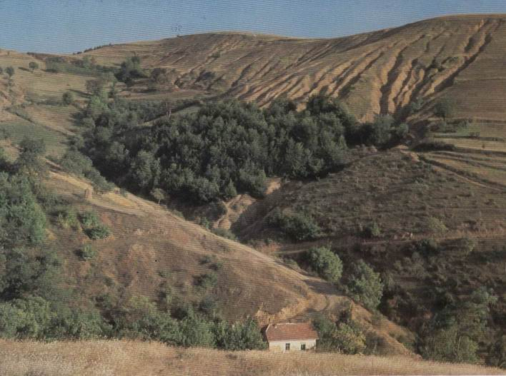

Figure 3. Sheet and gully erosion in the upper part of the watershed, before ECWs

3.2.Erosion control works (ECWs)
To control the erosion processes and torrential floods, and to reduce them to tolerant limits, large scale erosion control works were performed in the Aldinačka Reka watershed during the period 1965–1992. Along with the direct control of torrential floods, the main objective was to reduce erosion and sediment transport to the tolerant limits and to reinstate the degraded terrains in that hilly-mountainous region. Also, it was found out that the sustainable solution of water supply for the town Knjaževac and the surrounding villages, in addition to other sources, can be the construction of the storage "Žukovac" on Aldinačka Reka. The dam profile was to be about 8 km upstream of the village Žukovac. This was another reason to control erosion and torrential processes in the watershed, in order to prevent the siltation of the future storage. Table 7 presents erosion control works made in the watershed and in the hydrographic network of Aldinačka Reka.

Table 7. Erosion and Torrent Control Works
No | Type of ECW
1 | Stone masonry check dams (units) | 2
2 | Check dams of dry laid masonry (m³) | 1,200.00
3 | Horizontal walls (m') | 2,000.00
4 | Wattles (m') | 14,000.00
5 | Gradons (m') | 50,000.00
6 | Afforestation by different maner (ha) | 964.00
7 | Grassing (mixture of grasses) (ha) | 886.00

As the channel of the recipient and the main tributaries was cut into the bedrock, erosion control works were mainly directed to the works in the watershed: afforestation by various methods and grassing of the terrains endangered by erosion. As the steep slopes of the watershed were severely eroded, afforestation and grassing would not have succeeded without previous retention works (gradons, terraces, wattling, horizontal walls, etc.). These works provided a stable support to the development of the planted seedlings of Austrian pine, Scots pine, spruce and black locust, which were mainly applied in afforestation. Along with the above works, local population established orchards spontaneously on steep slopes on the former farmland.

3.3.Effects of erosion control works
The result of the performed ECWs was a considerable change of land use in the watershed (Table 3). The consequence of the changed land use was a considerable reduction of water erosion intensity on the watershed slopes and the reduction of sediment transport. Also, the consequences of the changed land use in the watershed after ECWs were the improved hydrological conditions, so the risks of torrential floods were also lowered.
There are no measured data on sediment transport after the changes in the watershed. Table 4 presents the present state of erosion in the watershed, based on erosion map designed by the method and based on S. Gavrilović's classification. Erosion map was produced in autumn 2003. As it can be seen, now the value of the coefficient of erosion is Z = 0.433, meaning that in general the prevailing processes are medium erosion, close to the limit of weak erosion.
The consequence is also the reduced sediment transport. The calculated values of sediment transport are shown in Table 5.
The works performed in the watershed and in the channel had a very positive role in reducing the intensity of erosion, sediment yield and transport, as well as in balancing the runoff regime (flood peak reduction and greater quantities of the so-called available water). What are further effects of EC works i.e. their productive results?
The newly established forest plantations are unfortunately neglected i.e. they were not tended. Namely, there were no thinning or other silvicultural measures. Now they are very dense Austrian pine plantations which do not reach the expected increment, and, on the other hand, if thinned in these conditions, they would be susceptible to windthrow and snowbreak. Consequently, further management of these lands is a serious problem. The Forest Estate Zaječar , which is within the State Enterprise «Srbijašume», is not interested in these plantations, because for the time being, they do not produce any yield, they only cause costs. The only benefit is that they successfully protect the soil against erosion and have a positive effect on the reduction of flood peaks, and on the reduction of sediment yield and transport.
The newly established grasslands were initially rather intensively utilized by the local population. As in the past decades there was an intensive migration from the villages in the watershed to Knyaževac and other towns in Serbia, only the elderly people households remained in the villages. All the economic activities stopped. The grasslands are abandoned and they are slowly invaded by weeds, producing no yield at all.

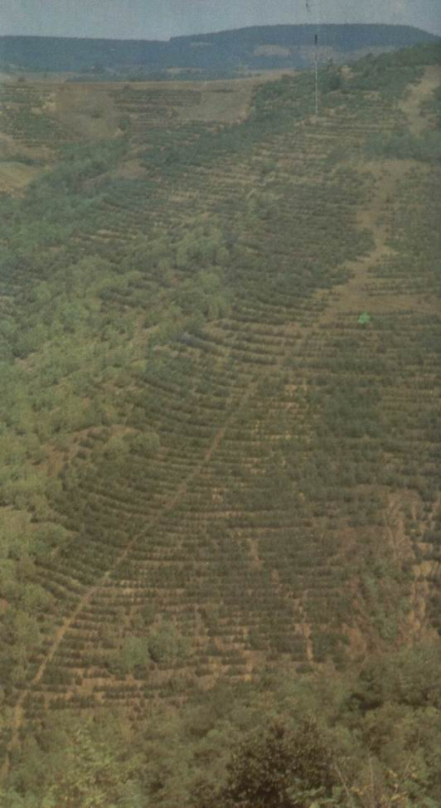

Figure 3. Afforestation of steep slope using the gradons

The newly established orchards fructified initially, but due to the absence of roads in that period and impossible marketing of the products, the orchards were abandoned. Now, they are already too old trees, which yield rarely or never. Still, taking into account that they were established on the terraces and contour ditches with the grassing of interspaces, the orchards have also contributed to the reduction of erosion intensity, sediment yield and transport and to the change of runoff regime from the slopes.
It can be concluded that erosion control works on the slopes of the Aldinačka Reka watershed have had a very positive role in the mitigating the erosion intensity and in balancing the runoff regime from the watershed. As other infrastructural conditions were not fulfilled (roads, electric power, village waterworks), the population migrated to the towns and the lands are deteriorated and do not achieve the yields which could be expected based on their potential. This was certainly contributed by the fact that the works were performed in the period when market economy was not dominant in Serbia and when public property was the main form of ownership. All the above conditioned the described progress of the situation.

4.Discussion
The research shows that, after ECW and changing of land use in the watershed, the intensity of erosion processes and sediment yield and transport were substantially reduced.Although all the designed erosion control works in the watershed and in the hydrographic network were not performed, i.e. the erosion control system was not completed, it can be stated that the ECWs had great positive effects.It should be noted that on the watershed slopes ECW were performed on about 18% of the total Aldinačka Reka watershed area, i.e. land use was changed on 18% of the watershed area. The positive effect of afforestation is confirmed by many other authors ( Douglas,I., 1996; Greer at al, 1996;Marinov,I.Ts., 1995;Nedyalkov,S., and Raev,I., 1980; Rahmanov,I., 1984; Tchagelishvili,R.G., 1977 etc)

The result of ECWs and reduced intensity of soil erosion was the reduction of sediment transport. If we adopt the Modified Poljakov–Kostadinov method as the design method for the calculation of sediment transport, we can see that mean annual transport after the performed ECWs is almost twice lower than during the period before the works (1964). This is very significant from the aspect of the protection of the future storage "Žukovac" against silting up.
The changed land use in the watershed improved the hydrological conditions in the watershed, which is reflected in the lower flood wave peak and in the absence of catastrophic torrential floods. In this way the flood hazard was reduced to a minimum. Unfortunately, the undeveloped conditions which were mainly brought about by soil erosion and torrential floods in the past, caused the intensive migration processes from the villages to the towns Knjaževac, Zaječar, Bor, Niš. For this reason, large areas of farmland and pastures are unutilised. This is good from the aspect of erosion control, but from the aspect of economy and society in general, it is not good. The problem could be solved by favourable credits offered by the State, for the development of arable farming and animal husbandry and forestry, on the principles of sustainable development.
This district has its natural potentials for the production of safe food and medicinal plants under the sustainable utilisation and improvement of natural resources. The base of such development has been made possible by the ECWs, which stopped the soil degradation. The continuation of ECWs (at the endangered sites) can lead to the dynamic development, under the selection of production programmes based on the principles of sustainable development.

As for areas affected by medium and weak erosion, which almost always occur on ploughed land (because it is on the slopes greater than 3%) and in pastures (on slopes above 10-15%), with occasional exceptions, there have not been any significant protection works. Therefore, the systems of erosion control in the study watershed have not been completed. Consequently, future efforts are required to solve this problem.

5.Conclusion
Before 1964, in the Aldinačka Reka watershed, the prevailing processes were in general the processes of intensive erosion as the result of the natural characteristics of the watershed and the inadequate land use, while the processes of excessive erosion occurred at some localities in the upper part of the watershed. The results were frequent torrential floods, which caused immense damage. Also, great quantities of sediment were transported to the lower parts of the watershed and in the Trgoviški Timok, itself.
After large-scale ECWs had been performed first of all in the Aldinačka Reka watershed, there was a significant change of land use in the watershed. This is reflected primarily in grassing and afforestation of farmland on steep slopes and its conversion into pastures or forests. Along with the works, a part of the farmland was simply abandoned, left uncultivated, because the population migrated to towns.
All the above circumstances led to a considerable decrease of the erosion intensity and sediment transport compared to the state before the ECWs.
This confirms the very positive role of erosion control works (although all the designed works have not been realised), which have created the conditions for planning the further development of the region based on the principles of sustainable development.

6.References

Douglas, I. (1996): The Impact of Land-use Changes, Especially logging, Shifting Cultivation, Mining and Urbanization Sediment Yields in Humid Tropical Southeast Asia. A review with special references to Borneo IAHS Publication No.236, Erosion and Sediment Yield: Global and Regional perspectives, Edited by D.E. Walling and B.W.Welb, Wallingford.
Gavrilović, S. (1972): Inženjering o bujičnim tokovima i eroziji (“Engeneering of torrents and erosion”). Journal Izgradnja, Spec. Edition, Belgrade, Serbia. (in Serbian)
Greer, T., Sinun, W., Douglas, I. and Bidin, K. (1996): Long Term Natural Forest Management and Land-Use Change in a Developing Tropical Catchment. IAHS Publication No.236, Erosion and Sediment Yield: Global and Regional perspectives, Edited by D.E. Walling and B.W.Welb, Wallingford, Sabah, Malesia.
Kostadinov, S. (1985): Research of Sediment Transport Regime in the Torrents of West and South-East Serbia. Doctoral Dissertation; Faculty of Forestry, Belgrade, Serbia. (in Serbian).
Kostadinov, S. (1993): Possibility of Measurements and Forecast of Sediment Transport in the Torrential Flows. In the book: “Causes and Effects of Soil Erosion and the Possibility of Erosion Control”, pp. 58-67, Faculty of Forestry, Belgrade, Serbia. (in Serbian).
Kostadinov,S., (1999): Sediment transport in the Torrents of Serbia; proceedings of Conference 30 of International Erosion Control Association, p.p. 285-294, Nashville, USA.
Marinov, I. Ts. 1995. Water-regulating and Soil-protecting Effects of Anti-erosion Coniferous Plantations. - Proceedings of the XX IUFRO World Congress, Technical Session on Natural Disasters in Mountainous Areas, August 7 - 10, Tampere, Finland.p. 209 - 216.
Nedyalkov, S., and Raev, I. (1980): Hidrološki efekti na gorskite ekosistemy. (“Hydrological Effects of the forest Ecosystems”), p.p. 1-102, Sofia. (in Bulgarian)
Rahmanov, V.V. (1984): Gidrologičeskaja rol lesov. (“Hydrological role of the forests”), Lesnaja promišlenost, Moskva (in Russian).
Ristivojević,M., (1960): Studija pronosa nanosa u slivu reke Timok ( Study of Sediment Transport in the River Timok Watershed). Journal “Saopštenja, (Announcies) No.20-21, p.p. 103-112. “Institute for water Management Jaroslav Černi“, Belgrade, Serbia.
Tchagelishvili, R.G. (1977): Sediment Transport in the Small Watersheds with Different Degrees of Forest Cover in the Mountains of Georgia, in Lesovodenie, No.5., p.p. 67-77 Tbilisi, Georgia. (in Russian)

EFFECT OF EROSION CONTROL WORKS ON SOIL EROSION AND SEDIMENT TRANSPORT IN THE ALDINAČKA REKA WATERSHED

Stanimir Kostadinov and Igor Stajić

Extended Abstract

Aldinačka Reka is the right tributary of the river Trgoviški Timok in East Serbia. Its drainage basin is 104.5 km², and all of its characteristics indicate that it is a typical torrential catchment.
After the Second World War, as the consequence of forest destruction and degradation and inadequate land management, the processes of severe and highly severe erosion (after S. Gavrilović's classification) had the coefficient of erosion Z = 0.76. The prevailing processes were sheet, rill and gully erosion.
Resulting from the intensive erosion processes in the drainage basin, Aldinačka Reka became a typical torrent with frequent torrential floods causing huge damage. During the peak floods, enormous quantities of sediment were transported.
During the period from mid fifties to 1992, to protect the settlements and agricultural areas from torrential floods, large-scale erosion control works (ECWs) were undertaken in the Aldinačka Reka channel and watershed.
The following erosion control works were performed: different methods of afforestation - 964 ha, grassing - 886.0; 15 check-dam constructed in the main stream and tributaries; dry laid masonry, etc.
After the erosion control works, the intensity of erosion decreased significantly. Based on field research, during the spring 2003, erosion map was produced by S.Gavrilović's method. It shows that the erosion intensity in the drainage basin ranged between weak and medium soil erosion.
To assess the ECW effect, sediment transport was calculated for the periods before and after the ECW. As there are no sediment transport measurement data in the drainage basin, mean annual sediment transport was assessed by S.Gavrilović's calculation methods and by the Poljakov's Modified Method. Erosion intensity before and after ECWs was defined based on erosion map made by S.Gavrilović's method.
Before ECWs, mean annual sediment transport was 135,000.0 m³year⁻¹. After the works, mean annual sediment transport was 45,000.0 m³year⁻¹.
The study results show that ECWs had a very significant effect reflected in the decrease of erosion and sediment transport intensities In order to protect the future storage from silting up, the designed ECWs should be continued.

Key words: soil erosion, erosion map, sediment transport, erosion control works, effect.

