SedImentation at small reservoires in serbia

Ratko Ristic¹, Milanko Ljujić². Zdravko Bukvić³, Vojislav Djekovic⁴

^{1,4}Department for Torrential Flows and Erosion, Forestry Faculty of Belgrade University, Belgrade, Serbia and Montenegro, e-mail: ratkor@yubc.net
²Public Enterprise "17 September", Gornji Milanovac, Serbia and Montenegro
³Galovica, Zemun, Serbia and Montenegro

Abstract:This paper presents the results of research in three experimental catchment areas in Serbia. Magnitudes of the catchments varies from A=13.4km² to A=25.4km², mean altitude from Hsr=148masl to Hsr=1280masl. Specific intensity of sedimentation amounts from qsp= 21.01 m^{3.}km⁻² yearly to qsp=92.91 m^{3.}km⁻² yearly. Reservoir Ljukovo is located in foothill (Northern Serbia) region with 50% of surface under cultivated agricultural land. Reservoir Velika Dicina (Central Serbia) is located in hilly-mountainous region with 48% of surface under forests. Reservoir Gvozdac is located in mountainous region (Central Serbia) with 96% of surface under quality beech-fir forests. Control profiles were on dams height from 7.7 to 17 meters. Volume of reservoires was measured using standard geodesy survey, echo-sounder and control cross-section profiles along the reservoires. Investigation started with forming of reservoires (1973-2000), (1966-2001), (1966-2000). Intensity of sedimentation is direct consequence of existing erosion processes and land use in catchments.
Keywords: sedimentation, small reservoires, erosion, land use

SEDIMENTATION IN KLEINE STAUSEE IN SERBIEN

Zusammenfassung: Die Ergebnisse aus drei experimentalen Wassergebeiten in Serbien sind in diesem Arbeit vorgestellt. Die Fläche von dieses experimentalen Wassergebieten unterschinden sich von A=13.4 km² bis A=25.4 km², und mittlere Höhe von Hsr=148 m bis 1280 m. Die Intensiteten des sedimentation sind von qsp=20.98 bis qsp=92.91 m^{3.}km⁻² jährlich. Der Inhalt des Tankes und niedergeschlagt Drift würden mit ehosonder gemaßt und durch benutzen des kontrol quere profilen. Die Intensität des sedimentation ist ein Konsequenz von Landbenutzen weise in Wassergebeiten.
Schlüsselworte: sedimentation, kleine stausee, erosion, die landbenutzen

1. Introduction
Territory of Serbia is very endangered by erosion processes of different categories and destructiveness on 86% of total surface (76355 km²). Annual yield of erosive material amounts to 37.25.10⁶ m³, and 9.35.10⁶ reach to the river systems. Erodible rocks cover 82.8% of Serbia territory, and 70.61% of surface is on the slopes steeper than 5% (Kostadinov, 1996). Deforested and degraded soil occupies 14010 km², equally 15.6% of Serbian territory. Favorable natural conditions for progress of erosion processes (Natural Hazard), and evident negative influence of anthropogenic factor (Manmade Hazard), has resulted in a critical state. Torrential floods are the most frequent phenomenon in the arsenal of natural disasters in Serbia. Transport of suspended and bed-load sediment in rivers, has visible dynamic effects (destructive action during torrential floods; fulfillment of useful spaces in reservoires; covering of fertile soil by sterile material). Also, it is charged by the presence of pollutants (anthropogenic and natural origin), which combine with damaged soil aggregates still in the process of erosive material production on the slopes (Foster, 1982).
Forest harvesting intensifies existing erosion processes (Macan, 1994). Even stable forest ecosystems can produce large amounts of erosive material after hard cuttings. Research, presented in this paper, concerns three small catchments, with different kinds of land use: agricultural activities; thinnings as salvage silvicultural measures; commercial cuttings. The aim of the research was to determine influence of different kinds of land use on sediment yield, in catchments with various natural characteristics. The important role of sedimentation in aquatic systems pay much attention in the last few decades from both an applied and a research point of view. Terrestrial sediments eroded from disturbed catchments are threatening small reservoires in Serbia. Presented impacts are ecological, but there may be often environmental, social or financial implications. As an example of financial impact, reservoires are filling more rapidly with mud, reducing useful space, and require dredging. Experts in the field of erosion control need to be able to asses how activities that disturb the soil are likely to impact on downstream sections.

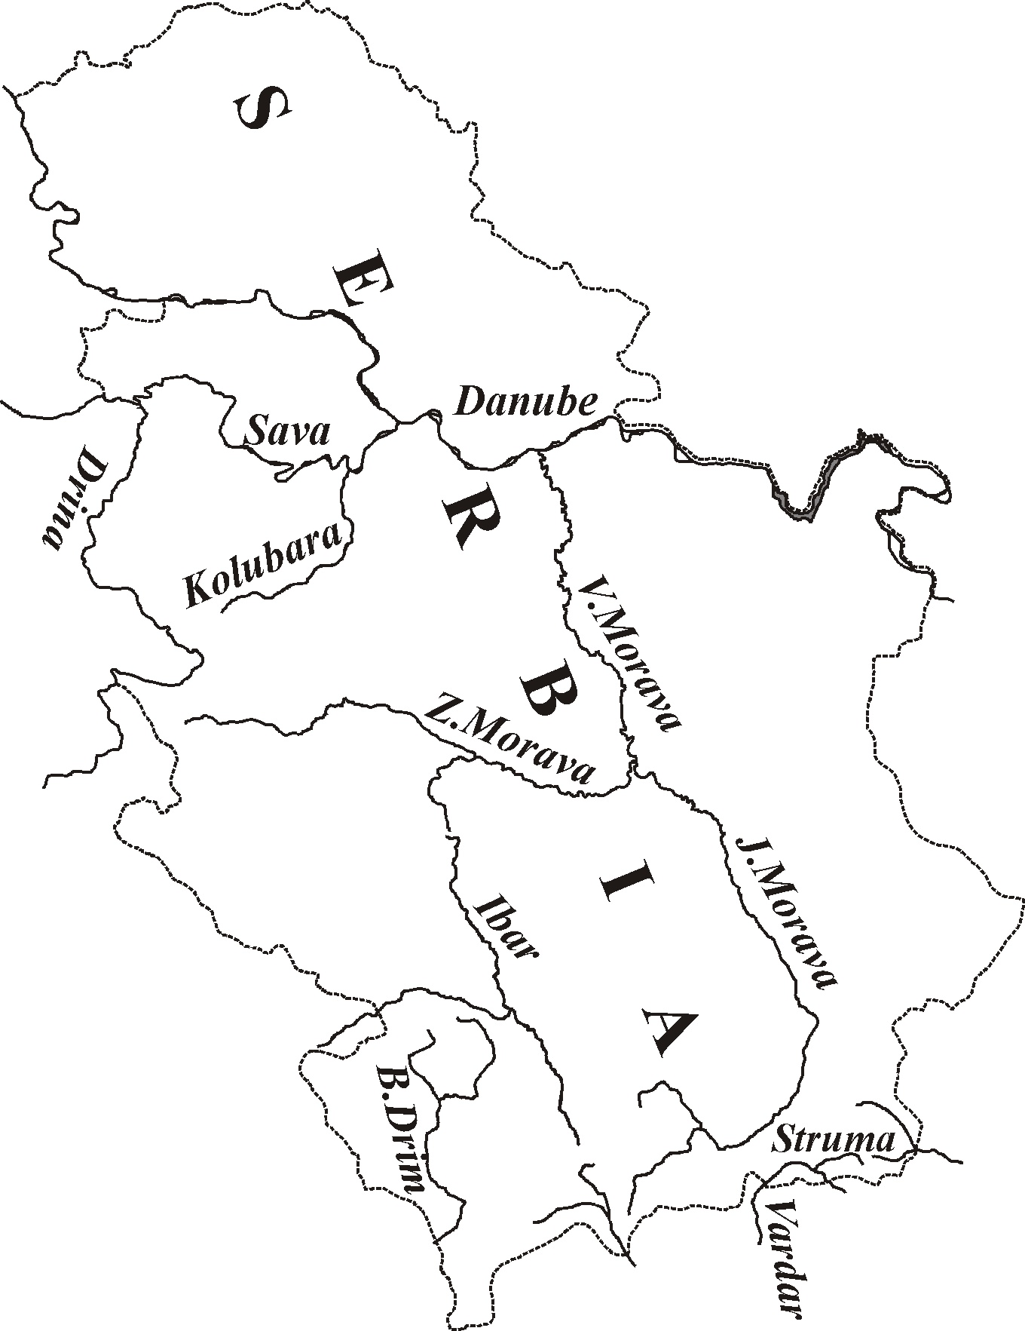
1
2
3

Figure 1-Disposition of investigated catchments

2. Site description
The catchments are located in foot-hill (1-Ljukovo), hilly-mountainous (2-Dicina), and mountainous (3-Gvozdac) regions (Figure 1). Fieldwork observations indicated that these sites were points source areas of sediment that was directly discharged into the drainage network. Nutrients, such as phosphorus, and many polutants, including heavy metals and pesticides, are transported in association with fine sediment, and deposited in reservoires. General climate and hydrographic characteristics of investigated catchments are presented in tables 1, 2.

Table 1 - Climate characteristics
Catchment area | Ljukovo | Dicina | Gvozdac
Climate | Continental,  temperate | Continental,  Mountainous type | Continnental, mountainous type
Mean annual precipitation [mm] | 680 | 890 | 1097
Pluviometric regime | Continental | Continental | Continental
Mean annual relative humidity [%] | 77 | 79 | 78
Mean annual temperature of air [ºC] | 10.9 | 9.3 | 8.9

2.1. Ljukovo
Control profile at Ljukovo catchment area is positioned on the small reservoir, formed in 1973 after building of a 7.7 m high dam (total volume of reservoir 980000 m³, useful space 930000 m³). Volume of reservoir was determined by geodesy survey, and simultaneously, control cross-section profiles were established, with distance of about 50 m along the reservoir. Final measurement were done in summer 2000, using standard geodesy methods. Structure of surfaces: forests (20%), plow fields (47%), pastures and meadows (30%), orchards (3%). Dominant type of soil is Mollic Fluvisol. Parent rock consists of loess and sandstone.

Table 2 - Hydrographic characteristics
Catchment area | Ljukovo | Dicina | Gvozdac
Magnitude [km²] | 17.53 | 25.4 | 13.4
Length [km] | 8.7 | 8.4 | 5.7
Mean width [km] | 2.01 | 3.02 | 2.35
Mean altitude [m.a.s.l.] | 148 | 700 | 1280
Drainage density [km.km⁻²] | 0.78 | 2.5 | 2.67
Peak point [m.a.s.l.] | 179 | 866 | 1430
Confluence point [m.a.s.l.] | 101 | 480 | 807
Mean slope of terrain [%] | 8 | 28.2 | 34.4
Absolute slope of river bed %] | 0.9 | 4.38 | 10.93

2.2. Dicina
Control profile at Dicina catchment area is positioned on the small reservoir, formed in 1966 after building of 17 m high dam (total volume of reservoir 343000 m³, useful space 310000 m³). Volume of reservoir was determined by geodesy survey, and simultaneously, control cross-section profiles were established, with distance of about 50 m along the reservoir. Final measurement were done in summer 2001, using standard geodesy methods. Dominant types of soil are: Humic Leptosol, Chromic Cambisol and Dystric Cambisol. Parent rock consists of marl, tuffits and porphyry breccia. Structure of surfaces: pastures 11.5%; plow fields 17%; bare lands 10%; forests 48%; meadows 13.5%.

2.3. Gvozdac
Control profile at Gvozdac catchment area is positioned on the small reservoir, formed in 1966 after building of a 12 m high dam (total volume of reservoir 60000 m³, useful space 52000 m³). Volume of reservoir was determined by geodesy survey, and simultaneously, control cross-section profiles were established, with distance of about 15 m along the reservoir. In year 2000 the reservoir was emptied for cleaning, and the final measurement was done, using standard geodesy methods. Analysis of deposited sediment (contents of heavy metals) was carried out by atomic absorption spectra-photometry (apparatus ”Varian-Spectra AA-10”).
Abieto-Fagetum association dominates (about 400 m³ of wood mass per hectare) on Dystric Cambisol (0.6-0.8 m deep), with developed humus-accumulative layer (the layer of litter is 0.1-0.12 m deep). Parent rock consists of granodiorite, andezite and phyllite with layers of marble. Degree of afforestation amounts to 96 %. There is also very dense network of forest roads (4.51 km per km²).

3. Results of investigation

3.1. Ljukovo
Reservoir Ljukovo reduced useful space for 43973 m³ (4.7% of total useful space) in period of 27 years. Bearing in mind that catchment area is object of intensive agricultural activities, specific sediment deposition of qsp=92.91 m^{3.}km⁻² yearly is under average value in Serbia of qsp=105.31 m^{3.}km⁻² yearly.
Barrier approach applied in the zones of reservoir and coarses in order to check surface runoff, removal and transport of soil particles. Grass and shrub strips in dense formations were used (contour position, grass strips 15 m wide, shrub strips 1.5 m wide). Special attention dedicated to erosive protection of pastures: soil erosion on pastures is often more intensive than on plow fields, with appearance of sheet erosion, furrows and gullies. The initial cause is degradation of the vegetation through overgrazing, which leads to removal of ground cover, leaving the soil exposed to erosion. Live fences and hedgerows used in order to prevent such phenomenon. Live fences helped to control livestock movement, hedgerows to separate surfaces for grazing, assisting rotational grazing. Also, small slope of terrain in the catchment (It=8%), and river bed (Ia=0.9%) influenced on decreased capability for transport of erosive materials. Intensity of sedimentation is illustrated on profile No. 28 (diagram 1).

3.2. Dicina
Reservoir Dicina reduced useful space for 18680 m³ (6% of total useful space) in period of 35 years. Specific sediment deposition amounts to qsp=21.01 m^{3.}km⁻² yearly. Maximal and minimal recorded concetrations of suspended material amounted to Csmax=93.7 mg.l⁻¹, and Csmin.=4.6 mg.l⁻¹. About 80% quantity of bed-load sediment was transported during the torrential flood waves, with highest recorded maximal discharge Qmax=19.8 m^{3.}s⁻¹.
Last few decades of XX century (1970-2000) were the period of intensive migration of native population, from villages to the neighboring cities (Gornji Milanovac, Cacak). It changed a traditional way of land use, and huge agricultural surfaces (plow fields, orchards, pastures) became forest. Consequently, erosion rates significantly decreased.

Diagram 1-Example for sedimentation intensity (reservoir Ljukovo)
3.3. Gvozdac
After 34 years of exploitation of forest (1966-2000), volume of reservoir Gvozdac was significantly reduced because of deposited sediment (diagram 2). Volume of reservoir was 52000 m³ (1966) and in 2000th just 10867 m³. In the same period, the water surface area was reduced from 25000 m² to 11000 m².
Commercial cuttings on the Gvozdac catchment area caused fulfillment of the reservoir. Deposition of sediment from catchment (90.28 m^{3.}km^{-2.}yr⁻¹) was consequence of commercial cuttings (1148 m^{3.}km^{-2.}yr⁻¹). Method of transport of logs, from the location of cutting to the roads (hauling tracks) influenced hard destruction of surface soil layer. Also, dense network of forest roads (4.51 km.km⁻²), with unprotected lateral slopes, was strong source of erosive material. Total volume of cut wood (period 1966-2000) amounts to 536787 m³, and volume of deposited sediment is 41133 m³ (7.7% of total volume of cut wood mass).
Cuttings caused serious forms of erosion: appearance of gullies (0.5-0.9 m deep) on the slopes where logs were transported; destruction of surface layer of soil (0.3-0.4 m deep); at places, appearance of furrows (0.1-0.15 m deep). But, vegetation covered devastated surfaces in 2-3 years, because Abieto-Fagetum association has high potential for self-regeneration. Analysis (done on 3 samples) of deposited sediment shows that it is quality substratum for nursery production:

- easy accessible phosphorus (P₂O₅>40 mg.100⁻¹ g) and potassium (K₂O>20 mg.100⁻¹ g )
- mild sour reaction pH=6.25-6.50
- total nitrogen (0.09-0.12%-medium level)
- contents of heavy metals (copper, 24-28.8 ppm.; zinc, 141-187 ppm; lead, 17-20 ppm; cadmium, 0.8-1.4 ppm; chrome, 27.2-35.8 ppm; nickel, 33.6-48.8 ppm) are under MPQ (Maximal Permitted Quantities) for soil.

5. Discussion
Catchment area of reservoir Ljukovo has more than 50% under agricultural land, with applied measures of agroforestry, so that total amount of sedimentation is very close to average value in Serbia (105.31 m^{3.}km⁻² yearly). Controlled agricultural activities produce 92.91 m^{3.}km⁻² yearly, similar to other reservoires in Serbia (point 4 on diagram 3, reservoir Topciderska with 100 m^{3.}km⁻² yearly). Uncontrolled agricultural activities can produce very high values of sediment deposition (point 5 on diagram 3, reservoir Grosnica with 900 m^{3.}km⁻² yearly). Application of agroforestry measures decreased sedimentation. Agroforestry is a collective name for land use systems in which woody perenials (trees, shrubs, etc.) are grown in association with herbaceous plants (crops, pastures) and/or livestock in a spatial arrangement, a rotation or both, and in wich there are both ecological and economic interactions between the tree and non-tree components of the system (Young, 1991).

Diagram 2-Example for sedimentation intensity (reservoir Gvozdac)
Sediment deposition on reservoir Dicina has very low values, as a consequence of: depopulation, decreased pressure on agricultural and forest land, transformation of plow fields into forest land.
Total volume of deposited sediment, at reservoir Gvozdac, decreased its useful space for 79.1 %, in period 1966-2000. This is the consequence of commercial cuttings, dense network of forest roads and unprotected lateral slopes.

6. Conclusions
This paper has examined the sediment deposition at three small reservoires in Serbia. The data analysed suggest that land use and natural characteristics of catchments exerts strong influence in the process of erosive material production on the slopes, its transport to the drainage network and sedimentation in reservoires.Sediment delivery is a major source of various ecological problems such as sediment deposition in river channels and reservoires and a aggravation of water quality.

Diagram 3-Specific intensity of sedimentation at small reservoires in Serbia

On the catchments with intensive agricultural activities application of agroforestry measures is indispensable (grass buffer strips, live fences, hedgerows), soil conservation measures on parcels with high soil loss rates, transformation of arable land to a non-erodible type of land use (forests, meadows and pastures).
Forest ecosystems are the best protection from erosion, especially in Serbia, where 86% of whole surface is endangered by erosion processes. But, it is necessary to bear in mind that forest ecosystems are very fragile, and cuttings either with commercial aspect or as salvage silvicultural measure could be the cause of serious disturbance, and consequently increment of sediment yield.
Agroforestry and soil-conservation measures, with best management practices in forestry (anti-erosive measures), have to be the framework of an integrated environmental catchment management for reducing sediment production and its deposition at reservoires.

7. References
Foster, G.R., (1982): Modeling the Erosion Process, In Haan, C.T. (ed.), Hydrologic Modeling of
Small Watersheds. ASAE, St. Joseph, USA.
Kostadinov, S., (1996): Torrential Flows and Erosion, Forestry Faculty, Belgrade,
Serbia&MonteNegro.
Macan, G., (1994): Forest Hydrology, Forestry Faculty, Belgrade, Serbia&MonteNegro.
Young, A. (1991): Agroforestry for soil conservation, CAB International, Wallingford, England.

