PRACTICAL Forecasting Method for Dilution Discharges

Dr. Andreea - Cristina Serban¹, Dr. Cristina Sorana Ionescu²

¹ECOTERRA, 48 Iancu de Hunedoara Blvd., Bucharest, Romania,
e-mail: andreserban@yahoo.com
²University “POLITEHNICA” of Bucharest, Chair of Hydraulics and Hydraulic Machinery, Bucharest, Romania, e-mail: cristina@hydrop.pub.ro

Abstract: The objective of the paper is to present a practical method that can be used to rapidly estimate dilution discharges needed to avoid pollution occurrence and its environmental impacts during dry summer periods. The forecasting method is based on the dissolved oxygen balance in water, which is controlled by air pressure and water temperature. The saturated concentration of oxygen is estimated using a multiple correlation algorithm, taking into account the following parameters: water temperature, ammonium, nitrate and organic substance concentrations. Additional water discharges needed to increase the reduced dilution capacity of the river are predicted based on dilution degree coefficients, calculated for selected characteristic cross-sections and specific concentration estimates of the water quality parameters. The practicality of the method in preventing the environmental consequences of water pollution is illustrated using as an example a pollution accident produced in Romania during the summer of 2002 on the Tarnava Mare river, which generated fish mortality.
Keywords: saturated dissolved oxygen concentration, accidental water pollution, dilution discharges, environmental impact management

PRAKTISCHE VORAUSSAGE METHODE FÜR VERDÜNNTE ABFLÜSSE

Auszug: Der Gegenstand des Artikels ist die Vorstellung einer praktischen Methode die zur schnellen Abflussverdünnungsauswertung verwendet sein kann zur Vermeiden der Verschmutzung und der Umwelteinflüsse auf die Dauer der trockenen Sommerzeiten. Die Voraussage Methode basiert sich auf dem Gleichgewicht des Sauerstoffes im Wasser, das durch den Luftdruck und Wassertemperatur gesteuert ist. Die Sättigungskonzentration von Sauerstoff ist erstellt durch einen mehrfaches Korrelationsalgorithmus, betrachtend die folgende Parameter: Wassertemperatur, Ammoniumnitrat- und organische Stoffenkonzentration, Zusätzliche Wasserabflüsse benötigt zur Erhöhung der reduzierter Verdünnungskapazität des Flusses sind aufgrund von Verdünnungsradkoeffizienten, berechnet für den ausgewählten Querschnitt und der spezifischen Konzentrationsabschätzungen für die Wasserqualitätsparameter vorausgesagt. Die Sachlichkeit der Methode zur Verhinderung der Umweltauswirkungen bei Wasserverschmutzung ist vorgestellt durch einen Beispiel eines Verunreinigungsereignis in Rumänien im Sommer 2002 auf den Tarnava Mare Fluss, der Fischsterblichkeit verursacht hat.

1. Introduction
During summer periods, characterized by low watercourse discharges, fish mortality phenomena may arise, mainly caused by decreased dissolved oxygen concentrations in water. For a particular water sector, characterized by a certain degree of historical pollution, only an increase in water temperature may produce the reduction of the dissolved oxygen concentrations in water. The decrease of the dissolved oxygen concentrations in water may as well be caused by accidental water pollution with organic substances and nitrogen.
Additional water supply should be provided to the watercourse to secure the required degree of dilution and refreshment, needed to prevent the occurrence of this phenomenon. To develop a forecasting method to estimate the dilution discharges, the balance of the dissolved oxygen in water must be analyzed. This is influenced by:
- the re-aeration capacity of the river;
- the sources to provide the oxygen;
- the sources of the oxygen consumption.
The most important sources of the oxygen in water besides the atmospheric oxygen are the oxygen provided by the aquatic flora by photosynthesis process and the oxygen of the fresh water from upstream.
Sources of oxygen consumption in water and sediments are due to carbon, nitrogen and phosphorous oxidation process as well as the aquatic flora respiratory process.

2. The assement of the disolved oxygen concentration in water
The saturated oxygen concentration in pure water is given by (***, 2002):
$\begin{aligned}\left\{C_{0}=\text{14}\text{.}\text{603}−0\text{.}\text{402}t+0\text{.}\text{00768}t^{2}−0\text{.}\text{0000692}t^{3}, \text{if} p=p_{0}=\text{1013}\text{.}\text{25} \text{mbar} | \right.\end{aligned}$ (1)
where: p₀ [mbar] is the normal atmospheric pressure, C₀ - the saturated oxygen concentration under normal pressure conditions, p_{h} [mbar] - the average atmospheric pressure corresponding to a given altitude h, C_{s} - the saturated oxygen concentration under different pressure conditions than the normal one.
The average atmospheric pressure p_{h} [mbar] corresponding to a given altitude h [m], is given by Schassmann equation:
${\text{log}}_{\text{10}}p_{h}={\text{log}}_{\text{10}}\text{1013}\text{.}\text{25}−\frac{h}{\text{18400}}$ (2)

The saturated oxygen concentration in water characterized by a certain pollution degree is computed using the recorded data during 1993-2001 (***, 1993-2001), in the main cross sections for water quality monitoring in the Târnava river, namely: Odorheiul Secuiesc, Cristuru Secuiesc, Vânărori, Upstream Mediaş, Upstream Blaj on the Târnava Mare river, Sărăţeni, Crăieşti on the Târnava Mică river (figure 1).
To derive the equation of the saturated oxygen concentration in water, a multiple correlation method was used, considering the following variables:
- water temperature;
- concentration of organic substance expressed by COD-Mn;
- concentration of ammonium NH₄⁺;
- concentration of nitrate NO₃⁻;
- concentration of nitrite NO₂⁻.
The analysis indicates that the dissolved oxygen in water significantly depends on water temperature, organic substance concentration and ammonium concentration. The correlation coefficients for the monitored cross sections of the Târnava river varied between 0.71 and 0.91 (Table 1).
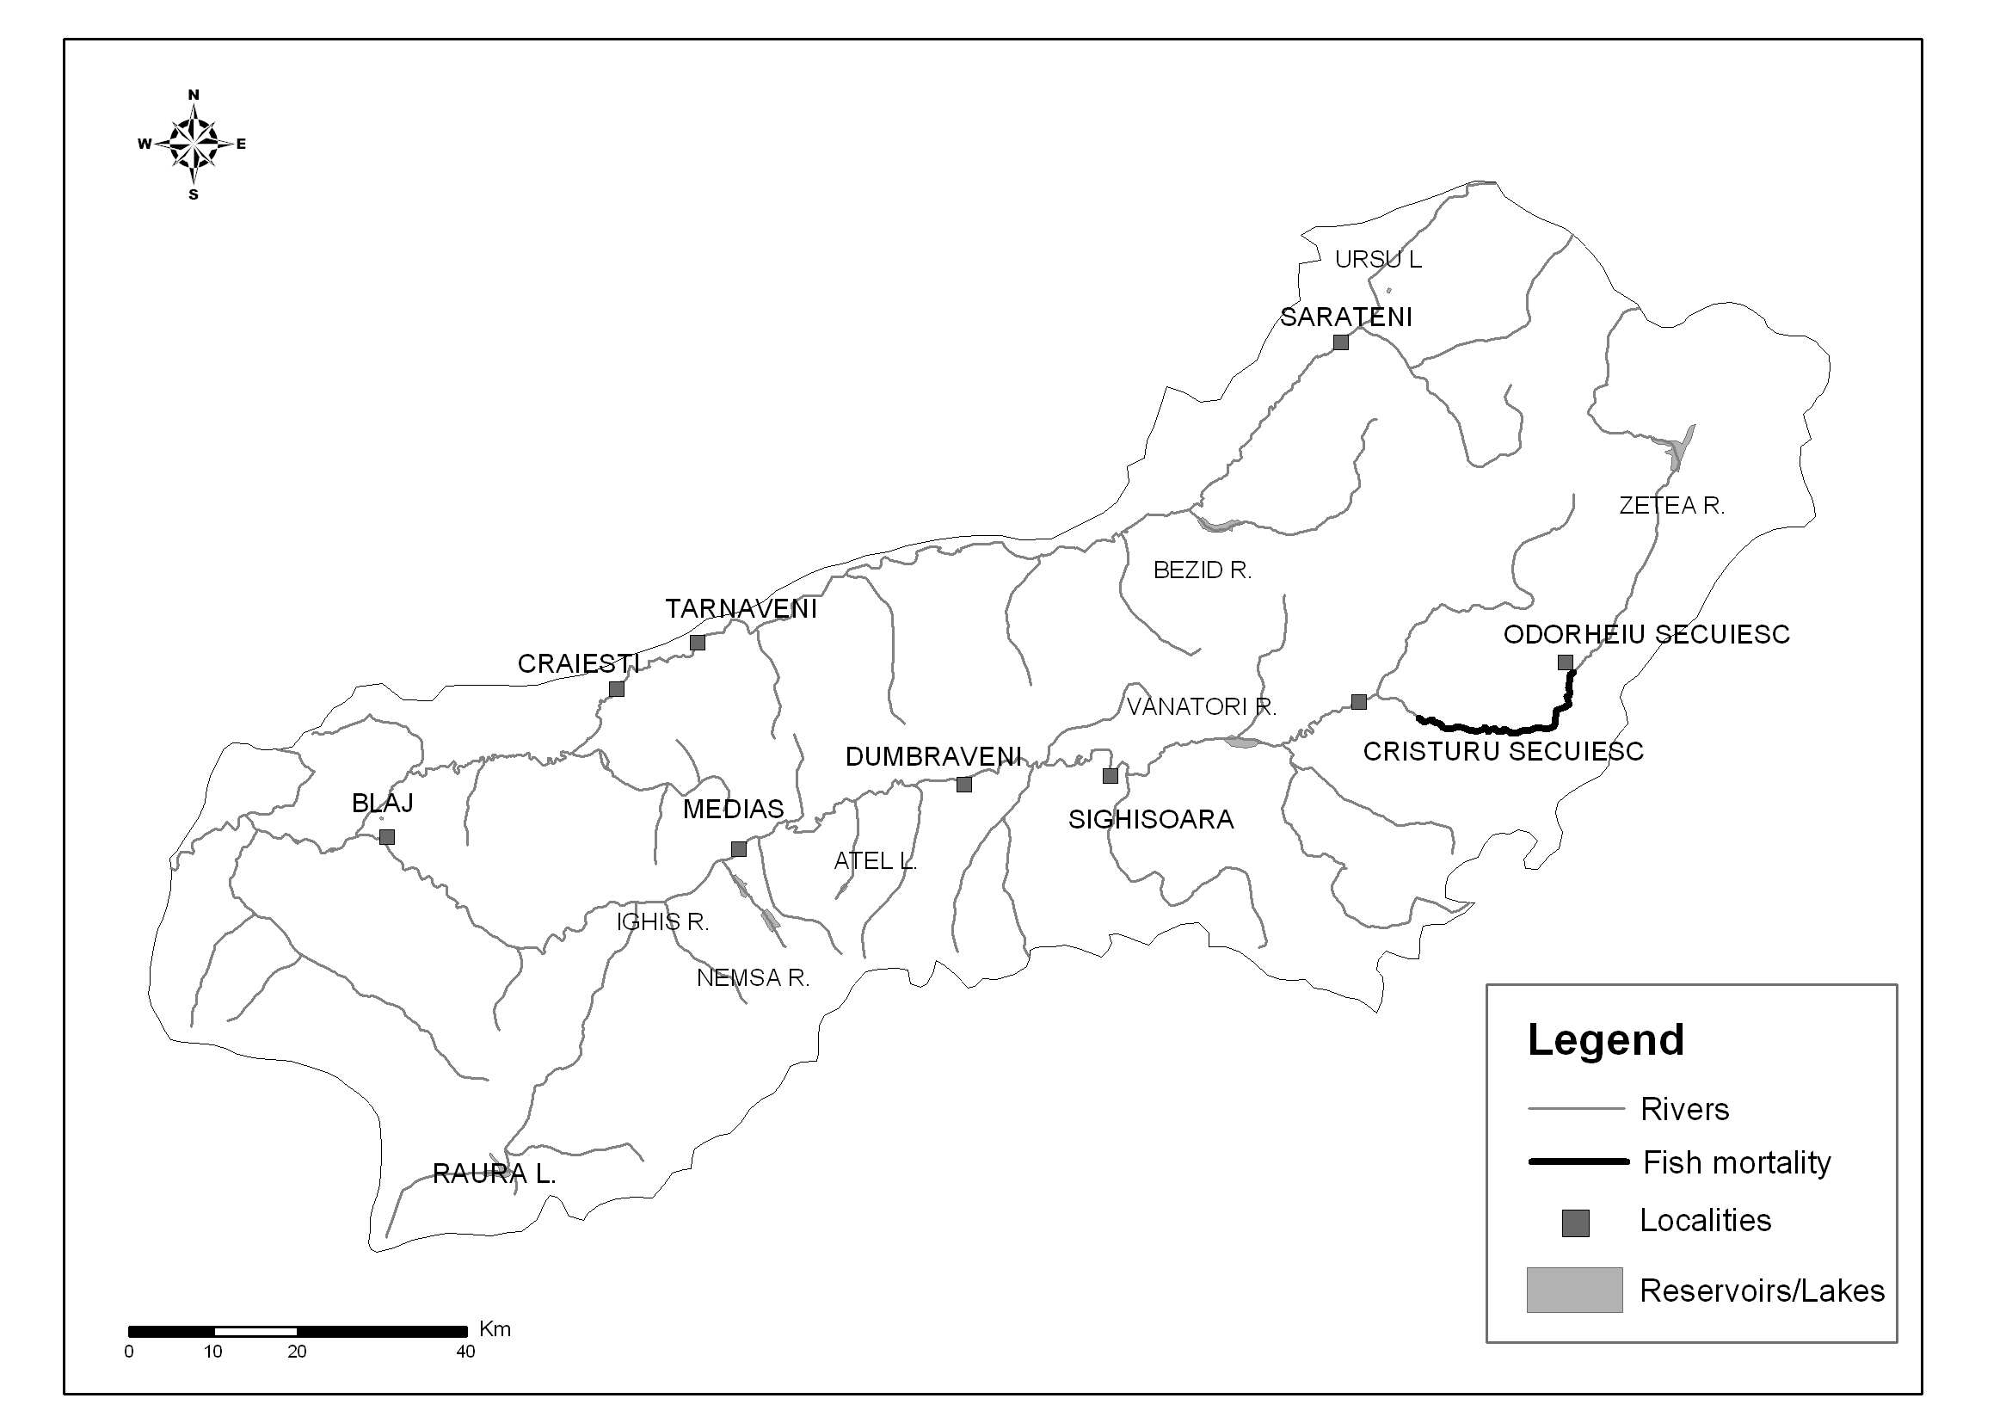
Figure 1 The Tarnava river basin
Table 1 Correlation coeficients for dissolved oxygen and
variables in the main cross sections on the Tarnava river basin
Cross sections | DO-T | DO-T-COD | DO-T-COD-NH₄⁺
Upstream Blaj | 0.89 | 0.90 | 0.91
Upstream Medias | 0.76 | 0.77 | 0.78
Craiesti | 0.76 | 0.78 | 0.81
Cristuru Secuiesc | 0.70 | 0.72 | 0.70
Sarateni | 0.71 | 0.75 | 0.76
Vanatori | 0.78 | 0.79 | 0.80
Odorheiul Secuiesc | 0.74 | 0.76 | 0.77

Figure 2 ilustrates the dependence of dissolved oxigen concentration on water temperature, in the cross section Odorheiul Secuiesc on the Târnava Mare river.
Figure 2 Dissolved oxygen concentration correlation with water temperature
in the cross section Odorheiul Secuiesc on the Târnava Mare river

3. The forecast of dilution discharges
The procedure to estimate dilution discharges needed to avoid pollution occurrence and its environmental impacts during low water periods involves the following steps:
- The characteristic water cross-sections (downstream the important pollution sources, downstream confluence) are selected;
- The following correlation are derived for each characteristic cross-section;
- The dependence of water temperature (t_{w}) on COD-Mn value (C_{COD-Mn}) and NH₄⁺ value (C_{NH4}⁺) - see table 2;
- The dependence of water temperature (t_{w}) on air temperature (t_{a}) - see figure 3;
- The concentration of organic substances and NH₄⁺ is estimated;
- The water temperature is estimated using the air temperature forecasted by the meteorologists;
- The supplementary dilution degree (x) is computed using the equations shown in table 2.
$x=\frac{0\text{.}\text{08}⋅C_{\text{COD}−\text{Mn}}+0\text{.}\text{50}⋅C_{{\text{NH}}_{4}}^{+}}{\text{12}\text{.}\text{25}−C_{\text{DO}}−0\text{.}2⋅t_{w}}$ (3)
The alert threshold for the dissolved oxygen concentration in water to indicate the fish mortality is 4 mg/l.

Additional fresh discharge is required to increase the dilution capacity of the river, only if the dilution degree fulfills the condition x > 1.
- The additional discharge to be released from the upstream reservoir to produce the proper dilution which prevents the occurrence of fish mortality is given by:
$ΔQ=Q_{r}⋅\left(x−1\right)$ (4)
where: $Q_{r}$ is the current discharge on watercourse.

Tabel 2 The variation of dissolved oxygen concentration with water temperature,
organic substance and ammonium concentrations
Cross-section | Equations
Tarnava Mare - Odorheiul Secuiesc | C_{DO}=11.69-0.20t_{w}
Tarnava Mare - Odorheiul Secuiesc | C_{DO}=12.11-0.20t_{w}-0.13C_{COD-Mn}
Tarnava Mare - Odorheiul Secuiesc | C_{DO}=12.25-0.20t_{w}-0.08C_{COD-Mn}-0.50C_{NH4}⁺
Tarnava Mare - Cristuru Secuiesc | C_{DO}=11.16-0.18t_{w}
Tarnava Mare - Cristuru Secuiesc | C_{DO}=11.50-0.17t_{w}-0.07C_{COD-Mn}
Tarnava Mare - Cristuru Secuiesc | C_{DO}=11.43-0.17t_{w}-0.07C_{COD-Mn}-0.08 C_{NH4}⁺
Tarnava Mare - Vanatori | C_{DO}=10.88-0.21t_{w}
Tarnava Mare - Vanatori | C_{DO}=14.16-0.21t_{w}-0.05C_{COD-Mn}
Tarnava Mare - Vanatori | C_{DO}=11.57-0.22t_{w}-0.05C_{COD-Mn}-0.38 C_{NH4}⁺
Tarnava Mare - Upstream Medias | C_{DO}=10.69-0.18t_{w}
Tarnava Mare - Upstream Medias | C_{DO}=10.90-0.17t_{w}-0.04C_{COD-Mn}
Tarnava Mare - Upstream Medias | C_{DO}=11.02-0.18t_{w}-0.04C_{COD-Mn}-0.13 C_{NH4}⁺
Tarnava Mare - Upstream Blaj | C_{DO}=10.64-0.20t_{w}
Tarnava Mare - Upstream Blaj | C_{DO}=10.70-0.20t_{w}-0.008C_{COD-Mn}
Tarnava Mare - Upstream Blaj | C_{DO}=11.61-0.20t_{w}-0.001C_{COD-Mn}-0.13 C_{NH4}⁺
Tarnava Mica - Sarateni | C_{DO}=11.51-0.18t_{w}
Tarnava Mica - Sarateni | C_{DO}=11.93-0.17t_{w}-0.11C_{COD-Mn}
Tarnava Mica - Sarateni | C_{DO}=12.12-0.18t_{w}-0.08C_{COD-Mn}-0.73 C_{NH4}⁺
Tarnava Mica - Craiesti | C_{DO}=11.12-0.20t_{w}
Tarnava Mica - Craiesti | C_{DO}=11.30-0.20t_{w}-0.04C_{COD-Mn}
Tarnava Mica - Craiesti | C_{DO}=11.82-0.20t_{w}-0.02C_{COD-Mn}-0.66 C_{NH4}⁺
Figure 3 The correlation between water temperature and air temperature for the Tarnava Mare river - Odorheiul Secuiesc cross-section

4. Case study - the Tarnava Mare river in Romania
On 24.06.2002 the operation of the wastewater treatment plant URBANA - Odorheiul Secuiesc has stopped, due to a 6 hours and 5 minutes interruption in electrical energy supply. All wastewater (0.177 m³/s) was directly discharged in Tarnava Mare producing water pollution. The water level raised with 2-3 cm, the water changed its color and had a bad smell. The same day fish mortality was noticed along a 12-km river length, downstream from the wastewater discharging point (figure 1).
The data forecasted on 24.06.2002 are listed below:
- The maximum air temperature at the Odorheiul Secuiesc meteorological station was 32°C.
- The water temperature was estimated at 22.8°C, using the correlation illustrated in figure 3.
- The water discharge of the river was 1.3 m³/s.
- The values of C_{COD-Mn} and C_{NH4} were estimated downstream the discharging point of wastewater treatment plant URBANA - Odorheiul Secuiesc, after the mixing was completed. The resulted concentration values were 32 mg/l for C_{COD-Mn} and 4 mg/l for C_{NH4}⁺.
- The supplementary dilution degree required on the Tarnava Mare river to prevent the occurrence of fish mortality is:
$x=\frac{0\text{.}\text{08}⋅C_{\text{COD}−\text{Mn}}+0\text{.}\text{50}⋅C_{{\text{NH}}_{4}}^{+}}{\text{12}\text{.}\text{25}−C_{\text{DO}}−0\text{.}2⋅t_{w}}=\frac{0\text{.}\text{08}⋅\text{32}+0\text{.}5⋅4}{\text{12}\text{.}\text{25}−4−0\text{.}2⋅\text{22}\text{.}8}=1\text{.}3$ (5)
- The resulted additional discharge that should be released from Zetea reservoir in order to avoid fish mortality is:
$ΔQ=Q_{r}⋅\left(x−1\right)=1\text{.}3⋅\left(1\text{.}3−1\right)=0\text{.}\text{36}{m^{3}}/s$ (6)

5. Conclusions
- Fish mortality on watercourses occurs, in particular, in low water periods, in summertime, when the dissolved oxygen concentration in water is decreased due to temperature increase and/or water pollution with organic substances and ammonium.
- To assess the concentration of dissolved oxygen in water, a multiple correlation method has been used to estimate water temperature, C_{COD-Mn} and C_{NH4}⁺ concentrations relationships.
- The multiple correlation method has been applied for 7 characteristic cross-sections, on the Tarnava river.
- To forecast the water temperature, for the characteristic water sector, the correlation with air temperature has been used.
- The formulas (3) and (4) have been used to compute the dilution discharge needed to compensate the effect of dissolved oxygen decrease, in water to avoid fish mortality.
- The forecast method was applied, to compute the dilution discharges required on the Tarnava Mare river, downstream Odorheiul Secuiesc to offset the effects of water pollution with organic substances, which occurred on 24-25.06.2002.

6. References
***(2002): Legea 458/2002 privind calitatea apei potabile. Monitorul Oficial, Partea I nr. 552,
Bucharest, Romania
*** (1993-2001): Sinteza protectiei calitatii apelor. National Administration “Apele Romane” –
Romanian Water Authority, Bucharest, Romania

