THE CHANGES OF WATER QUALITY

IN THE RIVERS OF UKRAINE DURING 1990-2002

Vishnevskiy Victor¹, Kovalchuk Ivan²

¹Central Geophysical Observatory, Kyiv, Ukraine, e-mail: vishnev@i.com.ua
²Lviv University, Lviv, Ukraine, e-mail: geomorph@franko.lviv.ua

Abstract: The hydrochemical characteristic of Ukrainian rivers during 1990-2002 was given. The impact of anthropogenic factor on hydrochemical characteristics of rivers and their changes were estimated.
Key words: river’s of Ukraine, water quality, anthropogenic impact

WASSERQUALITÄTSVERÄNDERUNGEN IN DEN FLÜSSEN DER UKRAINE
WÄHREND DER JAHRE 1990-2002

Zusammenfassung: Es sind Angaben über hydrochemischen Kennzeichnungen der Flüsse in der Ukraine während der Jahre 1990-2002 dargestellt. Es sind die Veränderungen, die unter antropogenen Einfluβ sich ereignet wurden, gezeigt. Und es ist der Einfluβ dieser Veränderungen auf hydrochemischen Kennzeichnungen der Flüsse, bestimmt.

Schlüsslworte: Flüsse der Ukraine, Wasserqualität, antropogenen Einfluβ.

1. Foreword
The water quality is depended on natural factors and anthropogenic impact. During last decades it is observed the tendency for the increase of the water runoff, caused mainly by the climatic changes. The next natural factor, that is more important – the weather conditions during certain years. The role of anthropogenic impact on the water quality essentially changed in Ukraine during the period after the year 1990. During these years the economic crisis occurred and the GDP became more than two times less. The dimension of GDP was occurred in some neighboring countries also.
The volume of water consumption and volume of waste waters during this period in Ukraine became two times less. Thus, the volume of water consumption from the Dnipro river in 1990 was 21.5 km³, in 2002 – 9.38 km³. The volume of waste waters simultaneously was equal to 10.62 and 5.44 km³ [5]. These volumes can be compared with the long-term runoff of the Dnipro river (53.5 km³). During 1990-th the volume of artificial fertilizers, used on the agricultural land reduced 15 times from 4.2 mln tons in the 1990 to 0.28 mln tons in 2000. At the same time the quantity of organic fertilizers dropped 9 times. The freight shipment on the rivers decreased 8 times. As a result of crisis it was happened the essential dimension of pollutants those are carried to the rivers. The crisis in Ukrainian economics finished only in 2000. From this year the GDP became to increase. More that, during last years it makes up 7-9% per year that is one of the best index in Europe.

2. Mineralization of water
As a result of above-mentioned changes in economic sphere it is observing some dimension of the mineralization of water. So, the mineralization of river’s water during 2000-2002 became 10-20% less, than in 1990-1992. Another factor that caused these changes is the increasing of water runoff in 2000-2002 in comparison with 1990-1992.
The changes the mineralization of water are observed on all large rivers, including the Danube river (Ukrainian name – the Dunai river) near its mouth. During 2000-2002 the average mineralization of water on Reni station (163 km from the river mouth) consists of 351 mg/l comparable with 419 mg/l in 1990-1992.
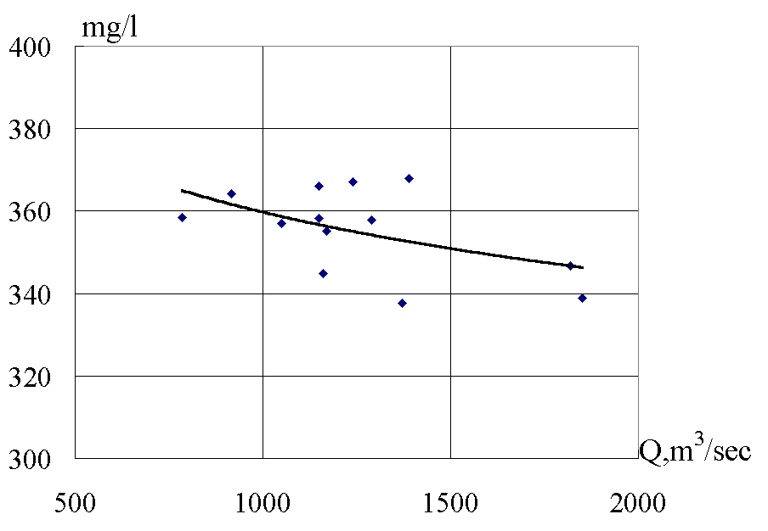
Figure 1. The dependence between water discharge and mineralization of water in the Dnipro river near Kherson

It is possible to suppose that some role in this case plays the volume of water runoff. Really, the average discharge during 2000-2002 was equal to 6740 m³/sec, that larger than long-term water runoff (6500 m³/sec) and water runoff during 1990-1992 (5310 m³/sec).
Actually, during last time the reverse dependence between water discharge and mineralization of water almost disappeared. It is characteristic for majority of Ukrainian rivers (fig.1).
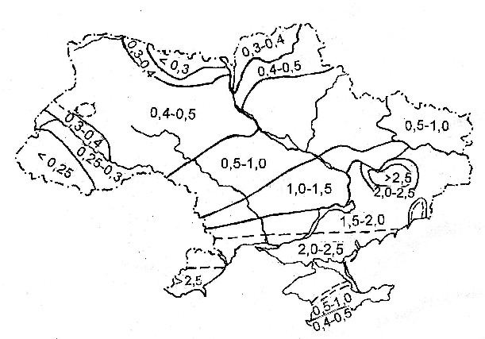
Figure 2. The maps of mineralization of water in Ukrainian’s rivers (in g/l): above – in 1947 (the period of low water [], down – nowadays (average data)

This peculiarity can be explained by the withdrawal of waste waters during period of high water.
Despite some dimension of mineralization during 1990-th it is nowadays much larger than some decades ago. During 1948-1950 and 1958-1959 it was observed 292 mg/l (Almazov, 1962). The average water runoff during these years was equal to 5660 m³/sec. The available data show that during that time it was observed the inverse ratio between water discharge and mineralization of water.
The modern data about mineralization of water give the opportunity to draw the corresponding map (fig.2).
The comparison of the new map with the oldest one (it was built on the observation data in 1947) shows the existence of some differences [2]. The first one – it is the increasing of mineralization of water on the larger part of Ukraine. The modern map is more detailed also. Finely, on the modern map there are some districts, those are appeared by the impact of anthropogenic factor. Thus, the right tributaries of the Siverskiy Donets river (the largest river on the Earth of Ukraine) have larger mineralization than left ones. It is explained by influence of human factor. This region (its name is Donbas) has the large population and it is characteristic by heavy industry. In ones term the main brunches of industry in this region are coal mining, steel production etc.
The average volume of underground water that one ought to pump from mines has the order 10 m³ for one ton of extracted coal. The total volume of this water is equal to about 0.7 km³. The mineralization of this water reaches 3-4 g/l. As a result of it is observed the essential increasing of mineralization of water in such rivers as Samara–Novomoskovs’k, Siverskiy Donets–Lysychans’k, Kazenyi Torets–Slovians’k, Kal’mius–Donets’k etc (fig.3).
In ones term the increasing of mineralization of water on the North of Ukraine is explained by the drainage lands. Nowadays its area consists of 3 mln ha or 5% of the total area of Ukraine [2, 4].

3. Water quality
The available data shows that most pollutant rivers of Ukraine are situated in Donbas and Priazovia – on the East and South–East of country. The water quality is much better in the rivers of Carpathian region and Polissia (the very North of Ukraine). The differences can reach 5-10 times by some indexes.
During period 1990-2002 it is observed the improvement of water quality in rivers, particularly with the content of NO₃. Thus, its content in the Danube river (Reni) changed from 1.13 mg/l in 1990-1992 to 0.9 mg/l in 2000-2002. More essential changes is observed in the most “dirty” rivers, that are situated in Donbas and other industrial regions [5].
These changes can be explained by the essential decrease of use of artificial fertilizers. The additional factor is the dimension of the volume of waste waters from industrial plants.
Some peculiarities are observed with content of oil products. There is increase in some rivers and decrease in others. It can be explained by decrease of volume of withdrawal from the industrial plants and the simultaneous growth of quantity of cars (during 1990-2002 its quantity became two times larger). The next factor – the changes in freight shipment. As it was said before it is dimensioned essentially.
The last factor concerns the content of oil products in the Danube river. It is happened the essential dimension (in some times) of freight shipment on the downstream district of river. As a result of it the content of oil products on Reni station dimensioned 5 times: from 0.28 mg/l in 1990-1992 to 0.056 mg/l in 2000-2002.

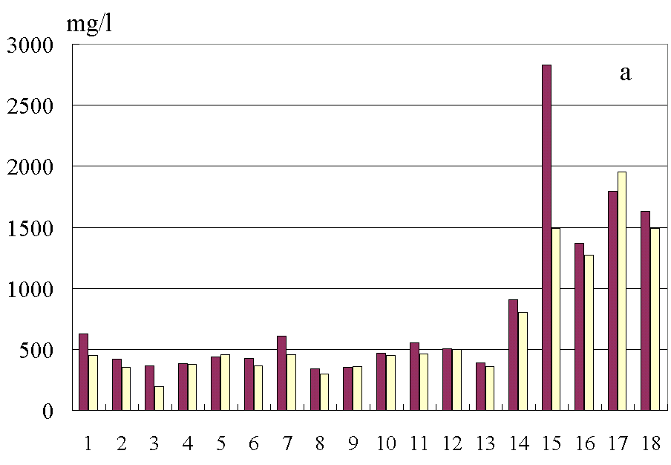
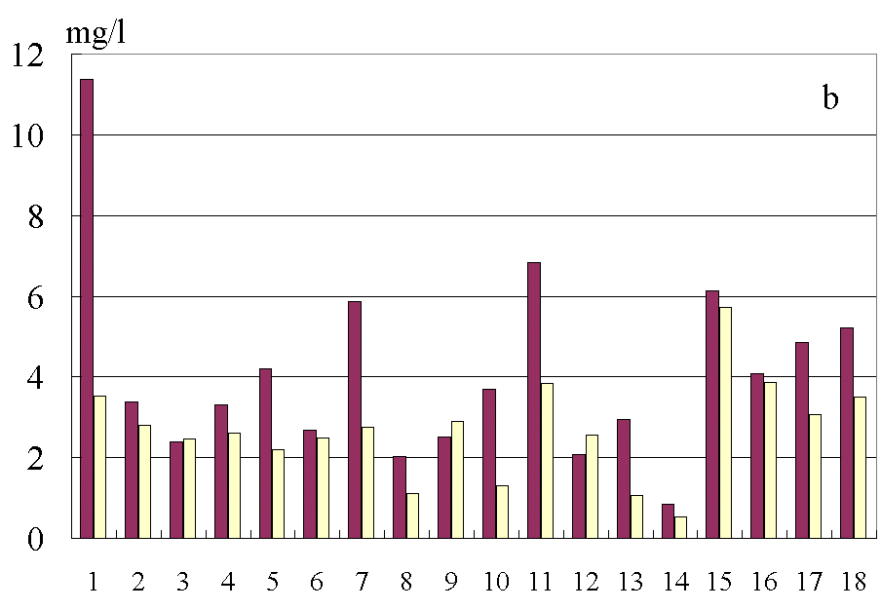
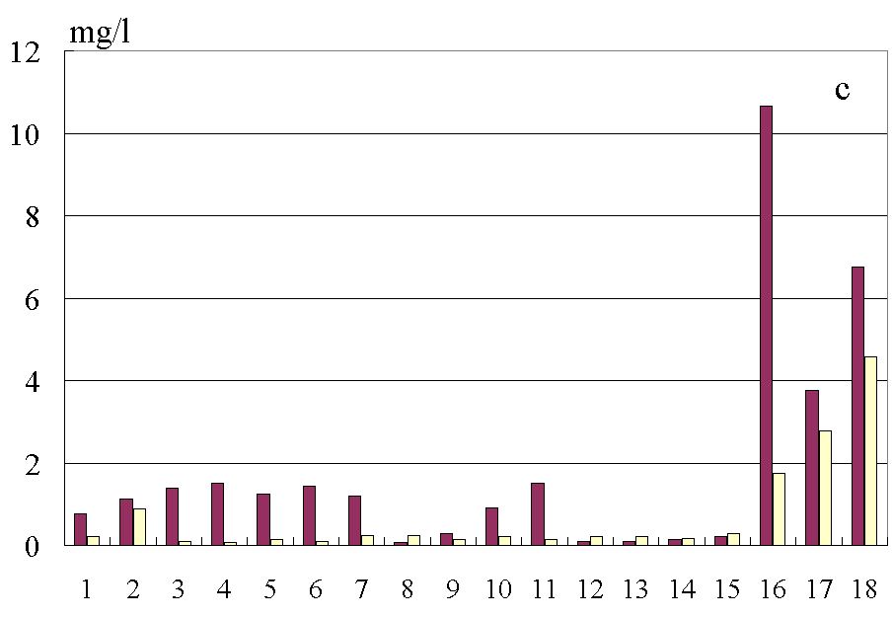
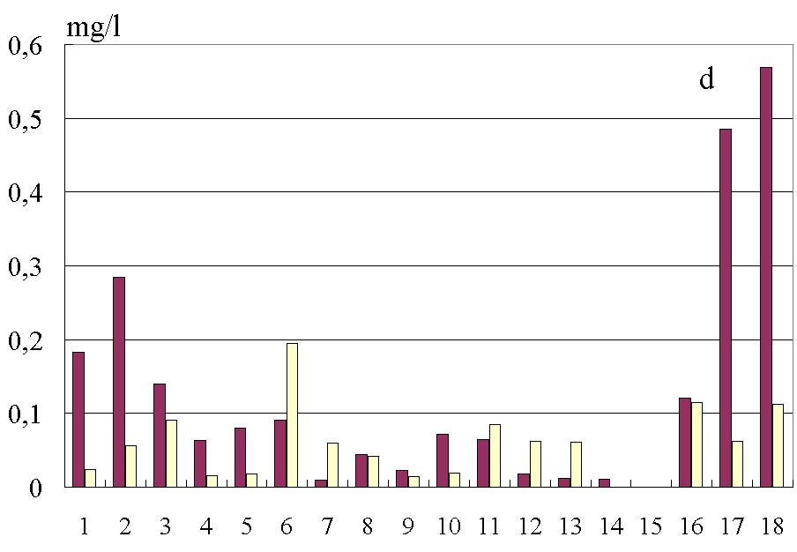
Figure 3. The changes of mineralization of water (a), BOD₅ (b), NO₃ (c), oil products (d) in main rivers of Ukraine: 1 – Zakhidnyi Bug–Kamianka-Buz’ka, 2 – Danube–Reni, 3 – Tysa–Chop, 4 – Siret–Storozhinets, 5 – Prut–Chernivtsi, 6 – Dnister–Sambir, 7 – Pivdenui Bug–Vinnytsa, 8 – Dnipro–Nedanchichy, 9 – Dnipro–Kherson, 10 – Styr–Luts’k, 11 – Horyn’–Slavuta, 12 – Ros’–Bila Tserkva, 13 – Desna–Chernihiv,, 14 – Sula–Lubny, 15 – Samara–Novomoskovs’k, 16 – Siverskiy Donets–Lysychans’k, 17 – Kazenyi Torets–Slovians’k, 18 – Kal’mius–Donets’k (left columns in 1990-1992, right ones – in 2000-2002)

4. Conclusion
During 1990-2002 it is happened essential changes of water quality in the rivers of Ukraine. It became better by the most cases.
These changes it is caused by two factors. The main among them – the essential decrease of human impact. The less important factor is increase of water runoff.

5. References
- Almazov A.M. (1962): Hydrochemistry of the river’s mouths. Academy of Science of Ukraine. –256 p. Кyiv, Ukraine.
- Gorev L.M., Peleshenko V.I., Hilchevskiy V.K. (1995): The hydrochemistry of Ukraine. Vuscha shkola. –308 p. Кyiv, Ukraine.
- Konenko A.D. (1952): The hydrochemical characteristics of small rivers of Ukraine. Academy of Science of Ukraine. – 172 p. Кyiv, Ukraine.
- Vishnevskiy V.I. (2000): The rivers and lakes of Ukraine. VIPOL. –376 p. Кyiv, Ukraine.
- Vishnevskiy V.I., Kosovets O.O. (2003): The hydrological characteristics of the rivers of Ukraine. Nika-Centre. –324 p. Кyiv, Ukraine.

