CONCENTRATIONS OF NITRATE IN SMALL STREAMS of the Švihov drinking water reservoir basin, cz

Martin Lexa, Tomáš Kvítek

Research Institute for Soil and Water Conservation Prague, Czech Republic,
e-mail: lexa@vumop.cz, kvitek@vumop.cz

Abstract: In the 90's there were monitored concentrations of nitrate in small streams of the Švihov drinking water reservoir basin on the Želivka river in the Bohemo-Moravian Highland. 36 profiles were analysed. Aim of this research was to identify factors of basin leading to high values of nitrate. Frequency of extractions was once per month. Monitored period was from June 1993 to June 2002. Unfortunately not all the streams were monitored all the time (according to amount of money for research). All the catchments are made of weathered acid crystalline rocks.
Although amount of fertilizers rapidly decreased in the 90’s in Czech agriculture concentrations of nitrate somewhere increased. There must be other important factors. 9 factors were researched in every catchment: C₉₀ (concentration which will not be exceeded with probability 90% - from measured data), amplitude of average month concentrations per year for all the period of monitoring, total area of the catchment, portion of arable land, portion of water areas, portion of infiltration areas covered by arable land (infiltration areas were delimited according to valuated soil-ecological units data - all the characteristics of soil were taken into account), portion of artificially drained areas, number of inhabitants per km², number of large animal units. These 9 factors were taken into the factor analysis. The factor analysis showed that the height of maximal values of nitrate concentrations in the end of winter and also the height of differences between summer minimums and winter maximums are influenced especially by the portion of arable land in the catchment, the portion of infiltration areas covered by arable land and the portion of artificially drained areas. On the contrary, water areas have the positive effect.
In 1955 extractions from some of the same profiles were taken. Therefore these data are valuable for the comparison. Although in the 1955 there lived more people and farm animals in the catchments the concentrations of nitrate were far lower than in the 90's. We can ask what has changed in the catchments so much. The main change in the landscape was the construction of drainage from the 60's to the 80's. The drainage induced a change of redox conditions and it accelerated runoff from the catchments. Before waterlogged grasslands in riparian zones with good conditions for denitrification often were changed into arable land.
Probable solution of this problem would be to grass over areas of infiltration in the catchment. But this would be unacceptable for local farmers because these areas located on flat tops of hills are intensively tilled. Other possible solutions would be the reduction of drainage and building of small ponds and wetlands.
Keywords: water quality, nitrate, land use, drainage

Zusammenballung von Nitraten in kleinen WasserstrÖmen des Quellgebietes von Švihov Reservoir fűr trinkWasser, CZ

Zusammenfassung: In den neunziger Jahren wurden Konzentrationen von Nitraten in kleinen Wasseströmen vom Quellgebiet des Flusses Želivka im Böhmisch-Mährischen Oberland, Švihov Reservoir für Trinkwasser überwacht. Das Ziel dieser Untersuchung war, die Faktoren dieses Quellgebietes, die die Hochwerte von Nitraten verursachen, zu identifizieren. Die Frequenz von Extraktionen war einmal im Monat. Die ganze Periode von Untersuchungen hat von Juni 1993 bis Juni 2002 gedauert. Unglücklicherweise konnten nicht alle Wasserströme in der gesamten Periode (mit Rücksicht auf das Geld für die Forschung) monitoriert werden. Alle Sammelgebiete sind auf dem sauren kristallinen Gestein.
Obwohl die Menge von Düngunsmitteln in der tschechischen Landwirtschaft in den neunziger Jahren schnell zurückgegangen ist, sind die Konzentrationen von Nitraten etwas höher geworden. Da müssen andere wichtige Faktoren mitwirken. Neun verschiedene Faktoren wurden in allen Quellgebieten untersucht: C₉₀ (Konzentration, die nicht überstiegen werden darf - mit 90%iger Warscheinlichkeit der gemessenen Angaben), der Stellwert von mittleren monatlichen Konzentrationen jährlich während der gesamten Periode der Űberwachung, das gesamte Territorium des Quellgebietes, der Anteil von Ackerböden, der Anteil der Wasserfläche, der Anteil vom mit den Ackerböden bedeckten Infiltrationsgebiet (Infiltrationsgebiet wurde im Zusammenhang mit ausgewerteten s.g. bodenökologischen Einheiten festgelegt – alle Bodenkennziffern wurden in Betracht gezogen), der Anteil des trockengelegten Gebietes, die Anzahl von Einwohnern/Quadratkilometr, die Anzahl von großen Tiereinheiten. Diese neun Faktoren wurden mit der Faktorenanalyse bearbeitet. Die Faktorenanalyse hat gezeigt, daß die Höhe von Höchstwerten der Nitratekonzentration am Ende des Winters und somit die Höhe der Differenz zwischen den Sommerkleinwerten und den Winterhöchstwerten besonders durch den Anteil von Ackerböden im Quellgebiet, durch den Anteil vom mit den Ackerböden bedeckten Infiltrationsgebiet und durch die Anzahl von drainierten Gebieten bewirkt sind. Wasserflächen haben aber eine positive Wirkung.
Im Jahre 1955 wurden in manchen von den ebendenselben Bodenprofilen die Extraktion gemacht und deshalb sind diese Angaben für die Vergleichung sehr wertvoll. Obzwar im Jahre 1955 dort viele Leute und viel Zuchtvieh gelebt haben, war die Konzentration von Nitraten viel niedriger als in den neunziger Jahren. Und so könnten wir fragen, was sich so viel in den Quellgebieten geändert hat. Die Hauptveränderung in der Landschaft war der Aufbau der Drainierung in den sechsziger bis achtziger Jahren. Die Bodenentwässerung hat die Veränderungen der Redox-Bedingungen verursacht und das Abfließen von den Quellgebieten beschleunigt. Die ursprünglich versumpften Böden, Wiesen in den Ufergebieten mit guten Bedingungen für die Denitrifikation wurden manchmal in Ackerböden geändert.
Die mögliche Lösung wäre das Begrassen von diesen Infiltrationsgebieten im Quellgebiet. Leider wäre diese Lösung kaum annehmbar für die örtlichen Bauer, weil diese Gebiete meistens auf den flachen Berggipfeln situiert sind und meistens intensiv bewirtschaftet werden. Die andere mögliche Lösung wäre die Reduktion von Drainierungen und der Aufbau von kleinen Teichen und Sumpfen.
Schlűsselworte: Wasserqualität, Nitrate, Bodennutzung, Drainierung (Bodenentwässerung)

Introduction
Nitrate pollution is a real trouble of Czech drinking water sources. Although amount of fertilizers rapidly decreased in the 90’s concentrations of nitrate are still very high. Not only point sources of pollution and fertilizing are responsible for its high concentrations. The limit of amount of nitrate in drinking water is 50 mg NO₃⁻ per litre (it equals 11,3 mg N-NO₃⁻ per litre; 1 mg N-NO₃⁻ per litre equals 4,426 mg NO₃⁻ per litre), in baby drinking water 15 mg NO₃⁻ per litre (it equals 3,39 mg N-NO₃⁻ per litre). Nitrate can be dangerous especially for babies until 3 months old. Nitrate is reduced to nitrite in the intestine and nitrite reacts with hemoglobin to methemoglobin which cannot transfer any oxygen. Only just fetal hemoglobin (hemoglobin F) reacts with nitrite easily than hemoglobin A which is in blood of older children and adults (Pitter, 1999). Babies who drink water with high amount of nitrate can get an oxygen deficit leading to the cyanosis (blue baby - blue colour of skin around mouth and terminal parts of fingers) and accelerated heart-beat.
In some streams there are nitrate concentrations quite low but in others they are high with high difference between summer minimums and winter maximums. This high difference means ecological instability of the catchment. Aims of this research were to find factors of catchments which cause high concentrations of nitrate in surface water and high difference between their summer minimums and winter maximums and to say what is necessary to improve in the catchments.

Methodology
Interest area was drinking water reservoir Svihov basin on the Zelivka river in the Bohemo-Moravian Highland (Figure 1). That is the most important source of drinking water for the capital Prague. Profiles which were significantly influenced by point sources of nitrate pollution were excluded from the analysis. But only two catchments were without any point source of pollution. Totally 36 profiles on small streams and their catchments were analyzed. Frequency of extractions was once per month and the monitored period was from June 1993 to June 2002. Unfortunately not all the profiles were monitored all the time. The monitoring of water quality was done by Agricultural Board of Water Industry.
All the Zelivka river basin is made by acid crystalline rocks. Average height above see level is about 500 m. From a geological point of view it is a very old archeozoic massif with flush top of hills. Average annual precipitation is 660 mm and average annual temperature is 7°C. Prevailing soil types are cambisol, acid cambisol in colder regions, gleying cambisol in lower parts of slopes, gley in valleys.

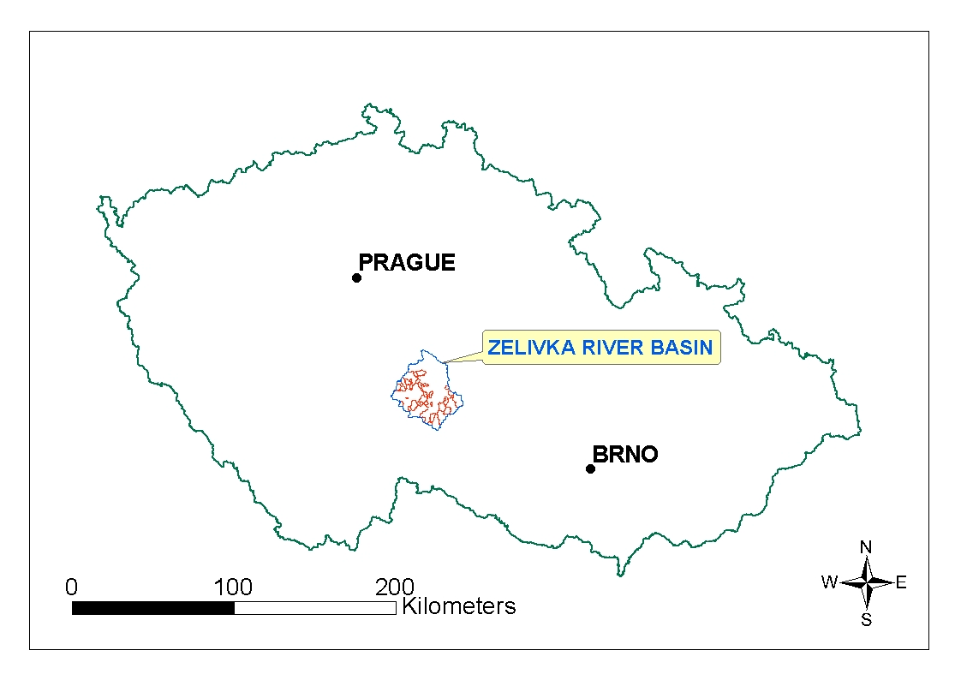
Figure 1: Zelivka river basin.

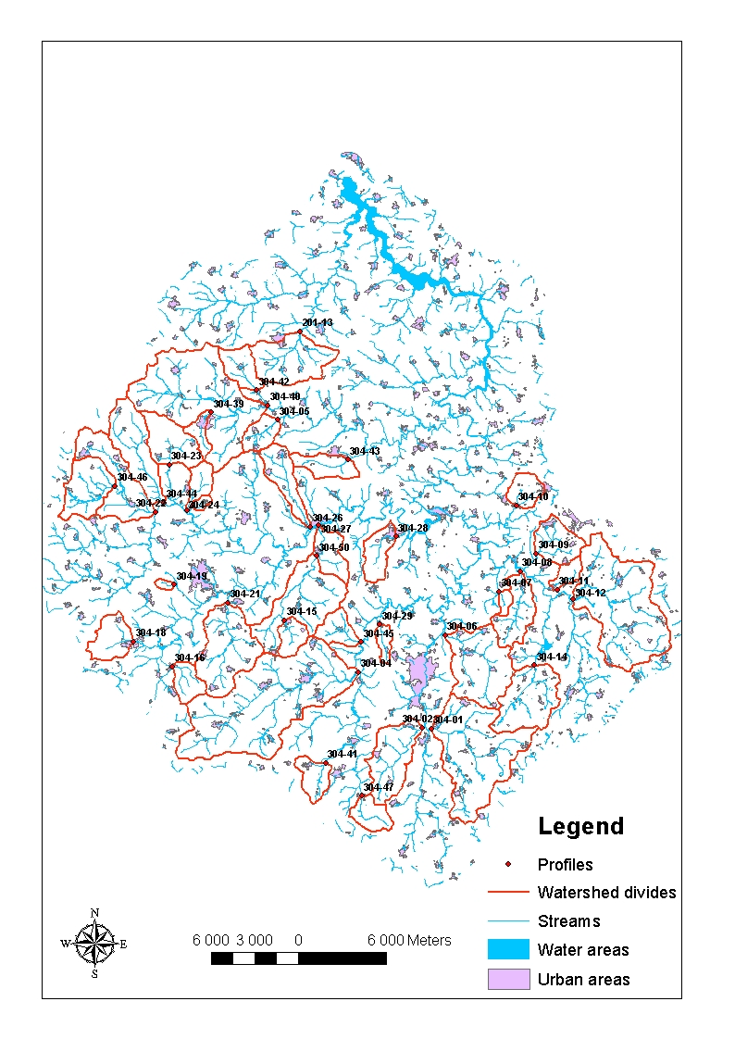
Figure 2: Svihov drinking water reservoir basin on the Zelivka river with watershed divides of analysed catchments.

Results
Annual course of nitrate concentrations is fluctuating a lot. But we can see periods of increase and periods of decrease from a long-term point of view. In this region the break year was 1996 (Figures 3 and 4). According to the amplitude of the curve of annual course of nitrate (difference between summer minimum and winter maximum) those catchments were sorted into 4 groups (Figure 5).

Figure 3: Concentrations of nitrate – period of increasing trend (1993-1996).

Figure 4: Concentrations of nitrate – period of decreasing trend (1996-2002).

Figure 5: Approximation of seasonal component of empirical series of nitrate concentrations by polynomial – 4 groups of analyzed catchments

Factor analysis
All 36 catchments were included into the factor analysis. Analyzed factors of each catchment were: C₉₀ (concentration of nitrate which will not be exceeded with probability 90% - this factor comes from Czech technical norm No. 75 7221 and it is calculated from all measured data in every profile), amplitude of average month concentrations per year for all the period of monitoring, total area of the catchment, portion of arable land, portion of water areas, portion of infiltration areas covered by arable land (infiltration areas were delimited according to valuated soil-ecological units data - all the characteristics of soil were taken into account - Janglová et al., 2003), portion of artificially drained areas, number of inhabitants per km², number of large animal units (1 large animal unit equals 500 kg of farm animal). Result of the factor analysis is BiPlot in the Figure 6. In this BiPlot we can see 3 groups of factors: 1.) both factors concerning nitrate (C₉₀ and annual amplitude), portion of the arable land, portion of infiltration areas covered by arable land and portion of artificially drained areas; 2.) alone factor portion of water areas; 3.) the third group of mutually positively correlated factors is composed by total area of the catchment, number of inhabitants and number of large animal units in the catchment. It is logical that larger catchments will have more inhabitants and more farm animals. But important information is that neither number of farm animals nor number of inhabitants influence concentrations of nitrate in streams too much. In the 4th (= the worst) group of catchments (Figure 5) there are also two small catchments with no point source of nitrate pollution. Excrements of animals used as fertilisation need not be shown in the place of animal keeping but they are applied on the arable land. Therefore portion of arable land together with possible artificial drainage are more important for nitrate contamination of water. Badly caulking tank of slurry at a farm can cause high concentrations of nitrate in a stream of course but it is possible to eliminate such a point source of pollution. According to the Figure 6 the most important factors leading to high nitrate contamination are portion of arable land, portion of infiltration areas covered by arable land and less portion of artificially drained areas. On the other hand, high portion of water areas leads to lower nitrate contamination. (We did not include portion of forest into analysed factors because it was clear from other research that higher portion of forest leads to lower concentrations of nitrate – Pačes, 1982; Kvítek, 1999.) The 1st component of the BiPlot explains relative variance of the file from 42,3 %. The 2nd component of the BiPlot explains relative variance of the file from 23,7 %. Therefore first two components displayed in the BiPlot explain together relative variance of the file from 66 %.

Figure 6: BiPlot from the factor analysis.

Comparison with the year 1955
In the year 1955 before building of the Svihov drinking water reservoir a complex exploration of the all basin was done including analyses of water quality in 47 profiles in February, April, June and August (Bulíček, 1956). Some of those profiles were the same as profiles monitored in the 90’s. Therefore those data are valuable for comparison. If we compare concentrations of nitrate from 1955 and from the 90’s a great difference is surprising there. What bad became in Czech landscape that in the end of the 20th century the concentrations are so much higher than 40 years ago? Not a single one measured nitrate concentration from the 90’s in the same profiles and months was not equal or lower than in 1955. But number of inhabitants and farm animals was higher in the 50’s than in the end of the 20th century in those catchments (it relates to depopulation of countryside). The first answer must be a better treatment of Czech landscape in the past. From the ecological point of view serious mistakes in our agriculture damaging Czech landscape were following: concentrating farm animals into enormous flocks, uniting of fields with destroying of small anti-erosive greenery, huge amounts of artificial fertilizers and last but not least building up of artificial drainage. These all exacerbating factors for landscape were to make Czech agriculture more intensive and to raise the yields.
In the Figure 7 there is a small difference between maximum in the end of winter and minimum in the end of summer. This fact is caused by high portion of permanent crops (forest and grassland) especially in infiltration areas of the catchment and high amount of small ponds where are good conditions for eliminating of nitrate (Figure 10). This catchment is quite ecologically stable. In the year 1955 there lived 253 inhabitants, number of large animal units there was 320,8 and no area was artificially drained there. In the 90’s there were 175 inhabitants, 117 large animal units and portion of artificially drained areas there was 9,9 %.
On the contrary in the Figure 8 there is a very high difference between winter maximum and summer minimum. This fact is probably caused by high portion of arable land in infiltration areas of the catchment (Figure 11) - (1955: 720 inhabitants, 1105,75 large animal units and no area was artificially drained there; the 90’s: 430 inhabitants, 1338,5 large animal units and portion of artificially drained areas there was 9,5 %).
In the Figure 9 there is an annual course of nitrate concentration in the profile whose catchment has no point source of nitrate pollution. Although there were no inhabitants and no kept farm animals the curve of nitrate concentration is very expressive. The reason of so high concentrations of nitrate and high amplitude of their annual course is high portion of arable land and especially high portion of artificially drained areas (24 %). The issue of the drainage system is near above the profile (Figure 12).
Figure 7: Average monthly concentrations of nitrate (N-NO₃⁻) with approximation of seasonal component of empirical series of nitrate concentrations by polynomial - profile 304-14 (monitored period was from June 1993 to April 1998 and data from the year 1955 for comparison).
Figure 8: Average monthly concentrations of nitrate (N-NO₃⁻) with approximation of seasonal component of empirical series of nitrate concentrations by polynomial - profile 304-27 (monitored period was from June 1993 to June 2002 and data from the year 1955 for comparison).

Figure 9: Average monthly concentrations of nitrate (N-NO₃⁻) with approximation of seasonal component of empirical series of nitrate concentrations by polynomial - profile 304-07 (monitored period was from June 1993 to May 1995).

Figure 10: Catchment of the profile 304-14.
Figure 11: Catchment of the profile 304-27.
Figure 12: Catchment of the profile 304-07.
Influence of artificial drainage on water and trophic regime
There is a positive effect of artificial drainage for increasing of the agricultural production because the physiological depth of soil and capacity of soil for processes feeding crops are increased. But after artificial decrease of water table a quick mineralization of organic matter in the soil begins and products of this mineralization leach out into drainage water especially in the nitrate form. Maximum of this leaching is from the 2nd till the 4th year after artificial drainage (Novák, 1994; Zlatušková et Novák, 2000).
Pačes (2001) described similar behavior of nitrate concentration after artificial drainage in a small experimental catchment (59 ha) in the Zelivka river basin. Before artificial drainage in the year 1982 minimal values of nitrate concentrations were about 4,5 mg N-NO₃⁻/l (20 mg NO₃⁻/l) (period 1976-1981). But in the years 1983-1987 maximal values achieved to 21,5 mg N-NO₃⁻/l (95 mg NO₃⁻/l). In the period with low values there were appeared samples of water with maximal nitrate concentrations about 11,3 mg N-NO₃⁻/l (50 mg NO₃⁻/l). In the period with high values there were appeared samples of water with minimal nitrate concentrations about 15,8 mg N-NO₃⁻/l (70 mg NO₃⁻/l). In the years 1987-1990 nitrate concentrations decreased again and after 1990 till the end of monitoring in 1999 they oscillated round 14,7 mg N-NO₃⁻/l (65 mg NO₃⁻/l). After the artificial drainage a part of originally wet grasslands in the upper part of the valley was ploughed (Figure 13). This fact more increased the nitrate leaching from the soil. The profile is situated after 30 meters of the drainage issue and there is no other source of water above the profile except the drainage. Therefore those samples are drainage water.
A neglected fact of the mineralization of organic matter in the soil after the artificial drainage is acidification of soil and water. During the oxidation of the organic matter many protons are released and the pH is decreasing (Pitter, 1999). Also production of CO₂ (greenhouse gas) owing to mineralization of soil carbon after drainage is enormous. Novák (2004) writes that after artificial drainage within 8-10 years until new balance was consolidated 2,2 tons of NO₃⁻ ion per every drained hectare of soil leached out into the hydrosphere and 113 tons of CO₂ per every drained hectare of soil escaped into the atmosphere. These numbers are huge and warning.
But the problem probably is not only in quick mineralization of organic matter in soil after the artificial drainage. It is visible in the Pačes report (2001) from the small experimental catchment. New stable nitrate concentration 65 mg NO₃⁻/l after the year 1990 is much higher than before the drainage. Kvítek et al. (2002) described another possible long-term effect of artificial drainage. Artificial drainage of the wet alluvial areas which were used as meadows and pastures enabled the use of heavy agricultural mechanization and these areas were ploughed in many cases. With the drainage the redox conditions in the soil were changed and anoxic places were aerated. Traditionally in the Bohemo-Moravian Highland there were tilled upper parts of the catchments where soil was thin and sandy. Those parts are infiltration areas of the catchments. Original alluvial grasslands were probably watered by springs with high amount of nitrate. Nitrate could be reduced in anoxic conditions by denitrification or fed by the grass cover. But owing to the artificial drainage of those riparian zones in the depth 1 meter by tubes nitrate has no place where it could be eliminated and it comes into the following rivers (Figures 14 and15). Building up of artificial drainage seriously damaged ecological stability of the landscape (drainage accelerates runoff of water of course too). The key role of the riparian zones is shown also by Schipper et Cooper et Dyck (1991) and Curie et al. (2004).
Soukup et Pilná (2003) also prove by evidence from 13 years lasting monitoring that drainage water contains 4-5 times more nitrate than surface water. Average monthly nitrate concentrations from all the period of monitoring there were from 10,8 mg N-NO₃⁻/l (48 mg NO₃⁻/l) in October up to 19,2 mg N-NO₃⁻/l (85 mg NO₃⁻/l) in February and March.

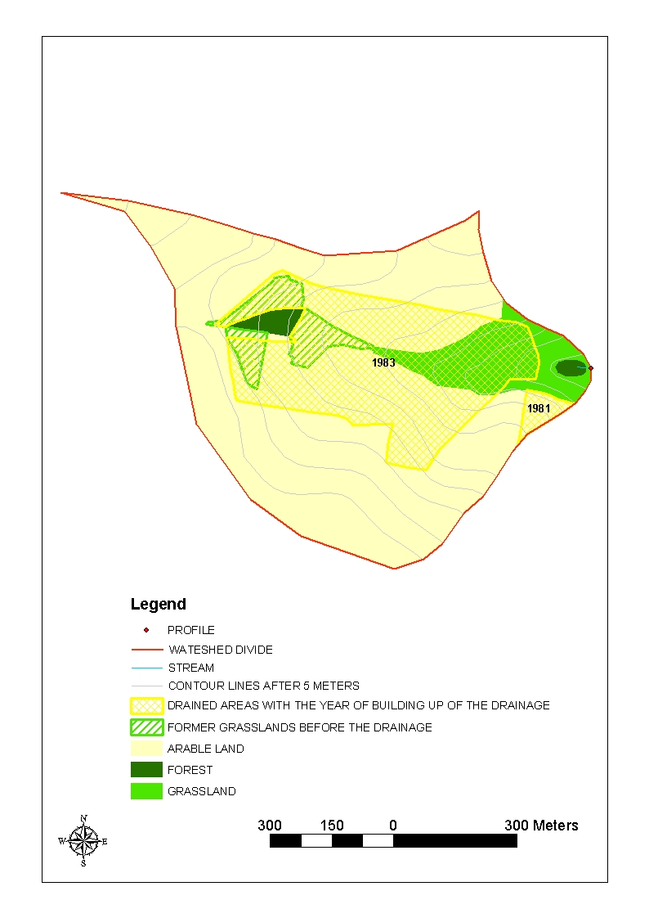
Figure 13: Experimental catchment Vocadlo of the Czech Geological Survey.

Figure 14: Water and trophic regime before artificial drainage.

Figure 15: Water and trophic regime after artificial drainage.
Conclusions
Factor analysis proved true that high nitrate concentrations in small streams and also high amplitude of their annual course (which shows ecological instability of the catchment - Forman et Godron, 1993) are influenced by portion of arable land, portion of infiltration areas covered by arable land and portion of artificially drained areas. On the contrary high portion of water areas leads to smaller nitrate contamination of water.
For improvement it would be necessary to grass over infiltration areas of the catchment. Cultivation of winter crops would bring a partial improvement because the highest leaching of nitrate from soil to water is in the end of winter from bare soil with no vegetation.
Another solution would be to build and keep small ponds and wetlands where nitrate could be eliminated in anoxic conditions by denitrification. Building up of artificial drainage from the 60’s to the 80’s was a serious damage for Czech landscape. About 25 % of Czech agricultural soils are artificially drained (Novák, 2004).

References
Bulíček, J. (1956): Healthy - water research of the Zelivka river basin. Water Research Institute Prague-Podbaba. Text – 1st and 2nd parts. Prague, the Czech Republic (in Czech).
Curie, F. et Ducharne, A. et Bendjoudi, H. et Billen, G. (2004): Testing a topographic index for quantifying wetlands denitrification in the Seine river basin. Geophysical Research Abstract, Vol. 6, 03856, 2004, European Geosciences Union (in English).
Czech technical norm CSN 75 7221: Water quality – Classification of the quality of surface water. Czech Normalization Institute. Prague, the Czech Republic,1998 (in Czech).
Forman, R. T. T. et Godron, M. (1993): Landscape ecology. Academia, Prague, the Czech Republic (in Czech).
Janglová, R. et Kvítek, T. et Novák, P. (2003): Categorization of infiltration capacity of soils based on geoinformation processing of soil exploration data. In Soil and Water 2/2003 Scientific studies, pp.61-81. Research Institute for Soil and Water Conservation, Prague, the Czech Republic (in Czech).
Kvítek, T. (1999): Development of nitrate concentration and analysis of stability of agricultural catchments in Svihov drinking water reservoir basin. Plant production, 45, 1999 (3): 107-111. Prague, the Czech Republic (in Czech).
Kvítek, T. et al. (2002): A stage of research intention MZe - M07 - 99 - 01 - 09: Creation of the system of different protection of soil and water from surface pollution with preference of permanent grasslands. Loss of nitrogen from the Kopaninsky stream basin. User issue. Research Institute for Soil and Water Conservation, Prague, the Czech Republic (in Czech).
Novák, P. (1994): Soil and water after artificial drainage. In conference proceedings Water management in agriculture and forestry. pp.125-128. Research Institute for Soil and Water Conservation, Prague, the Czech Republic (in Czech).
Novák, P. (2004): Positive and negative impacts of drainage and reclamation. In conference proceedings CD Melioration yesterday, today and tomorrow. Research Institute for Soil and Water Conservation, Prague, the Czech Republic (in Czech).
Pačes, T. (1982): Foundation of water geochemistry. Academia. Prague, the Czech Republic (in Czech).
Pačes, T. (2001): Results of long-term monitoring of mass balance in Vocadlo agricultural catchment in the period 1976-1999. A part of unpublished report of Czech geological survey. Prague, the Czech Republic, (in Czech).
Pitter, P. (1999): Hydrochemistry. VSCHT Publishing, Prague, the Czech Republic (in Czech).
Schipper, L. A. et Cooper, A. B. et Dyck, W. J. (1991): Mitigating nonpoint-source nitrate pollution by riparian-zone denitrification. In: Bogárdi, I. et Kuzelka, R. D. et Ennenga, W. G. (eds.): Nitrate contamination: exposure, consequence, and control. Springer Verlag, Berlin, pp. 401-413, Germany (in English).
Soukup, M. et Pilná, E. (2003): Development of nitrate concentrations in water from agricultural and forest parts of Cerhovicky stream experimental catchment. In Soil and Water 2/2003 Scientific Studies, pp.83-93. Research Institute for Soil and Water Conservation, Prague, the Czech Republic, (in Czech).
Zlatušková, S. et Novák, P. (2000): Influence of social and economical conditions on the development of the landscape in the Czech Republic during last 50 years. In Scientific studies 11, pp.173-184. Research Institute for Soil and Water Conservation, Prague, the Czech Republic, (in Czech).

Acknowledgement
This work was supported by Czech Ministry of Agriculture: MZe - M07 - 99 - 01 - 09.

