management of water quality and flood-risk on a basin-wide level – a challenge for the ICPDR

Igor Liska

International Commission for the Protection of the Danube River, VIC, Vienna, Austria,
e-mail: Igor.Liska@unvienna.org

Abstract: The management of water quality and flood risk in the Danube River Basin is legally based on the Danube River Protection Convention. To implement this Convention the Contracting Parties established the International Commission for the Protection of the Danube River (ICPDR). In line with its mandate the ICPDR deals with diverse issues of water management and protection. It operates a basin-wide water quality monitoring network as well as an accident emergency warning system. To address the problems and risks arising from floods in a transboundary context the ICPDR initiated the development of an Action Programme on Sustainable Flood Protection in the Danube River Basin. The Danube countries give a prime importance to the current river basin management policy of the EU. Consequently, the ICPDR was agreed to be the coordinating platform for the implementation of the EU Water Framework Directive in the Danube River Basin.
Keywords: ICPDR, the Danube River, Water Framework Directive, Transnational Monitoring Network, Accident Emergency Warning System, flood protection.

1. Introduction
Determined by the intention to intensify their water management cooperation in the field of water protection and use the Danube States developed the Danube River Protection Convention (DRPC). DRPC entered into force on 22 October 1998 and it became the overall legal instrument for cooperation and transboundary water management in the Danube River Basin. One of the major strategic goals of the Convention is to maintain and improve the status of water resources as to quality and quantity, to prevent, reduce and control water pollution, including accidental pollution and to control and reduce the risks originated from floods. To implement these goals the Danube countries have established the International Commission for the Protection of the Danube River (ICPDR). The Commission has created a set of Expert Groups to strengthen the proactive participation of all Contracting Parties. Furthermore, the Contracting Parties agreed that the ICPDR should serve as a common platform for the implementation of the EU WFD on a basin-wide scale.

2. Water quality management

2.1. Trans National Monitoring Network
To fulfill the provision of the DRPC asking to implement joint programmes for monitoring the riverine conditions in the Danube catchment area concerning both water quantity and quality the ICPDR established the Trans National Monitoring Network (TNMN). The main objective of the TNMN is to provide a structured and well-balanced overall view of the pollution status as well as of the long-term development of water quality and pollution loads in terms of relevant determinands for the major rivers in the Danube River Basin.

The TNMN monitoring network is based on the national surface water monitoring networks. For selection of TNMN sampling profiles following criteria were applied:

- site located just upstream/downstream of an international border
- site located upstream of confluences between Danube and main tributaries or main tributaries and larger sub-tributaries (mass balances)
- site located downstream of the largest point sources
- site located according to control of water use for drinking water supply

The original selection procedure has led to establishment of a final list of 61 monitoring locations to be included in TNMN Phase I. Although monitoring locations in Bosnia and Herzegovina constitute a part of the monitoring network, so far no data has been provided for them. On the other hand, in 2001, the monitoring stations in Serbia extended the monitoring network resulting in a final list of 79 monitoring stations (Figure 1). Each monitoring location may have up to three sampling points, located on the left side, right side or in the middle of a river. More than one sampling point was proposed for the selected monitoring locations in the middle and lower part of the Danube River and for the large tributaries such as the Tisza and Prut rivers. The minimum sampling frequency is 12 times per year for the chemical determinands in water and two times per year for biological parameters.

The analytical methodologies for the determinands applied in TNMN are based on a list containing reference and optional analytical methods. Moreover, the minimum required concentrations and the acceptable statistical tolerance have been defined for each determinand. The quality of the TNMN data is regularly checked by a basin-wide analytical quality control programme.

To evaluate the data collected by the TNMN an interim water quality classification scheme was developed (Table 1) that serves exclusively for the presentation of current status and assessment of trends of the Danube River water quality (i.e., it is not considered as a tool for the implementation of national water policies).

One of the main objectives of TNMN is to produce a reliable and consistent trend analysis of concentrations and loads of substances diluted in water or attached to sediments. The assessment of the pollution load in the Danube River is necessary to estimate the influx of polluting substances to the Black Sea and to provide an information basis for both policy development and assessment. The load assessment programme started in 2000. The pollution load is calculated for the following determinands: BOD₅, inorganic nitrogen, ortho-phosphate-phosphorus, dissolved phosphorus, total phosphorus, suspended solids and - on a discretionary basis – chlorides. An example of an output from the load assessment programme – the annual loads of inorganic nitrogen at the monitoring stations along the Danube River – is shown in Figure 2.

The statistically processed TNMN data and their evaluation using the interim water quality classification scheme are published annually in a Danube Water Quality Yearbook, which is publicly available. An electronic version of the Yearbook is available on the ICPDR web site (www.icpdr.org).

At present, in line with the implementation of the EU Water Framework Directive, TNMN is being revised to ensure a full compliance with the provisions of the WFD.

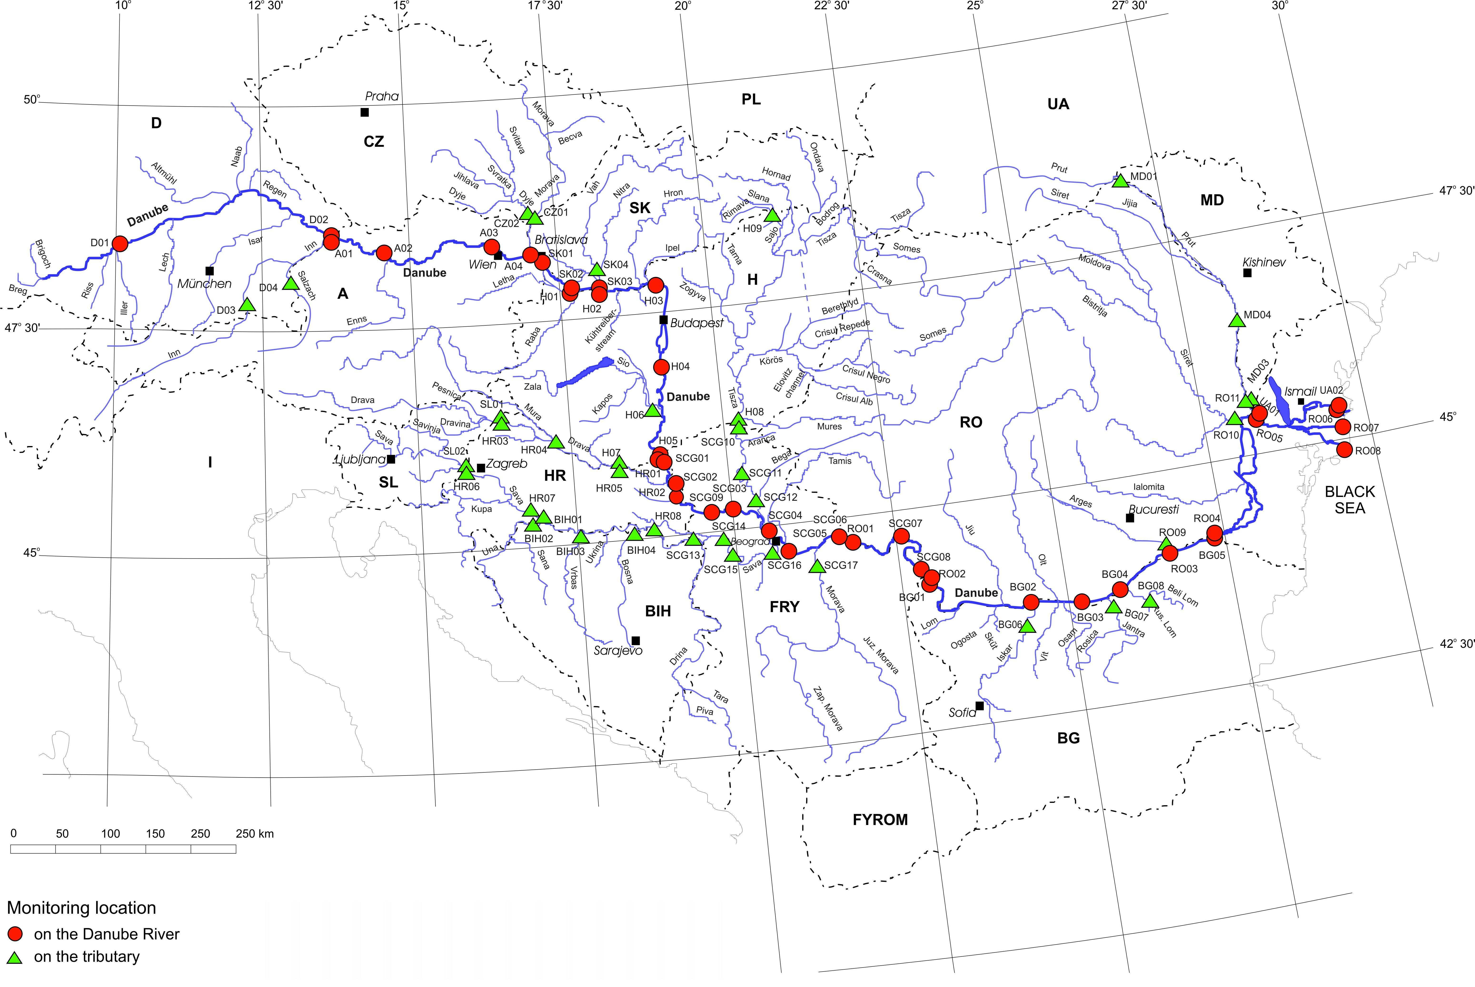
Figure 1: Transnational Monitoring Network in the Danube River Basin
Figure 2: Annual loads of inorganic nitrogen at monitoring stations along the Danube River
Table 1: Water Quality Classification used for TNMN purposes.
Determinand | Unit | Class
 |  | I | II - TV | III | IV | V
 |  | Class limit values
Oxygen/Nutrient regime
Dissolved oxygen * | mg.l⁻¹ | 7 | 6 | 5 | 4 | < 4
BOD₅ | mg.l⁻¹ | 3 | 5 | 10 | 25 | > 25
COD_{Mn} | mg.l⁻¹ | 5 | 10 | 20 | 50 | > 50
COD_{Cr} | mg.l⁻¹ | 10 | 25 | 50 | 125 | > 125
pH | - |  | > 6.5* and < 8.5
Ammonium-N | mg.l⁻¹ | 0.2 | 0.3 | 0.6 | 1.5 | > 1.5
Nitrite-N | mg.l⁻¹ | 0.01 | 0.06 | 0.12 | 0.3 | > 0.3
Nitrate-N | mg.l⁻¹ | 1 | 3 | 6 | 15 | > 15
Total-N | mg.l⁻¹ | 1.5 | 4 | 8 | 20 | > 20
Ortho-phosphate-P | mg.l⁻¹ | 0.05 | 0.1 | 0.2 | 0.5 | > 0.5
Total-P | mg.l⁻¹ | 0.1 | 0.2 | 0.4 | 1 | > 1
Chlorophyll-a | μg.l⁻¹ | 25 | 50 | 100 | 250 | > 250
Metals (dissolved) **
Zinc | μg.l⁻¹ | - | 5 | - | - | -
Copper | μg.l⁻¹ | - | 2 | - | - | -
Chromium (Cr-III+VI) | μg.l⁻¹ | - | 2 | - | - | -
Lead | μg.l⁻¹ | - | 1 | - | - | -
Cadmium | μg.l⁻¹ | - | 0.1 | - | - | -
Mercury | μg.l⁻¹ | - | 0.1 | - | - | -
Nickel | μg.l⁻¹ | - | 1 | - | - | -
Arsenic | μg.l⁻¹ | - | 1 | - | - | -
Metals (total)
Zinc | μg.l⁻¹ | bg | 100 | 200 | 500 | > 500
Copper | μg.l⁻¹ | bg | 20 | 40 | 100 | > 100
Chromium (Cr-III+VI) | μg.l⁻¹ | bg | 50 | 100 | 250 | > 250
Lead | μg.l⁻¹ | bg | 5 | 10 | 25 | > 25
Cadmium | μg.l⁻¹ | bg | 1 | 2 | 5 | > 5
Mercury | μg.l⁻¹ | bg | 0.1 | 0.2 | 0.5 | > 0.5
Nickel | μg.l⁻¹ | bg | 50 | 100 | 250 | > 250
Arsenic | μg.l⁻¹ | bg | 5 | 10 | 25 | > 25
Toxic substances
AOX | μg.l⁻¹ | 10 | 50 | 100 | 250 | > 250
Lindane | μg.l⁻¹ | 0.05 | 0.1 | 0.2 | 0.5 | > 0.5
p,p´-DDT | μg.l⁻¹ | 0.001 | 0.01 | 0.02 | 0.05 | > 0.05
Atrazine | μg.l⁻¹ | 0.02 | 0.1 | 0.2 | 0.5 | > 0.5
Trichloromethane | μg.l⁻¹ | 0.02 | 0.6 | 1.2 | 1.8 | > 1.8
Tetrachloromethane | μg.l⁻¹ | 0.02 | 1 | 2 | 5 | > 5
Trichloroethene | μg.l⁻¹ | 0.02 | 1 | 2 | 5 | > 5
Tetrachloroethene | μg.l⁻¹ | 0.02 | 1 | 2 | 5 | > 5
Biology
Saprobic index - macrozoobenthos | - | ≤ 1.8 | 1.81 – 2.3 | 2.31 – 2.7 | 2.71 – 3.2 | > 3.2
* values concern 10-percentile value bg background values
** for dissolved metals only guideline values are indicated TV target value
2.2. Investigative surveys
To supplement the information obtained from the regular monitoring the investigative surveys have been organized by the ICPDR. Until now, a Joint Danube Survey and a survey on the Tisa River were performed in 2001. These surveys were focussed on determinands and matrices, which are not included in the TNMN scheme (e.g., analysis of specific priority pollutants in sediments and suspended solids, analysis of zooplankton, phytoplankton and macrophytes). Using a single high-level laboratory for analysis of a particular determinand the homogenous data set was produced providing an excellent view on the water quality in the whole stretch of the Danube River. Moreover, during the Joint Danube Survey the first basin-wide monitoring of new EU WFD priority substances was performed. In addition to this, the surveys provided a possibility to meet the specific training needs, to exchange the in-country experience and also to promote public awareness. An example of data collected during the JDS is the longitudinal profile of phytoplankton and zooplankton in the Danube River (Figure 3).

Figure 3: Variation of phytoplankton biomass and zooplankton population density along the Danube during JDS in 2001

2.3. Concerted actions to achieve a good surface water status
The countries cooperating under the Danube River Protection Convention have agreed to use the ICPDR as the coordinating platform for the implementation of the EU Water Framework Directive (WFD) in the Danube River Basin. This means that also the non-EU Danube countries committed themselves to enforcing the EU legislative. To complete the environmental objective stipulated by the EU WFD, i.e., to achieve a good surface water status of all water bodies a complex set of tasks and measures must be performed within a fixed timeframe. At present, in line with the requirements of the Article 5 of the EU WFD, the Danube countries are completing the analysis of the Danube River Basin District. This includes the characterization of water bodies and their differentiation according to types. The Danube typology was developed using the abiotic parameters of System B and was then validated with biological data that had been collected during the Joint Danube Survey. According to Annex V of the EU WFD, the comparability of the biological monitoring results must be ensured. For this purpose an intercalibration exercise will be carried out by the EC in 2005/2006 that will be used to revise and establish by 2006 the appropriate monitoring systems. The ICPDR supports the intercalibration process by coordinating the activities in the so-called Eastern Continental geographical intercalibration group. This refers predominantly to defining of common intercalibration types and agreeing the intercalibration sites. Further issues addressed in the river basin district analysis are the identification of pressures and the assessment of the susceptibility of status of surface water bodies to these pressures, the characterization and the status of groundwater and the economic analysis of water uses. All these efforts will result in preparation of the report on characterization and analysis of the Danube River Basin District (roof report) that will be available by the end of 2004.

3. Accident pollution – prevention and control
In case of a significant pollution accident in the Danube River Basin the Accident Emergency and Warning System gets activated and ensures the propagation of a warning message downstream the Danube. The general objective of this system that came into operation in 1997 is to increase the public safety and protect the environment in the case of an accidental pollution by providing early information to the affected riparian countries. In the Danube countries the so-called Principal International Alert Centres (PIACs) have been established or are under development (Figure 4). The main function of these centres is to communicate the warning message at the international level. Each PIAC has three basic units –

Figure 4: Principal International Alert Centres in the Danube River Basin

the Communication Unit sends and receives the warning messages, the Expert Unit evaluates a possible transboundary impact of the accidents and the Decision Unit decides about international warnings. PIACs have 24-hour attendance at the communication unit. All accidents that triggered the AEWS are reported annually. The warning system has proved its efficiency many times in the past, the most remarkable example being the cyanide spill on Tisa in 2000 when timely warning enabled Hungary to reduce the adverse impacts of the spill.

For the accident risk spots (ARS) based on the industrial activities the ICPDR developed a method for the evaluation of a potential risk. The methodology used was based on the transposition of amounts of the hazardous substances stored in a particular site into the Water Risk Class 3 – equivalents (according to a German assessment system). From the sum of WRC 3 - equivalents a so-called WRI (water risk index – a logarithmic unit) was calculated to evaluate the overall risk potential of a site. The application of this procedure resulted in preliminary ranking of potential Accident Risk Spots in the Danube River Basin. The ARS inventory was finalized in 2001 for most of the Danube countries and updated in 2003 with the contributions of Austria and Bosnia and Herzegovina.

The floods of August 2002 highlighted the problem of inundation of landfills, dump sites and storage facilities where the harmful substances are deposited. In such case a transfer of the toxic substances into the water may occur posing an additional threat to the environment. Therefore, in addition to the ARS Inventory based on the ongoing industrial activities it was decided to prepare an inventory of contaminated sites related to closed-down waste disposal and industrial installations in flood prone areas. To enable pre-assessment of contaminated sites a special so-called M1-Methodology was elaborated. This methodology is used as a tool for a screening and preliminary ranking of suspected contaminated sites with regard to their risk potential. After this pre-ranking further assessment using flood probabilities will have to be done.

It is necessary to stress that all these inventories reflect only potential dangers; the actual danger to the environment will only be determined on the basis of safety measures that have been put in place including a thorough site analysis.

The ICPDR policy of the implementation of the safety measures to ARS is based on the presumption that the potential hazard to water bodies can be compensated by comprehensive technological and organisational safety precautions. In practical terms two major instruments are used by the ICPDR for accomplishing the safety policy: (i) Recommendations for safety guidelines as supporting mechanism for the Danube countries to improve the current standard of safety measures and (ii) the application of existing and the development of new checklists to control the implemented safety measures at the existing ARS.

4. Flood protection
Flood control belongs to the main scopes of the Danube Protection Convention. The Joint Action Programme of the ICPDR addressed the issue of minimising the impact of floods and necessitated the development of an Action Programme for Sustainable Flood Protection by 2005. The disastrous floods that occurred in August 2002 in the Danube and Elbe river basins further accelerated the efforts of the ICPDR to elaborate the Action Programme. At the 5th ICPDR Ordinary Meeting in 2002 the Contracting Parties decided to establish an Expert Group on Flood Protection (FP EG). This new expert body was charged with a clear priority task - to elaborate an Action Programme for Sustainable Flood Protection in the Danube River Basin until October 2004. At present, this document, which is based on the UN/ECE Guidelines on Sustainable Flood Prevention and on the EU Best practices on flood prevention, protection and mitigation, is under preparation by the ICPDR experts. The Table of Contents of the Action Programme is as follows:

- Introduction
- Floods and Flood Defense in the Danube River Basin
- Basic Principles and Approaches
- Targets of the Action Programme (basin-wide targets)
    - Improvement of flood forecasting and warning
    - Harmonisation of design criteria and safety regulations of the structures at border sections
    - Creating forums for exchange of expert knowledge
    - Recommendations on the structure and the content of the AP at sub-basin level
    - Increase awareness of flooding on basin-wide scale

- Measures
- Economic and Organisational Conditions of the Implementation

It is foreseen to present the final version of the Action Programme at the ICPDR Ministerial Conference in 2004.

