MAPPING OF DAILY WATER BALANCE COMPONENTS IN AUSTRIA

Parajka, J., Blöschl, G., Merz, R.

Institute of Hydraulics, Hydrology and Water Resources Management, Vienna University of Technology, Vienna, Austria, e-mail: parajka@hydro.tuwien.ac.at

Abstract: Knowledge of the spatial distribution of the water balance components of catchments can assist in solving a range of water management problems. The spatial estimation is particularly difficult in Alpine regions where data are sparse and the spatial variability of the hydrological environment is enormous. This study focuses on the estimation and spatial interpretation of the main water balance elements in Austria. A conceptual semi-lumped rainfall-runoff model with daily time resolution is used. Hydrologic input data include 22 years of daily streamflow (538 catchments), precipitation and snow depth (1091 stations) and air temperature (212 climatic stations). The model is calibrated on both streamflow data and snow depth data using the MOSCEM multi-objective calibration method and verified on both variables. The model parameters estimated by this procedure are expected to be more robust than if only runoff were used. The calibrated parameter sets are then used for estimating the water balance components for a number of elevation zones in all gauged catchments. Grid maps of corrected precipitation, actual evapotranspiration, runoff and snow water equivalent are prepared and their dynamics in different time periods are discussed. The calibrated model is also used for deriving grid maps of other hydrologically relevant variables such a low flow quantiles (Q95), high flow quantiles (Q5), runoff type (quick flow, interflow, base flow) and number of days when snow melt occurs .
Keywords: regional water balance, runoff modelling, hydrological mapping, multi-objective calibration.

REGIONALE WASSERBILANZKOMPONENTEN IN ÖSTERREICH

Zusammenfassung: Die Kenntnis der Wasserbilanzkomponenten in Einzugsgebieten ist eine wichtige Basis zur Lösung zahlreicher wasserwirtschaftlicher Fragen. Die räumliche Bestimmung der Komponenten ist jedoch gerade im alpinen Bereich schwierig, da hier wenige Messungen vorliegen und die hydrologische Variabilität sehr groß ist. In dieser Arbeit wird die räumliche Verteilung der Wasserbilanzkomponenten in Österreich auf Tagesbasis simuliert, wobei ein konzeptionelles Niederschlag-Abfluss Modell Anwendung findet. Als hydrologische Eingangsdaten werden Beobachtungen der täglichen Abflüsse über 22 Jahre an 538 Pegeln, Niederschlag und Schneehöhe an 1091 Stationen und Lufttemperatur an 212 Klimastationen verwendet. Das Abflussmodell wird sowohl am beobachteten Abfluss als auch an den beobachteten Schneehöhen mit Hilfe des MOSCEM-Algorithmus geeicht und auch für die Verifikation werden beide Variablen herangezogen. Es ist zu erwarten, dass die durch diese Vorgangsweise ermittelten Modellparameter robuster sind, als wenn sie nur an Abflussdaten geeicht würden. Die geeichten Parametersätze werden sodann zur Bestimmung der Wasserbilanzkomponenten in mehreren Höhenzonen in allen Pegeleinzugsgebieten verwendet. Rasterkarten des korrigierten Niederschlages, der aktuellen Verdunstung, des Abflusses und des Schneewasserwertes werden dargestellt und ihre Dynamik wird für verschiedene Zeitperioden diskutiert. Das geeichte Modell wird auch zur Bestimmung weiterer hydrologisch relevanter Kenngrößen auf Rasterbasis herangezogen, wie etwa Niederwasserabflüsse (Q95), Hochwasserabflüsse (Q5), Abflusskomponenten (rascher Abfluss, Zwischenabfluss, Basisabfluss), sowie Anzahl der Tage an denen Schneeschmelze auftritt.
Schlüsselworte: regionale Wasserbilanz, Abflussmodellierung, hydrologische Regionalisierung, Eichung mit Mehrfachzielsetzung

Introduction
Knowledge of the spatial distribution of the water balance components in catchments can assist in solving a range of problems in water resources management and planning. The components give an indication of the availability of water in the catchment, allow cross checking of hydrological and climatological models and can be used to determine the water budget of a catchment. The spatial estimation is particularly difficult in Alpine regions where data are sparse and the spatial variability of the hydrological environment is enormous.
This study focuses on the estimation and spatial interpretation of the main water balance elements in Austria using a conceptual semi-lumped rainfall-runoff model with daily time resolution. The main goals of the study are:
- Multi-objective calibration and verification of the model in 538 catchments covering different physiographic conditions in Austria,
- Spatial estimation of the main water balance components (precipitation, actual evapotranspiration, runoff and snow water equivalent) and other hydrologically relevant variables.

Data
Austria is hydrologically diverse, ranging from lowlands in the east to high Alpine catchments in the west. Elevations range from less than 200 m a.s.l. to more than 3000 m a.s.l.. The data used in this study include daily precipitation and snow depths (1091 stations) and daily air temperature (212 climatic stations) from the period 1976-1997. Daily runoff data from 538 stream gauges were also used with catchment areas ranging from 10 – 25000 km² and a median of 135 km². The spatial distribution of climatic stations and the topography of Austria is shown in Figure 1. The daily values of precipitation, snow depth and air temperature were spatially interpolated by interpolation methods that use elevation as auxiliary information (Pebesma, 2001). External drift kriging was used for precipitation and snow depths, the least-squared trend prediction method for air temperatures. Potential evapotranspiration was estimated by a modified Blaney-Criddle method (Parajka et al., 2003). A digital elevation model with a 1x1km grid resolution was used for deriving 200m elevation zones in each catchment. Time-series of precipitation, air temperature, potential evaporation and snow depth were then extracted for each of these elevation zones and used as an input to the water balance simulations.

Figure 1. Spatial distribution of climatic stations and topography in Austria.

Model
The model used in this paper is a semi-lumped conceptual rainfall-runoff model, following the structure of the HBV model (Bergström, 1976). The model runs on a daily time step and consists of a snow routine, a soil moisture routine and a flow routing routine (Merz, Blöschl, 2004). The snow routine represents snow accumulation and melt by a simple degree day concept. Catch deficit of the precipitation gauges during snowfall is corrected by a snow correction factor. A threshold temperature interval is used to distinguish between rainfall, snowfall and a mix of rain and snow. The soil moisture routine represents runoff generation and changes in the soil moisture state of the catchment and involves three parameters: the maximum soil moisture storage, a parameter representing the soil moisture state above which evaporation is at its potential rate, termed the limit for potential evaporation, and a parameter in the non-linear function relating runoff generation to the soil moisture state, termed the non-linearity parameter. Runoff routing on the hillslopes is represented by an upper and a lower soil reservoir. Excess rainfall enters the upper zone reservoir and leaves this reservoir through three paths, outflow from the reservoir based on a fast storage coefficient; percolation to the lower zone with a constant percolation rate; and, if a threshold of the storage state is exceeded, through an additional outlet based on a very fast storage coefficient. Water leaves the lower zone based on a slow storage coefficient. The outflow from both reservoirs is then routed by a triangular transfer function representing runoff routing in the streams. More details on the model are given in Merz and Blöschl (2004) and Parajka et al. (2004).
The model is run for all 538 gauged catchments in Austria. Inputs (precipitation, air temperature and potential evapotranspiration) are allowed to vary with elevation within a catchment, so the soil moisture accounting and snow accounting is performed independently in each elevation zone of 200 m altitudinal range. However, the same model parameters are assumed to apply to all elevation zones of a catchment. These parameters (14 in total) are estimated by model calibration.

Model calibration method
Manual calibration of a hydrological model by trial and error is a time-consuming method and results may be subjective (Seibert, Mc Donnell, 2003). Various approaches for automatic catchment model optimisation have therefore been proposed in the literature (e.g. Duan, 1992, Franchini, 1996, Kuczera, 1997). In this study we applied an efficient and effective Markov Chain Monte Carlo sampler, termed the Multi-objective Shuffled Complex Evolution Metropolis (MOSCEM) algorithm (Vrugt at al. 2003, Gupta et al., 2003). In contrast to single–objective optimisation, the results of the multi-objective calibration procedure consist of a set of parameter combinations (a so-called Pareto set) representing the trade-off between different objectives. In this study we constrained the model against two objectives: a function minimising the differences between simulated and observed runoff and a function minimising the differences between simulated and observed snow cover. The runoff objective function combines the Nash-Sutcliffe coefficient (ME) and the relative volume error (VE):

${\text{OF}}_{\text{RUNOFF}}=(1−\text{ME})+w×\text{VE}$, (1)

where

$\text{ME}=1−\frac{\sum_{i=1}^{n}{{\left(Q_{\text{obs},i}−Q_{\text{sim},i}\right)}^{2}}}{\sum_{i=1}^{n}{{\left(Q_{\text{obs},i}−\overline{Q_{\text{obs}}}\right)}^{2}}}$, (2)
$\text{VE}=\frac{\sum_{i=1}^{n}{Q_{\text{sim},i}−\sum_{i=1}^{n}{Q_{\text{obs},i}}}}{\sum_{i=1}^{n}{Q_{\text{obs},i}}}$ (3)

$Q_{\text{sim},i}$ is the simulated streamflow on day i, $Q_{\text{obs},i}$ is the observed streamflow, $\overline{Q_{\text{obs}}}$ is the average of the observed streamflow over the calibration (or verification) period, and the weight w =0.1. The snow objective function is represented by the number of days with poor snow cover simulation. The snow simulations on a particular day are considered to be poor if the difference between simulated and observed snow coverage is greater than 50% of the catchment area. More detailed information about the definition of the objective functions is given in Parajka et al. (2004). For the regional water balance modelling, we used only one parameter combination from the Pareto solution space for each catchment. The selection of the parameter set was based on the criterion of a minimum snow objective function within the best 15% of the parameters sets in terms of the runoff objective function. An example of the selected parameter set for the Wienerbruck catchment is presented in Figure 2 (green point).

Figure 2. Example of single and multiple-objective optimisation for the Wienerbruck catchment (36 km²). Each point represents one parameter set.

Model performance
In a first step, the data from the period of 1976 to 1997 was split into two 11-year periods. We calibrated the model using data from January 1, 1987 to December 31, 1997 and verified it for the period from January 1976 to December 31, 1986. The warm-up period for calibration was set to 300 days. For calibration we used the runoff data from 538 catchments. For the verification, data from only 432 catchments were available. We examined the model performance in terms of the efficiency of the model of simulating runoff (Nash-Sutcliffe coefficient, Equation 2; volume errors, Equation 3). We also examined the model performance in terms of the days of poor snow cover simulations. These performance measures have been evaluated independently for the calibration and the verification periods (Figure 3). The median over the 432 catchments of the snow performance measure in the calibration period is 212 days and in the verification period it is 219 days, which means that the model performance decreases slightly when moving from calibration to verification (Figure 3, left panel). The median of the Nash-Sutcliffe coefficient for the runoff simulations in the calibration period is 0.69. In the verification period it is 0.58, which again, indicates a slight decrease in model performance. The median of the runoff volume error in the calibration period is –0.47% and in the verification period it is –5.67%, indicating that the calibration is essentially unbiased while the verification period does exhibit a small bias. Overall the magnitudes of these model efficiencies are favourable and similar to results from other regional studies published in literature (e.g. Seibert, 1999, Perrin et al., 2001, Merz, Blöschl, 2004).

Figure 3. Model performance of the verification (1976-86) vs. the calibration (1987-97) periods. 432 catchments in Austria. Each point represents one catchment. The left panel relates to the number of days in an 11 year period with poor snow simulations; the centre panel relates to the Nash-Sutcliffe model efficiency of daily runoff simulations; the right panel relates to the percent volume errors of runoff simulations, i.e. the bias.

The spatial patterns of the model efficiencies of simulating runoff and snow are presented in Figure 4. The performance of runoff (Nash-Sutcliffe model efficiencies) is shown at the top, the performance of snow (number of days with poor snow cover simulation) is shown at the bottom. The performances for the calibration period are shown on the left, those for the verification period are shown on the right. Figure 4 indicates that in the Western part of Austria the simulation of runoff is significantly better than in the East. The highest Nash-Sutcliffe efficiencies (more than 0.9) in the calibration period occur in the high Alpine catchments in the South-west and West of Austria. The lowest calibration efficiencies were obtained for catchments in the dry flatlands of Eastern Austria. This suggests that the model simulates the runoff better in wet than in dry regions. The snow efficiencies indicate the best model performance in the state of Salzburg.

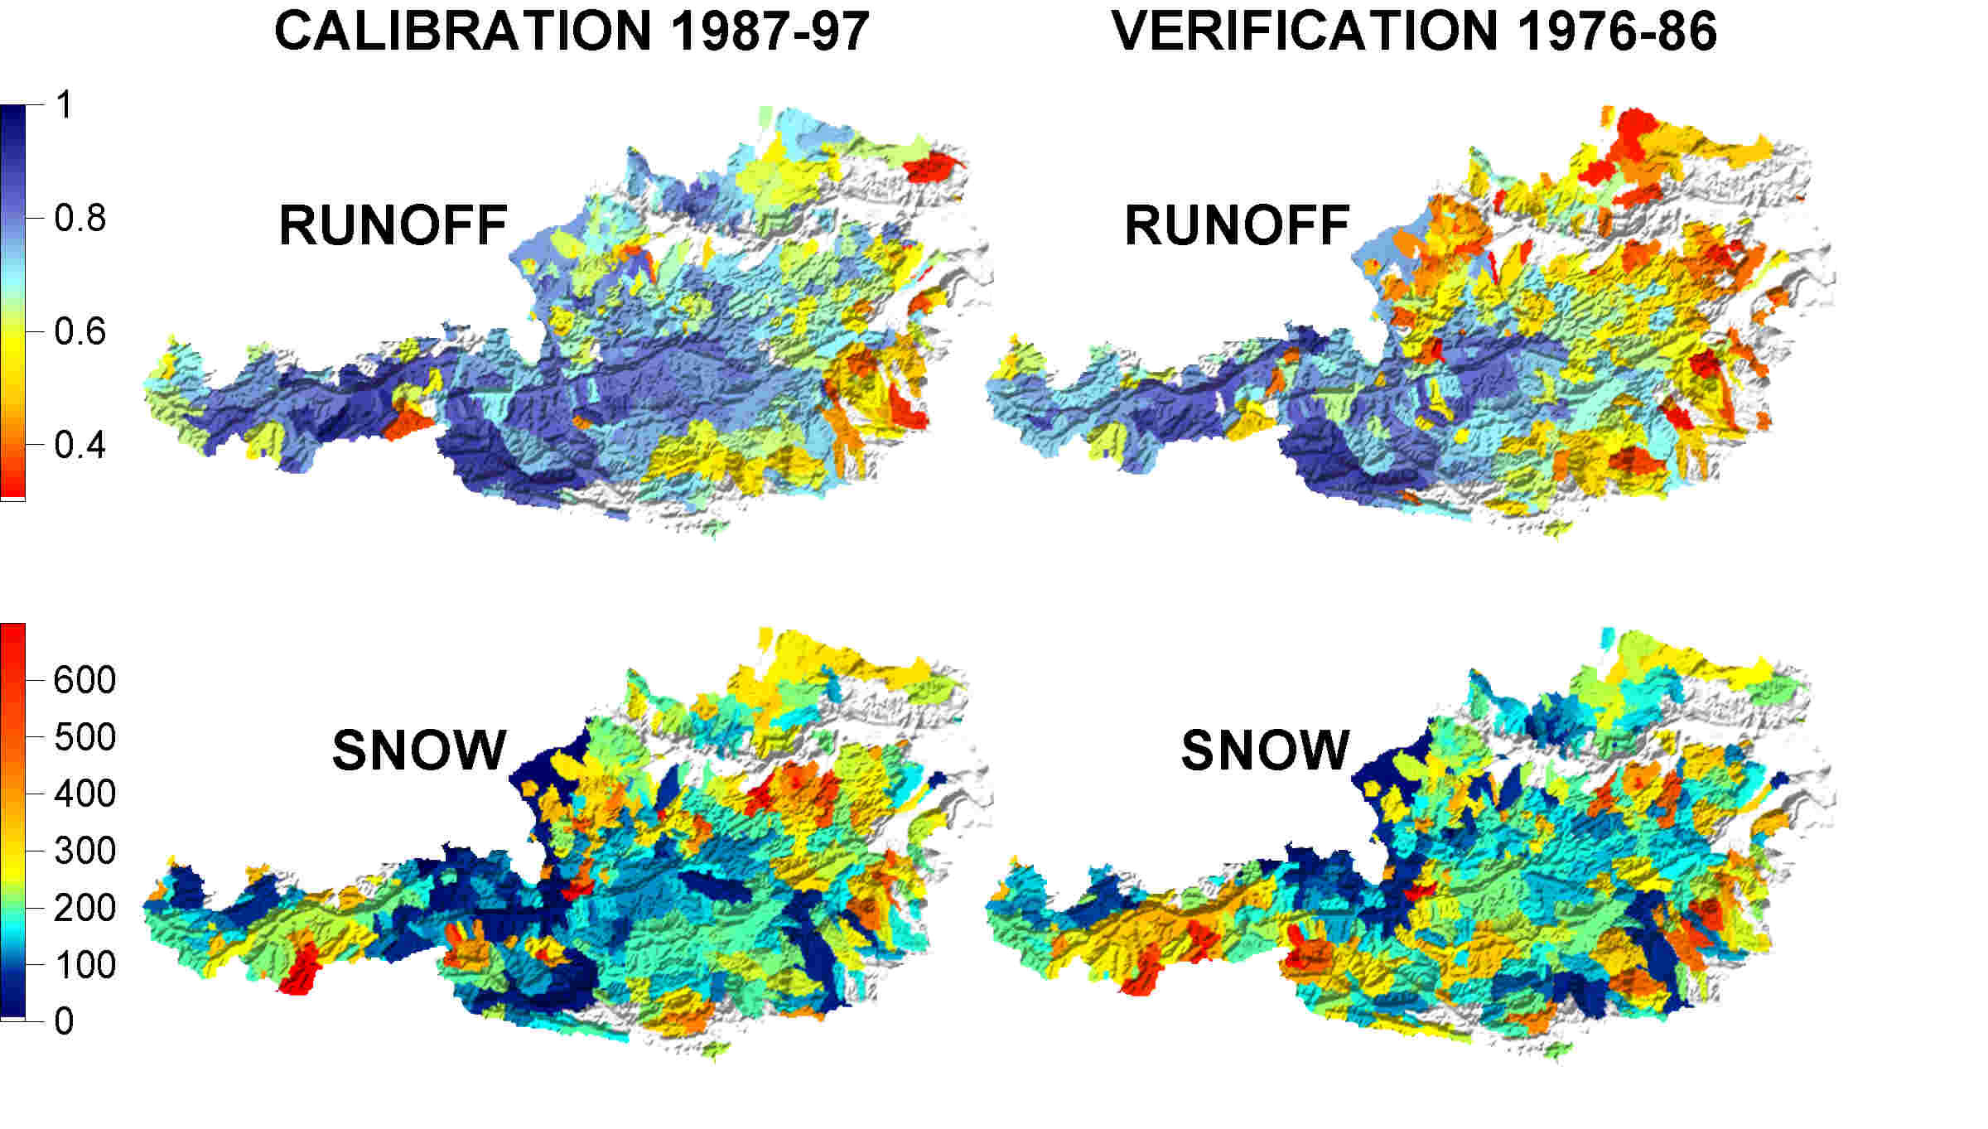
Figure 4. Regional patterns of the Nash-Sutcliffe model efficiency based on daily runoff (top, labelled "runoff") and number of days with poor snow cover simulations within an 11 year period (bottom, labelled "snow") for the calibration (left) and verification (right) periods. Red colours represent poor model performance; blue colours represent favourable model performance.

Results
In a second step, we used the parameter sets optimised for the calibration period (1987-1997) to simulate the daily water balance for all 538 catchments in the period from 1976-1997. In each catchment, the water balance components were calculated separately for different elevation zones. We were therefore able to obtain grid maps exhibiting subcatchment variability. For nested catchments, the components of the smaller catchments were plotted on top of those of the larger ones. The spatial patterns of the mean annual water balance components so estimated and other hydrologically relevant variables are presented in Figure 5.
The panels on the left show the mean annual water balance components for Austria. All water balance components exhibit a strong relation to topography. The highest values of corrected precipitation are observed along the northern fringe of the Alps, where the mean annual estimates exceed 2400 mm. The driest regions in Eastern Austria receive, on average, less than 550 mm precipitation per year. In some regions, the corrected annual precipitation is up to 15% larger than the uncorrected precipitation but in most catchments the difference is significantly smaller. Mean annual actual evapotranspiration estimates range from 0 mm in glacierised catchments to more than 600 mm in the lowlands of Eastern Austria.
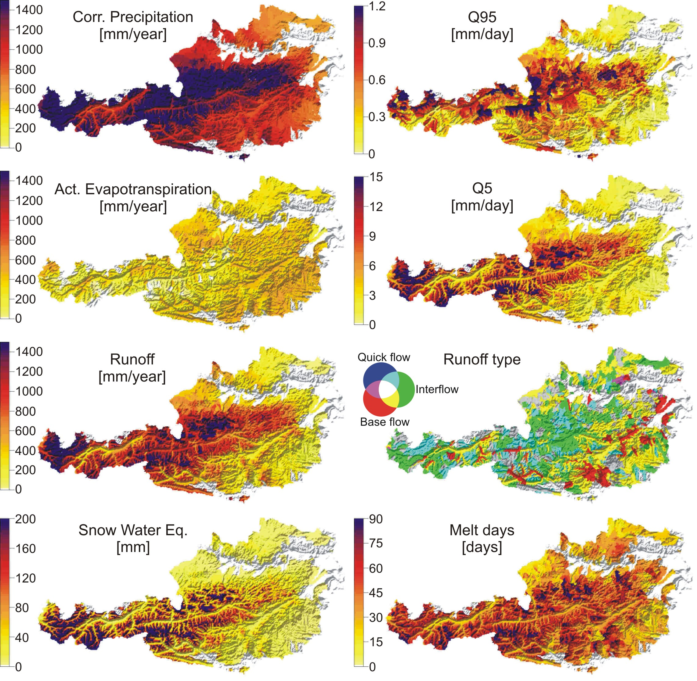
Figure 5. Estimated mean annual water balance components (panels on the left) and other hydrologically relevant variables (panels on the right) for the period 1976-1997.

The spatial patterns of mean annual runoff are very similar to the mean annual precipitation estimates. The highest values, more than 1700 mm, are simulated in the wettest regions of Austria. On the other hand, in the south-eastern part of Austria, the estimates of mean annual runoff are less than 100 mm. While in the Alpine areas almost all of the rainfall becomes runoff, in the eastern lowlands only one fifth or less becomes runoff. The rest is lost to evapotranspiration. The estimates of snow water equivalent, shown in the bottom left panel of Figure 5, represent the mean values over the days with snow cover in the period of 1976-1997. This water balance component exhibits the strongest relation to topography. The lowlands and the valleys show much lower values of the snow water equivalent than the mountains. In the lowlands, water equivalents average less than 20 mm while in the high Alpine regions the values exceed, on average in winter, 300 mm.
The panels on the right of Figure 5 show estimates of other hydrologically relevant variables for the same period 1976-1997. The Q95 low flow quantiles are the runoff depths that are exceeded, on average, on 95% of the days. Spatial patterns of this element are similar to estimates published in Laaha and Blöschl (2003). The lowest values of Q95 – less than 0.05 mm/day - were simulated for the south-eastern part of Austria, the highest values, greater than 1.5 mm/day were obtained for the Alpine regions. The Q5 high flow quantiles, are the runoff depths that are exceeded, on average, on 5% of the days. The estimates of this flood index range from more than 20 mm/day in the catchments located in the northern Alps to less than 0.5 mm/day in catchments in north-eastern Austria. The magnitude and spatial patterns of the high flow quantiles are very similar to the mean annual floods estimated by Merz (2002), although more spatial detail is provided here. The map of the runoff type index represents the relative contribution of the soil reservoirs as simulated by the model. The contribution of the lower reservoir is the slowest and can be thought of as base flow. If more than 90% of total runoff was simulated as base flow, the respective elevation zone has been colour coded as red. The contribution of the upper soil reservoir can be thought of as interflow and if more than 30% of total flow was interflow, green colours were assigned. The fastest component is excess outflow from the upper soil reservoir, which can be thought of as surface runoff. If the surface runoff was more than 2% of the total runoff, blue colours were assigned. Combinations of two of these criteria are displayed by combined colours (yellow, cyan and magenta). Grey represents a mix of the components. The spatial patterns of the runoff type suggest that base flow prevails in a number of mountain valleys and in the Vienna basin. The quick flow is relatively more important in the high rainfall areas at the northern fringe of the Alps. Figure 5 bottom right shows the spatial estimates of the average number of days with snowmelt in a year. In the high alpine regions melt occurs on more than 100 days in a year, in the lowlands and in the valleys melt occurs on less than 20 days in a year.
Each of the variables shown in Figure 5 exhibits significant seasonal variability. While a detailed analysis of the seasonal variability is beyond the scope of this paper and is presented elsewhere (Parajka et al., 2004) we will give the seasonal patterns of runoff as one example in Figure 6.
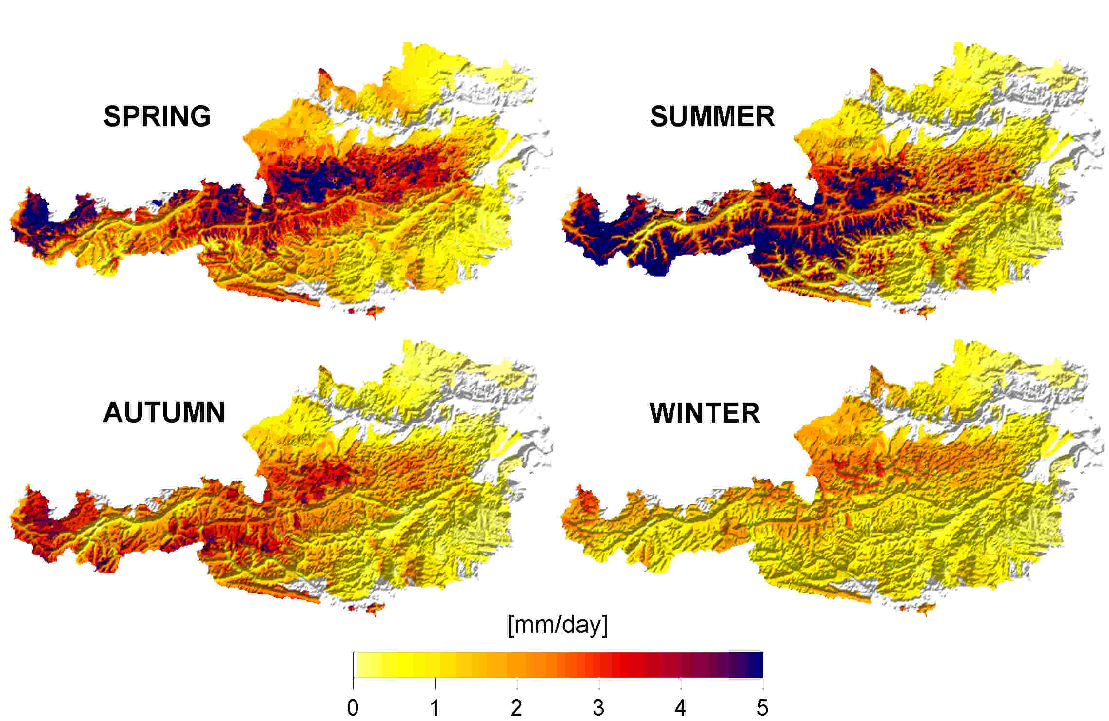
Figure 6. Mean seasonal simulated runoff depth for 1976–1997. Seasons are defined as: spring (March-May), summer (June-August), autumn (September-November), winter (December-February).

The largest seasonal runoff depths occur in summer in the Alpine regions (more than 15 mm/day), the second largest in spring at the northern fringe of the Alps. Runoff depths are always small in the eastern and south-eastern parts of Austria.

Conclusions
In this study we used both runoff data and snow depth data to calibrate a conceptual rainfall-runoff model for all gauged catchments in Austria. The favourable verification performance indicates that the parameter estimates are robust and that the model represents well the main characteristics of the catchments. The calibrated parameter sets were subsequently used for estimating the daily water balance components and other hydrologically variables for a number of elevation zones in each catchment. All results are plausible as compared to other regional analyses in the literature, which gives additional credence to the estimation results.

Acknowledgment
The authors would like to thank the Marie Curie Fellowship of the European Community programme HUMAN POTENTIAL under contract number HPMF-CT-2002-01872, the Austrian Science Foundation (FWF), project no. P14478-TEC, and the Austrian Academy of Sciences, project HÖ 18, for financial support. We would also like to thank the Austrian Hydrographic Service (HZB) for providing the hydrographic data.

References
Bergström, S. (1976): Development and application of a conceptual runoff model for Scandinavian catchments. Dept. Water Resour. Engng, Lund Inst. Technol./Univ. Lund, Bull. Ser. A52, 134 p.
Duan, Q., Sorooshian,S., Gupta, V. K. (1992): Effective and efficient global optimization for conceptual rainfall-runoff models. Water Resources Research, 28, p. 1015-1031.
Franchini, M. (1996): Use of a genetic algorithm combined with a local search method for the automatic calibration of conceptual rainfall-runoff models. Hydrological Sciences Journal, 41(1), p. 21-39.
Gupta, H. V., Bastidas, L. A., Vrugt, J. A., Sorooshian, S. (2003): Multiple criteria global optimization for watershed model calibration. In: Duan, et al. (Eds) Calibration of watershed models, Water Science and Application 6, AGU, Washington, p. 125-132.
Kuczera, G. (1997): Efficient subsurface probabilistic parameter optimization for catchment models. Water Resources Research, 33, p. 177-185.
Laaha, G., Blöschl, G. (2003): Saisonalität der Niederwasserspenden in Österreich, Mitteilungsblatt des Hydrographischen Dienstes in Österreich, 82, p. 59-68.
Merz, R. (2002): Understanding and estimating flood probabilities at the regional scale. Wiener Mitteilungen, Wasser-Abwasser-Gewässer, Band 181, Institut für Hydraulik, TU Wien, 193 pp.
Merz, R., Blöschl, G. (2004): Regionalisation of catchment model parameters. Journal of Hydrology 287, p. 95-123.
Parajka, J., Merz, R., Blöschl, G. (2003): Estimation of daily potential evapotranspiration for regional water balance modeling in Austria. In: 11th. International Poster Day and Institute of Hydrology Open Day “Transport of Water, Chemicals and Energy in the Soil – Crop Canopy – Atmosphere System”, 20. November 2003, Bratislava, Slovakia. Published on CD-ROM, Slovak Academy of Sciences , ISBN 80 – 89139 –02– 7, p. 299-306.
Parajka, J., Merz, R., Blöschl, G. (2004): Regionale Wasserbilanzkomponenten für Österreich auf Tagesbasis. Österreichischer Wasser- und Abfallwirtschaft Journal, in press.
Pebesma, E.J. (2001): Gstat user's manual. Dept. of Physical Geography, Utrecht University. Utrecht, The Netherlands.
Perrin, C., Michel, C. Andréassian, V. (2001): Does a large number of parameters enhance model performance? Comparative assessment of common catchment model structures on 429 catchments. Journal of Hydrology, 242, p. 275-301.
Seibert, J. (1999): Regionalisation of parameters for a conceptual rainfall-runoff model. Agricultural and Forest Meteorology, 98-99, p. 279-293.
Seibert, J., Mc Donnell, J. (2003): The quest for an improved dialog between modeler and experimentalist. In: Duan, et al. (Eds) Calibration of watershed models, Water Science and Application 6, AGU, Washington, p. 301-315.
Vrugt, J. A., Gupta, H. V., Bastidas, L. A., Bouten, V. Sorooshian, S. (2003): Effective and efficient algorithm for multi-objective optimization of hydrological models. Water Resources Research, 39, No. 8, 1214.

