APPLICATION OF MULTICRITERIA ANALYSIS ON WATER QUALITY MANGEMENT – THE DRAVA RIVER CASE STUDY

Mladen Petričec¹, Snježana Knezić², Nenad Mladineo³

¹Croatian Waters, Zagreb, Croatia, e-mail: petricec@voda.hr
²Faculty of Civil Engineering and Architecture, University of Split, Split, Croatia,
e-mail: knezic@gradst.hr
³Faculty of Civil Engineering and Architecture, University of Split, Split, Croatia, e-mail: mladineo@gradst.hr

Abstract: Water management in river basins relies on sustaining all stakeholder objectives and defining adequate solutions in order to meet the objectives in a compromise manner. Since a water system is evidently complex, it is very difficult to recognize all relationships among system elements and mutual influences between this and other systems as well as to evaluate all possible solutions. Therefore, in the process of management planning of a river basin, it is important to apply a system analysis. Even a superficial analysis of river basin management indicates that it belongs to the so-called “ill-defined problems”, therefore an application of the multicriteria analysis is the solution.
A system analysis which helps to recognize the system functions contributes to a better understanding of information flows, knowledge and decisions in the complex process of water resources management.
The principal objectives that originate from the need for “consistent balancing of all aspects of water condition and water uses: quantity and quality of available water, need for water, water consumption, pressures and influences on water” have to be expanded with the analysis of possible investments in the river basin as well as the analysis of other measures that can improve a water system state.
Multicriteria analysis of water quality management of the upper Drava basin pointed out to methodological, social and political advantages of such approach to this very complex problem. The advantage of adopted methodology is data transparency, which enables anyone to check if the parameters are correctly assessed.
Keywords: water quality management, multicriteria analysis, the Drava basin, Croatia

1. Introduction
Water resources management is, in principle, very complex, especially if it is related to the problems of water pollution. The complexity of a water system and the socio-economic factors demand a problem solving procedure which analyzes a larger number of variant solutions with different technical and technological characteristics, as well as social, economic and ecological influences.
The case study presented in this paper deals with the Drava River basin within the territory of the Republic of Croatia. The system analyzed herein, due to its physical, biological and institutional aspects, is very complex, and this complexity emerges in the management and decision processes. The case study deals with the upper part of the river basin, where there were significant deviations between the actual water quality and the figures quoted in the regulations. The causes for inadequate water quality differ, and along with the complexity of the mechanism of their action, contribute to the problem being ill-defined or unstructured. Moreover, decision makers were not fully aware of the exact values of the system parameters (unstructured information), and it was therefore decided to evaluate the procedure for strategic decision making process in the field of water quality management of the Drava basin.
Due to the unsatisfactory water quality and considering the referent water quality indicators, it was decided to determine the basic policy at the strategic level in order to achieve better water quality. This necessitated a study of the principle interaction mechanisms between the water, water system, environment, regulations and stakeholders, the selection of those that were most efficacious and combining them for the purpose of the system management policy evaluation.
Multicriteria analysis always poses the question about the relevancy of criteria taken into account and correctness of evaluation process, especially regarding those parameters that are evaluated by expert judgments. The Software Decision Lab 2000 has options for post-analysis and evaluation of what-if analysis. These options serve for removing a possible bias that is always present in decision process modelling.

RESULTS
EVALUATION OF ALTERNATIVES

INPUT
CRITERIA WEIGHTS DETERMINED BY SOCIAL AND POLITICAL AUTHORITIES AND OTHER EXPERTS

MULTICRITERIA ANALYSIS

INPUT
EXPERT TEAMS JUDGEMENTS

INPUT
FROM GIS ANALYSIS

CRITERIA USED IN GIS ANALYSIS:

Layout of criteria C1

Layout of criteria C2
.
.
.
.
.

.
.
.
Layout of criteria C13

Topology map

Figure 1: Schematic overview of multicriteria analysis procedures

The GIS support becomes an indispensable tool, which is the subject of interactive activity in the sense that spatial data are brought into a mutual relationship and logically ordered; on the other hand, it enables the detection of all potential involuntary errors and oversights in spatial analyses, such as possible "gaps” in data or inadequate accuracy of available maps. Figure 1 shows a general overview of multicriteria analysis procedures by using the GIS tools.

2. System analysis of the Drava River basin
The definition of the system scope depends on both decision and analysis context. In such case, the main subject is the lowering of pollution (point and disperse sources) by application of optimal protection measures within integrated water management. The system was therefore analyzed in a wider context for the purpose of defining all socio-economic, technical and ecological aspects of the problem. These aspects directly influence both the evaluation and selection processes of the variant solutions – the selection of optimal water protection measurements.
The main objective of the case study was to maximise water and environment quality of the Drava basin. This relates primarily to drinking water protection, as well as protection of water in the protected areas according to the regulations and nature preservation conventions. Fresh water protection is related to the regions declared as protected sanitary zones for water pumping facilities, where particular protection measures must be applied.
The problem solving procedure can be divided into two phases. The first phase analyzes basic solution concepts for a particular problem. The objective is to determine the rank of possible concepts/strategies as the problem solution. The second phase analyzes variant solutions that deal with particular projects within defined sub-objectives. The projects are limited by particular location, the type of water protection measures and the management plan for the region.
Generally speaking, in the process of generation of a variant solution in the field of water resources management there are three basic approaches:
- status quo option – “do nothing”;
- protection measures which do not include water structures, but change organisational and regulative aspects in the area – “legislative measures”;
- building structures as a part of management and protection policy - “technical measures”.
As previously explained, the basic objectives are aimed at variant solution generation. The analyzed data indicate that three dominant segments which show a significant interrelation with surface water quality can be determined:
- industry (I)
- agriculture (A)
- population (P)
In order to use the water resources of the Drava River in a sustainable manner in line with the needs of the entire region and in accordance with the national regulations on the uses of water resources, the interventions considered as management decisions are required. These interventions are management and planning strategies for the river water system, applied integrally and based on sectors. The procedure of strategy identification, i.e. generation of possible variant “actions” in the upper part of Drava river basin in Croatia is performed in several steps or decomposition levels. For the first level, different types of actions were considered and, as already mentioned, three dominant variants determined: (i) do nothing (N), (ii) legislative measures (L), (iii) technical measures (T).
The “do nothing” variant means keeping all system elements as found, apart from the regular maintenance, which was performed previously as well. The "legislative measures" variant means using the existing and establishing new forms of legislative activity to impact the system elements with the aim of improvement in surface water quality of the Drava River. Legislative measures include all non-technical activities, i.e. regulative and normative measures, administrative bans, incentive measures, such as changes in technological procedures, types of fertilizers or crops, etc.
Technological measures mean physical interventions in the system i.e. construction of public sanitation system facilities, such as preliminary treatment of industrial wastewater, etc., for the purpose of pollution reduction and water quality improvement.
The following step of the analysis, the third level, means spatial distribution of “action” variants, i.e. there is a possible limiting of either legislative or technical measures only to one or more areas (Figure 2). The shown example includes only considerations of areas A, B and C. Based on the pollution level, the absolute priority in taking either legislative or technical measures is given to area A, followed by areas B and C. Taking measures only in area B or C, or simultaneously in areas B and C, is not logical, since it would mean "bypassing" the hotspots of the system. For above reasons and considering the spatial distribution of potential activity measures, four activity sub-variants have been developed:
- A – taking measures only in area A (A)
- B - taking measures in areas A and B (A+B)
- C - taking measures in areas A and C (A+C)
- D - taking measures in areas A, B and C (A+B+C)

It should be noted that the efficiency of measures was evaluated by transfer from a lower to a higher water category, while simultaneously enabling all development activities and care for the ecosystem.
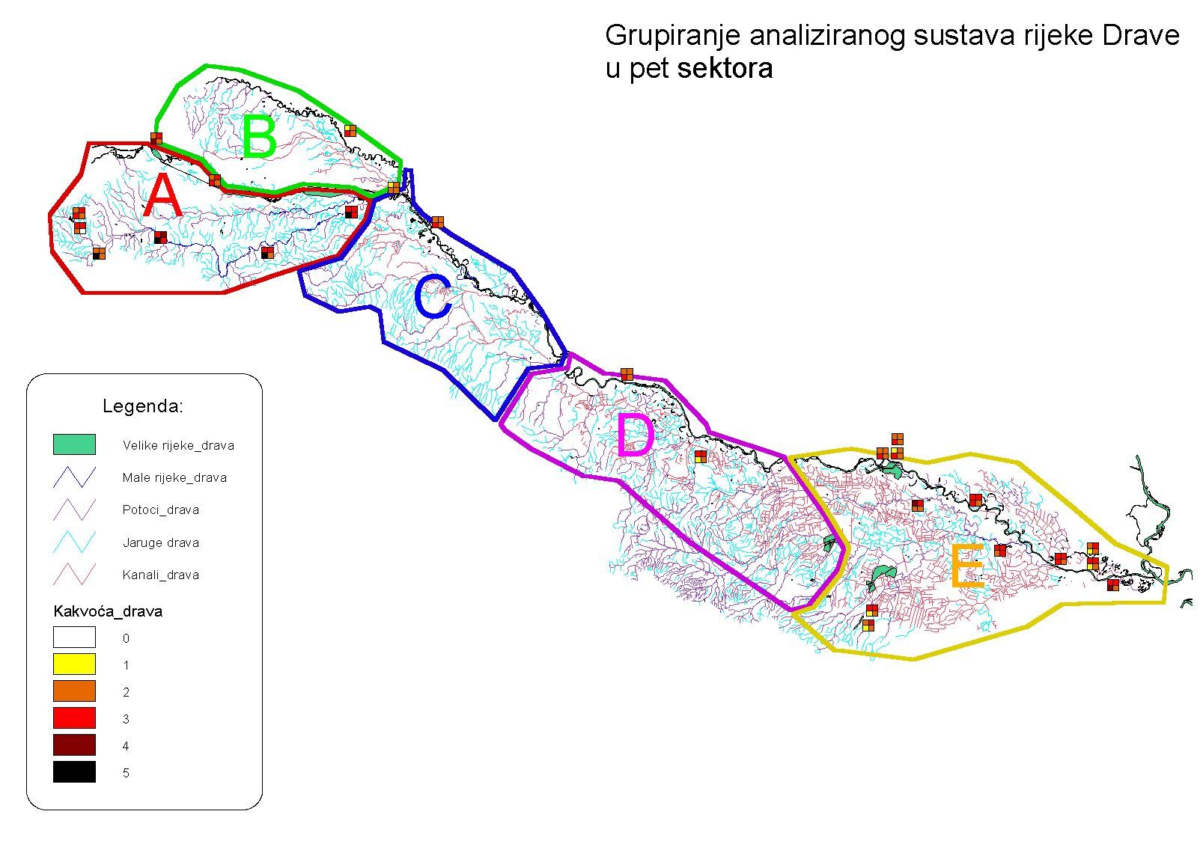

Figure 2: Grouping homogenous systems in the observed part of the Drava river basin
The selection of legislative or technical measures requires a certain gradation, which for legislative measures can mean population (or surface of agricultural land) covered by the measures (most frequently expressed in percentages), or the level of restrictiveness of prescribed measures (standard or very strict measures). Logically, the gradation of measures is in correlation with the pollution level; in other words, the measures have the "power", by applying restrictions, necessary to transfer a watercourse to a higher water quality level (e.g. from category IV to category III or II ).
By applying the same logic, technical measures also require gradation, which can relate to the treatment level at a wastewater treatment plant (e.g. only mechanical, or mechanical and biological treatment), number of obligatory connections to the sewerage system (also expressed in percentages), etc. The size of a technical intervention in the system (i.e. the size of investment) is correlated to the pollution level, i.e. the investment in the facilities has the "power" necessary to transfer water from a lower to a higher category. Based on the current knowledge of the system and its correlations, the following levels of potential measures have been determined:
- legislative measures
- industry: (1) 50 %, (2) 90 %
- agriculture: (1) 30 %, (2) 60 %
- technical measures
- industry: (1) 50 %, (2) 90 %
- population: (2) 30 %, (2) 60 %

Figure 3 gives a schematic overview of the generation of variant solutions, i.e. "actions" which can be taken in the system. At the first level decisions are made on the type of action, or possibly non-action, i.e. the selection of legislative or technical measures. At the following level decisions are made on the segment which will be impacted, i.e. whether action is directed at industry, agriculture or population. In this phase, the combinations of actions among the segments are not anticipated, but are allowed as an option in case the sensitivity analysis indicates to such need. At the third level legislative or technical measures are directed at individual areas, i.e. areas A, B or C.

Figure 3: Schematic overview of variant solutions generation
The matrix by which the procedure of variant solutions generation is modelled in accordance with defined levels (Table 1) is simultaneously used for the identification of realistic solutions, i.e. elimination of completely unrealistic solutions from further procedure. The sixth row in the table is used for determination of individual variant codes in order to make them easily recognizable in further procedure.
Each of 29 generated variants is a potential system management strategy for the Drava river basin; it is, therefore, essential to select the best strategy, or a group of best strategies, according to predefined objectives.
Professional literature, and even more so management practice, shows the presence of a relatively large number of methods or models for best solution generation. Since the selection of the multicriteria analysis has already been elaborated, the description and method of forming the input matrix, which is the first step in numerical processing, will be dealt with in the following section.
The evaluation of the "soundness" of individual solutions is performed through a group of criteria which present modelled positions of the decision maker with regards to the set objectives (Table 2). In other words, the set objectives and sub-objectives are made concrete through a group of criteria with the purpose of evaluating to which extent an individual variant (action) meets the set objectives. From Table 2 it is evident that the first group of criteria relates to "water quality", i.e. the criteria belonging to this group are used for evaluation of the soundness of the solution in relation to the set objective, i.e. ensuring the planned water category and simultaneously enabling the performance of economic activities which directly or indirectly use water resources. Thus the groups of criteria evaluate the following:
- C1_{(max)} –"highest water quality level possible "- evaluates to which extent an individual variant contributes to the increase in surface water quality, based on four parameters (oxygen, nutrients, microbiology, biological parameters).
- C2_{(max)} –"protection of drinking water quality in the protection zones"- evaluates to which extent an individual variant contributes to the increase in surface water quality in the drinking water protection zones.
- C3_{(max)} –"water quality for economy use"- evaluates to which extent an individual variant contributes to the increase in surface water quality for the purpose of their use for various economic uses, such as fish farming, tourism, etc.
- C4_{(max)} –" water quality for recreation"- evaluate to which extent an individual variant contributes to the increase in surface water quality for the purpose of watercourse use for recreation.
- C5_{(max)} –"water quality in protected areas"- evaluates to which extent an individual variant contributes to the increase in surface water quality in protected areas as defined by the Nature Protection Act, Forest Act and adopted international conventions.
The second group of criteria, "economic criteria", relates to those criteria through which costs or profits of each individual variant are expressed in specific monetary amounts (or relations).
- C6_{(min)} –"costs of intervention in the system"- evaluates to which extent an individual variant requires investment in the construction of a sewerage system, wastewater treatment plant, etc. The size of the investment can only be approximately assessed; it can, therefore, be expressed as a "relation", i.e. to which extent a variant is more or less expensive than the previous one, or a reference variant.
- C7_{(min)} –"reduced profit due to intervention in the system"- evaluates to which extent an individual variant reduces the profit per individual segment, primarily due to legislative measures (e.g. profit reduction in agriculture due to limited fertilizer use or in industry due to changes in technological processes or limited production).
- C8_{(max)} –"direct profit due to intervention in the system "- evaluates to which extent an individual variant contributes to increased profit in various economic water uses.
The third group of criteria, "general, financially unmeasurable profits from intervention in the system", relates to those criteria through which profits of each individual variant, not measurable in specific monetary amounts but assessed in mutual relations, are expressed.
- C9_{(max)} –"harmonized with the EU WFD "- evaluates to which extent an individual variant contributes to the harmonization with the European Water Framework Directive.
- C10_{(max)} –"increased quality of living"- evaluates to which extent an individual variant contributes to the increased quality of living.
- C11_{(min)} –"reduced level of endangering human health"- evaluates to which extent an individual variant contributes to the reduced level of endangering human health and safety.
- C12_{(max)} –"reduced level of endangering bio and zoo communities"- evaluates to which extent an individual variant contributes to the reduced level of endangering bio and zoo communities, i.e. sustaining biodiversity.
- C13_{(max)} –"increased level of system adaptability to disturbances in the environment"- evaluate to which extent an individual variant contributes to the increased level of system adaptability to disturbances in the environment, i.e. potential increase in its capacity in case of an accident.

3. Problem solving by multicriteria analysis method
The PROMETHEE (I, II) method is used as the software and concept for the Decision Support Systems for water quality management decision processes. Processing by PROMETHEE I method produces calculated «Phi» values, i.e. input (-) and output (+) flows or dominance relations of individual action pairs, as well as achieved rank based on the calculation of the net value by PROMETHEE II method. Method formulation includes multicriteria analysis characteristics that can be summarized as following:
- as the first step in problem solving, it is necessary to define criteria that characterize the problem in an integrated manner,
- alternative solutions, so-called actions, which are developed, represent alternatives, territorial areas, projects, plan variants, resources variant, or any other entities that have to be compared or ranked.
- each criterion is attributed its own weight, which represents its importance from the decision makers’ point of view.
- each criterion has a preference type representing the “formalization of decision makers’ behaviour”
- according to defined criteria, input data for each action are defined as absolute values (they can be defined as attribute expressions – values), which are in principle expressed in incomparable units (it is a very important characteristics, since for some criteria parameter values are expressed in units of water quality, or in the number of inhabitants of the analyzed area, in the quantity of certain crops, or in a specific currency if the costs or expected benefits after water quality protection measures have been conducted can be thus expressed).
Weights are obtained by calculating mean values based on expert estimations during interviews. The model base contains modules with mathematical and statistical packages as well as software for economic analysis (e.g. cost-benefit analysis). During project evaluation it has been observed that the ranking of the action could be obtained with criteria generated from the GIS, or obtained by expert estimations (meaning very fast and with relatively low estimation costs).
Processing results based on the Scenario 1 are shown in Table 3.

Moreover, the PROMETHEE method enables on-line weight stability analysis that is very important during the process of weight assessment by decision makers. Figure 4 shows the “screen“ with evaluated rank. Weight change (in the lower part of the screen) can be immediately seen on the upper part of the screen as the changed height of the bar representing the dominancy of particular action (municipality).

Table 1: Procedure of variant solutions generation based on predefined levels
I level  variant solution | Do nothing | Legislative measures |  |  |  |  |  |  |  |  |  |  |  |  |  |  |  |  |  |  |  |  |  |  |  | Technical measures
II level  variant solution |  | Industry |  |  |  |  |  |  |  | Agriculture |  |  |  |  |  |  |  | Population |  |  |  |  |  |  |  | Industry |  |  |  |  |  |  |  | Agriculture |  |  |  |  |  |  |  |  | Population
III level  variant solution |  | A |  | A + B |  | A + C |  | A + B + C |  | A |  | A + B |  | A + C |  | A + B + C |  | A |  | A + B |  | A + C |  | A + B + C |  | A |  | A + B |  | A + C |  | A + B + C |  | A |  | A + B |  | A + C |  |  | A + B + C |  | A |  | A + B |  | A + C |  | A + B + C
IV level of action |  | 50% | 90% | 50% | 90% | 50% | 90% | 50% | 90% | 30% | 60% | 30% | 60% | 30% | 60% | 30% | 60% |  |  |  |  |  |  |  |  | 50% | 90% | 50% | 90% | 50% | 90% | 50% | 90% |  |  |  |  |  |  |  |  |  | 30% | 60% | 30% | 60% | 30% | 60% | 30% | 60%
Realistic solutions | 1 | 1 | 1 | 1 | 1 | 1 | 1 | 1 | 1 | 1 | 1 | 1 | 1 | 0 | 0 | 0 | 0 | 0 | 0 | 0 | 0 | 0 | 0 | 0 | 0 | 1 | 1 | 1 | 1 | 1 | 1 | 1 | 1 | 0 | 0 | 0 | 0 |  | 0 | 0 | 0 | 0 | 1 | 1 | 1 | 1 | 1 | 1 | 1 | 1
Variant code | N000 | LIA1 | LIA2 | LIB1 | LIB2 | LIC1 | LIC2 | LID1 | LID2 | LPA1 | LPA2 | LPB1 | LPB2 |  |  |  |  |  |  |  |  |  |  |  |  | TIA1 | TIA2 | TIB1 | TIB2 | TIC1 | TIC2 | TID1 | TID2 |  |  |  |  |  |  |  |  |  | TSA1 | TSA2 | TSB1 | TSB2 | TSC1 | TSC2 | TSD1 | TSD2

Table 2: Overview of matrix for forming input data for multicriteria analysis
CRITERIA  ALTERNATIVE |  | Water quality |  |  |  |  | Economic criteria |  |  | Unmeasurable profits from intervention into the system
 |  | Highest water quality level as possible | Protection of water supply zones | Economic water uses | Water for recreation | Water in protected areas | Costs of intervention into the system (sewerage system) | Reduction of profit due to intervention into the system | Direct monetary benefits due to intervention into the system | General aspects of water and environment protection | Increase in the quality of living | Reduction of level of endangering human health | Reduction of level of endangering bio and zoo communities | Increase in adaptability of the system to disturbances
 |  | C1 | C2 | C3 | C4 | C5 | C6 | C7 | C8 | C9 | C10 | C11 | C12 | C13
 |  | MAX | MAX | MAX | MAX | MAX | MIN | MIN | MAX | MAX | MAX | MAX | MAX | MAX
1. | N000 | -34.21 | 0 | 0 | 0 | 0 | 0 | 0 | 0 | 0 | 0 | 0 | 0 | 0
2. | LIA1 | -21.57 | 1548 | 2.5 | 10 | 268 | 1 | 14 | 200 | 5 | 762 | 3335 | 1445 | 10
3. | LIA2 | -11.76 | 1857 | 3.0 | 12 | 322 | 1.45 | 21.4 | 240 | 6 | 914 | 4002 | 1734 | 12
4. | L1B1 | - 9.86 | 2310 | 9.5 | 15 | 278 | 2.5 | 23.5 | 560 | 7 | 1160 | 4930 | 1910 | 17.5
5. | LIB2 | 4.57 | 2771 | 11.4 | 18 | 334 | 3.8 | 33.7 | 640 | 8 | 1392 | 5916 | 2292 | 21
6. | LIC1 | - 8.52 | 2067 | 3.5 | 35 | 442 | 1.75 | 23.5 | 360 | 6 | 1000 | 5210 | 2160 | 30
7. | LIC2 | 9.63 | 2481 | 4.2 | 42 | 530 | 2.7 | 35.7 | 420 | 7 | 1200 | 6252 | 2592 | 36
8. | LID1 | 3.19 | 2849 | 10.5 | 40 | 451 | 3.3 | 33 | 900 | 9 | 1400 | 6805 | 2625 | 37.5
9. | LID2 | 25.96 | 3419 | 12.6 | 48 | 542 | 5 | 50 | 1000 | 10 | 1680 | 8166 | 3150 | 45
10. | LPA1 | -21.57 | 928 | 1.5 | 6 | 161 | 1.9 | 25 | 120 | 3 | 456 | 2001 | 867 | 6
11. | LPA2 | -11.76 | 1238 | 2.0 | 8 | 215 | 2.9 | 38 | 160 | 4 | 608 | 2668 | 1156 | 8
12. | LPB1 | - 9.86 | 1385 | 5.7 | 9 | 167 | 5 | 44 | 400 | 5 | 696 | 2958 | 1146 | 10.5
13. | LPB2 | 4.57 | 1847 | 7.6 | 12 | 222 | 7.6 | 67 | 560 | 7 | 928 | 3944 | 1528 | 14
14. | TIA1 | -21.57 | 928 | 1.5 | 6 | 161 | 8.7 | 0 | 120 | 3 | 456 | 2001 | 867 | 6
15. | TIA2 | -11.76 | 1238 | 4.5 | 8 | 215 | 13.3 | 0 | 160 | 4 | 608 | 2668 | 1156 | 8
16. | TIB1 | - 9.86 | 1385 | 5.7 | 9 | 167 | 17.7 | 0 | 400 | 5 | 696 | 2958 | 1146 | 10.5
17. | TIB2 | 4.57 | 1847 | 7.6 | 12 | 222 | 23.9 | 0 | 480 | 6 | 928 | 3944 | 1528 | 14
18. | TIC1 | - 8.52 | 1240 | 2.1 | 21 | 265 | 15 | 0 | 240 | 4 | 600 | 3126 | 1296 | 18
19. | TIC2 | 9.63 | 1654 | 2.8 | 28 | 354 | 22.8 | 0 | 300 | 5 | 800 | 4168 | 1728 | 24
20. | TID1 | 3.19 | 1709 | 6.3 | 24 | 271 | 22.7 | 0 | 700 | 7 | 840 | 4083 | 1575 | 22.5
21. | TID2 | 25.96 | 2279 | 8.4 | 32 | 361 | 34.5 | 0 | 800 | 8 | 1120 | 5444 | 2100 | 30
22. | TSA1 | -21.57 | 619 | 1.0 | 4 | 107 | 19 | 0 | 80 | 2 | 304 | 1334 | 578 | 4
23. | TSA2 | -11.76 | 928 | 1.5 | 6 | 161 | 29 | 0 | 120 | 3 | 456 | 2001 | 867 | 6
24. | TSB1 | - 9.86 | 924 | 3.8 | 6 | 111 | 50 | 0 | 320 | 4 | 464 | 1972 | 764 | 7
25. | TSB2 | 4.57 | 1385 | 5.7 | 9 | 167 | 76 | 0 | 400 | 5 | 696 | 2958 | 1146 | 10.5
26. | TSC1 | -8.52 | 827 | 1.4 | 14 | 177 | 35 | 0 | 180 | 3 | 400 | 2084 | 864 | 12
27. | TSC2 | 9.63 | 240 | 2.1 | 21 | 265 | 54 | 0 | 240 | 4 | 600 | 3126 | 1296 | 18
28. | TSD1 | 3.19 | 1140 | 4.2 | 16 | 181 | 66 | 0 | 600 | 6 | 560 | 2722 | 1050 | 15
29. | TSD2 | 25.96 | 1709 | 6.3 | 24 | 271 | 100 | 0 | 700 | 7 | 840 | 4083 | 1575 | 22.5
Težine | Sc.1 | 80 | 100 | 90 | 70 | 60 | 48 | 36 | 60 | 18 | 24 | 30 | 18 | 12
Kriterija | Sc.2 | 3 | 10 | 6 | 6 | 5 | 8 | 8 | 3 | 5 | 3 | 10 | 4 | 2

Table 3 – Results of ranking according to Scenario 1
Variants | Phi Plus | Phi Minus | Phi Net | Ranking
N000 | 0,0386 | 0,3745 | -0,3359 | 29
LIA1 | 0,0758 | 0,1383 | -0,0625 | 18
LIA2 | 0,1051 | 0,1086 | -0,0035 | 13
LIB1 | 0,1901 | 0,0674 | 0,1227 | 6
LIB2 | 0,2698 | 0,0538 | 0,2160 | 4
LIC1 | 0,1920 | 0,0738 | 0,1182 | 7
LIC2 | 0,2759 | 0,0604 | 0,2155 | 5
LID1 | 0,3588 | 0,0372 | 0,3216 | 2
LID2 | 0,4987 | 0,0476 | 0,4511 | 1
LPA1 | 0,0332 | 0,2204 | -0,1872 | 27
LPA2 | 0,0450 | 0,1808 | -0,1358 | 22
LPB1 | 0,0708 | 0,1509 | -0,0800 | 21
LPB2 | 0,1330 | 0,1320 | 0,0009 | 12
TIA1 | 0,0415 | 0,2032 | -0,1617 | 25
TIA2 | 0,0646 | 0,1390 | -0,0744 | 20
TIB1 | 0,0813 | 0,1172 | -0,0359 | 14
TIB2 | 0,1398 | 0,0741 | 0,0657 | 10
TIC1 | 0,0816 | 0,1221 | -0,0405 | 15
TIC2 | 0,1459 | 0,0798 | 0,0661 | 9
TID1 | 0,1636 | 0,0591 | 0,1045 | 8
TID2 | 0,2825 | 0,0364 | 0,2461 | 3
TSA1 | 0,0324 | 0,2588 | -0,2264 | 28
TSA2 | 0,0362 | 0,2032 | -0,1671 | 26
TSB1 | 0,0447 | 0,1985 | -0,1538 | 24
TSB2 | 0,0829 | 0,1538 | -0,0709 | 19
TSC1 | 0,0445 | 0,1920 | -0,1475 | 23
TSC2 | 0,0887 | 0,1405 | -0,0518 | 16
TSD1 | 0,0892 | 0,1462 | -0,0570 | 17
TSD2 | 0,1828 | 0,1195 | 0.0633 | 11

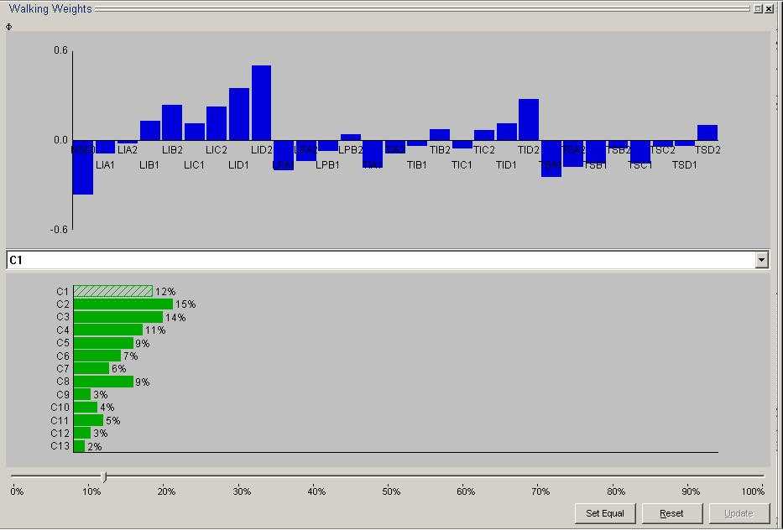

Figure 4: Graphical overview of relations of dominance actions (variant solution) and walking weights

5. Conclusions
Multicriteria analysis of the problem of water quality management of the upper Drava river basin has indicated to a number of methodological and socio-economic advantages of such approach to a very complex issue. The procedure of multicriteria analysis itself, if correctly conducted, requires cooperation practically involves all relevant stakeholders in the decision making process, which makes the implementation of priorities easier and dispels doubts as to a bias in the approach to the problem.
Many are dependent on water resources, so from a sociological viewpoint one has to bear in mind the fact that most activities in settlements close to watercourses have traditionally taken place at their banks, be it transport, economic activities or recreation in particular (walks, swimming, rowing, amateur fishing). Therefore there numerous inter-levels from the "ordinary" farmer or fisherman, over economic subjects which use water resources to forums and representative bodies of municipalities and the county, who are directly or indirectly interested in solving problems in a manner which does not harm their interests. More or less, they all expect their demands to receive priority treatments, and their interest in the correctness and “fairness” of process must be respected.
By offering insight into the process of selecting the optimal solution, tensions are relieved and at least partially alleviated frustrations over possible harming of “their” interests. On the other hand, the insight into the very process of selecting the optimal solution creates a climate of trusts and strengthens the opinion that the assessment of interests is perfumed "fairly", since they too can check most criteria based on which decisions are made. Transparency of available data which are the basis for analysis is of extreme importance.
From the methodological viewpoint, multicriterial analysis anticipates a systematic approach, which is methodologically the most efficient and most functional approach to problem solving.
Multicriterial analysis always questions whether all relevant criteria are taken into account and correctly assessed, particularly parameters which are the "result” of expert judgement.
For all above reasons, the Decision Lab 2000 programme support contains numerous options of "post" analysis and simulation assessment (e.g. “Walking Weights” option) for the purpose of maximally eliminating bias which is always present in modelling of "behaviour" in decision making.

6. References
- Brans, J.P., Mareschal, B. and VINCKE, P. (1984) 'PROMETHEE: A new family of outranking methods in MCDM', in IFORS'84, North Holland.
- Brans, J.P. and Mareschal, B. (1994) 'PROMCALC & GAIA : A new decision support system for multicriteria decision aid.', Decision Support Systems, 12, pp.297-310.
- Flug M., Seitz H.L.H., Scott J.F., (2000), Multicriteria decision analysis applied to Glen Canyon Dam, Journal of Water Resources Planning and Management, Vol.126, No.5. pp. 270-276
- Jankowski, P. (1995), “Integrating GIS and Multicriteria Decision Making Methods.” International Journal of Geographical Information Systems (3):251-273.
- Jankowski, P., M. Stasik., (1997) Spatial Understanding and Decision Support System - a Prototype for Public GIS. Transactions in GIS
- Jankowski P., Nyerges T. L., Smith A., Moore T. J. and Horvath E., (1997), Spatial group choice: a SDSS tool for collaborative spatial decision-making, International Journal of Geographical Information Science Publisher: Taylor & Francis Issue: Volume 11, Number 6/September 1, Pp. 577 - 602
- Jankowski, P., (1997), The use of Multiple Criteria Decision-Making Tools in GIS-Supported Collaborative Decision-Making. Paper presented at Forty-Forth North American Meeting of Regional Science Association International, Buffalo, Nov. 6-8
- Jankowski P., A. Lotov, and D. Gusev, (1999), Application of Multicriteria Trade-off Approach to Spatial Decision Making. In: J-C. Thill (Ed.) GIS and Multiple Criteria Decision Making: A Geographic Information Science Perspective, London: Ashgate, pp. 127-148.
- Jankowski. P., (2000), Collaborative spatial decision making in environmental restoration management: and experimental approach. Journal of Hydroinformatics, 2:3, pp.197-206.
- Jankowski, P. and T. Nyerges, (2001), GIS-Supported collaborative decision making: results of an experiment, Annals of the Association of American Geographers, 91(1), p.48-70.
- Jankowski P., Andrienko N., Andrienko G., (2001), Map-centred exploratory approach to multiple criteria spatial decision making, International Journal of Geographical Information Science Publisher: Taylor & Francis Issue: Volume 15, Number 2/March 1, 2001 pp. 101 - 127
- Jiang H., Eastman J.R., (2000), Application of fuzzy measures in multi-criteria evaluation in GIS, Journal of Geographic Information Science, Taylor&Francis, Vol. 14, No. 2
- Joerin F., Golay F., Musy A., (1998), GIS and Multicriteria Analysis for Land Management, Proceedings of COST-UCE Action 4 Conference, Information Technology in Urban Civil Engineering Sweden
- Knezić S., Margeta J., (2002), Integrated Management of Coastal Sewerage Systems: The Case of Kaštela Bay, Croatia, Water Resources Management, Vol. 16, No. 4, pp. 279-305.
- Margeta J., Knezić S., (2002), Selection of the Flood Management Solution of Karstic Field, Vrgorsko polje Case Study, Water International, Vol. 27, No. 3, pp. 431-441
- Mladineo, N., Stošić, S., i dr., (1992), The Application of Multicriterional Analysis for the Estimation of Pollution in Urban and Coastal Zones, Revue des systems de decision, Hermes, Paris Vol.1 No.4
- Mladineo N., Lozić I., Stošić-Knezić S., Mlinarić D., Radica T., (1992), An Evaluation of Multicriteria Analysis for DSS in Public Policy Decision, European Journal of Operational Research 61 219-229.

