Modelling the effect of sewerage overflow chambers on stream meter quality

Jaromír Říha, Tomáš Julínek, Jana Buchtová

Water Structures Institute, Faculty of Civil Engineering, Brno University of Technology, Brno, Czech Republic, e-mail: riha.j@fce.vutbr.cz

Abstract: The paper deals with the assessment of the pollution of the streams in the Brno area due to releases from storm water separators. The present state was compared with the newly proposed system of separators and storm tanks for six water quality indicators, namely BOD, COD, Ammonia nitrogen, total Nitrogen, Phosphorus and undissolved solids. The effect of the system proposed was assessed for two hydrological scenarios characterized by Q_{a} and Q₂₇₀ discharges. The comparison was carried out using a dynamic stream water quality model. The results of the research are expressed in terms of concentration of individual pollutants. The results of the solution proved a considerable improvement of the stream water quality by the newly proposed system during storm events.
Keywords: stream water quality, storm water separator, water quality modelling.

Modellierung der auswirkung der kanalisationÜberlaufkammern auf die WassermeterqualitÄt

Zusammenfassung: Das Referat behandelt die Auswertung der Fließgewässerverschmutzung in der Umgebung von Brno verursacht von Ablässen aus Űberlaufkammern. Der jetzige Zustand wurde mit dem neu vorgeschlagenen System für sechs Wasserqualitätkennzeichen verglichen, nämlich BSB, CSB, Ammoniak Stickstoff, Stickstoff insgesamt und Phosphor und ungelöste Feststoffe. Die Auswirkung des vorgeschlagenen Systems wurde für zwei hydrologische Szenarios ausgewertet charakterisiert von Q_{a} und Q₂₇₀. Der Vergleich wurde mittels dem dynamischen Fließgewässerqualitätsmodel ausgeführt. Die Lösungsergebnisse sind im Hinblick auf die Konzentration der einzelnen Schadstoffe formuliert. Die Lösung bewies eine erhebliche Aufbesserung in der Fließgewässerqualität während des Gewitters.
Schlüsselworte: Fließgewässerqualität, Űberlaufkammer, Wasserqualitätmodellierung

1. Introduction
Within the comprehensive reconstruction of the sewer network in the city of Brno, improvement of storm water separators is planned. A part of sewerage rehabilitation is also the design of storm tanks transforming peak discharges in the sewers and hence decreasing an amount of polluted water released to receivers.
The purpose of the study was to assess the course of concentration of six water quality indicators (BOD, COD, Ammonia nitrogen, total Nitrogen and Phosphorus, undissolved solids) in rivers in the Brno area. Those are the Svratka and the Svitava rivers, the stream Leskava and the Svitava headrace connecting the Svratka, Svitava and the Ponavka rivers (Fig. 1). Work consisted in the following steps:
- basic data assembly and analysis;
- design and set-up of a numerical model;
- numerical tests and solution;
- evaluation of results obtained.
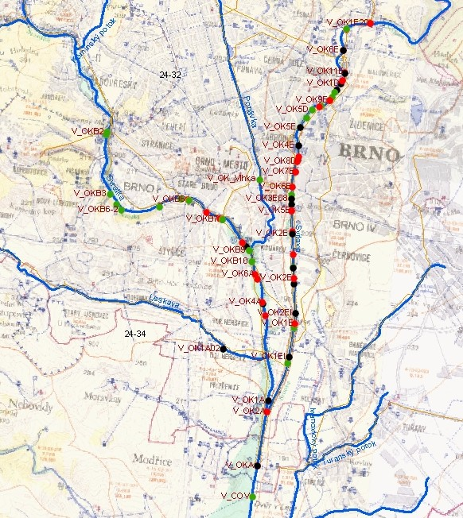

Fig. 1 Scheme of the area of interest

2. Data acquisition and manipulation
The following data were collected and prepared in an appropriate form for the numerical modelling:
- information on river network topology (e.g. bifurcation points, reach lengths, flow direction, etc.);
- stream geometry (cross sections) including information about structures (weirs, bed drops, bridges);
- catchment and stream hydrological parameters (e.g. catchment area, precipitation, rainfall-runoff, surface coverage, data from monitoring network – discharges and concentrations etc.);
- water intakes, pools and water reservoirs;
- location of pollution sources, storm water overflows;
- data about time series of a waste water release from individual separators and about water quality of the released waste water.
The data about the catchment and stream topology were obtained from the Morava River Basin Board, the hydrological data from the Czech Hydrometeorological Institute and the data about the waste water release from the numerical simulation of the run-off process and hydrodynamics of the sewer network.
The concentration of individual components in the water released was derived from the observed data in the sewer network during extreme rainfalls. Three sampling “campaignes” were organised by the South-Moravian Water Supply Administration to gather realistic pollution data in the sewers during storm events in various parts of the city of Brno. The data obtained were compared with generally used waste water quality data.
All the information can be considered as spatial data with a specified location and properties. Therefore they were processed using the ARC VIEW geographic information system (GIS) tool. Further on, GIS in connection with the numerical model make possible an integrated data analysis and processing.

3. Numerical model
The numerical model was applied to evaluate the present state of water quality in streams of interest and to assess the effect of possible scenarios on the stream water pollution improvement. The model was applied to predict the effects of proposed measures on the stream water quality. The process of a gradual “switching on” of individual separators was solved using a hydraulic and transport-dispersion one-dimensional model according to the equation (1).
$\frac{∂c}{∂t}=−\frac{∂(v\text{.}c)}{∂x}+\frac{∂(D\text{.}\frac{∂c}{∂x})}{∂x}−K⋅c$ (1)
with concentration c, mean stream velocity v, dispersion coefficient D and constitutive changes constant K. Boundary conditions were specified as known concentration in upstream river profiles and zero concentration gradient in the downstream profile in the Svratka river in Zidlochovice. An initial concentration was derived from concentration values observed during “no pollution” period (see table 1).

Table 1. Initial conditions
Stream | River reach | c [mg/l]
Stream | River reach | BOD | COD | N-NH₄ | N_{TOT} | P_{TOT} | US
Svratka | From Brno dam to the Svitava | 3 | 20 | 0.25 | 4.00 | 0.12 | 10
Svratka | From the Svitava to WWTP Modrice | 3 | 20 | 0.25 | 4.50 | 0.12 | 10
Svratka | From WWTP Modrice to Rajhrad | 6 | 25 | 1.50 | 7.00 | 0.25 | 17
Svitava | From Obrany to the Svratka | 3 | 20 | 0.25 | 6.00 | 0.20 | 9.0
Leskava | Entire stream | 4 | 21 | 0.30 | 6.00 | 0.20 | 9.0
Svitava race | Between the Svitava and the Svratka | 3 | 20 | 0.25 | 6.00 | 0.20 | 9.0

The effect of transversal mixing was neglected as the separators are located mostly on both banks of streams analysed.
In equation (1), dispersion coefficient was alternatively expressed as a product of stream velocity v and constant B (D = v.B). Model parameters (namely dispersion coefficient D, constant B and constant of constitutive changes K) were derived from a previous research. From 1992 to 1999 the comprehensive stream water quality model calibration was carried out in about 400 km river network. Further on, two sampling tests were organised in the Svitava and Svratka rivers (Riha et al 2001). The model parameters used for individual river reaches and for water quality indicators are shown in tables 2 and 3.

Table 2 Constants of constitutive changes K

Water quality indicator | Svratka K [1/day] | Svitava K [1/day]
BOD | 0.30 | 0.25
COD | 0.10 | 0.10
NH₄-N | 0.60 | 0.40
N_{TOT} | 0.70 | 0.55
P_{TOT} | 0.80 | 0.7
Undissolved solids | 0.85 | 0.65

Tab. 3 Applied values of dispersion coefficient D and river morphology constant B

Stream | D [m²/s] | B [m]
Svratka upstream from the Svitava | 6.5 | 14.5
Svratka downstream from the Svitava | 6.0 | 15
Svitava | 7.0 | 16
Leskava | 8.0 | 20
Svitava race | 7.5 | 19

4. The use of geographic information system
Most of the data mentioned were processed by GIS system (ESRI ARC VIEW tool). As usual, the geo-database respects a structure and a format of the numerical model while paying the great attention to link properly the database and software used for modelling purposes. Some minor programming was done using the Visual Basic programming language (Booth, Lamirand 2003).
First of all, a conceptual data model was created. The data model corresponds to purposes of the designed GIS and reflects only the system components related to the problems of a sudden deterioration of water quality due to the waste water released through separators. Therefore the data model relates hydraulic and hydrologic features to locations of storm water overflows.
Some routines were also made to enable an easy exchange of data between the model and GIS, in order to prepare input data and to process analysed output data. For example the GIS extension Tracking Analyst illustrating the migration of the pollutant was proposed. Based on the results of modelling the front of the pollution wave, its peak and tail in the given time are symbolized by differently coloured dots. In this way the time of the pass of pollution front and peak in a specified location can be assessed and interpreted using GIS (see figure 2).

5. Results and conclusions
The objective of the study was to assess the influence of the releases from the set of storm water separators on the stream water quality in urban area of the city of Brno. Two scenarios were solved, namely the present state and the proposed set of improvements regarding reconstruction of separators and rainfall storage tanks, an increase of sewer mains capacity and a comprehensive waste water treatment plant intensification.
The results of modelling showed that:
- at present state, the stream water quality during the extreme rainfall events in the Brno area exceeds prescribed water quality standards more than 10 times (in some cases, e.g. at the Svitava river and N-NH₄ more than 20 times),
- the improvements mentioned above will considerably decrease the pollution released. At the most critical reaches along the Svratka and Svitava river the concentration will be improved by approx. 50 %. However the stream water quality standards (immission limits) during such an extreme event will not be reached,
- in case of a simulated extreme event the water quality standards in rivers analysed will be violated for the period exceeding more than two hours by approximately 3 times bigger concentrations than those permitted (extremely at smaller courses exceeded 20 times, but for a shorter period).

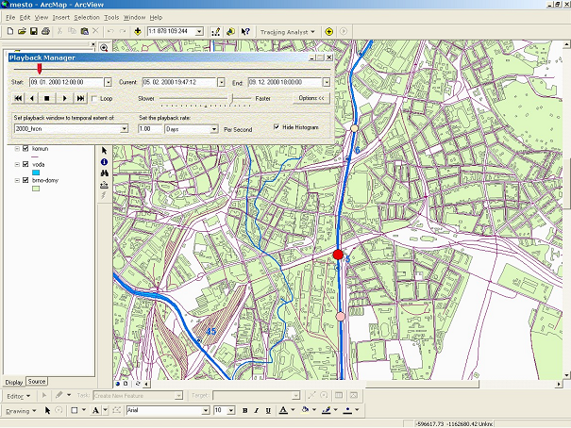
Fig. 2 GIS interpretation of the front, peak and tail of the pollution wave

The results of the solution are summarized in tables 4 and 5. The maximum calculated concentrations of pollutants observed along the individual river reaches are mentioned and compared with immission limits according the directive of the government of the Czech Republic No. 61/2003 about permissible water quality limits in open channels.
The project was performed in co-operation with Aquatis, JSC Consulting Engineers, which provided the stream water quality model with the released discharges and pollution from the sewerage system via strormwater separators.

Tab. 4 Maximum calculated concentrations of pollutants in [mg/l] and multiple of immission limit – present state at discharge Q_{a}
Water quality  indicator | Maximum concentration in [mg/l] / multiple of immission limit
Water quality  indicator | Svratka above Svitava | Svratka below Svitava | Svitava | Leskava | Svitava race | Immission limit
BOD | 116.3 / 19.4 | 64.8 / 10.8 | 61.5 / 10.3 | 4.0 / 0.7 | 169.1 / 28.2 | 6
COD | 293.1 / 8.4 | 192.6 / 5.5 | 195.3 / 5.6 | 22.0 / 0.6 | 260.0 / 7.4 | 35
N-NH₄ | 6.02 / 12.0 | 5.57 / 11.1 | 11.13 / 22.3 | 0.30 / 0.6 | 5.39 / 10.8 | 0.5
N_{TOT} | 25.6 / 3.2 | 16.1 / 2.0 | 22.1 / 2.8 | 5.5 / 0.7 | 35.6 / 4.5 | 8
P_{TOT} | 4.78 / 31.9 | 2.46 / 16.4 | 2.11 / 14.1 | 0.40 / 2.7 | 7.05 / 47.0 | 0.15
Undiss.solids | 661.8 / 26.5 | 351.0 / 16.4 | 281.1 / 14.1 | 10 / 0.4 | 897.7 / 35.9 | 25
Stationing [km] | 44.11 | 40.19 | 2.14; 11.2 | 1.15 | 2.28

Tab. 5 Maximum calculated concentrations of pollutants in [mg/l] and multiple of immission limit – after proposed improvements at discharge Q_{a}
Water quality  indicator | Maximum concentration in [mg/l] / multiple of immission limit
Water quality  indicator | Svratka above Svitava | Svratka below Svitava | Svitava | Leskava | Svitava race | Immission limit
BOD | 64.7 / 10.8 | 35.3 / 5.9 | 30.3 / 5.1 | 89.8 / 15.0 | 95.3 / 15.9 | 6
COD | 177.5 / 5.1 | 105.3 / 3.0 | 97.6 / 2.8 | 241.6 / 6.9 | 255.5 / 7.3 | 35
N-NH₄ | 3.48 / 7.0 | 3.04 / 6.1 | 5.11 / 10.2 | 4.80 / 9.6 | 5.09 / 10.2 | 0.5
N_{TOT} | 14.8 / 1.9 | 10.0 / 1.3 | 11.1 / 1.4 | 18.7 / 2.3 | 19.6 / 2.5 | 8
P_{TOT} | 2.78 / 18.5 | 1.47 / 9.8 | 1.13 / 7.5 | 3.78 / 25.2 | 4.0 / 26.7 | 0.15
Undiss.solids | 404.7 / 16.2 | 191.0 / 7.6 | 137.3 / 5.5 | 568.6 / 22.7 | 605.0 / 24.2 | 25
Stationing [km] | 44.11 | 40.19 | 2.14 | 1.15 | 2.28

As an examples the comparison of modelling results in terms of BOD concentrations in the Svratka and Svitava rivers is shown in Figures. 3 and 4. The stream junctions and stormwater separators locations are shown in Fig. 1.

Fig. 3 Comparison of the present and proposed state in the Svratka river – maximum BOD concentration at the discharge - Q_{a}

Fig. 4 Comparison of the present and proposed state in the Svitava river –maximum BOD concentration at the discharge Q_{a}

6. References
Riha, J. et al. (2001) The results of sampling tests in the Svitava and Svratka rivers. Final Report of Grant project GACR No. 103/99/0456. Water Structures Institute, FCE BTU Brno.
Booth B., Crosier S., Clark J., MacDonald A. (2002) “Building a Geodatabase”, ESRI, New York, USA, 460 p.
Booth, B., Lamirand J. (2003) “Using Image Analysis for ArcGIS”, EDAS, Atlanta, USA, 207 p.

Acknowledgment

This paper was published as part of the research project MSM 261100006.

