Sediments as a dynamic pool of Phosphorus in a stratified reservoir

Jakub Borovec¹, Josef Hejzlar ¹, Martina Brzáková¹, Jiří Jan²

¹Hydrobiological Institute AS CR and Faculty of Biological Sciences USB, České Budějovice, Czech Republic, e-mail: jborovec@hbu.cas.cz
²Faculty of Biological Sciences USB, České Budějovice, Czech Republic

Abstract: The ecosystem of the small, dimictic, and hypertrophic reservoir (Jordan Reservoir, Czech Republic) was studied from March 2001 till March 2004 to evaluate rates at selected pathways in the P-cycle. The rates were inferred from measurement of P mass-balance, sedimentation of seston, and P-release from sediments. A shift between seasonal changes of inflow and outflow P concentrations caused by P accumulation in the hypolimnion and the sediments was demonstrated. An important amount of P was temporally retained at the sediment surface during the summer stratification but a part of it was released back to water during the autumnal mixing, due to pore water “flushing out” and fast organic matter decomposition.
Keywords: P-release, sedimentation, retention, seston, mass-balance, Jordan Reservoir, decomposition

1. Introduction

Sediments play an important role in P-metabolism of lakes and reservoirs. Their impact depends on abilitiy to retain and to release phosphate, which often vary in place and time, as weather and the hydrology change during the year. Sediment properties are dependent on the trophic state of a water body. Sediments of oligotrophic water bodies tend to retain P, but sediments of eutrophic lakes and reservoirs are often thought to be a source of P, which is referred as internal load. Many authors used to calculate the internal load into the water body as (i) an annual mass balance of the inflow and outflow (e.g. Nürnberg, 1998, and Kozerski et al, 1999), or (ii) P-accumulation in hypolimnion during the summer stratification (Dillon & Mollot, 1996). Some authors tend to connect P-release directly from sediments with P internal load (Martinova, 1993; Kao, 1998).
The aim of this paper was to show the internal dynamics of the P-cycle in a hypertrophic reservoir during a year, especially the relationship between seston sedimentation and P-release from sediments.

2. Locality and methods
Jordan Reservoir, located in South Bohemia (49°25’N, 14°39’E), has the surface area of 0.5 km², the volume of about 2 mil. m³, and the maximum depth of 12.5 m. Measurements of reservoir hydrology and water sampling were carried out from March 2000 to March 2004 with a break in water sampling from May 2002 to March 2003. The measuring and sampling sites are shown in Figure 1. For hydrological balance of the reservoir see Hejzlar et al. (this proceedings).
The main inflow and the outflow were sampled in one-week and two-week intervals, respectively. The reservoir was monitored at sampling sites A and B in two-week intervals from March 2001 to April 2002 and in approximately two-month intervals during the other periods. Three samplings in the longitudinal transect (8 profiles) were done from March 2001 to April 2002 and five of them from March 2003 to April 2004. Vertical profiles of temperature and dissolved oxygen (DO) were measured in 0.5-m intervals with a probe (DataSonde 4; HYDROLAB, USA). Depth water samples were taken with a Friedinger sampler. Water chemistry analyses included total P (TP), dissolved P, dissolved reactive P (DRP), ammonia N (NH₄-N), nitrate N (NO₃-N), nitrite N, total suspended solids (dry mass at 105 °C) and their loss on ignition (500 °C), dissolved and particulate organic carbon, and chlorophyll-a (Chla).

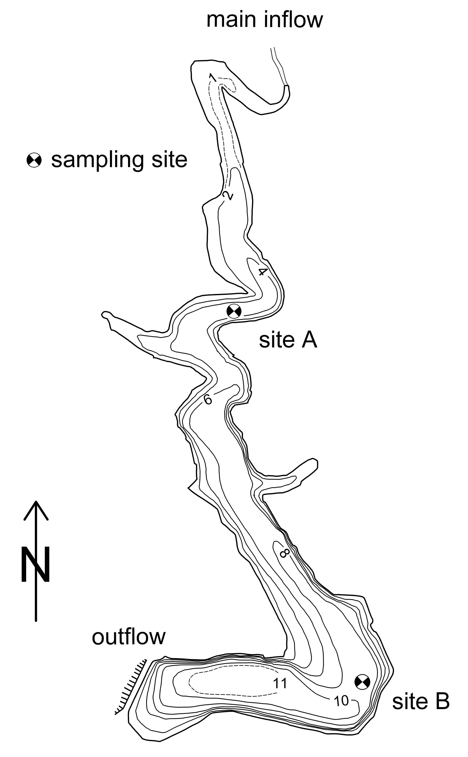
For calculations of water P content in reservoir water masses, the reservoir was divided into 6 segments horizontally and 2-m thick layers vertically. The volume of each segment was multiplied by the analysed concentrations.
Theoretical retention time was calculated from the mean volume of the reservoir divided by the average inflow for the period. P-loads into and from the reservoir were calculated according to equation: L = ΣciQavg-i, where L means load in the certain period, ci means concentration at point sample i and Qavg-i means average discharge from the middle of the period between samples i → i-1 and i → i+1. Retention in the reservoir R (%) was calculated according to equation: R = (Li – Lo + M2 – M1)/Li, where Li means total P load into the reservoir (by inflows and precipitation), Lo means P load by outflow, and M1 and M2 mean P amounts of the water in the reservoir at the beginning and the end of the balance period, respectively.
Seston sedimentation was determined at site B above the bottom in one-month intervals from March 2001 to April 2002. Sediment traps (Bloesch and Burns, 1980) were exposed for 24 hours. DM, LOI, P_{part}, and org-C_{part} were analysed in the suspension that was obtained after the traps retrieval. The settling intensities were calculated from the amount of settled material, the exposition time and the horizontal cross-sectional area of traps. Sedimentation fluxes in the whole reservoir were calculated as the sedimentation intensity in the beginning of the period multiplied by the reservoir surface area and multiplied by number of days of the period between samples.
Figure 1. Map of the Jordán Reservoir with sampling sites marked. The interval of isobaths is 2 m.
Sampling of sediments was done at site B in one-month intervals from March 2001 to April 2002. Bottom sediments were sampled with a gravity corer with Plexiglas tube (5-cm inner diameter) (Hruška, 1986). P-release rates were calculated from changes of DRP in the water above the sediment during 4-day incubation at in situ conditions. Release fluxes from sediments in the reservoirs were calculated from release rates measured in the beginning of the period multiplied by 0.7 times reservoir surface area, and multiplied by number of days of the period between samples.

3. Results and discussion
Seasonal changes of inflow and outflow concentrations of phosphorus were mutually shifted during the observed period (Fig. 2). The highest TP outflow concentrations, higher than the inflow ones in the same year, were found in the autumn 2002. The predominant fraction of the inflow TP was bound in particles that were largely organic and contained high concentrations of Chla (annual averages ranged from 57 to 83 µg l⁻¹). This was caused mainly by the growth of phytoplankton in many ponds and pre-reservoirs in the catchment of Jordan Reservoir. The seasonal pattern of TP concentration in the outflow differed from the inflow. Minimum and maximum concentrations occurred in the summer and at the end of the autumn, respectively. The autumnal maxima of TP consisted of a large proportion of DRP that was released from the decaying phytoplankton biomass after its sinking into the hypolimnion and onto the sediment surface (Hejzlar et al., 2004). This DRP was mixed into the whole water column during the autumnal period of circulation.

Figure 2. Concentrations of total phosphorus (TP) and dissolved reactive phosphorus (DRP) at the inflow and outflow of Jordan Reservoir from March 2000 to April 2004.

The P-release rates from sediment showed marked seasonal trend at site B (Fig. 3). Very low or negative P-releases were observed during the spring mixing. Later, a steep increase in P-release rates, 18 mg m⁻² d⁻¹ at the end of June 2001 occurred. Negative release rates (i.e. an uptake by sediments) were measured from the autumn overturn (mid of November) until the end of the winter stratification. Sedimentation rates of P in the reservoir showed an annual cycle with the maximum in the second half of the summer stratification and the minimum during the winter (Fig. 3) in the period from March 2001 to April 2002. The composition of the settling material did not change during the year, with the molar C:P ratio ranging from 65 to 75.

Figure 3. Left: Phosphorus release rates and phosphorus sedimentation rates measured at site B from March 2001 to April 2002. Right: P-retention in reservoir is calculated for each period between samplings (solid line) and P-release rates (dashed line) calculated for the whole reservoir for the period from March 2001 to April 2002. Negative P-retention (Jun-01, Nov – Dec-01) means P-release, i.e. P-sedimentation was lower than P-release.

P-retention in the reservoir was calculated for each period between samplings from March 2001 to April 2002. P-sedimentation was higher than P-release. The P-release was apparently limited by oxic conditions at the sediment/water interface where precipitated oxidised Fe-compounds at the sediment surface could be observed (Borovec and Jan, 2004). The seston that was deposited onto the sediment surface started to decompose, reduced precipitated Fe-compounds gradually released phosphorus. The P flux from sediments was higher than P-sedimentation in June 2001 and P was not retained in the reservoir (Fig. 3). P-sedimentation predominated over P-release from July 2001 to October 2001. The decomposition of freshly settled seston became lower due to deficiency of electron acceptors for respiration (depletion of DO and nitrate), and due to high hypolimnetic concentrations of accumulated P. Seston remained at the sediment surface. A discrepancy between the measured P-release and the calculated P-retention was found from October 2001 to December 2001 (Fig. 3). Small or negative P-release was measured by laboratory incubation, but according to mass-balance calculation a large P amount had to be released back to water column. Fast decomposition could be caused by either an import of electron acceptors to sediment surface that accelerated organic matter decomposition, or the P from sediment pore water was “washed out” due to more intensive water movements during the autumnal mixing. P-retention prevailed from January 2002 to March 2002.
P-retention in the reservoir was 0-15% of the total P inflow in the respective years (Tab. 1), which were very low values compared to reservoirs with similar hydraulic residence time (Straškraba et al., 1995). The low P-retention in the reservoir was caused by a low ability of sediments to retain phosphorus. The P content in the inflow and settling particles was about 5.5 mg g⁻¹ during the period of 2000-2003, but the content of P in sediments was 2.2 mg g⁻¹ on average (Borovec et al., 2002). The difference of P contents had to be released from particles back to the water. The reason for such a low long-term P-binding capacity of sediments was the occurrence of sulphide, which could bind Fe into insoluble compounds under prevalent anoxic conditions at the sediment/water interface. The short-term binding capacity was time dependent, when Fe-compounds precipitated at the surface and retained P during the spring, as described above. The precipitated Fe originated both from the water column and the inflow.

Table 1. Mean flow (Qi), theoretical retention time (TRT), P inputs, and P retentions (R) in Jordan Reservoir. The hydrological year was calculated from 1.IV. to 31.III.
Year | Q_{i}, m³ s⁻¹ | TRT, d | TP |  | DRP
 |  |  | input, kg | R, % | input, kg | R, %
2000 | 0.160 | 180 | 560 | 15 | 120 | -95
2001 | 0.470 | 57 | 1570 | 15 | 270 | -130
2003 | 0.200 | 110 | 560 | 0 | 100 | -42

Period | P_{input} | P_{output} | P_{reservoir} | δP_{reservoir} | P_{retention}
 | kg
26.3.01-23.4.01 | 108 | 103 | 272 | -140 | 145
23.4.01-20.8.01 | 381 | 214 | 197 | 120 | 46
20.8.01-11.3.02 | 935 | 1142 | 317 | -158 | -49
31.3.03-19.5.03 | 101 | 71 | 132 | -64 | 94
19.5.03-28.8.03 | 101 | 36 | 68 | 97 | -32
28.8.03-9.11.03 | 125 | 45 | 165 | 107 | -27
9.11.03-2.2.04 | 48 | 93 | 272 | -4 | -42
2.2.04-23.3.04 | 140 | 201 | 269 | -74 | 14
P-retention in the reservoir was high in the spring and in the first half of the summer stratification (Tab. 2) both in 2001 and 2003, apparently due to high sedimentation intensity of the spring peak of phytoplankton, oxic hypolimnion and low P-release from sediments. An increase in sedimentation of seston and its decomposition in the water column together with the fast release of P from the decomposition of freshly settled seston at the sediment surface during the summer (Borovec and Jan, 2004) caused an accumulation of P in hypolimnion.

Table 2. P inputs, P outputs, P amount in the reservoir at the beginning of period, changes of P content in the reservoir during period, and P retentions in Jordan Reservoir from March 2001 to March 2004.

P-release rates from sediments were lower in the end of the summer stratification due to absence of electron acceptors (DO, nitrate), which limited decomposition, and due to high hypolimnetic concentrations of accumulated P that lowered the concentration gradient at the sediment/water interface. The P-retention in reservoir was low in 2001 and negative in 2003 (Tab. 2). Destratification, mixing up of high P concentrations from the hypolimnion into the water column, and fast P-release from sediments led to negative P-retention in both periods. Oxic conditions in the water column and P uptake by sediments led to P-retention in the winter 2004.
According to the previous text, the autumnal P-release from sediment usually had to be very intensive to decrease P content of settled seston from 5.5 mg g⁻¹ to 2.2 mg g⁻¹ of P in sediment. A part of the phosphorus could be released during the summer, but the measured P-release rates decreased at the end of the summer and stayed low during the autumn (Fig. 3). Comparing the measured P-release rates with the P-retention in reservoir, a good agreement within increase of P-release from sediment and decrease of P-retention in reservoir (negative values) in June 2001 is evident. Later, sedimentation, i.e. retention, was higher than release till the autumn when negative P-retention in reservoir was calculated and no release but P uptake by sediments was measured (Fig. 3). The P-release from sediments could be mediated by (i) more intensive water movements near the sediment surface that were caused by circulation of water column and “washed out” an important amount of P from the sediment pore water; and (ii) an import of oxygen to sediment surface that accelerated organic matter decomposition and P-release.

4. Conclusions
It was found, that in hypertrophic Jordan reservoir:
(i) P settles and decomposes at the sediment surface and in the water column. P is temporarily retained at the sediment surface and/or in hypolimnion;
(ii) Sediments are able to partly and temporarily bind phosphorus. The P-retention capacity of sediments is approximately three times lower than P content in seston in Jordan Reservoir. The P difference circulates between sediment and water column or use to be removed from the reservoir during the autumnal circulation.
(iii) Described seasonal dynamics might be similar at another stratified reservoirs. Sediments with a good P-binding capacity can retain much of the accumulated phosphorus, so the P-release back to water might not be large.

5. Acknowledgements
This study was supported by the projects of AS CR Nos. S6017004, Z6017912, and K3046108, the research intention of MSM 12310004 (sampling, purchasing and maintenance of hydrologic and climatic monitoring stations) and by the project of Grant Agency AS CR No. A3017301.

6. References
Bloesch, J., Burns, N. M. (1980): A critical review of sedimentation trap techniques. Sweiz. Z. Hydrol. 42: 15:55.
Borovec, J., Hejzlar, J. (2001): Phosphorus fractions and phosphorus sorption characteristics of freshwater sediments and their relations to sediment composition. Arch. Hydrobiol. 151, 687-703.
Borovec, J., Jan, J. (2004): Faktory ovlivňující uvolňování fosforu ze sedimentů v nádrži. Sborník konference Pitná voda 2004, Tábor 7.6.-10.6.2004, W&ET Team, České Budějovice, v tisku.
Dillon, P. J., Molot, L. A. (1996): Long-term phosphorus budgets and an examination of steady-state mass balance model for Central Ontario Lakes. Water Res. 30: 2273-2280.
Hejzlar, J., Borovec, J., Jarošík, J., Růžička, M. (2004): Koloběh živin v eutrofizované nádrži (Jordán, Jižní Čechy). Vodní hosp. 54, 116-119.
Hruška, V., (1986): A simple self-releasing coresampler. Limnologica, Berlin 17, 259-261.
Kao, J. J., Lin, W. L., Tsai, C. H. (1998): Dynamic spatial modelling approach for estimation of internal phosphorus load. Wat. Res. 32: 47-56.
Kozerski, H. P., Behrendt, H., Kohler, J. (1999): The N and P budget of the shallow, flushed lake Muggelsee: retention, external and internal load. Hydrobiologia, 409: 159-166.
Martinova, M.V. (1993): Nitrogen and phosphor compounds in bottom sediments – mechanisms of accumulation, transformation and release. Hydrobiologia 252: 1-22.
Nürnberg, G. K. (1998): Prediction of annual and seasonal phosphorus concentrations in stratified and polymictic lakes. Limnol. Oceanogr. 43: 1544-1552.
Straškraba, M., Dostálková, I., Hejzlar, J., Vyhnálek, V. (1995): The effect of reservoirs on phosphorus concentration. Int. Rev. ges. Hydrobiol. 80, 403–413.

