CHROMIUM CONTAMINATION OF THE LJUBLJANSKO POLJE AQUIFER

Mitja Brilly¹, Brigita Jamnik², Damjana Drobne³

¹Faculty of Civil and Geodetic Engineering , Ljubljana, Slovenija
²Javno podjetje Vodovod – Kanalizacija, Ljubljana, Slovenija,
³Biotechnical Faculty, Department of Biology, Ljubljana, Slovenia

Abstract: Contamination of the Ljubljansko Polje aquifer with Cr⁺⁶, which dates back to 1986, has been considered as one of the best-investigated groundwater pollutions in Slovenia. In general, contamination provides a good tracer by giving information on groundwater flow, hydrodynamics dispersion and leaching of pollution out of the aquifer. Thus, a large amount of data on chromium levels at different observation points for the period after 1986 has been made available. Consequently, now a lower degree of pollution is to be expected. Further monitoring of the contaminant phenomena will provide insight and valuable empirical data on the hydrodynamic features of the plain Ljubljansko Polje.
The data Cr⁺⁶ concentration data are an excellent example for groundwater model calibration and verification. A discussion about the toxicity of Cr⁺⁶, sampling and measurements and results of groundwater models is also presented in the paper.
Keywords: Chromium, Contamination, Aquifer, Ljubljansko Polje

KONTAMINATION MIT CHROM DES GRUNDWASSERLEITERS DES FELDS LJUBLJANSKO POLJE

Zusammenfassung: Die Kontamination mit Cr⁺⁶ des Grundwasserleiters des Felds Ljubljansko Polje aus dem Jahr 1986 ist eine der best untersuchten Grundwasserverschmutzungen in Slowenien. Im Allgemeinen bietet die Kontamination einen guten Indikator mit Informationen über Grundwasserablauf, hydrodynamische Dispersion, und das Laugen der Verschmutzung aus dem Grundwasserleiter. Auf diese Weise wurde eine große Datenmenge über den Chromgehalt bei verschiedenen Beobachtungspunkten für die Zeit nach 1986 bereitgestellt. Somit kann man jetzt einen niedrigeren Grad der Kontamination erwarten. Weiteres Monitoring des Kontaminationsstoffes soll einen Einblick und wichtige empirische Daten über die hydrodynamischen Charakteristika des Felds Ljubljansko Polje geben.
Die Daten über die Konzentration von Cr⁺⁶ sind ein gutes Beispiel des Kalibrierens und der Verifikation des Grundwassers. Im Beitrag werden auch die Toxizität von Cr⁺⁶, Probennahme, Messungen und Resultate der Grundwassermodelle präsentiert.
Schlüsselworte: Chrom, Kontamination, Grundwasserleiters, Ljubljansko Polje

1. Introduction
Groundwater contamination in Ljubljansko polje (Ljubljana Field) by way of hexavalent chromium was the first major contamination of the water source that called for extensive remedy measures and caused a temporary halt of water pumping from one of the wells of the Kleče pumping station. This has so far been the only instance of contamination that endagared the aquifer of Ljubljansko polje to an extent that interfered with its proper functioning. The contamination was identified at the beginning of 1986, research and reorganisation measures were carried out between 1986 and 1990.
Hexavalent chromium makes an almost ideal indicator for water movement, owing to the unchangeability of its characteristics. Additionally, underground it does not bind to the matrix or it is absorbed mostly at its surface. As a consequence of the contamination, chemical analyses of chromium levels in its oxidation form +6 have become a necessary part of ground water monitoring and of the internal research of drinking water quality. Therefore, a large amount of data on chromium levels at different observation points for the period after 1986 has been made available. The level of hexavalent chromium is an indispensable non-natural indicator for making assumptions regarding underground water movements and dynamics of pollution movements, and their dispersion under conditions present in the Ljubljansko Polje groundwater. However, it needs to be pointed out that the level of determining chromium concentration in analyses was higher than today, the lower levels of determination in laboratories being more than 10 times higher than the lowest level of determination achieved in laboratories by using the modified standard methods nowadays. The concentrations identified today are often on the border of the limit of detection of the modified standard methods, in the majority of Slovene laboratories this being 5 μg/l, internal research in the JP VO-KA laboratory with the modified standard method reach determination level of 3 μg/l. Expert literature shows a decrease in the level of determination amounting to levels lower than 0.2 μg/l.
The regulations specifying the health suitability of drinking water (Ur.l. 46/97, 52/97, 54/98, 7/00) do not define the level of hexavalent chromium, only the upper permissible level of chromium as such is designated, amounting to 50 μg/l. This level has never been attained in any of the sample sites of the Ljubljansko Polje ground water.
Nowadays, the limit values that present no health hazard differ and have changed in the last twenty years considerably. European regulations on human consumption set the limit value of 50 μg/l of total chromium. Interestingly, the U.S. Environmental Protection Agency has defined the hexavalent chromium as cancer inducing only by inhalation and not by ingestion; in 1991 the bordering level value of chromium in drinking water was raised from 50 to 100 μg/l. The American State of California maintained on the basis of hazard assessments a lower limit value. Border values for chromium in drinking water are subjected to numerous examinations, of which some display more than 10-times lower values of the still accepted bordering value for chromium from those in validity today.
Nowadays, the limit values that present no health hazard differ and have changed in the last twenty years considerably. European regulations on human consumption set the limit value of 50 μg/l of total chromium. Interestingly, the U.S. Environmental Protection Agency has defined the hexavalent chromium as cancer inducing only by inhalation and not by ingestion; in 1991 the bordering level value of chromium in drinking water was raised from 50 to 100 μg/l. The American State of California maintained on the basis of hazard assessments a lower limit value. Border values for chromium in drinking water are subjected to numerous examinations, of which some display more than 10-times lower values of the still accepted bordering value for chromium from those in validity today.

2. General characteristics of chromium
Louis Nicolas Vauquelin found chromium in 1797. Its name is derived from Greek, hroma meaning ‘colour’, since its different compounds are usually very colourful. Chromium is a polyvalent element, found naturally in the air, soil, water and lithosphere. The most important natural chromium ore is the mineral chromate FeCr₂O₄. Oxidation states ranging from 2+ to 6+ are characteristic of chromium, however only the oxidation states 3+ and 6+ represent the chromium form used practically. Divalent chromium is relatively unstable, quickly oxidising into the trivalent chromium. In nature, trivalent chromium is the most stable state of chromium in nature and therefore most commonly found and its salts – mostly oxides – that are generally insoluble in water in the pH range of 4–11. Hexavalent chromic salts are less stable, more soluble and biologically active. The oxidation potential for transforming the trivalent chromium into the hexavalent one is high, and the probability of transformation into a higher oxidation form is reduced. So far, the research has shown that the hexavalent is not the prevailing natural chromium form, with few exceptions. The need for reducing the hexavalent chromium into the trivalent increases with a falling pH. The hexavalent chromium form usually linked to oxygen atoms is a strong oxidant. In the presence of organic elements in water, a reduction to the trivalent form is made possible.
Trivalent chromium is the chromium form found in plants, food and is (in traces, in low levels) of vital importance. According to research, the food that we eat contains the value of 0.5 ppm of the trivalent chromium. An estimated daily intake ranges from 0.03 to 0.1 mg of the trivalent chromium, the necessary dosage amounting to 0.01–0.04 mg of chromium tied in the form of organic particles and from 0.1 to 0.3 mg of chromium in inorganic form.
Despite the wide range of chromium in the soil and plants, it is rarely found in natural water above the concentration of the natural background, amounting to 1 μg/l. Higher concentrations are indicators of antropogenic pollution.
A widely used method for determining the hexavalent chromium in water is the spectrophometric method applying the diphenilcarbazide according to modified methods (SIST ISO 11083, Standard Methods for Examination of Water and Wastewater, Edition 20). In reactions with the diphenylcarbazide it forms a red/violet colour complex. The reaction is highly sensitive and specific for chromium and the substances possibly causing disturbances are in the drinking water present in negligible quantities. The absorption in measured at a wavelength of 540 nm.
The elementary form of chromium does not display any tendency towards migration from the surface through soil layers. Experiments have shown that a major part is withheld in the first few centimetres of soil. The chromium compounds in riverbeds are present a sediments, partially as suspended matter that are then adsorbed onto the river sediments.

3. Toxicity of chromium

Chromic chemicals are used in different industries. In leather industry for skin tannage in electroplating for coatings, in chemical industry for making pigments. Hexavalent chromium (Cr6+) is far more mobile than the trivalent (Cr3+) chromium. The trivalent chromium is immersed into poorly soluble substances that are inaccessible to organisms (Kožuh et al. 2000). Chromium is one of the elements essential to life, however in increased concentrations in environment these elements prove to be toxic. The trivalent chromium is the form having a biological function with regard to digesting sugar and fat.
Primary route of human exposure is through inhalation, ingestion and dermal contact. Inhalation is the most common form of exposure in several work environments. In day-to-day life the exposure to chromium occurs through food and water intake as well as through inhalation. The main route of chromium excretion is via kidneys into urine, and via bile duct into faeces. Irrespective of the manner of intake, Cr3+ is absorbed too a far lesser degree than Cr6+. Absorption of Cr6+ is smaller, if the chromium intake occurs through mouth cavity, and thereby the risk is not magnified. However, Cr6+ is highly toxic when entering through dermal contact and through respiratory tract, respectively. Chromium has the potential to bring about skin infections/ulcerations, nasal tissue damage and upper respiratory lesions, even lung cancer. Further on, contact dermatitis and hypersensitive reactions have been observed (Shrivastava 2002). The whole intake of Cr6+ is reduced into Cr3+ before penetrating into circulation of blood. Damaged immune system due to Cr6+ and Cr3+ has also been examined thoroughly. Cr5+ and Cr6+ cause apoptosis, i.e. human lymphocyte death. Citotoxic and genotoxic effect of chromium has also been well examined. Both types of injury occur when Cr6+ reduces into Cr3+. In the reduction process reactive free radicals are formed, causing great cell damage. Genotoxicity of chromium Cr6+ is shown in direct damage of DNA. Cr3+ does not penetrate into cells, on the other hand Cr6+ penetrates through plasmalemma with anion transmitters. Cr6+ does not react with macromolecules such as DNA, RNA, proteins and lipids. However, Cr3+ and intermediate Cr5+ form covalent bonds with macromolecules. Cr6+ compounds are 10–100-times more toxic than Cr3+ compounds. Generally, the hexavalent chromium is far more toxic due to its oxidation potential and fast penetration through cell membranes into cell interior (Katz SA. 1993).

4. Contamination and remedy measures
Contamination was identified at the end of 1985 while testing the neutralisation devices in the procedure of acquiring the occupancy permit in Iskra Mikroelektronika in the Stegne industrial zone. The wastewater sample contained 175 g/l of Cr(+6). Since chromium was not used in the described technological procedure, an analysis of drinking water was made at the starting stage of the technological procedure. The analysis displayed a concentration of 150  g /l, exceeding the permitted value (50  g /l). Investigations into water quality in the vicinity of the Kleče reservoir (Fig. 1) showed chromium contamination (g/l) in well 12 (150), well 11 (100), well 10 (75), well 9 (50), well 8 (30) and well 7 (30). Further analysis of water sampled from the rest of the wells and piezometers in Ljubljansko Polje revealed that chromium concentrations were not above the determination level at all, with the exception of the deserted well at the Šentvid train station where the level of chromium (+6) amounted to 380 g/l and the Mladinska knjiga enterprise well, where the chromium level reached the level of determination. In these analyses the determination level in laboratories was 30 g/l.
The major potential pollutants included emissions from galvanisation plants at the pumping station drainage area, investigated as early as in January 1986. It was established that chromium concentrations were in excess of the acceptance criteria by 100 times and that the piping system was damaged. The Vižmarje galvanisation plant was dealt with separately situated west of the well of the Šentvid railway station. The authorities had investigated into its inadequate functioning before. Examination of emissions into the sewage system had revealed that the system was badly damaged, causing the spread of wastewater into the aquifer. The galvanisation plant was shut down immediately and the entire complex removed. Out of the remaining galvanisation plants, the Bolka galvanisation plant was closed down, having one-way waste system.
The time period of groundwater pollution from the Vižmarje galvanization plant was not established. The contribution to groundwater pollution from other galvanization plants in the drainage area was also not established. Modern technological usage of chromium has been planned on closed systems, thereby avoiding outflow of wastewater containing chromium. Pollution sources today include soil saturation with chromium at the site of former galvanization plants and “wild” dumping sites.
Beside the reorganisation of galvanisation plants, the remedial measures were cleansing and pumping from the Šentvid railway station and pumping into the sewage system water from well 12 in the Kleče pumping station. The wells 11 and 10 were excluded from the system temporarily. Concern over chromium pollution and preparation for a new central purification plant have called for a more intensive control over polluters connected to the JP VO-KA sewage system. A special care was given to the monitoring of potential Cr (+6) polluters, due to a continuous presence of smaller traces of Cr (+6) of the Kleče pumping station. Due to high concentration of Cr +6 in waste water (1,7 mg/l) the galvanisation plant in the UNITAS firm was shut down.
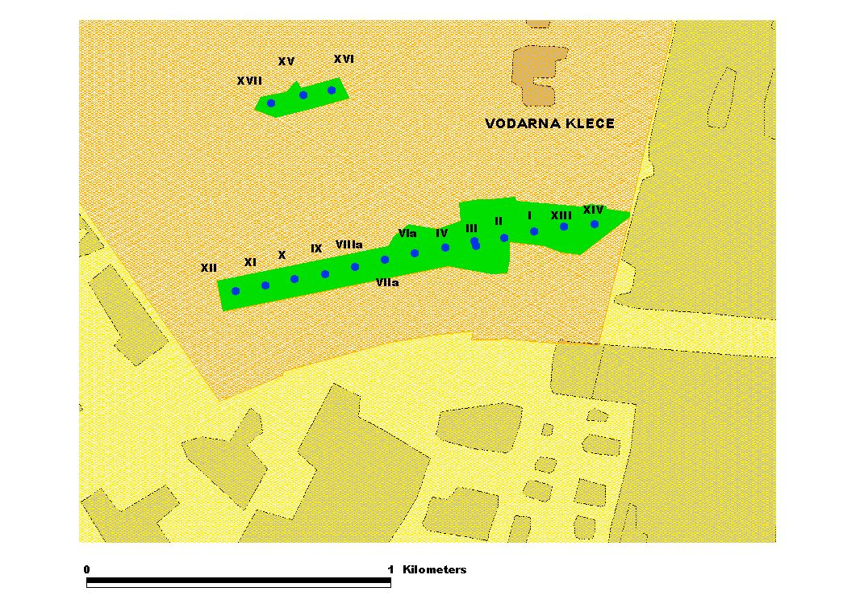
Figure 1. Teh Kleče pumping station

5. Analysis of observation and research data
Nevertheless, a detailed analysis of the emission potential of single pollutants has so far not been carried out. The primary sources of pollution are galvanization factories where aggressive sewage has damaged the sewer systems and caused its spillage into the underground. In industrial plants, warehouses and yards the grounds are saturated with chromium, and last but not least: in the past waste disposal was carried out insupervisedly. In the areas of galvanisation plants and illegal dumping grounds in Ljubljansko Polje decontamination and systematic monitoring of polluted grounds have never been carried out. Consequently, now a lower degree of pollution is to be expected. Further monitoring of the contaminant phenomena will provide experience and valuable empirical data on the hydrodynamic features of Ljubljansko Polje.
When the pollutant reaches groundwater it starts moving with the flow. In the process, small particles move with different speed, with regard to their size and form. Since the streamline keeps changing due to different hydrologic boundary conditions, there is a formation of a pollution cloud due to hydrodynamic dispersion. Single particles are bound to the matrix and water part in the saturated zone, standing still depending on the adsorption qualities of the polluter and adsorption characteristics of the matrix, i. e. its structure. Therefore, the groundwater pollution moves slowly, increasing in a relatively fast pace and leaching slowly. In reality, the respective particles of the polluter stay in soil permanently.
Pollution is distributed over area and depth of streamline. Sampling is done in the well, serving as the influent part of the perforated piping system. If the well is in contact only with surface groundwater, then the pollution possibly misses the well, however in pumping the sample reads a mean concentration of the polluter with regard to pumping quality and distribution of the polluter in the streamline. In respective pumping stations, the concentration depends on water pumping distribution from individual wells, i. e. groundwater streamlines in the pumping station prior to sampling and in-between. The polluter quantity changes depending on the direction course of the groundwater in a longer period of time prior to sampling and hydrologic boundary conditions. An analysis of changes in polluter concentrations provides valuable information on aquifer characteristics and groundwater movement; i.e. the polluter can be used for tracing purposes. The available data on chromium concentration were taken into account, ranging from 1986 onwards, as well as oscillation in groundwater level in the Kleče and Hrastnik pumping stations
Analyses of groundwater streamlines for extremely dry and humid periods show relatively small deviations in pace directions. Changes with regard to streamlines vary to a negligible degree even in extremely dry and humid periods, Figure 2 (Brilly 1988). In dry seasons, the streamlines in the Kleče pumping area are directed southeast–east towards the Sava River, and in humid periods from the Sava southwards. In the Hrastje pumping station area the streamlines in dry seasons are directed westwards and in humid seasons towards Northwest, that is in the Sava River direction.
Figure 2. Catchment areas of respective Ljubljansko Polje pumping stations
Hydrologic data on groundwater levels in the Kleče pumping station (Figure 3) reveal that pollution first came about at the time of longer period of groundwater level decline, July 1986–January 1987, followed by a period of higher groundwater levels until the end of 1987 and then a moderate period in 1988 that ended with a severe drought. The following years gained in humidity, especially during 1994 and 1997.
Data on chromium pollution are available for several wells of the Kleče and Hrastje wells and for several piezometers in Ljubljansko Polje. Mostly, the values lie at the border of the limit of detection (3 micrograms and 5 micrograms per litre, respectively). Therefore, in the graphs attached the concentration values of 3 and 5 respectively (or lower) are given the value of 0 or the value between 0 and 3.

Figure 3. Groundwater level in the Kleče pumping station, observation site at the well VIII

At times, a higher degree of chromium outside the pumping stations is identified, namely in the industrial wells of Julon and Koteks, at Petrol and in the piezometer at Jarški Brod 3. Other piezometers: Šentvid, Roje, Obrije, Navje, Brod11, Brod12, Stožice, Elok, Dekorativna in Jarški Brod 1 have not demonstrated any traceable concentrations of Cr (+6).

Figure 4. Measuring Cr (+6) concentration in groundwater in respective Kleče wells
Chromium concentration in the Kleče pumping facility wells was examined as early as in the very beginning of groundwater contamination with chromium, Figures 4. Due to successful remedy activities of the major polluter, Cr (+6) concentrations were reduced Figure 5 (Brilly 1990). First, pollutant traces were identified in the wells at the easternmost edge of the Kleče I pumping station. Other wells distributed values below the limit of detection, at the time amounting to 30 g/l. After remedial measures the concentration decreased quickly, achieving the values acceptable in water supply. Spreading of pollution of the pumping station to other wells was identified at well III in June 1990, at wells VIIa and VIIIa in July 1991, at wells IX, IV and VIa, at well II in September 1992 and at wells I and XIII. Only in the easternmost well XIV were measurements of Cr (+6) concentration at or below the limit of detection. Charateristically, in the central well III the contamination concentration was on the increase, exceeding the permissible values in October 1992 and then finally declining. In the respective period, the well contamination demonstrated higher values than those of the westernmost wells of the pumping did station did. The graph in Figure 5 illustrates the temporary phenomenon of an increase in pollution in wet periods and decline in dry periods regarding the groundwater level changes in the pumping station and contamination of well XI. The same can be observed with well VIIIa. In both wells, traces of chromium are identified in dry seasons only. Noticeably, the concentrations in well VIIIa decline significantly, reaching the level of detection limit (or below) in the past two years, see Graph in Figure 4. A similar situation can be identified for well XI, exhibiting concentrations slightly above the detection level. As it happens, further gradual decrease of pollution in the pumping station is to be expected.

Figure 5. Water level and contamination with Cr (+6) at Kleče 11

In the Hrastje pumping station (Figure 6), the hexavalent chromium was identified in 1987 in well 8 and in spring of 1988 in well 1a, Figures 6, 7 and 8. In July 1994 the contamination was identified in all wells of the western part of Hrastje. Later, traces of chromium above the limit of detection is identified in south wells only. In the northern part of the pumping facility with water outlet from the Sava, the chromium traces were rarely above the limit of detection. Secondary maximum in data occurred in 1994. Typically, pollution is on the increase with water level decline and vice versa, Figure 8. Characteristically for the values today is a gradual increase of Cr (+6) concentration with its emergence is dry periods. The possible cause may lie in the rise of water level at the Hrastje pumping station area, owing to reduced groundwater pumping in the facility or possibly to changed conditions in the Sava river bed at the Šentjakob Bridge, Figure 8. Similarly to the Kleče pumping station, the most polluted streamlines most likely evade the Hrastje pumping station.
By way of proving that the Hrastje pumping station fails to capture most polluted groundwater, internal investigation results at observation sites of the Kleče and Hrastje pumping facilities are given (L.P. Vodovodna, well at the Geološki Zavod Ljubljana, the Bauhaus well), where a significantly higher chromium concentration than in the pumping facilities has been identified in recent years (approx. 30 μg/l).
The issue of unidentified source or sources of chromium pollution was earlier discussed in the framework of the project entitled Mathematical Model of Ljubljansko Polje and Barje groundwater (DHI-Water&Environment et al., 2000). The results managed to confirm the prior statements of the Vižmarje galvanisation plant as the major pollutant source. Since pollution was not identified in the Dekorativna well, the IMP wells and in the wells of the northern part of the Kleče pumping station, it seems that the pollution spread in a narrow belt that started to spread eastwards no sooner than on the central Kleče area, due to pumping. The mathematical tool predicts the inflow of contamination to the pumping facilities of the western part of the station in a 3–6 month period, coinciding with the field findings. Theoretical calculations show that beside the Vižmarje galvanisation plant it is not possible to exclude other sources of chromium contamination the Hrastje facility.
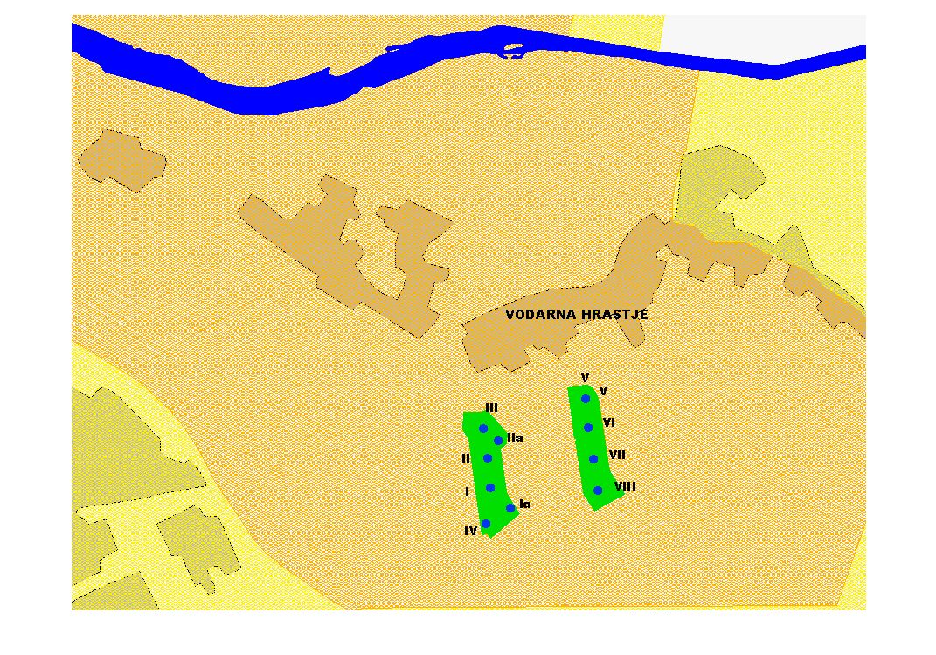
Figure 6. The Hrastje pumping station

Figure 7 Water levels at the Hrastje pumping station

Figures 8. Measuring Cr (+6) quantities in groundwater in the Hrastje wells

6. Conclusion
The total concentration of chromium in any of the sampling sites in Ljubljansko Polje does not exceed the value of 50 μg/l, this being the permissible level according to the Regulations on health suitability of potable water (Official Gazette of the Republic of Slovenia: 46/97, 52/97, 54/98, 7/00). Temporary concentrations of the hexavalent chromium in the Kleče pumping station are gradually declining and it is expected that they will sink below the lower limit of detection in all wells of the reservoir.

Figure 9. Area of Cr (+6) contamination

Noticeably, the Hrastje pumping station exhibits a trend of mild increase in Cr+6 concentration, spreading from the south northwards. The most likely cause is the pollution cloud from the vicinity of the Hrastje pumping station, moving towards the Hrastje pumping station owing to pumping works and changes in the currents’ courses - the groundwater level the Hrastje pumping station area having been raised. Namely, if groundwater levels are significantly higher then the streamlines from dense city areas are directed southwards towards the Sava River.
On-site and laboratory analyses of Cr+6 pollution have given valuable data and information on hydrodynamic features of geological formations of Ljubljansko Polje. These measurements have provided grounds for working out ground water models and will continue to do so in the future.
The groundwater regime at Ljubljansko Polje is highly specific and several phenomena, such as pollution trends and groundwater level movements, are being noticed not earlier than on the basis of several years’ monitoring.
Proper and prompt actions and decision-making can put a stop to pollution in Ljubljansko Polje. Point-source pollution as a rule stays within the narrow boundaries of streamlines, luckily failing to spread along the entire water aquifer. The removal of the pollution source will obviously cause the pollution cleanup.

Acknowledgements

The Ministry of Education, Science and Sport, the City council of Ljubljana and the JP Vodovod-Kanalizacija supported this work

References

Brilly M., 1990, Poročilo o onesnaženju vodarne Kleče s kromom, LMTe FGG, Ljubljana
Brilly M., Gorišek M., 1988, Valorizacija modela podtalnice Ljubljanskega Polja, UL FGG LMTe.
JP VO-KA 1986-1992 zapisniki, mnenja in poročila v zvezi z onesnaženjem s kromom, arhiv JP VO-KA, Ljubljana
Katz SA. 1993. Toxicity of chromium. Camden, Rutgers University, USA.
Kožuh N, Štupar J, Gorenc B. 2000. Reduction and oxidation processes of chromium in soils. Environ sci technol. 34, 112-119.
DHI-Water&Environment et al., 2000, Matematični model podtalnice Ljubljanskega polja in Ljubljanskega barja, arhiv JP VO-KA,
M. Predanič, P. Auersperger, 1992-2001, Rezultati internih preiskav kakovosti podtalnice in pitne vode, arhiv JP VO-KA,
Shrivastava R., Upreti PK, Seth UC, Chaturvedi UC. 2002. Effects of chromium on the immune system. FEMS Immun Med Microb 34:1-7.
B. Vidic, M. Izak, B. Kranjec, 1985-2001, Poročila o meritvah nivoja podtalnic arhiv JP VO-KA,
JP VO-KA, Poročila o količinah načrpane vode 1985-2001, arhiv JP VO-KA
Jamnik B at all, 999., Poročilo o vzorčenju v vodnjakih MV, , arhiv JP VO-KA.

