Regional Model of the Somes-Szamos Aquifer (RO - HU)

Radu Drobot¹, Serge Brouyère², Alain Dassargues³, Peter Szucs⁴, Margit Virag⁵,
Mihai Bretotean⁶, Marin-Nelu Minciuna⁶, Anca Filip⁶, Ileana-Cristina Popescu²,
Marilena Jianu¹, Nicolai Sirbu¹, Melinda Karsai⁴, Andrea Toth⁴, Krisztina Faur⁴

¹UTCB, Bucharest, Romania, e-mail: drobot@utcb.ro
² Université de Liège, GEOMAC and Aquapôle, Liège, Belgium,
e-mail: serge.brouyere@ulg.ac.be
³Université de Liège, GEOMAC, Liège, Belgium, e-mail: Alain.Dassargues@ulg.ac.be
⁴ University of Miskolc, Miskolci Egyetem, Hungary, e-mail: hgszucs@gold.uni-miskolc.hu
⁵ VIZITERV Consult Ltd, Nyiregyhaza, Hungary, e-mail : m.virag@chello.hu
⁶ INHGA, Bucharest, Romania, e-mail: marin.minciuna@hidro.ro

Abstract: The alluvial aquifer of Somes-Szamos River is a transboundary hydrogeological basin, shared between Romania and Hungary. The project focused on a better understanding of basic processes across many scales, using sophisticated computer simulation models and data acquisition techniques that provided valuable field data to supply the models. A 3 layers conceptual model was considered as a reasonable compromise between the complexity of the aquifer and the volume of reliable data. The parameters calibration was performed in steady state and transient conditions. A transient simulation was used for validation. Simulations testing different scenarios of future use led to the conclusion that the aquifer seems not to be at risk from a quantitative point of view. The research was carried out by a team formed by Belgium, Romanian and Hungarian partners, in the frame of the NATO Science for Peace programme.
Keywords: regional aquifer, conceptual model, calibration, validation, predictive simulations.

Zusammenfassung: Regionales Modell des Somes-Szamos Grundwasserleiters
Der alluviale Grundwasserleiter des Somes-Szamos Flusses ist ein grenzüberschreitendes hydrogeologisches Becken zwischen Rumänien und Ungarn. Das Projekt soll dazu dienen, das Verständnis einfacher Prozesse auf mehreren Ebenen zu verbessern indem komplizierte Computer-Simulationsmodelle und die Modelldaten liefernde Datenerfassungstechniken benutzt werden. Ein konzeptuelles Modell mit 3 Schichten ist als sinnvoller Ausgleich zwischen der Komplexität des Grundwasserleiters und der Anzahl verlässlicher Daten angesehen worden. Die Kalibrierung der Parameter ist unter stationären und instationären Bedingungen durchgeführt worden. Eine instationäre Simulation ist für die Validierung benutzt worden. Simulationen, die Szenarios einer zukünftigen Nutzung testen sollten, haben ergeben, dass der Grundwasserleiter von einem quantitativen Standpunkt aus scheinbar nicht gefährdet ist. Die Forschungen sind innerhalb eines ? multi-disziplinären ? Teams zusammengesetzt aus Partnern von Belgien, Rumänien und Ungarn im Rahmen eines NATO Science for Peace Programms durchgeführt worden.
Schlüsselworte: regionaler Grundwasserleiter, konzeptuelles Modell, Kalibrierung, Validierung, prädiktive Simulationen.

1. Introduction
In lowland permeable catchments, groundwater is commonly the main water resource, raising important issues of management and environmental protection. Especially lowland catchments are subject to a complex set of environmental pressures and associated management problems. This requires high quality experimental and measurement facilities, as well as the construction of numerical tools for integrated management of the groundwater resources.
The Somes-Szamos aquifer (Figure 1), which extends on both sides of the Romanian-Hungarian border, supplies drinking water to a population of about 395,000 inhabitants in Romania and 50,000 inhabitants in Hungary. Industry and agriculture are developed on both sides of the border, using water extracted from the alluvial aquifer, creating in the meantime important potential pollution problems for the groundwater.

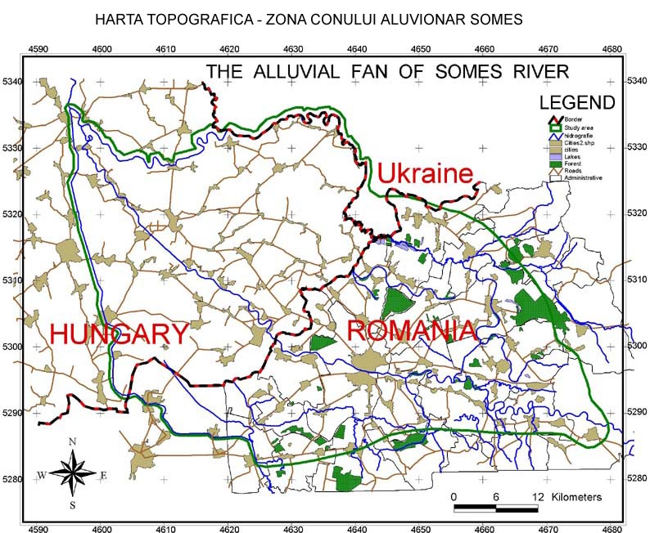

Figure 1. Location of the Somes-Szamos basin in Romania and Hungary.

A team formed by Belgium, Romanian and Hungarian partners carried out a research in the frame of the NATO Science for Peace programme (Project NATO SfP 973684 SQUASH). It was intended to improve the management of the aquifer in terms of groundwater quantity and quality. The project focused on a better understanding of basic processes across many scales, using sophisticated computer simulation models and data acquisition techniques that provided valuable field data to supply the models (Dassargues at al., 2001).
To establish a spatially distributed and ‘process-based’ numerical model various types of data concerning geology, hydrology, hydrogeology, geomorphology, topography were required. Some of these data were collected from old archives; others were obtained during four field campaigns, undertaken in October 2001, April 2002, April 2003 and October 2003.

2. Aquifer characterization. Hydrogeological cross-sections
The aquifer is made of permeable formations like sand, gravel and boulders in alternance with clay layers. The thickness of the Quaternary aquifer complex varies between 20 m in the Eastern part to 130 m at the border between Romania and Hungary and 190 m at the Western limit. The effective depth of the permeable layers lies in the range of 10-100 m.
The cross-sections put into evidence the granulometric evolution in the deposits from East to West: from elements having more that 15 cm diameter in the Eastern part to very fine sediments in the Western part of the aquifer. The permeable formations have a general slope oriented to the West, being confined in the Western part by pelitic sediments. The whole complex of sands and gravel was generated by the Somes river and its tributaries. Westwards from Satu-Mare town the gravel layers are replaced by fine sediments, only few lenses of gravels with diameters of 1-6 mm and a thickness of 5-15 m are occuring. A similar situation characterizes the South-West area where clay layers are predominant from the ground surface to depths of 30-35 m; practically in this area there are no phreatic aquifers.
Interpretation of the hydrogeological structure of the aquifer is complex because of the relatively high heterogeneity and intricated sedimentological palaeoconditions. Before this research, each country (i.e. Romania and Hungary) had a truncated understanding of the structure. One of the big issue between the Romanian and the Hungarian partners was undoubtedly to reach a common agreement about the aquifers to be studied as well as the establishment of a coherent concept concerning the hydrogeological structure.
Putting together lithological information existing in both countries, 7 hydrogeological cross-sections were proposed: 3 longitudinal approximately parallel with the main course of the Somes-Szamos river and 4 transverse to it. The 7 cross-sections, based on a concertation within the group and confrontation of the different hydrogeological concepts, reflect the a new hydrogeological interpretation in agreement with all available Romanian and Hungarian data.
On the Romanian territory, 15 deep wells (200-300 m) belonging to the National Hydrogeological Network of Romania were considered. On the Hungarian territory a number of 10 wells were used for continuing the cross-sections from the Romanian side of the aquifer and to interpretate two transversal new cross-sections. The limit between Quaternary and Pliocene deposits was determined on the basis of micro-palaeontological analysis, reaching to the conclusion that it corresponds to the bedrock of the alluvial deposits of the Somes river.
The lithology put into evidence that the layers developed till a maximum depth of 190 m represent the main aquifer due to their extent, hydrogeological parameters and abstracted discharges. In Figure 2 the cross-section along the Somes-Szamos river is presented.

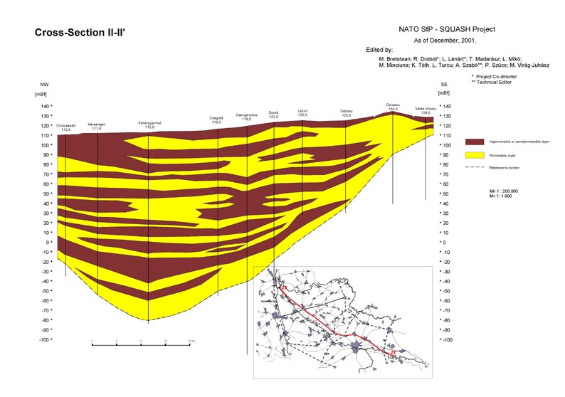
Figure 2. Main cross-section along the Somes-Szamos river

2. Developing the conceptual model
One of the most important steps in the mathematical modelling is the choice of the conceptual model of the aquifer. By keeping the essential features of the system, a compromise between the complexity of the aquifer and the available volume of reliable data concerning the structure and its hydrogeological parameters is proposed.

2.1. Vertical and areal extent
In the case of the Somes-Szamos aquifer the vertical extent of the model corresponds to the separation line between Quaternary and Pliocene formations. It can be considered that the alluvial fan corresponds to the superposition of two aquifer units:
- The shallow aquifer (the Holocene aquifer) is unconfined and has a depth of 25-35 m being formed by 2-3 layers hydraulically connected; it is located in the recent sediments of the meadows or in the lower terrace deposits.
- The medium depth aquifer (the Pleistocene aquifer), called subsequently for simplification the deep aquifer is confined, it is located between 30 – 120 m and it represents the main aquifer for water supply in the region.
Belgian, Romanian and Hungarian teams agreed on a conceptual model consisting of two aquifers and an aquitard between them (Figure 3).
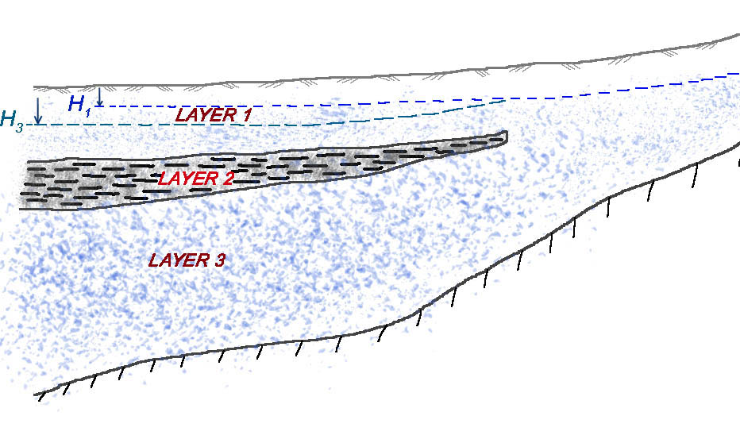

Figure 3. Conceptual model of the Somes-Szamos aquifer
The hypothesis of two main aquifers separated by an aquitard was sustained by the results obtained during the field campaign. The groundwater levels measured in the shallow and in the deep aquifer put into evidence different piezometric heads in the two formations (Figure 4).

Figure 4. Hydraulic head differences between the two aquifers
The areal extent of the model was chosen to correspond to the physical limits of the aquifer. The only exception is the Western and the Southern limits in Hungary, where the Tisza and Kraszna rivers delineate the model. The total surface of the aquifer in both countries is about 3500 km².

2.2. Boundary conditions
Boundary conditions represent the connection of the aquifer with external systems and are very important to define a problem well posed, leading to a unique solution.
The following boundary conditions were used:
a) Specified heads (Dirichlet conditions) are prescribed at the Eastern limit to take into consideration the recharge produced by surface runoff at the contact between the hill slopes and the plain. The same boundary condition is used at the Northern limit along the Tisa/Tisza river for the first layer, at the Western limit along the Crasna/Kraszna river for the first top layer and at internal boundaries to model the connection between the first layer and the rivers Somes/Szamos and Tur/Túr.
b) Specified fluxes (Neumann conditions) are prescribed in the third layer corresponding to the recharge area at the SW boundary (Nyirseg highland area); to take into account the lateral recharge. In the North-East and South part of the model, no-flow boundary conditions were considered at the contacts with naturally low permeability geological environments. Finally, the production rates of the pumping wells represent another specified flux condition.
c) Semi-permeable boundary conditions (Cauchy or Fourier conditions) are prescribed at the Western limit to model the connection of the second and third layer with the Tisza river.

2.3. Heterogeneity of the soil characteristics and recharge areas
The natural recharge of the aquifer is closely related to the soil characteristics. The main types of soils existing in the alluvial fan of Somes-Szamos river are presented in Figure 6, their main characteristics being listed in Table 1.

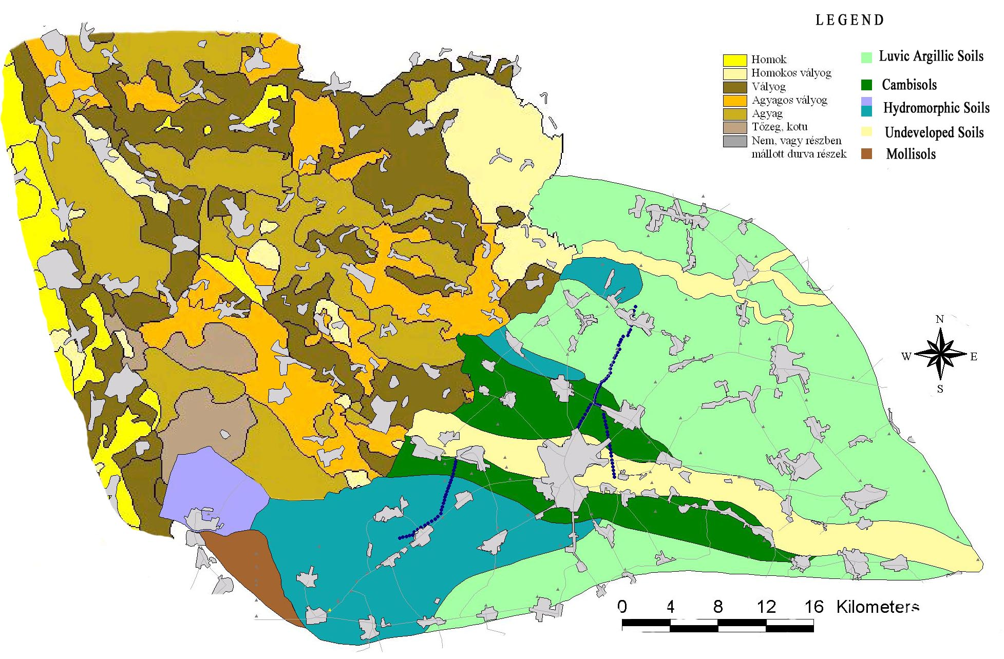

Figure 5. Soil map in Somes-Szamos area

An aggregation of soil types was necessary in order to reduce the number of recharge areas. A number of 5 zones were finally defined.

Table 1 – Soil characteristics

Type of soil | Soil depth  (cm) | Total porosity  (%) | Field capacity  (%) | Wilting coeff.  (%) | Hygrosco-  picity  (%)
LUVIC ARGILLIC SOILS  (Grey Brown Podzolic Soils, Pseudogley and Gley Grey Brown Podzolic Soils) | 140 | 45,33 | 23,1 | 10,8 | 7,2
CAMBISOLS  (Brown Forest Soils, Podzolic Brown Soil, Chernozemic Brown Soil) | 125 | 34,61 | 23,4 | 10,3 | 6,5
MOLLISOLS  (Argillic Chernozems) | 137 | 47,00 | 20,9 | 8,3 | 5,4
UNDEVELOPED SOILS  (Alluvial Soils) | 150 | 49,50 | 25.4 | 8.3 | 5.5
HYDROMORPHIC SOILS  (Humic Gley Soils and Gley Chernozems)  (Pseudogleys, Brown Forest Soils) | 150  130 |  | 26.4  23.3 | 12.7  11.4 | 8.6  6.3

Soil characteristics for each recharge area were introduced in the ALSUBTR model (Drobot, 1987; Drobot and Sirbu, 2003), which computes a water budget, based on a vertical discretization of the ground surface and unsaturated zone (Figure6).

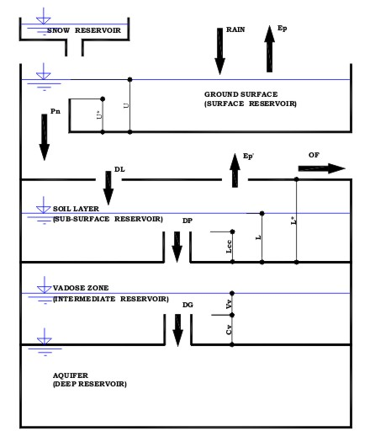 | - snow reservoir – it collects solid precipitation (snow)  b) surface reservoir – it models the interception and surface retention  c) sub-surface reservoir – it models the water content in the root zone  d) intermediate reservoir – it models the behaviour of the vadose zone  e) deep reservoir – it represents the aquifer

Figure 6. ALSUBTR conceptual model

The mathematical model corresponding to the conceptual model presented here above examines the water content variations in each reservoir, by considering their interdependency. Input data consist in daily temperatures and precipitations. The computation consists in the evaluation of water content in the reservoirs at the end of each day, these values becoming initial values for the next day; the computation continues until the end of the analysed period, which can be of dozens of years. The main advantage of this model is the possibility of evaluating the history of the natural recharge.
The physically based parameters of the model are obtained from the pedological information presented in Table 1. The remaining parameters are fitted so that the average values of the surface runoff, evapo-transpiration and aquifer recharge computed by the model are in good agreement with the hydrological balance of the corresponding area, respectively the water balance for the entire catchment. Because the area is very flat, the average value for the surface runoff is usually less than 5% of the multi-annual precipitation for the examined period. The real evapo-transpiration is in the range of 70 – 80 %, the natural recharge representing usually 10 – 20 % from the same value. Some exception can still occur: for example, in the region of Ecsedi swamps the evapo-transpiration is equal to the potential evapo-transpiration and the natural percolation was considered as equal to zero; the water excess in this case is provided by the groundwater discharge.
The zonation of the recharge areas is presented in Figure7.

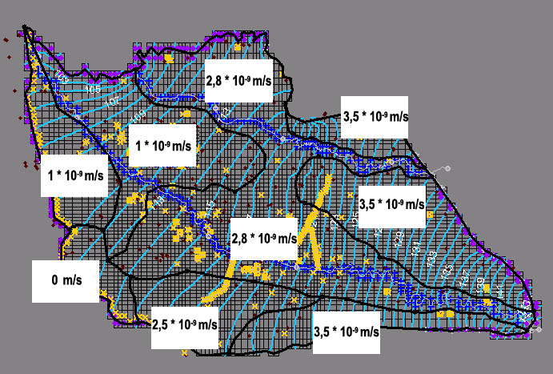 | Figure7. Zonation of the recharge areas

2.4. Heterogeneity of the aquifer properties
Prior to the field campaigns, an inventory of all existing hydrogeological parameters was undertaken. As a result, a preliminary zonation of the hydraulic conductivities and specific storage coefficients for both aquifers was determined. In principle, in the Eastern part of the aquifer, characterized by coarse sediments, the hydraulic conductivity is larger than in the Western part where finer sediments are dominant.
New pumping tests were undertaken in selected locations during the field campaigns. They confirmed the heterogeneity of the aquifer properties. Still, the parameters obtained during the pumping tests have a local character and do not measure areal properties as necessary in the regional model. In the same time, the duration of the pumping tests is limited to a few days maximum and the capacity of the aquifer to transfer water fluxes is not fully mobilised. As a consequence, the hydrogeological parameters have to be identified during the calibration phase. No matter which procedure is used (automatic calibration or trial –and-error method), the objective is to obtain a configuration of hydrogeological parameters that leads to the best agreement between the computed and the measured value of the piezometric heads.

3. Calibration and validation of the model
The calibration was performed using Groundwater Modeling System (EMS-i, 2002) both in steady state and in transient state. The steady state calibration was based on piezometric levels measured during the field campaign of October 2001. Considering the pluviometric regime, 2001 was a medium year; in the same time, in October the gropundwatr levels are low, corresponding to a dry period. The spatial distribution of differences between measured piezometric heads and the computed values after calibration are presented in Figure8.

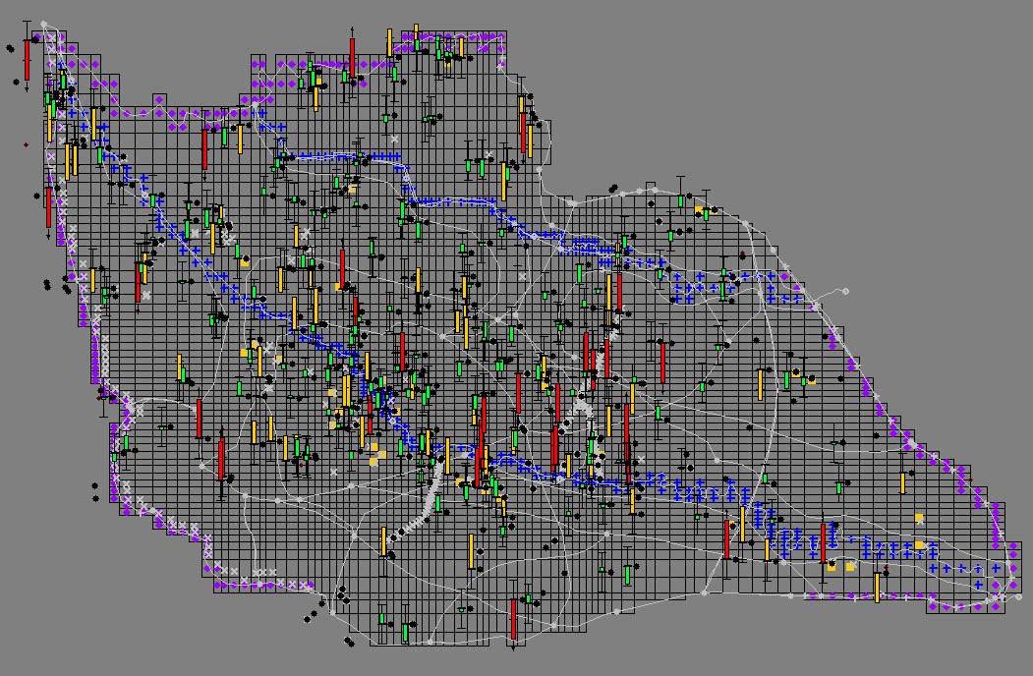

Figure 8. Differences between measured and computed heads after calibration

A correlation between the same values for the calibration in steady state is presented in Figure 10. The obtained errors: 1.63 m for RMSE, respectively 1.16 m for MAE were considered acceptable taking into account the total change of about 40 m of the hydraulic heads in the modeled area.

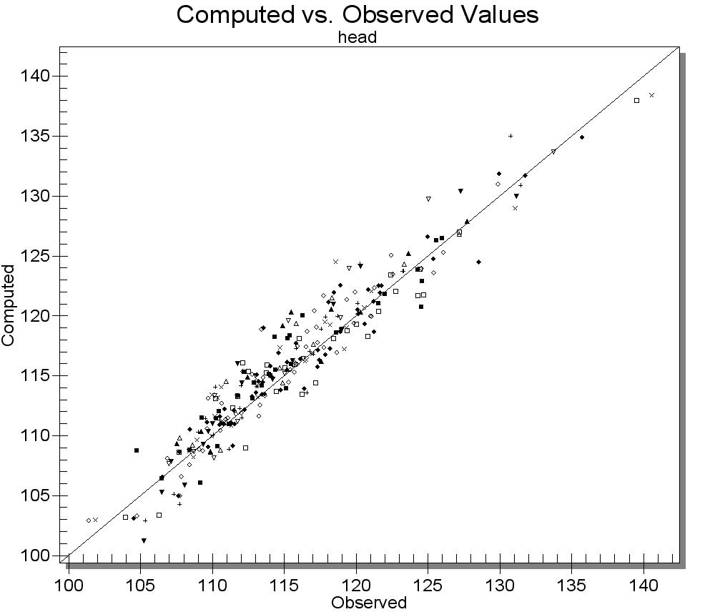 | Figure 9. Correlation  computed – measured heads  in steady state simulation

The hydraulic conductivities zonation after steady state calibration is presented in Figure 10.

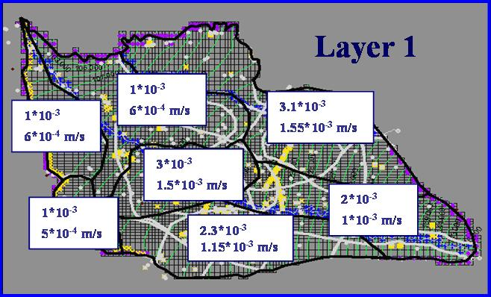

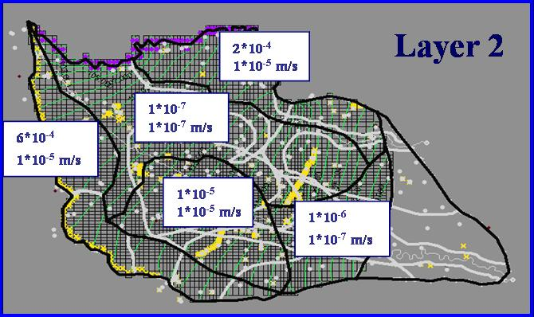

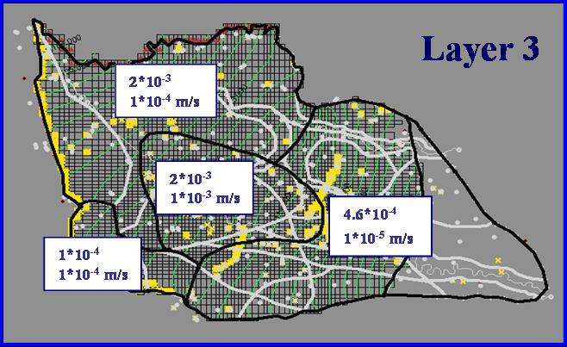

Figure 10. Zonation of the hydraulic conductivity after steady state calibration

The transient state simulation for the calibration of the specific yield, respectively of the specific storage coefficients was undertaken for the interval January 2001 – April 2002. The hydraulic conductivities obtained at the end of the steady state calibration were kept unchanged during the transient calibration. The history of groundwater levels, pumping rates, recharge values and time dependent boundary conditions for stress periods of one month were used as additional data. The hydraulic heads at the beginning of January 2001 were obtained by steady state simulation using data characterizing the year 2000. By a trial and error procedure, the storage coefficients were adjusted successively until an acceptable root mean squared error was obtained for the time dependent water levels in the observation wells. The storage parameters obtained at the end of the transient calibration are presented in the Figure 11.

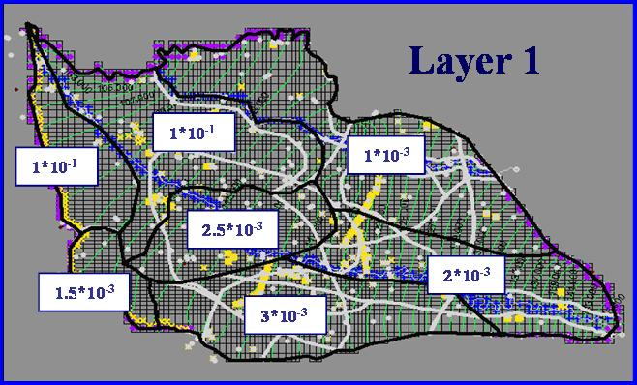

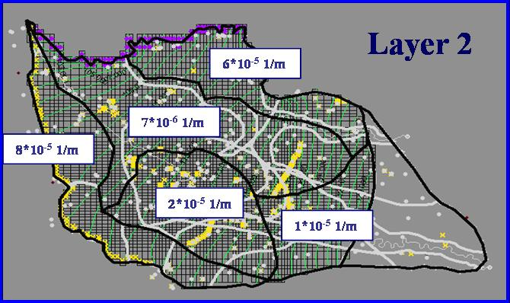

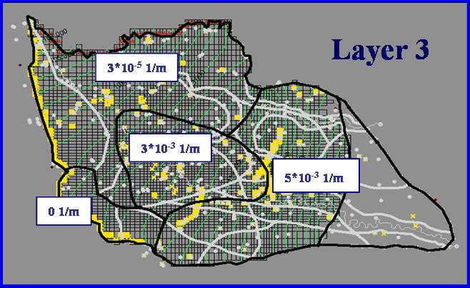

Figure 11. Zonation of the specific yield (layer 1) and specific storage (layers 2 and 3)
after transient calibration

After the calibration, a transient simulation for the interval May 2002 – December 2002 represented the base for the model validation.

4. Model predictions
After the model validation, several scenarii were considered for the future use of the aquifer. Among these scenarii, the most unlikely which was tested consists in doubling the present pumping rates for all production wells. A steady state simulation showed that the drawdowns resulted in the 1st layer are less than 0.5 m, while in the 3rd layer representing the main aquifer for water supply the maximum drawdowns are 1.5 m (Figure 12).

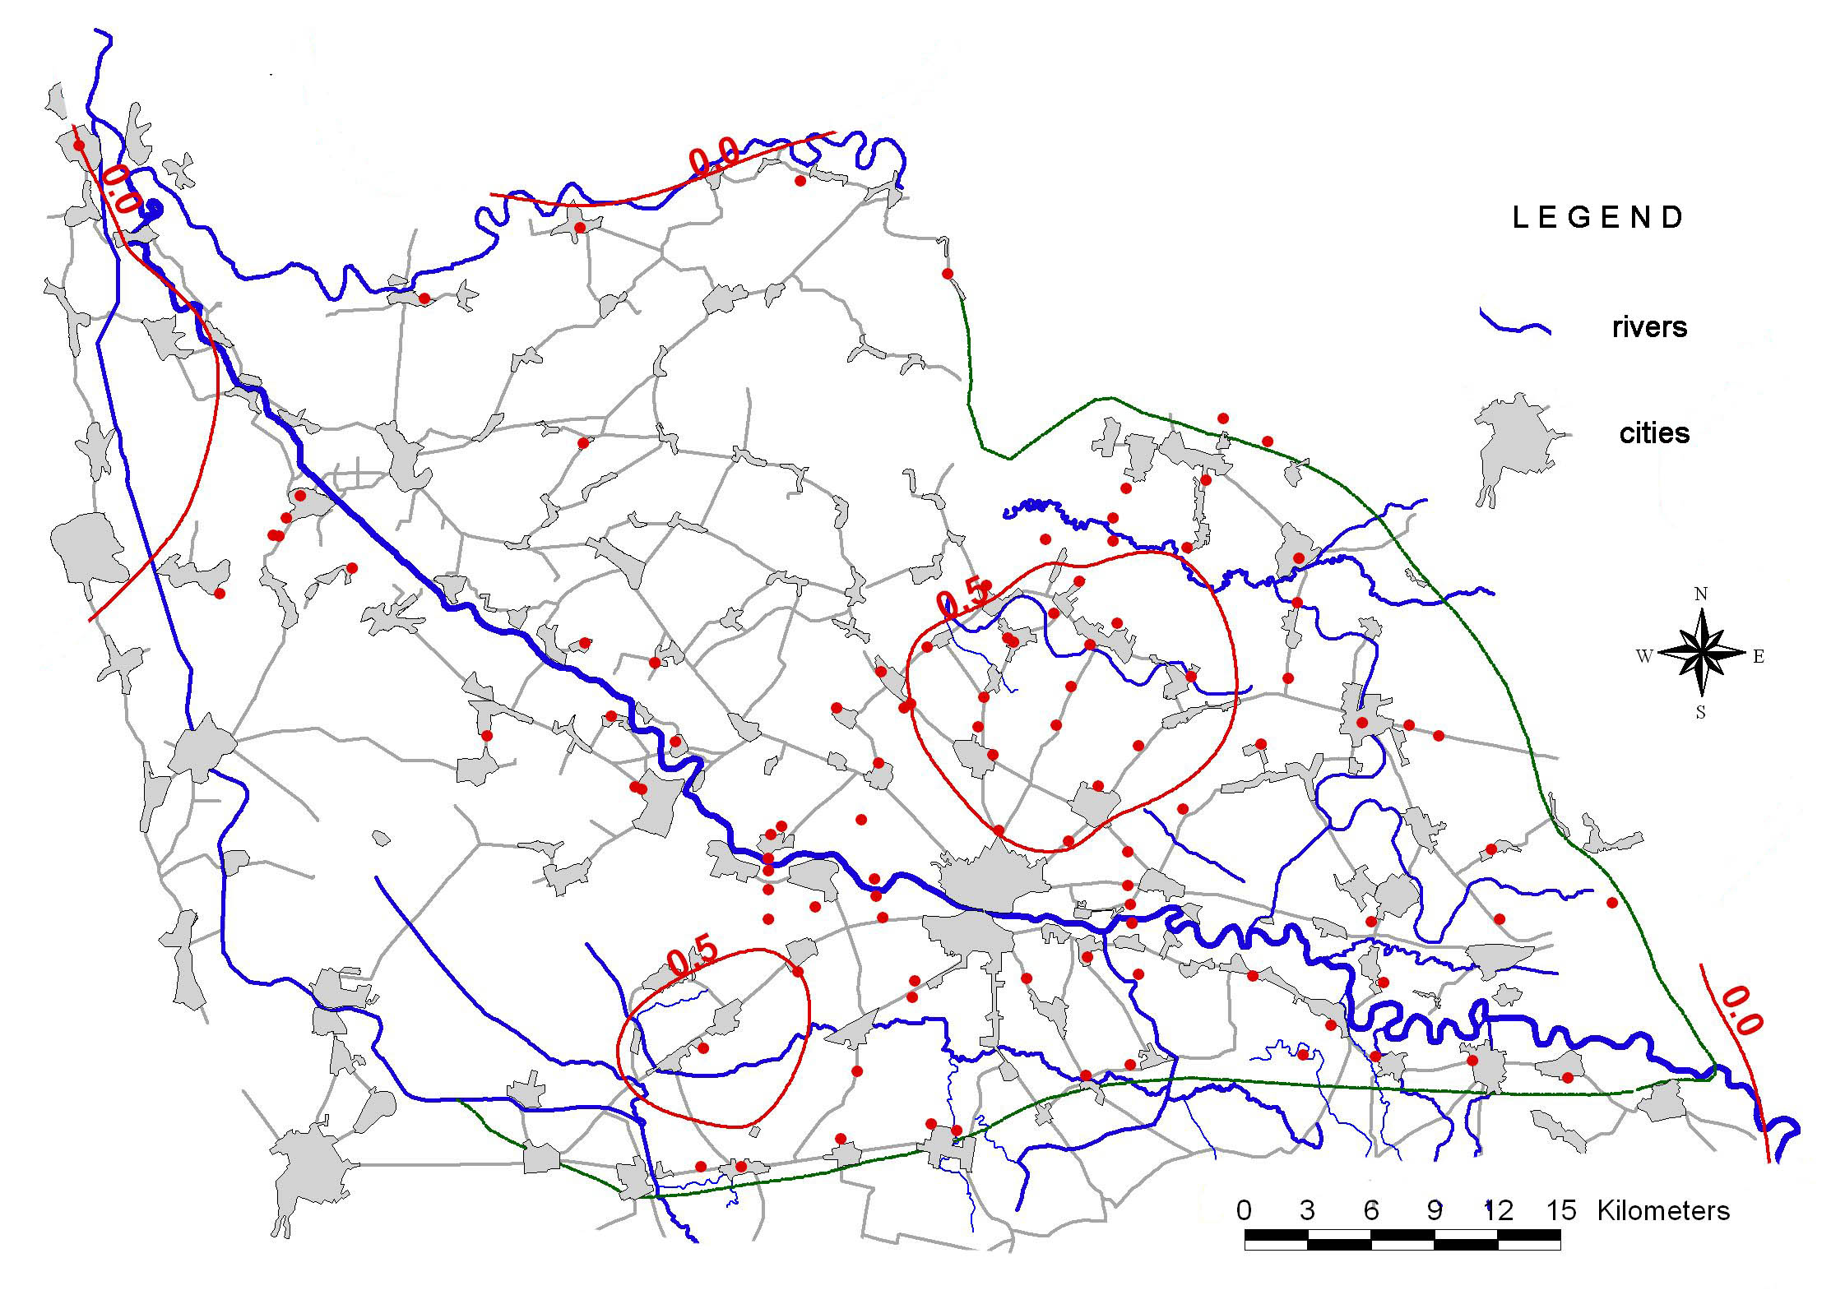

a)
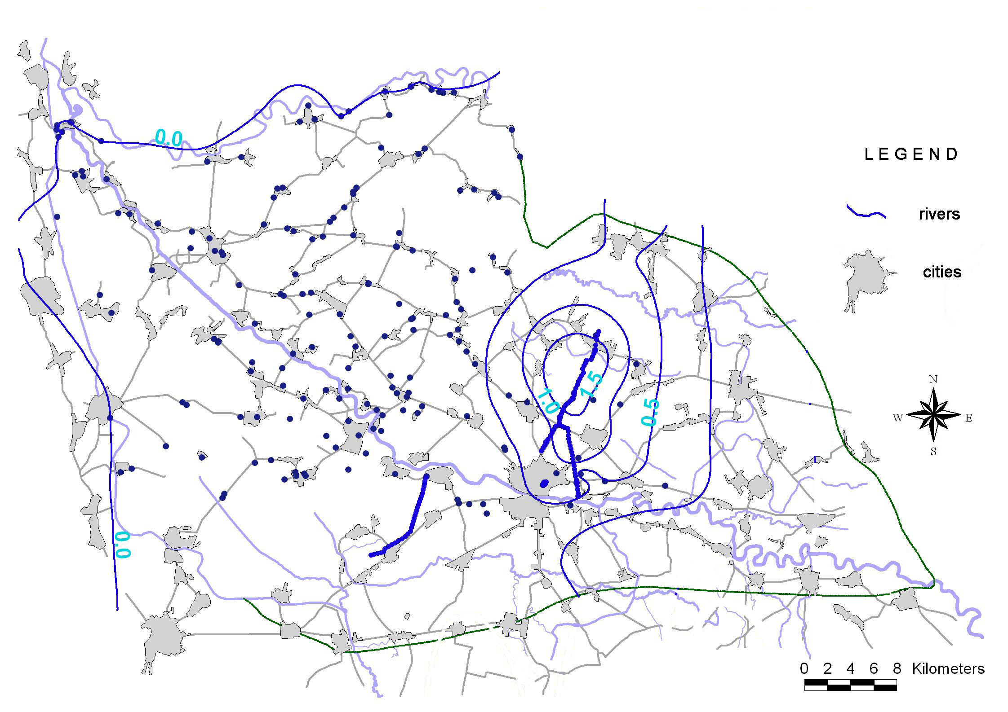

b)

Figure 12. Drawdowns due to doubling present pumping rates
a) shallow aquifer; b) deep aquifer

In the 3rd layer the drawdowns reach the inpervious limit of the model, but do not interfere with the recharge limits. Thus, the results provided by the model can be considered as correct; still, possible changes in the water fluxes have to be examined. As previously mentioned the tested increase of the pumping rates is not likely in the foreseen future. According to these results the aquifer seems not to be at risk from quantitative point of view.

Besides quantity, the quality aspects of groundwater resources are also of great interest. Using the frame provided by the regional model, some local models were developed both in Romania and in Hungary. The areas around the waste disposals of Satu-Mare and Fehergyarmat towns were modelled and some remediation measures were proposed to control the possible plume penetration in the next 15 years into the main aquifer.

5. Final remarks
The research project NATO SfP 973684 SQUASH gathered together the expertise of 3 teams from Belgium, Hungary and Romania, which worked together for more than 3 years. The regional model of the Somes-Szamos alluvial fan is one of the most important outputs of this project. A huge volume of data (more than 250.000 registrations) obtained from old archives and 4 field campaigns represented the informational base for the mathematical modelling.
Due to the complex structure of the aquifer, a simplified conceptual model was defined. Despite the fact that this model was calibrated and validated some uncertainties persist. In fact, any model is an instrument of knowledge and interpretation of the reality; by solving some problems, it raises other problems and questions about the real structure and behaviour of the modelled system. Among the problems that have to be solved in the future one can mention: the sedimentology of the Somes-Szamos alluvial fan and the corresponding hydrogeologic conceptual model, the role of the Ecsedi swamps in the aquifer budget, the utility of increasing the heterogeneity degree, the necessity of discarding the water levels measured by the wells penetrating layers that are not isolated etc. Still, these reserves do not put into question the quality of the present model and the obtained results. They suggest only possible developments both from theoretical and practical points of view.

6. References
Dassargues, A., Lenart, L., Drobot, R. (2001): Quantitative and Qualitative Hydrogeological
Study of the Alluvial Aquifer of Somes/Szamos (Romania-Hungary). Hydraulics Days.
3rd Edition. CD-ROM. Bucharest. Romania.
Dassargues, A., Brouyère, S., Popescu I-C., Drobot, R., Bretotean, M., Lenart, L., Szucs, P.,
Minciuna, M., Virag, M., Miko, M., Madarasz, T., Filip, A., Nistea, F., Szendrei, A.,
Curtean, S. (2004): Common Characterization of the Transboundary Aquifer of Somes-
Szamos River. Balwois Conference. CD-ROM. Ohrid. Macedonia.
Drobot, R., Caravia, S., Tomescu, (1987). Improvements in mathematical modelling of
groundwater resources. 137 p. NIHM. Bucharest. Romania.
Drobot, R., Sirbu, N. (2003). Improvement of the ALSUBTR model for evaluating natural
recharge. Annual conference of NIHWM. CD-ROM. Bucharest. Romania
Environmental Modelling Research Laboratory (2002). Groundwater Modelling System.
Tutorials – vol. 2. MODFLOW, MODPATH, MT3D, SEAM3D. Brigham Young University.
USA.

