MONITORING OF SURFACE WATER QUALITY AND INSTALLATION OF ADDITIONAL AUTOMATIC STATIONS

Gîlcă Gavril, Cazac Valeriu

Monitoring Centre on Environment Quality, State Hydrometeorological Service, Chisinau, Republic of Moldova, e-mail: gilca@hidromet.meteo.md, cazac@cni.md

Abstract: The Republic of Moldova is a small country situated in the Southeast part of Europe and characterized by the moderate continental climate. The hydrographic network includes 3621 main and small rivers (7 rivers are 100 km long and 247 are over 10 km long), 57 lakes (surface is 52,6 km²) and about 3000 reservoirs. Total rivers length exceeds 16.000 km. Hydrographic basin of the Nistru (Dniester) River is located at the borders of Ukraine and Moldova and constitutes 57% of the country’s territory with annual water discharge of 10 km³. Another river situated at the borders of Moldova and Romania is the Prut River that constitutes 24% of the territory and its annual water discharge reaches 2,4 km². The rest 19% of the territory are under small rivers basins flowing into the Danube River and Black Sea. The main natural lakes are on the Prut River watercourse and small artificial lakes are Costesti-Stinca reservoir on the Prut River (736 mln. m³) and Dubasari Reservoir on the Nistru River (277,4 mln. m³).
Average density of hydrographic network is 0,48 km/km² ranging from 0,84 km/km² in the north to 0,12 km/km² on the left bank of the Nistru River. The average annual water volume in Moldova is 1,32 milliard m³. Average annual amount of precipitation varies from 500-600 mm in the north-west to 370-400 mm in the south-west. In Codrii zone located in the centre the precipitation amount increases to 550-600 mm per year. The main forms of precipitation are rains and only 10% are snow.
The main sources of water are Nistru River (54%), Prut River (16%), groundwater (23%) and other surface water sources (7%). One of the important sources of water are over 132 thousand of wells.
The issue optimization of regime, balance and water quality is interrelated with the human activities impact on the environment leading to deforestation, expanse of virgin lands, drainage of wetlands, storage of potable water and assessment of polluted water, establishment of water reservoirs that qualitatively and quantitatively affect hydrographic network of the country.
These changes could be determined in real time through the complex monitoring system that aims at systematic observation of environment objects, determination of high and extremely high pollution, warning of decision-making authorities and mitigation of impact on the environment and human health.
Monitoring of the environment quality is a complex system by means of which the government systematically exercises control over the environment, natural resources and anthropogenic impact by temporal and spatial indices capable to provide informative and legislative base for operative assessment of ecological state.
Monitoring of surface water quality and environment objects is carried out by the Monitoring Centre on Environment Quality of the State Hydrometeorological Service of the Republic of Moldova. The Centre has ample monitoring network of hydrometeorological stations and posts allocated all over the country.
Systematic observation of surface water quality in the Republic of Moldova is carried out at 48 posts by 47 hydrochemical indices and 5 hydrobiological indices. The posts are located on 16 major and small rivers (including transboundary rivers: Prut, Nistru, and Danube), 6 watersheds and an estuary.
Monitoring of surface water quality started in 1960 but since 1980 it took on systematic and complex character. The primary monitoring objectives are as follows: determination of surface waters pollution level, detection of accidental pollution and dissemination of warings amoung local and central decision-making authorities, elimination and mitigation of impact on the environment and human health.

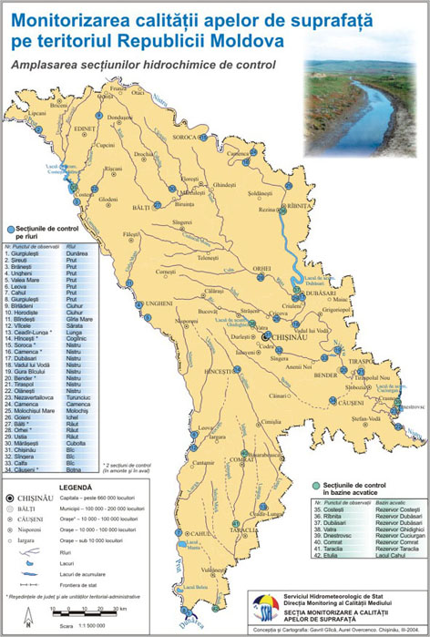

Fig. 1. Surface Water Monitoring Network

Being situated in the South-east part of Europe, in a cross-point of various bio-ecographic zones, the Republic of Moldova benefits from several transboundary rivers such as the Danube, Prut and Nistru, which water quality is systematically monitored.
Transboundary rivers pollution may have various implications on the local, regional and international levels and their use is subject to a number of agreements the most relevant of which is the Convention on protection and use of transboundary watercourses and international lakes (1992).
Also, transboundary rivers pollution rises the problem of relations stability between the neighbouring countries (Moldova – Romania, Moldova – Ukraine). This problem solution lies in maintenance of outflow water quality at the same level as inflow water quality. The strict application of this criterion favours its globalization due to which the upstream countries are bound not to affect the downstream countries.
This criterion was the main argument for installation of automatic monitoring stations on the rivers Nistru and Prut within the monitoring network of the State Hydrometeorological Service.
In 2001 within the NATO Programme “Science for Peace” and Project “Real Time Monitoring and Decision Support for International Rivers – Application to the Nistru and Prut Rivers” the State Hydrometeorological Service was supplied with 4 automatic monitoring stations that are located on the inflow and outflow of the two major transboundary rivers: the Nistru (in localities Naslavcea and Tudora) and the Prut (in localities Sirauti and Valea Mare).

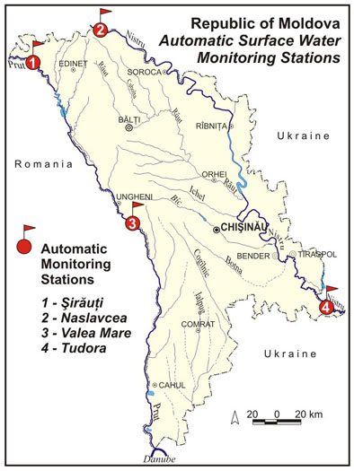

Fig. 2. Automatic Surface Water Monitoring Network

The locations were subject to joint decision of NATO and national experts.
These stations provide for:
- systematic and complex monitoring of transboundary rivers quality;
- reliability of data and measurement quality;
- efficiency of results analysis;
- operative delivery of data and warnings about extremely high pollution of transboundary rivers to the neighbouring countries, local and central public authorities, Ministries and Departments concernced, economic agents and population.

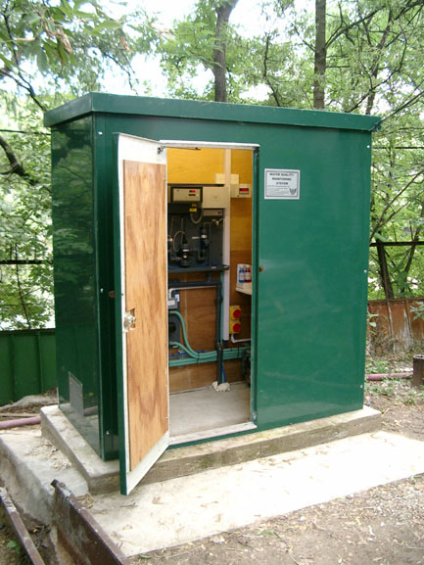

Fig. 3. Automatic control station of water quality on the transoundary rivers Prut and Nistru

The stations are equipped with continuous on-line monitors for pH, dissolved oxygen, conductivity, turbidity and temperature. Data from the monitoring stations are transmitted automatically to the central laboratory, where it is further analyzed, and transferred into the National Database.
The respective data are transmitted to other Information Centres in Romania, Ukraine, public central and local authorities, ministries and departments. When the high pollution level is detected the data urgently shall be transmitted to other institutions according to the complex scheme.
The outcomes of surface water quality monitoring are summarized, processed, evaluated and integrated in various invormative bulletins, yearbooks, reports, and maps that are interpreted by the national research institutions as well.
International collaboration, especially with Romania and Ukraine, and accidental pollution warning of the Danube Principle International Alert Centres (PIAC) plays an important role in monitoring of surface water quality in Moldova.
A new stage in monitoring of transboundary rivers quality and detection of priority pollutants begins in 1999 with analytical equipment supply to the laboratories and staff training at the European institutions in the framework of the Convention on Cooperation for the Protection and Sustainable Use of the Danube River and TACIS Programme “Accident Emergency Warning System in the Danube River Basin” (AEWS).
The article 16 of the Convention on Cooperation for the Protection and Sustainable Use of the Danube River signed on 29 June 1994 in Sofia stipulates the need for creation of a complex Accident Emergency Warning System. The article 16 of the Convention was endorsed by a number of bilateral and multilateral agreements for the Danube River and its tributaries (Bucharest Declaration, 1985; Guidance on Accident Transboundary Pollution of Internal Rivers, 1990; Convention on Transboundary Affects of Industrial Accidents, 1991; Convention on Protection and Use of Transboundary Watercourses and International Lakes, 1992 etc.).

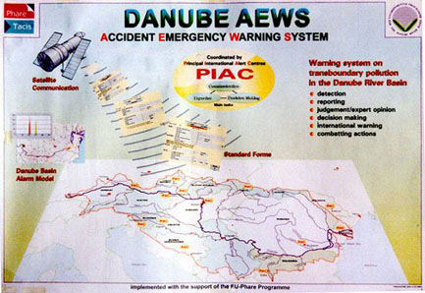

Fig. 4. Danube AEWS

The main tasks of the AEWS:
- Capacity-building for authorities and institutions to protect consumers of water from the Danube River and its tributaries (use of potable water, fishery, industry, national economy, irrigation, recreation and ecosystems protection);
- Processing and delivery of data on possible accidents on the Danube River and its tributaries;
- Processing and delivery of data on unexpected fluctuation of water level of Danube River and its tributaries;
- Processing and delivery of data on accident pollution with toxic chemicals as result different accidents;
In the Republic of Moldova the first warnings about extremely high pollution or raising of water level can be issued by various institutions (stationary and mobile posts of the State Hydrometeorological Service, fishery authorities, pump stations, natural reservations, local environment agencies, economic agents and population).
In present the efforts are made to update and implement the AEWS-Moldova, that can result in:
- elaboration of “Regulation on Danube AEWS Operation in the Republic of Modlova”;
- examination of the Regulation by the relevant Ministries, departments and institions;
- adoption of the Regulation by the Government;
- supply of the equipment and technologies necessary for complex functioning;
- staff training;
- inventory of all potential pollution sources and establishment of national database;
- inventory of all sourses vulnerable to pollution (sourses and potable water reservoirs, ecosystems with rare species of plants and animals) and establishment of natinal database;
- elaboration and preparation of National Action Guidance on industrial accidents leading to the pollution of the environment and Danube River Basin;
- compilation of electronic version of national list of organizations and persons as component of AEWS-Moldova structure;
- periodic announcements about Danube AEWS importance by means of mass media.

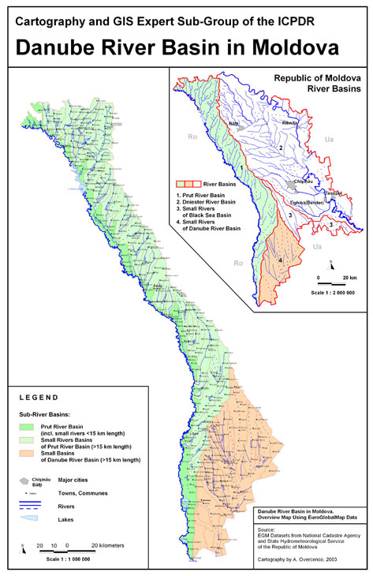

Fig. 5. Danube River Basin in Moldova

Environment protection became one of the priority policy directions of the Republic of Moldova particularly since the UN Conference on Environment and Development (Rio de Janeiro, 1992). The outcomes of the Conference were 3 official documents and a number of legislative acts, decisions and international conventions signed and ratified by the Parliament of the Republic of Moldova.
The surface water quality assessment is realized by the State Hydrometeorological Service that is in capacity to monitor the environmental quality (surface waters, atmospheric air, soil, radioactivity) and disposes of an ample monitoring system in the territory of the Republic of Moldova.
In conformity with the organoleptic and general hydrochemical parameters, chemical labor findings show that the water quality is better then in the past years of 1980-1990: mineralization is 10-15% reduced to the limit of 248-473 mg/dm³ (Nistru River), 232-644 mg/dm³ (Prut River) and 278-550 mg/dm³ (Danube River); nitrates content is also twice- and/or triply reduced to 0.2-0.3 mg/dm³; phosphate content is reduced to 0.08-0.1 mg/dm³, and the content of humus substances is twice- and/or five times reduced comparably to the mentioned period.
Heavy metals concentration in surface waters and river basins varies, being at the high in the downstream of industrially developed centers and at the confluence of the tributaries.
Calculation of water pollution index (WPI) (pollutant rate to maximum admissible concentration (MAC)) for Nistru and Prut rivers is represented below in diagram form.

Fig 6. Water quality of the Prut River (1998-2002)

Fig. 7. Water quality of the Nistru River (1998-2002)

In the course of reference period, it was established that the water quality of the Prut River is of medium grade(III class – moderate polluted), and that the WPI values are within the limits of 0.62 along the Prut River (year 2000, Branesti Village) and of 2.78 in the downstream of Jijia River head (year 2003, Ungheni Town).
On average the water of Nistru River is of medium grade (III class-moderate polluted). The WPI values are within the limits of 0.64 (2001) and of 2.64 (2003) in the downstream of the Raut River head, Dubasari Town.
In the course of the period, the most polluted small river is the Bic River (in the area of Chisinau Municipality and in the downstream of the river – Singera and Calfa villages), where the water quality is classed as very polluted (VI class) and extremely polluted water (VII class).

Fig. 8. Water quality of Bic River (1999-2003)

In the course of the reference period, the water of the Raut River is classed as degraded water(IV class), and in the downstream of the Raut River it is classed as polluted(V class, in the area of Balti Municipality); the water of the Botna River is classed as degraded (IV class); in the area of Ceadir-Lunga Town in the upstream of the Lunga River the water is classed as polluted (V class), but in the downstream – as very polluted (VI class); the water of the Cogilnic River is classed as degraded (IV class).

Fig. 9. Water quality of the Cogilnic River (1999-2003)
In the mentioned period the average concentrations exceeded the MAC value in both sections of monitoring, except the recorded value of 0.35 mgN/dmc in the area of Hincesti Town in the upstream of the river (2001).

Fig. 10. Water quality of the Raut river (1999-2003)

Fig. 11. High and extremely high pollution of surface waters, due to the deficiency of the dissolved oxygen (1998-2003)

As water is one of the most general environmental component, the efficient actions on water resources are needed to be taken through the domestic implementation of:
- environmentally-friendly technology with a minimum water use;
- modern waterworks and retrofit of obsolete installations, taking into consideration their impurity level;
- and observance of protection measures of navigable waterways and small tributaries against accidental pollution, mostly provoked by the water streams as result of abundant rains;
- rational apply of fertilizers and pesticides with observance of stocking and storing norms and requirements.
The use of modern technology and of water quality monitoring stations, as well as the appropriate administration of AEWS-Moldova on the transboundary rivers will facilitate the data exchange on water quality in the Republic of Moldova, Romania, Ukraine and Danube countries, and will contribute to a sustainable water resources management, will alert the neighbor countries on emergency pollution and will prevent the water pollution.
MONITORING OF SURFACE WATER QUALITY AND INSTALLATION OF ADDITIONAL AUTOMATIC STATIONS

Gîlcă Gavril, Cazac Valeriu
Monitoring Centre on Environment Quality
State Hydrometeorological Service
193, Grenoble str. MD-2043, Chisinau, Republic of Moldova
E-mail: gilca@hidromet.meteo.md, cazac@cni.md

Summary

Keywords: monitoring, monitoring network, automatic control station, Accident Emergency Warning System, surface water quality.

The issue optimization of regime, balance and water quality is interrelated with the human activities impact on the environment leading to deforestation, expanse of virgin lands, drainage of wetlands, storage of potable water and assessment of polluted water, establishment of water reservoirs that qualitatively and quantitatively affect hydrographic network of the country.
Monitoring of surface water quality and environment objects is carried out by the Monitoring Centre on Environment Quality of the State Hydrometeorological Service of the Republic of Moldova. The Centre has ample monitoring network of hydrometeorological stations and posts allocated all over the country.
Systematic observation of surface water quality in the Republic of Moldova is carried out at 48 posts by 47 hydrochemical indices and 5 hydrobiological indices. The posts are located on 16 major and small rivers (including transboundary rivers: Prut, Nistru, and Danube), 6 watersheds and an estuary.
In 2001 within the NATO Programme “Science for Peace” and Project “Real Time Monitoring and Decision Support for International Rivers – Application to the Nistru and Prut Rivers” the State Hydrometeorological Service was supplied with 4 automatic monitoring stations that are located on the inflow and outflow of the two major transboundary rivers: the Nistru (in localities Naslavcea and Tudora) and the Prut (in localities Sirauti and Valea Mare).
A new stage in monitoring of transboundary rivers quality and detection of priority pollutants begins in 1999 with analytical equipment supply to the laboratories and staff training at the European institutions in the framework of the Convention on Cooperation for the Protection and Sustainable Use of the Danube River and TACIS Programme “Accident Emergency Warning System in the Danube River Basin” (AEWS).
The surface water quality assessment is realized by the State Hydrometeorological Service that is in capacity to monitor the environmental quality (surface waters, atmospheric air, soil, radioactivity) and disposes of an ample monitoring system in the territory of the Republic of Moldova.
In conformity with the organoleptic and general hydrochemical parameters, chemical labor findings show that the water quality is better then in the past years of 1980-1990: mineralization is 10-15% reduced to the limit of 248-473 mg/dm³ (Nistru River), 232-644 mg/dm³ (Prut River) and 278-550 mg/dm³ (Danube River); nitrates content is also twice- and/or triply reduced to 0.2-0.3 mg/dm³; phosphate content is reduced to 0.08-0.1 mg/dm³, and the content of humus substances is twice- and/or five times reduced comparably to the mentioned period.
Heavy metals concentration in surface waters and river basins varies, being at the high in the downstream of industrially developed centers and at the confluence of the tributaries.

