Hydrogeomorphic response assessment of the Danube River channel and floodplain to the 2002 flood events

Anna Grešková, Milan Lehotský

Institute of Geography, Slovak Academy of Sciences, Bratislava, Slovak Republic,
e-mail: greskova@savba.sk, geogleho@savba.sk

Abstract: Floods in the context of the presumed climatic changes become ever more frequent and important geomorphological and landscape-forming phenomena. The article focuses on the geomorphic response of the bank and floodplain of the Danube river and the lower reach of the Morava river above its confluence with the Danube in the area of the Devínska Nová Ves and Čuňovo villages to two extraordinary floods in March and August 2002.
Keywords: assessment, Bratislava, Danube, flood, hazard, river, hydromorphology.

Zusammenfassung: Die Überschwemmungen und Wasserflutkatastrofen vorfindet sich immer häufig in Zusammenhang mit der vorausgesetzte Klimaumwandlung und stellen ein bedeutende geomorphologische und Landschaftsformige Phänomen vor. Der Artikel konzentriert sich an geomorphologische Flutauswirkungen im Ufer und Auengebiet der Donau und March im weiteren Umgebung von Bratislava. Vorlegende Beitrag vermittelt die Ergebnisse, welche durch detaillierte morphologische Untersuchungen gewonnen wurden. Die einzelnen geomorphologischen Auswirkungen, Prozeβen unf Formen hervorrufene durch Überschwemmungen in März und August 2002 eingeschätzt und interpretieren wurden.
Schlűsselworte: Einschätzung, Bratislava, Donau, Wasserflut, Hazard, Fluß, hydrogeomorphologie.

1. Introduction
The frequent occurrence of flood events in recent years in Central European region has roused attention of a wide spectre of specialists. Varied manifestation of flood events, their consequences and implications found reflection in the increased interest of geographers and geomorphologists who concentrated upon floods as the natural hazard and an important morphological phenomenon. In spite of the fact that in the past in many countries such as USA, Great Britain, Australia, South Africa or in Poland the fluvial geomorphology or hydromorphology developed, less attention was paid to the issue in Slovakia or Czechia. The fact that fluvial-morphological theme was neglected by the Slovak geomorphology and geography manifested above all in insufficient terminology. In recent years the issue of floodplains and especially fluvial-morphological aspects of floods was addressed in works of Grešková (2000, 2002). The work of Pišút (2002) which dealt with history of the river channel and the floodplain of the Slovak section of the Danube is an important contribution. Works of Lehotský (2001, 2002), Lehotský and Grešková (2003, 2004) contain an overall view of the theme and enlightenment of the basic terminological notions concerning the channel-floodplain system. The effect of big floods on the channel morphology and sediment transport was widely studied and researched in the world scientific community. For example, considerable attention was given to fluvial morphology and especially morphological effects of floods in Poland. Morphological changes during floods in small mountain valleys were reported by Klimek (1989), Bamugart-Kotarba (1983), Wyzga (1997). Gebica et al. (1998) described erosive and accumulation forms which originated after breach of dikes during the floods of the Wisla River in 1997. Kotarba (1999) studied the geomorphic effect of the 1997 flood in valleys of the middle-mountain forest belt of the Tatras. Zielinski (2002) described deposition effects of two great floods of the Nysa drainage basin, as well as the alluvial forms and deposits of channels and floodplains . Geomorphic effects of the July 1997 flood in the Northern Moravia and Silesia was studied by Hrádek (2000). Channel widening is one of the most typical geomorphological changes in the Sudeten and the Carpathian region. The effect of big floods on the transport of sediments, channel morphology and patterns of channel change were described by Eaton and Lapointe (2001) on the Sainte Marguerite River in Canada. The geomorphic impact of large floods on channel and floodplain changes and implication for valley-floor ecosystems in floodplain surface of the Lamar River in the Yellowstone National Park has been investigated by Meyer (2001). In the case study of the valley floor in the piedmont zone of the Scottish upland, Werritty and Leys (2001) have studied valley reworking, channel shifting across the floodplain while they recognised the robust and responsive landforms.

2. Aim
Activities in the field of integrated flood management were initiated at the world level through programmes involved in care after water. Integrated flood management is based on holistic interpretation of mutual interactions and processes which take place inside and between the natural and anthropised environment in the framework of the whole basin. Recently, the myth of absolute safety against floods (c.f. Hajtašová et al. 2004) proved to be unsustainable. Experts understand now that safeguarding or absolute protection against floods is not possible both from the technical and economic aspects. Flood control is linked to estimates of sizes of extreme floods; they are generally imprecise and they will most probably modify under the global climatic change effect. The present modern society will have to address the issue of floods, as well as the management of uncertainties and risks as the flood risk is connected above all with hydrological uncertainties. It will be necessary to seek a balance between the flood risk and development of the territory in question. Hydromorphological manifestations of floods are spatially and temporally located in a differentiated and hierarchized way. Sudden extreme hydrological and climatic anomalies provoke instability of the channel-floodplain systems, they predetermine unclear future. On the other side, complexity and dimensions of their impacts must be recognised. Due to the deficit of hydromorphological terminology, methods, and standard procedures in field work, no detailed research focused on morphological efficiency and response of floods exists. This paper concentrates on identification and understanding of spatial distribution of morphological responses to floods, as well as generation of source material for survey and monitoring of morphological response to floods, confrontation with the intentions of territorial plans and estimation of flood risks and hazards in the hinterland of Bratislava.

3. Study area
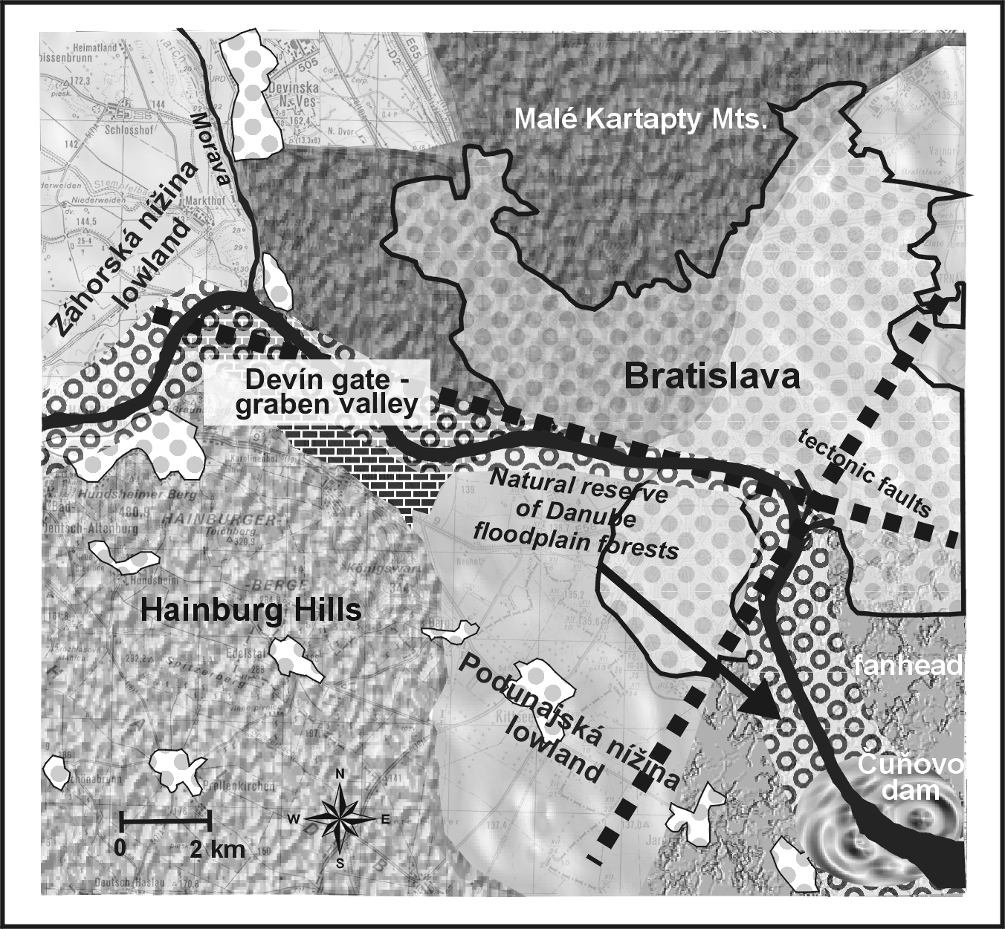
The study reach of the Danube and Morava Rivers coincides with the channel-floodplain system characterised by the following specific features (Fig. 1). The model territory is situated in the western part of Slovakia, on the contact of the Záhorská nížina Lowland and the westernmost promontory of the Podunajská nížina Lowland, in the wider environs of the Devínska brána Gate. It is about 5.5 kilometre long left bank riverine landscape of the lower reach of the Morava above its mouth into the Danube and the 25 kilometre long riverine landscape with anti-flood dikes on both sides of the Slovak reach of the Danube from its confluence with Morava as far as the Čuňovo village (figure 1). Both streams more or less stabilised in this space already during the Lower Pleistocene. In the west, the Danube flows from the confluence with the Morava through the centre of Bratislava on the left bank and Wolfstahl village on its right bank and on through the tectonically determined graben valley between the Hainburg Mts. and Little Carpathians. The eastern part of the channel is situated in the neotectonically very active transitory edge of the Gabčíkovo basin and from the point of morphology, it represents the head of the bulky alluvial fan. From the point of view of fluvial morphology, both rivers represent the alluvial type with a high aggradation potential and lateral channel shift. They are also characterised by sinuous, anastomosing and anabranching channel patterns and asymmetrical right-bank development of floodplains in the western part of the study area and the relevant spatial structure of relief microforms. Existence of the bulky ford of the Danube system in and around Bratislava has of course determined, inter alia, the founding and development of the town and its hinterland. On the other side, high aggradation which manifests in many places as the river bed raising contributes to the probability of flood occurrence. Human interventions into the Danube riverine landscape were relatively common and frequent in the past, though increasing fluvial activity during the 18th
Figure 1. Geographical position of study area

century was responsible for their limited efficiency. The effect of floods was probably amplified by human works which resulted in stabilisation of the side channels and tributaries, simplification of the river channel pattern and concentration or widening of the main channel (Pišút 2002). The study area of the Danube River along with its arm system represents a territory with remains of original floodplain forests unique in Central Europe, with high ecological value of the landscape and high retention capacity. Floodplain forest had significantly contributed to the natural flood control in the past.
The final stage of adaptations of the Danube riverine landscape was carried out by the end of the last century along with the construction of the Gabčíkovo dam. A new system of protective dikes, which was supposed to solve the problem of as much as 500-year water for Bratislava, was constructed. However, the intensified aggradation process and building up of the Danube bottom accompanied by its proceeding up the stream (all effects of putting the Gabčíkovo dam in operation) modify the conditions determining the morphological response to inundation events on the Danube and the adjacent Morava – now distinctly affected by the global climatic changes. If urbanising intentions in the inundation area and the high possibility of flooding of the wider centre of Bratislava are taken into account, the aggradation process on the one side and the erosive effect on the other are among the most complicated problems of the Capital to be addressed in the middle-term future.

4. Hydrometeorological situation in time of flood event
In the last decade the floods on study reach of the Danube normally occurred in summer. In 2002 floods occurred both in March and August.

4.1. The flood in March
The March flood in Bratislava stemmed in the upper part of the Danube basin where the pronounced increase of water table was caused by abundant precipitation which struck Bavaria, including the upper and later also the lower parts of Austria. Between 19th and 22nd March the frontal disturbances proceeded eastward in strong western flows over central Europe . The effect of snow thaw was originally negligible. The onset and process of flood was rapid. In four days the water table of the Danube gauged at Bratislava-Devín increased by 577 cm (Fig. 2). The culminating water table in Bratislava-Devín (on March 24) reached the value of H_{max}. = 828 cm and discharge Q = 8628 m³.s⁻¹. The Danube culminated in Bratislava (The Nový most bridge) at H_{max}. = 872 cm (discharge in Bratislava is not expressed as it is influenced by the Gabčíkovo dam).
Figure 2. Mean daily discharges of the Danube river in Bratislava

In the consequence of abrupt increase water table and rapid increase of discharges, the stream of the Danube was fierce. The waters carried wooden debris even whole trees which got stuck by bridge pillars and other barriers and accumulated in the channel nooks and backwaters. Although mean water level were reported on the Morava River, its lower reach was impounded due to high waters of the Danube.

4.2. The August flood
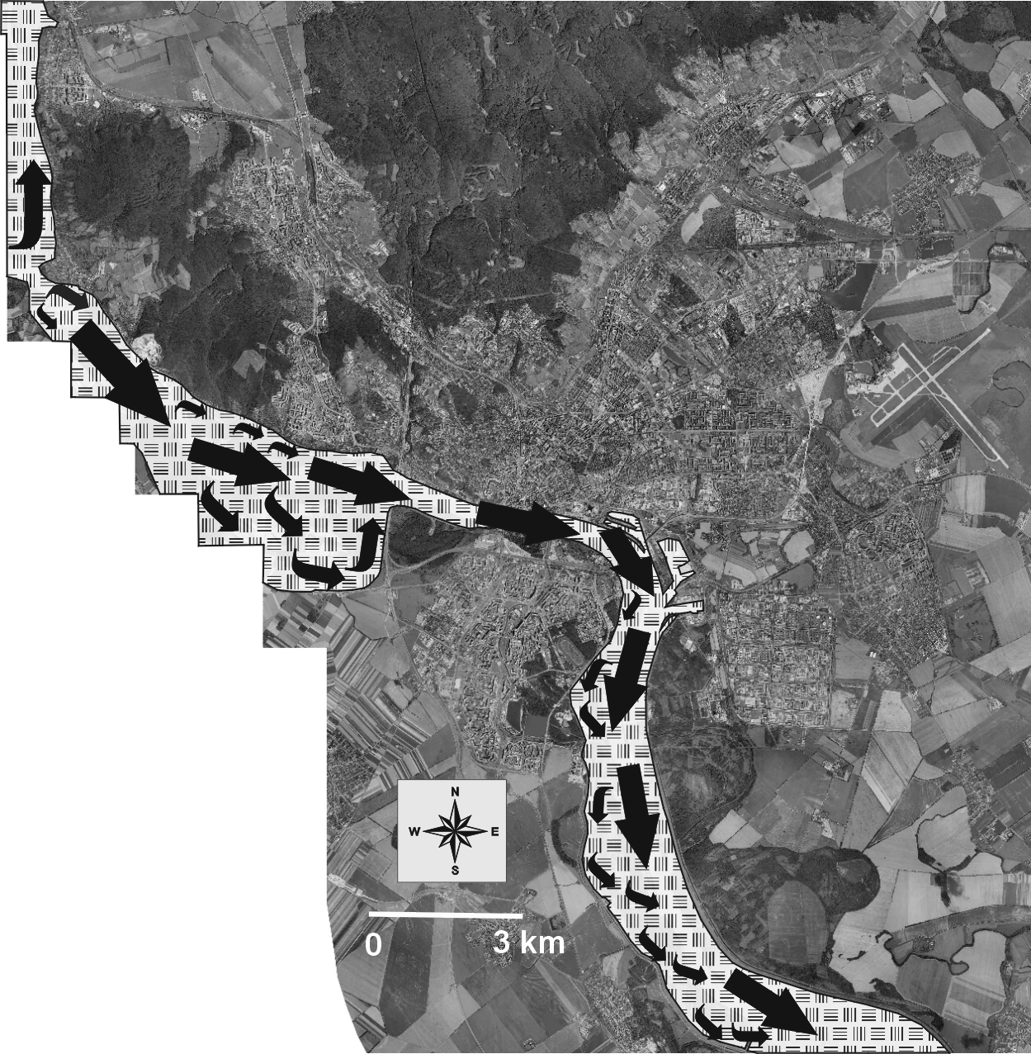
Two flood situations in a very short interval occurred on the Danube in August. The first of them was indeed extraordinary both from the hydrological and historical points of view. It was caused by abundant precipitation which covered a large territory in the German and Austrian parts of the basin. The most abundant precipitation fell on 6th and 7th August. The following precipitation fell on the already waterlogged basin and caused the second extraordinary flood on 9th to 12th August. The Danube culminated in Bratislava-Devín with 948 cm and discharge of 10,390 m³.s⁻¹ on 16th August, what is more than a 50-year water. The highest water level in Bratislava was at 991 cm. The interesting thing is that the high water (over 900 cm) maintained in Bratislava for more than two days. It only dropped below 700 cm on 18th August. The flood situation also manifested on the lower reach of the Morava. The impoundment caused higher levels on the Morava as far as the village Záhorská Ves. The extent of floods in August was larger than in March. Inundation flows directions are showed in Figure 3.

Figure 3. Inundation flows directions

5. Methods and hydromorphological survey
The first step was to divide the study territory into sections in the sense of the River Morphologic Hierarchical Classification (RMHC, Lehotský, Grešková 2003, 2004) based on maps (1:10 000), ortho-photo maps, aerial photographs and field research (Table 1, Figure 4).

Table 1. Criteria of division of the Morava (1-3) and the Danube Rivers (1-10) into reaches

 | Morava |  |  | Danube
River reach  Criteria | 1 | 2 | 3 | 1 | 2 | 3 | 4 | 5 | 6 | 7 | 8 | 9 | 10
1.valley setting | c | b | b | a | b | b | b | c | c | c | c | c | c
2.river channel pattern | b | a | a | d | a | c | d | b | b | c | c | c | c
3. river reach according to degree of sinuosity | a | a | a | b | b | a | a | a | b | b | b | a | a
4. channel width | a | a | a | b | b | c | b | b | b | c | b | b | b
5. floodplain width in interdike area | c | b | b | b | d | d | c | - | a | b | c | c | c
6. morphological character of floodplain | a | a | b | b | b | b | b | - | a | b | b | b | b
7. type of L bank | 2a | 2a | 2b | 1a,2c | 1b | 1c | 2d | 2d | 2d | 2d | 2d | 1c | 2a
7. type of R bank | 1c | 1c | 2a | 1b | 1a | 1c | 2d | 2d | 2d | 1b | 1a | 1c | 2a
8. influencing of the lower reach | b | b | c | c | c | c | a | a | a | c | c | c | b
9. channel bed and floodplain sediment character | b | b | b | a | a | a | a | a | a | a | a | a | a
10. land cover in interdike area | a | b | b | b | b | b | b | c | c | b | a | a | a
11. restriction of L inundation | c | c | b | b | b | b | b | a | a | a | a | a | a
11. restriction of R inundation | c | a | c | c | a | a | a | a | a | a | a | a | a
12. direction of flow as against thalweg | d | d | d | a | b | b | c | a | a | a | b | b | c
13. occurrence of water bodies | a,b | a,b | a | a | a | a | b | - | - | a | a | a, b | a,b

Explanatory notes: Criteria applied to division of the river into reaches (static, dynamic and other)
Criteria:
1. valley setting: a) confined, b) asymmetric partly confined, c) alluvial valley setting
2. river channel pattern: a) anastomosing, b) single main channel, c) pleisio and paleo side channels, d) main channel and paleo side channels
3. river reach according to degree of sinuosity: a) straight, b) in bent
4. channel width: a) <100 m, b) 260-300 m, c) 300-400 m
5. floodplain width in the interdike area (not quoted if not identified): a) <500 m, b) 500-1000 m, c) 1000-2000 m, d) >2000 m
6. morphological character of floodplain: a) undulating, b) dissected (with side channel)
7. bank type (separate for each bank side; L - left, R – right): 1) natural - lateral movement possible: 1a) concave, 1b) convex, 1c) straight, 2) adjusted: 2a) toe protection, revetment, spur-dike field (lateral movement partially limited), 2b) embankment (lateral movement limited)

8. influencing the lower reach regarding permeability and retention of water and sediments: a) narrowed, accelerating - vertically expanding, b) widened and slowing horizontally expanding - retentive, c) asymmetrically widened - horizontally expanding - asymmetrically retentive

9. character of bottom sediments and of floodplain: a) permeable, b) less permeable
10. land cover interdike area – barrier effect : a) reach with permeable land cover, b) reach with semi-permeable land cover, c) reach with relatively impermeable land cover
11. restriction of inundation (separate for each bank side; L - left, R – right: a) dike, embankment, b) slope with communication, c) none
12. prevailing direction of inundation flow with relation to thalweg: a) parallel, b) divergent, c) convergent, d) impoundment
13. occurrence of water bodies: a) pleisiochannels, b) paleochannels, c) artificial water bodies, d) none

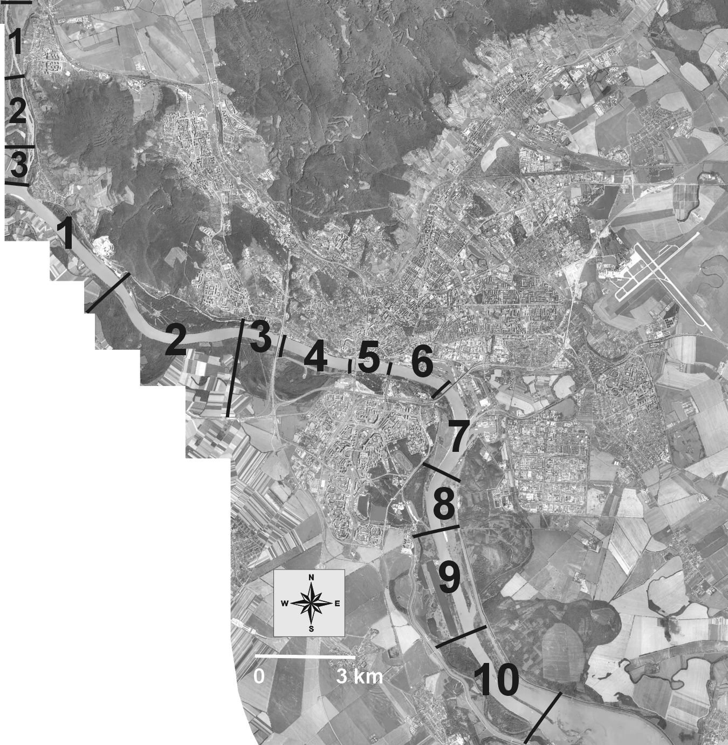

Figure 4. River reches of Morava and Danube rivers

In order to identify the geomorphic response to floods, a detailed morphological survey in river reaches - small scale mapping (reach scale) was carried out immediately after the retreat of the March and August floods in 2002.
The depth of sedimentation was determined by probes. The difference between sedimentation deposited by the March and August floods was assessed by means of herb vegetation. The speed of sedimentation in the course of the last decades was determined by:
- dendromorphochronological method relying on:
- assessment of tree age though a sample collected by the dendrological auger,
- assessment of the depth of the collar root of the tree (in cm), i.e. assessment of sediment thickness
- assessment of sedimentation speed based on the ratio of the identified sediment thickness and the age of the tree (cm/year)
- analysis of artifacts (military bunker) leaning on the known age of the artifact and sedimentation thickness deposited on it.
At the same time corresponding hydrological data were statistically processed.

6. Results and discussion
Applying a similar geomorphic survey, the processes and geomorphologic manifestations of floods (sedimentation, erosion, transport and other) were identified in the individual reaches. Table 2. brings the results of field mapping.

Table. 2. Morphological response of floods: sedimentation (S), erosion (E), transport (T), other (O).
–––––––––––––––––––––––––––––––––––––––––––––––––––––––––––––––––

River reach Morphological response of floods in the river reaches

_______________________________________________________________________

M1
S: overbank deposits, floodplain deposits, slackwater sediments, E: moderate bank erosion, T: trash line, O: -

M2
S:, floodplain deposits, muddy traps, slackwater sediments, E: moderate bank erosion and erosion of toe protection, flat avulsion runnels, T: trash line, O: -

M3
S: overbank deposits up 30 cm, floodplain deposits, muddy trapes, slackwater sediments, E: minimum bank erosion, T: trash line, LWD (large woody debris), O: -

D1
S: floodplain sand deposits. E: avulsion trough, avulsion runnels, T: -, O: -

D2
S: overbank deposits, E: -, T: -, O: -

D3
S: slackwater sediments, E: bank erosion, erosion of revetment, erosion bank-nook, avulsion runnel, T: LWD, O: -

D4
S: -, E: -, T: predominante transport and sediment redeposition of allochtonous material, O: -

D5
S: slight sand overbank deposites, E: -, T: transport predominante over sedimentation, LWD, O: piping, seepage,
D6
S: slight overbank deposits, E: -, T: -, O: -

D7
S: overbank sand deposits, floodplain ripples and dunes build by sand deposits, E: bank erosion, undercut bank, river-cut cliff, bank cracking, erosion bank-nook, avulsion runnels, bar and swale,
T: LWD, O: -
D8
S: overbank sand deposits, floodplain dunes, E: -, T: LWD, O: -
D9
S: floodplain deposits, floodplain dunes, E: -, T: LWD, O: -
D10
S: floodplain deposits, floodplain dunes, E: -, T: LWD, O: -
_______________________________________________________________________

Field research and comparison of two flood events from 2002 showed that the geomorphic response to August floods was proportionally larger to the water volume flowing down the channel and the duration of flood event. August floods intensified the sedimentation processes which started in March and deepened the manifestations of erosive processes. Great amount of sediments was transported and redeposited. Survey of the trash line proved that during the August flood less organic material (above all large wooden debris deposits, fallen trees) was transported and deposited than in March which in fact cleaned the river channels and riverine areas.
Age of trees in the M2 river reach was estimated applying dendromorphochronological survey to about 30 years and the thickness of alluvial deposits to about 42 cm, what represents a yearly increment of sediments about 1-1.5 cm a year. Dendromorphochronological survey of younger stands (8-year old trees) in the M3 river reach also revealed that about 30-32 cm of sediments was deposited since the 1997 flood. The sediment increment on consolidated surface of older sediments and on solid surface (trail for cyclists in the vicinity of the river channel) to 6 cm was identified after the March flood in 2002. Thickness of sediments after the August flood was up to 20 cm.
Military bunker is situated on the bank of the D8 river reach, which was part of defensive structures of Czechoslovak frontiers in the 1930s. In locality „bunker“ the sediment thickness was established at 100 cm (above its doorstep) and the speed of aggradation was set at about 1.6 cm a year. Since 1937 when the bunker was built, 22 flood events occurred on the Danube with discharge surpassing 6,000 m³.s⁻¹. The survey results indicated that the aggradation speed of floodplain deposits was increasing with frequency of flood events in recent years. Results confirmed that the largest increment of overbank sediments has been deposited by the 2002 floods. Apart from accumulation forms the 2002 floods manifested through numerous erosion forms and processes disturbing banks and riverine zone above all (Table 2). Repair and remedy for erosion and accumulation phenomena after every flood require considerable finances.

7. Conclusions
The possible consequences of the potential climatic changes, increasing frequency of floods and flood risk in study are manifest through acceleration of active and ever present fluvial-geomorphologic processes. The results suggest high sensitivity, susceptibility and instability of the study reaches in the context of flood pulse which is a long-term permanent natural threat in the intensively urbanised hinterland of Bratislava. The level of flood threat is determined by a wide scale of factors beginning with possible climatic change, coincidence of floods of the Morava and Danube Rivers , the Gabčíkovo dam, longitudinal and transversal dimension of the channel-floodplain systems, silting of the river beds and inundation and ending by dredging and other earth works in the area. The presents of two contradictory fluvial-geomorphologic processes (bank erosion, accumulation on the bottom of the river channel and on the floodplain) requires a permanent maintenance of the channel bed and riparian zone accompanied by confrontation of urbanisation intentions in territory with these facts.
Uncertainty of a successful technical solution to floods in the territory of Bratislava is high. Search for solutions and alternatives to coexistence of man and natural threat on artificial surfaces calls for applications based on sustainable development, management of acceptable flood risk and future development of the territory.

Acknowledgement
This paper was prepared with support of the VEGA Grant Agency as part of the Project No. 2/3084/24.

8. References
Baumgart-Kotarba, M. (1983): Study of braided channel processes of the Bialka river during 6 years without floods and dduring a flood in 1980. Studia geomorphologica carpatho-balcanica, 61, 161-181.
Eaton, B., C., Lapointe, M., F. (2001): Effects of large floods on sediment transport and reach morphology in the cobble-bed Sainte Marguerite River. Geomorphology, 40, 291-309.
Gebica, P., Patkowski, B., Lasek, A. Sokolowski, T. (1998): Geomorfologiczne i sedymentologiczne skutki przervania walow przeciwpowodziowych w doline Wisly v lipcu 1997 roku. In Powodz w dorzeczu gornej Wisly w lipcu 1997 roku. Kraków, 185-194.
Grešková, A. (2000): Mapovanie zaplavených a zamokrených území aplikáciou leteckých čiernobielych snímok (na príklade inundačného územia rieky Moravy). Geografický časopis, 52, 353-361.
Grešková A. (2002): Dynamika a transformácia nivy rieky Moravy študovaná pomocou historických máp a leteckých snímok. Geomorphologia Slovaca, 2, 40-44.
Hajtašová, k., Lešková, D., Rončák, P. (2004): Integrovaný manažment povodní podľa princípov Svetovej meteorologickej organizácie a Global Water Partnership. In: Integrovaný manažment povodí a implementácia Rámcovej smernice EÚ o vode. Zborník z celoslovenskej konferencie, Bratislava, 123-127.
Hrádek, M. (2000): Geomorfologické účinky povodně v červenci 1997 na území Severní Moravy a Slezska. Geografický Časopis 52, 303-321.
Klimek, K. (1989): Flood plains activity during floods in small mountain valleys, The Bieszczady Mts., The Carpathians, Poland, Quaest. Geogr., Poznan, Spec., Issue 2, 93-100.
Kotarba, A. (1999): Geomorphic effect of the catastrophic summer flood of 1997 in the Polish Tatra mountains. Studia Geomorphologica, Carpatho-Balcanica, Krakow, 33, 101-115.
Lehotský, M. (2001): Fluviálna geomorfológia - úvod do metodológie a terminológie. In Současný stav geomorfologických výzkumu. Ostrava, 79-85.
Lehotský, M. (2002): Korytovo-nivný systém – terra incognita v slovenskej geomorfológii. Geomorphologia Slovaca, 2, 22-30.
Lehotský, m., Grešková, a. (2003): Ekologické aspekty hodnotenia riečneho systému (výzva pre fluviálnu geomorfológiu), In: Mentlím P. (ed). Geomorfologický sborník 2, Stav geomorfologických výzkumú, Plzeň, 2003, 75-79.
Lehotský, M., Grešková A. (2004): Geomorphology of riverine landscape: ecological implications and river management strategy. Ekológia (Bratislava), in print.
Lehotský, m., Grešková, a. (2003): Geomorphology, fluvial geosystems and riverine landscape (methodological aspects). Geomorphologia Slovaca 2003, Roč. 3, č. 2, s. 46-59.
Molnar, p., Burlando, P., Ruf, W. (2002): Integrated catchment assessment of riverine landscape dynamics. Aquatic Sciences, 64, 129-140.
Meyer, G., A. (2001): Recent large-magnitude floods and their impact on valley-floor environments of northeastern Yellowstone. Geomorphology, 40, 271- 290.
Pišút, P. (2002): Channel evolution of the pre-channelized Danube river in Bratislava, Slovakia (1712-1886). Earth Surface Processes and landforms, 27, 369-390.
Werritty, A., Leys, K., F. (2001): The sensitivity of Scottish rivers and upland valley floors to recent environmental change. Geomorphology, 42, 251-273.
Wyzga, B. (1997): Methods for studying the response of flood flows to channel change. Journal of Hydrology, 198, 271-288.
Zielinski, T. (2002): Catastrophic flood effects in alpine/foothill fluvial system (a case study from the Sudetes Mts, SW Poland). Geomorphology, 1-14.

